UNIFIED MENTOR PVT. LTD. · DATA ANALYST INTERNSHIP · MANUFACTURING CATEGORY
AI-Based Manufacturing Efficiency
Classification
Using Sensor, Production, Quality, Maintenance and 6G Network Data
Research Paper
By Mimoh Naik
Thales Group business scenario · Portfolio case study

Provenance note: This is a Unified Mentor internship portfolio project. Thales Group is used as the manufacturing business scenario; the work is not presented as an official Thales engagement, commissioned study or production deployment.

Post-evaluation validated version · 2026

Contents
1. Project Context and Executive Overview
2. Original Evaluation and Remediation Scope
3. Dataset Overview and Data Quality
4. Exploratory Data Analysis
5. Target Construction Audit
6. Feature Engineering
7. Model Development and Evaluation Design
8. Results and Probability Diagnostics
9. Feature Ablation
10. Future-Prediction Feasibility
11. Explainability
12. Streamlit Application
13. Business Interpretation and Recommendations
14. Limitations and Future Data Requirements
15. Reproducibility and Quality Gates
16. Conclusion
Appendix A. Metric Definitions and Decision Rule
Version note: The original internship submission received 8/10 (Excellent). This report documents the post-evaluation methodology review and the final validated interpretation of the same project.

1. Project Context and Executive Overview
This project was completed as a Unified Mentor Data Analyst Internship project in the Manufacturing category. The analysis uses a Thales Group smart-manufacturing business scenario and a supplied dataset of machine, production, quality, maintenance and network telemetry. The portfolio objective is to demonstrate a complete analytical workflow rather than to claim an official Thales deployment.
The original project framed the task as real-time efficiency classification. The post-evaluation review retained that current-state classification use case but tested whether the model results supported broader predictive claims. The review found that Efficiency_Status is almost entirely encoded by contemporaneous Error_Rate_% and Production_Speed_units_per_hr. A transparent rule disagrees with only two of 100,000 records and achieves perfect agreement on the final chronological holdout.
Accordingly, the final architecture is best described as descriptive manufacturing analytics plus transparent current-state efficiency classification, with machine-learning models retained as benchmarks for nonlinear classification, probability diagnostics and explainability. Separate temporal diagnostics do not support future-risk forecasting.
100,000  source observations | 50  machines | 77.8%  Low class
2  full-data rule disagreements | 20,000  chronological holdout rows | 12/12  sanity tests passed

1.1 Research Questions
- What patterns characterize the supplied manufacturing telemetry and efficiency labels?
- How much of the current-state label can be reconstructed by transparent rules?
- How do Logistic Regression, Random Forest and XGBoost perform under imbalance-aware and chronological evaluation?
- Does performance survive when target-linked features are removed?
- Does the dataset contain enough temporal dependence to justify a future-efficiency prediction claim?
- How should model explainability and dashboard outputs be interpreted once target construction is understood?

2. Original Evaluation and Remediation Scope
The original Unified Mentor submission received an 8/10 (Excellent) evaluation. The evaluator highlighted the breadth of the manufacturing dashboard, including efficiency monitoring, machine-level trends, operation-mode views, historical heatmaps, network reliability, configurable thresholds, at-risk record views and interactive simulation. The principal improvement request was stronger validation because the target is highly imbalanced and very high agreement or confidence can make model performance appear more general than the evidence supports.
The remediation therefore did not simply add more models. It audited the label itself, established transparent and majority-class baselines, replaced shuffled cross-validation with chronological evaluation, added feature ablation and probability-quality metrics, tested temporal feasibility, and added automated sanity checks. These changes preserve the original evaluated submission as historical context while producing a more defensible final portfolio interpretation.
Methodology review: The evaluator feedback was valid but incomplete: class imbalance was a visible problem; the deeper issue was that the target could be reconstructed almost deterministically from two contemporaneous production variables.

3. Dataset Overview and Data Quality
The dataset contains 100,000 timestamped observations across 50 machines between 1 January and 10 March 2025. Each row includes operation mode, sensor measurements, power, network telemetry, quality metrics, production speed, a predictive-maintenance score, error rate and the target label Efficiency_Status.
Field | Description
Date / Timestamp | Calendar date and recorded observation time
Machine_ID | Identifier for one of 50 machines
Operation_Mode | Active, Idle or Maintenance
Temperature_C | Machine temperature
Vibration_Hz | Vibration measurement
Power_Consumption_kW | Power draw
Network_Latency_ms | Network latency
Packet_Loss_% | Packet loss percentage
Quality_Control_Defect_Rate_% | Quality defect rate
Production_Speed_units_per_hr | Production throughput
Predictive_Maintenance_Score | Supplied maintenance score
Error_Rate_% | Operational error rate
Efficiency_Status | Target: High / Medium / Low

Data-quality audit results: 100,000 rows, 14 raw columns, 0 missing values and 0 duplicate rows. No imputation or deduplication is required. The dataset is sorted chronologically for validation and future-signal diagnostics.
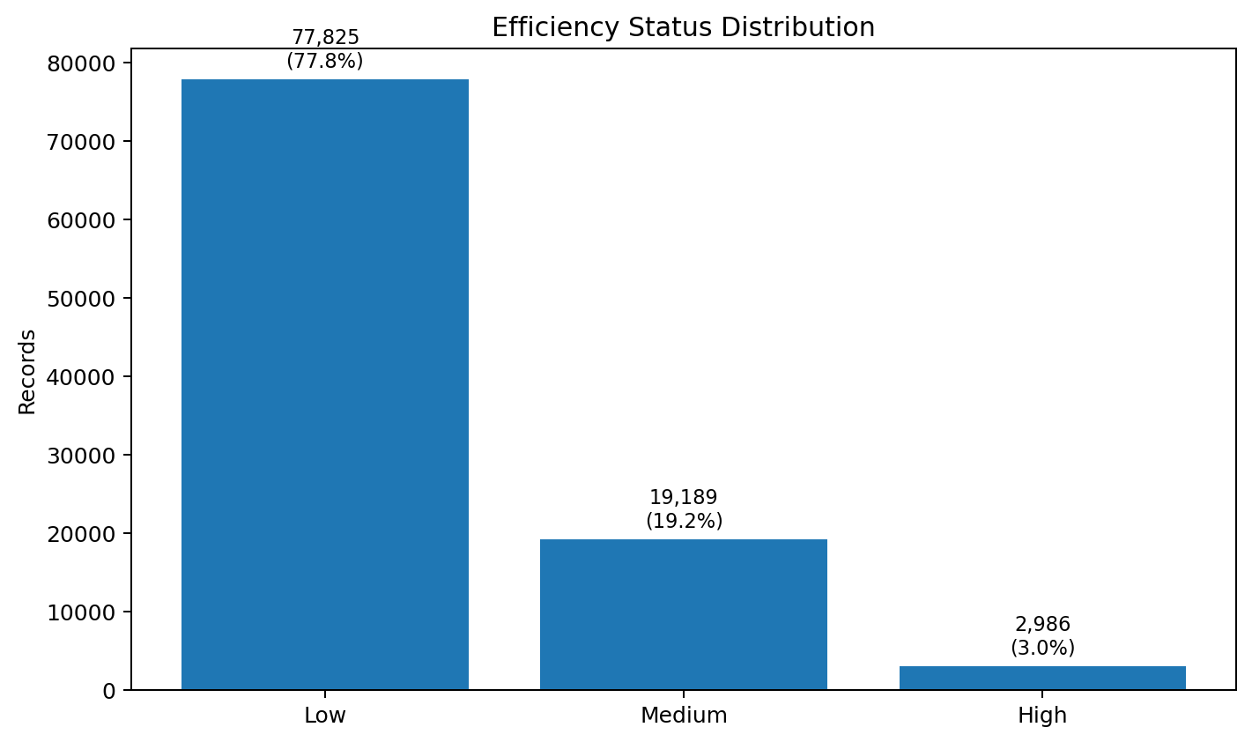
Figure 1. Efficiency_Status is strongly imbalanced: 77.8% Low, 19.2% Medium and 3.0% High.

4. Exploratory Data Analysis

4.1 Class and Rule Geometry
The strongest separation occurs in the two-dimensional space formed by Production_Speed_units_per_hr and Error_Rate_%. The class boundaries align with simple thresholds, while the remaining sensor and network variables have very similar distributions across the three supplied classes.
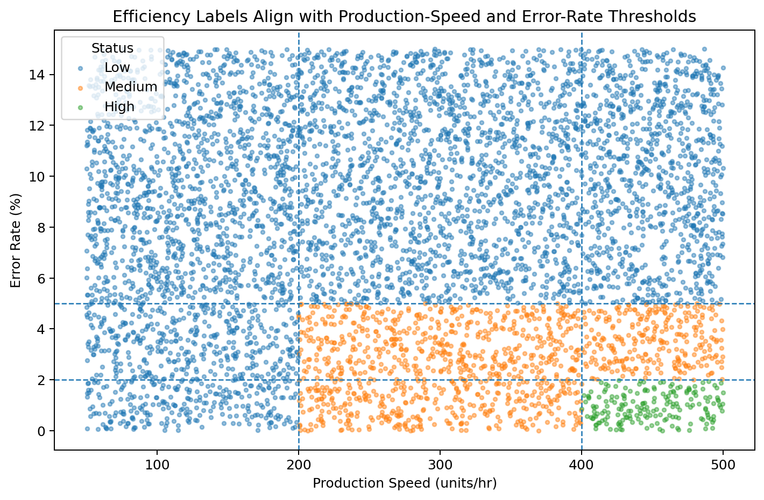
Figure 2. A sample of 6,000 observations shows the near-deterministic target geometry.

4.2 Operation Mode
The efficiency mix is nearly identical across Active, Idle and Maintenance records. Low share is 77.70% for Active, 78.25% for Idle and 77.82% for Maintenance. Operation mode is therefore useful context for monitoring but provides little independent evidence for the supplied target.
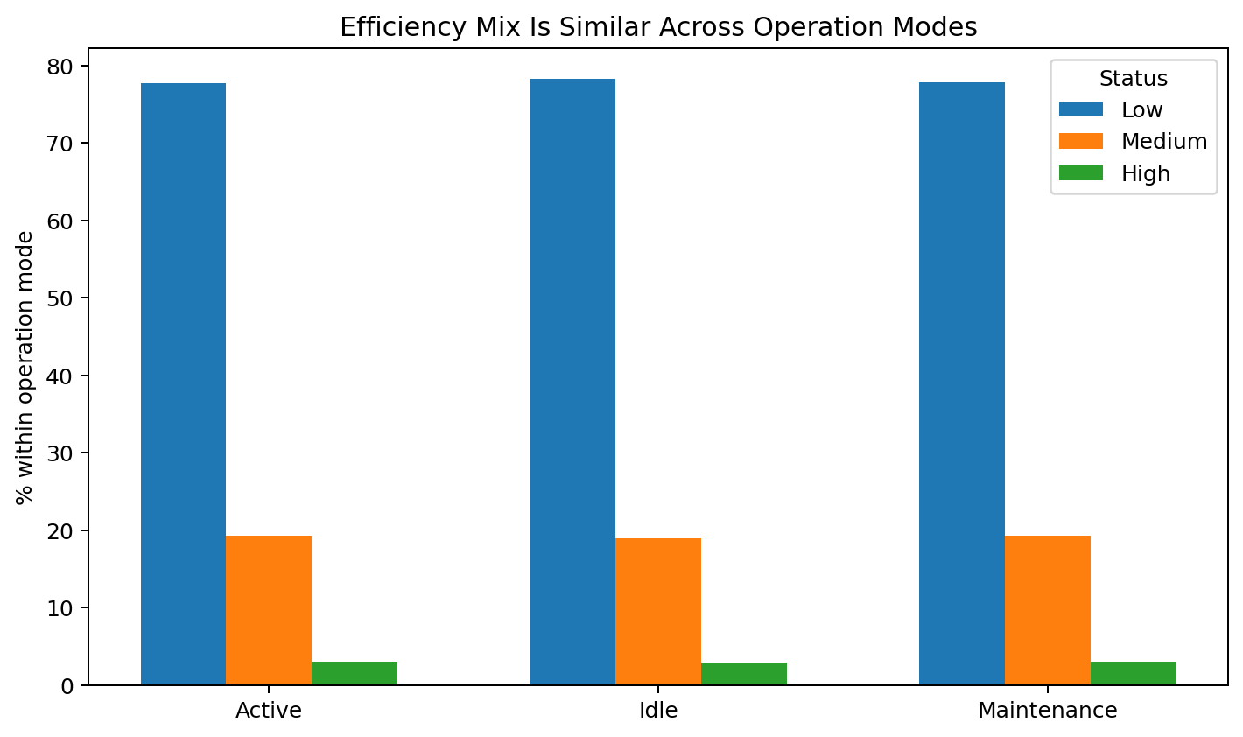
Figure 3. Efficiency mix is similar across operation modes.

4.3 Machine and Time Patterns
Across machines, the Low-efficiency share ranges from 76.09% to 80.43%. No individual machine dominates the target distribution. Daily class proportions are also stable across the observation window. These descriptive patterns do not imply temporal predictability; that question is tested separately in Section 10.
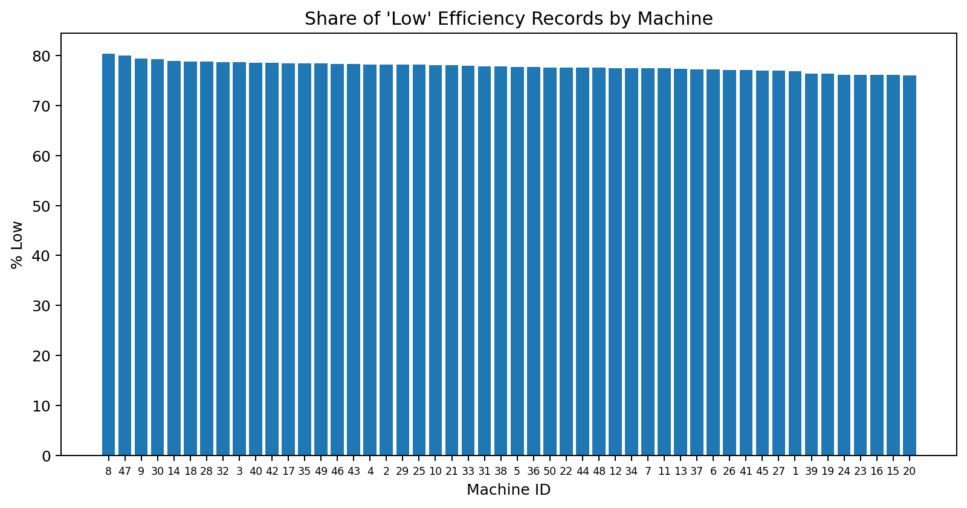
Figure 4. Share of Low-efficiency records is narrowly distributed across the 50 machines.
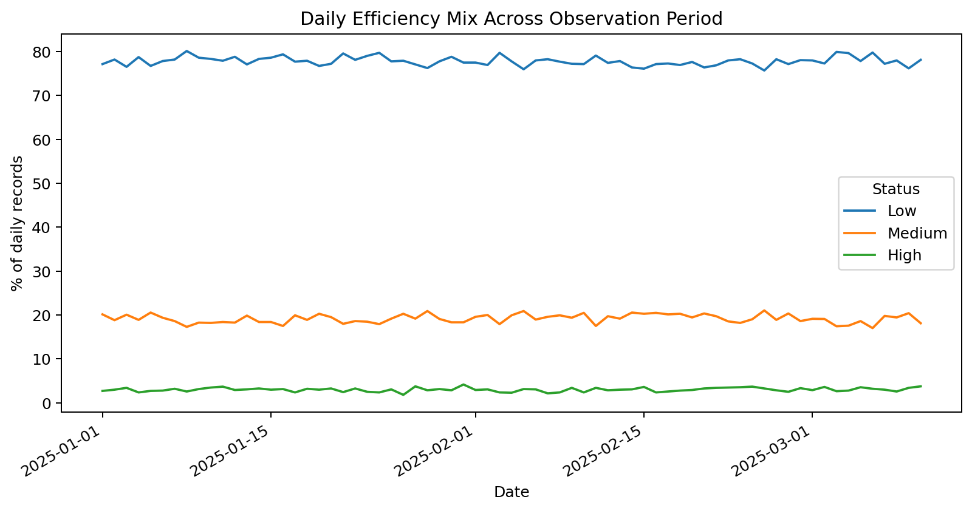
Figure 5. Daily efficiency proportions remain broadly stable across the observation period.

5. Target Construction Audit
A target audit tests whether the label can be recreated directly from contemporaneous features. The following transparent rule matches 99,998 of 100,000 records:
Condition | Current-state classification
Error Rate > 5% OR Production Speed < 200 units/hr | Low
Error Rate ≤ 2% AND Production Speed ≥ 400 units/hr | High
Otherwise | Medium
The two disagreements both have Error_Rate_% recorded as exactly 5.0 and Production Speed above 400 units/hr while the logged target is Low. Their placement exactly on the displayed error threshold is consistent with a boundary/rounding discrepancy. On the final chronological 20% holdout there are no disagreements.
This result changes the meaning of the machine-learning benchmark. A model that has access to Error_Rate_%, Production_Speed_units_per_hr or derived features that encode those quantities can reproduce the target policy extremely well. Such performance is useful for automation benchmarking but is not evidence of independent future prediction.
Analytical implication: Target reconstruction should be checked before interpreting feature importance, confidence or accuracy. Without this step, near-perfect scores can be mistaken for general predictive intelligence.

6. Feature Engineering
The feature-engineering layer is retained because it supports reproducible benchmarking and descriptive analytics. The final interpretation distinguishes between features that are operationally descriptive and features that algebraically encode the target-defining variables.
Feature | Definition / role | Interpretation
Sensor_Stability_Score | Rolling stability measure from temperature and vibration | Descriptive machine-sensor context
Energy_Efficiency_Ratio | Production speed divided by power consumption | Rule-linked because production speed is an input
Error_to_Output_Ratio | Error rate divided by production speed × 1000 | Strongly rule-linked; combines both target-defining variables
Quality_Adjusted_Error | Error rate + quality defect rate | Rule-linked through error rate
Network_Reliability_Score | Composite of normalized latency and packet loss | Descriptive network context
Hour / Is_Weekend | Derived from Datetime | Temporal context; does not create meaningful future signal

The distinction matters for ablation: removing only Error_Rate_% and Production_Speed_units_per_hr still leaves derived variables that carry their information. The decisive independent test removes the direct inputs and their mathematical derivatives.

7. Model Development and Evaluation Design

7.1 Models
Three supervised models are retained: class-balanced Logistic Regression, class-balanced Random Forest and weighted XGBoost. The transparent business rule and majority-class classifier are included as explicit baselines.

7.2 Chronological Holdout
The first 80,000 chronologically ordered records form the development set and the most recent 20,000 form the final holdout. The final holdout is not shuffled. This design better reflects the intended direction of time and prevents evaluation from mixing later observations into training.

7.3 Expanding-Window Validation
Within the development set, expanding-window TimeSeriesSplit validation replaces the original shuffled StratifiedKFold approach. Scaling is fit within each Logistic Regression training fold rather than globally. This tests stability as the training window grows through time.

7.4 Metrics
Because Low represents almost 78% of the data, accuracy is secondary. The evaluation reports balanced accuracy, Macro F1, Weighted F1, per-class precision/recall, confusion matrices and High-class performance. Probabilistic models also receive Macro ROC-AUC, Macro Average Precision, High-class Average Precision, log loss, multiclass Brier score and Expected Calibration Error (ECE).

8. Results and Probability Diagnostics
Method | Accuracy | Balanced Accuracy | Macro F1 | Weighted F1
Majority Baseline | 0.77995 | 0.33333 | 0.29212 | 0.68353
Transparent Business Rule | 1.00000 | 1.00000 | 1.00000 | 1.00000
Logistic Regression | 0.88150 | 0.90009 | 0.82012 | 0.88866
Random Forest | 1.00000 | 1.00000 | 1.00000 | 1.00000
XGBoost | 0.99755 | 0.99756 | 0.99680 | 0.99755

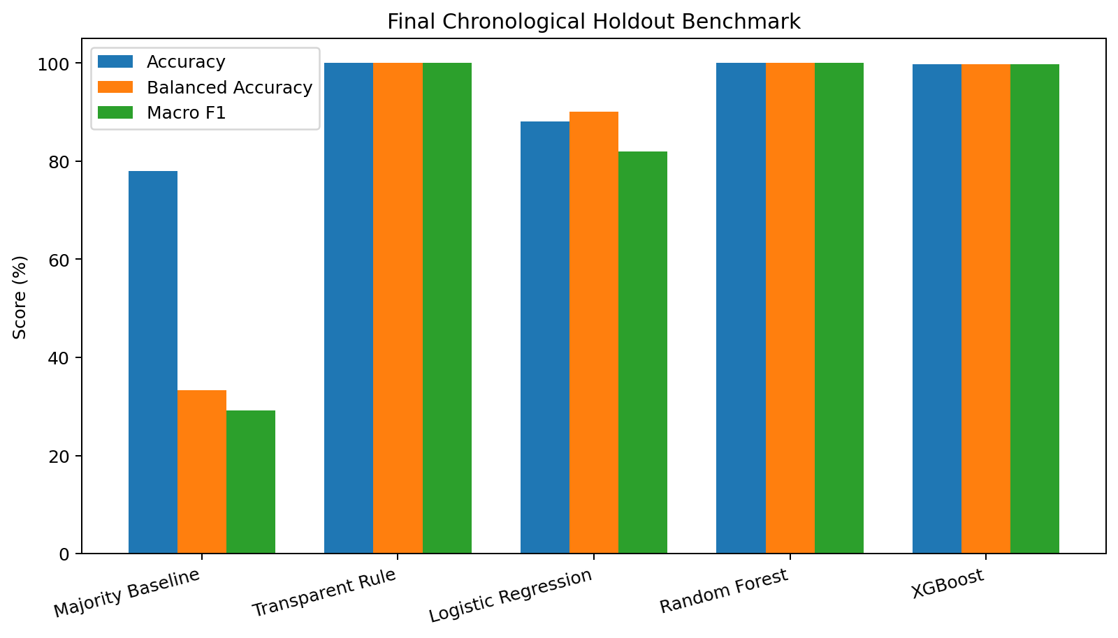
Figure 6. Final chronological holdout benchmark with imbalance-aware metrics.
Random Forest is the strongest ML benchmark by Macro F1, but the transparent rule is the primary operational method for this dataset because it is simpler, fully auditable and directly reflects target construction. XGBoost remains a useful benchmark for probability diagnostics and SHAP attribution.

8.1 Probability Quality
Model | Macro ROC-AUC | Macro AP | High AP | Log Loss | Brier | ECE
Logistic Regression | 0.97595 | 0.92231 | 0.93793 | 0.24805 | 0.16290 | 0.03089
Random Forest | 1.00000 | 1.00000 | 1.00000 | 0.01348 | 0.00168 | 0.01299
XGBoost | 0.99999 | 0.99996 | 0.99999 | 0.00727 | 0.00408 | 0.00165

These probability metrics describe confidence quality for the current-state benchmark task. They must not be reinterpreted as future operational-risk probabilities.

8.2 Temporal Validation
Average Macro F1 across expanding chronological folds is 0.8168 for Logistic Regression, 0.9991 for Random Forest and 0.9964 for XGBoost. Strong temporal stability does not remove the target-construction caveat; the same rule-linked information is available in each fold.
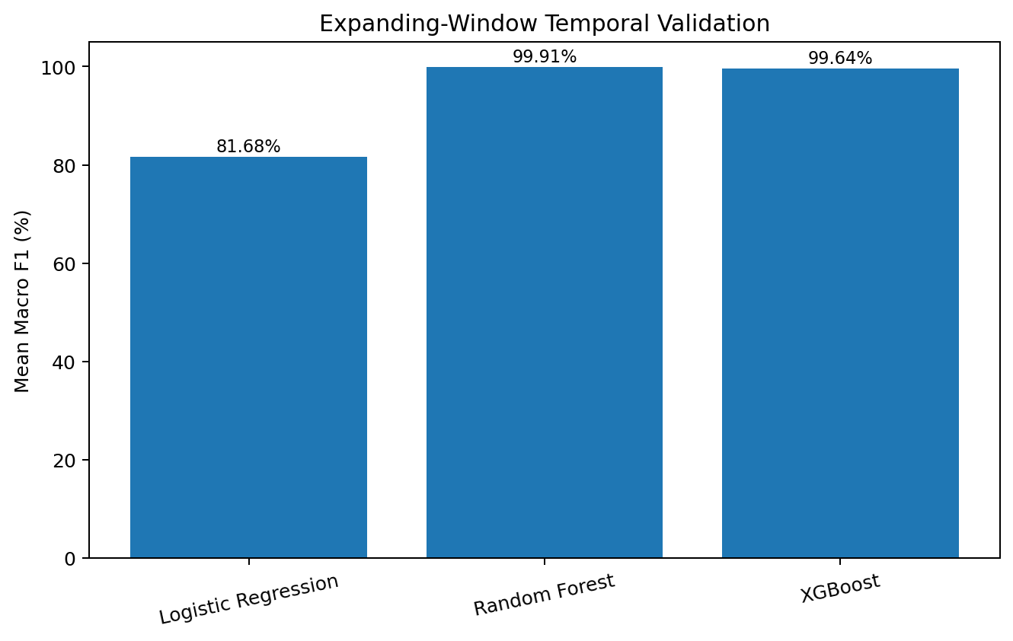
Figure 7. Mean Macro F1 under expanding-window temporal validation.

9. Feature Ablation
Feature ablation is the central test of whether the models rely on independent telemetry or on target-linked variables.
Experiment | Accuracy | Balanced Accuracy | Macro F1 | High Recall
All features | 1.0000 | 1.0000 | 1.0000 | 1.0000
Remove direct rule features | 0.9228 | 0.9230 | 0.8221 | 0.9787
Remove all rule-linked features | 0.6538 | 0.3320 | 0.3314 | 0.0393
Sensor + network only | 0.6538 | 0.3320 | 0.3314 | 0.0393

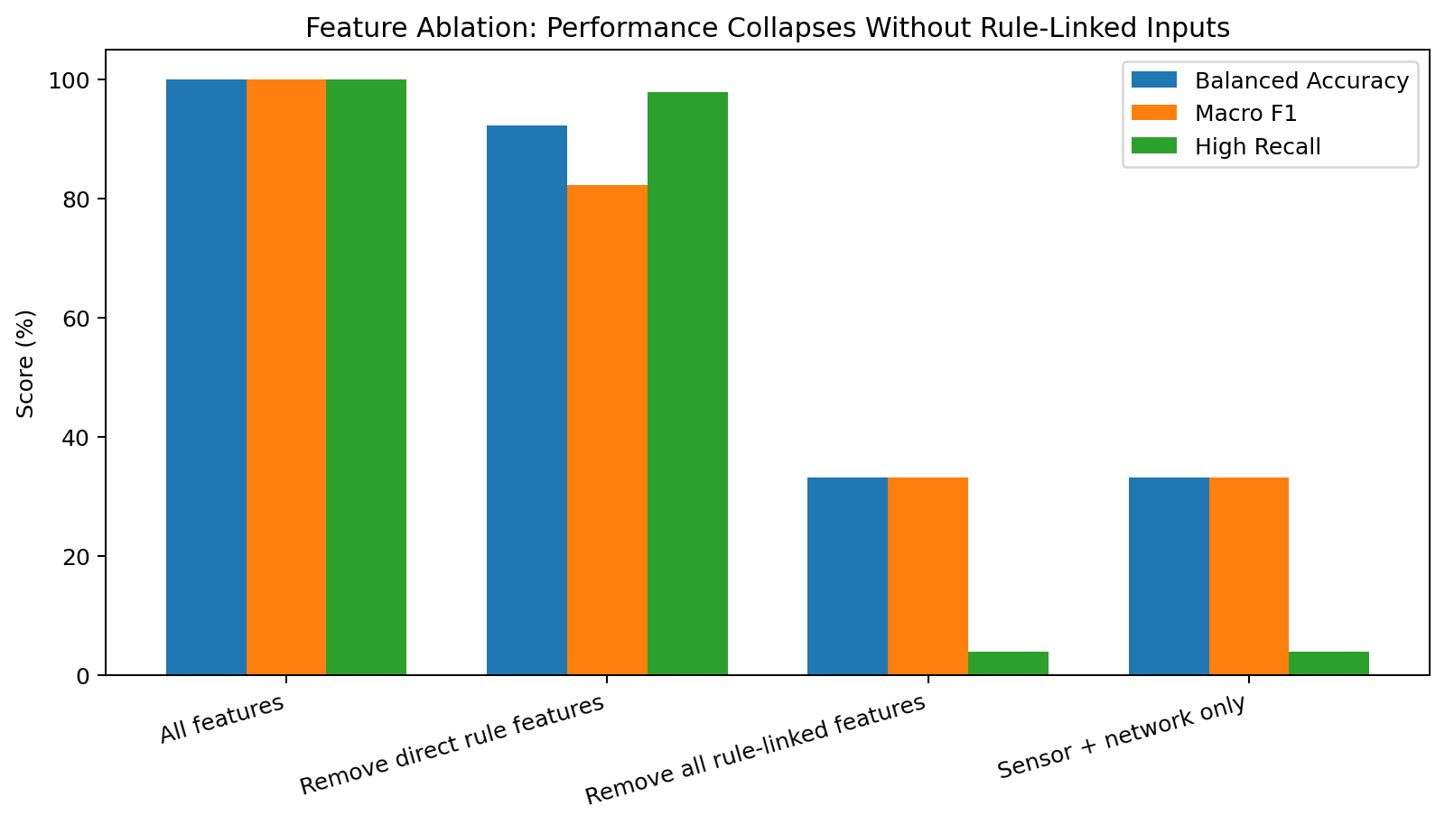
Figure 8. Performance collapse after all direct and derived rule-linked features are removed.
The "remove direct rule features" experiment remains partially contaminated because Energy_Efficiency_Ratio, Error_to_Output_Ratio and Quality_Adjusted_Error still encode production speed and/or error rate. The meaningful independent comparison is the no-rule-linked condition. Its balanced accuracy and Macro F1 are approximately 0.33, demonstrating little independent class signal in the remaining features.

10. Future-Prediction Feasibility
A separate diagnostic asks whether the dataset supports prediction of a later efficiency state. This is distinct from current-state classification and must be established before using terms such as future risk or predictive maintenance.

10.1 Irregular Observation Timing
Consecutive observations for the same machine are not evenly spaced. The median gap is 34 minutes, the mean is about 49.3 minutes and the maximum is 514 minutes. Therefore, an h=1 target means "next recorded observation," not a fixed 34-minute forecast horizon.
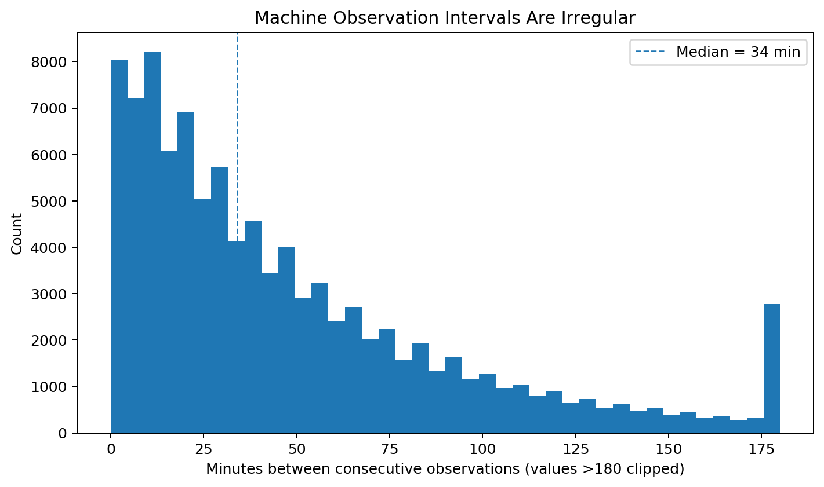
Figure 9. Consecutive machine observations are irregularly spaced.

10.2 Status Persistence
At h=1, observed same-status persistence is 0.6427 while the agreement expected from the class marginals is approximately 0.6434. Cohen's kappa is -0.0018 and mutual information is effectively zero. Similar results hold at h=3, h=5 and h=10 observation steps.
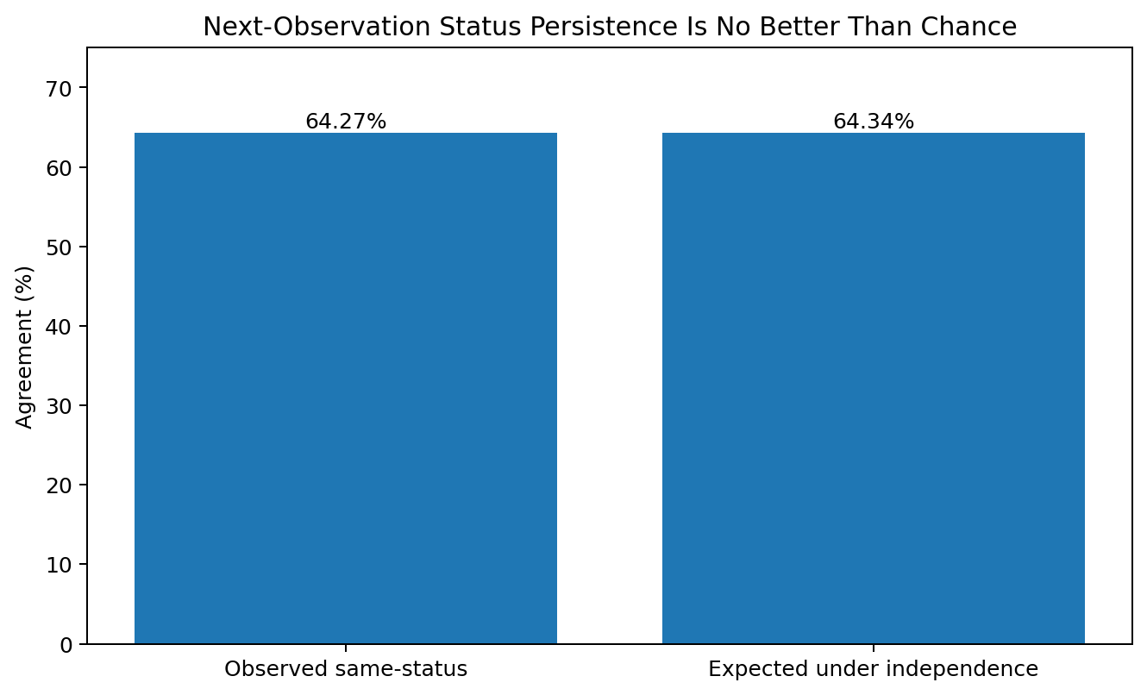
Figure 10. Observed next-status persistence is no better than the independence baseline.

10.3 Telemetry Autocorrelation
Average within-machine lag-1 autocorrelation is near zero for temperature, vibration, power consumption, latency, packet loss, quality defect rate, production speed, maintenance score and error rate. The data behaves more like independently sampled states than a smooth degradation sequence.
Feasibility decision: Do not build or claim a future-risk model from this dataset. A defensible forecasting project would require a defined future outcome, fixed or well-characterized sampling cadence, causal temporal ordering and measurable persistence or precursor signal.

11. Explainability
SHAP analysis is retained for the XGBoost benchmark. The strongest global attributions are Error_Rate_%, Production_Speed_units_per_hr and Error_to_Output_Ratio, followed by Quality_Adjusted_Error and Energy_Efficiency_Ratio. This ranking is consistent with the target audit and ablation results.
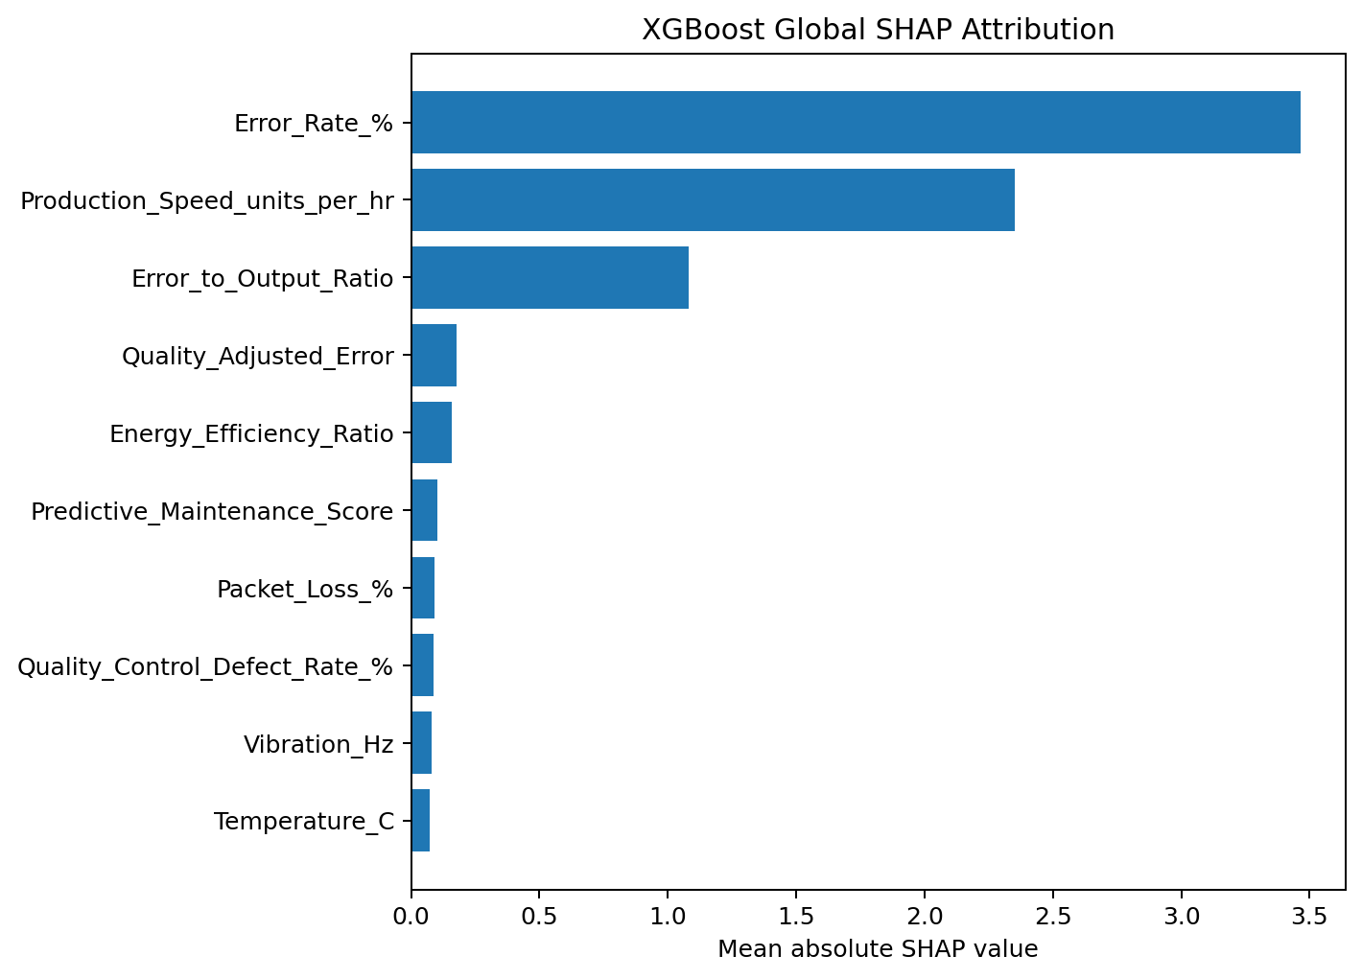
Figure 11. XGBoost global SHAP attribution from a 3,000-record sample.
The interpretation is deliberately narrow: SHAP explains how the benchmark model reconstructs the current-state label. It does not establish causal effects and does not imply that increasing or decreasing a feature would cause the efficiency state to change in a real plant.
The dashboard local explanation view therefore uses terms such as attribution, comparison and threshold flag rather than causal driver or future-risk reason.

12. Streamlit Application
The revised dashboard makes the validated methodology explicit. The default current-state method is the Transparent Business Rule, while Logistic Regression, Random Forest and XGBoost remain selectable benchmark methods. A methodology note states that the ML models are not validated future-risk predictors.
Module | Purpose
Current-State Classification | Rule/model selection, manual what-if inputs, current classification and filtered-batch agreement audit
Machine Insights | Historical machine patterns, rankings and summary views
Explainability | SHAP and model importance with current-state attribution language
Operational Monitoring | Operation mode, network reliability and threshold-based current-state flags
Model Validation | Class balance, baselines, chronological validation, ablation and temporal limitations

The interface supports machine selection, operation-mode filters, time windows, network-reliability filtering and operational thresholds. These controls are for exploratory and monitoring use; they do not convert the underlying dataset into a live production-control system.

13. Business Interpretation and Recommendations

13.1 Supported Findings
- The supplied current-state efficiency label is almost deterministic from error rate and production speed.
- The class distribution is highly imbalanced, so balanced and per-class metrics are required.
- Sensor and network variables provide little independent label signal after rule-linked information is removed.
- Operation mode and machine identity are useful descriptive slices but do not explain the supplied label strongly.
- The supplied sequence does not contain meaningful temporal persistence for future-efficiency forecasting.

13.2 Recommendations
- Use the transparent rule as the primary current-state decision logic for this dataset and retain ML models as benchmarks.
- Use the dashboard for descriptive monitoring, current-state thresholding and validation demonstrations rather than predictive-maintenance claims.
- Collect real plant data with independently defined labels and a documented labeling process before evaluating deployment performance.
- Define a future business outcome and prediction horizon before training any future-risk model.
- Re-run target leakage audits, ablation, class-sensitive metrics, calibration and temporal diagnostics whenever the data or labeling policy changes.

14. Limitations and Future Data Requirements
- Target construction: Efficiency_Status is almost deterministic from contemporaneous Error_Rate_% and Production_Speed_units_per_hr, limiting the independent value of ML benchmarking.
- Class imbalance: High represents only about 3% of observations; accuracy alone is misleading.
- Temporal structure: machine observations are irregular and show near-zero autocorrelation, so next-row targets are not fixed-time forecasts.
- Causality: correlations, feature importance and SHAP values do not establish causal manufacturing effects.
- External validity: the supplied dataset does not establish generalization to other plants, machine types or real Thales operations.
- Production readiness: latency, drift monitoring, access control, fail-safe integration, data contracts and live operational outcomes are not validated by this portfolio dataset.
A future forecasting dataset should include machine-specific continuous sequences, a known collection cadence, clear event/outcome timestamps, maintenance interventions, failure/degradation labels, independently defined targets and sufficient historical depth to separate development, calibration and final temporal test periods.

15. Reproducibility and Quality Gates
The remediated project is reproducible from the repository root. The pipeline runs EDA, feature engineering, modeling, explainability and validation diagnostics using centralized project paths. The engineered dataset is written both to the authoritative data directory and the dashboard deployment directory.
Quality gate | Status
Raw schema / row count / missing / duplicate audit | PASS
Engineered feature dataset completeness | PASS
Target classes and rule diagnostics | PASS
Serialized sklearn model loading | PASS
Model metadata contract | PASS
Final benchmark outputs | PASS
Feature-ablation outputs | PASS
Temporal diagnostic rejects future claim | PASS
Dashboard/source synchronization | PASS
Automated sanity suite | 12/12 PASS

The final validation workflow also compiles the Python source and re-runs the full analytical pipeline from the project root. This ensures that the reported outputs are generated by the same code path represented in the repository.

16. Conclusion
The post-evaluation rebuild changes the interpretation of the project more than it changes the headline model scores. Random Forest still achieves 100% on the current-state holdout and XGBoost remains near-perfect, but those results are now explained by the target construction rather than presented as evidence of general predictive intelligence.
The transparent business rule is the most appropriate operational representation of the supplied label. Machine-learning models remain valuable as benchmark implementations and as a vehicle for demonstrating class-sensitive evaluation, probability diagnostics and SHAP attribution. Separate feature-ablation and temporal-signal tests show that independent sensor/network signal is weak and that future-efficiency forecasting is unsupported by this dataset.
As a portfolio project, the strongest outcome is the analytical feedback loop: submission → evaluator feedback → methodology audit → target diagnosis → validation redesign → corrected dashboard and documentation. That process demonstrates the judgment required to distinguish a high-scoring model from a defensible data-analysis conclusion.
Final status: Original Unified Mentor evaluation: 8/10 - Excellent. This report is the later validated portfolio version and preserves that historical evaluation without presenting the original claims as the final methodology.

Appendix A. Metric Definitions and Decision Rule
Metric | Why it is used
Accuracy | Overall share correct; secondary because the target is imbalanced
Balanced Accuracy | Average recall across classes; prevents Low-class dominance from hiding minority performance
Macro F1 | Unweighted mean F1 across High, Medium and Low; primary comparison metric
Weighted F1 | Class-frequency-weighted F1
Average Precision | Probability ranking quality under class imbalance
Log Loss | Penalty for incorrect probability assignments
Multiclass Brier Score | Squared error of predicted class probabilities
ECE | Difference between predicted confidence and empirical correctness across probability bins

A.1 Transparent Current-State Rule
Condition | Current-state classification
Error Rate > 5% OR Production Speed < 200 units/hr | Low
Error Rate ≤ 2% AND Production Speed ≥ 400 units/hr | High
Otherwise | Medium
Full-data agreement: 99.998% (99,998 / 100,000). Final chronological holdout agreement: 100%.

A.2 Important Interpretation Boundaries
- Current-state classification is not the same task as predicting a later state.
- Model probability is not future operational risk.
- SHAP attribution is not causality.
- Removing only raw target inputs is insufficient when engineered features algebraically re-encode them.
- Observation-step horizons are not fixed-time horizons when sampling intervals are irregular.

