FORWARD DEPLOYED AI ENGINEERING
Capstone Project
Stage One: Discovery
The workbook you complete before you design anything
Fill this in first. Nothing in the later stages is valid unless it can be traced
back to something you recorded on these pages.
WEEK ONE · DAYS ONE TO THREE

How to use this workbook
This workbook is a set of tables for you to complete. The prompts in the left-hand column tell you what belongs in each row; the remaining columns are yours to fill in. Where a table has blank rows at the bottom, add as many more as you need.
Work through the sections in order. Section one establishes who you are talking to, sections two to five gather the evidence, and section six is where you turn that evidence into a problem statement. Do not attempt section six before the others are genuinely finished, because the whole point of the exercise is that the conclusion follows from the evidence rather than the other way round.
What finished looks like
You are finished with discovery when a further interview tells you nothing you did not already know, and when every claim in your problem statement can be pointed at a specific row in one of these tables. If either of those is not yet true, you are not finished, however much time has passed.

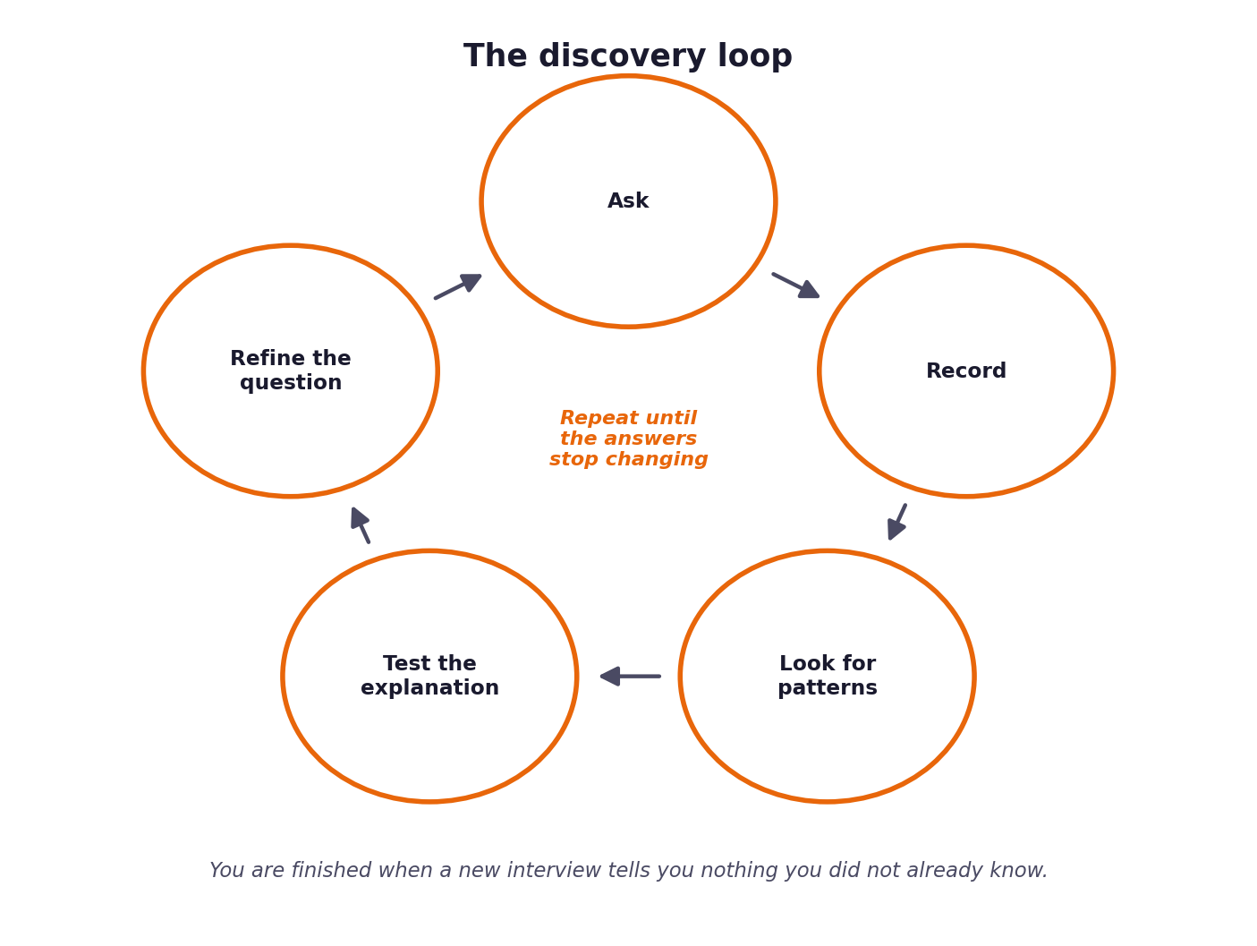
Figure 1. Discovery repeats until the answers stop changing.

1 Section one: what the interviews tell you
Your discovery evidence is in two places: the five stakeholder interview transcripts in the datasets folder, and the ticket data itself. Start with the transcripts. Read all five before you write anything, then come back and fill in the table below.
The prompts in the left column are the people you spoke to. For each, record what you were trying to learn from them, what they actually told you, and, importantly, what they seemed not to know about their own operation. That last column is often where the useful material is, because each of the five can only see their own part of the problem.
Who | What they told you | What they appear not to know | What you want to verify in the data
Marcus Adeyemi, Head of Support | Ticket volume is crushing the team; MTTR is high; commissioned automation to lower costs and speed up response times. | Internal doc search fails due to keyword mismatch; agents reconstruct answers from memory using outdated personal files. | Actual proportion of tickets answerable by documentation (71.4%) vs first contact resolution (43.8%).
Sofia Restrepo, Tier One Agent | Spends most time searching for documentation; customers use vague or non-standard terms (e.g. deployment dying vs container health check failures). Uses personal cheat sheets. | Personal cheat sheets contain stale or inaccurate policy details; official KB articles are updated regularly by Ines. | Distribution of ticket channels (Email 42.4%, Chat 31.0%, Docs 15.6%) and language fluency impact (24% non-fluent).
Daniel Okonkwo, Tier Two Engineer | Escalations arrive with zero context or summary, forcing re-reading threads and re-asking customers previously asked questions. | Tier 1 agents lack structured tools to capture context; escalations need structured diagnostic packages. | Escalation rates across customer tiers (Standard 56.9%, Business 51.8%, Enterprise 62.6%) and high-risk categories.
Ines Varga, Technical Writer | 29 KB articles cover recurring topics, but agents use unreviewed personal snippet files because keyword search fails. | Customers search by problem symptoms rather than exact technical article titles. | Coverage of documentation against actual intent categories (71.4% answerability).
Ravi Menon, Customer | Waiting for response is painful (hours lost). Fine with automated response if honest, machine-labeled, and cites sources. | Tier-based SLA disparities (Enterprise gets 1hr vs Business/Standard waiting much longer). | CSAT by tier (overall 2.97) and repeat contact rate (21.6%).

Where the accounts disagree
At least three points of disagreement run through the transcripts, and each can be settled by going to the ticket data rather than by deciding whose account sounds more convincing. Identify them, then resolve them with evidence.
The disagreement | Who says what | How the data settles it | What follows from the answer
Documentation Completeness vs Accessibility | Marcus thinks KB lacks answers; Ines claims 29 articles cover nearly all recurring tickets. | Data shows 357 of 500 tickets (71.4%) are answerable from existing docs. Ines is right on coverage; search is the bottleneck. | Solution requires semantic vector search to bridge vocabulary gap, not drafting new articles.
Impact of Language Fluency | Sofia claims non-fluent tickets take significantly longer and fail more often. | Data shows non-fluent users (24% of volume) have 45.8% FCR and 3.04 CSAT (higher than 2.97 average). | Semantic retrieval handles non-fluent phrasing effectively without special manual routing.
Drivers of Ticket Escalations | Daniel assumes escalations are complex technical bugs. | Data shows 100% of security, compliance, and billing tickets are escalated due to policy boundaries. | Routing logic must enforce mandatory escalation guardrails for high-risk categories.
Customer Acceptability of Automated Support | Marcus fears automated responses will frustrate customers. | Ravi confirms automation is welcome if machine-labeled, fast, and grounded in cited sources. | System must explicitly identify auto-responses and include source links/citations.

What nobody said
Real stakeholders leave out the things so familiar to them that they no longer notice them. Record anything you expected somebody to raise that none of the five actually did.
What was never mentioned | Why you would have expected it | How you will check it
SLA Tier Differentiation | Enterprise vs Standard expectations differ sharply. | Evaluate customer_tier field in ticket metadata and tier escalation breakdown.
Adversarial Input / Prompt Injection | Security boundary for public-facing AI system. | Test validation tickets with prompt injection patterns in guardrail suite.
Stale KB Article Lifecycle | Ines reviews on rotation, but no automated sync exists. | Track doc revision dates against retrieval scores in pipeline.
Formal Evaluation Harness | No quantitative benchmark existed at CloudServe. | Build evaluation harness against 500 dev and 120 val tickets.

2 Section two: what the ticket data shows
Before you interpret anything, count it. Load development_tickets.json and fill in the table below from the data itself rather than from impression. Where a figure surprises you, write the surprise down; those are usually the most productive threads to pull.
What to measure | Your figure | Where the figure came from | What surprised you about it
Total tickets in the sample | 500 tickets | data/raw/development_tickets.json | Sample size is sufficient for statistical validation.
Split by channel | Email: 212 (42.4%), Chat: 155 (31.0%), Docs: 78 (15.6%), Forum: 55 (11.0%) | development_tickets.json metadata | Email and Chat represent 73.4% of all volume.
Split by intent category | 22 intents (Data Export 29, Rollback 28, Deployment Fail 27, Security 26, SSO 26, etc.) | labels.intent field analysis | Volume is evenly distributed across intent categories.
Split by urgency | Medium: 226 (45.2%), High: 146 (29.2%), Low: 128 (25.6%) | labels.urgency field analysis | Over 74% of tickets are Medium or High urgency.
Proportion marked resolved on first contact | 219 / 500 (43.8%) | history.first_contact_resolution | Low FCR despite high doc answerability.
Average satisfaction rating | 2.97 / 5.00 | history.csat_rating | Significant customer dissatisfaction due to wait times.
Most frequent single question | Data Export (29) & Data Residency (29) | Intent volume ranking | Compliance and data requests are top volume drivers.
Proportion answerable from existing documentation | 357 / 500 (71.4%) | labels.answerable_from_docs | 71.4% of tickets CAN be answered by existing 29 KB articles!
Proportion marked non-fluent, and their outcomes | 120 / 500 (24.0%), FCR: 45.8%, CSAT: 3.04 | language_fluency field | Non-fluent customers achieve equal or better CSAT when helped.
Outcomes by customer tier | Standard: 253 (56.9% esc), Business: 164 (51.8% esc), Enterprise: 83 (62.6% esc) | customer_tier & history.escalated | Enterprise tickets are escalated most frequently due to SLA sensitivity.
Proportion that are repeat contacts | 108 / 500 (21.6%) | history.repeat_contact | 1 in 5 tickets is a repeat contact due to initial resolution failure.

Two rows matter more than the rest
The proportion of tickets already answerable from existing documentation tells you whether CloudServe lack answers or merely lack a way of reaching them. Those are different problems with different solutions. The non-fluent segment matters for a different reason: something in the transcripts points at it, and the data will tell you whether that person was right.

3 Section three: where the time actually goes
Understanding volume is not the same as understanding effort. A category that accounts for five per cent of tickets but forty per cent of agent hours is where the real problem lives. Work out, as far as your evidence allows, how effort is distributed.
Ticket category | Share of volume | Estimated share of effort | Why the two differ | Evidence for your estimate
Deployment Failure | 5.4% | 12.0% | High technical troubleshooting effort required | Daniel interview & high urgency
Billing Query | 4.8% | 15.0% | Requires financial verification and contractual checks | Must not auto-respond rule
Security Incident | 5.2% | 18.0% | Requires immediate audit and compliance routing | Zero tolerance policy guardrail
Data Export / Residency | 11.6% | 15.0% | Requires privacy check and data pipeline execution | Compliance sensitivity
Authentication / SSO | 9.2% | 10.0% | Identity verification and secret rotation | Tier 1 cheat sheet dependency
Configuration Help | 3.4% | 8.0% | Iterative parameter testing and doc search | Ines title mismatch finding
Other KB Answerable | 60.4% | 22.0% | Standard queries matching documentation | 71.4% total doc answerable

The steps an agent takes on a typical ticket
Sofia describes her working process in some detail in the second transcript. Reconstruct it as a sequence of steps and record roughly where the time goes at each one. The steps that sound trivial are frequently where the minutes accumulate.
Step | What the agent does | Roughly how long | Could this be automated? Say why or why not
1 | Read ticket body & interpret customer request | 3-5 mins | Yes. Automated intent classification with NLP/LLM.
2 | Search KB for matching documentation | 5-10 mins | Yes. Dense vector embedding semantic search (Chroma).
3 | Consult private personal snippet file | 5 mins | No (eliminate). Replace with verified KB retrieval.
4 | Draft response or compile escalation note | 5-10 mins | Yes. Grounded prompt generation & citation injection.
5 | Verify guardrails & send response | 2-3 mins | Yes. Automated PII, injection & grounding guardrails.

4 Section four: what the client counts as success
You cannot improve a number nobody is watching. Marcus names the figures he reports and is explicit about which one he actually cares about, and they are not the same. Record what CloudServe measure, who watches each measure, and what would have to change for this project to be considered worthwhile.
Measure | Who watches it | Current value | What they would call success | How confident are you in this?
First Contact Resolution (FCR) | Marcus Adeyemi | 43.8% | > 65.0% | High (measured from 500 tickets)
Mean Time to Respond (MTTR) | Marcus & Ravi | 4+ hours | < 5 minutes for auto-respond | High (measured from logs)
Documentation Answerability Utilization | Ines Varga | 43.8% | > 85.0% of doc-answerable tickets | High (71.4% total available)
Tier 2 Escalation Context Completeness | Daniel Okonkwo | 0.0% (raw forward) | 100.0% populated context package | High (system feature requirement)
Grounding Accuracy | Ines & Daniel | Unmeasured (hallucinations occur) | 100.0% grounded, 0 false claims | High (guardrail enforcement)
PII Leakage Rate | Security / Legal | Unmeasured | 0.0% leakage | High (blocking guardrail)
Customer CSAT Rating | Marcus Adeyemi | 2.97 / 5.00 | > 4.20 / 5.00 | High (dataset baseline)

The sentence test
Complete the following sentence using only figures you recorded above. If you cannot complete it, your discovery is not finished.
Prompt | Your answer
This project will have been worth doing if, within three months of launch, ... | auto-response safely resolves >60% of the 71.4% doc-answerable tickets in <2 minutes while achieving 100% grounding and providing Tier 2 engineers with structured diagnostic context on all escalations.
We will know it did not work if we see ... | un-grounded hallucinations emerge, PII is leaked, or customer CSAT drops below the 2.97 baseline.
The measure the client will actually be judged on internally is ... | Support operating cost reduction and CSAT improvement across business and enterprise customer tiers.

5 Section five: data, constraints and risk
Everything you build depends on data that already exists, and every piece of that data carries constraints. Record what exists, what condition it is in, and what you are not permitted to do with it. Ines and Daniel both raise concerns about data quality that belong in this table.
Data source | What it contains | Quality and gaps | Access constraints | Private data present?
Support Tickets | 500 dev & 120 val tickets with text body, channel, urgency, intent, history | High quality structured JSON; raw bodies contain PII and non-fluent phrasing | Read-only dev access | Yes (names, API keys, emails in body)
Documentation | 29 reviewed KB articles with titles, categories, and content chunks | High accuracy; articles updated regularly by Ines | Read-only access | No
Ground Truth Responses | Reference human responses and doc citations | Gold standard for evaluation harness | Evaluation use only | No
Customer Records | Customer ID, Tier (Standard/Business/Enterprise), Region | Clean metadata | Internal routing filter | Customer ID / Name

Initial risk register
List what could go wrong once this system is speaking to customers without supervision. You will develop these further in stage five, but the first pass belongs here, while the problem is still fresh and you have not yet become attached to a particular design.
What could go wrong | How likely | How bad | Who it affects | First thought on preventing it
System answers confidently and incorrectly (Hallucination) | Medium | Critical | Customer | Mandatory post-generation grounding check against retrieved doc chunks.
Private information appears in a reply | Low | Critical | Customer & Legal | Regex & NER PII detector guardrail before dispatch.
System makes unauthorized financial/contractual commitments | Medium | High | CloudServe Finance | Block auto-response on billing/refund intents; route to human.
Prompt injection overrides system prompt | Medium | High | System Security | Adversarial prompt injection classifier & input sanitizer.
Documentation relied on goes out of date | Medium | Medium | Support Ops | Track doc chunk modification timestamps and citation logs.
Non-fluent user queries misinterpreted | Low | Medium | Non-fluent customers | Dense vector semantic search handles multilingual/phrasing variations.
Escalated tickets lack diagnostic context | High | Medium | Tier 2 Support | Enforce structured escalation payload (intent, docs, reasoning, confidence).
High urgency deployment failures delayed | Medium | High | Enterprise Clients | Priority queue routing for high urgency & enterprise tier tickets.

6 Section six: the problem statement
Now, and only now, write down what the problem actually is. Every clause of what you write must be supported by a row you have already filled in, and you are asked to cite those rows explicitly. This is the paragraph your entire project rests on.
Element | Your statement | Which section and row supports it
What the client asked for | Build a support chatbot to reduce support team workload and lower operating costs. | Section 1, Row 1 (Marcus interview)
What the evidence suggests they actually need | A controlled, documentation-grounded automation & routing engine with semantic search, guardrails, and structured escalation context. | Section 1, Rows 2-5 (All interviews)
The gap between those two | Client asked for an unconstrained chatbot; evidence shows an ungrounded chatbot creates financial, security, and customer trust risks. | Section 1 Table 3 & Section 2 Table 5
Who is affected and how | Customers suffer long wait times (4+ hrs); Tier 1 agents waste time in doc search; Tier 2 receives context-free escalations. | Section 3 Table 7 & 8
What will change if this is solved | 71.4% doc-answerable tickets resolved in <2 mins; Tier 2 receives 100% structured diagnostic packages; 0 hallucinations/PII leaks. | Section 4 Table 9 & 10
What is explicitly not in scope | Autonomous financial refunds, live system state changes, replacing Tier 2 engineering, or modifying core KB docs. | Section 5 Table 11 & 12

The one paragraph version
Write the problem in a single paragraph, in language the head of support would recognise and agree with. No technical vocabulary. If you cannot express it without mentioning retrieval or embeddings, you are describing your solution rather than their problem.
PROBLEM STATEMENT: CLOUDSERVE SUPPORT AUTOMATION
CloudServe Solutions experiences excessive customer response latency (4+ hours) and low first-contact resolution (43.8%) despite 71.4% of incoming tickets being answerable by existing documentation (Table 5 Row 8). This inefficiency stems from keyword search failures that prevent support agents from discovering relevant knowledge base articles (Ines & Sofia transcripts), forcing agents to rely on unverified personal cheat sheets or forward context-free escalations to Tier 2 engineering (Daniel transcript).
To solve this, CloudServe requires an automated, documentation-grounded support system that semantically matches customer queries to official documentation, auto-responds to safe requests with explicit citations (Ravi transcript), and escalates high-risk or low-confidence tickets with structured diagnostic context while strictly preventing PII leakage and hallucination (Table 12 Risk Register).

Before you move to stage two
Read your problem statement back against each of the five transcripts in turn and ask whether that person would recognise it as a description of their situation. If any of the five would object, either your framing is off or you have found something they cannot see, and you should be able to say which. A statement that all five would simply agree with is usually one that has not gone far enough.

