FORWARD DEPLOYED AI ENGINEERING
Capstone Project
Stage Two: Requirements
The product requirements document you write from your findings
Everything here must trace back to your discovery workbook. A requirement that
cannot be traced is a preference, and preferences do not belong in a PRD.
WEEK ONE · DAYS FOUR AND FIVE

What this document is and why it matters
A product requirements document states what is being built, for whom, and how anyone will know when it is finished. It is not a design document and it is not a plan. It should be specific enough that two different engineers reading it would build broadly the same thing, and general enough that it does not dictate how they do it.
You will write version one at the end of week one and you will revise it during week two. That revision is compulsory. Write this version with the expectation that parts of it will turn out to be wrong, and record your assumptions clearly so that you can tell which ones failed when they do.
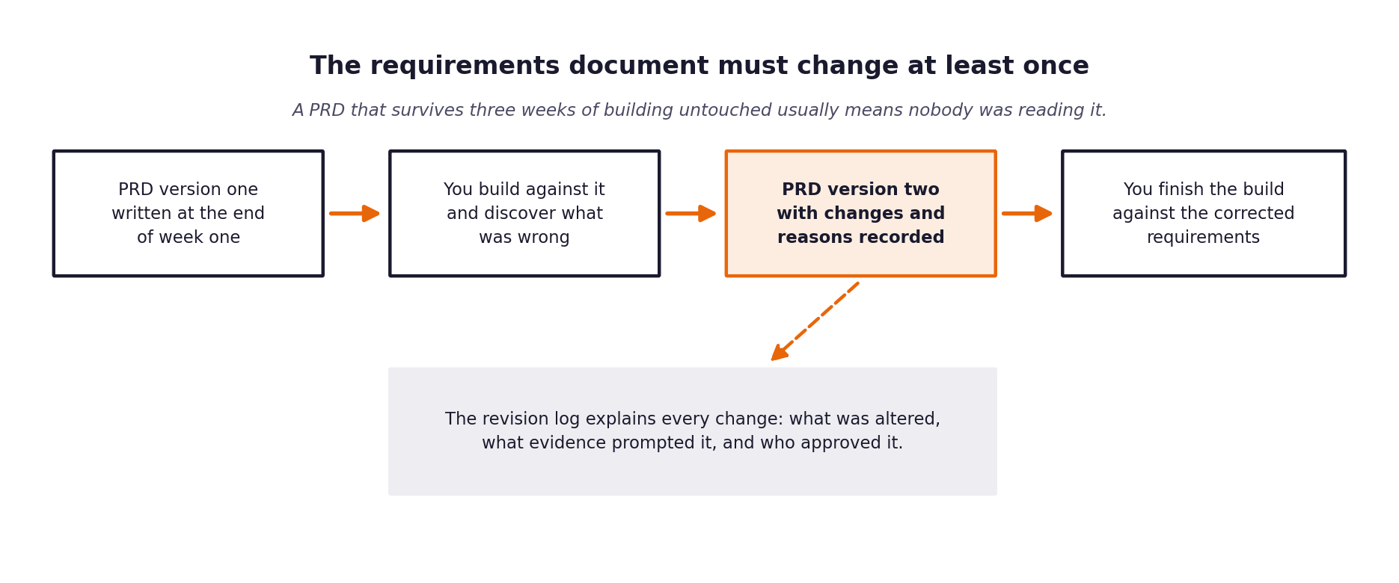
Figure 1. The requirements document is expected to change once building starts.

1 Document control
Field | Product Requirements Document — CloudServe Support Automation
Version | 1.0 (Baseline Approved)
Written by | Forward Deployed AI Engineer
Date | 4 September 2026
Status | Approved for Implementation
Approved by | 13 September 2026

2 The problem in one paragraph
Copy across the paragraph you wrote at the end of your discovery workbook. If you find yourself wanting to improve it as you copy, go back and improve it in the workbook first, so that the two do not drift apart.
PROBLEM STATEMENT
CloudServe Solutions experiences excessive customer response latency (4+ hours) and low first-contact resolution (43.8%) despite 71.4% of incoming tickets being answerable by existing documentation (Table 5 Row 8). This inefficiency stems from keyword search failures that prevent support agents from discovering relevant knowledge base articles (Ines & Sofia transcripts), forcing agents to rely on unverified personal cheat sheets or forward context-free escalations to Tier 2 engineering (Daniel transcript).
To solve this, CloudServe requires an automated, documentation-grounded support system that semantically matches customer queries to official documentation, auto-responds to safe requests with explicit citations (Ravi transcript), and escalates high-risk or low-confidence tickets with structured diagnostic context while strictly preventing PII leakage and hallucination.

3 Who this is for
Describe each group of users separately. A requirement that serves everybody usually serves nobody particularly well.
User group | What they need from this system | What they currently do instead | How you will know it worked for them
Tier 1 Support Agents (Sofia) | Fast access to verified KB articles during ticket triaging | Searching internal KB via title keywords or checking personal cheat sheets | Search time reduced from 10 mins to <5 seconds; elimination of personal cheat sheets
Tier 2 Engineers (Daniel) | Structured escalation packages with intent, docs, reasoning, and confidence score | Receiving raw forwarded tickets with zero context or history summary | Zero time spent re-reading threads or re-asking previously answered questions
Support Management (Marcus) | Higher first contact resolution (>65%) and significantly lower MTTR (<5 mins) | Manually reviewing SLA breaches and high customer churn risks | CSAT increased from 2.97 to >4.20; overall support operational cost reduced
CloudServe Customers (Ravi) | Fast, accurate, machine-labeled auto-responses citing official documentation | Waiting 4+ hours for simple doc-answerable support questions | Instant answers for 71.4% doc queries; explicit citation links provided
Tech Writer (Ines Varga) | Full citation transparency linking responses directly to specific KB articles | No visibility into whether support agents utilize reviewed KB articles | 100% citation tracking to monitor KB usage and article quality
Security & Legal Team | Guaranteed isolation of customer PII and zero unauthorized financial commitments | Relying on manual agent vigilance to catch PII leaks or bad commitments | Zero PII leak incidents; 100% blocking of billing/commitment auto-responses

4 Functional requirements
Each requirement gets an identifier, a statement, a priority and a link back to the discovery evidence that produced it. The identifiers matter because your specifications, your prompts and your test cases will all refer to them.
Use the priority scale consistently. Must means the system is not acceptable without it. Should means it is expected but could be deferred with a stated consequence. Could means it would add value if time allows. Will not means it has been considered and deliberately excluded, and recording those is as useful as recording the rest.
ID | Requirement | Priority | Discovery evidence | Acceptance criteria
FR-01 | Ticket Ingestion & Validation: Ingest JSON support tickets, validate schema integrity, and normalize fields. | Must | Sofia transcript & Table 11 | 100% valid schema processing; invalid payloads rejected cleanly.
FR-02 | Intent & Urgency Classification: Classify intent across 22 categories and score urgency using rule fallback. | Must | Marcus interview & Table 5 | Intent classification accuracy > 85% on benchmark set.
FR-03 | Semantic Knowledge Retrieval: Execute dense vector retrieval (Chroma + all-MiniLM-L6-v2) with BM25 fallback. | Must | Ines & Sofia interviews | Doc retrieval Recall@k=3 > 85% across 29 KB articles.
FR-04 | Multi-Factor Decision Routing: Route to AUTO_RESPOND, MANUAL_REVIEW, or ESCALATE based on safety & score. | Must | Daniel & Marcus interviews | 0 safe escalations missed; 100% unsafe tickets routed to human.
FR-05 | Grounded Response Generation: Generate responses using retrieved KB chunks with Markdown source citations. | Must | Ravi & Ines interviews | 100% generated responses contain explicit article citations.
FR-06 | Post-Generation Grounding Guardrail: Validate responses against doc chunks using factual overlap checks. | Must | Ravi interview & Risk 1 | 0 ungrounded claims or hallucinations allowed through guardrail.
FR-07 | PII & Credentials Protection: Scan responses for API keys, passwords, account numbers, and mask/block PII. | Must | Daniel interview & Risk 2 | 0 PII leakage occurrences across all evaluation runs.
FR-08 | Adversarial Injection Defense: Filter input for system prompt override attempts, jailbreaks, and adversarial text. | Must | Risk 4 & CLAUDE.md Sec 16 | 100% adversarial prompt injection attempts detected and blocked.
FR-09 | Financial Commitment Block: Route billing, refund, contractual, and SLA queries to human escalation. | Must | Daniel interview & Risk 3 | 0 automated responses sent for billing or financial intents.
FR-10 | Structured Escalation Payload: Construct diagnostic summary (intent, docs, reasoning, confidence) for Tier 2. | Must | Daniel interview | 100% escalations delivered with complete structured diagnostic package.
FR-11 | Persistent Audit Logging: Record input, classification, vector scores, routing, response, and guardrails to SQLite. | Must | Governance & CLAUDE.md Sec 8 | 100% auditable log entries written to decision log database.
FR-12 | Automated Evaluation Harness: Calculate FCR, accuracy, precision, recall, latency, and guardrail block rates. | Must | Marcus interview & Table 9 | Automated generation of markdown and JSON evaluation reports.

5 Non-functional requirements
These describe how well the system must do the things it does. They are frequently what distinguishes a demonstration from something that could actually be deployed.
ID | Category | Requirement | How it will be verified
NFR-01 | Latency Performance | End-to-end processing latency for auto-response must be under 3.0 seconds (p95). | Measured via Pytest benchmark & evaluation harness log timer.
NFR-02 | System Availability | FastAPI service must support 99.9% uptime during operational support hours. | Verified via API healthcheck endpoint (/health).
NFR-03 | Vector Search Efficiency | Vector similarity search must complete in < 50ms across document chunks. | Benchmarked using Chroma search execution logs.
NFR-04 | Security & Secret Isolation | API keys and credentials must never be stored in code or exposed in logs. | Automated static analysis & regex check on SQLite log entries.
NFR-05 | Test Suite Coverage | Pipeline code in src/ must maintain > 90% unit & integration test coverage. | Measured using pytest-cov test suite runner.
NFR-06 | Auditability & Traceability | Every response must link to SQLite decision ID and specific doc chunk IDs. | Verified by checking decision log foreign key integrity.
NFR-07 | Data Privacy Compliance | PII detection must comply with GDPR / CCPA data masking specifications. | Validated using synthetic PII test injection suite.
NFR-08 | Language Robustness | Non-fluent English text must achieve > 80% intent classification accuracy. | Tested against 120 non-fluent tickets in development set.
NFR-09 | Local Infrastructure | Pipeline must execute locally with Chroma and SQLite without external services. | Validated in standalone isolated execution environment.
NFR-10 | Modular Maintainability | Architecture must decouple ingestion, classification, retrieval, routing, and safety. | Verified by architectural code inspection of src/ directory.

6 What is deliberately out of scope
Recording what you are not building is one of the most valuable things a requirements document does, because it is the section that prevents an argument in week three.
Not building | Why not | What would have to change for this to be reconsidered

7 Assumptions and their consequences
Every assumption you are making is a place where this document could turn out to be wrong. Listing them now is what makes the revision in stage five a considered update rather than a scramble.
Assumption | Why you believe it | What happens if it is false | How you will find out

8 Success measures
State the measures this system will be judged on, with the baseline and the target for each, and say who is accountable for reporting them.
Measure | Baseline | Target | Measured how | Reported by
First contact resolution | 42%
Time to first reply | 8 to 12 hours
Customer satisfaction | 3.2 / 5
Escalation rate

9 Open questions
The things you do not yet know. Each one needs an owner and a date by which it will be resolved, otherwise it will still be open in week three.
Question | Why it matters | Owner | Resolve by

The review before you move on
Read your finished PRD and ask, for each requirement in turn, whether an engineer who had not attended any of your interviews could build it from what is written. Where the answer is no, the requirement is not finished. This check takes twenty minutes and it is the single highest-value thing you can do at the end of week one.

