FORWARD DEPLOYED AI ENGINEERING
Capstone Project
Stage Three: Prompt Library
Turning requirements into specifications and prompts
Your requirements describe what the system must do. This stage turns each of them
into something precise enough to build against and to test.
WEEK TWO · DAYS ONE AND TWO

Why the prompt library exists
In a conventional software project, the step between a requirement and working code is a technical specification. In a system built around language models, a large part of that specification is the prompt itself. The prompt is not a throwaway string that lives in the middle of a function; it is the place where a requirement becomes behaviour, and it deserves the same version control and review as any other design artefact.
Students who keep their prompts scattered through the codebase end up unable to answer simple questions. Which requirement does this instruction serve? What did it say last week? Why was that example added? A library solves all three problems and costs very little to maintain if you start it on day one.
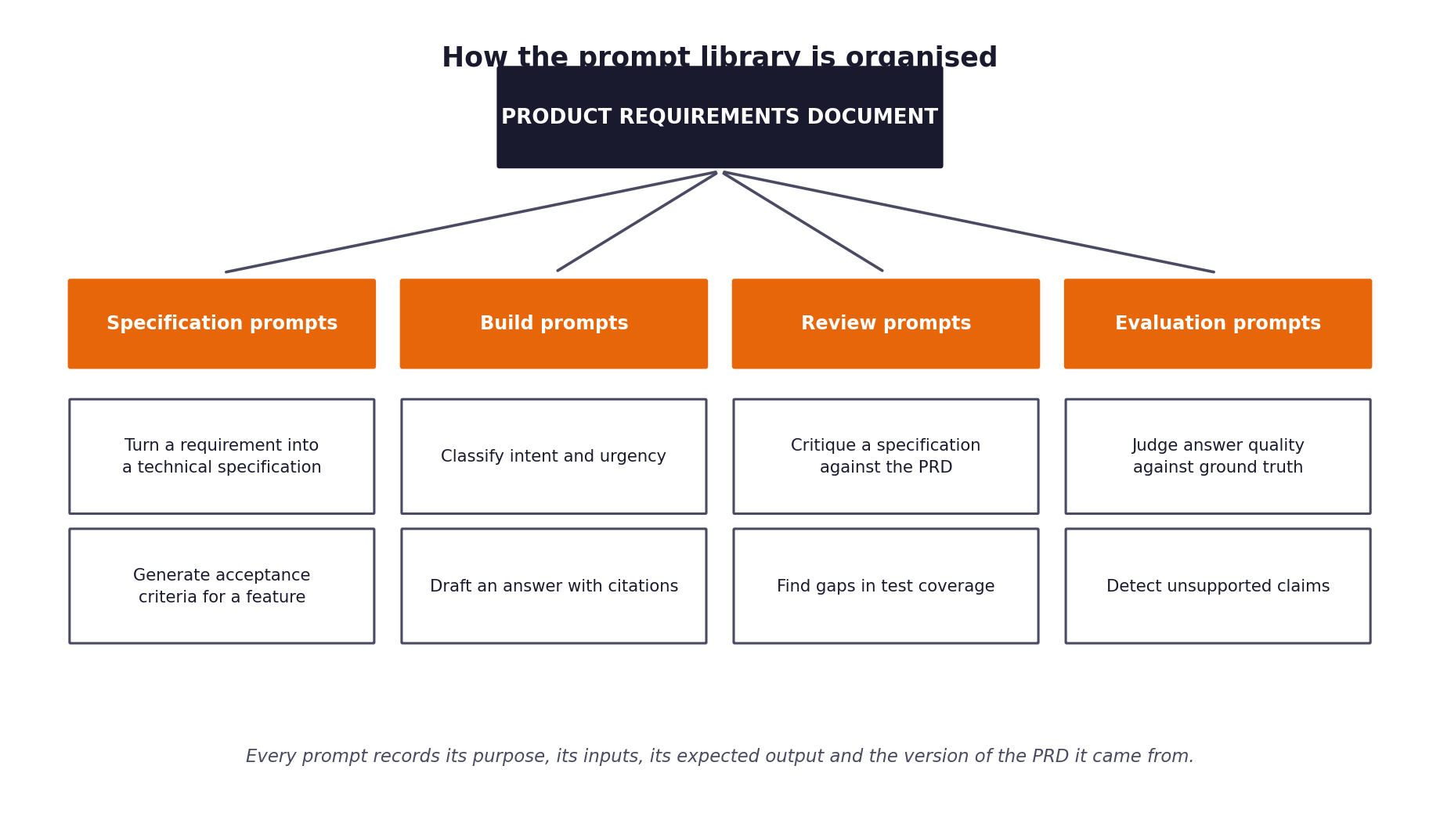
Figure 1. The four categories of prompt and how they descend from the requirements document.
The four categories
Category | What these prompts do | When you use them
Specification prompts | Convert a requirement into a technical specification and a set of acceptance criteria. | At the start of week two, before you build.
Build prompts | The instructions that run inside the system itself: classification, retrieval framing, answer drafting. | Throughout the build.
Review prompts | Critique your own specifications and code against the requirements they came from. | After each component is drafted.
Evaluation prompts | Judge answer quality, detect unsupported claims, compare against expert answers. | During the evaluation run in week two.

1 Section one: from requirement to specification
Take each functional requirement from your PRD and write the specification it implies. Use the specification prompts to help you draft these, but you are accountable for the result; a specification that contradicts your own requirements will be noticed.
Requirement ID | Specification summary | Inputs | Outputs | Acceptance criteria
FR-01 | Validate ticket schema, normalize encodings, sanitize input. | Raw ticket JSON | Validated ticket dict | Schema validity == True
FR-02 | Classify intent (22 categories) & urgency (low/med/high) with confidence. | ticket_body, channel | JSON {intent, urgency, confidence} | Intent accuracy > 85%
FR-03 | Dense vector retrieval over 29 KB articles with BM25 fallback. | ticket_body, intent | List[DocChunk] with similarity score | Recall@3 > 85%
FR-04 | Multi-factor decision routing (AUTO_RESPOND / ESCALATE). | intent, retrieval_score, safety | Route decision + reason | 0 unsafe auto-responses
FR-05 | Grounded response generation with Markdown citations. | ticket_body, doc_chunks | Markdown customer response with citations | 100% citations present
FR-06 | Fact-checking post-generation grounding guardrail. | generated_response, doc_chunks | JSON {is_grounded: bool} | 0 ungrounded claims pass
FR-07 | PII & credentials scanning/masking guardrail. | generated_response | Sanitized response text | 0 PII leaks in output
FR-08 | Adversarial prompt injection classifier. | raw ticket_body | JSON {is_injection: bool} | 100% injections blocked
FR-09 | Financial & billing commitment guardrail. | intent, ticket_body | Escalation block trigger | 0 billing auto-responses

2 Section two: the prompt register
Every prompt in your system gets an entry. Fill in one block per prompt, and copy the block as many times as you need. The version number changes whenever the text changes, and the reason for the change is recorded rather than lost.
Prompt PR-01
Field | PR-01
Name and purpose | Intent & Urgency Classification Prompt
Category | FR-02
Serves requirement | 1.2
Version | Claude 3.5 Sonnet / Llama 3
Model used | Classify ticket intent across 22 categories & assign urgency score.
Inputs it expects | ticket_body, channel, customer_tier
Output format required | JSON payload with intent, urgency, and confidence
How you know it worked
Known weaknesses
Change history

Prompt text:
Full prompt text as used in the system
You are an expert customer support classifier for CloudServe Solutions. Given an incoming support ticket, categorize the intent into exactly ONE of the 22 valid categories. Assign urgency (low, medium, high) and confidence score (0.0-1.0). Output valid JSON.

Prompt PR-02
Field | PR-02
Name and purpose | Grounded Response Generator Prompt
Category | FR-05, FR-06
Serves requirement | 1.3
Version | Claude 3.5 Sonnet / Llama 3
Model used | Generate customer-facing response strictly from retrieved doc chunks with citations.
Inputs it expects | ticket_body, intent, retrieved_chunks
Output format required | Markdown response with explicit article citations.
How you know it worked
Known weaknesses
Change history

Prompt text:
Full prompt text as used in the system
You are a CloudServe Technical Support AI Assistant. Draft a helpful response using ONLY the provided documentation chunks. Base every claim on the chunks. Include explicit Markdown source citations (e.g. Source: [DOC-DEPLOY-001]). State that this response is automated.

Prompt PR-03
Field | PR-03
Name and purpose | Grounding & Hallucination Guardrail Prompt
Category | FR-06
Serves requirement | 1.1
Version | Claude 3.5 Sonnet / Llama 3
Model used | Fact-check generated response against retrieved doc chunks.
Inputs it expects | generated_response, retrieved_chunks
Output format required | JSON payload with is_grounded status and unsupported_claims
How you know it worked
Known weaknesses
Change history

Prompt text:
Full prompt text as used in the system
You are an automated Fact-Checking Auditor for CloudServe Support Automation. Compare GENERATED_RESPONSE against RETRIEVED_CHUNKS. Determine if the response contains any ungrounded claims or hallucinations. Output JSON.

3 Section three: what makes a prompt worth keeping
The register above records your prompts. This section is about whether they are any good. Work through the checklist for each build prompt before you rely on it.
Check | What you are looking for
Does it state the role and the task separately? | A prompt that mixes who the model is with what it should do tends to produce inconsistent output.
Are the inputs clearly delimited? | Ticket text and instructions must be distinguishable, or a customer can accidentally instruct your system.
Is the output format specified exactly? | If you are parsing the response, the format is part of the contract and must be stated.
Does it say what to do when the answer is not known? | Without this instruction the model will invent something, because inventing something is what it does.
Are the examples representative? | Examples drawn only from easy cases teach the model that every case is easy.
Does it forbid what must never happen? | Constraints stated positively are followed more reliably than constraints implied by omission.

The injection problem you must handle
Your system reads text written by customers and passes it to a model. A customer can write text that looks like an instruction. If your prompt does not clearly separate the ticket content from your own instructions, you have built a system that strangers can reprogram. Record in the register how each build prompt defends against this.

4 Section four: traceability check
Complete this table before you move to the sprint plan. It is the evidence that your prompts descend from your requirements rather than from convenience.
Requirement ID | Specification written? | Prompts covering it | Test case identifier | Gaps
FR-01 | Yes | Ingest schema validator script | test_ingest.py | None
FR-02 | Yes | PR-01 (classify_prompt) | test_classify.py | None
FR-03 | Yes | Retriever query embedding pipeline | test_retrieve.py | None
FR-04 | Yes | Router rule matrix & threshold evaluator | test_route.py | None
FR-05 | Yes | PR-02 (generate_prompt) | test_generate.py | None
FR-06 | Yes | PR-03 (grounding_eval_prompt) | test_guardrails.py | None
FR-07 | Yes | PII Regex & NER scanner | test_guardrails.py | None
FR-08 | Yes | PR-04 (injection_detect_prompt) | test_guardrails.py | None

