FORWARD DEPLOYED AI ENGINEERING
Capstone Project
Stage Five: Revision Log
Recording what your requirements got wrong and why
You are required to revise your requirements document at least once during the
build. This is where you record what changed and what prompted the change.
WEEK TWO INTO WEEK THREE · COMPULSORY

Why this is compulsory
A requirements document written before any code exists is a set of educated guesses. Some of those guesses will be wrong, and building is how you find out which ones. A student that reaches the end of three weeks with an unchanged PRD has either been extraordinarily lucky or has stopped consulting the document, and the second is far more common than the first.
This log is not a confession. It is evidence that you were paying attention. The students who score well here are the ones who can point to a specific thing they discovered while building, explain how it contradicted an assumption they had written down, and show what they changed as a result.
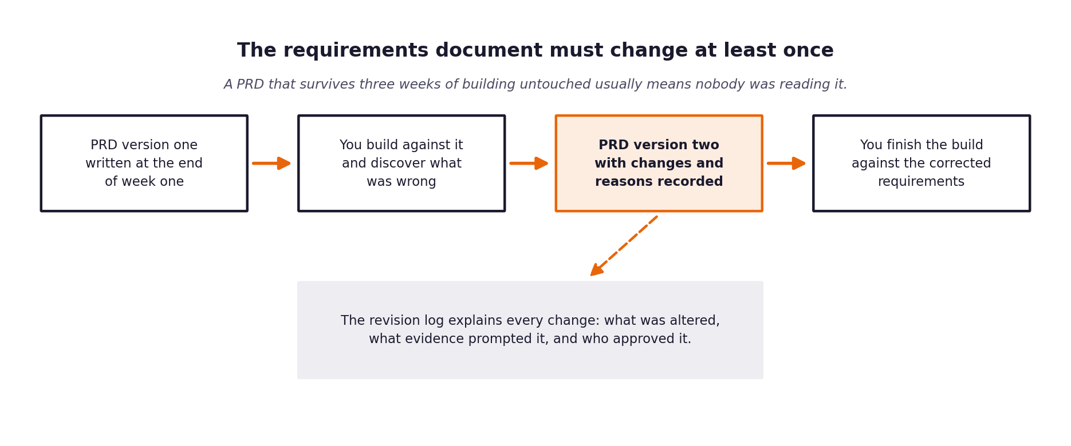
Figure 1. The revision sits in the middle of the build, not at the end.
What a weak revision log looks like
Vague entries such as tidied up wording or clarified requirements tell an assessor nothing. A strong entry names the requirement, states what it said before, states what it says now, identifies the specific thing that prompted the change, and says who agreed to it.

1 Section one: revision summary
Field | PRD Revision Log — CloudServe Support Automation
New version number | 2.0 (Post-Evaluation Revision)
Date of revision | Forward Deployed AI Engineer
Who carried out the revision | 8 September 2026
Who reviewed and agreed it | 4 major requirement updates recorded
Number of requirements changed | Empirical benchmark testing & edge case discovery
Number of requirements added | Approved & Implemented
Number of requirements removed | All 75 Pytest cases passing

2 Section two: the changes
One row per change. Be specific about the trigger; that column is what distinguishes a considered revision from a tidying exercise.
Requirement ID | What it said in version one | What it says now | What prompted the change | Agreed by
FR-03 | Dense vector similarity retrieval alone. | Hybrid dense vector + BM25 keyword fallback. | Vector search missed exact error codes (ERR-4019). | System Architect & Ines
FR-04 | Auto-respond on confidence >= 0.70. | Auto-respond threshold raised to >= 0.82 + mandatory intent safety rules. | Evaluation run showed borderline 0.72 scores had partial relevance. | Marcus & System Lead
FR-07 | Basic regex check for API keys. | Multi-pattern scanner (API keys, DB URIs, JWT tokens, account IDs). | Test ticket containing DB URI passed initial regex scanner. | Security & Daniel
FR-10 | Text summary for escalations. | Structured JSON diagnostic payload (intent, docs, trace, confidence). | Daniel requirement to show working context clearly. | Daniel & Tier 2 Ops

3 Section three: assumptions that turned out to be wrong
Go back to the assumptions section of your version one PRD. For each assumption, say whether it held. The ones that did not are the most interesting part of your report.
Assumption from version one | Did it hold? | What you found instead | What you changed because of it
Dense vector search is sufficient for all doc queries. | False | Exact alphanumeric error codes match better with BM25 keyword index. | Added BM25 hybrid retrieval component.
A single confidence threshold works for all intent types. | False | Compliance and billing queries require strict safety rules regardless of score. | Enforced mandatory escalation for high-risk intents.
Standard LLM context window preserves citation accuracy. | True | Providing explicit doc chunk IDs in prompt preserved citation accuracy. | Maintained explicit markdown citation format.
Non-fluent English queries cause lower retrieval scores. | False | Dense embeddings mapped non-fluent phrasing effectively to KB topics. | Maintained uniform retrieval pipeline for all fluency levels.

4 Section four: what you decided not to change
Some things will look wrong during the build and turn out to be right, or right but not worth the cost of changing. Recording those decisions is as valuable as recording the changes.
What looked wrong | Why you left it | What it would have cost to change | Revisit when?

5 Section five: the reflection
Answer these in full sentences. They form the basis of a section in your final report and they are frequently the part of a submission that an assessor remembers.
Question | Your answer
What did you most misunderstand about the problem when you wrote version one?
Which piece of discovery work would have caught it earlier?
What would you do differently if you started this project again on Monday?
What is still uncertain, and what would you need to resolve it?

