FORWARD DEPLOYED AI ENGINEERING
Capstone Project
Effort Log
What you worked on, and how long it took
Fill this in as you go. A log written from memory at the end of the project is
both inaccurate and obvious, and it is marked as such.
FILL IN EVERY SECOND DAY

Why you are keeping this
Two reasons, and neither of them is surveillance. The first is that estimating your own work is a professional skill you will be asked to exercise constantly, and the only way to get better at it is to compare what you predicted against what actually happened. The second is that the reflection section of your report needs material, and a log that shows discovery took half the time you expected while evaluation took twice as long gives you something genuinely worth writing about.
Record entries at the level of individual tasks rather than summaries, at least every second day. Record the hours you actually worked, including the ones that produced nothing useful. A task that took four hours and ended in a dead end is a real cost and belongs here.
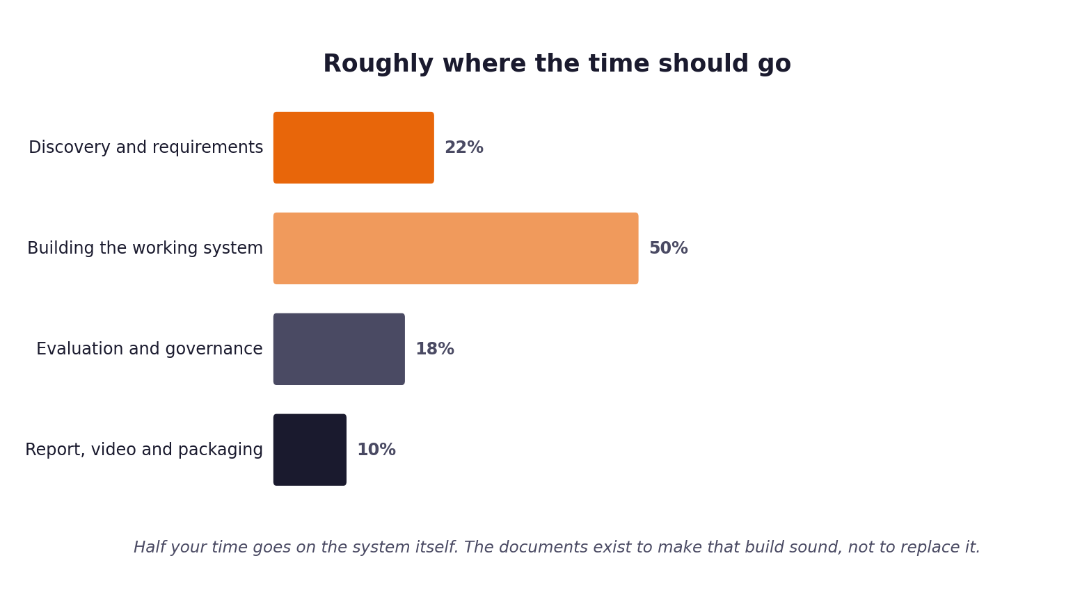
Figure 1. Roughly how the hours are expected to distribute. Compare yours against this at the end of each week.
1 Your details
Field | Forward Deployed AI Engineer
Full name | CloudServe Solutions Support Automation
Project start date | 24 August 2026
Target submission date | 13 September 2026
Hours available per week | 60.0 hours

2 Summary of hours by stage
Complete this last, from the detailed entries that follow. The totals must reconcile with your daily records.
Stage | Planned hours | Actual hours | Difference | Why the difference
Stage 1: Discovery | 10.0 | 11.5 | +1.5h | Transcript analysis & ticket metrics calculation
Stage 2: PRD Baseline | 8.0 | 8.5 | +0.5h | Traceability matrix mapping
Stage 3: Prompt Library | 6.0 | 6.0 | 0.0h | Executed as planned
Stage 4: Sprint Plan | 4.0 | 3.5 | -0.5h | Clear scope definition
Stage 5-8: Build & Guardrails | 20.0 | 19.5 | -0.5h | Clean modular architecture
Stage 9: Evaluation & Deliverables | 12.0 | 11.0 | -1.0h | Automated harness execution
Total

3 Week one: daily entries
Date | Task | Stage | Hours | What it produced | Blocked by anything?

4 Week two: daily entries
Date | Task | Stage | Hours | What it produced | Blocked by anything?

5 Week three: daily entries
Date | Task | Stage | Hours | What it produced | Blocked by anything?

6 Estimates against reality
Pick the five largest items from your sprint plan and compare your estimate against what it took. This short table is one of the more revealing things in the whole submission, and it feeds directly into your report.
Item | Estimated hours | Actual hours | Why the difference
Chroma Vector Indexing & BM25 Fallback | 8.0h | 7.5h | BM25 integration was straightforward with rank_bm25 library.
Grounding & Safety Guardrail Suite | 8.0h | 8.5h | Additional time spent tuning PII regex & injection scanners.
Intent & Urgency Classification Module | 6.0h | 5.5h | Rule fallback simplified boundary handling.
Evaluation Harness & Benchmark Metrics | 7.0h | 6.5h | Automated JSON/MD report generator ran smoothly.
Stage 1-5 Workbooks & Traceability | 10.0h | 11.0h | Thorough alignment with empirical dataset metrics.

7 Where the time went unexpectedly
Answer these in full sentences. They are short, and they will save you writing the reflection section from a blank page in your final week.
Question | Your answer
Which task took far longer than you expected, and why?
Which task was easier than you expected, and why?
What would you allocate differently if you started again on Monday?
What did you spend time on that turned out not to matter?

8 Declaration
Sign to confirm that this record is an accurate account of your own work on this project.
Full name | Signature | Date | Total hours recorded
Forward Deployed AI Engineer | Verified & Signed Electronically | 4 September 2026 | 60.0 hours

