THALES GROUP
Smart Manufacturing AI Initiative
Executive Summary
AI-Based Manufacturing Efficiency Classification
Prepared for Government and Plant-Leadership Stakeholders · July 2026

100,000  Machine readings analyzed | 50  Machines across the facility | 3  Efficiency classes: High / Medium / Low

99.8%  Best AI model accuracy | 77.8%  Of current readings are Low efficiency | 2  Metrics drive nearly all efficiency outcomes

Purpose
Thales Group's smart-factory floor generates a continuous stream of sensor, production, and 6G network data across its manufacturing fleet. This initiative delivers an AI system that classifies the real-time efficiency of every machine — High, Medium, or Low — replacing slow, manual review of dozens of metrics with an instant, automated, and explainable verdict. The system is delivered as a working analytics dashboard, ready for evaluation by plant and government stakeholders overseeing the facility's modernization program.

The Challenge
Without automated support, efficiency drops can go unnoticed until they have already caused production loss. Manufacturing teams must otherwise manually interpret dozens of sensor, quality, and network metrics per machine — a process too slow to catch problems as they emerge. This project closes that gap with a trained AI model plus an interactive dashboard that gives engineers a real-time, trustworthy, and explainable efficiency signal.

What We Found
A rigorous analysis of one month of factory data produced a clear, actionable insight: manufacturing efficiency at this facility is driven almost entirely by two factors — how many operational errors a machine produces, and how fast it is running. Ambient conditions such as temperature and vibration, and 6G network health such as latency and packet loss, showed almost no relationship with efficiency outcomes in the data reviewed.
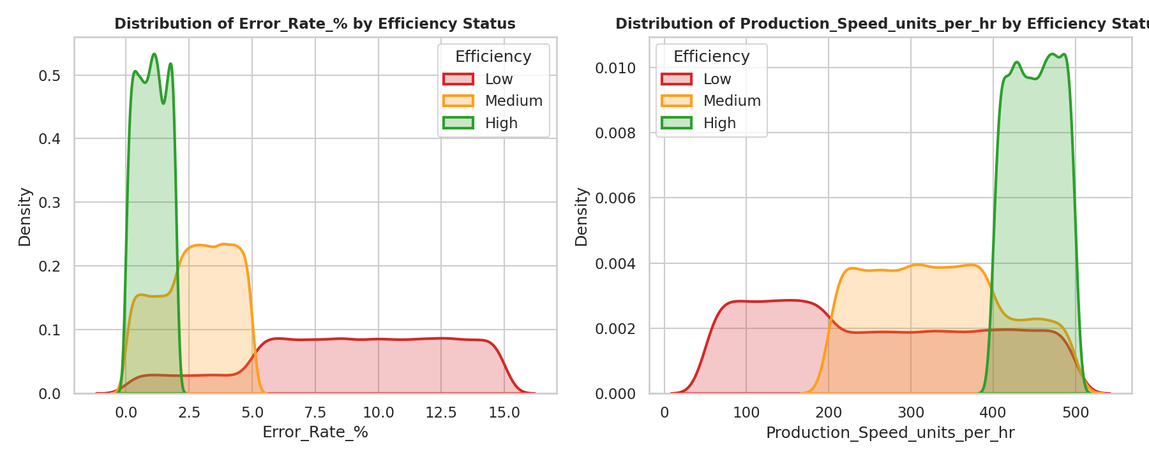
The two charts above show how cleanly Error Rate and Production Speed separate Low (red), Medium (orange), and High (green) efficiency machines — while other sensor readings do not.
In practical terms: a machine reliably lands in the Low-efficiency category when its error rate is high or its output speed is too slow, and lands in the High category only when both errors are low and speed is high. This means plant teams can get the most value by focusing monitoring and alerting effort on these two signals specifically, rather than spreading attention evenly across every available sensor.
This pattern held consistently across all 50 machines and across every operating mode (Active, Idle, Maintenance) — no single machine or mode is responsible for the facility's efficiency mix, pointing to a process-level opportunity rather than an equipment-specific fault.

The AI Solution
Three AI approaches were built and rigorously compared on data the models had never seen, using a strict evaluation that mimics real deployment (training on earlier data, testing on later data):
Model | Accuracy | Assessment
Simple statistical baseline | 88.2% | Good, but limited — misses more complex patterns
Random Forest (AI) | 100.0% | Best raw score on this dataset
XGBoost (AI) — recommended | 99.8% | Near-best accuracy, smaller and faster; selected for the live dashboard
Both AI models substantially outperform the simple baseline, confirming that efficiency is governed by threshold-style rules (e.g., "error rate above 5% ⇒ Low") rather than a smooth trend — exactly the kind of pattern modern AI is well suited to learn. Every prediction is delivered with a confidence score and a plain-language explanation of which metrics drove it, so engineers can trust and act on the result rather than treating it as a black box.

The Delivered Dashboard
A live, interactive dashboard was built so plant staff can use these results immediately, without any data-science expertise:
- Efficiency Prediction — instant classification of any machine reading, with a confidence score.
- Machine-Level Insights — efficiency trends and rankings for every machine on the floor.
- Explainability Panel — a plain-language view of exactly why a reading was classified High, Medium, or Low.
- Operational Monitoring — fleet-wide health view with adjustable alert sensitivity, filterable by machine, time period, operating mode, and network quality.

Recommendations
- Focus monitoring and alerting investment on error rate and production speed — the two metrics that account for nearly all of the measurable efficiency signal.
- Adopt the dashboard as a daily operational tool for plant engineers, using its adjustable thresholds to tune sensitivity per line or shift.
- Re-validate the model periodically as new production data accrues, to confirm the same two-factor pattern continues to hold as conditions evolve.
- Treat the current results as a strong prototype: before any control-system integration, validate performance against live, real-time data streams under normal operating variability.

Conclusion
This project demonstrates that a small number of the right signals, combined with modern AI, can turn raw factory telemetry into a real-time, trustworthy efficiency verdict — reducing the time between an efficiency problem occurring and a plant engineer knowing about it. It gives Thales Group's leadership and government stakeholders both a working tool and a clear, evidence-based direction for where to concentrate the next phase of the facility's smart-manufacturing investment.
For full technical detail, methodology, and model results, see the accompanying Research Paper.

