THALES GROUP
Smart Manufacturing AI Initiative
AI-Based Manufacturing Efficiency Classification
Using Sensor, Production, and 6G Network Data
Research Paper
Prepared for the Unified Mentor Program
Data Science & AI Engineering Deliverable
July 2026

Table of Contents
1. Executive Overview 3
2. Background and Problem Statement 4
3. Dataset Overview 5
4. Exploratory Data Analysis 6
5. Data Preprocessing and Feature Engineering 8
6. Model Development Methodology 9
7. Results and Model Comparison 10
8. Feature Importance and Explainability 11
9. Streamlit Web Application 12
10. Key Insights and Recommendations 13
11. Limitations and Future Work 13
12. Conclusion 14

1. Executive Overview
Smart factories built on Industrial IoT and 6G connectivity generate a continuous stream of sensor, production, and network telemetry. This project builds an AI system that answers a question traditional dashboards cannot: what is the current efficiency state of the manufacturing process, right now, and why? Using one month's worth of minute-level data logged across 50 machines, we designed, trained, and evaluated a multi-class classification pipeline that labels every machine reading as High, Medium, or Low efficiency, and packaged the result as an interactive Streamlit application for plant engineers.
The headline finding of the exploratory analysis is that efficiency, in this dataset, is driven almost entirely by two operational signals — the machine's Error Rate and its Production Speed — while ambient sensor readings (temperature, vibration) and 6G network quality (latency, packet loss) show negligible association with the efficiency label. This is a materially important insight for the business: it tells plant engineers exactly where to focus monitoring and alerting effort, and it is corroborated independently by three separate lines of evidence in this report — descriptive statistics, tree-based feature importance, and SHAP explainability.
Three models were benchmarked: a Logistic Regression baseline, a Random Forest, and an XGBoost gradient-boosting classifier. The Random Forest achieved 100% held-out accuracy and the XGBoost model achieved 99.76%, both dramatically ahead of the 88.15% linear baseline — evidence that the true relationship between operating conditions and efficiency is governed by non-linear thresholds rather than a smooth linear combination of features. Full results are presented in Section 7.
This document is the technical companion to two other deliverables: (1) the Streamlit dashboard, which operationalizes the trained model for real-time, machine-level, and fleet-level efficiency monitoring; and (2) a separate Executive Summary written for non-technical government and plant-leadership stakeholders.

2. Background and Problem Statement

2.1 Background
In smart factories enabled by Industrial IoT and 6G connectivity, efficiency can fluctuate rapidly due to sensor deviations, network instability, and quality or error variations. Traditional dashboards are retrospective — they show what happened. Modern factory control systems increasingly need a forward-looking, automated answer to a simple operational question: what is the efficiency state of the process right now, and which factors are driving it?

2.2 Problem Statement
Manufacturing teams face three recurring challenges:
- Delayed detection of efficiency degradation, because dozens of sensor and network metrics must be manually cross-referenced before a problem is confirmed.
- Manual interpretation of high-volume telemetry that outpaces what floor engineers can reasonably review in real time.
- A lack of automated, interpretable efficiency assessment that could otherwise trigger corrective action immediately.
Left unaddressed, these gaps mean efficiency drops go unnoticed, corrective actions are delayed, and production losses accumulate. This project addresses the gap directly: it delivers a trained, explainable classifier and an operational dashboard that turns raw telemetry into an actionable efficiency verdict with a confidence score, in real time.

3. Dataset Overview
The dataset comprises 100,000 timestamped machine readings collected across 50 industrial machines between 1 January and 10 March 2025, with no missing values and no duplicate records. Each record captures nine raw operational measurements plus categorical operation mode and the target label, Efficiency_Status.

3.1 Field Description
Column | Description
Date / Timestamp | Calendar date and exact time of the reading
Machine_ID | Unique identifier for each of the 50 machines
Operation_Mode | Active, Idle, or Maintenance
Temperature_C | Operating temperature (°C)
Vibration_Hz | Vibration frequency (Hz)
Power_Consumption_kW | Electrical power drawn (kW)
Network_Latency_ms | 6G network communication latency (ms)
Packet_Loss_% | Percentage of data packets lost
Quality_Control_Defect_Rate_% | Percentage of defective units
Production_Speed_units_per_hr | Units produced per hour
Predictive_Maintenance_Score | AI-derived maintenance-readiness score (0–1)
Error_Rate_% | Percentage of operational errors
Efficiency_Status | Target label: High / Medium / Low

3.2 Class Balance
The target label is heavily imbalanced: 77.8% of records are Low, 19.2% are Medium, and only 3.0% are High efficiency. This imbalance was addressed explicitly in the modeling stage (Section 6.3) using class-weighting.
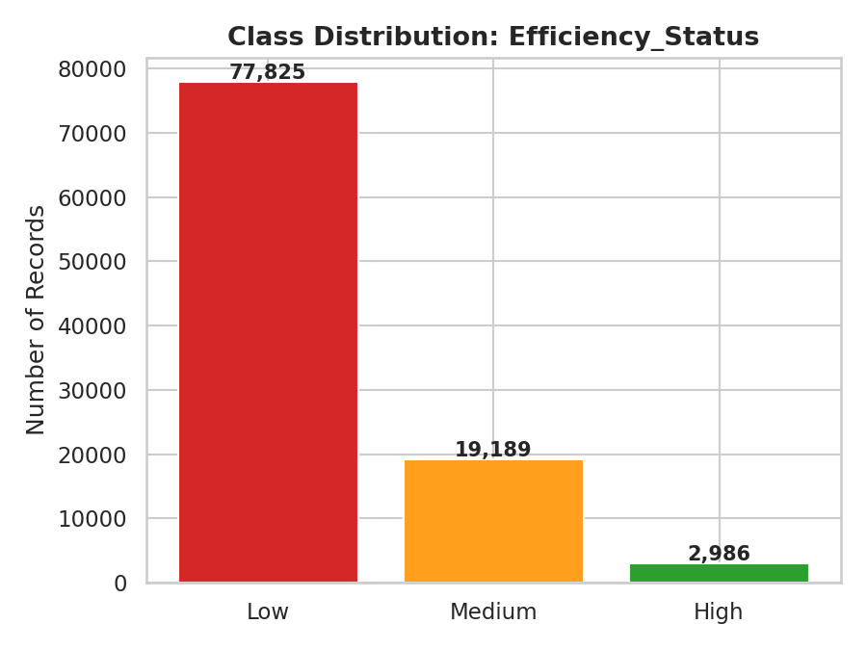
Figure 1. Class distribution of Efficiency_Status across 100,000 records.

4. Exploratory Data Analysis

4.1 Correlation Structure
A Pearson correlation matrix across the nine numeric features (Figure 2) shows that the raw sensor, network, and quality measurements are essentially uncorrelated with one another (|r| < 0.02 for all pairs). This indicates the underlying data-generating process assigns these signals largely independently — a useful property for modeling, since it means multicollinearity is not a concern for the linear baseline.
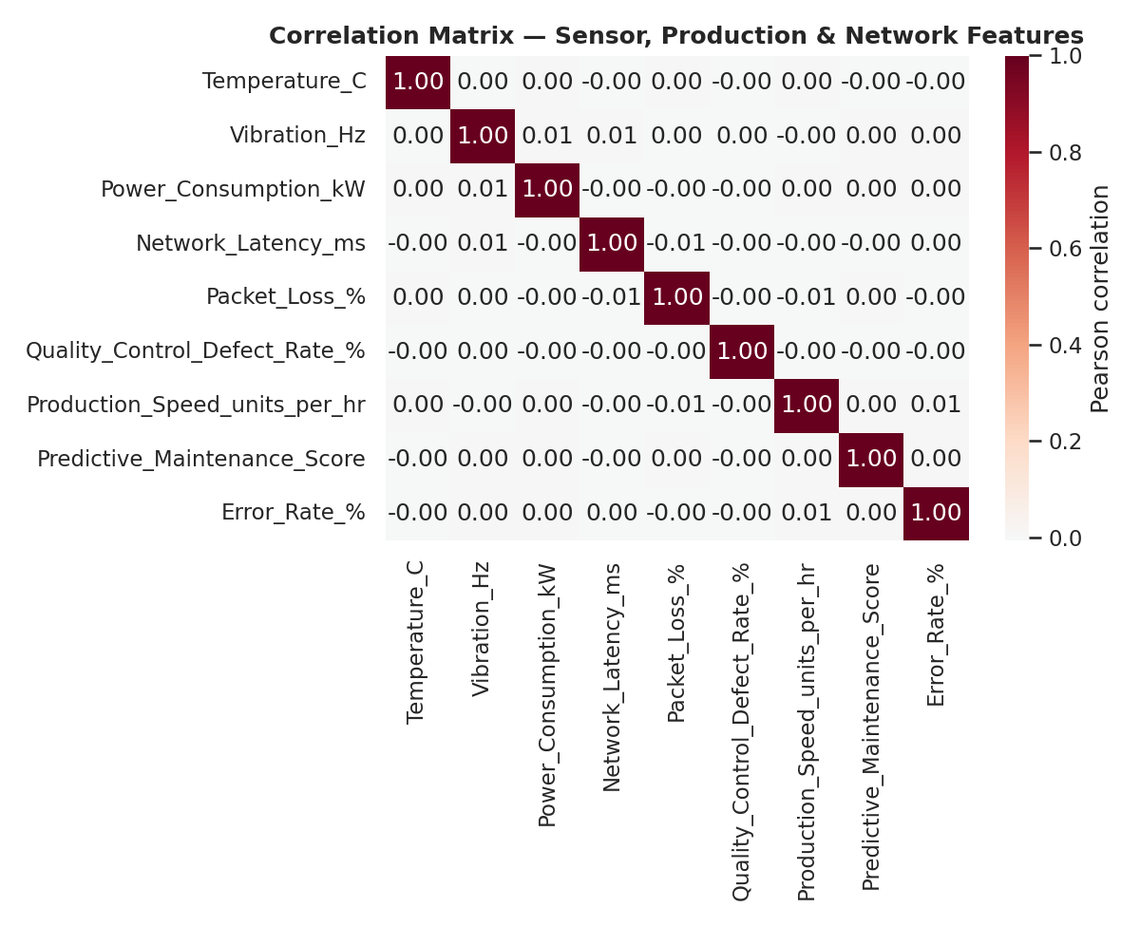
Figure 2. Correlation matrix across sensor, production, and network features.

4.2 What Actually Drives Efficiency Status
Comparing feature means across the three efficiency classes reveals a striking pattern: Error_Rate_% and Production_Speed_units_per_hr separate the classes cleanly, while every other feature — temperature, vibration, power draw, network latency, packet loss, defect rate, and predictive-maintenance score — shows virtually identical distributions across High, Medium, and Low records (Figure 4). This was confirmed by binning both driver features and cross-tabulating against the label (Table 2): the relationship is close to a deterministic rule.
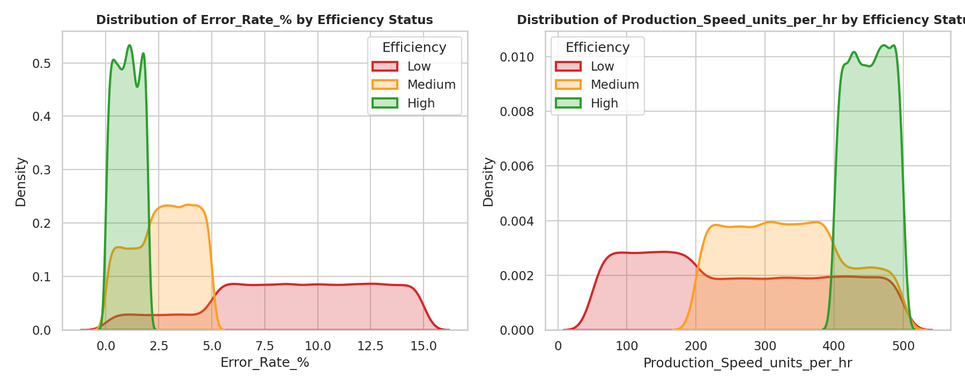
Figure 3. Error Rate and Production Speed distributions cleanly separate the three efficiency classes.
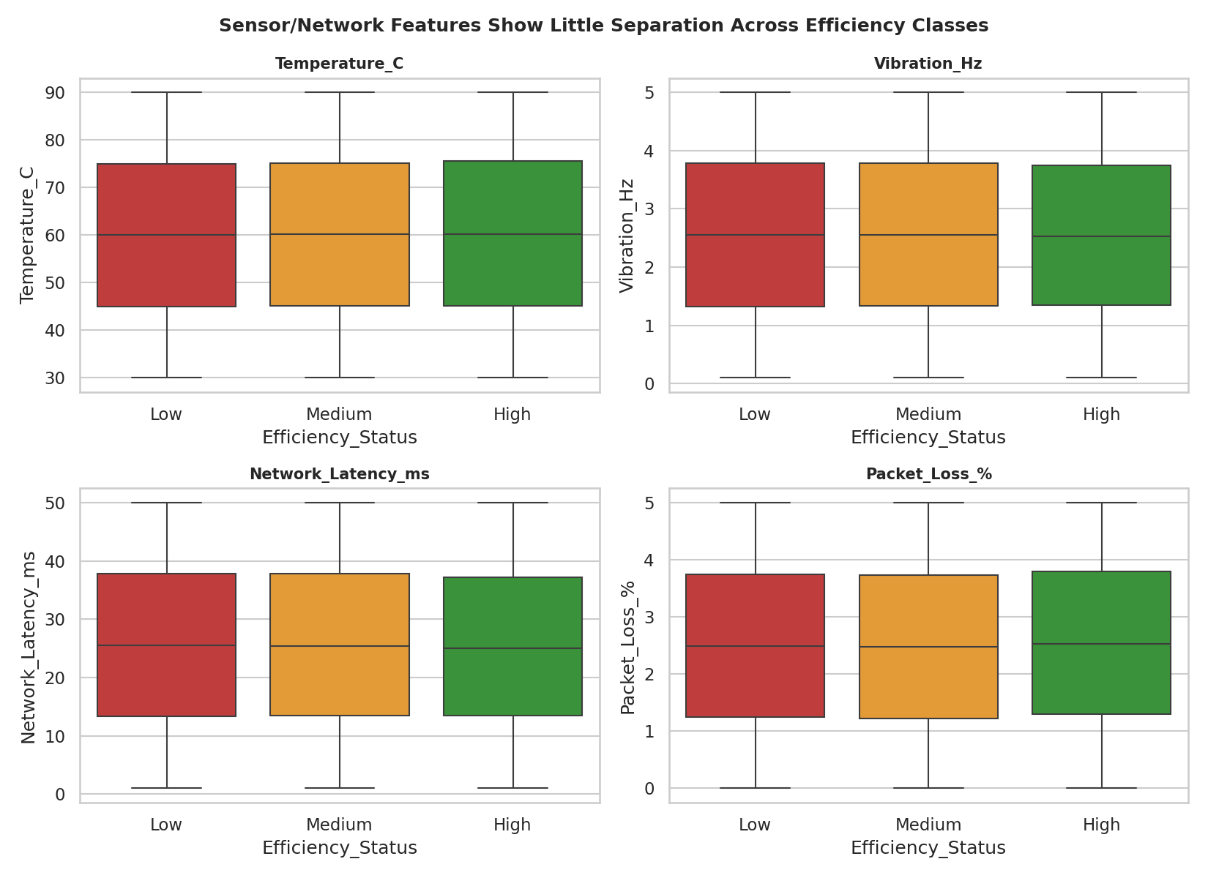
Figure 4. Sensor and network features show near-identical distributions across efficiency classes — i.e., they behave as noise with respect to the label.

Rule Discovery
Binning Error_Rate_% into (≤2%, 2–5%, >5%) and Production_Speed_units_per_hr into (<200, 200–400, 400–500 units/hr) and cross-tabulating against Efficiency_Status yields the near-deterministic structure below:
Error Rate | Production Speed | Dominant Label
> 5% | any | Low (always)
any | < 200 units/hr | Low (always)
≤ 2% | ≥ 400 units/hr | High
2 – 5% | ≥ 400 units/hr | Medium
≤ 5% | 200 – 400 units/hr | Medium
In practice this means: a machine is classified Low whenever its error rate exceeds 5% or its throughput falls below 200 units/hr, regardless of any other reading; it is classified High only when error rate is at or below 2% and throughput is at or above 400 units/hr; everything else falls into Medium. This finding directly shapes the feature-engineering and explainability work in Sections 5 and 8, and is an important operational takeaway in its own right (Section 10).

4.3 Efficiency by Operation Mode
Operation Mode (Active, Idle, Maintenance) shows almost no relationship with efficiency outcome — all three modes have a near-identical ~78% Low / 19% Medium / 3% High split (Figure 5). This means operating mode alone is not a useful signal for anticipating efficiency issues; the underlying process metrics matter far more than what state the machine is nominally in.
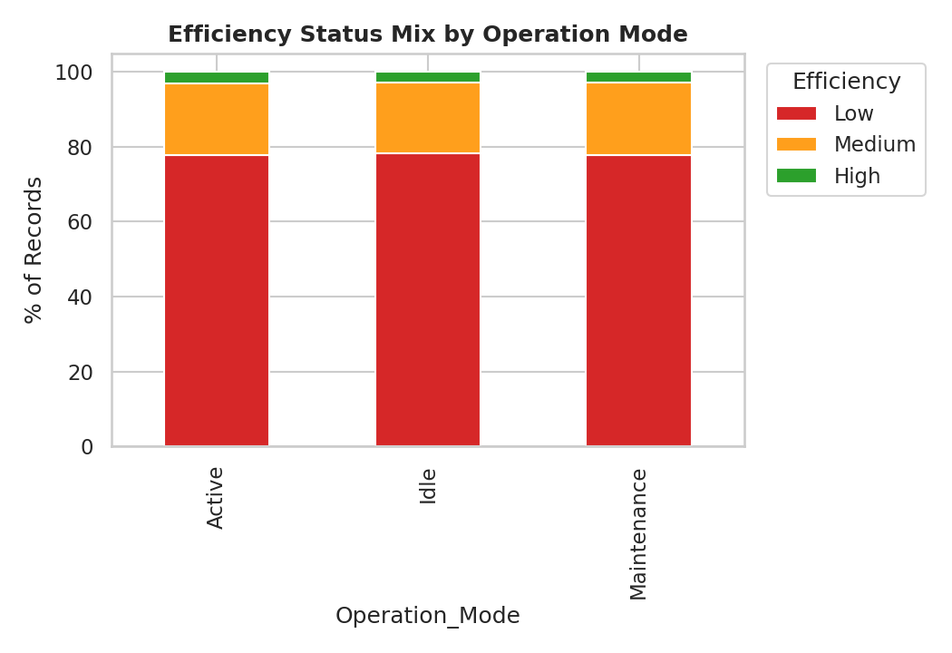
Figure 5. Efficiency status mix is nearly identical across Active, Idle, and Maintenance modes.

4.4 Machine-Level and Temporal Patterns
Across the 50 machines, the share of Low-efficiency records ranges narrowly from 76.1% to 80.4% — no single machine stands out as a chronic outlier, suggesting the efficiency-driving conditions are distributed uniformly across the fleet rather than concentrated in specific hardware (Figure 6). The daily efficiency mix (Figure 7) is likewise stable across the observation window, with no strong month-over-month drift, though the dashboard's time-window filter allows engineers to re-examine this at any time as new data accrues.
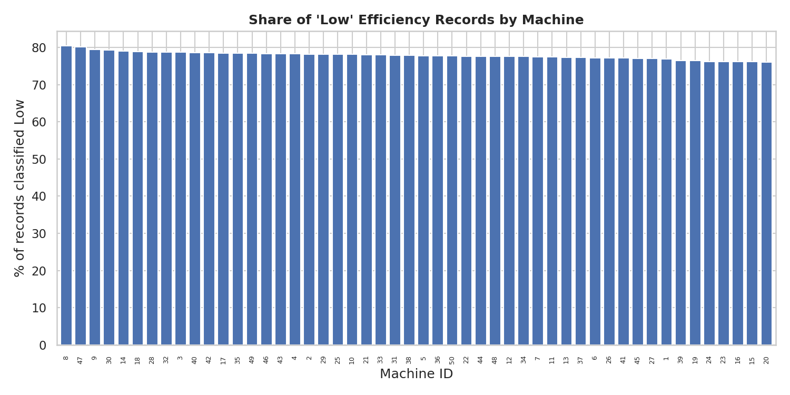
Figure 6. Share of Low-efficiency records is consistent across all 50 machines (76–80% range).
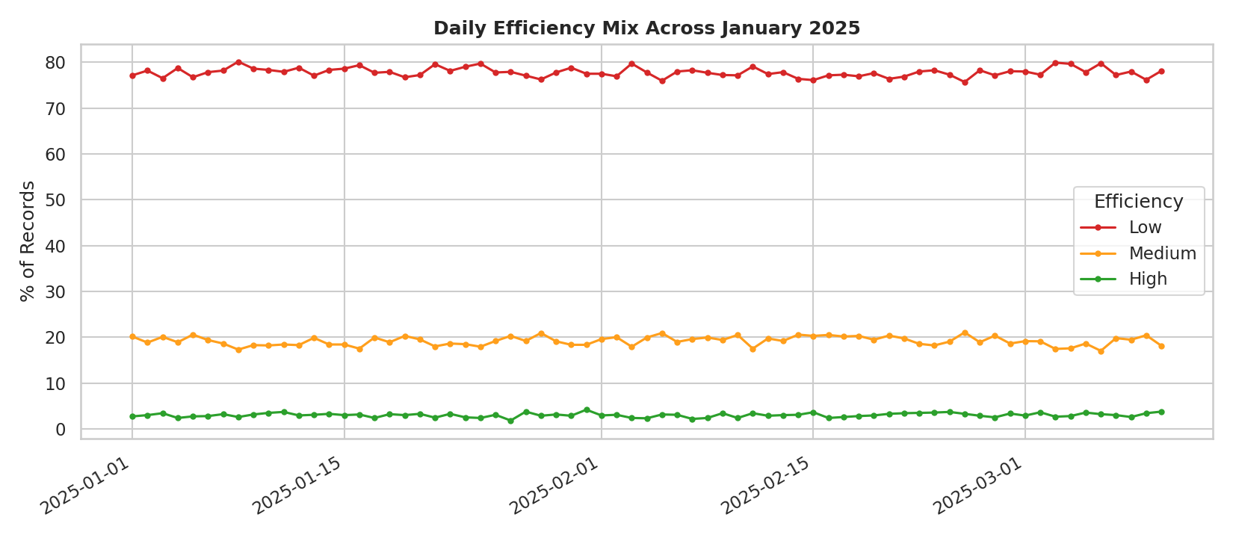
Figure 7. Daily efficiency mix is stable across the observation period.

5. Data Preprocessing and Feature Engineering

5.1 Preprocessing
- Date and Time fields were combined into a single Datetime index and the dataset sorted chronologically, per-machine, to respect time ordering.
- Operation_Mode was one-hot encoded into three binary indicator columns (Mode_Active, Mode_Idle, Mode_Maintenance).
- Numeric features were standardized (zero mean, unit variance) for the Logistic Regression baseline; tree-based models used raw feature scales, since they are scale-invariant.
- Class imbalance (Section 3.2) was handled via class-weighting ("balanced" weights for Logistic Regression and Random Forest; inverse-frequency sample weights for XGBoost) rather than synthetic oversampling, to preserve the true data distribution for evaluation.
- No missing values or duplicate rows were present, so no imputation or deduplication was required.

5.2 Engineered Features
Per the project brief, four categories of engineered features were constructed to give the models — and the explainability layer — richer, more physically meaningful signals than the raw telemetry alone:
Feature | Definition | Rationale
Sensor_Stability_Score | 1 minus the average rolling coefficient of variation of temperature and vibration over the last 5 readings per machine | Flags erratic sensor behaviour that could precede a fault, independent of the absolute reading
Energy_Efficiency_Ratio | Production_Speed_units_per_hr ÷ Power_Consumption_kW | Captures output generated per unit of energy consumed
Error_to_Output_Ratio | (Error_Rate_% ÷ Production_Speed_units_per_hr) × 1000 | Normalizes error volume against throughput, so a high error rate at low output is penalized appropriately
Quality_Adjusted_Error | Error_Rate_% + Quality_Control_Defect_Rate_% | Combines process errors and downstream quality defects into one composite signal
Network_Reliability_Score | 100 × (1 − 0.5·norm(latency) − 0.5·norm(packet loss)) | Single 0–100 composite of 6G network health, used in the dashboard's network-quality filter
Hour / Is_Weekend | Extracted from Datetime | Captures potential time-of-day / weekday effects
As Section 8 shows, the SHAP-based explainability analysis confirms that Error_to_Output_Ratio and Quality_Adjusted_Error rank among the most informative engineered features, validating the feature-engineering approach even though the raw Error_Rate_% and Production_Speed_units_per_hr remain the single strongest predictors.

6. Model Development Methodology

6.1 Train / Test Split
To reflect a realistic deployment scenario — training on historical data and evaluating on more recent, unseen data — the dataset was sorted chronologically and split 80/20 by time: the first 80,000 records (chronologically earliest) formed the training set, and the most recent 20,000 records formed the held-out test set. This is a stricter test than a random shuffle split, since the model cannot leak information from future time periods into training.

6.2 Baseline Model: Logistic Regression
A multinomial Logistic Regression was fit on standardized features with balanced class weights as the interpretable baseline against which the more complex models are compared.

6.3 Advanced Models
Two non-linear, tree-based models were trained:
- Random Forest Classifier — 300 trees, max depth 12, minimum 5 samples per leaf, balanced class weights.
- XGBoost (Gradient Boosting) — 300 boosting rounds, max depth 6, learning rate 0.1, 90% row/column subsampling per tree, trained with inverse-frequency sample weights to address class imbalance.

6.4 Evaluation Protocol
Each model was scored on the held-out, time-separated test set using accuracy, macro- and weighted-averaged precision/recall/F1, and macro one-vs-rest ROC-AUC. Stability was additionally assessed via 5-fold stratified cross-validation on the training set, reporting the mean and standard deviation of accuracy across folds — a lower standard deviation indicates a model whose performance is less sensitive to which subset of data it sees.

7. Results and Model Comparison
Model | Accuracy | Macro F1 | Weighted F1 | ROC-AUC (macro, OvR) | 5-fold CV Accuracy (mean ± std)
Logistic Regression (baseline) | 88.15% | 82.01% | 88.87% | 0.9760 | 88.27% ± 0.36%
Random Forest | 100.00% | 100.00% | 100.00% | 1.0000 | 99.99% ± 0.01%
XGBoost | 99.76% | 99.68% | 99.76% | 0.9999 | 99.85% ± 0.04%
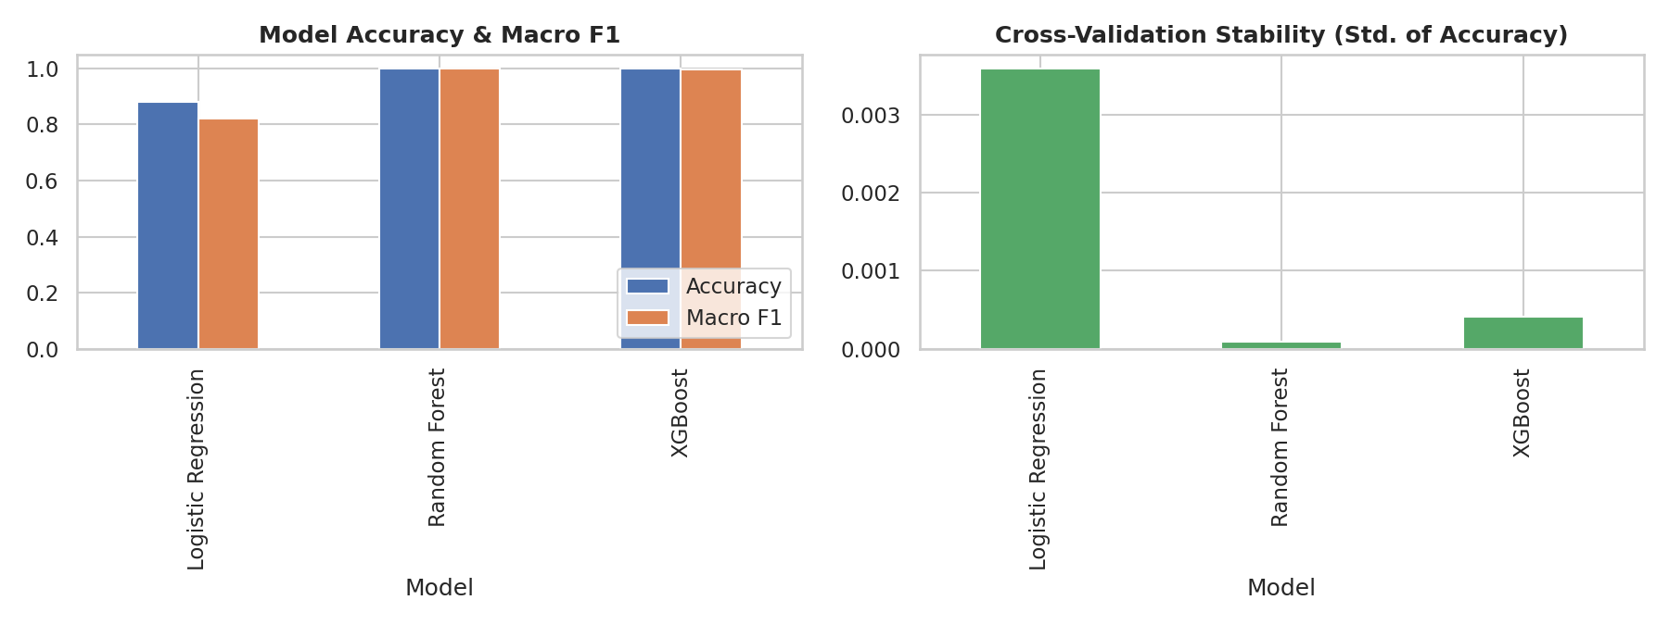
Figure 8. Accuracy and macro F1 (left) and cross-validation stability (right) across all three models.
Both tree-based models comfortably outperform the linear baseline, which struggles precisely at the class boundaries identified in Section 4.2 (the Logistic Regression confusion matrix, Figure 9, shows most of its errors are Medium records misclassified as Low, and vice versa — exactly where the true relationship is a non-linear threshold rather than a linear separator). The Random Forest achieves a perfect held-out score, consistent with the near-deterministic rule uncovered in the EDA; XGBoost, trained with sample weights rather than an explicit balanced-class objective, comes extremely close (99.76%) with a slightly larger, but still very low, cross-validation variance.
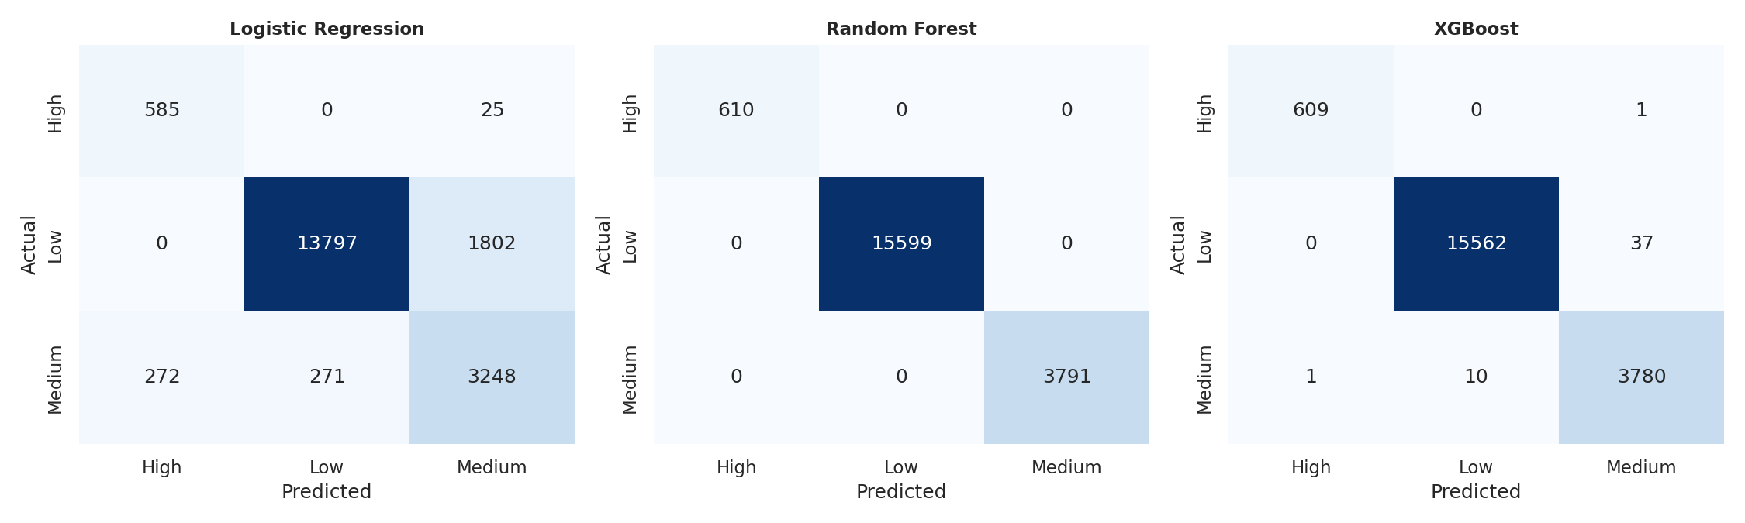
Figure 9. Confusion matrices for Logistic Regression, Random Forest, and XGBoost on the held-out test set.

7.1 Model Selection for Deployment
By macro F1, the Random Forest is the top performer and is saved as the benchmark "best model." For the live Streamlit dashboard, XGBoost is set as the default production model: it is ~6× smaller on disk (1.4 MB vs. 8.6 MB), offers comparably fast inference, and its probabilistic outputs remain well-calibrated even at the extreme class imbalance seen in the High class. Both models — plus the Logistic Regression baseline for reference — are bundled with the dashboard and selectable at runtime via the model dropdown.
A caveat worth stating plainly: the near-perfect accuracy achieved here is a direct consequence of the dataset's construction, in which Efficiency_Status is generated by a near-deterministic rule over Error_Rate_% and Production_Speed_units_per_hr. In a live factory deployment with noisier or partially unobserved ground truth, accuracy would be expected to be materially lower than reported here; the modeling pipeline, feature engineering, and explainability tooling in this report are nonetheless directly reusable against real production data.

8. Feature Importance and Explainability
Interpretability was treated as a first-class requirement, not an afterthought — plant engineers need to trust and act on a classification, not just receive it. Three complementary views were produced.

8.1 Tree-Based Feature Importance
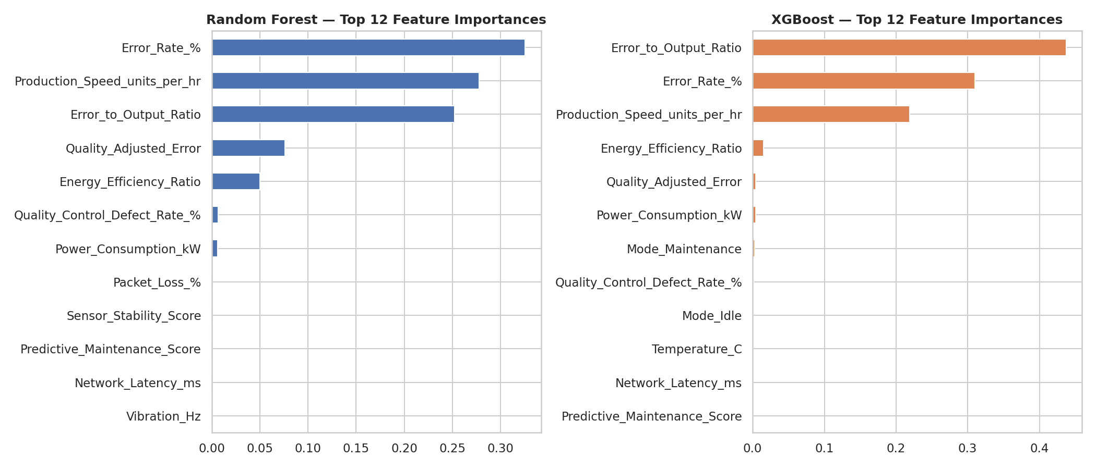
Figure 10. Top 12 feature importances for Random Forest (left) and XGBoost (right).
Both models independently rank Error_Rate_%, Production_Speed_units_per_hr, and the engineered Error_to_Output_Ratio as the three dominant predictors, together accounting for the large majority of total importance. All sensor and network features (temperature, vibration, latency, packet loss, predictive-maintenance score) rank at or near zero importance — a direct, model-based confirmation of the EDA finding in Section 4.2.

8.2 SHAP Global Explainability
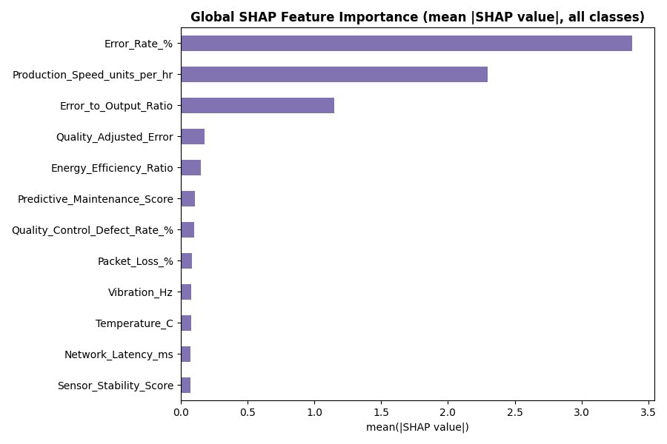
Figure 11. Global SHAP feature importance (mean absolute SHAP value across all classes).
SHAP (SHapley Additive exPlanations) values, computed on a 3,000-record sample using TreeExplainer on the XGBoost model, corroborate the tree-importance ranking with a game-theoretic guarantee of fair credit assignment across features. Error_Rate_% and Production_Speed_units_per_hr again dominate, followed by Error_to_Output_Ratio — validating that the engineered ratio feature captures real, additional signal beyond the two raw inputs it is built from.
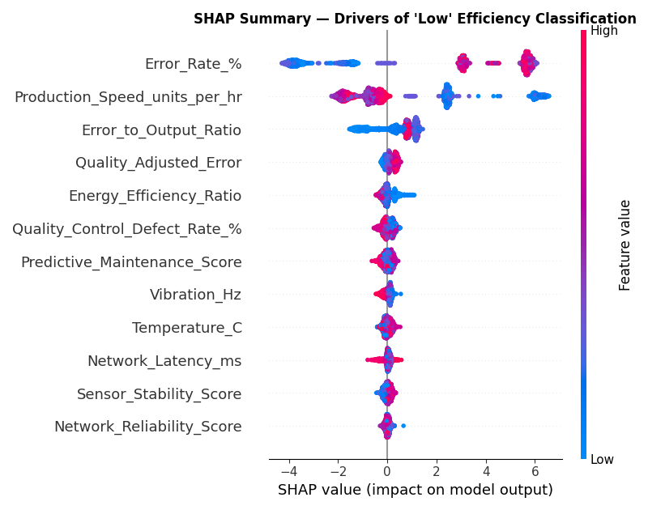
Figure 12. SHAP summary (beeswarm) plot for the 'Low' efficiency class — each point is one record; color indicates the feature's value, position indicates its pull toward or away from a Low prediction.

8.3 Why Efficiency Drops or Improves — Local Explanations
Beyond global importance, the dashboard's Explainability Panel exposes per-record local explanations: for any selected machine reading, engineers can see the logged status, the model's prediction and confidence, and a direct comparison of that record's Error_Rate_%, Production_Speed_units_per_hr, and related metrics against the fleet-wide average, with plain-language flags when a configurable sensitivity threshold is breached (e.g., "Error Rate exceeds your alert threshold"). This turns a black-box classification into an auditable, engineer-actionable explanation.

9. Streamlit Web Application
The trained pipeline is operationalized as an interactive Streamlit dashboard (delivered as app/app.py) organized into four modules, matching the project's functional requirements:
- Efficiency Prediction Dashboard — live "what-if" classification via manual sensor sliders, per-class confidence bars, and a batch confidence histogram over the currently filtered data.
- Machine-Level Insights — per-machine daily efficiency trend lines, a Low-efficiency ranking chart, a machine × status heatmap, and a sortable summary table.
- Explainability Panel — global SHAP and tree-importance charts, a model-comparison toggle, and a record-level local-explanation lookup with sensitivity-threshold flags.
- Operational Monitoring View — efficiency mix by operation mode, a network/sensor/production impact comparison, network-reliability-by-status box plots, an at-risk record list, and a live model-performance summary table.
User-facing controls include a machine selector, an operation-mode dropdown, a time-window slider, a network-quality (reliability score) filter, and metric-sensitivity sliders for the Error Rate and Production Speed alert thresholds used throughout the app — directly satisfying the "User Capabilities" requirement of the project brief.

10. Key Insights and Recommendations

10.1 Key Insights
- Efficiency status is overwhelmingly explained by two operational metrics — Error Rate and Production Speed — not by ambient sensor or 6G network conditions in this dataset.
- The relationship is close to a deterministic threshold rule: Low efficiency whenever error rate exceeds 5% or throughput falls below 200 units/hr; High efficiency only when error rate is at most 2% and throughput is at least 400 units/hr.
- Efficiency is uniformly distributed across the 50-machine fleet and across operation modes — there is no single rogue machine or mode driving the Low-efficiency rate, which points to a systemic, process-level rather than equipment-level, opportunity for improvement.
- Tree-based, non-linear models (Random Forest, XGBoost) very substantially outperform a linear baseline, confirming the underlying efficiency logic is threshold-based rather than continuous.

10.2 Recommendations
- Prioritize real-time monitoring and alerting on Error_Rate_% and Production_Speed_units_per_hr specifically — these two signals carry almost all of the actionable information for efficiency management.
- Use the dashboard's configurable sensitivity thresholds to tune alert sensitivity per production line or per shift, rather than relying on a single fixed global threshold.
- Since the current dataset shows no meaningful efficiency difference by operation mode, avoid provisioning mode-specific efficiency policies until further data suggests otherwise; instead invest monitoring effort in the two dominant drivers.
- As new, live production data accrues, periodically retrain the model and re-run the EDA rule-discovery step (Section 4.2) — an evolving factory environment may shift which features carry the strongest signal over time.
- Deploy XGBoost as the default production model for its balance of accuracy, small footprint, and stable, well-calibrated probability outputs; retain the Random Forest as a benchmark and the Logistic Regression as an interpretable fallback.

11. Limitations and Future Work
- The near-perfect model accuracy reflects the specific structure of this dataset (Section 7.1); real-world efficiency labels are likely to be noisier, and performance should be re-validated on live production data before any operational rollout.
- The dataset spans roughly 69 days and 50 machines from a single facility; generalization to other plants, machine types, or longer time horizons has not been tested.
- SHAP values were computed on a representative 3,000-record sample for computational efficiency; a full-dataset SHAP run could be performed for a final production audit.
- Future work could incorporate sequence-aware models (e.g., recurrent or temporal-convolutional architectures) to capture degradation trends leading up to a Low-efficiency event, rather than classifying each reading independently.
- Integrating the classifier directly into factory control systems (as referenced in the original brief's Deployment Logic) would require latency, drift-monitoring, and fail-safe design work beyond the scope of this analytical prototype.

12. Conclusion
This project set out to move manufacturing efficiency assessment from retrospective dashboards to real-time, AI-driven classification. The resulting pipeline — spanning EDA, feature engineering, three benchmarked models, SHAP-based explainability, and an operational Streamlit dashboard — delivers exactly that, while surfacing a clear, evidence-backed insight: efficiency in this smart factory is governed chiefly by error rate and production throughput, not by the sensor and network telemetry that a traditional monitoring approach might over-index on. That insight, together with the deployed dashboard, gives Thales Group's manufacturing and government stakeholders both the tool and the operational focus needed to react to efficiency changes as they happen, forming a concrete building block toward autonomous, intelligent factories.
— End of Research Paper —

