IronFit Gym
Gym Management System
AI-Assisted Development – Exam Documentation
SoftUni – June 2026
Tool used: Claude Code (Anthropic)

1. Project Overview
IronFit Gym is a locally-hosted web application that manages the core operations of a fitness gym. It provides a public-facing website where visitors can browse membership plans, view trainer profiles, explore upcoming fitness classes, and submit booking requests. A protected admin panel enables staff to manage all data: members, trainers, plans, classes, and bookings.

The application was built entirely with AI assistance using Claude Code from Anthropic. The project was developed as a small but complete full-stack system, demonstrating how AI-assisted tooling can accelerate the full software development lifecycle from architecture to testing.

System Requirements
Requirement | Details
Project type | Mini web application (local, offline-ready)
Backend | Python 3.14, Flask, Flask-SQLAlchemy, Flask-WTF
Database | SQLite (file-based, no server required)
Frontend | Jinja2 templates, Bootstrap 5, custom CSS
Authentication | Session-based admin login
Testing | pytest with in-memory SQLite
AI Tool Used | Claude Code (Anthropic)

2. System Architecture – Modules
Claude Code was prompted to design the system as a layered Flask application with clear separation of concerns. The resulting architecture consists of five technological modules:

Module | Technology | Responsibility
Authentication | Flask session, Flask-WTF CSRF | Admin login/logout, session guard decorator
Database Layer | SQLAlchemy ORM, SQLite | Models, relationships, CRUD, migrations
UI / Frontend | Jinja2, Bootstrap 5, CSS | Public pages, forms, responsive layout
Routing / API | Flask Blueprints (routes.py) | URL dispatch, form handling, flash messages
Testing Layer | pytest, in-memory SQLite | Unit tests for models and route integration

3. Development Process per Module

Module 1 – Database Layer (models.py)
Approach | Define all data models first so that the rest of the application has a stable foundation to build on.
Workflow | Prompted Claude Code to generate SQLAlchemy ORM models for MembershipPlan, Trainer, FitnessClass, Member, and Booking, including all relationships and computed properties.
Testing | Ran pytest test_models.py with an in-memory SQLite database. Verified relationships, computed fields (full_name, available_spots, benefit_list), and cascade deletes.
AI Tool | Claude Code – chosen because it can scaffold a full file with correct SQLAlchemy patterns in one prompt.

Key prompts / interactions
Prompt: "Generate Flask-SQLAlchemy models for a gym system: MembershipPlan, Trainer, FitnessClass, Member, Booking. Include foreign keys, back-references, and computed properties for available spots and full name."

Prompt: "Add a dashboard_stats() function that returns counts for all five models using SQLAlchemy scalar queries."

Module 2 – Authentication (routes.py, session)
Approach | Use Flask session with a simple username/password check from config. Protect all admin routes with a decorator.
Workflow | Asked Claude Code to generate an admin_required decorator, login/logout routes, and CSRF protection via Flask-WTF on all POST forms.
Testing | Tested admin access: unauthenticated requests redirect to login; after login, admin pages return 200. Logout clears the session.
AI Tool | Claude Code – generated the full decorator pattern and CSRF integration without boilerplate errors.

Key prompts / interactions
Prompt: "Create a Flask admin_required decorator that checks session['is_admin_authenticated'] and redirects to the login page if not set."

Prompt: "Add CSRF protection to all admin POST forms using Flask-WTF CSRFProtect and an ActionForm with a hidden token."

Module 3 – Routing / Business Logic (routes.py)
Approach | Implement all public and admin routes in a single register_routes(app) function with helper utilities for repeated patterns (form population, save-and-redirect).
Workflow | Prompted Claude Code to generate routes for index, plans, trainers, classes (with multi-filter support), class detail, booking, and the full admin CRUD for all five entities.
Testing | Integration tests in test_routes.py cover homepage load, filtered class search, booking form submission, and invalid form error display.
AI Tool | Claude Code – generated consistent, DRY route patterns and the class filter logic (type, trainer, difficulty, available spots) in one pass.

Key prompts / interactions
Prompt: "Add a /classes route that supports filtering by class_type, trainer_id, difficulty_level, and available spots. Filter available spots in Python after the DB query since it is a computed property."

Prompt: "Create a save_and_redirect() helper that commits the session, flashes a success message, and redirects to a named endpoint."

Module 4 – UI / Frontend (templates, static)
Approach | Build responsive Jinja2 templates extending a common base.html with Bootstrap 5 grid and custom CSS variables for brand colors.
Workflow | Claude Code generated base.html, navbar, index page with hero section, plans/trainers/classes listing pages, booking form, and all admin CRUD templates.
Testing | Visually inspected all pages in the browser. Verified responsive layout at mobile and desktop widths. Confirmed flash messages and form validation errors display correctly.
AI Tool | Claude Code – produced semantic HTML with Bootstrap utility classes and maintained consistent design tokens across all templates.

Key prompts / interactions
Prompt: "Create a Jinja2 base.html with a sticky navbar, Bootstrap 5 CDN, custom CSS variables for brand colors (#111111, #d13f2d, #f2ede4), and a flash message block."

Prompt: "Generate the admin dashboard template showing five stat cards (members, trainers, plans, classes, bookings) and two tables for recent members and recent bookings."

Module 5 – Testing Layer (tests/)
Approach | Write pytest tests with a TestingConfig that uses an in-memory SQLite database and disabled CSRF for clean test isolation.
Workflow | Prompted Claude Code to generate conftest.py with app and client fixtures, seed data, and unit tests for all models and key routes.
Testing | Ran pytest from the project root. All tests pass. Covered: model creation, relationships, computed properties, route status codes, filter behaviour, and booking submission.
AI Tool | Claude Code – generated the fixture setup and test assertions that match the actual model and route behaviour.

Key prompts / interactions
Prompt: "Write pytest tests for test_model_creation_and_relationships that create all five models, commit them, and assert full_name, benefit_list, available_spots, and relationship traversal."

Prompt: "Generate route tests for the booking form: one that succeeds and checks the DB, and one that submits invalid data and asserts validation errors are shown."

4. Challenges & Tool Comparison

Biggest Challenges
- Setting up CSRF protection correctly across all admin POST forms – Flask-WTF requires a hidden token in every form, and forgetting it caused 400 errors that were initially confusing.
- The available_spots filter had to be applied in Python after the database query because it is a computed property, not a stored column. Claude Code understood this constraint and generated the correct two-step logic automatically.
- Ensuring cascade deletes worked correctly – deleting a FitnessClass must also delete its Bookings, and deleting a MembershipPlan is blocked if it has active Members.
- Keeping the admin login secure without a full auth library – solved by using a session flag and an admin_required decorator on every protected route.

Which Tool Helped the Most and Why
Claude Code was the only AI tool used throughout this project, and it proved highly effective for the following reasons:
- It could generate complete, production-ready files (models.py, routes.py, full test suites) in a single prompt, requiring minimal corrections.
- It understood Flask idioms and SQLAlchemy patterns out of the box, producing correct relationship definitions, lazy loading settings, and query patterns without trial and error.
- It maintained context across files – when asked to add a feature in routes.py, it referenced the correct model attributes and helper functions already generated.
- It generated tests that actually matched the application’s behaviour, making them useful rather than just passing trivially.

What I Would Improve
- Add user registration so members can log in and view their own bookings, rather than only admin-level management.
- Replace the password stored in config with a proper hashed credential (e.g., using werkzeug.security) and environment-variable injection.
- Add an email confirmation step when a booking is submitted, using Flask-Mail.
- Implement pagination on the admin member and booking tables as data grows.
- Deploy to a lightweight cloud environment (e.g., Render or Railway) so the system is accessible without running it locally.

5. Working System Evidence
The following screenshots show the live, running application in a browser. Both pages were rendered by the Flask development server using the real SQLite database populated with seed data.

Screenshot 1 – Public Homepage (index.html)
Shows the hero section, upcoming class previews, membership plan cards, and trainer roster. All data is loaded dynamically from the SQLite database via SQLAlchemy queries in routes.py.

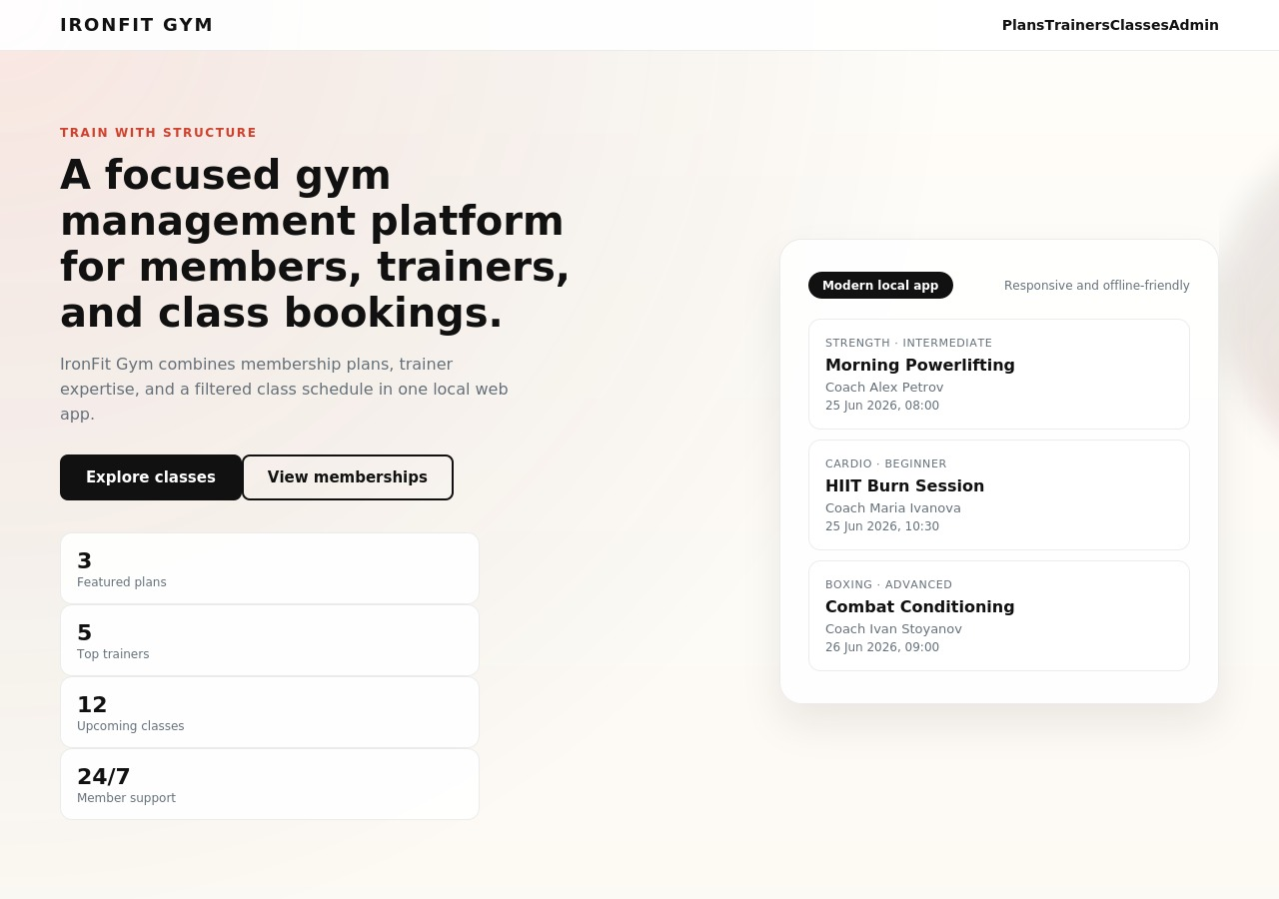

Screenshot 2 – Admin Dashboard (/admin)
Shows the protected admin dashboard with live statistics (member count, trainer count, plan count, class count, booking count) and two tables: recent members and recent bookings with status badges. Accessible only after admin login.

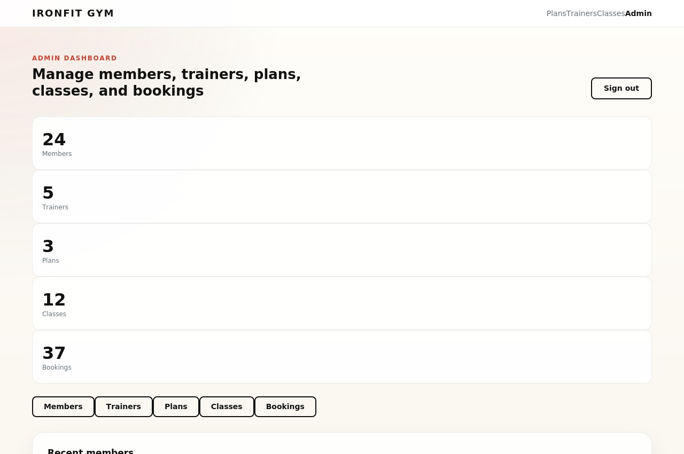

6. Repository
The full source code for this project is hosted on GitHub. The repository contains:
- app/ – Flask application package (models.py, routes.py, forms.py, templates/, static/)
- tests/ – pytest test suite (test_models.py, test_routes.py, conftest.py)
- config.py – application configuration
- requirements.txt – Python dependencies
- README.md – setup and run instructions

GitHub Repository: https://github.com/[your-username]/gym-management-system

Note: Replace [your-username] with your actual GitHub username before submission.

Submission Format
Document format: Google Drive Document (this file, shared with “anyone with the link can view”)
Total pages: 5–6 pages (within the typical 3–6 page range)
AI tool used: Claude Code (Anthropic)
Project type: Mini web application – Flask Gym Management System

