Pedro Câmara

Technical Game Designer Test

**Playing Instructions**

* Use Unity Version 2019.3.10
* The game’s control scheme currently only works with Oculus Rift/ Oculus Rift S.
* Please try to position your body always on top of the circular shadow on the floor, so collision will work correctly.

**Summary**

**Mystical Sands** is set in a fictional and magical version of Chaldea, in the 6th century BCE. At that time, babylonian magic was being rediscovered when King Nabonidus decided to restore old temples from ancient Babylonia. The priests, however, were the only ones to get their hands on such magic. Or so they thought. It was rare, but some people could also practice magic. They were known as kassapu, or sorcerers, and being one was a crime punishable by death.

Our protagonist is **Amytis**, a sorceress who stumbled upon a text that taught her how to manipulate sand and stone. She was caught using her magic and had to flee but her father was captured by the priests. Her only chance of getting her father back was finding relics to learn more about magic so she could become strong enough to face the priests. **The level I showcase here is a fictional Ziggurat created for the worship of Nabu, the god of knowledge.** The location features not only an example of chaldean and babylonian architecture, but also the desertic region in which the ziggurat is located.

The ziggurat is protected by golems on the outside and on the stairs, who patrol the area in search of invaders. In the main hall of the ziggurat there are also priests, who are gathered there performing a ritual. **For the player, the place works as a fortress where an incantation bowl is hidden in a chamber at the top of the ziggurat.** The incantation bowl is a relic that expands the magic of the player, making Amytis a more powerful sorceress.

**Architectural References:** Ziggurat of Ur and Alamut Castle

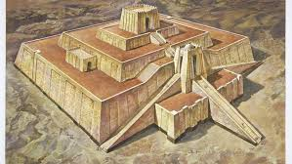 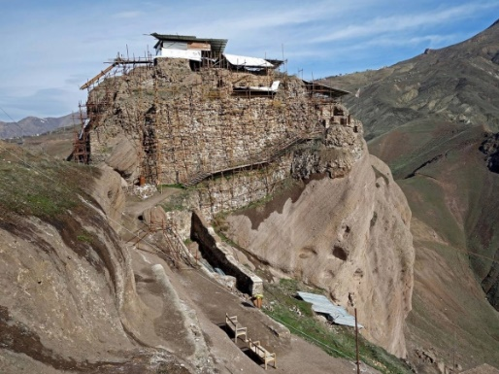

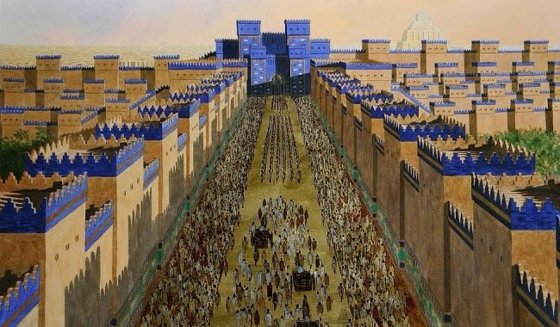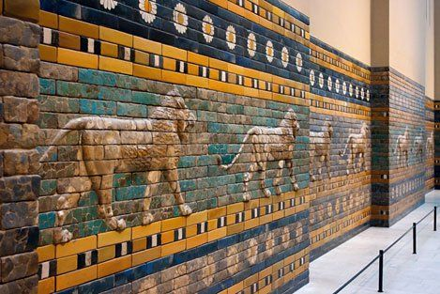**Chromatic References**

**Gameplay**

**Process**

* Since I am primarily aiming for the Technical Game Designer role, I decided to make the game VR-based and focus on finding a mechanic that would be fun to use for locomotion.
* I started the whole process by brainstorming mechanics. My selection criteria was something that would 1) be easy to prototype and implement; 2) make transversal fun in a 3D environment; 3) add depth to the stablished stealth and combat mechanics.
* The babylonian setting came as a result of the “magical” gameplay and necessity of an abundance of fragile materials (sand­) and strong materials (stone).

**Main Mechanic: Alchemy Pillar**

* This mechanic replaces jumping and climbing from traditional action games with a vertical movement scheme that is comfortable for VR users.
* It is useful for vertical and horizontal transversal but also combat (pushing enemies to their death or crushing them), stealth (hiding behind walls) and puzzle-solving.
* Aim any hand at any **mineral** surface (e.g. not wood) and hold the Oculus Trigger button to create an alchemy pillar.
* Keep holding the button and use your hand movement to control its extrusion. It’s possible to move around while you do it.
* The player can do this at anytime (does not consume mana) but there’s a limit of **3 pillars at the same time**. (not implemented)
* If enemies see pillars being created they become alert and immediately try to find the player. Human enemies are more intelligent and become alert just by seeing a pillar that wasn’t there before.
* When the player is riding the pillar, it grows with **constant speed** instead, to avoid causing motion sickness (not implemented)

**Level design ingredients:**

* **Stone terrain:** Stone pillars created here can be extended for up to 3m instead of the usual 1m. They also hit enemies harder and faster than sand pillars.
  + From a LD standpoint it is used to control which paths the player can take to ascend to higher ground.
* **Brimstone terrain:** Stone pillars created here can be extended for up to 7m, but **can only be used once**. They hit enemies harder and faster than stone pillars.
  + Use it to add a factor of resource management to stealth segments. Think of this as how an “explosive barrel” adds strategy options in an FPS. Must be somewhat rare, at most 3 per room.

**Debug**

* Press the right analog stick to toggle debug movement mode. While in this mode, aim with your head and use the analog stick to fly around the scene. Button “A” switches between different speed values.

**Metrics**

**Process**

* I researched easy 3D level design tools and found Unity’s ProBuilder. I decided to use it and played around a little bit to get familiarized with it.
* I used a separate scene (the same I used to test the mechanics) to take measurements and create modules.
* At first there was a jump mechanic, I took measurements of the jump length, but it was discarded because, ideally, the pillar mechanic would replace the need for jumping.
* I took notes of minimum passage narrowness (to avoid claustrophobia) and slope angles (based on VR comfort and architectural references).
* Alchemy pillar heights were tested in different situations to determine pillar height:
  + A **1m** sand pillar is enough to create a cover for defense;
  + **3m** was considered a good height to drop and kill enemies, so It was used as the height of most obstacles, “climbing” segments and also the Stone pillar itself. Since these pillars are also used to knock down enemies from staircases, this also became the standard width for elevated platforms and staircases.
  + The Brimstone pillar is **7m** high because it can be used to escape to elevated safe locations.
* 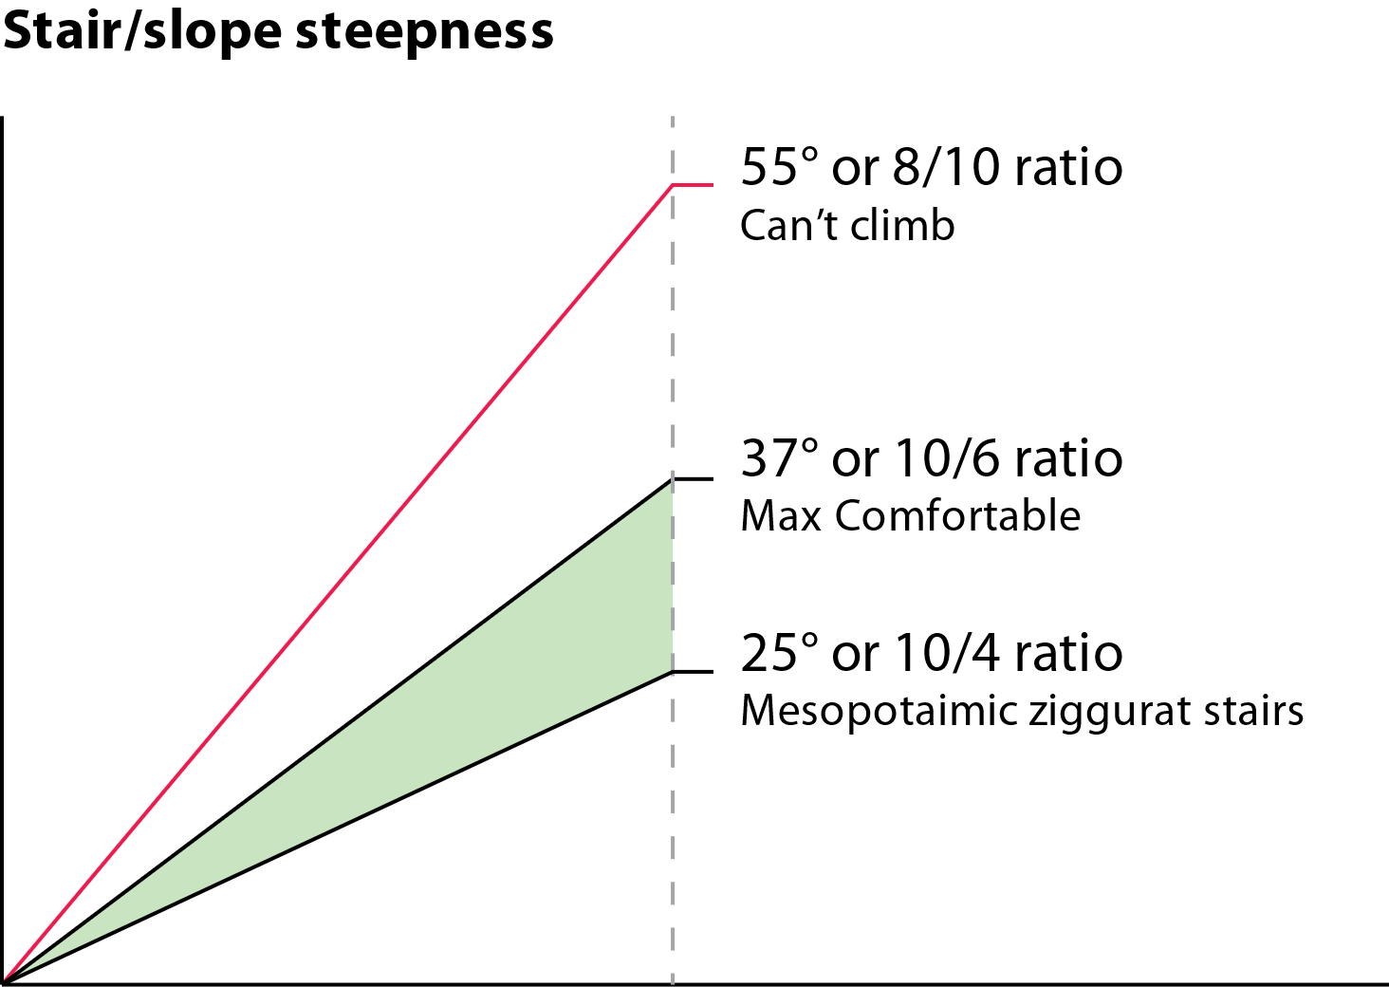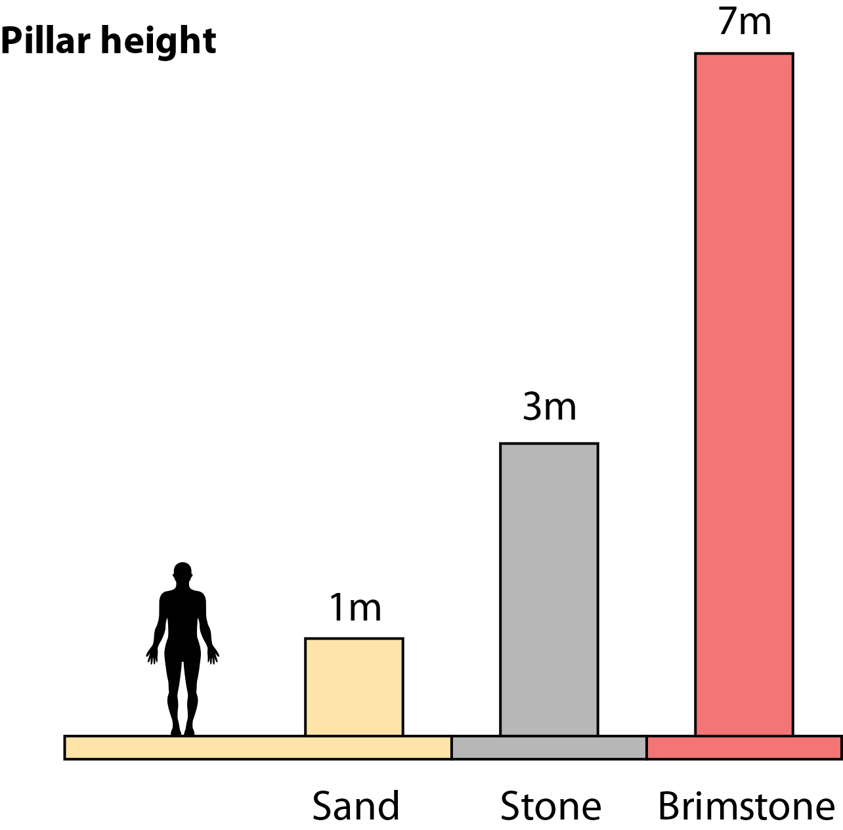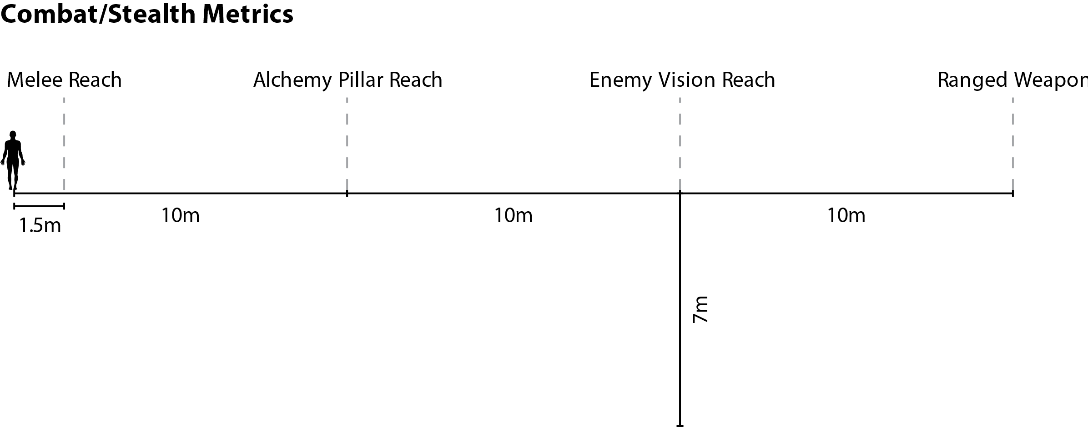Max distance for casting the alchemy pillar was set to 10 to ensure player has to get inside enemy vision reach to use it.

**Map**

**Process**

* First, I created a graph of the “macro”-level design, representing different areas of the level, how they relate to each other and which playstyles they encourage.
* Since the game is open-world, I decided to make a building with multiple entrances and one main objective. To simplify, I decided to not include side-objectives:

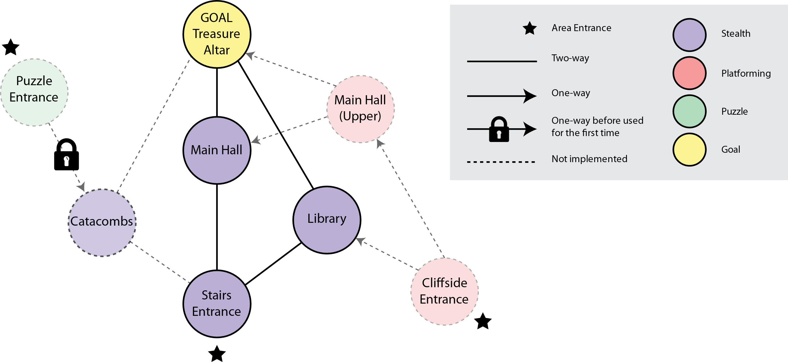

* I sketched the temple creating a geographical layout of the above flow and giving context to those areas, and also concepting what would make each area unique (see sketches in the end of the document):
  + **Stairs Entrance:** Focused on climbing mezzanines without being seen
  + **Puzzle Entrance:** A secret entrance by the side of the ruins activated with alchemy. The underground puzzle room would be based on activating pressure switches.
  + **Cliffside Entrance:** Platforming-focused, player uses pillars as bridges to reach an opening in the ceiling and traversing the top part of all rooms by walking on structural beams.
  + **Catacombs:** Stealth segment with many iron grates, which makes you easily spotted but also create opportunities for “crushing” enemies by using alchemy on the other side of the grate.
  + **Library:** Stealth-segment based on climbing shelves and dropping to kill enemies.
  + **Main Hall:** Stealth segment based on the brimstone mechanic.
  + **Altar:** Where your goal is.
* Due to time constraints I decided to choose a single path in the level flow and implement it. I sketched a few of these areas and chose the simplest one: **Stairs -> Library -> Altar.** For this reason, the **catacombs** and **cliffside** paths were left out of the game.
* I made rough blocks of the important areas that the player would see (including the Main Hall) testing the scale in VR and fine-tuning based on travel distances, composition and general feeling of each room.
* Next, I blocked the chosen areas on gameplay-level, creating opportunities for using the main mechanics, taking into consideration the stealth and action elements of the game.
* I playtested each room several times and iterated through them ensuring they had more than one approach and that the player made use the game’s main mechanic several times in each room.

**Walkthrough**

* **Stairs Entrance**
  + First, the player has to climb the Ziggurat stairs. They can dispose of golem guards by pushing them out of stairs while avoiding being seen, but they can also do a “pacifist” route focused on transversal by using stone pillars to climbing the mezzanines.
  + When reaching the top, the player enters the door and finds themselves at the Main Hall’s entrance.
* **Main Hall / Nave**
  + The player must drop and take the door below the staircase. There is an opportunity to kill a priest by dropping on top of them.
* **Library**
  + The player must traverse the library populated by priests.
  + The level layout creates opportunities for sneaking past enemies, crushing them on the walls or climbing bookshelves to drop and kill them.
  + When reaching the staircase, the player has the option of crushing the golem and climbing it or climbing the mezzanine by using stone pillars as a bridge from the top of the bookshelves.
* **Way Back**
  + The player goes through the same rooms in reverse order.
  + With side-missions (such as finding collectables), players would be encouraged to explore the temple by taking routes they didn’t go through in the way in.

**Top-down view**

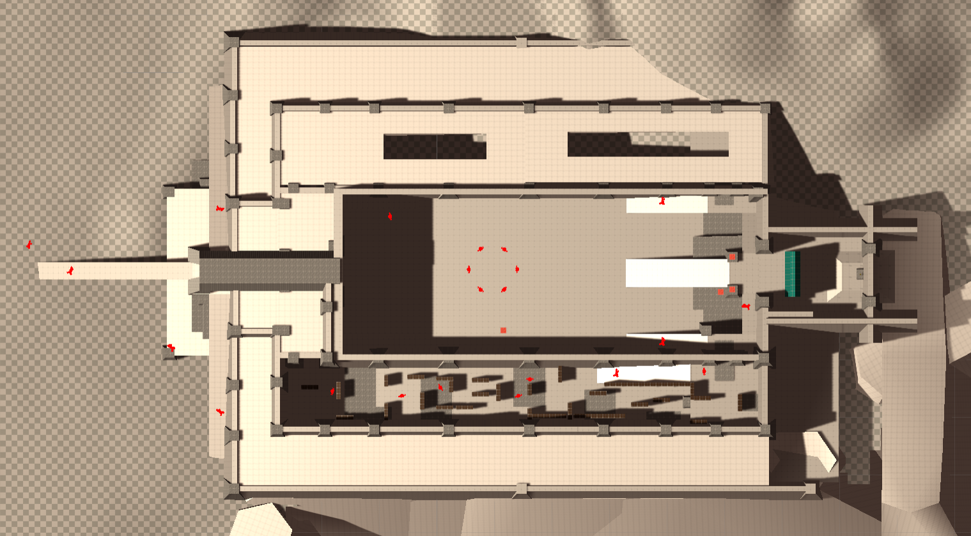

**Sketches**

**Brainstorming**

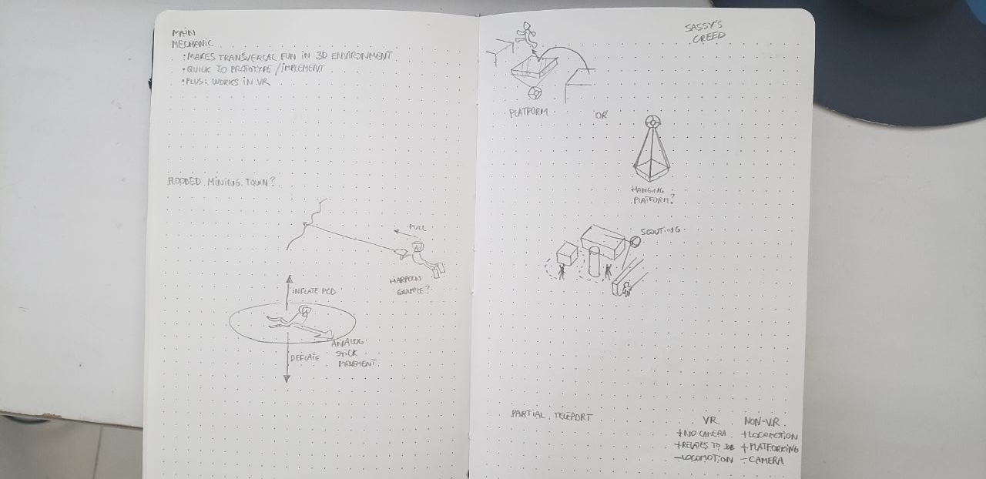

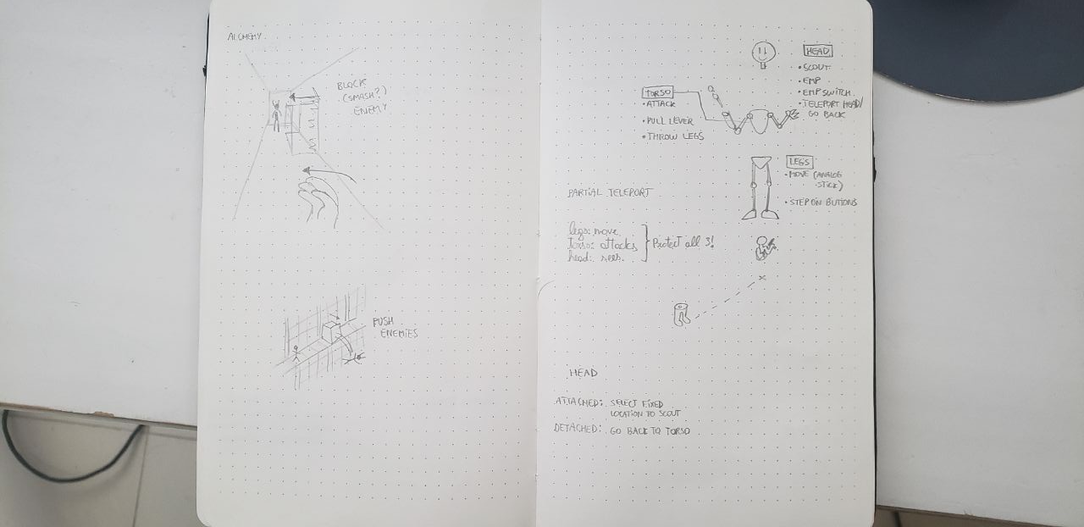

**Level Flow**

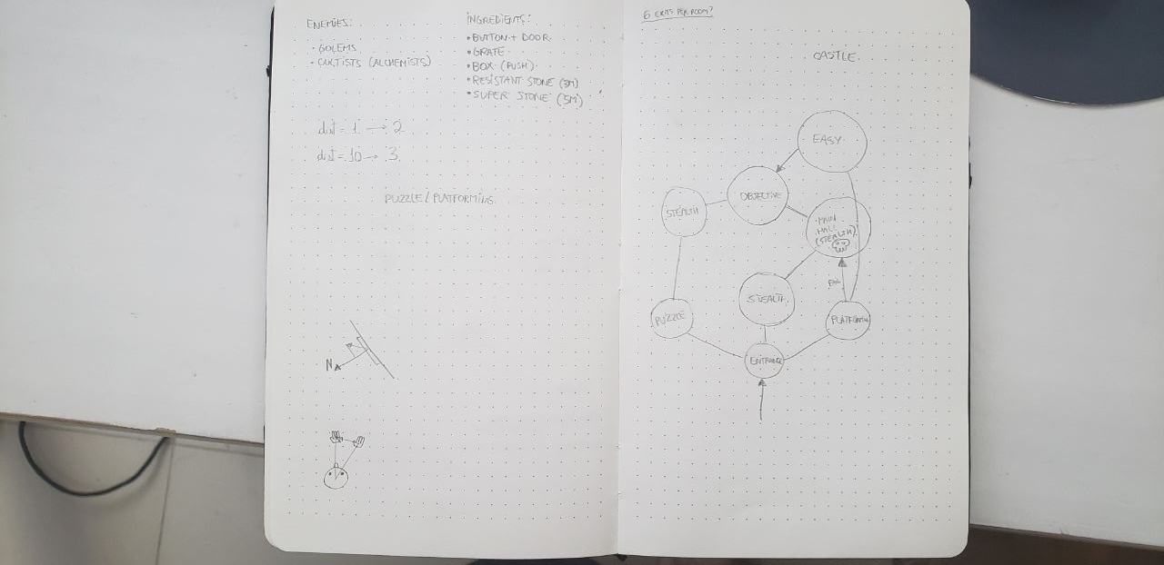

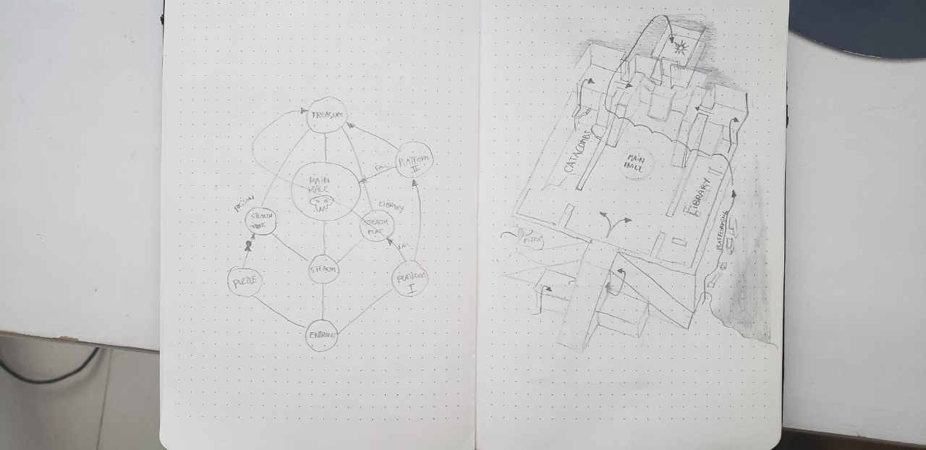

**Room Design**

