**Splunk**

**TCP Connection**

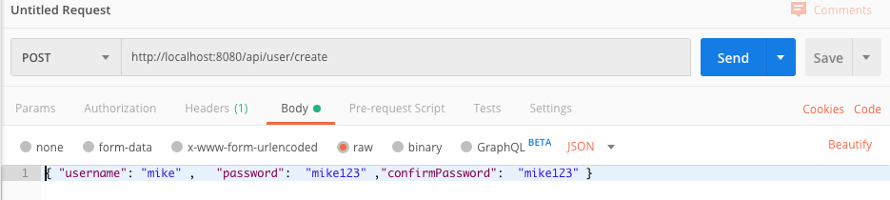

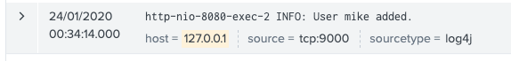

Search User with non existing id (3)

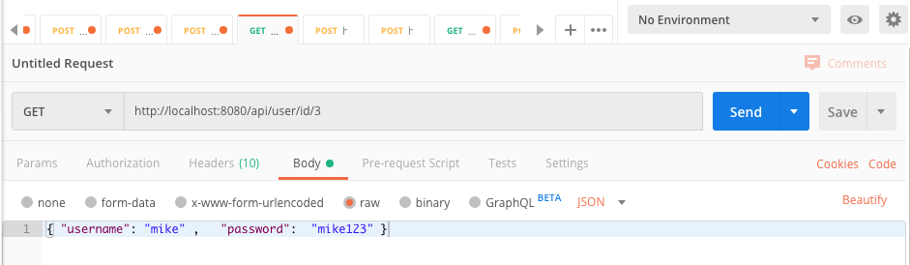

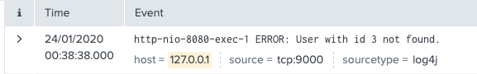

Creating user with wrong password size

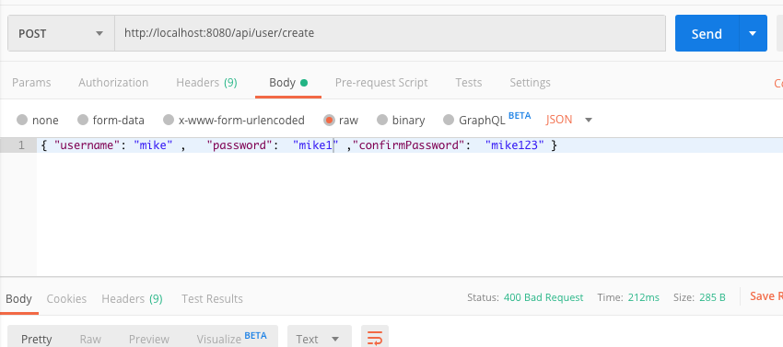

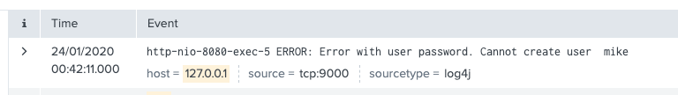

Order submitted

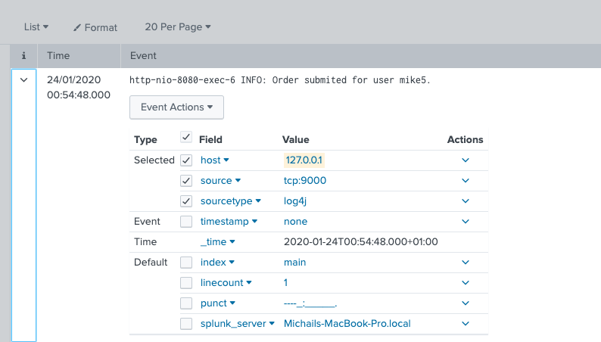

Order Failure

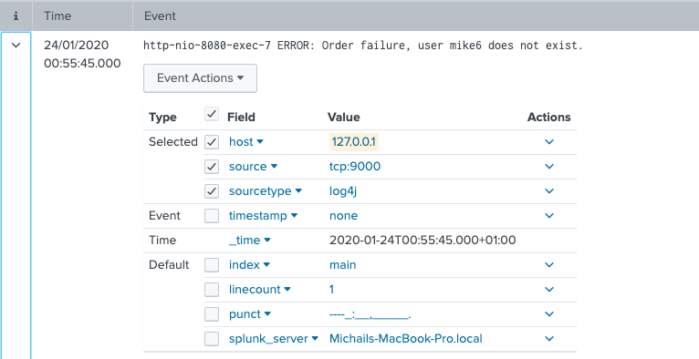

Indexed Logs in Splunk

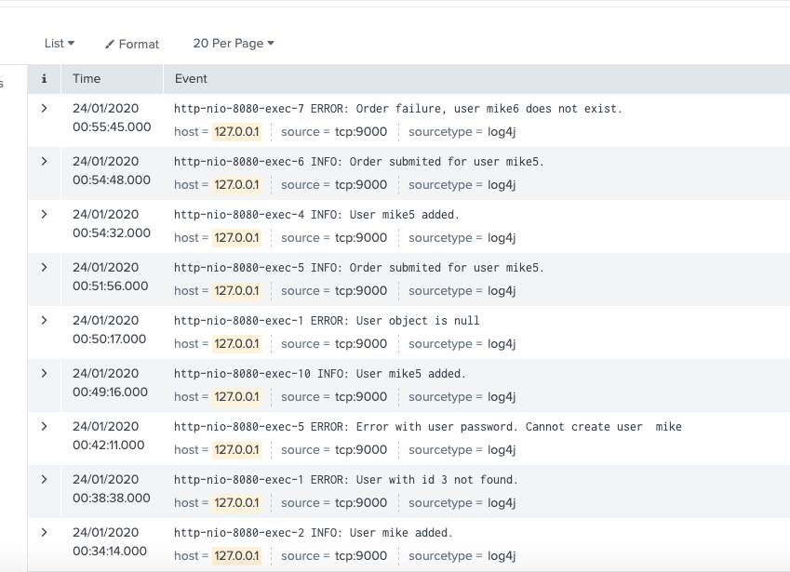

Alerts

success rate per minute of CreateUser

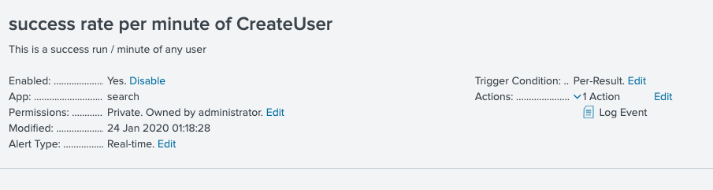

success

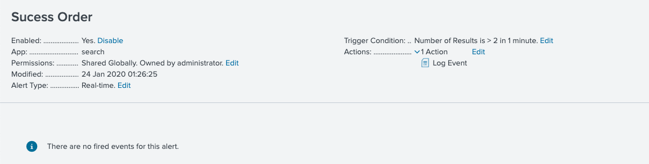

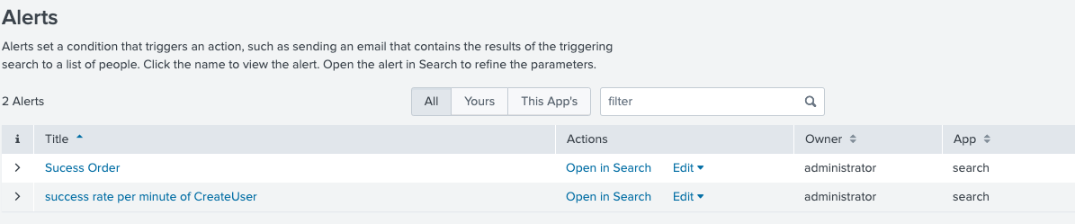

Dashboard

