**BACKPAC METHOD (Schema and data)**

https://www.youtube.com/watch?v=rXLQUn-IOGg

Use this setting in Database settings

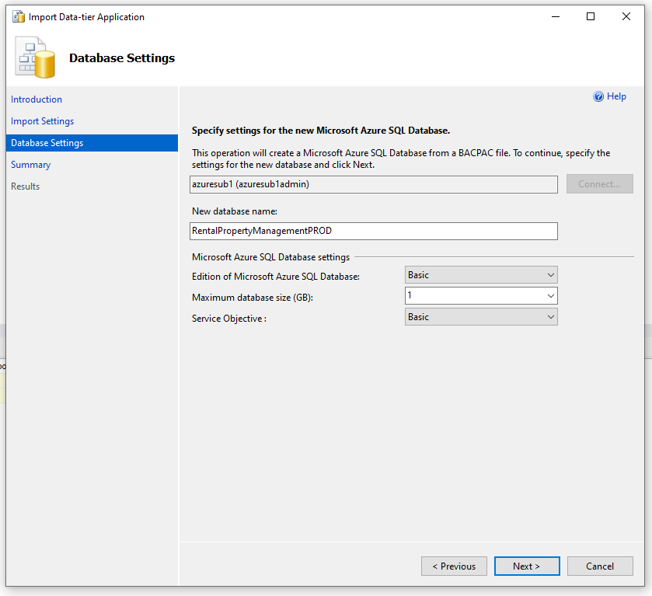

**DACPAC METHOD (Schema only)**

1. Right click source database > Task > Extract Data Tier Application
2. Follow steps to save a .dacpac file.
3. Right click target database > Task > Upgrade Data Tier Application
4. Follow steps to do the update.