Follow the instructions below for setup and execution

* Open visual studo code and copy the following files in the cypress/integration folder

AccountCreationWithGmail.js

CreateAccount.js

DatadrivenLogin.js

ProductManagement.js

ValidateFields.js

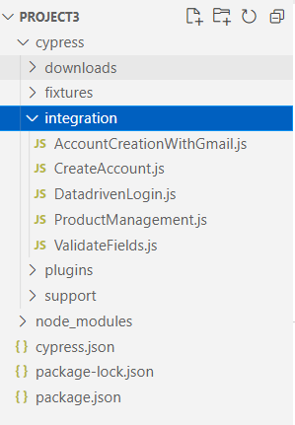

* Copy the example.json (with test data in it in the fixture folder)

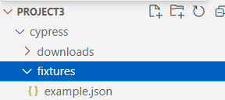

* To run the test case and write command npx cypress open

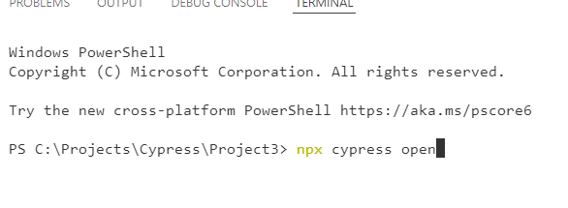

* Following runner will be displayed

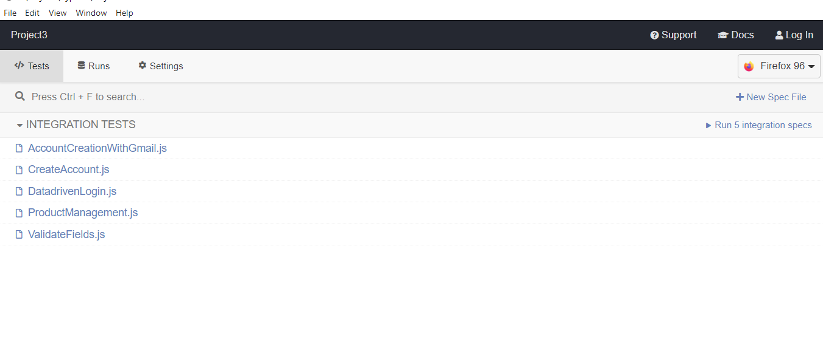

* Run selected test cases run all