Follow the steps below for test execution

1. Open Eclipse IDE
2. Go to Help -> Eclipse Market Place

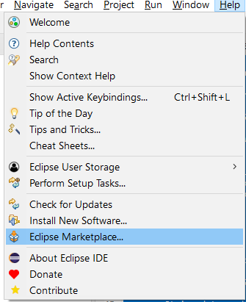

1. Search and Install TestNG

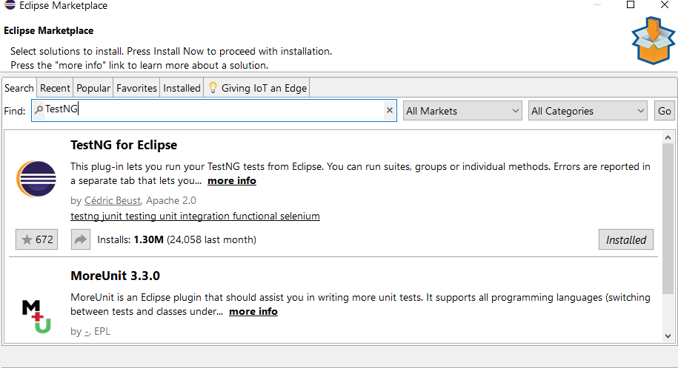

1. Create a project named MyAutomation Test
2. Download Selenium JAVA bindings from

<https://www.selenium.dev/downloads/> and add to ClassPath by using Add External Jar option

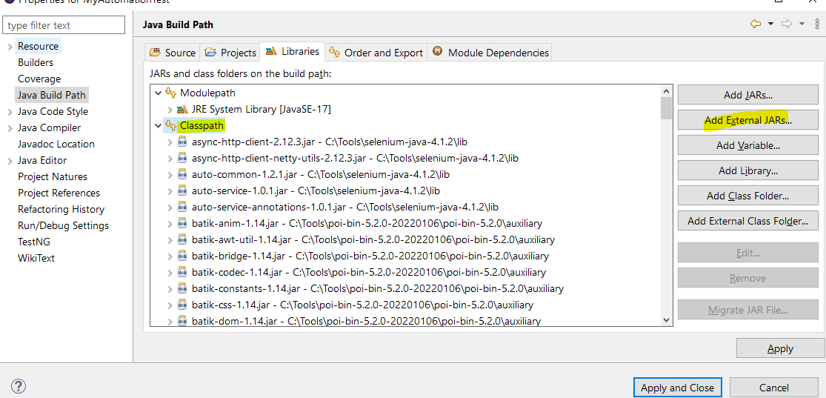

1. Click Apply and Close
2. Create the following folder structure and copy the code for the files
   1. ExcelDataConf.java
   2. LoginPage.java
   3. MainTest.java
3. Copy the values of testdata in TestData.xlsx
4. To run the tests, right click on MainTest.java and select Run as TestNG Test

