433模块串口发送
2026年9月9日
20:25

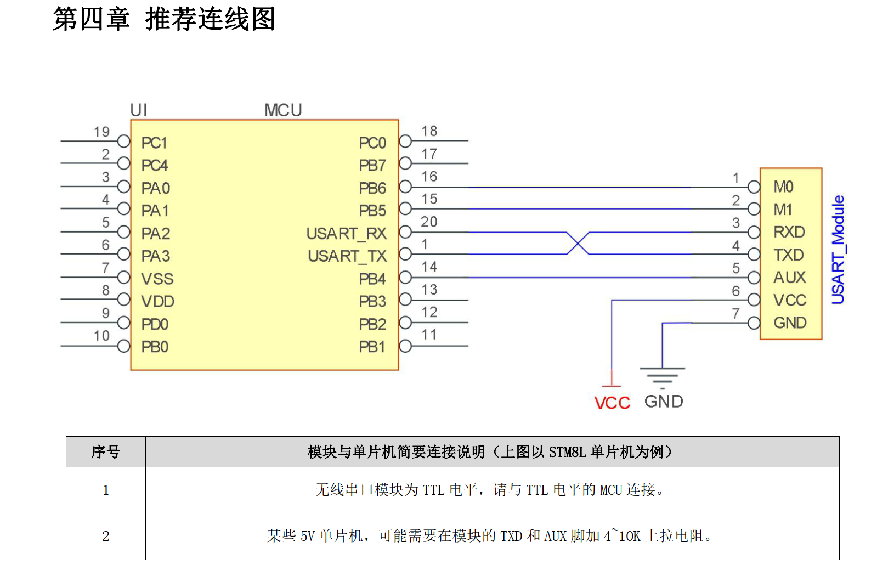

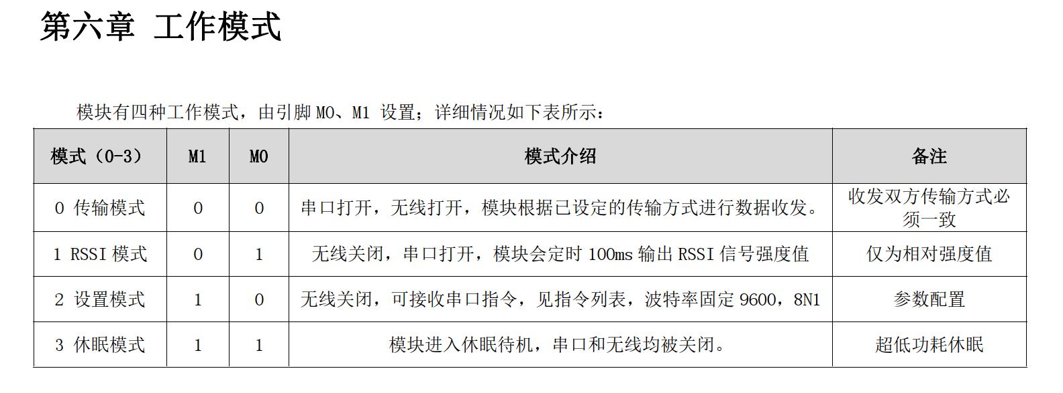

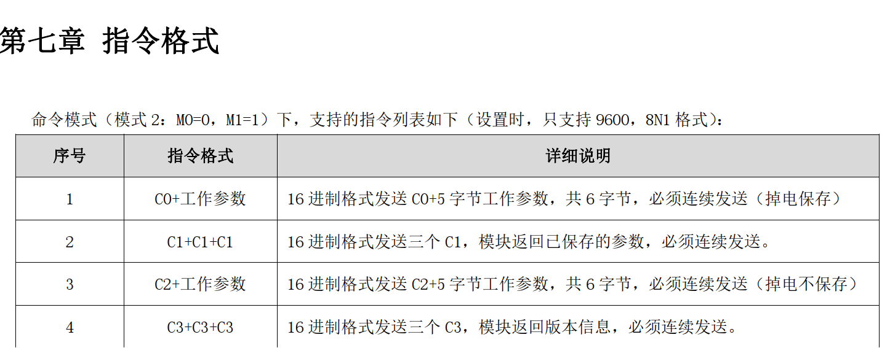

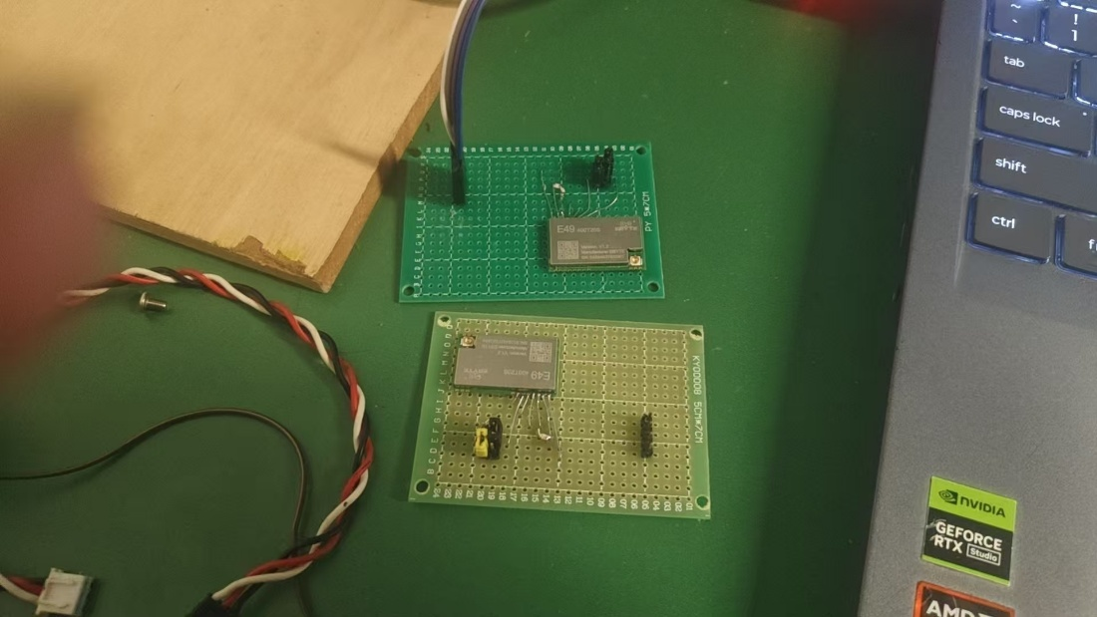
自制的测试架,通过跳线控制m0和m1

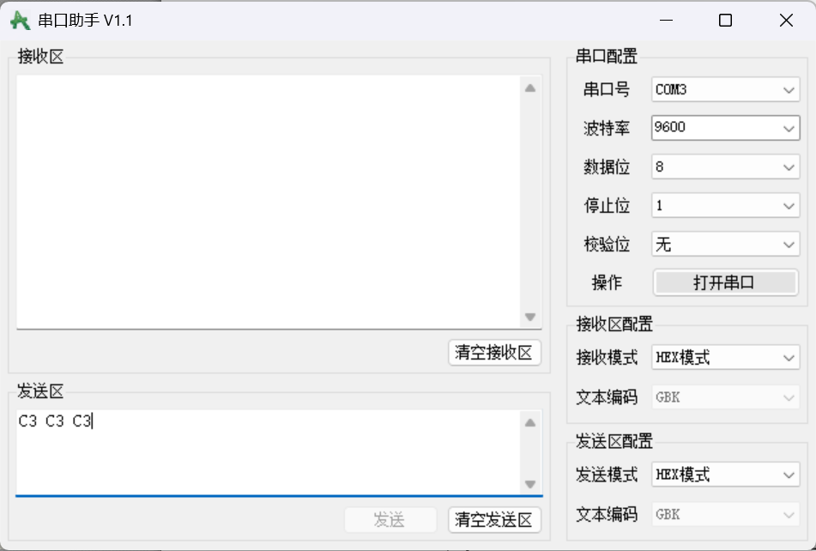

这样可以发送3个C3

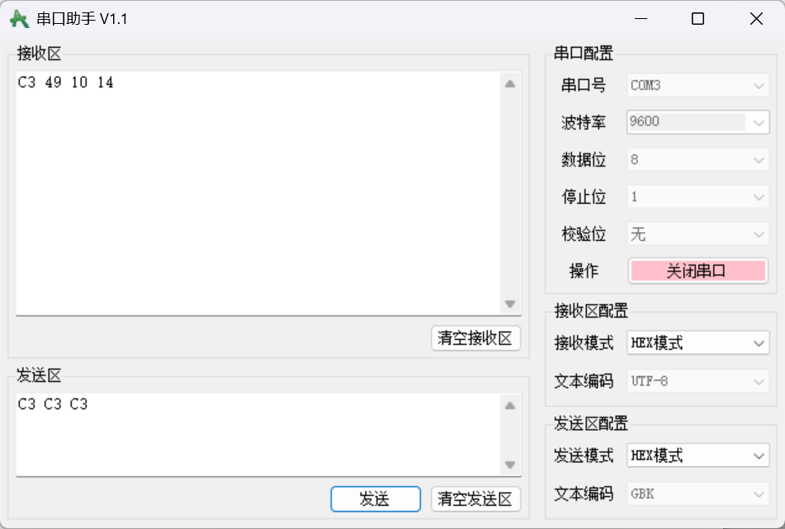
回报大概长这样

关于参数读取

后面我写了个上位机软件
文件在这
<<E49_400T20S_上位机.py>>

上位机的python打包命令
pyinstaller -F -w E49_400T20S_上位机.py
现在把两个模块都改成：
- 地址：31A7
- UART：9600 bps
- 空中速率：2.4 kbps
- 频率：434.5 MHz
- 透明传输
- 功率：20 dBm
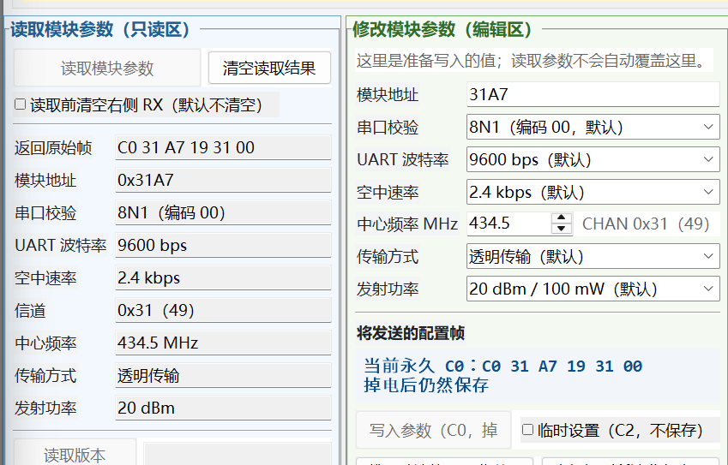
# -*- coding: utf-8 -*-
"""
E49-400T20S 专用串口上位机（单文件版）

运行：
python E49_400T20S_上位机.py

依赖：
python -m pip install pyserial

离线协议自测：
python E49_400T20S_上位机.py --self-test

普通 USB-UART 不能控制模块 M0/M1：
参数读取/修改：M1=1、M0=0，本机串口固定 9600 8N1
透传数据收发：M1=0、M0=0，本机串口使用模块配置的 UART 参数
"""

from __future__ import annotations

import argparse
import ctypes
import re
import sys
import time
from dataclasses import dataclass, field
from datetime import datetime
from typing import Any, Dict, List, Optional, Sequence, Tuple

import tkinter as tk
from tkinter import messagebox, scrolledtext, ttk

try:
import serial # type: ignore
from serial.tools import list_ports # type: ignore

SERIAL_AVAILABLE = hasattr(serial, "Serial")
SERIAL_IMPORT_ERROR: Optional[BaseException] = None
except BaseException as exc:
serial = None # type: ignore
list_ports = None # type: ignore
SERIAL_AVAILABLE = False
SERIAL_IMPORT_ERROR = exc

APP_NAME = "E49-400T20S 参数与透传工具"
APP_VERSION = "2.1.0"

READ_PARAMETERS_COMMAND = b"\xC1\xC1\xC1"
READ_VERSION_COMMAND = b"\xC3\xC3\xC3"

BG = "#F3F4F6"
PANEL = "#FFFFFF"
TEXT = "#202124"
MUTED = "#61666D"
BLUE = "#1769AA"
BLUE_DARK = "#0D4F84"
GREEN = "#177245"
ORANGE = "#A85B00"
RED = "#B3261E"
NOTICE_BG = "#FFF4CE"
NOTICE_FG = "#7A4B00"
READ_BG = "#F2F8FD"
READ_BORDER = "#6E9FC8"
EDIT_BG = "#F4FAF1"
EDIT_BORDER = "#76A66A"
DATA_BG = "#FFF8EE"
DATA_BORDER = "#C9914C"

PARITY_CHOICES: List[Tuple[str, int, str]] = [
("8N1（编码 00，默认）", 0, "N"),
("8O1（编码 01）", 1, "O"),
("8E1（编码 10）", 2, "E"),
("8N1（编码 11）", 3, "N"),
]

UART_CHOICES: List[Tuple[str, int, int]] = [
("1200 bps", 0, 1200),
("2400 bps", 1, 2400),
("4800 bps", 2, 4800),
("9600 bps（默认）", 3, 9600),
("19200 bps", 4, 19200),
("38400 bps", 5, 38400),
("57600 bps", 6, 57600),
("115200 bps", 7, 115200),
]

AIR_CHOICES: List[Tuple[str, int, int]] = [
("1.2 kbps", 0, 1200),
("2.4 kbps（默认）", 1, 2400),
("4.8 kbps", 2, 4800),
("9.6 kbps", 3, 9600),
("19.2 kbps", 4, 19200),
("50 kbps", 5, 50000),
("100 kbps", 6, 100000),
("200 kbps", 7, 200000),
]

POWER_CHOICES: List[Tuple[str, int, int]] = [
("20 dBm / 100 mW（默认）", 0, 20),
("17 dBm", 1, 17),
("14 dBm", 2, 14),
("10 dBm", 3, 10),
]

TRANSFER_CHOICES: List[Tuple[str, bool]] = [
("透明传输（默认）", False),
("定点传输", True),
]

SERIAL_BAUD_VALUES = [str(item[2]) for item in UART_CHOICES]
SERIAL_FORMAT_VALUES = ["8N1", "8O1", "8E1"]

def choice_by_code(choices: Sequence[Sequence[Any]], code: int) -> str:
for item in choices:
if int(item[1]) == code:
return str(item[0])
raise ValueError("未知编码：{}".format(code))

def code_by_choice(choices: Sequence[Sequence[Any]], label: str) -> int:
for item in choices:
if str(item[0]) == label:
return int(item[1])
raise ValueError("未知选项：{}".format(label))

def bool_by_choice(choices: Sequence[Sequence[Any]], label: str) -> bool:
for item in choices:
if str(item[0]) == label:
return bool(item[1])
raise ValueError("未知选项：{}".format(label))

def require_int(name: str, value: Any, minimum: int, maximum: int) -> int:
if isinstance(value, bool) or not isinstance(value, int):
raise ValueError("{}必须是整数".format(name))
if not minimum <= value <= maximum:
raise ValueError("{}必须在 {}~{} 之间".format(name, minimum, maximum))
return value

def parse_hex_bytes(text: str) -> bytes:
"""严格解析 HEX；支持空格、逗号、换行、0x 前缀和连续字节。"""
if not text or not text.strip():
raise ValueError("请输入要发送的 HEX 数据")
tokens = [part for part in re.split(r"[\s,;:_]+", text.strip()) if part]
chunks: List[str] = []
for token in tokens:
value = token[2:] if token.lower().startswith("0x") else token
if not value:
raise ValueError("0x 后面必须有十六进制数字")
if re.fullmatch(r"[0-9A-Fa-f]+", value) is None:
raise ValueError("非法 HEX 片段：{}".format(token))
if len(value) % 2:
raise ValueError("HEX 片段位数必须为偶数：{}".format(token))
chunks.append(value)
return bytes.fromhex("".join(chunks))

def parse_address(text: str) -> int:
value = text.strip().upper()
if value.startswith("0X"):
value = value[2:]
if not value or len(value) > 4 or re.search(r"[^0-9A-F]", value):
raise ValueError("地址应为 0000~FFFF 的 1~4 位十六进制数")
return int(value, 16)

def frequency_to_channel(value: Any) -> int:
try:
frequency = float(str(value).strip())
except ValueError as exc:
raise ValueError("频率必须是数字，例如 433.0") from exc
if not 410.0 <= frequency <= 510.0:
raise ValueError("频率范围必须是 410.0~510.0 MHz")
doubled = (frequency - 410.0) * 2.0
rounded = round(doubled)
if abs(doubled - rounded) > 1e-7:
raise ValueError("频率必须按 0.5 MHz 步进")
return int(rounded)

def channel_to_frequency(channel: int) -> float:
channel = require_int("信道", channel, 0, 0xC8)
return 410.0 + channel * 0.5

def hex_bytes(data: bytes) -> str:
return bytes(data).hex(" ").upper()

@dataclass(frozen=True)
class E49Config:
head: int
address: int
parity_code: int
uart_code: int
air_code: int
channel: int
fixed_mode: bool
power_code: int
reserved_bits: int = 0

@property
def uart_bps(self) -> int:
return UART_CHOICES[self.uart_code][2]

@property
def air_bps(self) -> int:
return AIR_CHOICES[self.air_code][2]

@property
def uart_format(self) -> str:
return PARITY_CHOICES[self.parity_code][0].split("（", 1)[0]

@property
def frequency_mhz(self) -> float:
return channel_to_frequency(self.channel)

@property
def power_dbm(self) -> int:
return POWER_CHOICES[self.power_code][2]

def to_frame(self) -> bytes:
sped = (
((self.parity_code & 0x03) << 6)
| ((self.uart_code & 0x07) << 3)
| (self.air_code & 0x07)
)
option = (
(0x80 if self.fixed_mode else 0x00)
| (self.reserved_bits & 0x7C)
| (self.power_code & 0x03)
)
return bytes(
[
self.head,
(self.address >> 8) & 0xFF,
self.address & 0xFF,
sped,
self.channel,
option,
]
)

def decode_config_frame(frame: bytes) -> E49Config:
frame = bytes(frame)
if len(frame) != 6:
raise ValueError("配置帧必须正好 6 字节")
head, addh, addl, sped, channel, option = frame
if head not in (0xC0, 0xC2):
raise ValueError("配置帧 HEAD 应为 C0 或 C2")
if channel > 0xC8:
raise ValueError("信道 0x{:02X} 超出 0x00~0xC8".format(channel))
return E49Config(
head=head,
address=(addh << 8) | addl,
parity_code=(sped >> 6) & 0x03,
uart_code=(sped >> 3) & 0x07,
air_code=sped & 0x07,
channel=channel,
fixed_mode=bool(option & 0x80),
power_code=option & 0x03,
reserved_bits=option & 0x7C,
)

def build_config_frame(
persistent: bool,
address: int,
parity_code: int,
uart_code: int,
air_code: int,
channel: int,
fixed_mode: bool,
power_code: int,
) -> bytes:
if not isinstance(persistent, bool):
raise ValueError("持久化标志必须是 bool")
if not isinstance(fixed_mode, bool):
raise ValueError("传输方式标志必须是 bool")
config = E49Config(
head=0xC0 if persistent else 0xC2,
address=require_int("地址", address, 0, 0xFFFF),
parity_code=require_int("串口校验编码", parity_code, 0, 3),
uart_code=require_int("UART 速率编码", uart_code, 0, 7),
air_code=require_int("空中速率编码", air_code, 0, 7),
channel=require_int("信道", channel, 0, 0xC8),
fixed_mode=fixed_mode,
power_code=require_int("功率编码", power_code, 0, 3),
)
return config.to_frame()

def decode_version_frame(frame: bytes) -> Tuple[int, int, int]:
frame = bytes(frame)
if len(frame) != 4 or frame[:2] != b"\xC3\x49":
raise ValueError("版本返回应为 C3 49 xx yy")
return frame[1], frame[2], frame[3]

@dataclass
class PendingRequest:
kind: str
signatures: Tuple[bytes, ...]
expected_len: int
deadline: float
buffer: bytearray = field(default_factory=bytearray)
discarded_count: int = 0
invalid_candidates: int = 0

class E49ToolApp:
POLL_INTERVAL_MS = 25
RESPONSE_TIMEOUT_SECONDS = 1.5
RX_FRAME_GAP_SECONDS = 0.030
MAX_READ_CHUNK = 4096
MAX_LOG_CHARS = 1_000_000

def __init__(self, root: tk.Tk) -> None:
self.root = root
self.ser: Any = None
self.pending: Optional[PendingRequest] = None
self.last_read_config: Optional[E49Config] = None
self.closing = False
self.poll_job: Optional[str] = None
self.port_display_to_device: Dict[str, str] = {}
self.log_sizes: Dict[str, int] = {}
self.tx_total = 0
self.rx_total = 0
self.rx_frame_buffer = bytearray()
self.rx_frame_started_at: Optional[datetime] = None
self.rx_last_byte_at: Optional[float] = None

self._configure_window()
self._configure_style()
self._create_variables()
self._build_ui()
self._attach_traces()
self.refresh_ports()
self.update_edit_preview()
self._update_connection_ui()

self.root.protocol("WM_DELETE_WINDOW", self.on_close)
self.root.bind("<Configure>", self._resize_notice, add="+")
self.poll_job = self.root.after(self.POLL_INTERVAL_MS, self.poll_serial)
if not SERIAL_AVAILABLE:
self.root.after(250, self.show_pyserial_help)

def _configure_window(self) -> None:
self.root.title("{} v{}".format(APP_NAME, APP_VERSION))
screen_w = self.root.winfo_screenwidth()
screen_h = self.root.winfo_screenheight()
width = min(1380, max(1080, screen_w - 60))
height = min(850, max(680, screen_h - 80))
x = max(0, (screen_w - width) // 2)
y = max(0, (screen_h - height) // 2)
self.root.geometry("{}x{}+{}+{}".format(width, height, x, y))
self.root.minsize(1040, 650)
self.root.configure(bg=BG)
if sys.platform == "win32":
try:
self.root.state("zoomed")
except tk.TclError:
pass

def _configure_style(self) -> None:
style = ttk.Style(self.root)
if "vista" in style.theme_names():
style.theme_use("vista")
elif "clam" in style.theme_names():
style.theme_use("clam")
default_font = ("Microsoft YaHei UI", 9)
self.root.option_add("*Font", default_font)
style.configure(".", font=default_font)
style.configure("TFrame", background=BG)
style.configure("Panel.TFrame", background=PANEL)
style.configure("TLabel", background=BG, foreground=TEXT)
style.configure("Panel.TLabel", background=PANEL, foreground=TEXT)
style.configure("Muted.Panel.TLabel", background=PANEL, foreground=MUTED)
style.configure("TLabelFrame", background=PANEL, padding=8)
style.configure(
"TLabelFrame.Label",
background=BG,
foreground=TEXT,
font=("Microsoft YaHei UI", 10, "bold"),
)
style.configure("Primary.TButton", padding=(13, 7))
style.configure("Small.TButton", padding=(8, 4))

def _create_variables(self) -> None:
self.port_var = tk.StringVar()
self.host_baud_var = tk.StringVar(value="9600")
self.host_format_var = tk.StringVar(value="8N1")
self.connection_var = tk.StringVar(value="未连接")
self.status_var = tk.StringVar(value="准备就绪")

self.clear_rx_before_read_var = tk.BooleanVar(value=False)
self.read_frame_var = tk.StringVar()
self.read_status_var = tk.StringVar(value="读取结果为空")
self.read_version_var = tk.StringVar()
self.read_vars: Dict[str, tk.StringVar] = {
name: tk.StringVar() for name in (
"address",
"parity",
"uart",
"air",
"channel",
"frequency",
"transfer",
"power",
)
}

self.edit_address_var = tk.StringVar(value="0000")
self.edit_parity_var = tk.StringVar(value=PARITY_CHOICES[0][0])
self.edit_uart_var = tk.StringVar(value=UART_CHOICES[3][0])
self.edit_air_var = tk.StringVar(value=AIR_CHOICES[1][0])
self.edit_frequency_var = tk.StringVar(value="433.0")
self.edit_transfer_var = tk.StringVar(value=TRANSFER_CHOICES[0][0])
self.edit_power_var = tk.StringVar(value=POWER_CHOICES[0][0])
self.edit_channel_var = tk.StringVar(value="CHAN 0x2E（46）")
self.edit_preview_var = tk.StringVar()
self.write_status_var = tk.StringVar(value="修改区与读取区互不影响")
self.temporary_write_var = tk.BooleanVar(value=False)
self.write_button_text_var = tk.StringVar(value="写入参数（C0，掉电保存）")

self.send_format_var = tk.StringVar(value="HEX 原始字节")
self.append_crlf_var = tk.BooleanVar(value=False)
self.rx_timestamp_var = tk.BooleanVar(value=True)
self.tx_count_var = tk.StringVar(value="0 B")
self.rx_count_var = tk.StringVar(value="0 B")

def _build_ui(self) -> None:
self.root.columnconfigure(0, weight=1)
self.root.rowconfigure(1, weight=1)
self._build_serial_panel()

main = ttk.Panedwindow(self.root, orient="horizontal")
main.grid(row=1, column=0, sticky="nsew")
self.main_paned = main

panel_font = ("Microsoft YaHei UI", 10, "bold")
self.read_panel = tk.LabelFrame(
main,
text="读取模块参数（只读区）",
bg=READ_BG,
fg="#225F91",
font=panel_font,
bd=2,
relief="groove",
highlightthickness=1,
highlightbackground=READ_BORDER,
padx=8,
pady=8,
)
self.edit_panel = tk.LabelFrame(
main,
text="修改模块参数（编辑区）",
bg=EDIT_BG,
fg="#336B2B",
font=panel_font,
bd=2,
relief="groove",
highlightthickness=1,
highlightbackground=EDIT_BORDER,
padx=8,
pady=8,
)
self.data_panel = tk.LabelFrame(
main,
text="透传与底层原始数据",
bg=DATA_BG,
fg="#865313",
font=panel_font,
bd=2,
relief="groove",
highlightthickness=1,
highlightbackground=DATA_BORDER,
padx=8,
pady=8,
)
main.add(self.read_panel, weight=30)
main.add(self.edit_panel, weight=36)
main.add(self.data_panel, weight=34)

self._build_read_panel()
self._build_edit_panel()
self._build_data_panel()
self._build_status_bar()
# 最大化完成后再设置初始分栏；用户仍可用鼠标拖动两条分隔线。
self.root.after(120, self._set_initial_sashes)

def _set_initial_sashes(self) -> None:
try:
width = self.main_paned.winfo_width()
if width >= 900:
self.main_paned.sashpos(0, int(width * 0.30))
self.main_paned.sashpos(1, int(width * 0.66))
except tk.TclError:
pass

def _build_serial_panel(self) -> None:
panel = ttk.LabelFrame(self.root, text="串口设置", padding=(10, 7))
panel.grid(row=0, column=0, sticky="ew", padx=10, pady=(8, 7))
panel.columnconfigure(9, weight=1)

ttk.Label(panel, text="端口").grid(row=0, column=0, padx=(0, 5), sticky="w")
self.port_combo = ttk.Combobox(panel, textvariable=self.port_var, width=25)
self.port_combo.grid(row=0, column=1, padx=(0, 5), sticky="ew")
ttk.Button(panel, text="刷新", command=self.refresh_ports, style="Small.TButton").grid(
row=0, column=2, padx=(0, 14)
)

ttk.Label(panel, text="本机波特率").grid(row=0, column=3, padx=(0, 5))
self.host_baud_combo = ttk.Combobox(
panel,
textvariable=self.host_baud_var,
values=SERIAL_BAUD_VALUES,
width=10,
state="readonly",
)
self.host_baud_combo.grid(row=0, column=4, padx=(0, 10))
ttk.Label(panel, text="格式").grid(row=0, column=5, padx=(0, 5))
self.host_format_combo = ttk.Combobox(
panel,
textvariable=self.host_format_var,
values=SERIAL_FORMAT_VALUES,
width=7,
state="readonly",
)
self.host_format_combo.grid(row=0, column=6, padx=(0, 8))
self.apply_serial_button = ttk.Button(
panel,
text="应用本机串口参数",
command=self.apply_serial_settings,
style="Small.TButton",
)
self.apply_serial_button.grid(row=0, column=7, padx=(0, 8))
self.connect_button = ttk.Button(
panel,
text="打开串口",
command=self.toggle_connection,
style="Primary.TButton",
)
self.connect_button.grid(row=0, column=8, padx=(0, 12))
self.connection_label = tk.Label(
panel,
textvariable=self.connection_var,
bg="#ECEFF1",
fg=MUTED,
padx=10,
pady=5,
anchor="center",
)
self.connection_label.grid(row=0, column=9, sticky="e")

self.mode_notice_label = tk.Label(
panel,
text=(
"硬件模式：读取/修改参数时 M1=1、M0=0（软件自动使用 9600 8N1）；"
"透传收发时 M1=0、M0=0。普通 USB-UART 不能替你切换 M0/M1。"
),
bg=NOTICE_BG,
fg=NOTICE_FG,
padx=9,
pady=6,
anchor="w",
justify="left",
)
self.mode_notice_label.grid(row=1, column=0, columnspan=10, sticky="ew", pady=(7, 0))

def _build_read_panel(self) -> None:
panel = self.read_panel
panel.columnconfigure(1, weight=1)

button_row = ttk.Frame(panel, style="Panel.TFrame")
button_row.grid(row=0, column=0, columnspan=2, sticky="ew", pady=(0, 5))
self.read_button = ttk.Button(
button_row,
text="读取模块参数",
command=self.read_parameters,
style="Primary.TButton",
)
self.read_button.pack(side="left", fill="x", expand=True)
self.clear_read_button = ttk.Button(
button_row,
text="清空读取结果",
command=self.clear_read_result,
style="Small.TButton",
)
self.clear_read_button.pack(side="left", padx=(7, 0))

ttk.Checkbutton(
panel,
text="读取前清空右侧 RX（默认不清空）",
variable=self.clear_rx_before_read_var,
).grid(row=1, column=0, columnspan=2, sticky="w", pady=(0, 7))

ttk.Separator(panel).grid(row=2, column=0, columnspan=2, sticky="ew", pady=(0, 7))
self._read_row(panel, 3, "返回原始帧", self.read_frame_var)
self._read_row(panel, 4, "模块地址", self.read_vars["address"])
self._read_row(panel, 5, "串口校验", self.read_vars["parity"])
self._read_row(panel, 6, "UART 波特率", self.read_vars["uart"])
self._read_row(panel, 7, "空中速率", self.read_vars["air"])
self._read_row(panel, 8, "信道", self.read_vars["channel"])
self._read_row(panel, 9, "中心频率", self.read_vars["frequency"])
self._read_row(panel, 10, "传输方式", self.read_vars["transfer"])
self._read_row(panel, 11, "发射功率", self.read_vars["power"])

ttk.Separator(panel).grid(row=12, column=0, columnspan=2, sticky="ew", pady=7)
version_row = ttk.Frame(panel, style="Panel.TFrame")
version_row.grid(row=13, column=0, columnspan=2, sticky="ew")
version_row.columnconfigure(1, weight=1)
self.version_button = ttk.Button(
version_row,
text="读取版本",
command=self.read_version,
style="Small.TButton",
)
self.version_button.grid(row=0, column=0, padx=(0, 7))
ttk.Entry(version_row, textvariable=self.read_version_var, state="readonly").grid(
row=0, column=1, sticky="ew"
)

self.read_status_label = tk.Label(
panel,
textvariable=self.read_status_var,
bg="#F7F8FA",
fg=MUTED,
anchor="w",
justify="left",
padx=7,
pady=7,
)
self.read_status_label.grid(row=14, column=0, columnspan=2, sticky="ew", pady=(9, 7))

self.copy_to_edit_button = ttk.Button(
panel,
text="把本次读取值复制到修改区 →",
command=self.copy_read_to_edit,
state="disabled",
)
self.copy_to_edit_button.grid(row=15, column=0, columnspan=2, sticky="ew")

panel.rowconfigure(16, weight=1)
mode_help = tk.LabelFrame(
panel,
text="M1 / M0 模式与接线速查",
bg="#E8F3FC",
fg="#225F91",
font=("Microsoft YaHei UI", 9, "bold"),
bd=1,
relief="solid",
padx=8,
pady=6,
)
mode_help.grid(row=16, column=0, columnspan=2, sticky="nsew", pady=(10, 0))
self.mode_help_label = tk.Label(
mode_help,
text=(
"M1=0，M0=0 传输模式：串口和无线都打开，正常收发数据。\n"
"M1=0，M0=1 RSSI 模式：无线收发关闭，每 100 ms 输出一次强度值。\n"
"M1=1，M0=0 设置模式：无线关闭，用固定 9600 8N1 读写参数。\n"
"M1=1，M0=1 休眠模式：串口和无线均关闭，超低功耗。\n\n"
"切换建议：先等 AUX=高，改变 M1/M0 后再等 AUX=高（或至少 2 ms）。\n"
"接线始终不变：USB-TTL TX → 模块 RXD，USB-TTL RX ← 模块 TXD，GND 共地。"
),
bg="#E8F3FC",
fg=TEXT,
justify="left",
anchor="nw",
wraplength=520,
)
self.mode_help_label.pack(fill="both", expand=True)
panel.bind(
"<Configure>",
lambda event: self.mode_help_label.configure(
wraplength=max(230, event.width - 55)
),
add="+",
)

def _read_row(self, parent: tk.LabelFrame, row: int, title: str, variable: tk.StringVar) -> None:
ttk.Label(parent, text=title).grid(row=row, column=0, sticky="w", padx=(0, 8), pady=4)
ttk.Entry(parent, textvariable=variable, state="readonly").grid(
row=row, column=1, sticky="ew", pady=4
)

def _build_edit_panel(self) -> None:
panel = self.edit_panel
panel.columnconfigure(1, weight=1)
ttk.Label(
panel,
text="这里是准备写入的值；读取参数不会自动覆盖这里。",
style="Muted.Panel.TLabel",
).grid(row=0, column=0, columnspan=2, sticky="w", pady=(0, 7))

ttk.Label(panel, text="模块地址").grid(row=1, column=0, sticky="w", padx=(0, 8), pady=4)
ttk.Entry(panel, textvariable=self.edit_address_var).grid(row=1, column=1, sticky="ew", pady=4)

self._edit_combo_row(panel, 2, "串口校验", self.edit_parity_var, [item[0] for item in PARITY_CHOICES])
self._edit_combo_row(panel, 3, "UART 波特率", self.edit_uart_var, [item[0] for item in UART_CHOICES])
self._edit_combo_row(panel, 4, "空中速率", self.edit_air_var, [item[0] for item in AIR_CHOICES])

ttk.Label(panel, text="中心频率 MHz").grid(row=5, column=0, sticky="w", padx=(0, 8), pady=4)
frequency_row = ttk.Frame(panel, style="Panel.TFrame")
frequency_row.grid(row=5, column=1, sticky="ew", pady=4)
frequency_row.columnconfigure(0, weight=1)
self.frequency_spinbox = ttk.Spinbox(
frequency_row,
from_=410.0,
to=510.0,
increment=0.5,
textvariable=self.edit_frequency_var,
width=10,
)
self.frequency_spinbox.grid(row=0, column=0, sticky="ew")
ttk.Label(
frequency_row,
textvariable=self.edit_channel_var,
style="Muted.Panel.TLabel",
).grid(row=0, column=1, padx=(8, 0))

self._edit_combo_row(
panel,
6,
"传输方式",
self.edit_transfer_var,
[item[0] for item in TRANSFER_CHOICES],
)
self._edit_combo_row(panel, 7, "发射功率", self.edit_power_var, [item[0] for item in POWER_CHOICES])

ttk.Separator(panel).grid(row=8, column=0, columnspan=2, sticky="ew", pady=8)
ttk.Label(panel, text="将发送的配置帧", font=("Microsoft YaHei UI", 9, "bold")).grid(
row=9, column=0, columnspan=2, sticky="w"
)
self.preview_label = tk.Label(
panel,
textvariable=self.edit_preview_var,
bg="#F2F6FA",
fg=BLUE_DARK,
font=("Consolas", 10, "bold"),
anchor="w",
justify="left",
padx=8,
pady=7,
)
self.preview_label.grid(row=10, column=0, columnspan=2, sticky="ew", pady=(4, 8))

write_row = ttk.Frame(panel, style="Panel.TFrame")
write_row.grid(row=11, column=0, columnspan=2, sticky="ew")
write_row.columnconfigure(0, weight=1)
self.write_button = ttk.Button(
write_row,
textvariable=self.write_button_text_var,
command=self.write_parameters,
style="Primary.TButton",
)
self.write_button.grid(row=0, column=0, sticky="ew", padx=(0, 10))
self.temporary_write_checkbox = ttk.Checkbutton(
write_row,
text="临时设置（C2，不保存）",
variable=self.temporary_write_var,
)
self.temporary_write_checkbox.grid(row=0, column=1, sticky="e")

utility_row = ttk.Frame(panel, style="Panel.TFrame")
utility_row.grid(row=12, column=0, columnspan=2, sticky="ew", pady=(8, 0))
utility_row.columnconfigure(0, weight=1)
utility_row.columnconfigure(1, weight=1)
ttk.Button(utility_row, text="载入默认值（不发送）", command=self.load_defaults).grid(
row=0, column=0, sticky="ew", padx=(0, 4)
)
self.business_uart_button = ttk.Button(
utility_row,
text="本机切到所选业务串口",
command=self.apply_business_uart,
)
self.business_uart_button.grid(row=0, column=1, sticky="ew", padx=(4, 0))

self.write_status_label = tk.Label(
panel,
textvariable=self.write_status_var,
bg="#F7F8FA",
fg=MUTED,
anchor="w",
justify="left",
padx=7,
pady=7,
)
self.write_status_label.grid(row=13, column=0, columnspan=2, sticky="ew", pady=(9, 0))

panel.rowconfigure(14, weight=1)
parameter_help = tk.LabelFrame(
panel,
text="参数作用简述",
bg="#EAF5E6",
fg="#336B2B",
font=("Microsoft YaHei UI", 9, "bold"),
bd=1,
relief="solid",
padx=8,
pady=6,
)
parameter_help.grid(row=14, column=0, columnspan=2, sticky="nsew", pady=(10, 0))
self.parameter_help_label = tk.Label(
parameter_help,
text=(
"模块地址：16 位本机地址，用于寻址、定点及广播/监听；FFFF 有广播/监听含义。\n"
"串口校验：模块与电脑/单片机的有线串口格式，双方必须一致。\n"
"UART 波特率：只影响模块与电脑/单片机之间；无线双方可以不同。\n"
"空中速率：无线双方必须一致；越低通常距离越远、抗干扰更强，但更慢。\n"
"中心频率：无线双方必须一致；频率 = 410 + CHAN × 0.5 MHz。\n"
"传输方式：透明模式原样收发；定点模式把每帧前 3 字节作为目标信息。\n"
"发射功率：越高通常距离越远、耗电越大；20 dBm 时电源应能提供 100 mA 以上。\n"
"写入方式：默认 C0，掉电保存；勾选“临时设置”后使用 C2，断电即丢失。"
),
bg="#EAF5E6",
fg=TEXT,
justify="left",
anchor="nw",
wraplength=650,
)
self.parameter_help_label.pack(fill="both", expand=True)
panel.bind(
"<Configure>",
lambda event: self.parameter_help_label.configure(
wraplength=max(280, event.width - 55)
),
add="+",
)

def _edit_combo_row(
self,
parent: tk.LabelFrame,
row: int,
title: str,
variable: tk.StringVar,
values: Sequence[str],
) -> None:
ttk.Label(parent, text=title).grid(row=row, column=0, sticky="w", padx=(0, 8), pady=4)
ttk.Combobox(parent, textvariable=variable, values=list(values), state="readonly").grid(
row=row, column=1, sticky="ew", pady=4
)

def _build_data_panel(self) -> None:
panel = self.data_panel
panel.columnconfigure(0, weight=1)
panel.rowconfigure(2, weight=1)
panel.rowconfigure(3, weight=2)

send_box = ttk.LabelFrame(panel, text="发送透传报文 / 手动命令", padding=7)
send_box.grid(row=0, column=0, sticky="ew")
send_box.columnconfigure(0, weight=1)

send_options = ttk.Frame(send_box, style="Panel.TFrame")
send_options.grid(row=0, column=0, sticky="ew", pady=(0, 5))
ttk.Label(send_options, text="输入格式", style="Panel.TLabel").pack(side="left")
self.send_format_combo = ttk.Combobox(
send_options,
textvariable=self.send_format_var,
values=["HEX 原始字节", "UTF-8 文本"],
state="readonly",
width=14,
)
self.send_format_combo.pack(side="left", padx=(6, 10))
self.crlf_checkbox = ttk.Checkbutton(
send_options,
text="文本末尾加 CRLF",
variable=self.append_crlf_var,
state="disabled",
)
self.crlf_checkbox.pack(side="left")

self.send_text = tk.Text(
send_box,
height=3,
wrap="word",
font=("Consolas", 10),
undo=True,
relief="solid",
borderwidth=1,
)
self.send_text.grid(row=1, column=0, sticky="ew")
self.send_text.insert("1.0", "01 02 03 04")
send_actions = ttk.Frame(send_box, style="Panel.TFrame")
send_actions.grid(row=2, column=0, sticky="ew", pady=(7, 0))
send_actions.columnconfigure(1, weight=1)
ttk.Button(
send_actions,
text="清空输入",
command=self.clear_send_input,
style="Small.TButton",
).grid(row=0, column=0, padx=(0, 7))
self.send_button = ttk.Button(
send_actions,
text="发送",
command=self.send_user_data,
style="Primary.TButton",
)
self.send_button.grid(row=0, column=1, sticky="ew")

pure_notice = ttk.Label(
panel,
text="持续追加实际 HEX 字节；RX 按连续字节后空闲 30 ms 作为一帧。",
style="Muted.Panel.TLabel",
)
pure_notice.grid(row=1, column=0, sticky="w", pady=(7, 4))

tx_box = ttk.LabelFrame(panel, text="底层发送数据（TX）", padding=6)
tx_box.grid(row=2, column=0, sticky="nsew", pady=(0, 5))
tx_box.columnconfigure(0, weight=1)
tx_box.rowconfigure(1, weight=1)
tx_head = ttk.Frame(tx_box, style="Panel.TFrame")
tx_head.grid(row=0, column=0, sticky="ew", pady=(0, 4))
ttk.Label(tx_head, textvariable=self.tx_count_var, style="Muted.Panel.TLabel").pack(side="left")
ttk.Button(tx_head, text="清空 TX", command=self.clear_tx_log, style="Small.TButton").pack(side="right")
self.tx_log = scrolledtext.ScrolledText(
tx_box,
height=3,
wrap="word",
state="disabled",
font=("Consolas", 10),
background="#FBFCFD",
)
self.tx_log.grid(row=1, column=0, sticky="nsew")

rx_box = ttk.LabelFrame(panel, text="底层接收数据（RX）", padding=6)
rx_box.grid(row=3, column=0, sticky="nsew")
rx_box.columnconfigure(0, weight=1)
rx_box.rowconfigure(1, weight=1)
rx_head = ttk.Frame(rx_box, style="Panel.TFrame")
rx_head.grid(row=0, column=0, sticky="ew", pady=(0, 4))
ttk.Label(rx_head, textvariable=self.rx_count_var, style="Muted.Panel.TLabel").pack(side="left")
ttk.Checkbutton(
rx_head,
text="显示帧时间戳",
variable=self.rx_timestamp_var,
).pack(side="left", padx=(12, 4))
ttk.Button(rx_head, text="清空 RX", command=self.clear_rx_log, style="Small.TButton").pack(side="right")
self.rx_log = scrolledtext.ScrolledText(
rx_box,
height=6,
wrap="word",
state="disabled",
font=("Consolas", 10),
background="#FBFCFD",
)
self.rx_log.grid(row=1, column=0, sticky="nsew")

def _build_status_bar(self) -> None:
bar = tk.Frame(self.root, bg="#E8EAED", height=28)
bar.grid(row=2, column=0, sticky="ew")
bar.grid_propagate(False)
self.status_label = tk.Label(
bar,
textvariable=self.status_var,
bg="#E8EAED",
fg=TEXT,
anchor="w",
padx=12,
)
self.status_label.pack(fill="both", expand=True)

def _attach_traces(self) -> None:
for variable in (
self.edit_address_var,
self.edit_parity_var,
self.edit_uart_var,
self.edit_air_var,
self.edit_frequency_var,
self.edit_transfer_var,
self.edit_power_var,
self.temporary_write_var,
):
variable.trace_add("write", lambda *_args: self.update_edit_preview())
self.send_format_var.trace_add("write", lambda *_args: self._update_send_format())

def _resize_notice(self, event: tk.Event) -> None:
if event.widget is self.root and hasattr(self, "mode_notice_label"):
self.mode_notice_label.configure(wraplength=max(500, event.width - 45))

def _update_send_format(self) -> None:
if self.send_format_var.get() == "UTF-8 文本":
self.crlf_checkbox.configure(state="normal")
else:
self.append_crlf_var.set(False)
self.crlf_checkbox.configure(state="disabled")

def set_status(self, message: str, level: str = "info") -> None:
colors = {
"info": TEXT,
"success": GREEN,
"warning": ORANGE,
"error": RED,
}
self.status_var.set(message)
self.status_label.configure(fg=colors.get(level, TEXT))

def show_pyserial_help(self) -> None:
detail = "\n\n导入错误：{}".format(SERIAL_IMPORT_ERROR) if SERIAL_IMPORT_ERROR else ""
messagebox.showerror(
"缺少串口组件",
"当前 Python 没有可用的 pyserial。请执行：\n\n{} -m pip install pyserial{}".format(
sys.executable,
detail,
),
parent=self.root,
)

def refresh_ports(self) -> None:
previous_device = self._selected_device(silent=True)
self.port_display_to_device.clear()
values: List[str] = []
if SERIAL_AVAILABLE and list_ports is not None:
try:
ports = sorted(list_ports.comports(), key=lambda item: item.device)
for port in ports:
description = port.description or "串口设备"
display = "{} — {}".format(port.device, description)
self.port_display_to_device[display] = port.device
values.append(display)
except Exception as exc:
self.set_status("刷新串口失败：{}".format(exc), "error")
self.port_combo.configure(values=values)
chosen = ""
for display, device in self.port_display_to_device.items():
if device == previous_device:
chosen = display
break
if not chosen and values:
chosen = values[0]
if chosen:
self.port_var.set(chosen)
self.set_status("发现 {} 个串口".format(len(values)), "info")
elif not self.port_var.get().strip():
self.port_var.set("未发现串口" if SERIAL_AVAILABLE else "未安装 pyserial")

def _selected_device(self, silent: bool = False) -> str:
value = self.port_var.get().strip()
if value in self.port_display_to_device:
return self.port_display_to_device[value]
if " — " in value:
return value.split(" — ", 1)[0].strip()
if value and value not in ("未发现串口", "未安装 pyserial"):
return value
if silent:
return ""
raise ValueError("请选择或输入串口，例如 COM3")

def _serial_parity(self, value: str) -> Any:
mapping = {
"8N1": serial.PARITY_NONE if SERIAL_AVAILABLE else "N",
"8O1": serial.PARITY_ODD if SERIAL_AVAILABLE else "O",
"8E1": serial.PARITY_EVEN if SERIAL_AVAILABLE else "E",
}
if value not in mapping:
raise ValueError("不支持的串口格式：{}".format(value))
return mapping[value]

def toggle_connection(self) -> None:
if self._is_connected():
self.disconnect("串口已断开")
else:
self.connect()

def connect(self) -> None:
if not SERIAL_AVAILABLE:
self.show_pyserial_help()
return
try:
device = self._selected_device()
baud = int(self.host_baud_var.get())
parity = self._serial_parity(self.host_format_var.get())
self.ser = serial.Serial(
port=device,
baudrate=baud,
bytesize=serial.EIGHTBITS,
parity=parity,
stopbits=serial.STOPBITS_ONE,
timeout=0,
write_timeout=0.3,
)
self._update_connection_ui()
self.set_status(
"已打开 {}，本机串口 {} {}".format(device, baud, self.host_format_var.get()),
"success",
)
except Exception as exc:
self.ser = None
self._update_connection_ui()
messagebox.showerror("打开串口失败", str(exc), parent=self.root)
self.set_status("打开串口失败：{}".format(exc), "error")

def disconnect(self, reason: str) -> None:
pending_kind = self.pending.kind if self.pending is not None else ""
self.pending = None
self._flush_rx_frame_if_idle(force=True)
if self.ser is not None:
try:
self.ser.close()
except Exception:
pass
self.ser = None
if pending_kind == "config":
self.read_status_var.set("读取已取消：{}".format(reason))
elif pending_kind == "version":
self.read_version_var.set("读取已取消")
self._update_connection_ui()
self.set_status(reason, "warning")

def _is_connected(self) -> bool:
return self.ser is not None and bool(getattr(self.ser, "is_open", False))

def _update_connection_ui(self) -> None:
connected = self._is_connected()
if connected:
self.connection_var.set("已连接 {}".format(getattr(self.ser, "port", "")))
self.connection_label.configure(bg="#E5F3EA", fg=GREEN)
self.connect_button.configure(text="关闭串口")
self.port_combo.configure(state="disabled")
else:
self.connection_var.set("未连接")
self.connection_label.configure(bg="#ECEFF1", fg=MUTED)
self.connect_button.configure(text="打开串口")
self.port_combo.configure(state="normal")
self._update_control_states()

def _update_control_states(self) -> None:
if not hasattr(self, "read_button"):
return
connected = self._is_connected()
idle = self.pending is None
command_state = "normal" if connected and idle else "disabled"
for widget in (
self.read_button,
self.version_button,
self.write_button,
self.send_button,
):
widget.configure(state=command_state)
self.temporary_write_checkbox.configure(state="normal" if idle else "disabled")
self.apply_serial_button.configure(state="normal" if idle else "disabled")
self.business_uart_button.configure(state="normal" if idle else "disabled")
self.host_baud_combo.configure(state="readonly" if idle else "disabled")
self.host_format_combo.configure(state="readonly" if idle else "disabled")
copy_state = "normal" if self.last_read_config is not None and idle else "disabled"
self.copy_to_edit_button.configure(state=copy_state)

def _require_connection(self) -> bool:
if self._is_connected():
return True
if not SERIAL_AVAILABLE:
self.show_pyserial_help()
else:
messagebox.showwarning("串口未打开", "请先在顶部选择端口并点击“打开串口”。", parent=self.root)
self.set_status("请先打开串口", "error")
return False

def apply_serial_settings(self, quiet: bool = False) -> bool:
if self.pending is not None:
self.set_status("正在等待模块返回，暂不能更改串口参数", "warning")
return False
try:
baud = int(self.host_baud_var.get())
parity = self._serial_parity(self.host_format_var.get())
if self._is_connected():
self.ser.baudrate = baud
self.ser.bytesize = serial.EIGHTBITS
self.ser.parity = parity
self.ser.stopbits = serial.STOPBITS_ONE
if not quiet:
self.set_status(
"本机串口已切换为 {} {}".format(baud, self.host_format_var.get()),
"success",
)
elif not quiet:
self.set_status(
"已预选 {} {}，打开串口时生效".format(baud, self.host_format_var.get()),
"info",
)
return True
except Exception as exc:
if not quiet:
messagebox.showerror("应用串口参数失败", str(exc), parent=self.root)
self.set_status("应用串口参数失败：{}".format(exc), "error")
return False

def _use_config_uart(self) -> bool:
self.host_baud_var.set("9600")
self.host_format_var.set("8N1")
return self.apply_serial_settings(quiet=True)

def apply_business_uart(self) -> None:
if self.pending is not None:
self.set_status("正在等待模块返回，暂不能更改串口参数", "warning")
return
try:
parity_code = code_by_choice(PARITY_CHOICES, self.edit_parity_var.get())
uart_code = code_by_choice(UART_CHOICES, self.edit_uart_var.get())
baud = UART_CHOICES[uart_code][2]
serial_format = PARITY_CHOICES[parity_code][0].split("（", 1)[0]
self.host_baud_var.set(str(baud))
self.host_format_var.set(serial_format)
if self.apply_serial_settings(quiet=True):
if self._is_connected():
self.set_status(
"本机已切到业务串口 {} {}；模块应切到 M1=0、M0=0".format(
baud, serial_format
),
"success",
)
else:
self.set_status(
"已预选业务串口 {} {}，打开串口时生效".format(baud, serial_format),
"info",
)
except ValueError as exc:
messagebox.showerror("参数有误", str(exc), parent=self.root)

def poll_serial(self) -> None:
if self.closing:
return
try:
if self._is_connected():
waiting = int(self.ser.in_waiting)
if waiting > 0:
data = bytes(self.ser.read(min(waiting, self.MAX_READ_CHUNK)))
if data:
self._record_raw("RX", data)
self._feed_pending(data)
self._flush_rx_frame_if_idle()
self._check_pending_timeout()
except Exception as exc:
self.disconnect("串口异常断开：{}".format(exc))
finally:
if not self.closing:
self.poll_job = self.root.after(self.POLL_INTERVAL_MS, self.poll_serial)

def send_raw(self, data: bytes, note: str) -> bool:
if not self._require_connection():
return False
if not data:
messagebox.showwarning("没有数据", "发送数据不能为空。", parent=self.root)
return False
try:
written = int(self.ser.write(data))
if written:
self._record_raw("TX", bytes(data[:written]))
if written != len(data):
raise IOError("串口只写入 {} / {} 字节".format(written, len(data)))
self.set_status("已发送 {} 字节：{}".format(len(data), note), "success")
return True
except Exception as exc:
messagebox.showerror("发送失败", str(exc), parent=self.root)
self.set_status("发送失败：{}".format(exc), "error")
return False

def _record_raw(self, direction: str, data: bytes) -> None:
if direction == "TX":
self._append_log(self.tx_log, hex_bytes(data) + "\n")
self.tx_total += len(data)
self.tx_count_var.set("{} B".format(self.tx_total))
else:
now = time.monotonic()
# 若 GUI 曾短暂忙碌而错过定时检查，先结束上一帧再接收新帧。
if (
self.rx_frame_buffer
and self.rx_last_byte_at is not None
and now - self.rx_last_byte_at >= self.RX_FRAME_GAP_SECONDS
):
self._flush_rx_frame_if_idle(force=True)
if not self.rx_frame_buffer:
self.rx_frame_started_at = datetime.now()
self.rx_frame_buffer.extend(data)
self.rx_last_byte_at = now
self.rx_total += len(data)
self.rx_count_var.set("{} B".format(self.rx_total))

def _flush_rx_frame_if_idle(self, force: bool = False) -> None:
if not self.rx_frame_buffer:
return
if not force:
if self.rx_last_byte_at is None:
return
if time.monotonic() - self.rx_last_byte_at < self.RX_FRAME_GAP_SECONDS:
return
frame = bytes(self.rx_frame_buffer)
started_at = self.rx_frame_started_at or datetime.now()
self.rx_frame_buffer.clear()
self.rx_frame_started_at = None
self.rx_last_byte_at = None
if self.rx_timestamp_var.get():
timestamp = started_at.strftime("%H:%M:%S.") + "{:03d}".format(
started_at.microsecond // 1000
)
line = "[{}] {}\n".format(timestamp, hex_bytes(frame))
else:
line = hex_bytes(frame) + "\n"
self._append_log(self.rx_log, line)

def _append_log(self, widget: scrolledtext.ScrolledText, text: str) -> None:
key = str(widget)
widget.configure(state="normal")
widget.insert("end", text)
size = self.log_sizes.get(key, 0) + len(text)
if size > self.MAX_LOG_CHARS or int(widget.index("end-1c").split(".")[0]) > 5000:
widget.delete("1.0", "501.0")
counted = widget.count("1.0", "end-1c", "chars")
size = int(counted[0]) if counted else 0
self.log_sizes[key] = size
widget.see("end")
widget.configure(state="disabled")

def _clear_log(self, widget: scrolledtext.ScrolledText) -> None:
widget.configure(state="normal")
widget.delete("1.0", "end")
widget.configure(state="disabled")
self.log_sizes[str(widget)] = 0

def clear_tx_log(self, show_status: bool = True) -> None:
self._clear_log(self.tx_log)
self.tx_total = 0
self.tx_count_var.set("0 B")
if show_status:
self.set_status("TX 发送记录已清空", "info")

def clear_rx_log(self, show_status: bool = True) -> None:
self.rx_frame_buffer.clear()
self.rx_frame_started_at = None
self.rx_last_byte_at = None
self._clear_log(self.rx_log)
self.rx_total = 0
self.rx_count_var.set("0 B")
if show_status:
self.set_status("RX 接收记录已清空", "info")

def clear_send_input(self) -> None:
self.send_text.delete("1.0", "end")
self.send_text.focus_set()

def send_user_data(self) -> None:
if self.pending is not None:
self.set_status("正在等待模块返回，请稍后再发送", "warning")
return
content = self.send_text.get("1.0", "end-1c")
try:
if self.send_format_var.get() == "HEX 原始字节":
data = parse_hex_bytes(content)
else:
if not content:
raise ValueError("请输入要发送的文本")
data = content.encode("utf-8")
if self.append_crlf_var.get():
data += b"\r\n"
if self.send_raw(data, "透传/手动数据") and len(data) > 54:
self.set_status(
"已发送 {} 字节；超过模块单个 54 字节无线包".format(len(data)),
"warning",
)
except ValueError as exc:
messagebox.showerror("发送内容有误", str(exc), parent=self.root)
self.set_status("发送内容有误：{}".format(exc), "error")

def _config_from_edit(self, persistent: bool) -> Tuple[bytes, E49Config]:
frame = build_config_frame(
persistent=persistent,
address=parse_address(self.edit_address_var.get()),
parity_code=code_by_choice(PARITY_CHOICES, self.edit_parity_var.get()),
uart_code=code_by_choice(UART_CHOICES, self.edit_uart_var.get()),
air_code=code_by_choice(AIR_CHOICES, self.edit_air_var.get()),
channel=frequency_to_channel(self.edit_frequency_var.get()),
fixed_mode=bool_by_choice(TRANSFER_CHOICES, self.edit_transfer_var.get()),
power_code=code_by_choice(POWER_CHOICES, self.edit_power_var.get()),
)
return frame, decode_config_frame(frame)

def update_edit_preview(self) -> None:
try:
c0, config = self._config_from_edit(True)
c2 = bytes([0xC2]) + c0[1:]
if self.temporary_write_var.get():
self.edit_preview_var.set("当前临时 C2：{}\n断电后不会保留".format(hex_bytes(c2)))
self.write_button_text_var.set("写入参数（C2，临时不保存）")
else:
self.edit_preview_var.set("当前永久 C0：{}\n掉电后仍然保存".format(hex_bytes(c0)))
self.write_button_text_var.set("写入参数（C0，掉电保存）")
self.edit_channel_var.set("CHAN 0x{:02X}（{}）".format(config.channel, config.channel))
except (ValueError, tk.TclError) as exc:
self.edit_preview_var.set("参数未完成：{}".format(exc))
self.edit_channel_var.set("CHAN --")

def load_defaults(self) -> None:
self._populate_edit(decode_config_frame(bytes.fromhex("C0 00 00 19 2E 00")))
self.write_status_var.set("已载入默认值，但尚未发送")
self.set_status("已载入默认值（未发送）", "info")

def _populate_edit(self, config: E49Config) -> None:
self.edit_address_var.set("{:04X}".format(config.address))
self.edit_parity_var.set(choice_by_code(PARITY_CHOICES, config.parity_code))
self.edit_uart_var.set(choice_by_code(UART_CHOICES, config.uart_code))
self.edit_air_var.set(choice_by_code(AIR_CHOICES, config.air_code))
self.edit_frequency_var.set("{:.1f}".format(config.frequency_mhz))
self.edit_transfer_var.set(TRANSFER_CHOICES[1 if config.fixed_mode else 0][0])
self.edit_power_var.set(choice_by_code(POWER_CHOICES, config.power_code))
self.update_edit_preview()

def copy_read_to_edit(self) -> None:
if self.last_read_config is None:
self.set_status("当前没有可复制的读取结果", "warning")
return
self._populate_edit(self.last_read_config)
self.write_status_var.set("已把本次读取值复制到修改区；尚未写入模块")
self.set_status("读取值已复制到修改区（未发送）", "success")

def clear_read_result(self, show_status: bool = True) -> None:
self.read_frame_var.set("")
self.read_version_var.set("")
for variable in self.read_vars.values():
variable.set("")
self.last_read_config = None
self.read_status_var.set("读取结果为空")
self._update_control_states()
if show_status:
self.set_status("参数读取结果已清空；修改区未改变", "info")

def _populate_read_result(self, config: E49Config, frame: bytes) -> None:
self.read_frame_var.set(hex_bytes(frame))
self.read_vars["address"].set("0x{:04X}".format(config.address))
self.read_vars["parity"].set(
"{}（编码 {:02b}）".format(config.uart_format, config.parity_code)
)
self.read_vars["uart"].set("{} bps".format(config.uart_bps))
self.read_vars["air"].set(
"{:.1f} kbps".format(config.air_bps / 1000.0)
if config.air_bps < 100000
else "{} kbps".format(config.air_bps // 1000)
)
self.read_vars["channel"].set("0x{:02X}（{}）".format(config.channel, config.channel))
self.read_vars["frequency"].set("{:.1f} MHz".format(config.frequency_mhz))
self.read_vars["transfer"].set("定点传输" if config.fixed_mode else "透明传输")
self.read_vars["power"].set("{} dBm".format(config.power_dbm))
self.last_read_config = config
self._update_control_states()

def write_parameters(self) -> None:
if self.pending is not None:
self.set_status("请先等待当前读取结束", "warning")
return
if not self._require_connection():
return
persistent = not self.temporary_write_var.get()
try:
frame, config = self._config_from_edit(persistent)
except ValueError as exc:
messagebox.showerror("修改参数有误", str(exc), parent=self.root)
self.set_status("修改参数有误：{}".format(exc), "error")
return
if not self._use_config_uart():
return
name = "永久写入 C0" if persistent else "临时写入 C2"
if self.send_raw(frame, name):
self.write_status_var.set(
"已发送 {}：{}\n手册未明确规定写入回包，请再点左侧“读取模块参数”核对。".format(
name, hex_bytes(frame)
)
)
self.set_status("{} 已发送；模块应处于 M1=1、M0=0".format(name), "success")

def _prepare_read(self, name: str) -> bool:
if not self._require_connection():
return False
if self.pending is not None:
self.set_status("已有读取命令等待返回，暂不能执行{}".format(name), "warning")
return False
return True

def _drain_old_rx(self) -> int:
if not self._is_connected():
return 0
total = 0
try:
for _ in range(16):
waiting = int(self.ser.in_waiting)
if waiting <= 0:
break
chunk = bytes(self.ser.read(min(waiting, self.MAX_READ_CHUNK)))
if not chunk:
break
total += len(chunk)
self._record_raw("RX", chunk)
self.ser.reset_input_buffer()
except Exception as exc:
self.set_status("清理旧接收数据失败：{}".format(exc), "warning")
# 无论驱动里是否还有字节，都在发送命令前结束当前显示帧，避免新响应粘到旧帧。
self._flush_rx_frame_if_idle(force=True)
return total

def read_parameters(self) -> None:
if not self._prepare_read("读取参数"):
return
if not self._use_config_uart():
return
self.clear_read_result(show_status=False)
old_count = self._drain_old_rx()
if self.clear_rx_before_read_var.get():
self.clear_rx_log(show_status=False)
if not self.send_raw(READ_PARAMETERS_COMMAND, "读取参数 C1"):
return
self._start_pending("config", (b"\xC0", b"\xC2"), 6)
self.read_status_var.set("已清空旧结果，正在等待新的 6 字节返回……")
suffix = "；已丢弃 {} 个请求前旧字节".format(old_count) if old_count else ""
self.set_status("已发送 C1 C1 C1，等待参数返回{}".format(suffix), "info")

def read_version(self) -> None:
if not self._prepare_read("读取版本"):
return
if not self._use_config_uart():
return
self.read_version_var.set("")
old_count = self._drain_old_rx()
if self.clear_rx_before_read_var.get():
self.clear_rx_log(show_status=False)
if not self.send_raw(READ_VERSION_COMMAND, "读取版本 C3"):
return
self._start_pending("version", (b"\xC3\x49",), 4)
self.read_version_var.set("等待返回……")
suffix = "；已丢弃 {} 个请求前旧字节".format(old_count) if old_count else ""
self.set_status("已发送 C3 C3 C3，等待版本返回{}".format(suffix), "info")

def _start_pending(self, kind: str, signatures: Sequence[bytes], expected_len: int) -> None:
normalized = tuple(bytes(item) for item in signatures)
if not normalized or any(not item for item in normalized):
raise ValueError("等待签名不能为空")
self.pending = PendingRequest(
kind=kind,
signatures=normalized,
expected_len=expected_len,
deadline=time.monotonic() + self.RESPONSE_TIMEOUT_SECONDS,
)
self._update_control_states()

@staticmethod
def _signature_suffix_length(data: bytes, signature: bytes) -> int:
maximum = min(len(data), max(0, len(signature) - 1))
for length in range(maximum, 0, -1):
if data[-length:] == signature[:length]:
return length
return 0

@staticmethod
def _find_earliest_signature(
data: bytes, signatures: Sequence[bytes]
) -> Optional[Tuple[int, bytes]]:
matches: List[Tuple[int, bytes]] = []
for signature in signatures:
index = data.find(signature)
if index >= 0:
matches.append((index, signature))
return min(matches, key=lambda item: item[0]) if matches else None

def _feed_pending(self, data: bytes) -> None:
pending = self.pending
if pending is None:
return
pending.buffer.extend(data)
while self.pending is pending:
match = self._find_earliest_signature(bytes(pending.buffer), pending.signatures)
if match is None:
keep = max(
self._signature_suffix_length(bytes(pending.buffer), signature)
for signature in pending.signatures
)
removed = len(pending.buffer) - keep
pending.discarded_count += removed
pending.buffer[:] = pending.buffer[-keep:] if keep else b""
return
index, _signature = match
if index:
pending.discarded_count += index
del pending.buffer[:index]
if len(pending.buffer) < pending.expected_len:
return
frame = bytes(pending.buffer[: pending.expected_len])
try:
parsed: Any
if pending.kind == "config":
parsed = decode_config_frame(frame)
elif pending.kind == "version":
parsed = decode_version_frame(frame)
else:
raise ValueError("未知读取类型")
except ValueError:
pending.invalid_candidates += 1
pending.discarded_count += 1
del pending.buffer[0]
continue
kind = pending.kind
discarded = pending.discarded_count
invalid = pending.invalid_candidates
trailing = len(pending.buffer) - pending.expected_len
self.pending = None
self._update_control_states()
self._handle_read_success(kind, frame, parsed, discarded, invalid, trailing)
return

def _handle_read_success(
self,
kind: str,
frame: bytes,
parsed: Any,
discarded: int,
invalid: int,
trailing: int,
) -> None:
details: List[str] = []
if discarded:
details.append("返回前忽略 {} 字节".format(discarded))
if invalid:
details.append("跳过 {} 个无效候选".format(invalid))
if trailing:
details.append("返回后另有 {} 字节，仍保留在 RX".format(trailing))

if kind == "config":
config: E49Config = parsed
self._populate_read_result(config, frame)
if config.head == 0xC2:
details.append("返回头为 C2（临时参数）")
if config.reserved_bits:
details.append("OPTION 保留位非零：0x{:02X}".format(config.reserved_bits))
self.read_status_var.set(
"读取成功" + ("；" + "；".join(details) if details else "")
)
self.set_status(
"参数读取成功；修改区没有被改变",
"warning" if details else "success",
)
else:
family, version, feature = parsed
value = "C3 49 {:02X} {:02X}｜系列 0x{:02X}，版本 0x{:02X}，特性 0x{:02X}".format(
version, feature, family, version, feature
)
if details:
value += "｜" + "；".join(details)
self.read_version_var.set(value)
self.set_status("版本读取成功", "warning" if details else "success")
self.root.bell()

def _check_pending_timeout(self) -> None:
pending = self.pending
if pending is None or time.monotonic() < pending.deadline:
return
candidate = hex_bytes(bytes(pending.buffer)) if pending.buffer else "无"
kind = pending.kind
self.pending = None
self._update_control_states()
if kind == "config":
self.read_status_var.set(
"读取超时（候选数据：{}）。结果区保持为空，不会显示旧参数。".format(candidate)
)
else:
self.read_version_var.set("读取超时")
self.set_status("读取超时：检查 M1=1、M0=0、TX/RX、共地及 9600 8N1", "error")
self.root.bell()

def on_close(self) -> None:
self.closing = True
if self.poll_job is not None:
try:
self.root.after_cancel(self.poll_job)
except tk.TclError:
pass
self.poll_job = None
self._flush_rx_frame_if_idle(force=True)
if self.ser is not None:
try:
self.ser.close()
except Exception:
pass
self.ser = None
self.root.destroy()

def run_self_test() -> None:
assert READ_PARAMETERS_COMMAND == bytes.fromhex("C1 C1 C1")
assert READ_VERSION_COMMAND == bytes.fromhex("C3 C3 C3")
assert parse_hex_bytes("C0 00,00;19_2E:00") == bytes.fromhex("C0 00 00 19 2E 00")
assert parse_hex_bytes("0xC1 0XC1 0xc1") == READ_PARAMETERS_COMMAND
assert parse_hex_bytes("c1c1c1") == READ_PARAMETERS_COMMAND
assert parse_address("0x1234") == 0x1234
assert frequency_to_channel("433.0") == 0x2E
assert channel_to_frequency(0x2E) == 433.0

default = bytes.fromhex("C0 00 00 19 2E 00")
config = decode_config_frame(default)
assert config.address == 0x0000
assert config.parity_code == 0
assert config.uart_bps == 9600
assert config.air_bps == 2400
assert config.channel == 0x2E
assert config.frequency_mhz == 433.0
assert not config.fixed_mode
assert config.power_dbm == 20
assert config.reserved_bits == 0
assert config.to_frame() == default

assert [item[2] for item in UART_CHOICES] == [
1200, 2400, 4800, 9600, 19200, 38400, 57600, 115200
]
assert [item[2] for item in AIR_CHOICES] == [
1200, 2400, 4800, 9600, 19200, 50000, 100000, 200000
]
assert [item[2] for item in POWER_CHOICES] == [20, 17, 14, 10]

for parity_code in range(4):
for uart_code in range(8):
for air_code in range(8):
frame = build_config_frame(
True, 0xABCD, parity_code, uart_code, air_code, 0x2E, False, 0
)
decoded = decode_config_frame(frame)
assert decoded.parity_code == parity_code
assert decoded.uart_code == uart_code
assert decoded.air_code == air_code

for fixed_mode in (False, True):
for power_code in range(4):
frame = build_config_frame(True, 0, 0, 3, 1, 0, fixed_mode, power_code)
decoded = decode_config_frame(frame)
assert decoded.fixed_mode is fixed_mode
assert decoded.power_code == power_code
assert decoded.reserved_bits == 0

assert build_config_frame(True, 0x1234, 0, 3, 1, 0x2E, True, 0) == bytes.fromhex(
"C0 12 34 19 2E 80"
)
assert build_config_frame(False, 0x1234, 0, 3, 1, 0x2E, True, 0) == bytes.fromhex(
"C2 12 34 19 2E 80"
)
assert decode_version_frame(bytes.fromhex("C3 49 12 34")) == (0x49, 0x12, 0x34)
assert channel_to_frequency(0x00) == 410.0
assert channel_to_frequency(0xC8) == 510.0

# 不创建 GUI，也验证串口分段、前导噪声和无效候选后的重新同步。
probe = object.__new__(E49ToolApp)
captured: List[Tuple[Any, ...]] = []
probe._update_control_states = lambda: None # type: ignore
probe._handle_read_success = lambda *args: captured.append(args) # type: ignore
probe.pending = PendingRequest(
kind="config",
signatures=(b"\xC0", b"\xC2"),
expected_len=6,
deadline=time.monotonic() + 1.0,
)
probe._feed_pending(bytes.fromhex("99 C0 00 00 19 FF 00 C0 00"))
assert probe.pending is not None
probe._feed_pending(bytes.fromhex("00 19 2E 00"))
assert probe.pending is None
assert captured[-1][0] == "config"
assert captured[-1][1] == default

probe.pending = PendingRequest(
kind="version",
signatures=(b"\xC3\x49",),
expected_len=4,
deadline=time.monotonic() + 1.0,
)
probe._feed_pending(bytes.fromhex("AA C3"))
assert probe.pending is not None
probe._feed_pending(bytes.fromhex("49 12 34"))
assert probe.pending is None
assert captured[-1][0] == "version"
assert captured[-1][1] == bytes.fromhex("C3 49 12 34")

invalid_cases = [
lambda: parse_hex_bytes(""),
lambda: parse_hex_bytes("ABC"),
lambda: parse_hex_bytes("GG"),
lambda: parse_hex_bytes("00x1"),
lambda: parse_hex_bytes("0xC10xC1"),
lambda: parse_hex_bytes("-01"),
lambda: parse_address("10000"),
lambda: frequency_to_channel("433.1"),
lambda: channel_to_frequency(0xC9),
lambda: channel_to_frequency(46.9),
lambda: decode_config_frame(bytes.fromhex("C1 00 00 19 2E 00")),
lambda: decode_config_frame(bytes.fromhex("C0 00 00 19 C9 00")),
lambda: decode_version_frame(bytes.fromhex("C3 48 01 00")),
lambda: build_config_frame(True, 1.9, 0, 3, 1, 0, False, 0),
lambda: build_config_frame(1, 0, 0, 3, 1, 0, False, 0),
]
for invalid in invalid_cases:
try:
invalid()
except ValueError:
pass
else:
raise AssertionError("预期 ValueError，但测试未失败：{}".format(invalid))

print("E49 协议自测通过：{}".format(APP_VERSION))

def enable_windows_dpi_awareness() -> None:
if sys.platform != "win32":
return
try:
ctypes.windll.shcore.SetProcessDpiAwareness(1)
except Exception:
try:
ctypes.windll.user32.SetProcessDPIAware()
except Exception:
pass

def main(argv: Optional[Sequence[str]] = None) -> int:
parser = argparse.ArgumentParser(description=APP_NAME)
parser.add_argument("--self-test", action="store_true", help="运行协议自测，不打开 GUI")
args = parser.parse_args(argv)
if args.self_test:
run_self_test()
return 0

enable_windows_dpi_awareness()
root = tk.Tk()
E49ToolApp(root)
root.mainloop()
return 0

if __name__ == "__main__":
raise SystemExit(main())
关于433模块最新进展:
通过单片机给模块发送了,模块也有回报
但是模块一直返回0xff,接下来需要测数据发送是否正确

关于控制板的理解
2026年9月16日
14:20

要输出PWM到电机接口,跳线帽要接上

要输出到串口,跳线帽也要接上
关于为什么串口烧录要插跳线帽子
不插R43上拉为HIGH,A侧→B侧U15主动驱动PA9/PA10，干扰CH340
插上拉到LOW,B侧→A侧,B侧成为输入，释放PA9/PA10，CH340可通信

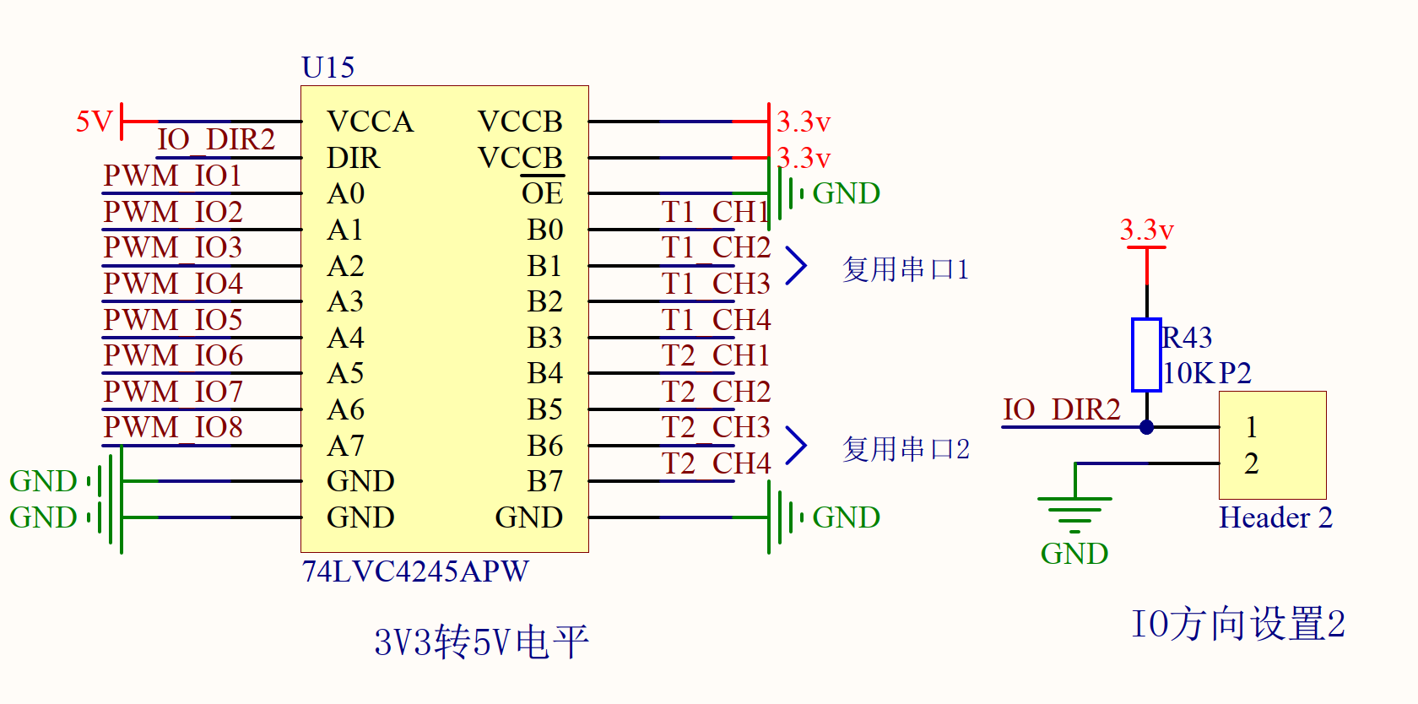

关于串口接收模块
2026年9月17日
21:03

实现思路:底层架构实现想法

现在我需要修改BSP_433.c和BSP_433.h文件,这是遥控器接收的文件夹,用来接收远程遥控器的按钮数据
数据大概长下面这样,时间戳是上位机加的
[19:37:51.741] 57 51
[19:37:51.895] 57 51
[19:37:52.456] 57 51
[19:37:52.612] 57 51
[19:37:52.987] 53 41
[19:37:53.112] 53 41 53 41
[19:37:53.545] 58 5A
[19:37:53.701] 58 5A 58 5A 53 41 58 5A
[19:37:53.857] 58 5A 58 5A 58 5A
[19:37:54.385] 58 4D
[19:37:54.510] 58 4D
[19:37:56.599] 58 5A
[19:37:56.723] 58 5A
[19:37:57.409] 58 4D
一般遥控器的数据是两个16进制
如果遥控器连发了就会多发送几组
我觉得好像不适合用IDLE中断?
尝试能不能用环形缓冲区解析的方法来做
然后还有一个需求就是我需要两个按键同时按下,实现把前进和左转右转分开?左转右转按钮单独按下是原地转圈,然后按前进就是单独前进,按左右转加前进就弧度转弯,这样是不是就更加符合人类的思考习惯,操作灵活新也更高
[20:04:27.646] 4F 50 53 41 4F 50 53 41 4F 50 53 41 4F 50
[20:04:27.833] 53 41 4F 50 53 41 4F 50 53 41 4F 50
[20:04:28.020] 53 41 4F 50 53 41 4F 50 53 41 4F 50
[20:04:28.268] 53 41 4F 50 53 41 4F 50 53 41 4F 50 53 41 4F 50
[20:04:28.456] 53 41 4F 50 53 41 4F 50 53 41 4F 50 53
[20:04:28.676] 41 4F 50 53 41 4F 50 53 41 4F 50 53 41 4F 50
[20:04:28.891] 53 41 4F 50 53 41 4F 50 53 41 4F 50 53 41 4F
[20:04:29.076] 50 53 41 4F 50 53 41 4F 50 53 41 4F 50
[20:04:29.323] 53 41 4F 50 53 41 4F 50 53 41 4F 50 53 41 4F 50
[20:04:29.479] 53 41 4F 50 53 41 4F 50
这是我两个按钮同时按下时接收的报文,其中指令码是5341和4f50,
还是那个问题啊,就算使用环形缓冲区解析,那key值也是会不断被遥控器新数据覆盖,好像不能实现两个按键一起执行?我想到一个方法是全部按键单独获得一个标志位,来对应按键数据时标志位置位,并且增加一个时间检测机制,超过一段时间就把这个标志位复位,控制代码里只需要检测是不是两个标志位都为1,如果都是1,就执行这个,如果只有一个是1就执行那个.
关于超时时间你也给我宏定义了吧,关于标志位的定义就内部定义就行,留出一个函数接口,输入键值,输出布尔量,当然我肯定不会记键值,直接输入宏定义就行,函数名字帮你想好了BSP_433_GetKeyState(uint16_t key_cmd)
当然控制模块现在还不需要你去做,我想先只是实现串口接收模块
关于键码和宏定义的对应关系我代码里面已经给出了,代码里还有遥控器形状的描述
如果需要串口回调函数就写模块里
还有一件事,就算关于注释,代码可读性要比性能优先,只是个接收模块也不会耗费多少性能吧,然后注释一定要写!并且必须增加关键注释,没有复用性和可读性的代码就是垃圾代码

这个是关于给codex的需求

关于电机驱动的思路
2026年9月17日
21:13

修改BSP_Servo.c和BSP_Servo.h两个文件,里面现在是我写的一点测试代码,验证硬件的,已经没用了,该删就全部删掉吧.
接下来我需要写电机控制的代码,电机需要的是20ms周期的pwm波,低电平有效,默认高电平(关于这个我已经通过pwm的极性翻转实现了),20ms周期我变成了20000的cnt,然后就是需要输入一个ccr的值,ccr的值要在1.25毫秒到1.75毫秒之间(大概就是ccr要大于1250和小于1750),其中1500是不转,1250是反转最大值,1750是正转最大值并且变化大概是线性关系
还有可能范围不是1250到1750的500级可调范围,可能是600,比如1200到1800
驱动板上的架构是一个8位单片机解析20ms周期1点几毫秒低电平pwm波然后控制电机驱动ic完成驱动的原理
但是电机有消磁,驱动板也有点年代了,导致有时候1500不是停车,并且还有10%左右的死区,而且相同百分比动力下,电机的转速可能不同,
电机的情况交代完了,那我说一下需要什么接口吧,
先需要一个初始化函数,把该初始化的初始化了,电机的pwm改变函数不要直接用hal库的,包装一层,为了方便以后移植,并且一样的把定时器句柄宏定义一下哈
需要四个轮子的接口,接收一个int16类型的数据,正数表示正转,负数表示反转,这个in16类型的数据实际上是一个百分比,用万分制,0的不动,10000是最大,就这么简单一个函数,主要方便作为模块内调用和我个人单步调试,
pwm通道1是右前轮,pwm通道2是左前轮,pwm通道3是左后轮,pwm通道4是右后轮,这四个函数接口里面务必写明
其次需要一个轮子融合函数,我们这里就先假设四个轮子全部是线性的速度变化,没有死区(死区会在下面消除,我们这里得到是是线性的干净的底层接口),然后这个融合函数需要做的就是接收两个int16位的数据,第一个数据表示油门百分比,正为前进,负为后退,第二个数据表示左右转百分比,正为右转,负为左转,然后有了参数指示控制要求,就通过这个函数算出应该给四个轮子什么样大小的百分比,这里就直接调用上面的四个轮子控制函数就行,至于左右转的逻辑其实应该就是一侧轮子做加法,一侧轮子做减法,如果不给油门,只给左右转就是原地转圈圈,并且数值大小可以控制转圈圈的速度,然后可能这里需要增加两个宏定义,因为是四轮车,使用有轮距,也有轴距,单位是厘米,我们直接用轴距和轮距做除法得到一个比例,用这个比例来给四轮差数做补偿,尽量减少四个轮子打架,比如转弯时内圈钱轮是不是要比内圈后轮要转速小一点,对于四轮固定（无舵机）的车，标准的做法是滑移转向（Skid-Steer）混控,如果太难做四轮差数算法就不做,总之先把代码跑起来,我先看看效果能不能达到项目需求
所以我需要以下几个模块
第一个是输出限幅的模块,如果我宏定义最大输出上限是250,那么输出就会是1250到1750的范围,如果我定义是300,那么输出就是1200到1800的范围,输出需要变化,当然这里是把1500当作电机不转的参考点去计算,如果第二点里面的停车参考点偏移了,那么就需要以停车参考点作为参考进行计算输出范围
第二点就是,我需要的是一个停车校准模块,用四个宏定义给四个轮子单独校准可以不,如果校准值填入1500,那么输出范围就是1250到1750.如果校准值填1400,那么输出范围就是1150到1650
第三点就是,还有一个死区补偿模块,只需要一个宏定义参数,就是死区的大小,如果我设置死区大小是40这个数字,那么就会先拿到上层函数给的期望转速百分比,先用最大可输出值-死区得到一个范围值,在用这个范围值去乘这个百分比得到一个pwm值,再用这个pwm值直接加上死区得到最终输出值,达到一个死区线性补偿的效果,当然正反转都需要死区补偿哈,反转也是一样的逻辑
关于带年纪转速不同其实很难解决,软件层面我先不解决,其实现实中转速相差的不是很大,我自己挑四个转速差不多接近的电机就行.还有关于匀速加减速的代码先不写,后面我看实际效果怎么样在决定怎么写
然后宏定义写一起吧,注明这个宏定义解决我的什么痛点,这比较符合我的思维方式,还有一样的就是关于注释,代码可读性要比性能优先,只是个控制模块也不会耗费多少性能吧,然后注释一定要写!并且必须增加关键注释,没有复用性和可读性的代码就是垃圾代码
我不需要你修改代码,我这样的需求表述明白了吗,我要发给codex,有没有什么遗漏吗,写的怎么样,帮我看一下
a

【角色设定】
你是一个资深的机器人底层驱动工程师，精通 STM32 HAL 库和 C 语言。代码风格要求：可读性优先，必须包含详细的核心逻辑和数学公式注释，拒绝毫无复用性的代码。
【任务目标】
请帮我重写 BSP_Servo.c 和 BSP_Servo.h 文件。这是一个四轮驱动（滑移转向）底盘的电机 PWM 控制模块。
注意：当前文件里原有的测试代码全部删除，从零开始严格按照以下需求编写。
【硬件背景与痛点说明】
- PWM 参数：20ms 周期，ARR=20000。极性已在底层反转，代码中只需改变 CCR 即可。
- 控制信号：驱动板通过解析 PWM 脉宽控制电机。标准中位（停车）是 1500，1250 为反转最大，1750 为正转最大。
- 硬件缺陷：
  - 中位偏移：老化导致 1500 不一定是绝对停车。
  - 机械死区：电机启动有约 10% 的死区。
  - 我们需要在软件中通过三个模块（中位校准、输出限幅、死区补偿）来解决这些痛点。
【宏定义要求（在 .h 文件集中定义）】
必须将所有核心参数宏定义在一起，并详细注释其解决的痛点：
- 定时器句柄宏：方便后续移植。
- 四轮独立中位校准宏：定义四个轮子的绝对停车 CCR 值（如 1500、1520、1490 等），解决电机中位偏移痛点。
- 最大输出范围宏（幅度）：如 MAX_OUTPUT_AMP = 250。表示 CCR 变化范围是 [中位-250, 中位+250]。
- 死区补偿宏：如 DEAD_ZONE = 40。解决电机低速不转的痛点。
- 底盘机械参数宏：定义轮距（TRACK_WIDTH）和轴距（WHEEL_BASE）的厘米值，用于计算转向补偿比例。
【底层接口开发要求（四大车轮控制）】
编写 4 个独立的轮子控制函数，以及一个底层 PWM 包装函数：
- 底层包装函数：封装 HAL 库的 __HAL_TIM_SET_COMPARE，不要让应用层直接调 HAL 库。
- 四个独立控制函数：
  - 对应关系：CH1=右前轮(FR)，CH2=左前轮(FL)，CH3=左后轮(RL)，CH4=右后轮(RR)。函数名需明确。
  - 输入参数：int16_t speed_percent。取值范围 [-10000, 10000]，代表万分比（-100.00% 到 100.00%）。正数前进，负数后退。
  - 核心数学转换逻辑（必须严格实现）：
    - 若输入为 0：输出 对应的中位校准宏。
    - 若输入不为 0：
计算有效控制范围 = (MAX_OUTPUT_AMP - DEAD_ZONE)；
线性映射值 = 有效控制范围 * (abs(speed_percent) / 10000.0)；
死区补偿值 = 线性映射值 + DEAD_ZONE；
最终 CCR = 独立中位宏 + (方向符号 * 死区补偿值)。
【上层接口开发要求（混控融合函数）】
编写底盘控制函数：void BSP_Chassis_Drive(int16_t throttle, int16_t steering)
- 参数定义：throttle 为油门（正前负后），steering 为转向（正右负左），范围均为 [-10000, 10000]。
- 转向补偿计算：计算补偿系数 k = WHEEL_BASE / TRACK_WIDTH（注意浮点转换）。
- 滑移转向混控逻辑：
  - 基础逻辑：左侧轮 = 油门 + 转向；右侧轮 = 油门 - 转向。
  - 补偿逻辑：为了减少轮胎打架，转向时内侧轮转速需乘以补偿系数 k（如果太复杂，直接给出一个清晰的数学混控公式即可，保证基础的前进和原地旋转正确）。
  - 将计算出的结果使用限幅算法约束在 [-10000, 10000] 之间。
  - 调用刚才写好的四个独立轮子控制函数输出。
【初始化接口】
编写 BSP_Servo_Init(void)：开启对应的定时器 PWM 通道，并将所有轮子初始化为独立中位宏的 CCR 值，确保上电绝对静止。>

关于遥控器的研究
2026年9月23日
14:18

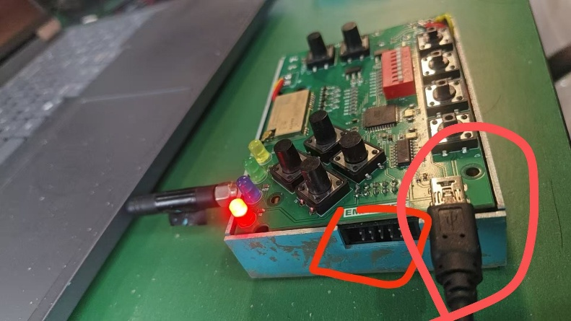

板子上有两个信号口,一个10口,一个usb口,
现在已经推断出的信息来看,usb口只是用来调试的,用来观测遥控器串口输出的是什么

用来烧录的是10口
用来推荐的是智峰zf-007/zf-009的烧录器,但是现在找不到烧录器,
接口如图所示
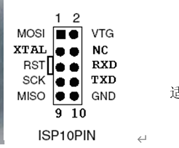
但是这个烧录器停产了,所以我准备找兼容型号
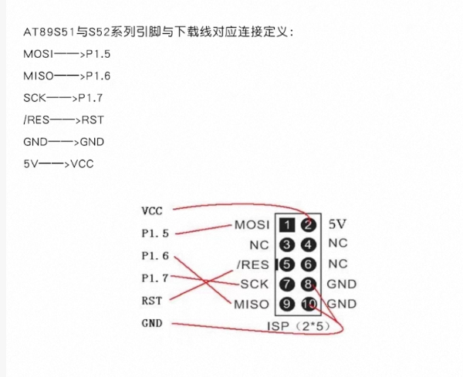
也就是这个

准备用这个替代原装烧录器
关于界面设置和操作方法
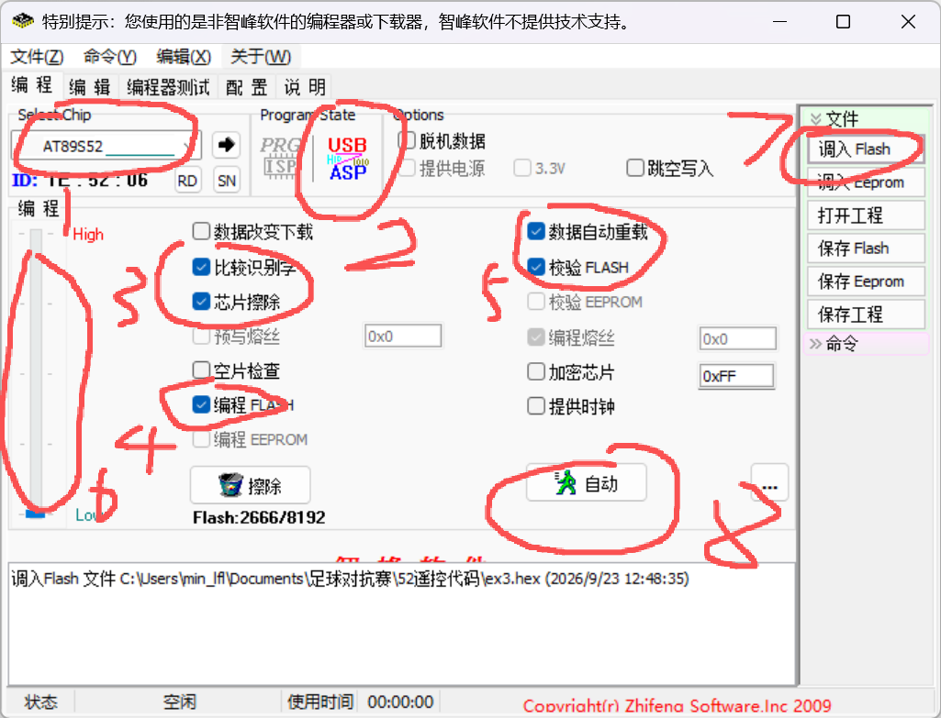
按这个步骤来,然后也可以先设置
