1. Setup NFS and Samba on Ubuntu to implement the folder shared.

sudo apt-get install nfs-common nfs-kernel-server

sudo apt-get install samba samba-client

1. Install Java
   1. Create java folder on /opt/;

>cd /

>cd opt

>sudo mkdir java

* 1. Copy jdk1.8.0_65 to /opt/java/ folder;

>sudo cp –r jdk1.8.0_65 /opt/java/

* 1. Update profile;

>sudo gedit /etc/profile

Add the following script on the bottom;

export JAVA_HOME=/usr/lib/java/jdk1.8.0_65

export JRE_HOME=/usr/lib/java/jdk1.8.0_65/jre

export CLASSPATH=.:$CLASSPATH:$JAVA_HOME/lib:$JRE_HOME/lib

export PATH=$PATH:$JAVA_HOME/bin:$JRE_HOME/bin

* 1. Make the change effect;

>source /etc/profile

1. Tomcat
   1. >sudo apt-get install tomcat7
   2. /usr/share/tomcat7/lib, it is /usr/share/java in fact;
   3. /var/lib/tomcat7/webapps/
   4. >sudo /etc/init.d/tomcat7 restart
   5. Open <http://localhost:8080/> to check;
2. Install MySQL
   1. sudo apt-get install mysql-server mysql-client
   2. sudo apt-get install mysql-workbench
3. Eclipse

Copy it to /opt/ folder;

Windows -> Performance -> Server -> Runtime Environment

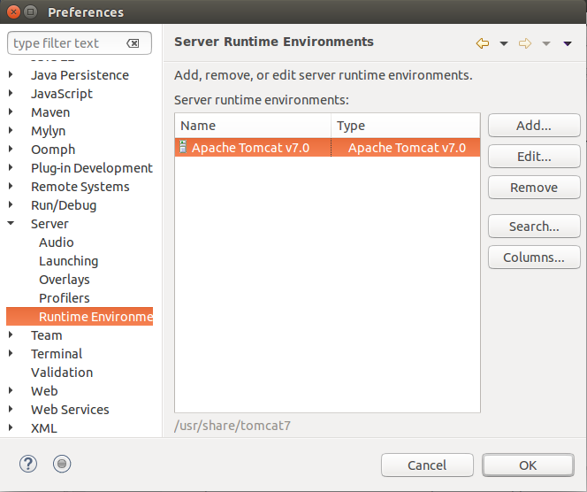

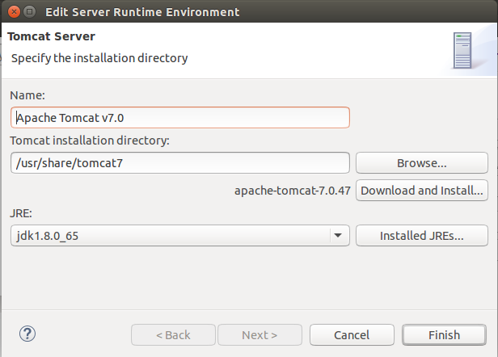

Windows -> Performance -> Java-> Installed JREs

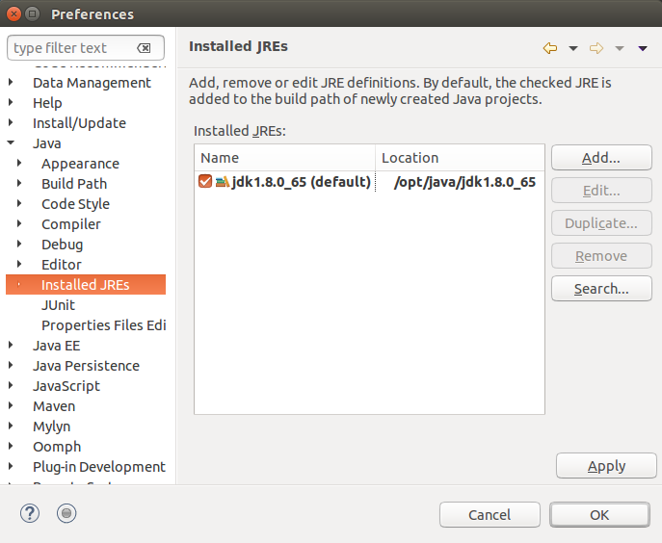

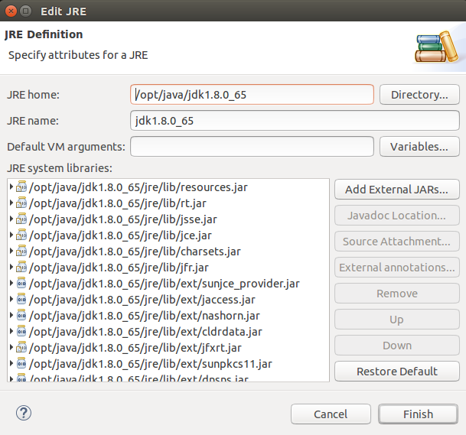

1. Install Git

sudo apt-get install git