Dormitory Management System
Versions
Date | Version | In charge | Description
10 Nov 2026 | V1.2 | Project team | Complete Sections I to VII and the corresponding Java implementation.

Abbreviation
DMS Dormitory Management System
OOP Object Oriented Programming
DAO Data Access Object
JDBC Java Database Connectivity
CRUD Create Read Update Delete
PK and FK Primary Key and Foreign Key
GUI Graphical User Interface

List of Figures
Figure 1 Dormitory use cases 7
Figure 2 Entity inheritance at analysis stage 9
Figure 3 Domain class design 10
Figure 4 Application layers 14

List of Tables
Table 1 User roles 6
Table 2 List of objects 8
Table 3 Details of classes 10
Table 4 Abstract classes 12
Table 5 DAO interfaces 16
Table 6 Service interfaces 16
Table 7 Data access control table 17
Table 8 Method access control table 18

Table of Contents
I INTRODUCTION 6
II CLASS ANALYSIS 7
1 Objects 7
2 Classes 8
III CLASS DESIGN 9
1 Classes 9
2 Abstract classes 12
3 Some OOP techniques 12
3.1 Overloading methods 12
3.2 Overriding methods 13
4 Inheritance 13
IV THREE TIER MODEL 13
V PACKAGE DESIGN 15
VI INTERFACE DESIGN 15
VII ACCESS CONTROL 17
1 Data access control 17
2 Method access control 18
3 User permissions in service methods 19

I INTRODUCTION
The dormitory office needs a desktop program to keep student profiles, rooms, accommodation contracts, maintenance requests and fees in one database. Paper records make it easy to assign a full room or lose the payment history. Our Dormitory Management System uses Java OOP, JavaFX and PostgreSQL for these daily operations.
Admin creates staff accounts and manages the dormitory. Staff register students, maintain rooms and room types, allocate beds using contracts, process maintenance requests and record payments. Students update their own profile, view rooms and their contracts, send room requests and check invoices. Amounts are whole numbers in VND.
Table 1 User roles
Role | Allowed functions | Restrictions
ADMIN | All dormitory functions; create staff and admin accounts. | First admin setup only before any account exists.
STAFF | Manage students, room types, rooms, contracts, requests and invoices. | Cannot create staff or admin accounts.
STUDENT | Register; update own profile; view rooms; read own contracts and invoices; submit own room requests. | Cannot allocate beds, resolve requests, record payments or read another student's records.

Table 1 maps to the Role enum. Java access modifiers protect class members; service checks decide which signed-in role can run an operation. A public method is not automatically available to every application user.
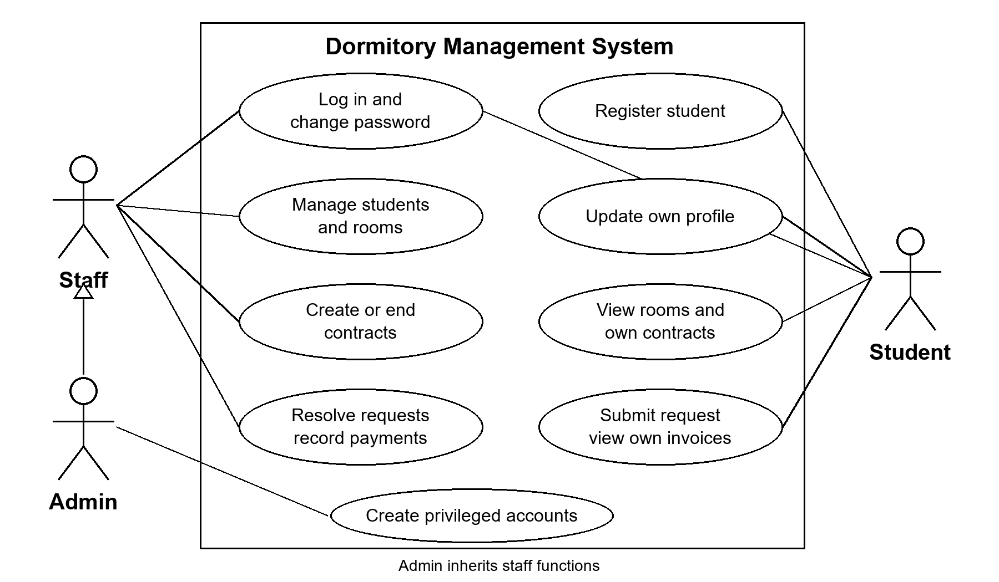
Figure 1 Dormitory use cases
Figure 1 separates student work from office work. Admin and staff share the dormitory management functions; only admin creates privileged accounts. Protected functions require login. Student registration and first admin setup are entry operations before login.
A student has at most one ACTIVE contract. A contract allocates a bed immediately, so its start date cannot be in the future and its end must follow the start. Full or maintenance rooms cannot receive another contract. Creation increases occupancy; cancellation or expiration releases the bed once. Staff use Expire old contracts after the end date passes. A maintenance request needs an active contract for that room. Record payment means staff have received money; there is no bank integration.

II CLASS ANALYSIS

1 Objects
We group records by their state and what the program does with them. Table 2 uses example objects, rather than actual residents.
Table 2 List of objects
No | Object name | State | Behaviours
1 | Admin account | Admin email, password hash, admin role | Log in; change password; create staff account.
2 | Student An | SV001, Nguyen An, 0901234567, male | Update profile; search profile; submit room request.
3 | Four bed type | Capacity 4, price 500000 VND | Add type; change capacity/price; list types.
4 | Room A101 | Building A, number 101, occupancy 1, available | Find available rooms; edit room; allocate or release bed.
5 | An's contract | SV001, A101, start/end dates, active | Create; terminate; expire; list by student/room.
6 | Broken fan request | SV001, A101, fan description, pending | Submit; process; resolve with time and resolver.
7 | November invoice | Contract number, room fee, 500000 VND, unpaid | Issue; list unpaid fees; record payment.

The groups in Table 2 become Account, Student, RoomType, Room, Contract, Request and Invoice. Entities hold state. Their business operations are implemented by services and DAOs, so a Room object does not execute SQL itself.

2 Classes
All seven entities need an identity, so we use an abstract BaseEntity parent. Student uses a student code; other entities use generated numeric IDs. Account and Student stay separate because staff/admin accounts do not need student profiles.
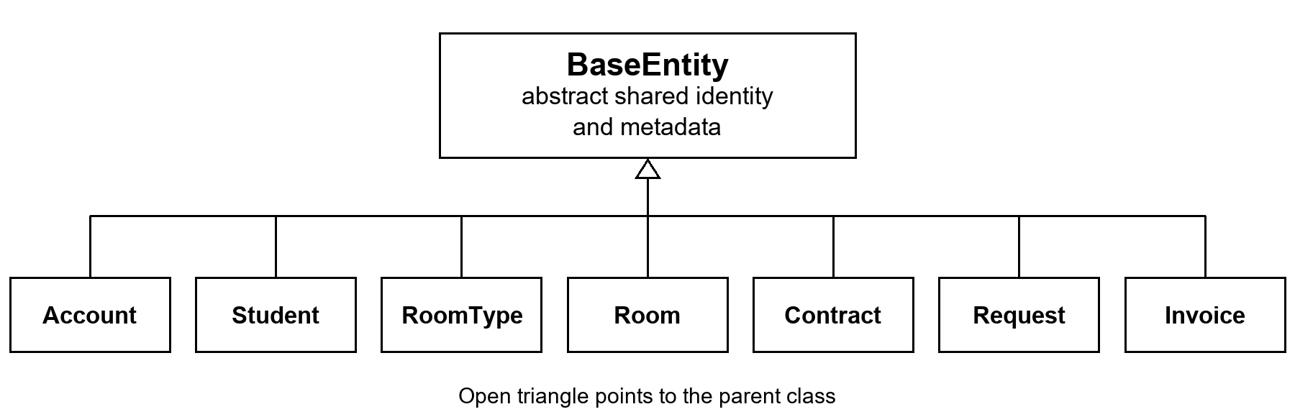
Figure 2 Entity inheritance at analysis stage
Figure 2 shows inheritance without Java types or method signatures, as this is the analysis stage. Child classes share identity operations and provide their own metadata. RoomType is associated with Room, rather than being its parent. A Student is linked to an Account instead of inheriting its password and role.

III CLASS DESIGN

1 Classes
Relationships are stored as IDs because JDBC reads database rows. The service checks linked records before creating a contract, request or invoice.
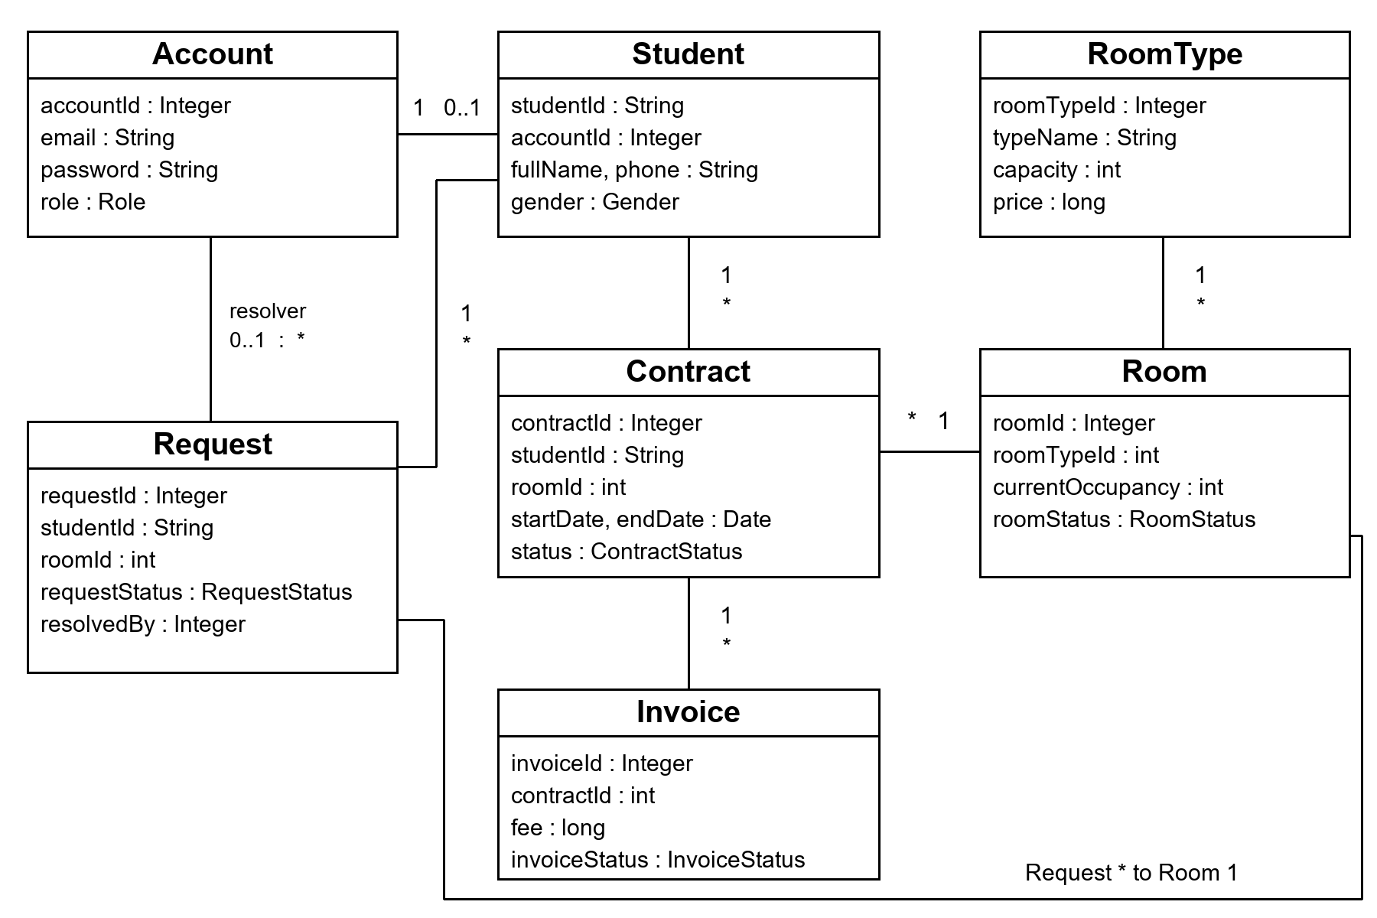
Figure 3 Domain class design
In Figure 3, one room type describes many rooms. One room and one student can each have many contracts over time, but a student has only one active contract. Each invoice belongs to a contract. Each request belongs to a student and room, with an optional account resolver. An account has zero or one student profile. All entities inherit from BaseEntity as shown in Figure 2.
Table 3 Details of classes
No | Class | Instance variables | Methods | Description
1 | Account | String email, password  Role role | Constructors; getters/setters; metadata | Login identity. Password field stores a salted hash.
2 | Student | Integer accountId  String fullName, phone  Gender gender | Constructors; getStudentId(); getters/setters; metadata | Profile with an inherited String ID.
3 | RoomType | String typeName  int capacity  long price | Constructors; getters/setters; metadata | Shared capacity and price definition.
4 | Room | int roomTypeId  String roomNumber, building  int currentOccupancy  RoomStatus roomStatus | Constructors; getters/setters; metadata | Physical room; contract services change occupancy.
5 | Contract | String studentId  int roomId  Date startDate, endDate  ContractStatus contractStatus | Constructors; getters/setters; metadata | Accommodation assignment and lifecycle.
6 | Request | Student/room IDs; title/description; status; requested/resolved timestamps; optional resolver ID | Constructors; getters/setters; metadata | Maintenance report and processing result.
7 | Invoice | int contractId  String title  long fee  Status and paid timestamp | Constructors; getters/setters; metadata | Contract fee and payment record.

Table 3 lists each class's own fields. BaseEntity supplies protected ID id, public ID accessors, boolean isPersisted(), equality and hash code. Student extends BaseEntity<String>; the other six extend BaseEntity<Integer>. Nullable account/resolver IDs use Integer instead of int. SQL Date and Timestamp represent database dates and times. Status fields use enums rather than arbitrary strings.
For example, Room exposes public int getCurrentOccupancy() and public void setCurrentOccupancy(int value). Setters only change state; services validate edits. Metadata methods return String values, such as room and room_id. Sources: src/main/java/com/dorm/model/ and model/enums/.

2 Abstract classes
Table 4 Abstract classes
Abstract class | Abstract methods | Concrete methods | Description
BaseEntity<ID> | getTableName(); getIdColumnName() | ID access, isPersisted, equals, hashCode, toString | Common identity and metadata contract.
AbstractDAO<T,ID> | Row mapping; table/ID names; insert/update SQL; parameter binders | CRUD, count/existence checks, query helpers | Shared JDBC algorithm; subclasses supply entity-specific details.

Table 4 shows two uses of abstraction. BaseEntity shares entity state. AbstractDAO shares persistence logic. Its query methods call mapRow(ResultSet) on the concrete DAO. StudentDAOImpl.save overrides normal insertion because its String primary key is supplied by the caller, rather than generated by PostgreSQL.

3 Some OOP techniques

3.1 Overloading methods
RoomService overloads getRoomsByBuilding. One version takes only the building; the other takes building and status. Java selects the overload from the arguments at compile time. Models also overload constructors with an empty version and a version receiving their full state.
public List<Room> getRoomsByBuilding(String b) throws SQLException {
Session.requireLogin();
return rooms.findByBuilding(b);
}
public List<Room> getRoomsByBuilding(String building,
RoomStatus status) throws SQLException {
List<Room> result = new ArrayList<>();
for (Room r : getRoomsByBuilding(building)) {
if (status == null || r.getRoomStatus() == status) result.add(r);
}
return result;
}
Source: src/main/java/com/dorm/logic/code/RoomServiceImpl.java. Java passes arguments by value. Passing a Room copies its reference, so a setter can change that object. Reassigning the parameter to a different Room would not replace the caller's variable.

3.2 Overriding methods
Each entity overrides BaseEntity metadata methods. Room supplies its actual table and key column:
@Override
public String getTableName() { return "room"; }
@Override
public String getIdColumnName() { return "room_id"; }
Source: src/main/java/com/dorm/model/Room.java. Concrete DAOs similarly override SQL, binding and row-mapping hooks. @Override helps the compiler catch a wrong signature. A BaseEntity reference holding a Room calls Room's implementation at runtime.

4 Inheritance
Room extends BaseEntity<Integer> reuses identity and adds room fields. Its full constructor calls super(roomId). RoomDAOImpl extends AbstractDAO<Room,Integer> reuses CRUD and implements RoomDAO for additional room queries. We use inheritance where a child can act as its parent. Other domain relationships use linked IDs. We do not create separate Admin and Staff entity subclasses that repeat Account fields; their category is the Role enum.

IV THREE TIER MODEL
The program separates presentation, business and persistence responsibilities. These are logical layers in one desktop process; PostgreSQL runs separately.
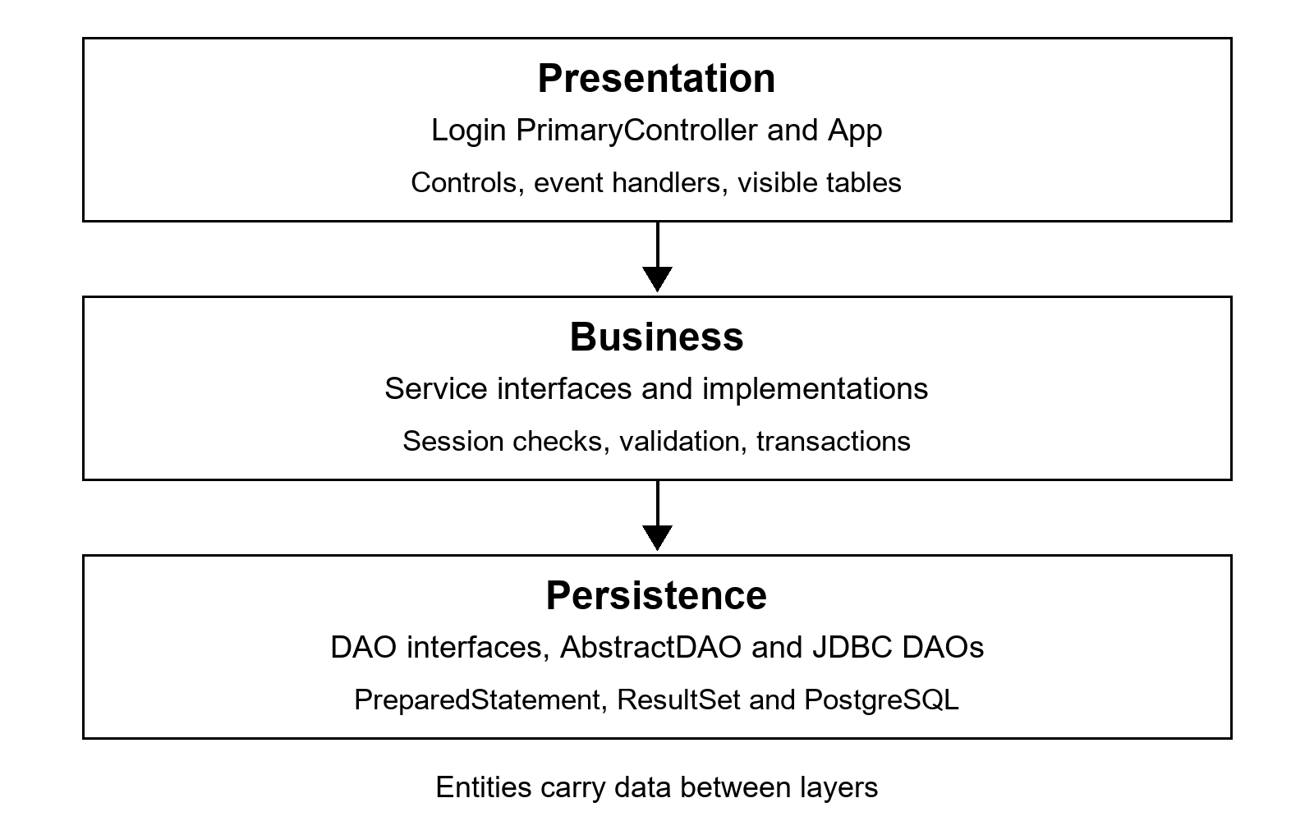
Figure 4 Application layers
Figure 4 shows the normal call direction. PrimaryController handles controls and button events. Services check the session and input, then call DAOs. DAOs bind PreparedStatement parameters, execute JDBC and map ResultSet rows to models. The screen displays returned records or an error message.
For Create contract, the button calls ContractServiceImpl.createContract. The service checks dates, locks the student and room records, rejects another active contract or a full/maintenance room, inserts the contract and increases occupancy. Both writes share a transaction. Failure rolls back both; a partial unique index also prevents duplicate ACTIVE contracts. Cancelling the same contract twice does not release two beds.
ServiceSupport saves the previous auto-commit setting, disables it, commits on success, rolls back SQL/runtime errors and restores the setting. The transaction synchronizes on the connection manager because this small program uses one JDBC connection. Statements and result sets use try-with-resources. Invalid input and denied operations raise IllegalArgumentException; database errors use SQLException.
App loads LoginPage.fxml with the Login controller. Successful login opens the PrimaryController dashboard. The original primary.fxml and secondary.fxml remain navigation examples. Account administration reads summaries after an admin check, and login initialization checks the account count, through AccountDAOImpl. These small exceptions to layer separation can be moved into an account service later. Business changes go through services.

V PACKAGE DESIGN
Packages follow the layers and keep related source files together. The following tree starts at src/main/java/.
com.dorm
App.java application entry
model/ seven entities and BaseEntity
enums/ role, gender and workflow statuses
dao/ generic and seven DAO interfaces
impl/ AbstractDAO and JDBC implementations
db/ connection manager and schema setup
logic/
itf/ six business interfaces
code/ implementations, Session and helpers
com.ui.controller
Login.java FXML login and registration controller
PrimaryController.java dormitory dashboard
SecondaryController.java retained FXML example
src/main/resources/schema.sql defines seven tables. resources/com/dorm/ contains LoginPage.fxml, its Log.fxml include view, primary.fxml, secondary.fxml and dorm.css. src/test/java/com/dorm/ holds password, workflow and JavaFX tests. Maven targets Java 21 with JavaFX 21.0.9 and PostgreSQL JDBC 42.7.4. The project was built with JDK 25 targeting Java 21.
The DAO contracts depend on models. DAO implementations use the database manager. Services use models and DAOs, and UI code uses services. module-info.java declares the JavaFX, JDBC and Java desktop dependencies and exports application packages. FXML reflection is opened for the application/controller packages. Active table columns use getter functions and do not need reflective access to model properties.

VI INTERFACE DESIGN
GenericDAO<T,ID> defines common persistence operations. T extends BaseEntity and ID extends Serializable, supporting String student codes and Integer generated keys.
Table 5 DAO interfaces
Interface | Operations beyond common CRUD | Implementation
GenericDAO<T,ID> | Save/update/delete; find one/all; count; existence check. | AbstractDAO
AccountDAO | Find by email/role; verify password; email existence. | AccountDAOImpl
StudentDAO | Find linked account; search name; filter gender; ID existence. | StudentDAOImpl
RoomTypeDAO | Find type by name. | RoomTypeDAOImpl
RoomDAO | Find by building/status/type; available rooms; update occupancy. | RoomDAOImpl
ContractDAO | Find by student/room/status; active contracts. | ContractDAOImpl
RequestDAO | Find by student/room/status/resolver; pending requests. | RequestDAOImpl
InvoiceDAO | Find by contract/status; unpaid invoices and unpaid by student. | InvoiceDAOImpl

Each entity DAO in Table 5 extends GenericDAO. Optional<T> represents a lookup that can be absent; List<T> returns zero or more rows. AbstractDAO uses ArrayList for query results. SQL values are parameters, while table/column names come from fixed DAO methods.
Table 6 Service interfaces
Interface | Main operations | Business checks
AuthService | Login; register student/admin; change password; find profile. | Validate identity, hash password, create account/profile atomically.
StudentService | Read/search/filter; update/delete profile. | Ownership, name/phone/gender and fixed account link.
RoomService | Room/type CRUD; building/status/availability queries. | Positive capacity, nonnegative price, consistent occupancy/status.
ContractService | Create/read/list; cancel; expire. | Single active assignment, room capacity, transactional occupancy.
RequestService | Submit/read/list; process/resolve. | Room membership, manager role, resolution state/time.
InvoiceService | Create/read/list unpaid; record payment. | Nonnegative fee, owner checks on reads, manager payment permission.

Each interface in Table 6 has a concrete implementation with the Impl suffix. RoomService service = new RoomServiceImpl() lets a caller use the interface while the implementation performs the work. Staff registration, manager all-record lists and batch expiration are additional concrete methods used by PrimaryController. Source directories are com/dorm/logic/itf/ and com/dorm/logic/code/.

VII ACCESS CONTROL

1 Data access control
Table 7 Data access control table
Data | Class | Modifier | Reason
id | BaseEntity | protected | Subclasses reuse identity; other callers use accessors.
Email, password hash, role | Account | private | Prevent direct writes; authentication handles password checks/changes.
Profile and room fields | Student, Room, RoomType | private | State is read through getters and edited through services.
Workflow state | Contract, Request, Invoice | private | Services decide allowed transitions.
instance, connection | DatabaseConnection | private | Callers use the manager API.
Connection settings | DatabaseConnection | private static final | One configuration per JVM, loaded from properties/environment.
Current account | Session | private static | One signed-in user per desktop process.
DAO references | Service implementations | private final | Dependencies stay internal and cannot be reassigned.

Table 7 describes Java visibility, rather than database permissions. Private fields prevent direct access, but model setters are simple. The UI must call services for validation and role checks. Code with direct DAO/database access can bypass these checks; those components are internal to the application.

2 Method access control
Table 8 Method access control table
Method or member | Class | Modifier | Purpose
Constructors and accessors | Entities | public | DAOs construct records and screens read returned state.
CRUD interface methods | GenericDAO | public | Shared persistence contract; interface methods are implicitly public.
Row mapping and SQL/binding hooks | AbstractDAO | protected abstract | Subclasses implement entity-specific behaviour.
Query and connection helpers | AbstractDAO | protected | DAO subclasses reuse JDBC work.
Business operations | Service implementations | public | UI entry points with permission and validation checks.
Role-check methods | Session | public static | Reusable checks without creating Session objects.
Validation, transaction and lock helpers | ServiceSupport | package-private | Shared only in the business implementation package.
Constructor | DatabaseConnection | private | Only getInstance creates the shared manager.
Form builders and UI helpers | PrimaryController | private | Screen implementation details stay internal.

Table 8 keeps implementation hooks out of the public UI API. Entity and service classes are public so other application packages can use them. ServiceSupport and its Work interface have default package access. The final modifier on a DAO reference prevents reassignment; it does not make the referenced object immutable. Module exports control access across named modules, while Java modifiers control member access.

3 User permissions in service methods
Session.requireManager() accepts ADMIN and STAFF. Student reads call ServiceSupport.ownStudent, comparing the requested student ID with the signed-in account's profile. Contract/invoice lookup checks ownership through related records. Only the signed-in staff/admin can be stored as a request resolver.
public static void requireManager() {
requireLogin();
if (account.getRole() == Role.STUDENT)
throw new IllegalArgumentException("Only staff or admin can do this.");
}
Source: src/main/java/com/dorm/logic/code/Session.java. After the first account exists, creating another admin requires ADMIN. First admin setup uses a database table lock. Passwords use PBKDF2WithHmacSHA256, 120000 iterations and a random 16-byte salt. Account.toString omits the password field.
WorkflowTest checks denial of another student's invoice/contract and denial of staff escalation. GuiTest checks role-specific JavaFX tabs. Hiding buttons helps the user follow the workflow, and service checks reject unauthorized application operations.

