**INSPECTION REPORT**

|  |  |  |  |
| --- | --- | --- | --- |
| Product |  | Inspection Date |  |
| Order Number |  | **Customer** |  |
| Production Qty |  | **Sampling Qty** |  |
| Inspect Result | **PASS** | | |

**Test Equipment**

|  |  |  |
| --- | --- | --- |
| Item | HW/SW | Description |
| 1 | HW | Keysight N9320B Spectrum Analyzer |
| 2 | HW | LeCroy WaveRunner 64Xi Oscilloscope |
| 3 | HW | PDS Pulse Generator |

**Inspection Result**

|  |  |  |  |
| --- | --- | --- | --- |
| Item | Test Item | Result | Remark |
| 1 | **Visual Inspection** | **PASS** |  |
| 2 | **Label Inspection** | **PASS** |  |
| 3 | **Frequency Inspection** | **PASS** |  |
| 4 | **Sensitivity Inspection** | **PASS** |  |

**Inspector: Approver:**

/ Quality Engineer / Quality Manager Signed for and on behalf of PDS TAIWAN LTD.

**414367**

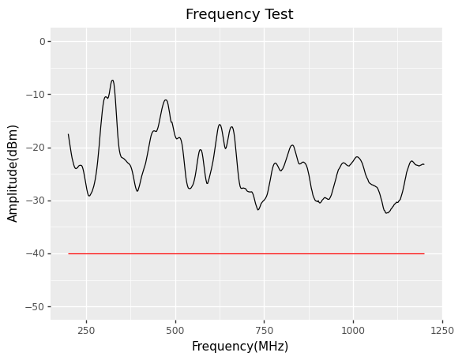

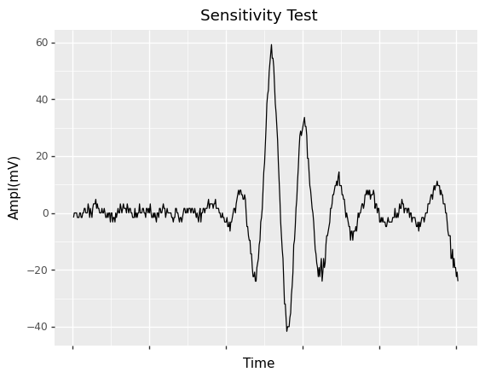

**414368**

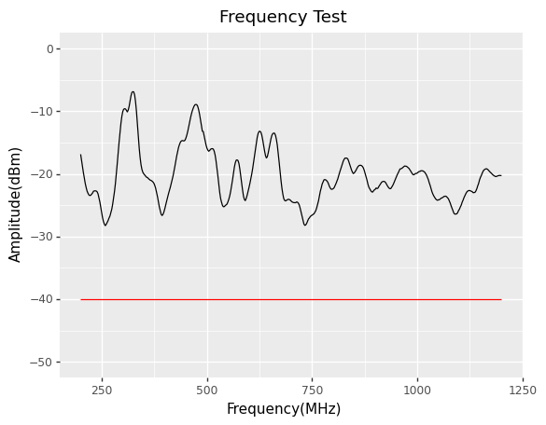

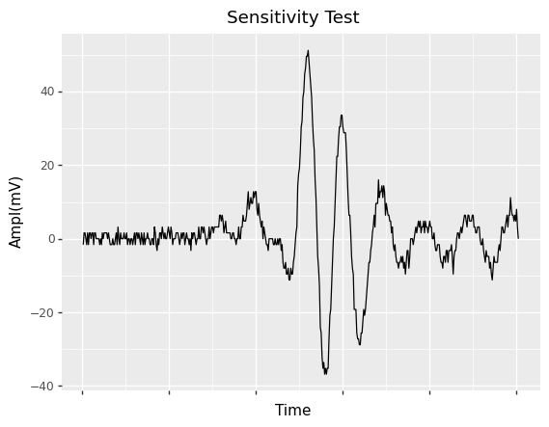

**414369**

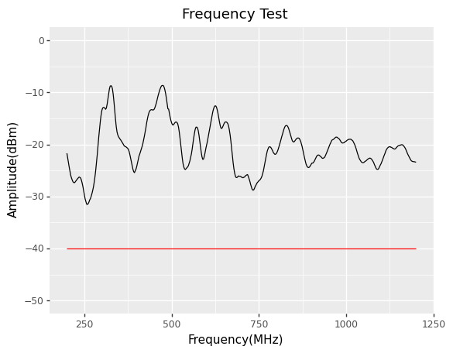

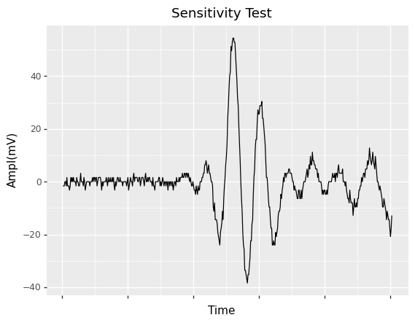

**414370**

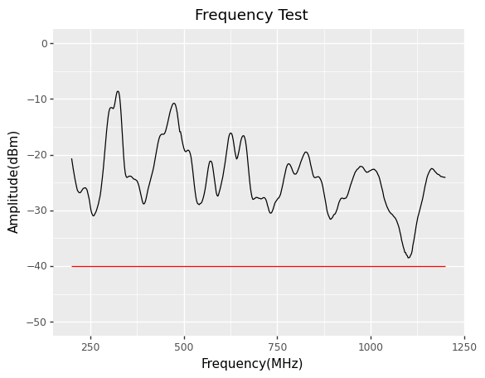

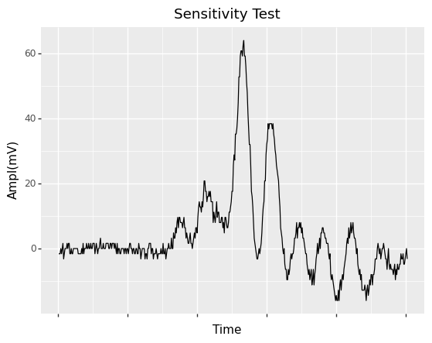

**414371**

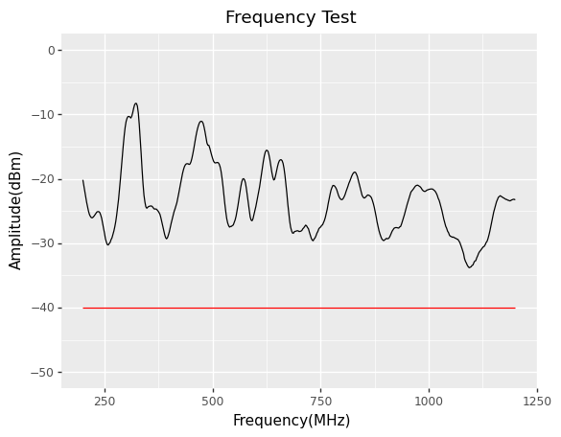

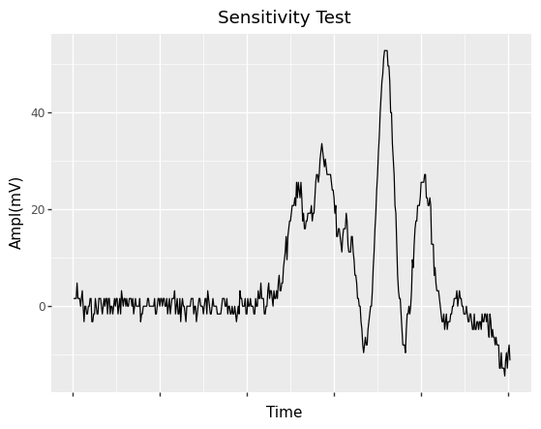

**414372**

