PROJECT 2
FortiGate + Cisco ASR
OSPF & API Automation Lab
Physical routing • Dynamic routing • IPsec VPN • REST API • Python

Portfolio Lab Documentation
September 2026 • Version 1.0

1. Project Overview

This project documents a physical networking and security lab using a FortiGate 40F firewall, Cisco ASR1001-X router, managed switch, Windows workstation, and MacBook Air management workstation. The lab combines Layer 3 connectivity, OSPF dynamic routing, IPsec VPN configuration, firewall policy review, FortiGate REST API testing, Python automation, and multi-workstation device administration.
The emphasis was on verification and troubleshooting: each major function was tested independently so that routing, security policy, API authentication, and automation problems could be isolated rather than treated as one combined issue.
Verified key results
- ASR <-> workstation routing and ICMP connectivity
- OSPF neighbor state FULL/DR
- OSPF-learned default route O*E2 via 192.168.30.1
- Successful FortiGate REST API system-status response
- Working Python script that prompts for the API token at runtime
- Documented IPsec Phase 1/Phase 2 and VPN firewall policy design

2. Objectives

- Build routed connectivity between the FortiGate, Cisco ASR, and Windows workstation.
- Use the MacBook Air as a separate management workstation for FortiGate GUI administration, troubleshooting, and project/GitHub documentation.
- Establish and verify an OSPF adjacency over the 192.168.30.0/24 network.
- Advertise a default route from the FortiGate and verify that the ASR learns it dynamically.
- Configure and document an IPsec site-to-site VPN design using protected networks 192.168.50.0/24 and 192.168.40.0/24.
- Review VPN firewall policies and confirm NAT is disabled on protected traffic.
- Test the FortiGate REST API from Windows before introducing Python.
- Automate a FortiGate system-status request without hardcoding the API token.
- Document commands, evidence, troubleshooting steps, and lessons learned for a GitHub portfolio.

3. Lab Equipment

Component | Role in Project 2
FortiGate 40F | Firewall, OSPF peer, VPN endpoint, REST API target
Cisco ASR1001-X | Router, OSPF peer, routed workstation interface
Managed Ethernet switch | Carries the FortiGate-ASR VLAN20 underlay
Windows workstation | ICMP, SSH, PowerShell/cURL, and Python automation testing
MacBook Air | FortiGate GUI administration, troubleshooting, project documentation, and GitHub workflow
FortiOS 7.2.6 | FortiGate operating system
Cisco IOS XE | Cisco routing platform software
Python 3 | REST API automation

4. Network Topology

The routing underlay between the FortiGate and ASR uses 192.168.30.0/24. The ASR also provides a directly connected 192.168.40.0/24 segment to the Windows workstation. The MacBook Air connects through the managed-switch side of the lab as a separate management workstation for FortiGate GUI access, troubleshooting, and project documentation. The IPsec design protects 192.168.50.0/24 on the FortiGate side and 192.168.40.0/24 on the ASR side.
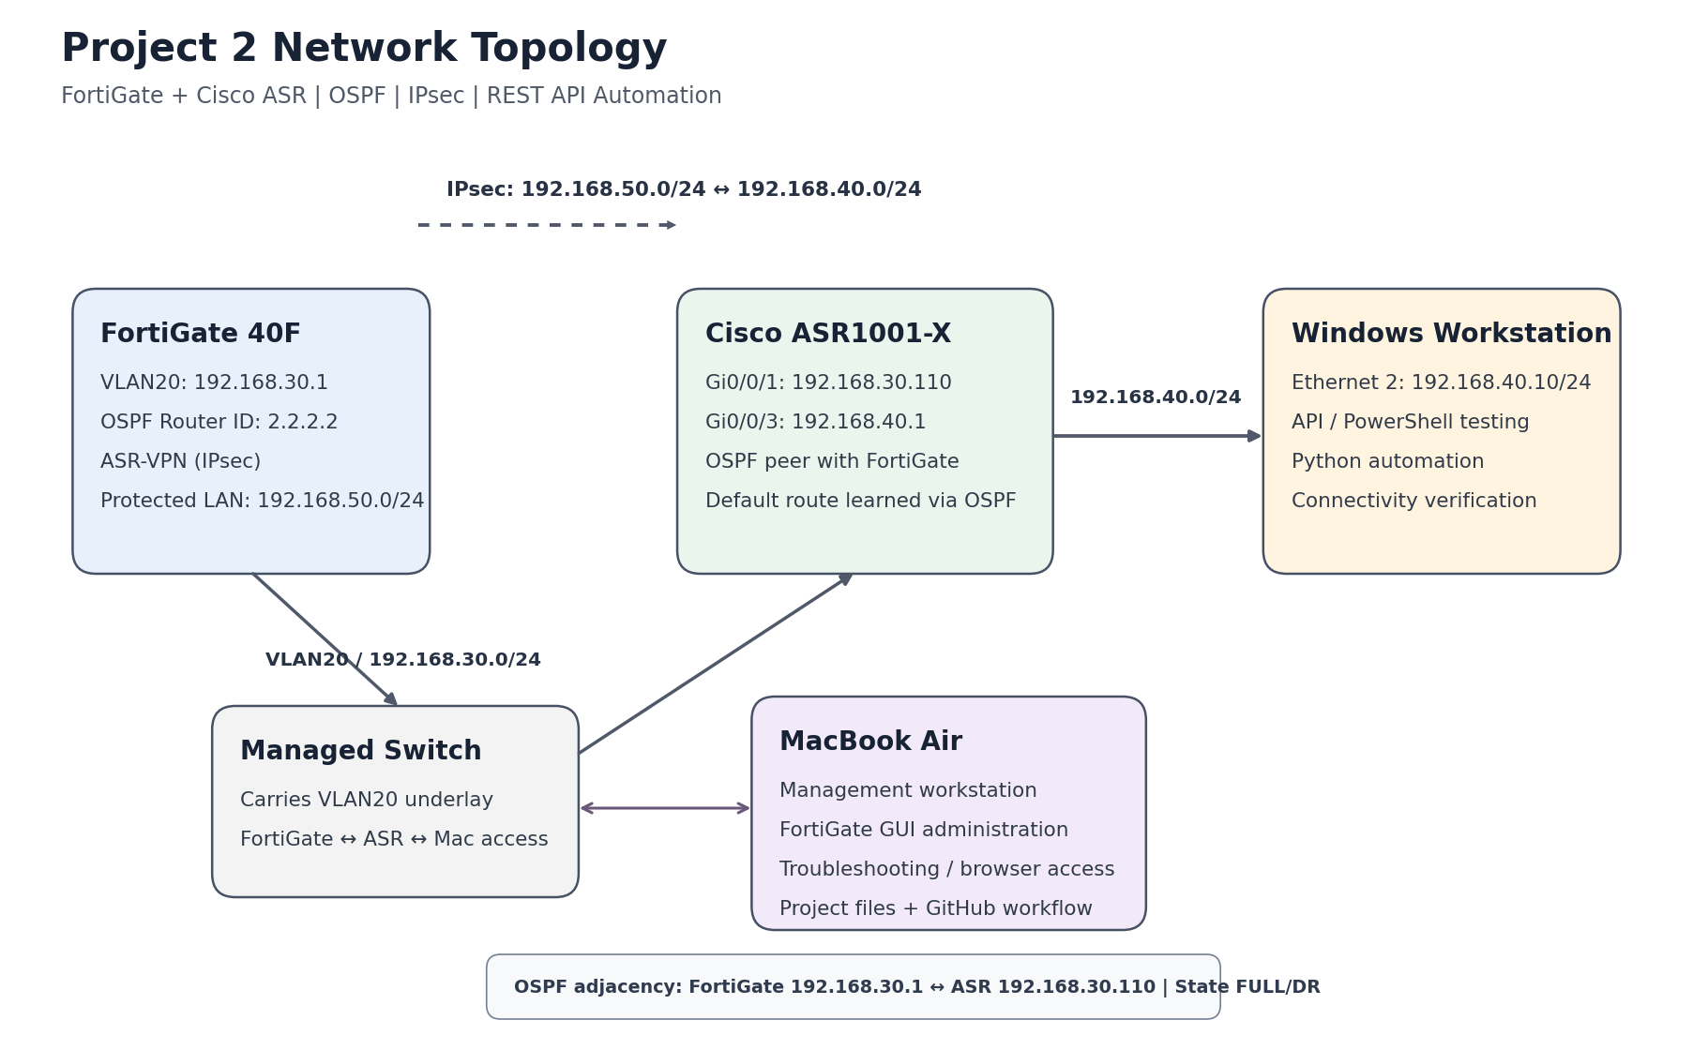
Figure 1. Project 2 logical topology.

5. IP Addressing Plan

Device / Interface | Address | Purpose
FortiGate VLAN20 | 192.168.30.1 | FortiGate side of OSPF/routing network
Cisco ASR Gi0/0/1 | 192.168.30.110 | ASR interface toward FortiGate
Cisco ASR Gi0/0/3 | 192.168.40.1 | ASR interface toward Windows test host
Windows Ethernet 2 | 192.168.40.10/24 | Test/management workstation
MacBook Air | VLAN20 management access | FortiGate GUI administration and project management
VPN local protected network | 192.168.50.0/24 | FortiGate Phase 2 local selector
VPN remote protected network | 192.168.40.0/24 | FortiGate Phase 2 remote selector

6. Routing and OSPF Configuration

OSPF was configured between the FortiGate and Cisco ASR across VLAN20. The FortiGate used router ID 2.2.2.2 in area 0.0.0.0 and advertised a default route as External Type 2 with metric 10.
- Neighbor state verified as FULL/DR on the ASR.
- Neighbor address verified as 192.168.30.1 on GigabitEthernet0/0/1.
- ASR routing table showed O*E2 0.0.0.0/0 via 192.168.30.1.
- OSPF administrative distance was 110.
router# show ip ospf neighbor
Neighbor ID Pri State Address Interface
2.2.2.2 1 FULL/DR 192.168.30.1 GigabitEthernet0/0/1

router# show ip route
O*E2 0.0.0.0/0 [110/10] via 192.168.30.1
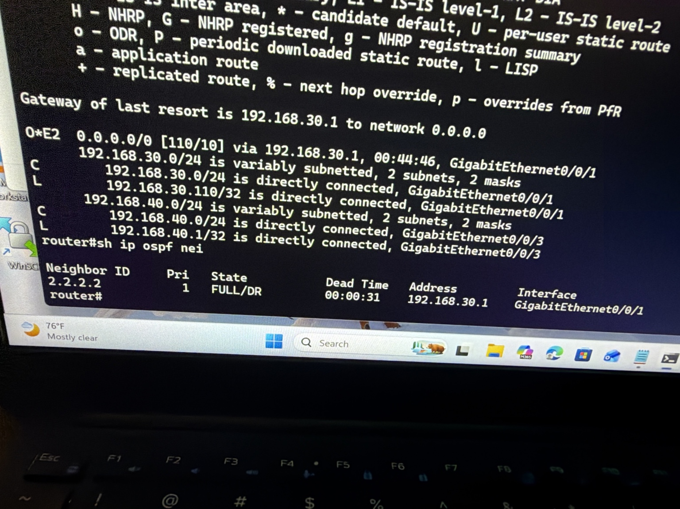
Figure 2. Cisco ASR routing table and OSPF neighbor verification.
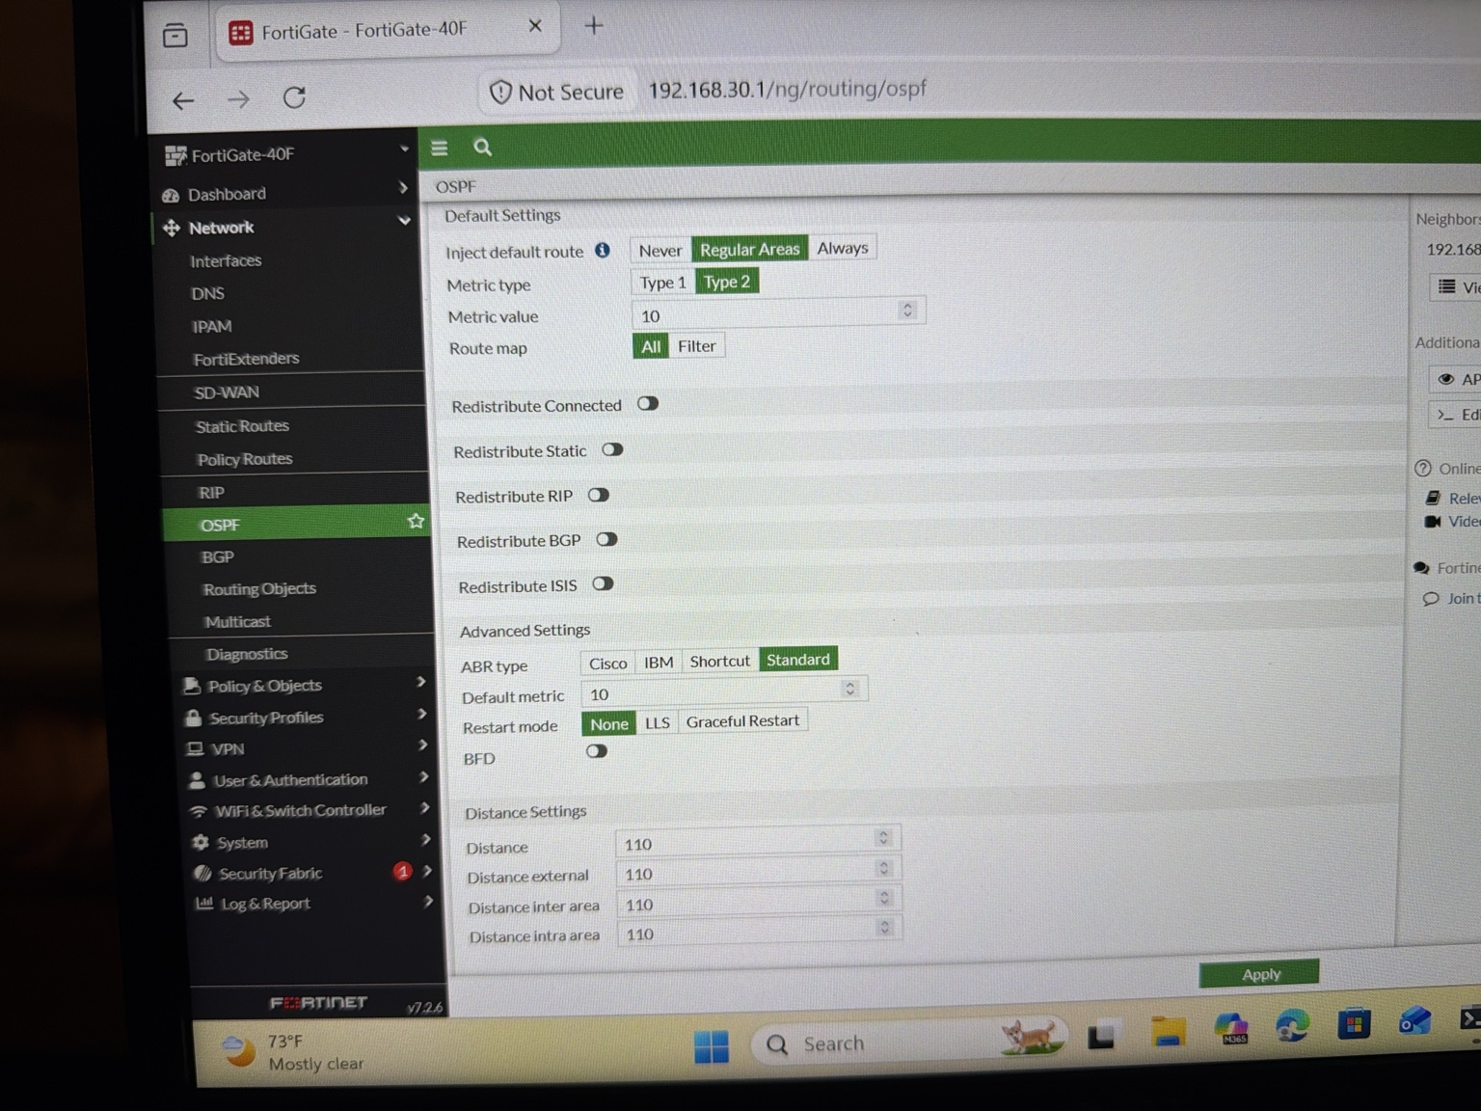
Figure 3. FortiGate OSPF default-route injection and metric settings.

7. Firewall and IPsec VPN Configuration

The FortiGate VPN was created as ASR-VPN using a Cisco site-to-site template. The VPN peers communicate over the 192.168.30.0/24 underlay, while the Phase 2 selectors identify the protected networks.
Setting | Verified value
Remote peer | 192.168.30.110
Outgoing interface | VLAN20
Authentication | Pre-shared key (not documented)
IKE / mode | IKEv1 / Main
Phase 1 proposal | AES256-SHA256
DH group | 14
Phase 1 lifetime | 86400 seconds
Phase 2 proposal | AES256-SHA256
Phase 2 lifetime | 3600 seconds
PFS | Disabled
Local protected subnet | 192.168.50.0/24
Remote protected subnet | 192.168.40.0/24
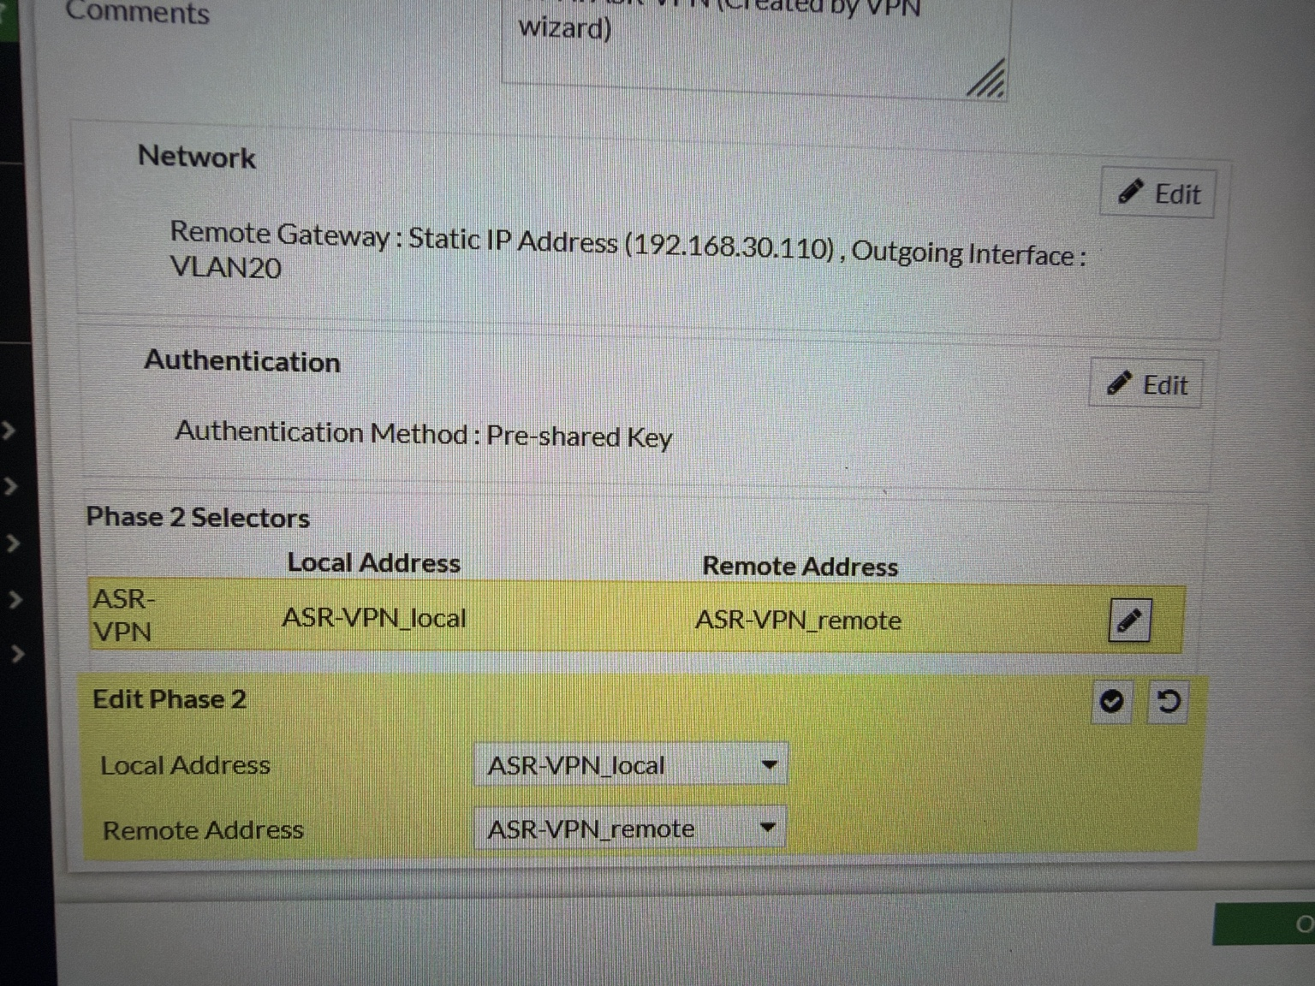
Figure 4. FortiGate ASR-VPN peer and Phase 2 selector configuration.
VPN policies were present in both directions between ASR-VPN and VLAN50. NAT was disabled on these policies, which preserves the original private addresses for protected traffic.
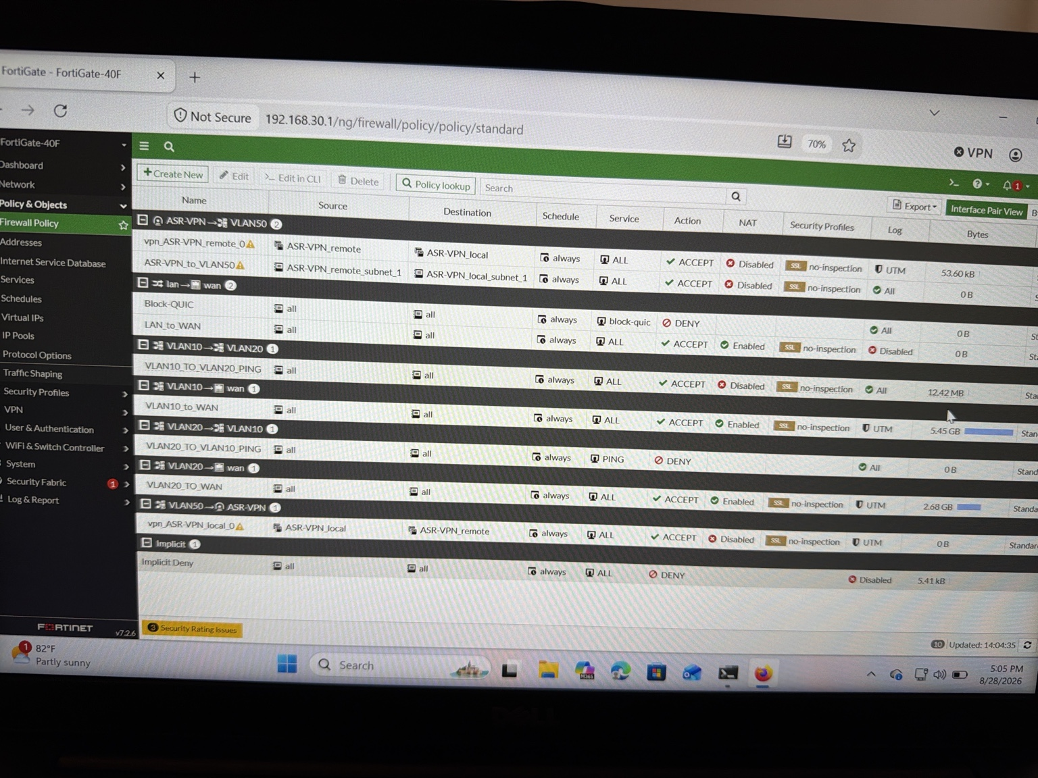
Figure 5. FortiGate firewall policies showing ASR-VPN <-> VLAN50 policy pairs with NAT disabled.

8. Testing and Verification

Connectivity was verified from both the Cisco ASR and the Windows workstation. The MacBook Air was also used as a separate management workstation for FortiGate GUI administration, troubleshooting, and the documentation/GitHub workflow.
MacBook Air management path: FortiGate GUI access and administration through the lab switch, plus project documentation/GitHub management.
ASR -> Windows:
router# ping 192.168.40.10
Success rate is 100 percent (5/5)

Windows -> ASR:
PS> ping 192.168.40.1
Packets: Sent = 4, Received = 4, Lost = 0 (0% loss)
The first Windows ping showed one timeout before successful replies. The immediate repeat test completed with 0% loss, consistent with initial neighbor/ARP resolution rather than a persistent routing failure.
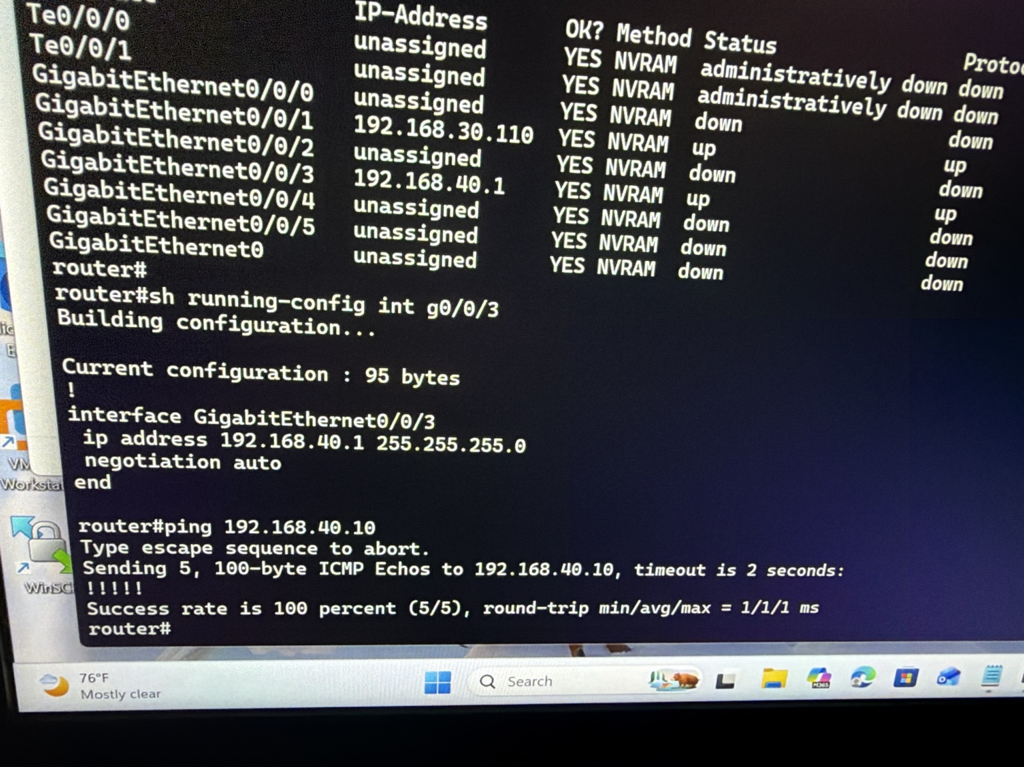
Figure 6. ASR interface addressing and successful ping to the Windows workstation.
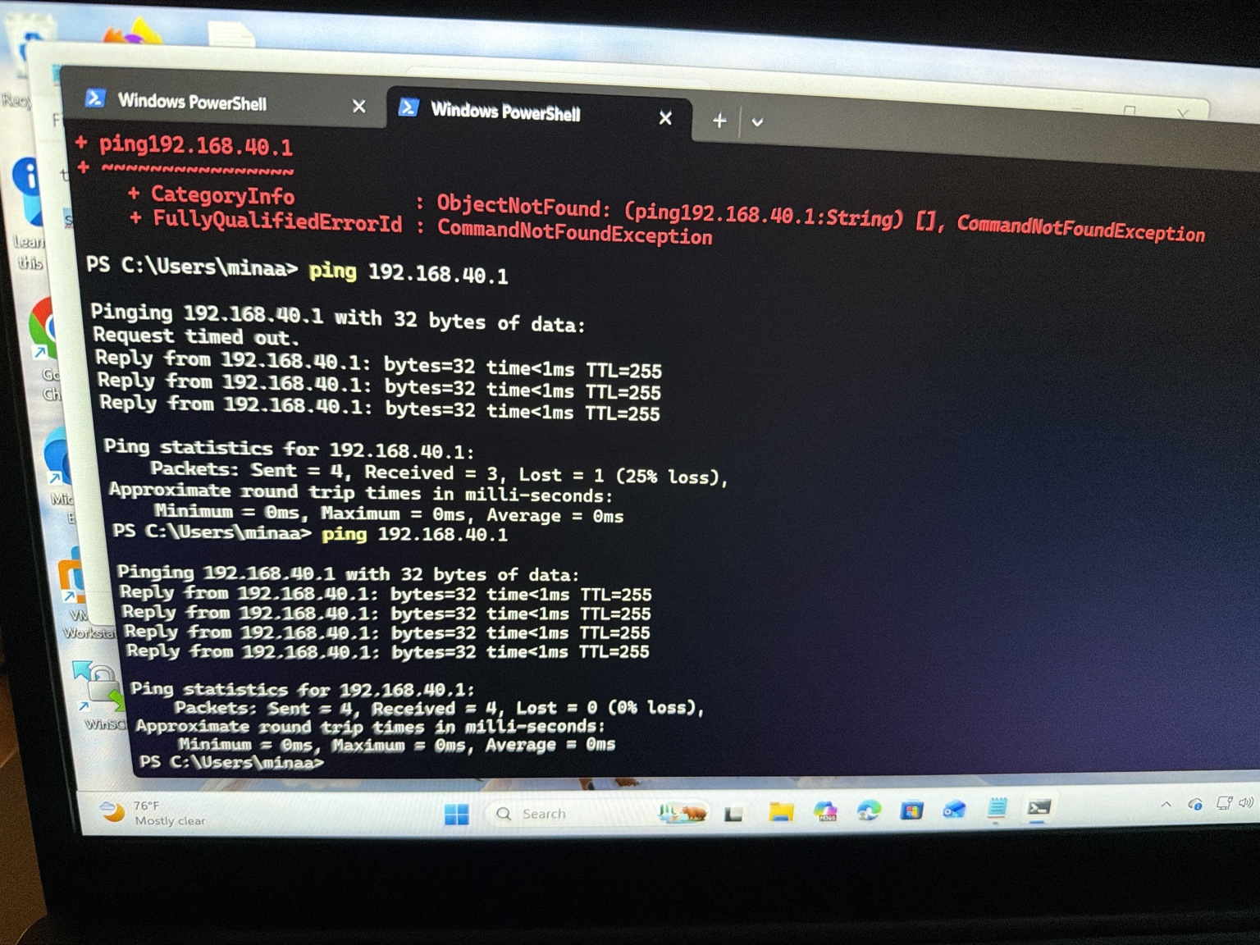
Figure 7. Windows connectivity test to ASR Gi0/0/3.

9. REST API and Python Automation

The FortiGate REST API was first tested manually from Windows. This separated network and authentication problems from Python logic. The endpoint used throughout the lab was:
/api/v2/monitor/system/status
After the request flow was corrected, the endpoint returned status success and reported the FortiGate-40F model, FortiOS v7.2.6, and build 1575.
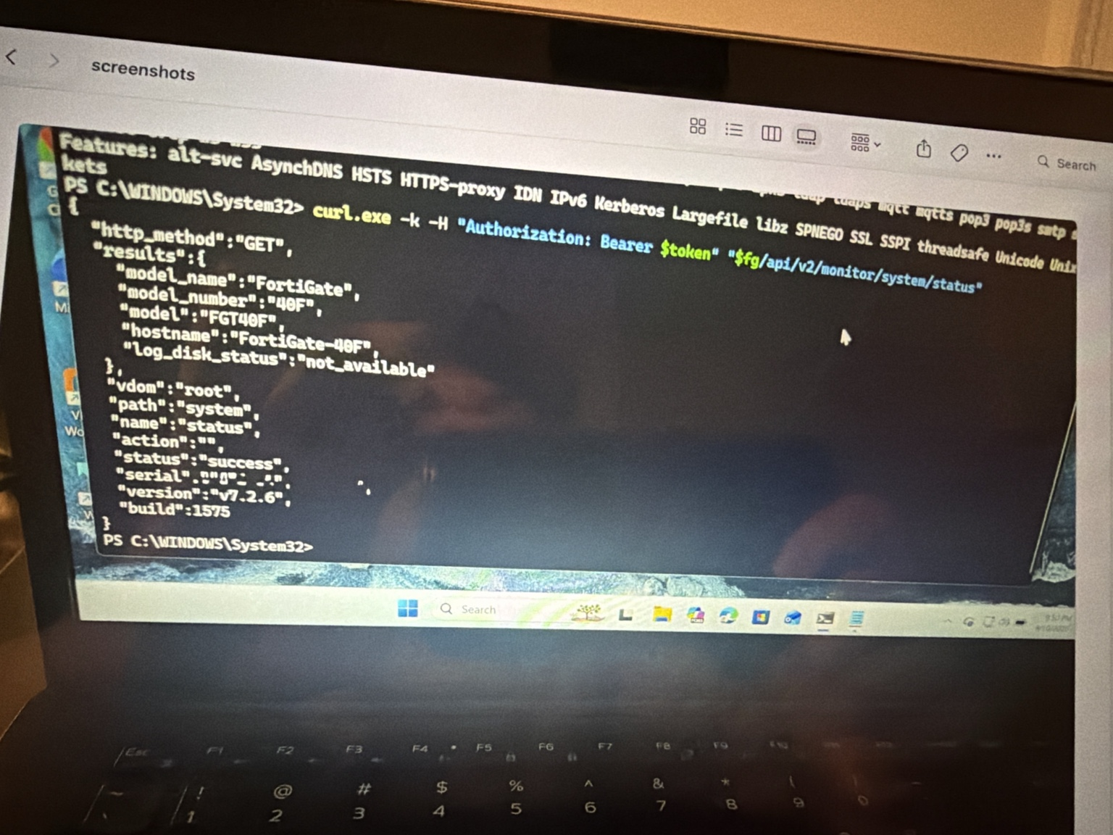
Figure 8. Successful FortiGate REST API system-status response.

Python automation behavior
- Prompts for the API token at runtime with getpass().
- Sends an authenticated HTTPS request with the Bearer token.
- Parses the returned JSON.
- Prints status, hostname, model, FortiOS version, and build.
- Does not hardcode the API token in the source file.
Because the home lab uses a self-signed certificate, the demonstration script disables certificate verification. Production automation should use a trusted certificate and keep TLS verification enabled.

10. Troubleshooting

The project used a layered troubleshooting process rather than changing multiple devices at once. A recurring goal was to prove each layer before moving upward.
- Verify device power, cabling, and interface state.
- Verify IP addresses and subnet masks.
- Test directly connected reachability.
- Inspect the routing table.
- Verify OSPF neighbor state.
- Verify route advertisement separately from neighbor formation.
- Review firewall policies and VPN selectors.
- Test the REST API independently.
- Verify authentication and request syntax.
- Run and validate the Python automation.

API troubleshooting example
During API testing, HTTP 401 Unauthorized and 429 Too Many Requests responses were observed. The troubleshooting process checked the endpoint, Bearer authorization header, token validity, request frequency, and HTTPS behavior.
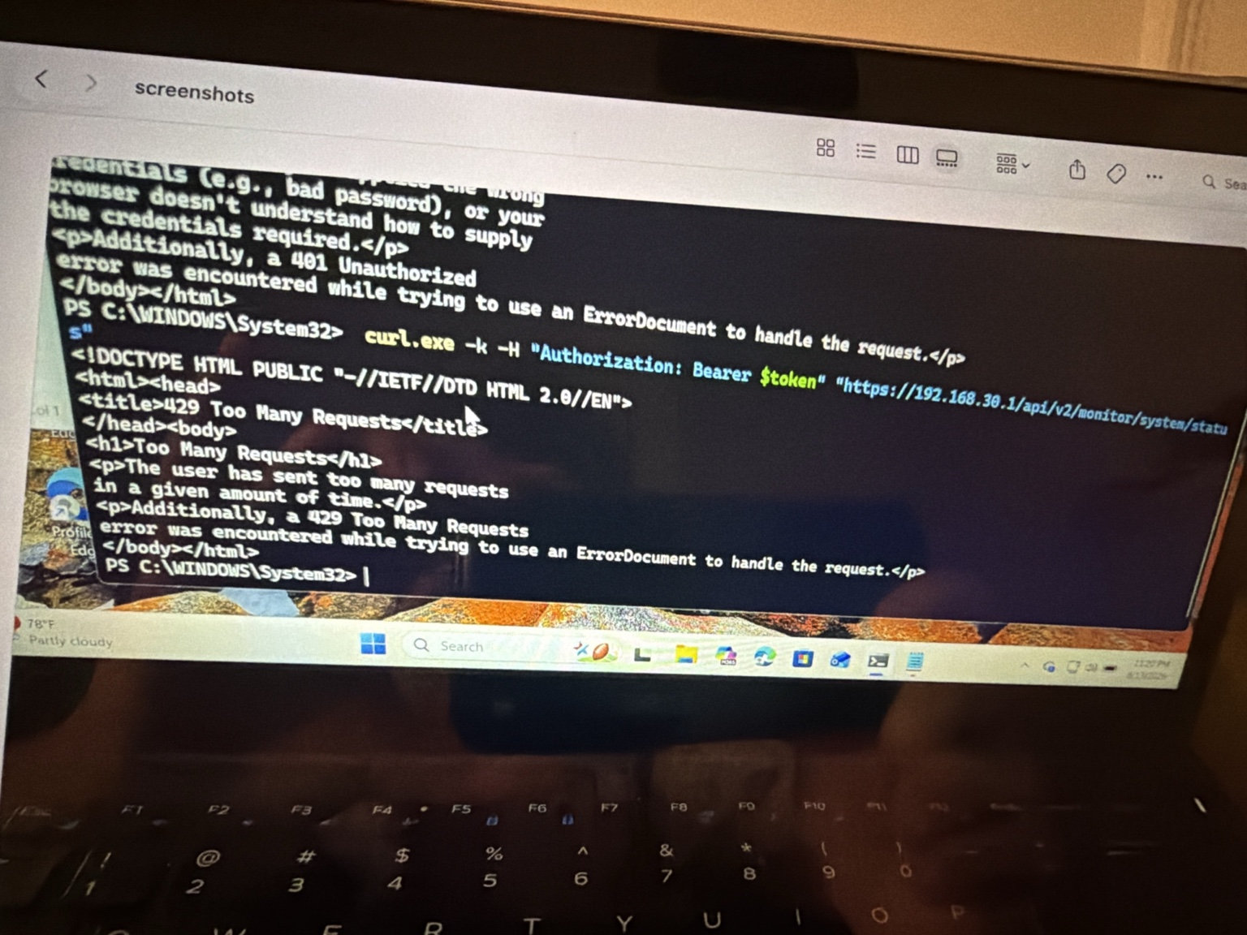
Figure 9. API troubleshooting evidence showing authentication and request-rate errors.

11. Lessons Learned

OSPF adjacency and route advertisement are separate. A FULL neighbor state proves the peers formed an adjacency; it does not by itself prove the desired default route is being advertised.
C and L route codes have different meanings. C identifies a connected network; L identifies the router's own local interface address.
A transport network is not the same as a protected VPN network. 192.168.30.0/24 carries peer communication, while 192.168.50.0/24 and 192.168.40.0/24 are the protected selectors.
Test APIs before automating them. A manual cURL/PowerShell success isolates API connectivity and authentication before Python is introduced.
Credentials should not be stored in code. Prompting for the token at runtime keeps the secret out of the repository.
Troubleshooting is faster when the problem domain is narrowed first. Physical, IP, routing, firewall/VPN, API, and automation layers can be validated one at a time.

12. Conclusion

Project 2 extended the home lab from basic segmentation and device access into dynamic routing, VPN design, REST API interaction, automation, and multi-workstation management. The Cisco ASR and FortiGate established a verified OSPF FULL/DR adjacency, the ASR learned a default route dynamically, direct Windows workstation connectivity was verified in both directions, the MacBook Air provided a separate FortiGate management/documentation path, and the FortiGate REST API returned a successful system-status response.
The project also documented the IPsec configuration and firewall policy design, while keeping secrets such as API tokens and the VPN pre-shared key out of the portfolio files. The final repository structure includes the report, topology, automation script, command reference, troubleshooting notes, and selected verification screenshots.
PROJECT STATUS: COMPLETED

