Implementation of Noble Gas Ingrowth

To do list
- Literature review of noble gas ingrowth;
- Add different noble gas into database;
- Consider noble gas absorption and partition in organic materials such as oil.

1. Ingrowth of helium

1.1 Review of Ballentine and Burnard 2002, Production, Release and Transport of Noble Gases in the Continental Crust.

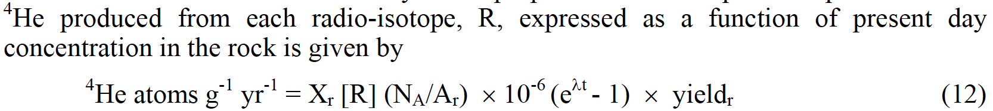
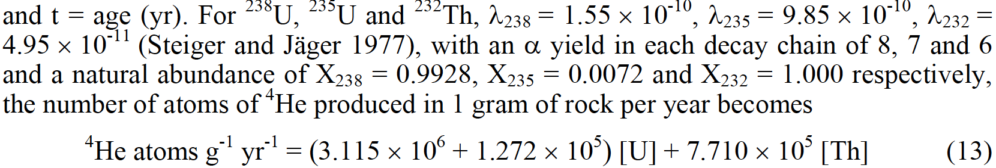

Looks like Equation 12 is not quite right. The rate should be divided by time t.
$${}_{}^{4}{He atoms g^{-1} {yr}^{-1}}=X_{r}\left[R\right]\left(N_{A}/A_{r}\right)×{10}^{-6}\left(e^{λt}-1\right)×{yield}_{r}/t$$
Or
$${}_{}^{4}{He atoms g^{-1} {yr}^{-1}}=X_{r}\left[R\right]\left(N_{A}/A_{r}\right)×{10}^{-6}\left(e^{λ}-1\right)×{yield}_{r}$$
Otherwise, put different t in equation 12 will have quite different production rate. Verification is shown in the table below, which matches equation 13 if the modified formula is used.
We can either the above modified one (more general, more parameters) or equation 13 (based on natural parameters, less parameters, but may not be used as specific case).
Variables | U238 | U235 | Th232
Xr | 0.9928 | 0.0072 | 1
[R] | 1 | 1 | 1
Na | 6.02E+23 | 6.02E+23 | 6.02E+23
Ar | 238.051 | 235.044 | 232.038
yield | 8 | 7 | 6
lamda | 1.55E-10 | 9.85E-10 | 4.95E-11
t | 2 | 2 | 2
Rate [g-1 yr-1] - eq 12 | 6.230E+06 | 2.544E+05 | 1.542E+06
Rate [g-1 yr-1] - new | 3.115E+06 | 1.272E+05 | 7.709E+05
The results in blue is calculated based on equation 12, which does not match equation 13 if t is not 1.
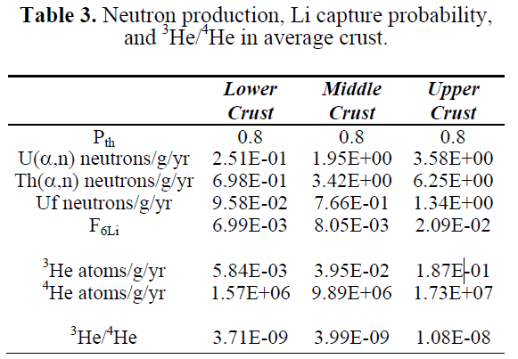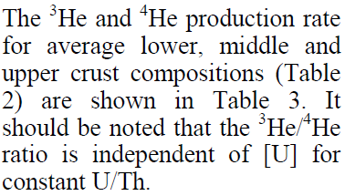
Can the production rate of ³He considered constant for the upper curst?
The earth’s crust contains an average of about 2-4 ppmuranium, 8.1 ppm thorium.
Average production rate of ⁴He calculated based on the correction equation is 1.27e+7 to 1.92e+7, which is consistent with the value 1.73e+7 in Table 3
Variable | Group 1 |  |  |  | Group 2
 | U238 | U235 | Th232 |  | U238 | U235 | Th232
Xr | 0.9928 | 0.0072 | 1 |  | 0.9928 | 0.0072 | 1
[R] | 2.00E+00 | 2.00E+00 | 8.1 |  | 4.00E+00 | 4.00E+00 | 8.1
Na | 6.02E+23 | 6.02E+23 | 6.02E+23 |  | 6.02E+23 | 6.02E+23 | 6.02E+23
Ar | 238.051 | 235.044 | 232.038 |  | 238.051 | 235.044 | 232.038
yield | 8 | 7 | 6 |  | 8 | 7 | 6
lamda | 1.55E-10 | 9.85E-10 | 4.95E-11 |  | 1.55E-10 | 9.85E-10 | 4.95E-11
t | 2 | 2 | 2 |  | 2 | 2 | 2
Rate [g-1 yr-1] | 6.230E+06 | 2.544E+05 | 6.244E+06 |  | 1.246E+07 | 5.089E+05 | 6.244E+06
Sum of rate | 1.273E+07 |  |  |  | 1.921E+07

1.2 Rate production formula to be implemented
For equation 13, the required parameters include the concentration of [U] and [Th] in solid phase, ppm or g/m^3 solid?

For more general equation, we need fractional natural abundance of isotope R, Avogadro’s number Na (constant), Molar mass of R (g, also constant), decay constant of R (yr⁻¹, constant), number of alpha particles emitted in the complete decay chain (8, 7, 6 for U238, U235 and Th232).
$${}_{}^{4}{He atoms g^{-1} {yr}^{-1}}=X_{r}\left[R\right]\left(N_{A}/A_{r}\right)×{10}^{-6}\left(e^{λt}-1\right)×{yield}_{r}/t$$

The production of He (mol) during one time step for one control volume can be calculated by
Q = ⁴He (atoms g⁻¹ yr⁻¹) *delt (yr) * cvol (m³) * bulk density (g m⁻³) / 6.02e23 (atmos mol⁻¹) => x mol

Do we need to consider ³He? If considered, use user specified rate of ³He or user specified ratio of ³He/⁴He?

1.3 How to implement in MIN3P code
Taking Helium as an example.
- Aqueous components be added (⁴He(aq)).
- Gas species to be added (⁴He).
- Reaction between aqueous and gas phases: ⁴He(aq) ⇔ ⁴He, ³He(aq) ⇔ ³He.
- Reaction between aqueous and mineral phases to represent production of helium and then calculate the updated aqueous concentration and gas saturation. This part is implemented as a source/sink term. We calculate how much He is generated during current time step delt and pass it to the right hand side. Since the production rate does not dependent on the aqueous phase of [U] and [Th], no Jacobi matrix modification is required.
- Verification examples? Compare results to the model without considering noble gas ingrowth. What kind of conceptual model shall we use?

I’d like to get this done in more general terms, as follows:
Ideally this would be done through mineral.dbs with a series of first-order decay reactions and the opportunity to specify the initial 238U, 235U and 232U concentrations in the domain, as a function of rock unit. This will make use of the existing framework for source-sink terms and can easily be expanded. However, this will require some modifications, because:
- The release of noble gases is dependent on a solid phase concentration, not an aqueous concentration. mineral.dbs does not allow to express a first order reaction based on a solid phase concentration at this time. This would have to be added.
- It would be nice to keep track of the products (not only He). This is also not facilitated by mineral.dbs at this point, since interactions only take place between a single mineral and aqueous components. This would require to include consumption and production of a solid phase. This step is probably more complicated, but much less important. Probably best to leave out for now.
This can be done as a function of volume fraction directly or solid phase concentration. In the future, this would lend itself well to extend the formulation to look at noble gas ingrowth directly linked to mineralogical composition. For example, the reaction ²³⁸U -> ²⁰⁶Pb + 8 ⁴He would go in the database along with the first order decay constant. ²³⁸U and ²⁰⁶Pb would be solids. ⁴He is the aqueous component. The rate would be written as R = - k [²³⁸U], leading to the production of ²⁰⁶Pb (no need to keep track of that initially) and the release of 8 ⁴He to the water phase. Since there is no limit on ²³⁸U over time scales of interest, this should be fairly straightforward. ²³⁸U (and possibly ²⁰⁶Pb) can be updated at end of time step. Concentrations would have to be given in terms of [mol L-1 bulk] (volume fraction does not make sense in this case). Therefore some adjustments needed re input in .dat file, or .min file.
We can discuss this in a meeting next week.
Specifically for the case with He (from Wikipedia https://en.wikipedia.org/wiki/Uranium-238):
Note all rate coefficients end up the same as in Ballantine paper.
238U – yield 8 He
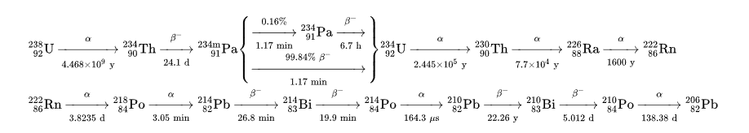
Effectively (because 1st step is rate-determining): ²³⁸U -> ²⁰⁶Pb + 8 ⁴He with k = 0.693/ t1/2 = 0.693 / 4.468 x 10^9 = 1.55 x 10-10 yr-1
R = - k [²³⁸U] or in terms of production of ⁴He: R = 8 k [²³⁸U], note that ²³⁸U is U in solid phase

235U – yield 7 He
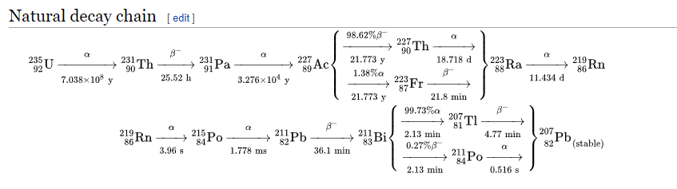

Effectively: ²³⁵U -> ²⁰⁷Pb + 7 ⁴He with k = 0.693/ t1/2 = 0.693 / 7.038 x 10^8 = 9.85 x 10-10 yr-1
R = - k [²³⁵U] or in terms of production of ⁴He: R = 7 k [²³⁵U], note that ²³⁵U is U in solid phase

232 Th – Yield 6 He

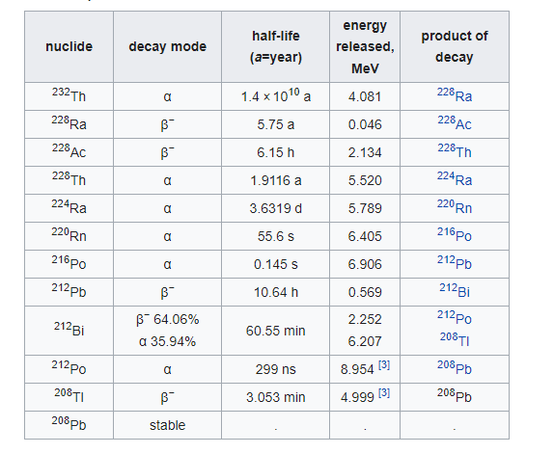

Effectively: ²³²Th -> ²⁰⁸Pb + 6 ⁴He with k = 0.693/ t1/2 = 0.693 / 1.4 x 10^10 = 4.95 x 10-11 yr-1
R = - k [²³²Th] or in terms of production of ⁴He: R = 6 k [²³²Th], note that ²³²Th is Th in solid phase

Formulation and keywords to be used
Rate formulation: R = - k [M] =ln2/(t_halflife)

Input file
‘Components’
‘4He(aq)’
‘206Pb(aq)’ ;can be ignored if this is not necessary to be considered
‘207Pb(aq)’
‘208Pb(aq)’

‘minerals’
‘238U-yield-8He’
‘235U-yield-7He’
‘232Th-yield-6He’

‘scaling for kinetic reactions’
4.919e-18 ; s⁻¹, = 1.55 x 10⁻¹⁰ yr-1
3.123e-17 ; s⁻¹, = 9.85 x 10⁻¹⁰ yr-1
1.570e-18 ; s⁻¹, = 4.95 x 10⁻¹¹ yr-1

Database mineral.dbs
! Noble gas ingrowth - May 2022
!
!'238u-yield-8he'
!
'238u-yield-8he'
'surface'
238.0 19.1 ;to be updated
1 '4he(aq)' 8 ; 2 '206Pb(aq)' 1.0 '4he(aq)' 8
'irreversible dissolution'
'log rate constant' -17.308
'fractional C^m' 1 ;function of solid or mineral phase concentration
'238u-yield-8he' 1

!
!'235u-yield-7he'
!
'235u-yield-7he'
'surface'
235.0 19.1 ;to be updated
1 '4he(aq)' 7 ; 2 '207Pb(aq)' 1.0 '4he(aq)' 7
'irreversible dissolution'
'log rate constant' -16.505
'fractional C^m' 1 ;function of solid or mineral phase concentration
'235u-yield-7he' 1

!
!'232th-yield-6he'
!
'232th-yield-6he'
'surface'
232.0 11.7 ;to be updated
1 '4he(aq)' 6 ; 2 '208Pb(aq)' 1.0 '4he(aq)' 6
'irreversible dissolution'
'log rate constant' -17.804
'fractional C^m 1 ;function of solid or mineral phase concentration
'232th-yield-6he' 1

Batch reaction; 1D diffusion; probably DGR site?

Assuming [238U] = 1ppm = 1mg L⁻¹ = 1g/m³ solid, cvol = 1 m³, delt = 1 year,

1 g ²³⁸U equals 10⁶ g rock, generates ⁴He in one year according to equation 13
Q (4He)= 3.115e6*1*1*1*1.0e6/6.02e23=5.17e-12 mol

1 g ²³⁸U generates ⁴He in one year according to rate constant from wikipedia
²³⁸U -> ²⁰⁶Pb + 8 ⁴He with k = 0.693/ t1/2 = 0.693 / 4.468 x 10^9 = 1.55 x 10-10 yr-1
Q(4He)=1.0/238*1.55e-10*8=5.21e-12 mol

Andrews et al. 1989, Atmospheric and radiogenic gases in groundwaters from the Stripa granite, Geochimica et Cosmochimica Acta, Vol 53, pp. 1831-1841

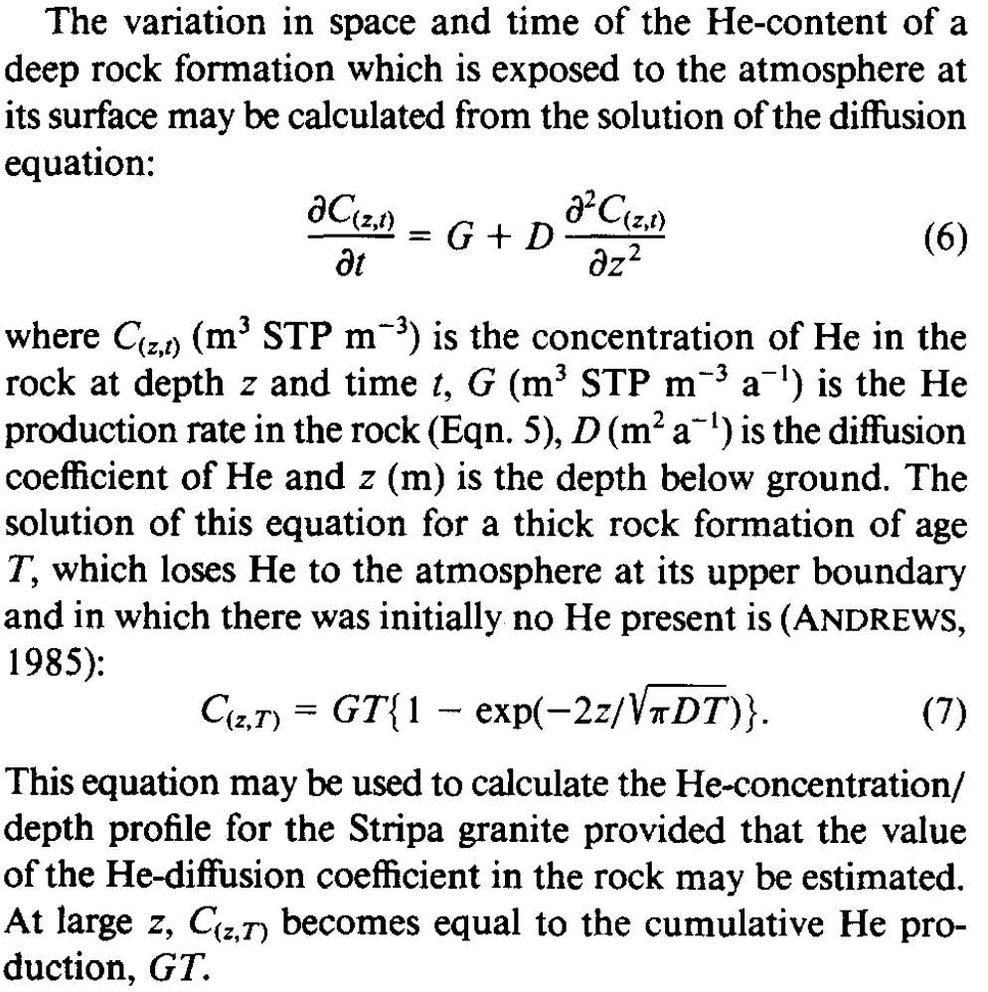

Static fluid in a fracture within a rock containing stored He must gradually acquire He by diffusion out of the rock matrix. An equilibrium is established when the chemical potentials for He in the rock matrix and in the water phase are equal.

