

1. (2k+1)-point discrete Hilbert transform filter

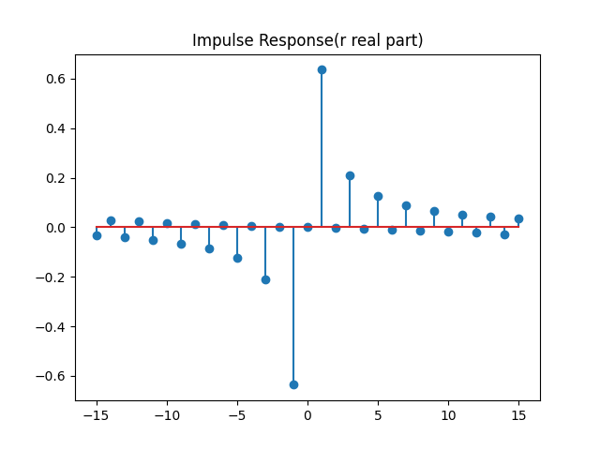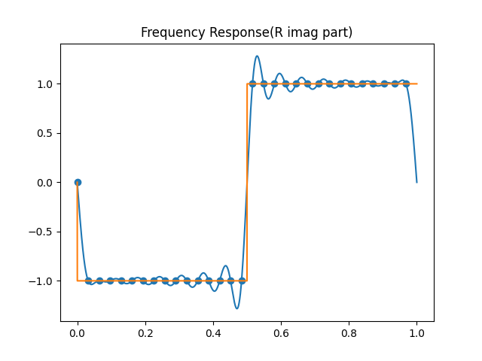In our python file, we can open it using **python DiscreteHilbert.py 15** the last parameter is an integer number of k

