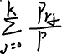

2、

import cv2

import numpy as np

import matplotlib.pyplot as plt

def imgfilter2D(img, filter, ratio):

    img_x, img_y = img.shape

    filter_x, filter_y = filter.shape

    result_mtx = np.zeros(((img_x - filter_x + 1), (img_y - filter_y + 1)))

    for i in range(result_mtx.shape[0]):

        for j in range(result_mtx.shape[1]):

            result_mtx[i][j] = np.abs(np.sum(img[i:i + filter_x, j:j + filter_y] * filter) / ratio)

    return result_mtx.astype('uint8').reshape(result_mtx.shape[0], result_mtx.shape[1], 1)

def gaussian_filter(filter_size, sigma):

    filter = np.zeros((filter_size, filter_size))

    img_x, img_y = filter.shape

    center = (img_x//2, img_y//2)

    for x_loc in range(img_x):

        for y_loc in range(img_y):

            dist_x_center = x_loc-center[0]

            dist_y_center = y_loc-center[1]

            r_sqr = ((dist_x_center)**2 + (dist_y_center)**2)

            filter[x_loc][y_loc] = np.exp(-r_sqr/(2*(sigma**2)))

    return filter

img=cv2.imread("479632_checkerboard1024-shaded.tif", cv2.IMREAD_GRAYSCALE)

padding_img = np.pad(img, (128, 128), 'reflect')

g_filter = gaussian_filter(257, 64)

gaussian_blur_img = imgfilter2D(padding_img, g_filter, np.sum(g_filter))

plt.imshow(gaussian_blur_img, "gray")

plt.show()

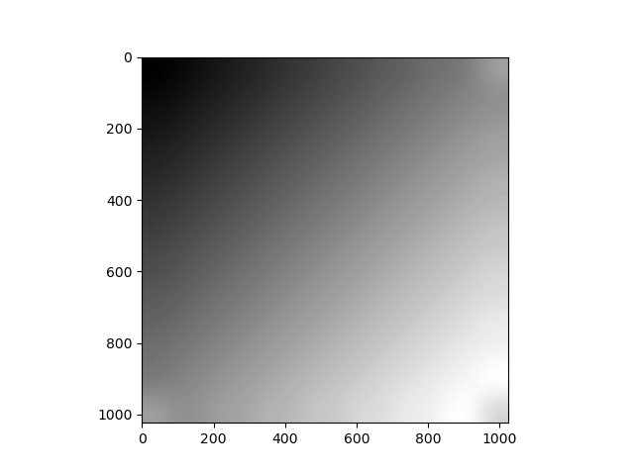

process_img = (img/gaussian_blur_img)

plt.imshow(process_img, "gray")

plt.show()

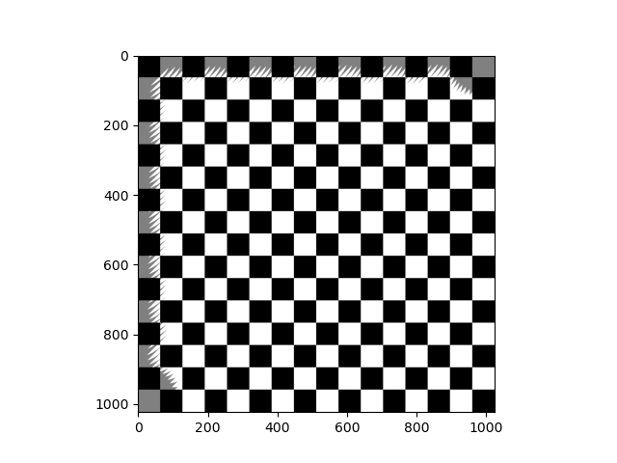

In another way we use

FFT base low pass filter will rect kernel radius 8

def low_pass_filter(dia, img_shape):

    filter = np.zeros(img_shape[:2])

    img_x, img_y = filter.shape

    center = (img_x//2, img_y//2)

    for x_loc in range(img_x):

        for y_loc in range(img_y):

            if dia > ((x_loc-center[0])**2 + (y_loc-center[1])**2)**0.5:

                filter[x_loc][y_loc] = 1

    return filter

def rever_fft_with_filter(fftshift_img, filter_size):

        passfilter_fftshift_img = fftshift_img * low_pass_gaussian_filter(filter_size, sigma, (fftshift_img.shape))

    passfilter_ifftshift_img = np.fft.ifftshift(passfilter_fftshift_img)

    passfilter_img = np.fft.ifft2(passfilter_ifftshift_img)

    return passfilter_img

fft_img = np.fft.fft2(img)

fftshift_img = np.fft.fftshift(fft_img)

low_pass_8 = np.abs(rever_fft_with_filter(fftshift_img, 8))

low_pass_img = np.clip(np.abs(rever_fft_with_filter(fftshift_img, 8, 4)), 0, 255)

process_img = (img-low_pass_img).astype("uint8")

plt.imshow(low_pass_img, "gray")

plt.show()

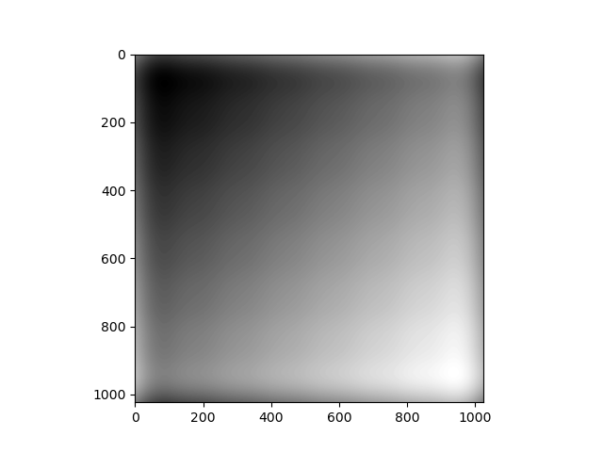

plt.imshow(process_img, "gray")

plt.show()

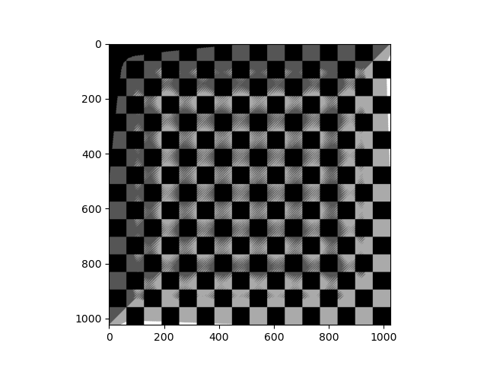

2-2、

Due to our use reflecting method padding so the right bottom block padding will add another 3 black block around his neighbor.

3、

import cv2

import numpy as np

import matplotlib.pyplot as plt

def bgr2gray(img):

    return ( img[:, :, 0]*0.114 + img[:, :, 1]*0.587 + img[:, :, 2]*0.299).astype('uint8').reshape(img.shape[0],img.shape[1],1)

def hist_equal(img_array):

    flat = img_array.flatten()

    n = len(flat)

    img_bincount = np.bincount(flat)

    T = 190 * np.cumsum(img_bincount)/n

    T = T.astype('uint8')

    return T[img_array.astype('uint8')]

def custom_equal(img_array):

    flat = img_array.flatten()

    n = len(flat)

    img_bincount = np.bincount(flat)

    new_mapping_table = np.arange(len(img_bincount))

    T = ((new_mapping_table-73) * 0.5) + np.clip(((new_mapping_table-85) * 6.5), 0, 2222) - np.clip(((new_mapping_table-103) * 5.5), 0, 2222)

    print(T)

    T = T.astype('uint8')

    return T[img_array.astype('uint8')]

img=cv2.imread("479632_einstein-low-contrast.tif", cv2.IMREAD_GRAYSCALE)

after_hist = hist_equal(img)

# gray_img = bgr2gray(img)

array_img = np.asarray(img)

result = custom_equal(array_img)

flat = after_hist.flatten()

plt.hist(flat, bins=50)

plt.show()

plt.imshow(after_hist, cmap = 'gray')

plt.show()

we read as gray image will show a not bad result

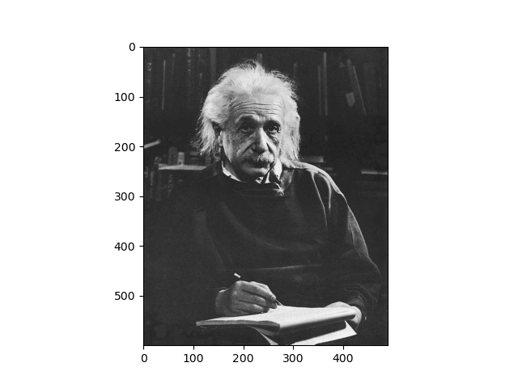

use normal histogram equalizer we will get

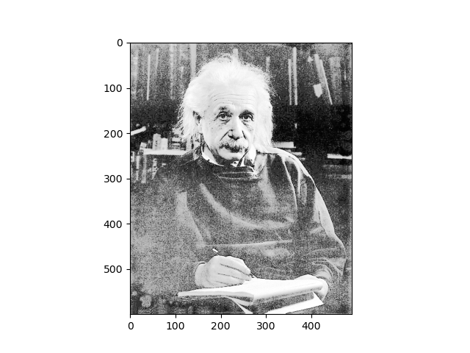

And we use our customization way to enhance the data distribution

Raw data

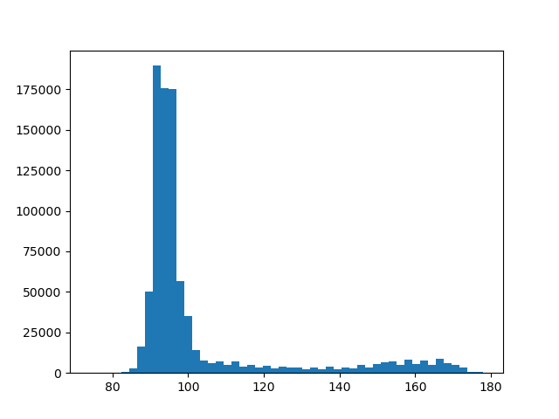

After histogram equalization

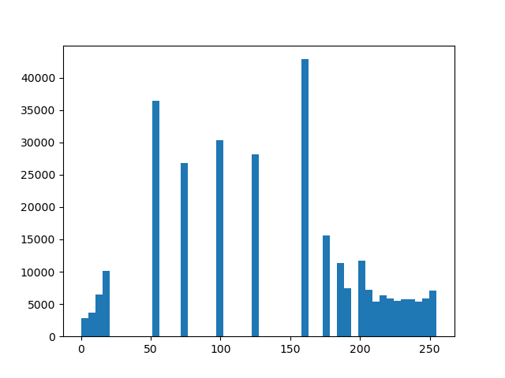

In above result we have to enhance 80-110 intensity resolution in raw picture we use our customization way

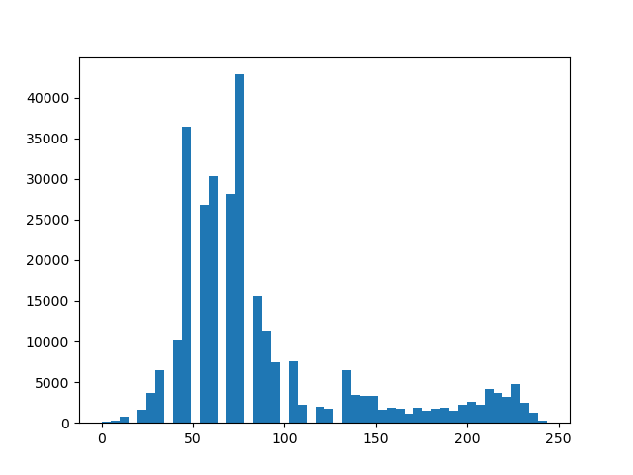

Get better result in distribution

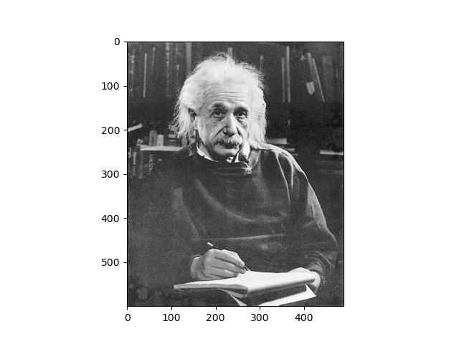

Also in our processed image