1、

import numpy as np

import cv2

import matplotlib.pyplot as plt

from matplotlib.colors import LogNorm

keyboard_img = cv2.imread("480548_keyboard.tif", cv2.IMREAD_GRAYSCALE)

fft_img = np.fft.fft2(keyboard_img)

spec_img = np.fft.fftshift(fft_img)

plt.imshow(np.abs(spec_img), norm=LogNorm(vmin=5))

plt.show()

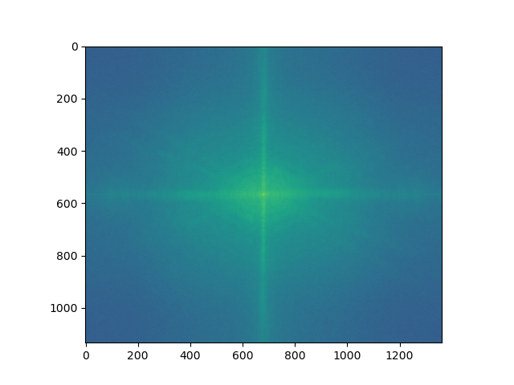

(a) Show the Fourier spectrum of the test image “keyboard” specified for this homework.

kernel=np.array([[-1, -2, -1],[0, 0, 0],[1, 2, 1]], dtype="int")

(b)Enforce odd symmetry on the kernel.

# odd symmetry the kernel change to below I don't know the question exactly “odd symmetry” means

# kernel=np.array([[0, -1, -2],[1, 0, -1],[2, 1, 0]], dtype="int")

# the original also odd symmetry in y axis

padding_size = (keyboard_img.shape[0] - kernel.shape[0], keyboard_img.shape[1] - kernel.shape[1])

kernel = np.pad(kernel, (((padding_size[0]+1)//2, padding_size[0]//2), ((padding_size[1]+1)//2, padding_size[1]//2)), 'constant')

kernel = np.fft.ifftshift(kernel)

freq_sobel_img = np.real(np.fft.ifft2(np.fft.fft2(keyboard_img) * np.fft.fft2(kernel)))

plt.imshow(freq_sobel_img, 'gray')

plt.show()

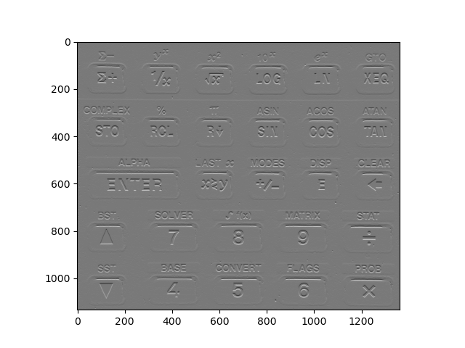

(c) Show the result of frequency-domain filtering of the test image using the horizontal Sobel kernel.

def imgfilter2D(img, filter, ratio):

    filter = np.flip(filter)

    img_x, img_y = img.shape

    filter_x, filter_y = filter.shape

    result_mtx = np.zeros(((img_x - filter_x + 1), (img_y - filter_y + 1)))

    for i in range(result_mtx.shape[0]):

        for j in range(result_mtx.shape[1]):

            result_mtx[i][j] = np.sum(img[i:i + filter_x, j:j + filter_y] * filter) / ratio

    result_mtx = ((result_mtx/np.max(np.abs(result_mtx))) + 1)*127.5

    return result_mtx.astype('uint8')

kernel=np.array([[-1, -2, -1],[0, 0, 0],[1, 2, 1]], dtype="int")

result_sobel_y = imgfilter2D(keyboard_img, kernel, 4)

plt.imshow(result_sobel_y, 'gray')

plt.show()

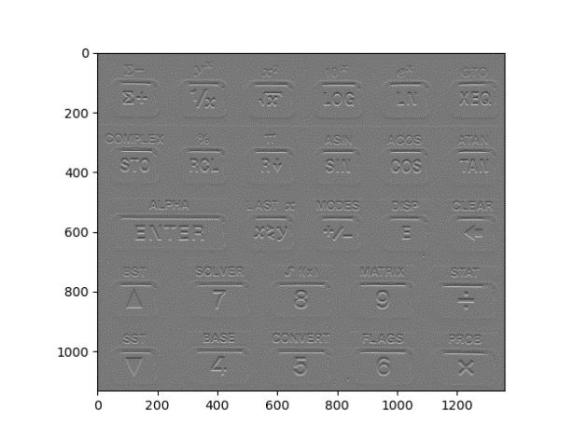

Left is frequency domain right is space domain

(d)Compare your result in (c) with the result of space-domain filtering.

Not obviously different in this case

(e) Show the result of frequency-domain filtering of the test image using the horizontal Sobel kernel without enforcing odd symmetry on the kernel.

kernel=np.array([[-1, -2, -1],[0, 0, 0],[1, 2, 1]], dtype="int")

padding_size = (keyboard_img.shape[0] - kernel.shape[0], keyboard_img.shape[1] - kernel.shape[1])

kernel = np.pad(kernel, (((padding_size[0]+1)//2, padding_size[0]//2), ((padding_size[1]+1)//2, padding_size[1]//2)), 'constant')

kernel = np.fft.ifftshift(kernel)

freq_sobel_img = np.real(np.fft.ifft2(np.fft.fft2(keyboard_img) * np.fft.fft2(kernel)))

plt.imshow(freq_sobel_img, 'gray')

plt.show()



2、

import numpy as np

import cv2

import matplotlib.pyplot as plt

from matplotlib.colors import LogNorm

img_newspaper = cv2.imread("480548_newspaper.tif", cv2.IMREAD_GRAYSCALE)

fft_img = np.fft.fft2(img_newspaper)

spec_img = np.fft.fftshift(fft_img)

plt.imshow(np.abs(spec_img), norm=LogNorm(vmin=5))

plt.show()

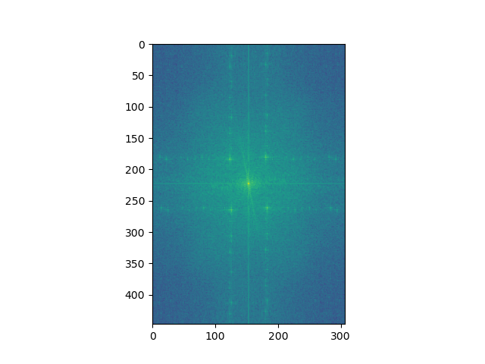

Get spectrum

reject_filter = np.ones(img_newspaper.shape)

reject_filter[:, 120:130] = 0

reject_filter[:, 175:185] = 0

reject_filter[190:255, 120:130] = 1

reject_filter[190:255, 175:185] = 1

reject_filter[170:190, :] = 0

reject_filter[255:275, :] = 0

reject_filter[170:190, 130:175] = 1

reject_filter[255:275, 130:175] = 1

plt.imshow(reject_filter*255, "gray")

plt.show()

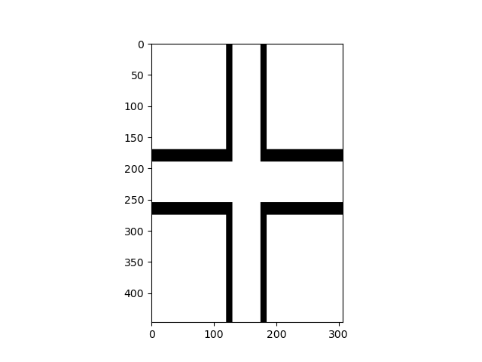

Our design reject filter

filter_spectrum = spec_img * reject_filter

filter_spectrum = np.fft.ifftshift(filter_spectrum)

result_img = np.fft.ifft2(filter_spectrum)

plt.imshow(np.abs(result_img), "gray")

plt.show()

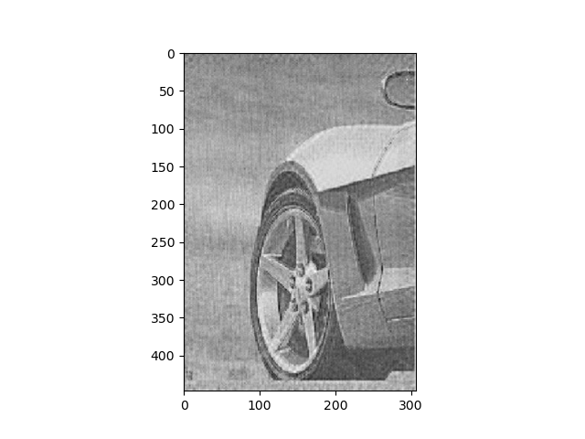

Image processing result

img_cassini = cv2.imread("480548_cassini.tif", cv2.IMREAD_GRAYSCALE)

fft_img = np.fft.fft2(img_cassini)

spec_img = np.fft.fftshift(fft_img)

plt.imshow(np.abs(spec_img), norm=LogNorm(vmin=5))

plt.show()

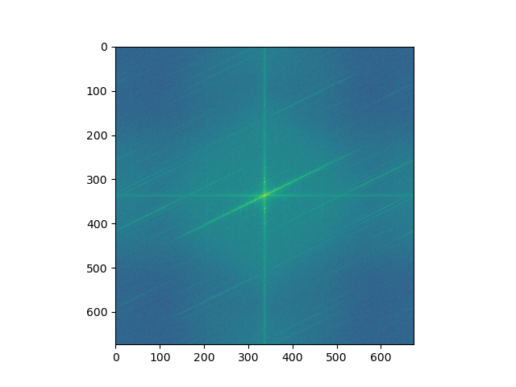

Image spectrum

reject_filter = np.ones(img_cassini.shape)

reject_filter[:, 335:339] = 0

reject_filter[330:350, 335:339] = 1

plt.imshow(reject_filter*255, "gray")

plt.show()

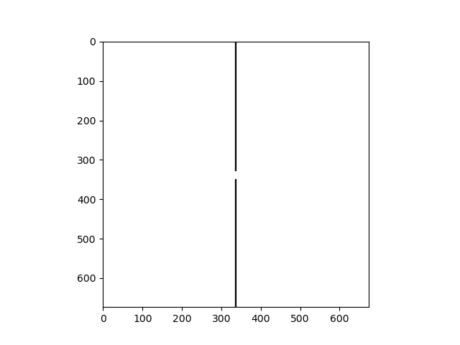

Reject filter

filter_spectrum = spec_img * reject_filter

filter_spectrum = np.fft.ifftshift(filter_spectrum)

result_img = np.fft.ifft2(filter_spectrum)

plt.imshow(np.abs(result_img), "gray")

plt.show()

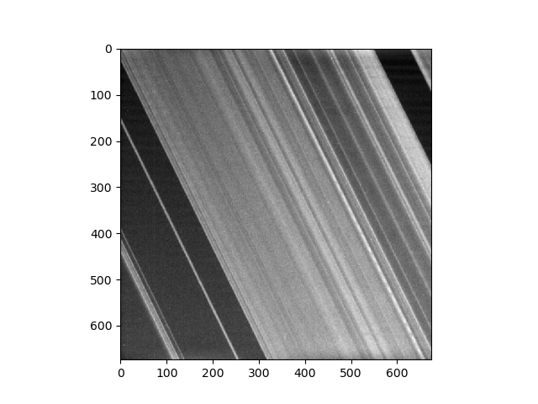

Image Result