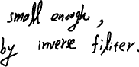

2.

我們利用size挑選filter 大小 degree 則是相對於中心點的角度，若坐落於該角度則設置為 1 反之為 0，然後再padding到相同於輸入圖片的大小。

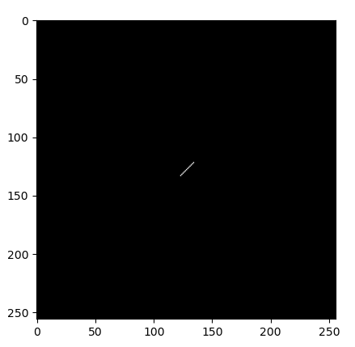

Photographer denoise we use motion filter for -45 degree motion in size 13 like above figure with K = 0.25 to get the result but not processing very well.

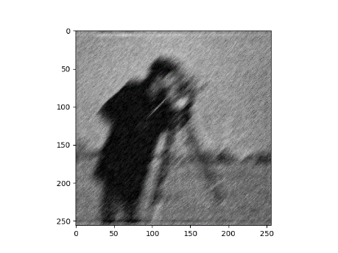

Football image we use motion filter for -45 degree motion in size 15 with K = 0.01 to get the result.

