**Neural networks task 1**

**Team ID: CS_H22**

Team members:

- Amgad AbdelBaset 20191700132

- Andrew Nassef Amin 20191700144

- Mina Sami Anwar 20191700676

**Note: training accuracy always between 98%– 100%, in all models our goal was to solve overfitting.**

**Trial 1: CNN Model**

At first, we tried to implement the architecture found in LAB 7 in many ways as of changing the hyperparameters (filter size, number of filters, stride size, activation functions) as well as the number of layers (fully connected, convolution, maximum pooling), also adding regularization methods to prevent overfitting (batch normalization, dropout)

**Conclusion**



Public accuracy: 80%

Private accuracy: 78%

We began to understand what to do in case of overfitting, underfitting, understanding the process for hyperparameter tuning and how to deal with insufficient data.

**Trial 2: VGG16 Model (without weights)**

We then tried to look online for models used to solve similar classification problems and found the VGG16 model, so we tried to implement its architecture but without weights

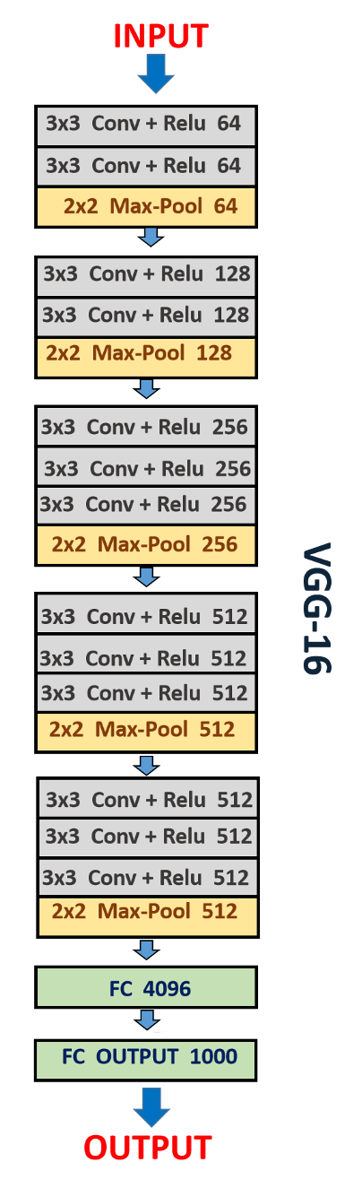

**Conclusion**



Public accuracy: 76%

Private accuracy: 77%

We noticed that using the model without its weight achieved similar accuracy to trial 1 accuracy, so we tried to use transfer learning

**Trial 3: VGG16 Model (with weights)**

We then saw that using the model’s pretrained weights that was trained on a dataset called ImageNet achieved higher accuracy

**Conclusion**



Public accuracy: 83%

Private accuracy: 82%

Using the model pre-trained weights achieved higher accuracy so we decided to always use the weights

**Trial 4: Xception Model (with weights)**

We then decided to use the Xception Model and implement its architecture which achieved the highest accuracy in the ImageNet problem hoping to achieve higher accuracy in our problem

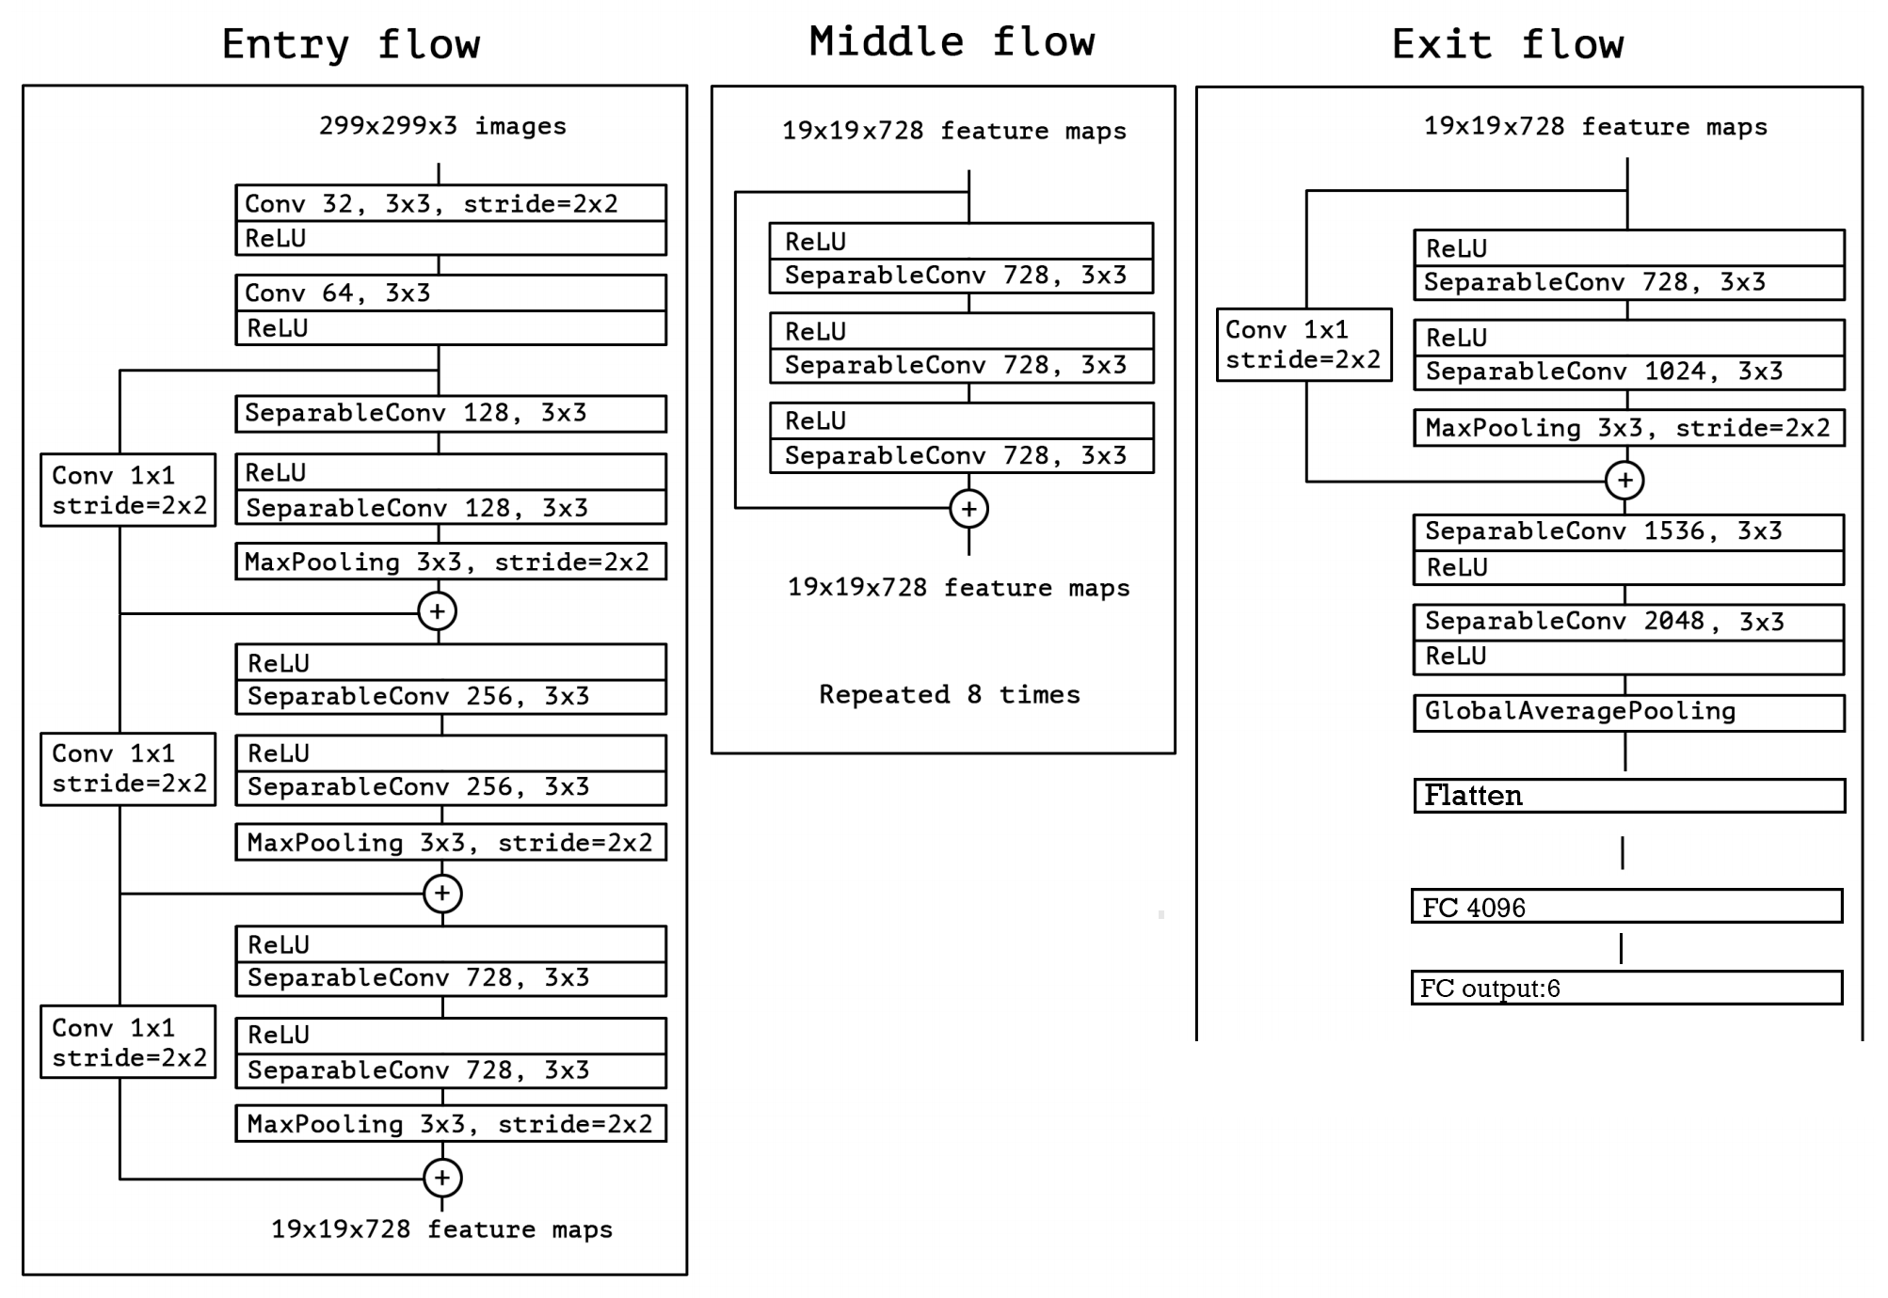

**Conclusion**



Public accuracy: 95%

Private accuracy: 93%

As expected, when we used the xception model with its pre-trained weights we achieved even higher accuracy than the VGG16 and that was the best accuracy we could achieve.