My skills
Microsoft Power BI

Power Platform Assistant / Junior Power Platform Expert at AstraZeneca
MongoDB


NoSQL

Yrkeshögskolan Campus Mölndal
Entity Framework

NBI/Handelsakademin
API Development


Monte Carlo Simulation


Chalmers University of Technology
Retrieval-Augmented Generation (RAG)

Chalmers University of Technology
Large Language Models (LLM)

Chalmers University of Technology
DevOps

Yrkeshögskolan Campus Mölndal
Containerization

Yrkeshögskolan Campus Mölndal
Helm (Software)


Yrkeshögskolan Campus Mölndal
ARM Architecture

Yrkeshögskolan Campus Mölndal
TensorFlow

Chalmers University of Technology
Recommender Systems

Chalmers University of Technology
Model Interpretation

Chalmers University of Technology
Lime

Chalmers University of Technology
Azure Cosmos DB


System Developer at Sigma Technology Group
Agile Application Development


Software Development




Representational State Transfer (REST)


AWS CloudFormation

Yrkeshögskolan Campus Mölndal

Microsoft PowerPoint

Power Platform Assistant / Junior Power Platform Expert at AstraZeneca


Powershell

Power Platform Assistant / Junior Power Platform Expert at AstraZeneca
Database Design

Power Platform Assistant / Junior Power Platform Expert at AstraZeneca


Microsoft Power Automate

Power Platform Assistant / Junior Power Platform Expert at AstraZeneca
Microsoft Power Apps


Power Platform Assistant / Junior Power Platform Expert at AstraZeneca
Data Analysis

Chalmers University of Technology
Computer Vision

Chalmers University of Technology
Deep Learning

Chalmers University of Technology
Scikit-Learn

Chalmers University of Technology
NumPy


Chalmers University of Technology
Pandas (Software)

Chalmers University of Technology
Linux

Yrkeshögskolan Campus Mölndal
Continuous Integration and Continuous Delivery (CI/CD)

Yrkeshögskolan Campus Mölndal
Kubernetes

Yrkeshögskolan Campus Mölndal
Docker

Yrkeshögskolan Campus Mölndal
GitHub

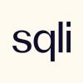



Microsoft Office




ASP.NET MVC
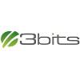
System Software Developer at 3bits Consulting AB

NBI/Handelsakademin
.NET Framework

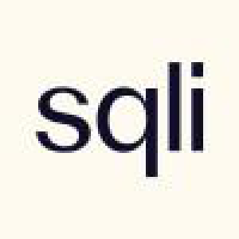


Passed LinkedIn Skill Assessment
Dataverse - Power Platform

Power Platform Assistant / Junior Power Platform Expert at AstraZeneca
SharePoint

Power Platform Assistant / Junior Power Platform Expert at AstraZeneca
Azure Service Bus
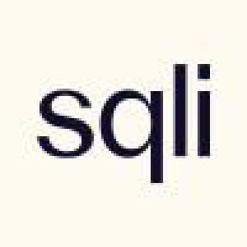
System Developer at SQLI Nordics
RabbitMQ

System Software Developer at 3bits Consulting AB

AMQP
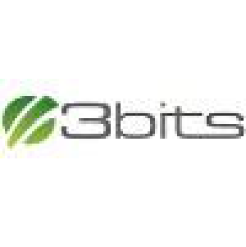
System Software Developer at 3bits Consulting AB
ADO.NET

System Software Developer at 3bits Consulting AB
SOAP

System Software Developer at 3bits Consulting AB
Active Directory

System Developer at Sigma Technology Group
REST APIs

System Developer at Sigma Technology Group
Python (Programming Language)


Chalmers University of Technology
Machine Learning

Chalmers University of Technology
Artificial Intelligence (AI)

Chalmers University of Technology
Statistics

Chalmers University of Technology
PyTorch

Chalmers University of Technology
ASP.NET Core


NBI/Handelsakademin
Database Design & Modeling

NBI/Handelsakademin
Data Management and Storage

NBI/Handelsakademin
Software Testing & Quality Assurance

NBI/Handelsakademin
Unit Testing

NBI/Handelsakademin
Test Automation (basic)

NBI/Handelsakademin
Agile / Scrum


System Developer at SQLI Nordics

NBI/Handelsakademin
Consulting and Communication Skills

NBI/Handelsakademin
Problem Solving

NBI/Handelsakademin
Work-Based Learning (LIA Projects)

NBI/Handelsakademin
Object-Oriented Programming in C#

System Developer at Sigma Technology Group


Yrkeshögskolan Campus Mölndal
Test and Quality Assurance

Yrkeshögskolan Campus Mölndal
Fundamental Cloud Applications

Yrkeshögskolan Campus Mölndal
Object-Oriented Architecture

Yrkeshögskolan Campus Mölndal
Scalable Cloud Applications

Yrkeshögskolan Campus Mölndal
AWS Lambda


Yrkeshögskolan Campus Mölndal
Consulting Approach and Communication

Yrkeshögskolan Campus Mölndal
Low-Code Development Platforms
Cloud Computing
Amazon Web Services (AWS)
Google Cloud Platform (GCP)
Microsoft Azure
Microsoft Power Platform

Power Platform Assistant / Junior Power Platform Expert at AstraZeneca Programming
Marketing Strategy
SQL

NBI/Handelsakademin
JavaScript
Agile Methodologies
HTML
Passed LinkedIn Skill Assessment
Databases


Power Platform Assistant / Junior Power Platform Expert at AstraZeneca
Microsoft SQL Server


Object-Oriented Programming (OOP)

NBI/Handelsakademin
C#



NBI/Handelsakademin
Passed LinkedIn Skill Assessment
ASP.NET
.NET Core
ASP.NET Web API
jQuery
React.js

Git
Bootstrap
Docker Products
WordPress
Entity Framework (EF) Core

System Developer at Sigma Technology Group

NBI/Handelsakademin
Product Information Management
Inriver

System Developer at SQLI Nordics
Azure Functions

Yrkeshögskolan Campus Mölndal

