Round Robin vs SRTF

Simulation, Analysis & Comparison Documentation

Project Title
Round Robin vs SRTF Comparison Project

Table of Contents
# | Section
1 | Project Overview
2 | System Architecture
3 | Algorithm Design
3.1 | Round Robin Scheduling
3.2 | SRTF – Shortest Remaining Time First
4 | Metrics Calculation
5 | Input Validation
6 | GUI & Interface Description
7 | Test Scenarios
8 | Comparison & Analysis
9 | Conclusion

1. Project Overview
This project implements and compares two important CPU scheduling algorithms:
- Round Robin Scheduling (RR)
- Shortest Remaining Time First (SRTF)
The project demonstrates how different scheduling techniques affect CPU performance, fairness, response time, waiting time, and turnaround time.
The simulator allows the user to enter process information such as arrival time and burst time, then execute both algorithms on the same workload for comparison.

The project includes:
- CPU scheduling simulation
- Gantt chart visualization
- Metrics calculation
- GUI implementation using Python Tkinter
- Comparison tables between algorithms
- Input validation and error handling

Project Goals
- Simulate both algorithms using identical process inputs.
- Display execution order using Gantt Charts.
- Calculate WT, TAT, RT, and CT for every process.
- Compare average metrics between algorithms.
- Demonstrate scheduling trade-offs through multiple test scenarios.
- Provide a user-friendly GUI for scheduling visualization.

Technology Stack
Component | Technology
Programming Language | Python
GUI Framework | Tkinter
Scheduling Engine | Python Algorithms
Data Structures | deque, lists
IDE | VS Code / PyCharm

2. System Architecture
The project follows a simple layered structure:
- Process Layer
- Scheduling Layer
- Metrics Layer
- GUI Layer

File Structure
project/
│
├── main.py
├── Process class
├── SRTF algorithm
├── Round Robin algorithm
├── Metrics functions
├── GUI functions
└── Validation functions

Data Flow
- User enters process data through the GUI.
- The program validates the input values.
- Processes are copied for each algorithm.
- SRTF scheduling executes.
- Round Robin scheduling executes.
- Metrics are calculated.
- Results tables and Gantt charts are displayed.

Process Data Structure
Field | Type | Description
pid | int | Process ID
arrival | int | Arrival Time
burst | int | Burst Time
remaining | int | Remaining Burst Time
completion | int | Completion Time
turnaround | int | Turnaround Time
waiting | int | Waiting Time
response | int | Response Time

3. Algorithm Design

3.1 Round Robin Scheduling

Rule & Behavior
- Processes execute using a fixed time quantum.
- Each process receives CPU time equally.
- If the process does not finish within the quantum, it is returned to the ready queue.
- The scheduler continues until all processes finish.
- If no process exists in the ready queue, the CPU enters Idle state.

Algorithm Steps
- Sort processes by arrival time.
- Add arrived processes to the queue.
- Execute the front process for min(quantum, remaining_time).
- Add newly arrived processes during execution.
- If the process is unfinished, return it to the queue.
- Record completion time if finished.
- Repeat until all processes finish.

Key Characteristics
Property | Round Robin
Type | Preemptive
Fairness | High
Starvation Risk | Very Low
Context Switching | High
Best Use Case | Time-sharing systems

3.2 SRTF – Shortest Remaining Time First

Rule & Behavior
- The process with the shortest remaining burst time gets CPU access.
- The scheduler checks processes every clock tick.
- Newly arrived shorter jobs immediately preempt the running process.
- If no process is available, the CPU enters Idle state.
- Tie-breaking uses arrival time then PID.

Algorithm Steps
- Scan all arrived processes.
- Select the process with minimum remaining time.
- Execute for one clock tick.
- Decrease remaining time.
- If remaining time becomes zero, record completion time.
- Continue until all processes finish.

Key Characteristics
Property | SRTF
Type | Preemptive
Fairness | Medium
Starvation Risk | Possible for long jobs
Average Waiting Time | Very Low
Best Use Case | Throughput optimization

4. Metrics Calculation
The following metrics are calculated for both algorithms.
Metric | Formula | Description
Turnaround Time (TAT) | CT – AT | Total execution duration
Waiting Time (WT) | TAT – BT | Time spent waiting
Response Time (RT) | First CPU Access – AT | Delay before first execution
Completion Time (CT) | Finish Time | Time process completes
Average WT | Σ WT / n | Average waiting efficiency
Average TAT | Σ TAT / n | Overall turnaround efficiency
Average RT | Σ RT / n | Overall responsiveness
Where:
- CT = Completion Time
- AT = Arrival Time
- BT = Burst Time

5. Input Validation
The project validates all inputs before simulation.

Validation Rules
Check | Rule
Number of Processes | Must be > 0
Arrival Time | Must be >= 0
Burst Time | Must be > 0
Quantum | Must be > 0
Empty Fields | Not allowed
Invalid Characters | Rejected

Error Handling
If invalid input is detected:
- Simulation stops.
- Error message appears using Tkinter messagebox.
- User must correct input before continuing.
Example Error Message:
Please enter valid positive numbers

6. GUI & Interface Description
The project includes a GUI developed using Python Tkinter.

GUI Sections
Section | Description
Process Input Area | Enter AT and BT values
Quantum Input | Enter Round Robin quantum
Run Simulation Button | Executes both algorithms
Results Table | Displays metrics
Gantt Chart Area | Shows execution order
Average Metrics Area | Displays average WT/TAT/RT

GUI Features
- Dynamic process generation.
- Input validation.
- Automatic metric calculation.
- Gantt chart generation.
- Side-by-side algorithm comparison.
- Colorful and readable interface.

7. Test Scenarios
The following scenarios were tested using both algorithms.

7.1 Normal Cases

Scenario 1 – Single Process
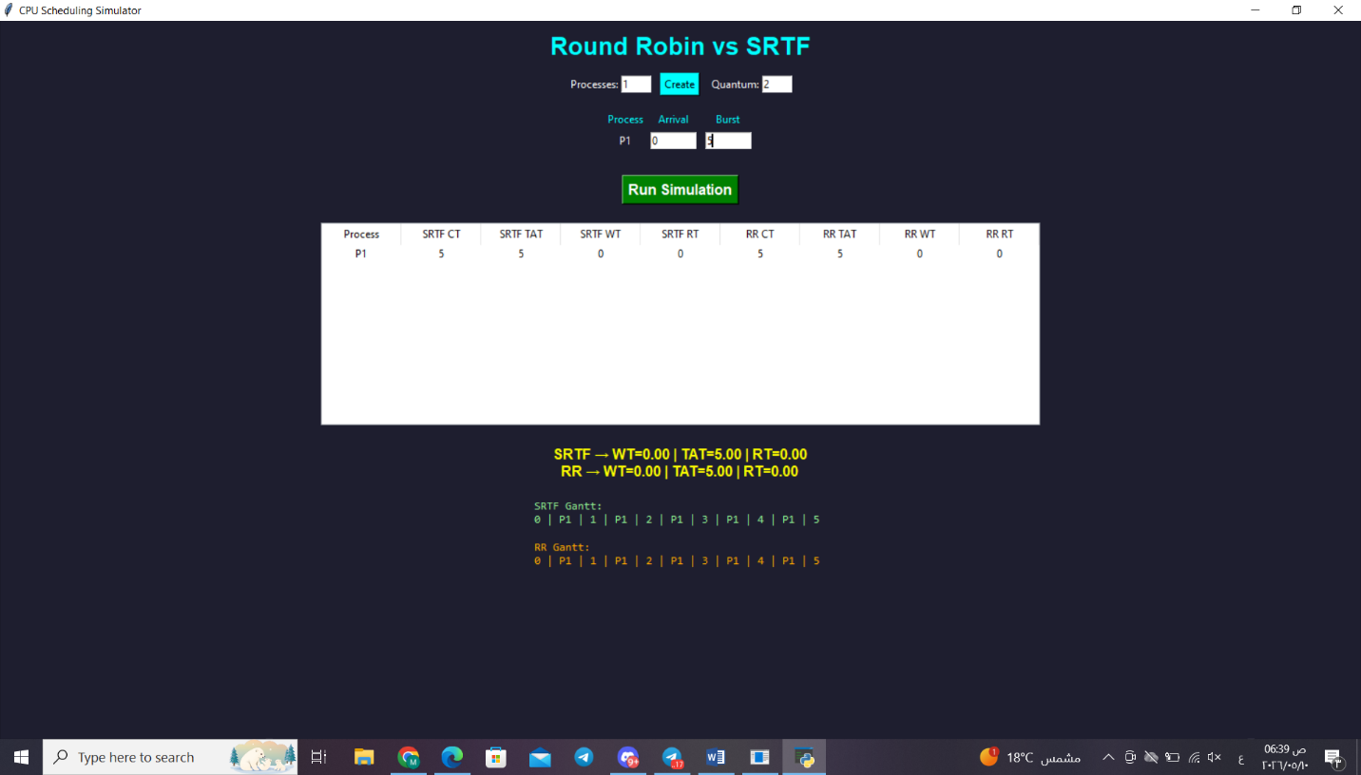
Purpose:
- Verify basic execution.
- Ensure metrics are calculated correctly.

Scenario 2 – All Processes Arrive at Time 0
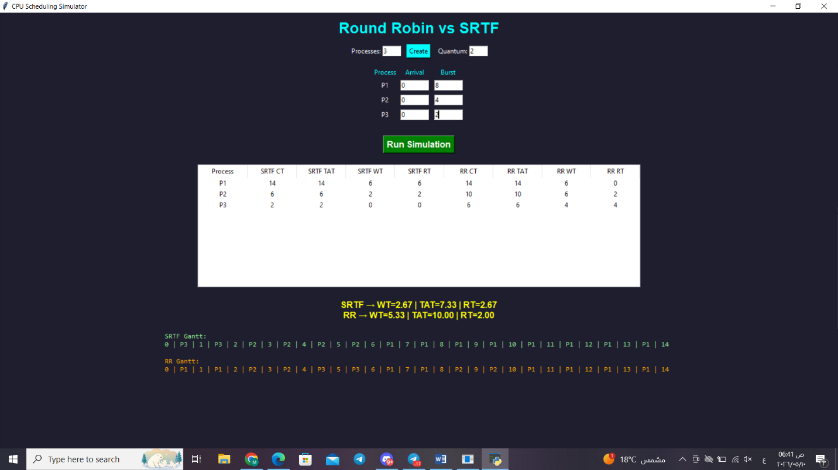
Purpose:
- Compare fairness.
- Observe SRTF preference for short jobs.

Scenario 3 – Different Arrival Times
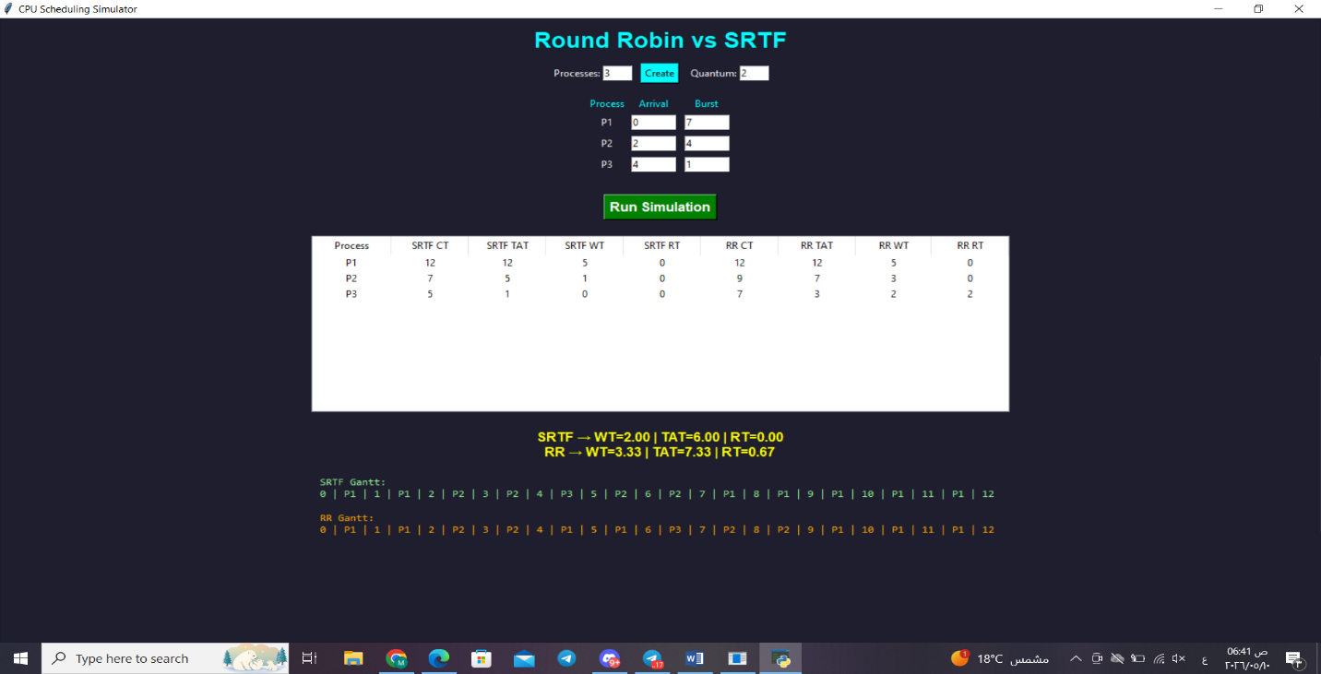
Purpose:
- Demonstrate preemption behavior.
- Observe scheduling changes over time.

Scenario 4 – Sequential Arrival
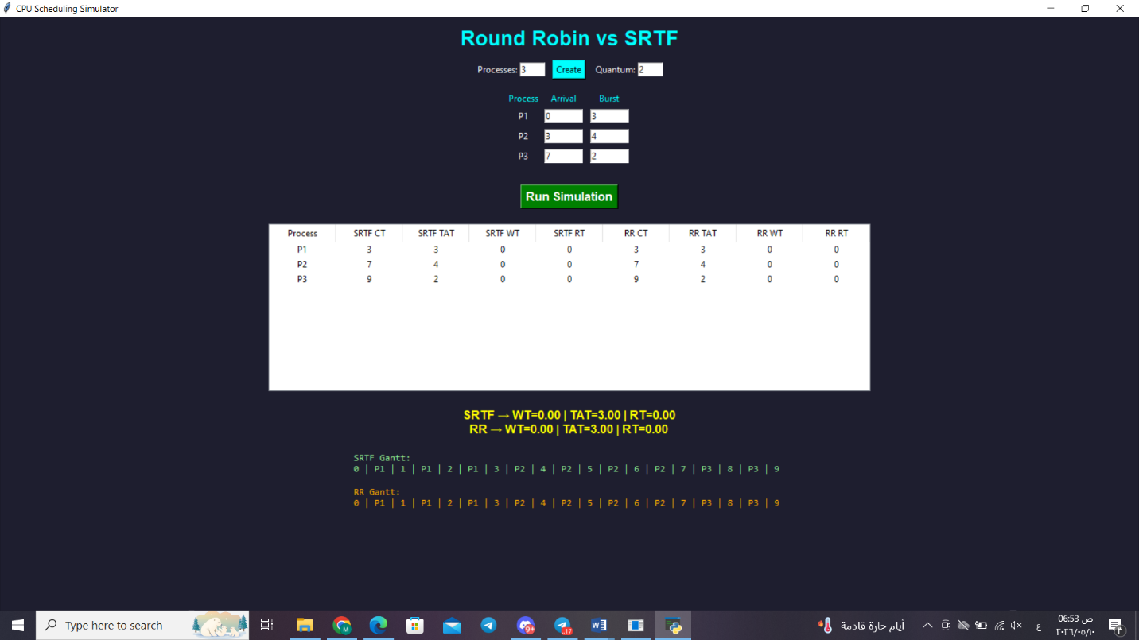
Purpose:
- Observe normal sequential scheduling.
- Verify correct handling of arrivals.

7.2 Behavioral Cases

Scenario 5 – Long Process vs Short Processes
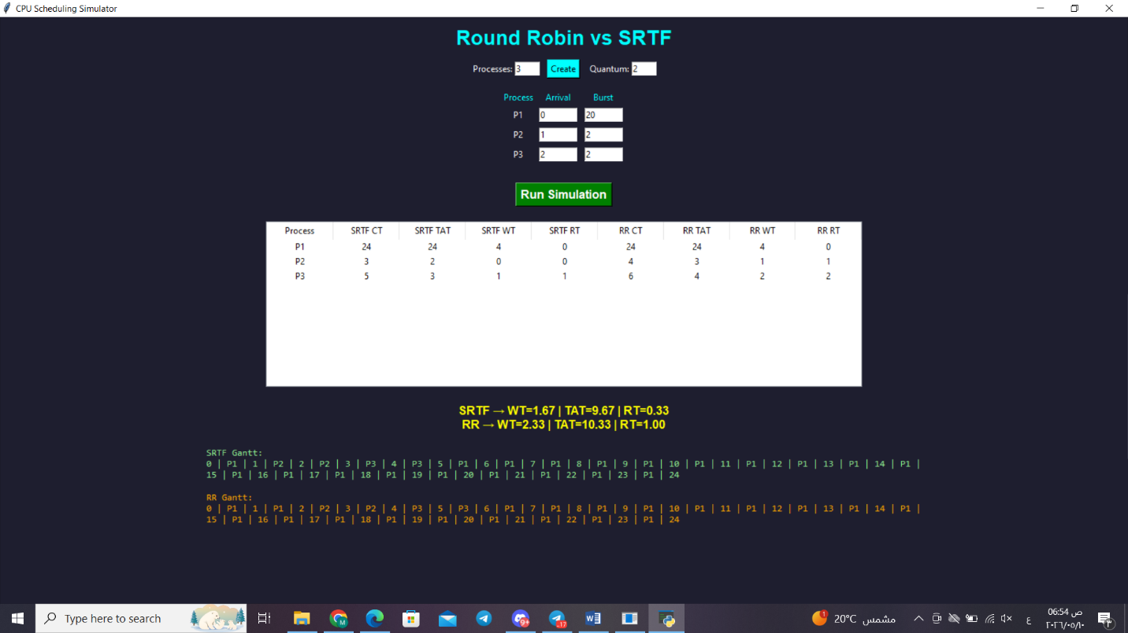
Purpose:
- Show SRTF preference for short jobs.
- Compare fairness between algorithms.

Scenario 6 – CPU Idle Case
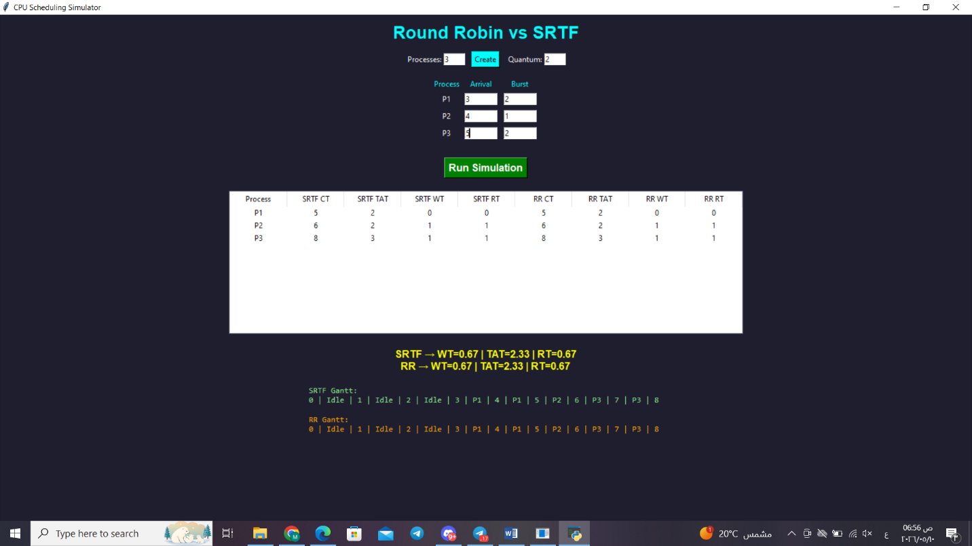
Purpose:
- Verify Idle state handling.
- Ensure Gantt chart displays Idle periods.

Scenario 7 – Equal Burst Times
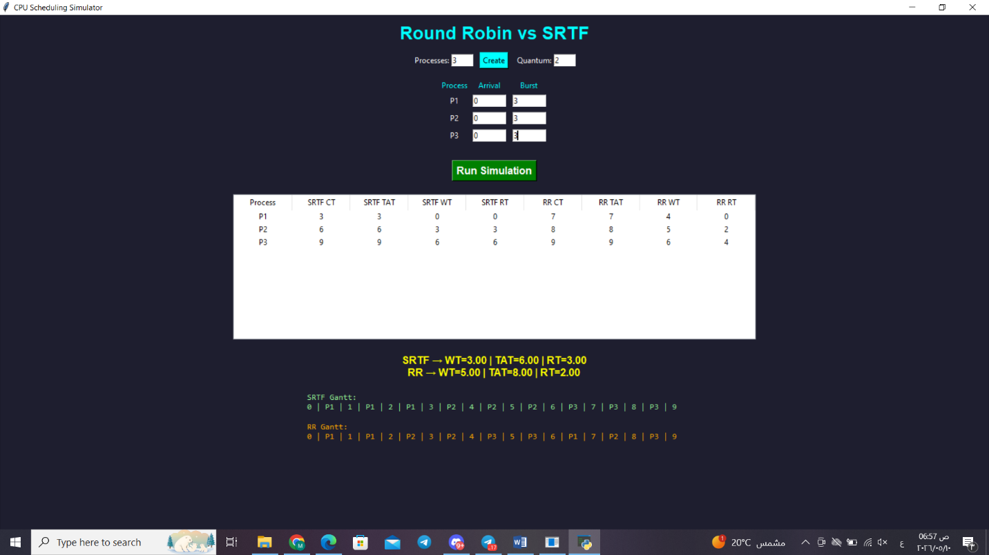
Purpose:
- Verify tie-breaking rules.
- Compare execution fairness.

Scenario 8 – Very Small Quantum
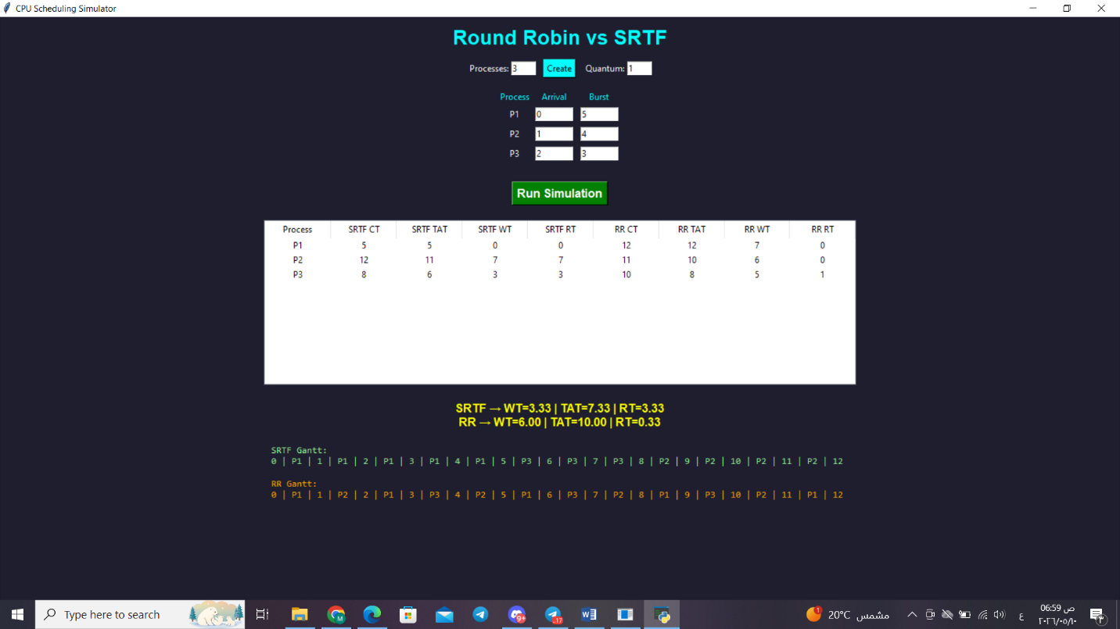
Purpose:
- Observe excessive context switching.
- Compare RR responsiveness.

7.3 Validation Cases

Scenario 9 – Negative Arrival Time
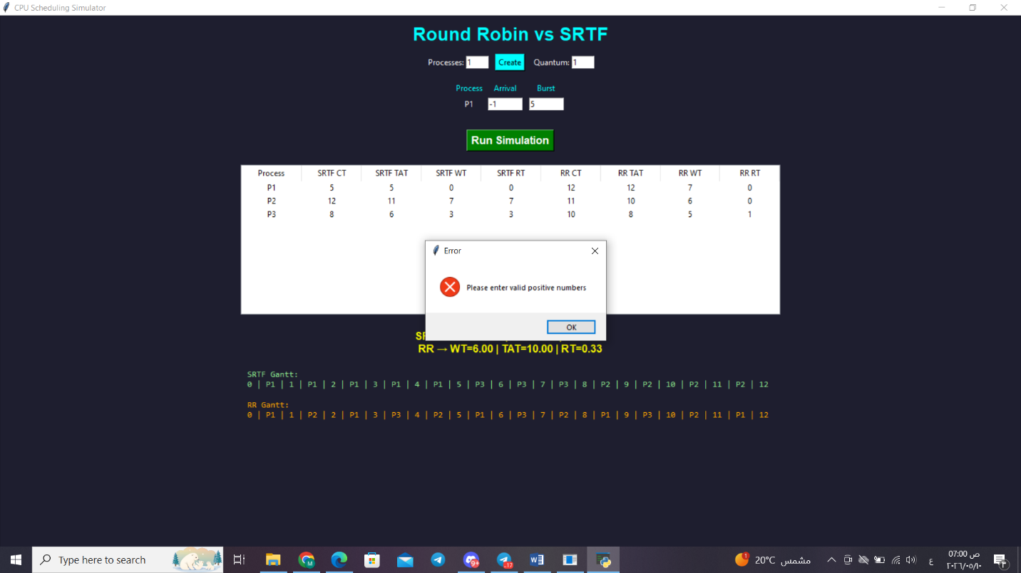
Expected Result:
- Error message appears.

Scenario 10 – Burst Time = 0
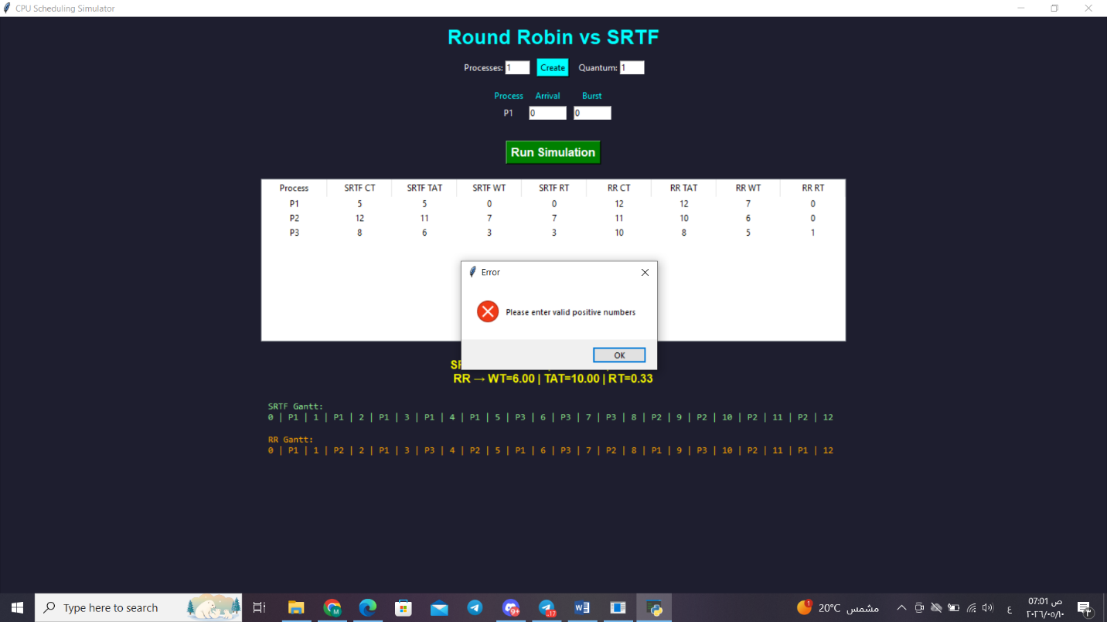
Expected Result:
- Simulation rejected.

Scenario 11 – Quantum = 0
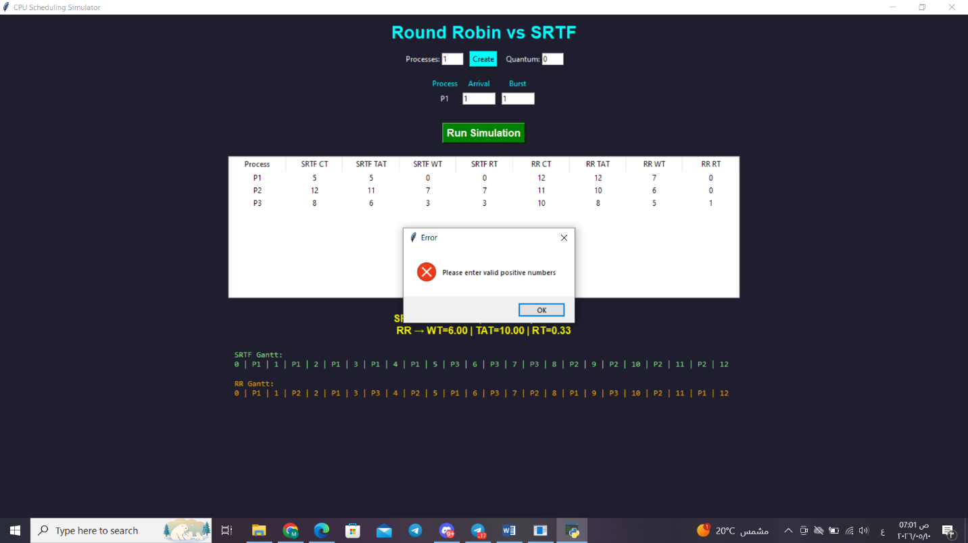
Expected Result:
- Error message appears.

Scenario 12 – Empty Fields
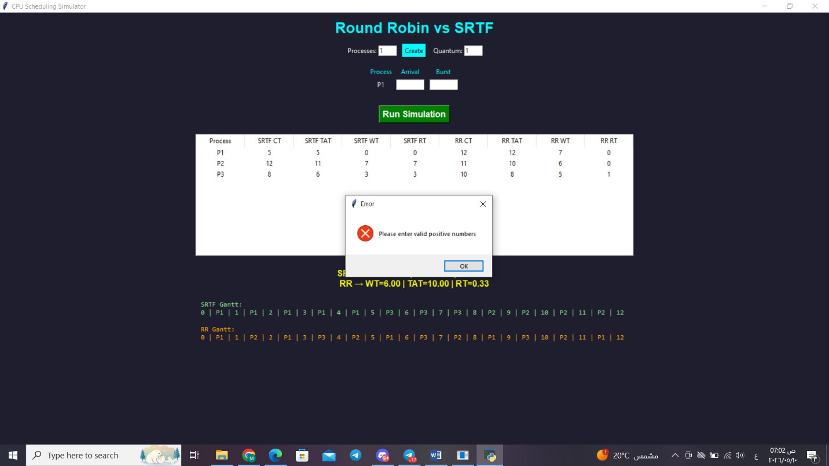
Expected Result:
- Simulation blocked.
- User prompted to fill all fields.

8. Comparison & Analysis

Which Algorithm Produced Lower Waiting Time?
SRTF generally produces lower average waiting time because it always executes the shortest remaining process first.
Round Robin provides fair CPU sharing but may increase waiting time because every process receives equal CPU slices regardless of burst length.

Which Algorithm Produced Better Response Time?
Round Robin often provides faster initial response for all processes because each process receives CPU access quickly.
SRTF favors short jobs and may delay long jobs.

Fairness Analysis
Property | Round Robin | SRTF
Fairness | High | Medium
Starvation Risk | Very Low | Possible
Throughput | Medium | High
Context Switching | High | Medium
Response Time | Good | Excellent for short jobs
Waiting Time | Medium | Low

Key Observations
- SRTF minimizes average waiting time.
- Round Robin improves fairness.
- Small quantum values increase context switching.
- Long jobs may suffer in SRTF.
- RR is suitable for time-sharing systems.

9. Conclusion
The project successfully implemented and compared Round Robin and SRTF scheduling algorithms.
Results showed:
- SRTF achieves lower average WT and TAT.
- Round Robin provides better fairness.
- SRTF strongly favors short jobs.
- Round Robin prevents starvation effectively.

Recommendation
Use Round Robin When… | Use SRTF When…
Fairness is important | Minimizing WT is important
Interactive systems | Batch processing systems
Time-sharing environments | Short-job workloads
Starvation must be avoided | Throughput optimization

For this project, SRTF produced better raw efficiency metrics, while Round Robin demonstrated better fairness and responsiveness across processes.
Both algorithms are important in modern operating systems and each one is suitable for different scheduling environments.

