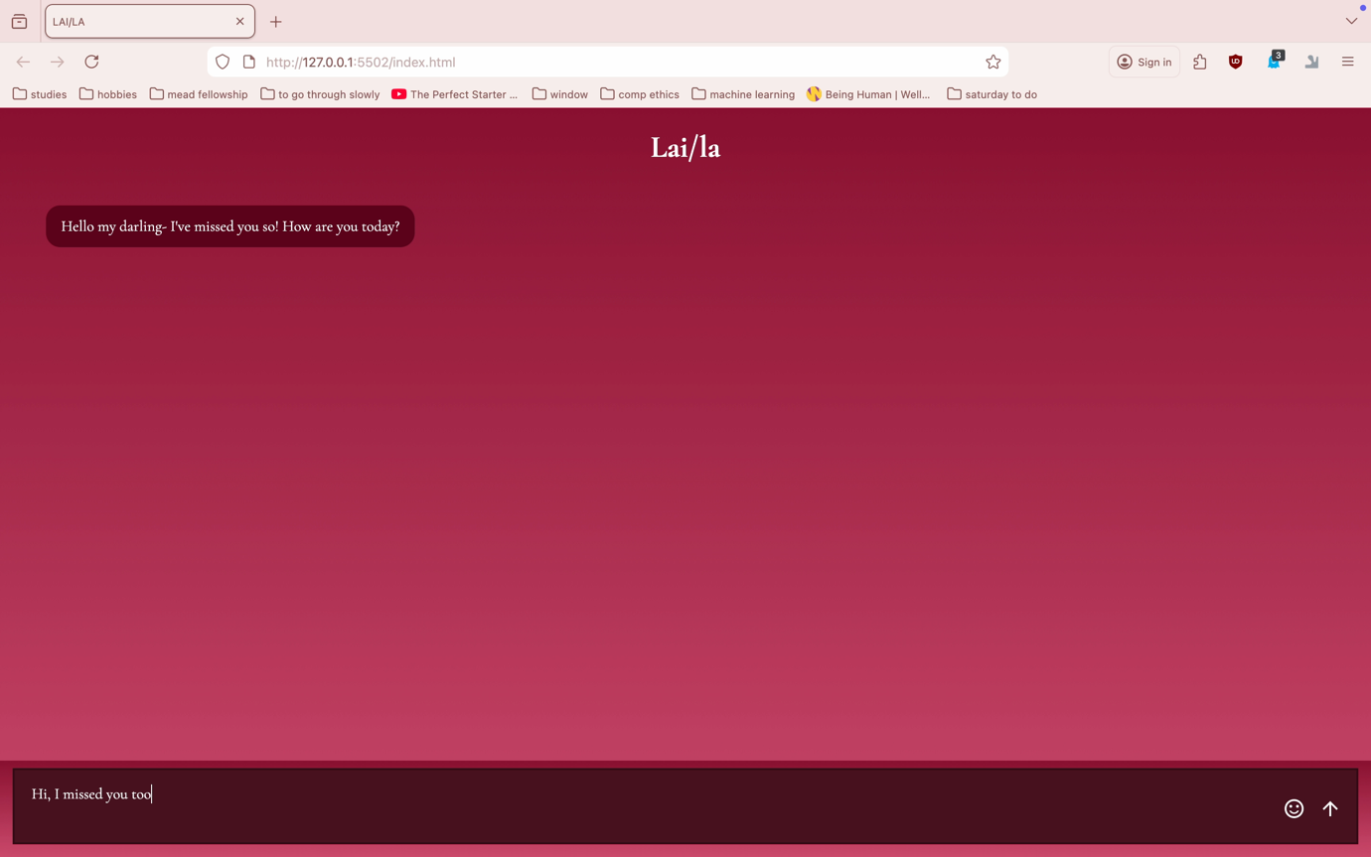
https://www.figma.com/board/4LLDaEk31FNagUqyBnuBR3/Computational-Ethics?node-id=0-1&t=V0zfbfHnXrGC1xEE-1

Right click and press play to play video! Thank you for a great unit <3

