

ASSIGNMENT 1
CLOUD COMPUTING
SUBMITTED BY: MINAHIL AYUB
GROUP :B
ROLL NO . 23

Task 1 Install Gitea and push a repository from the Ubuntu server

task1_gitea_running.png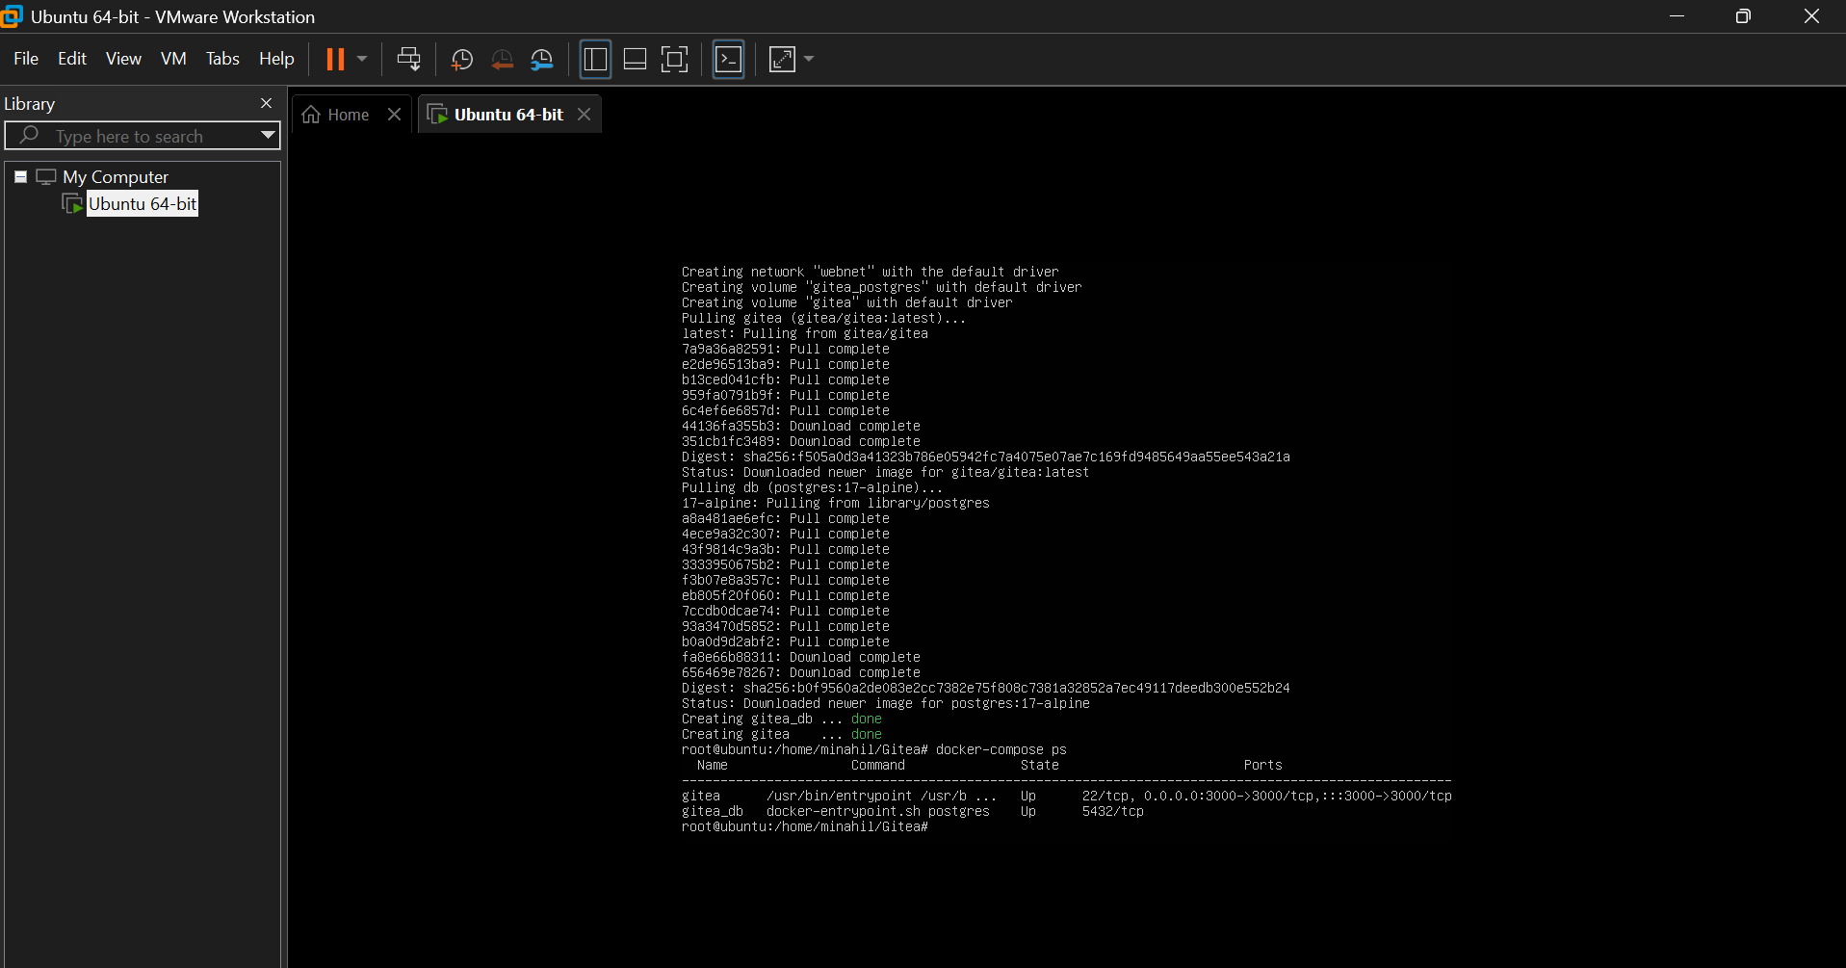
task1_gitea_push.png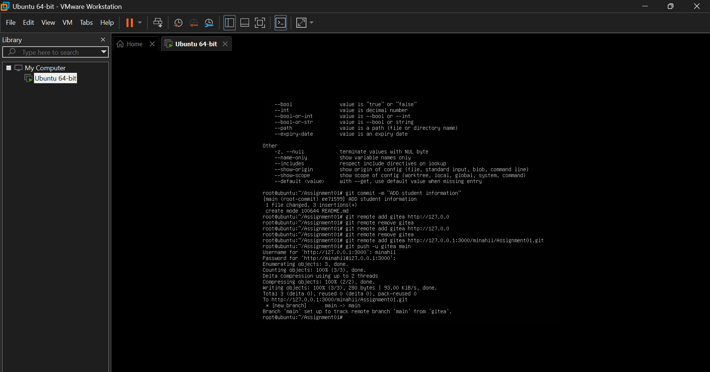

task1_gitea_repository.png
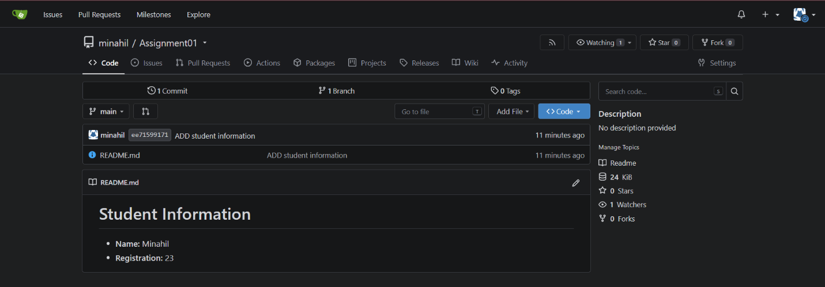

Task 2: Push the Same Repository to GitHub
task2_remotes.png
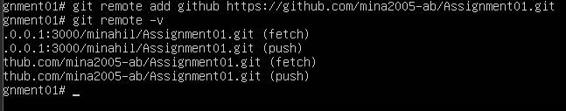
task2_github_push.png
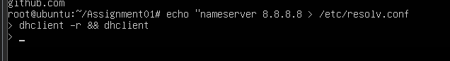

task2_github_repository.png
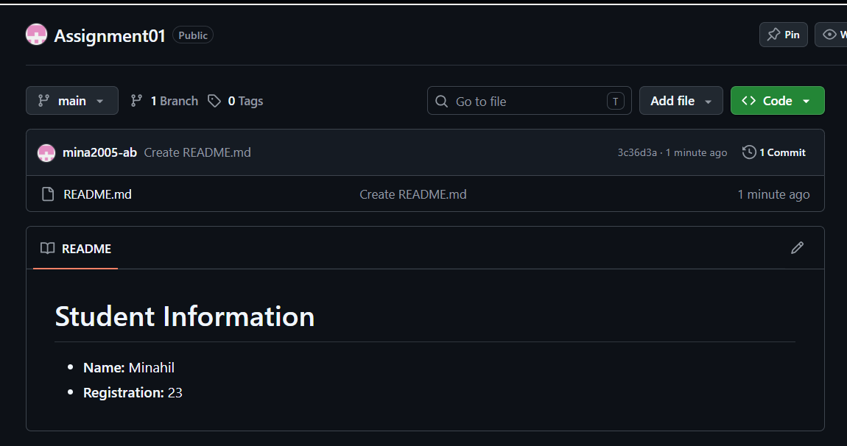

Task 3: Track Three Large Files with Git LFS
task3_lfs_setup.png
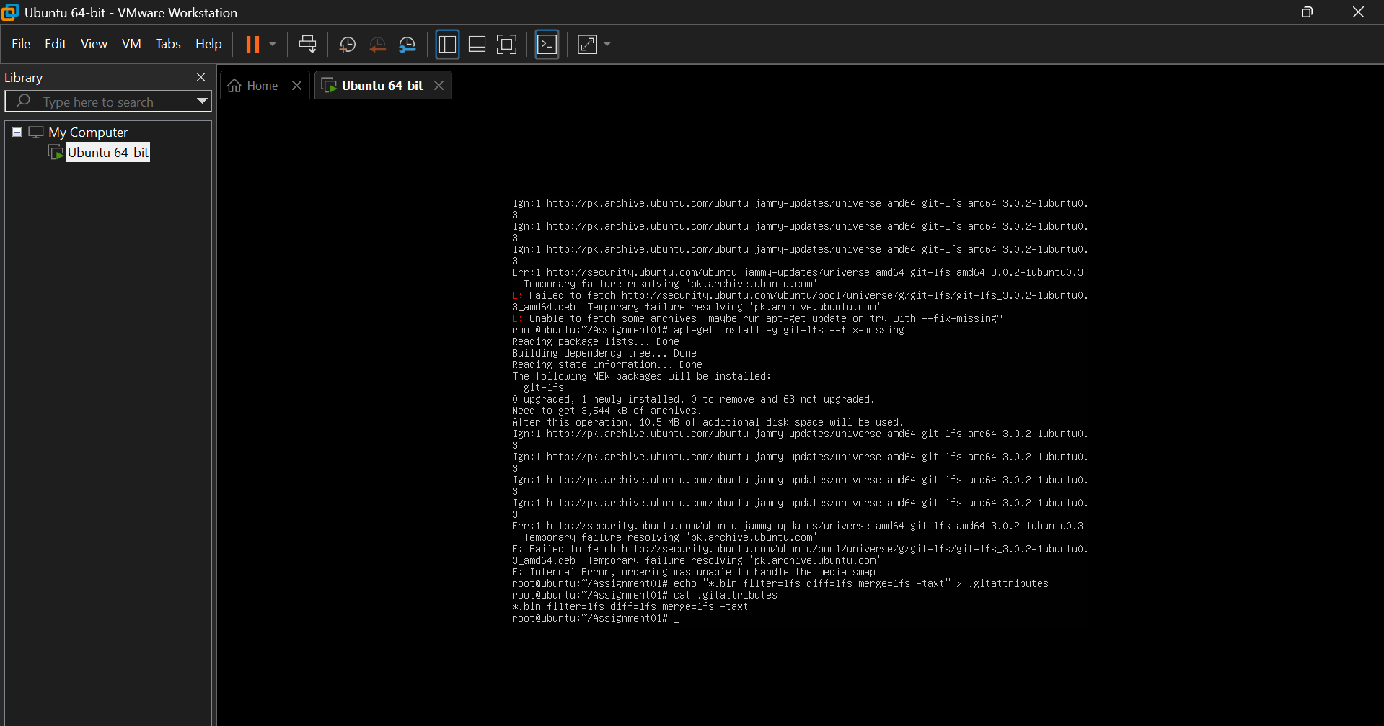

task3_lfs_files.png
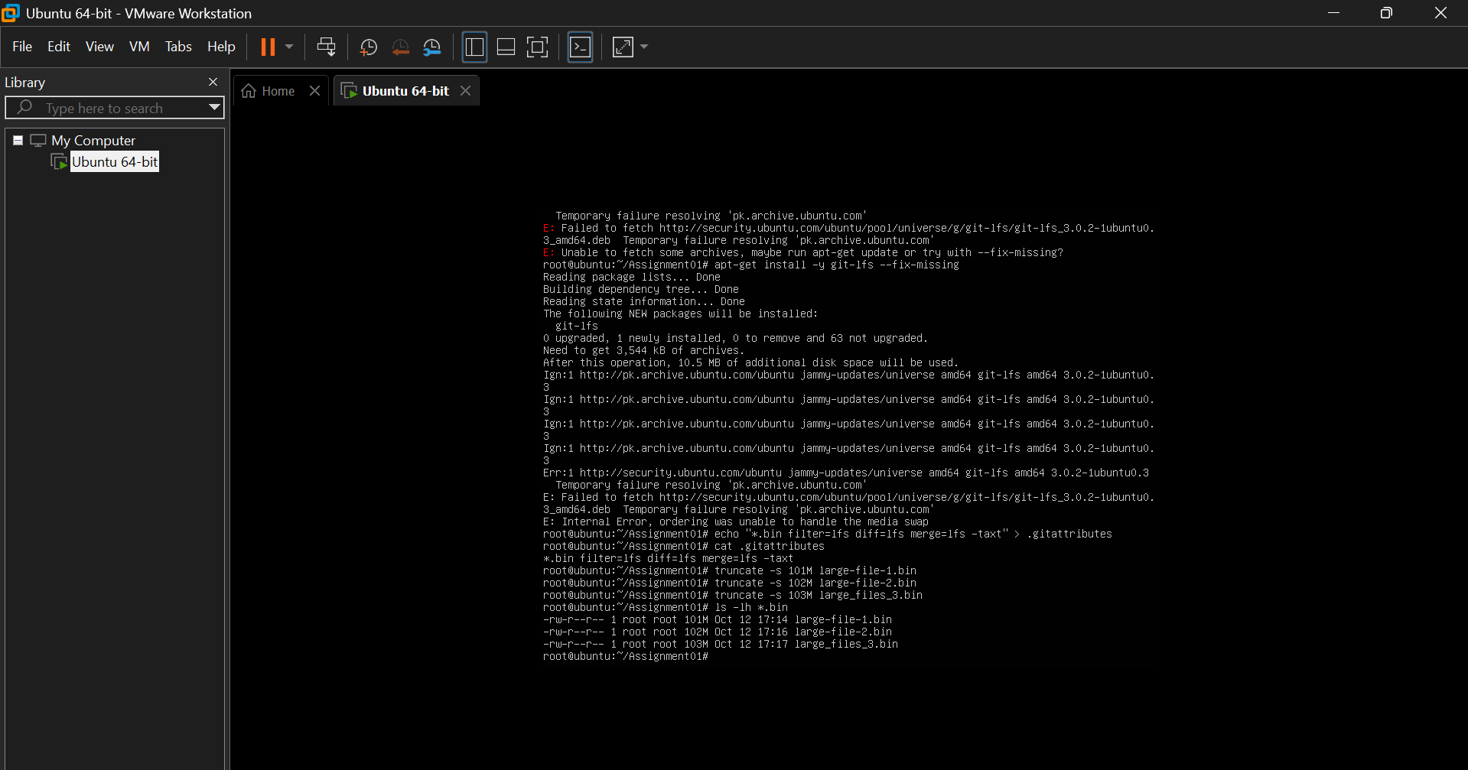
task3_lfs_push.png
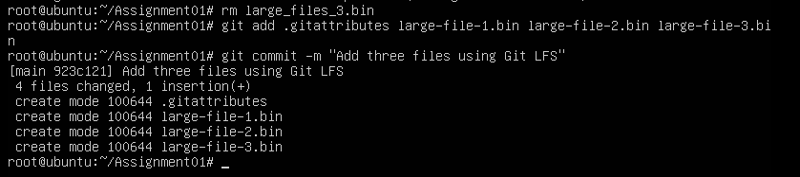

Task 4: Create a Portfolio or CV with GitHub Pages

task4_pages_repository.png
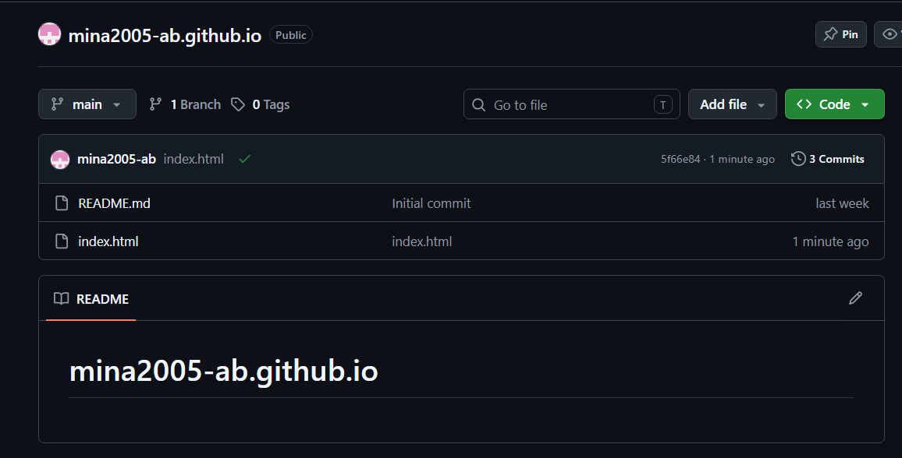
task4_pages_deployment.png
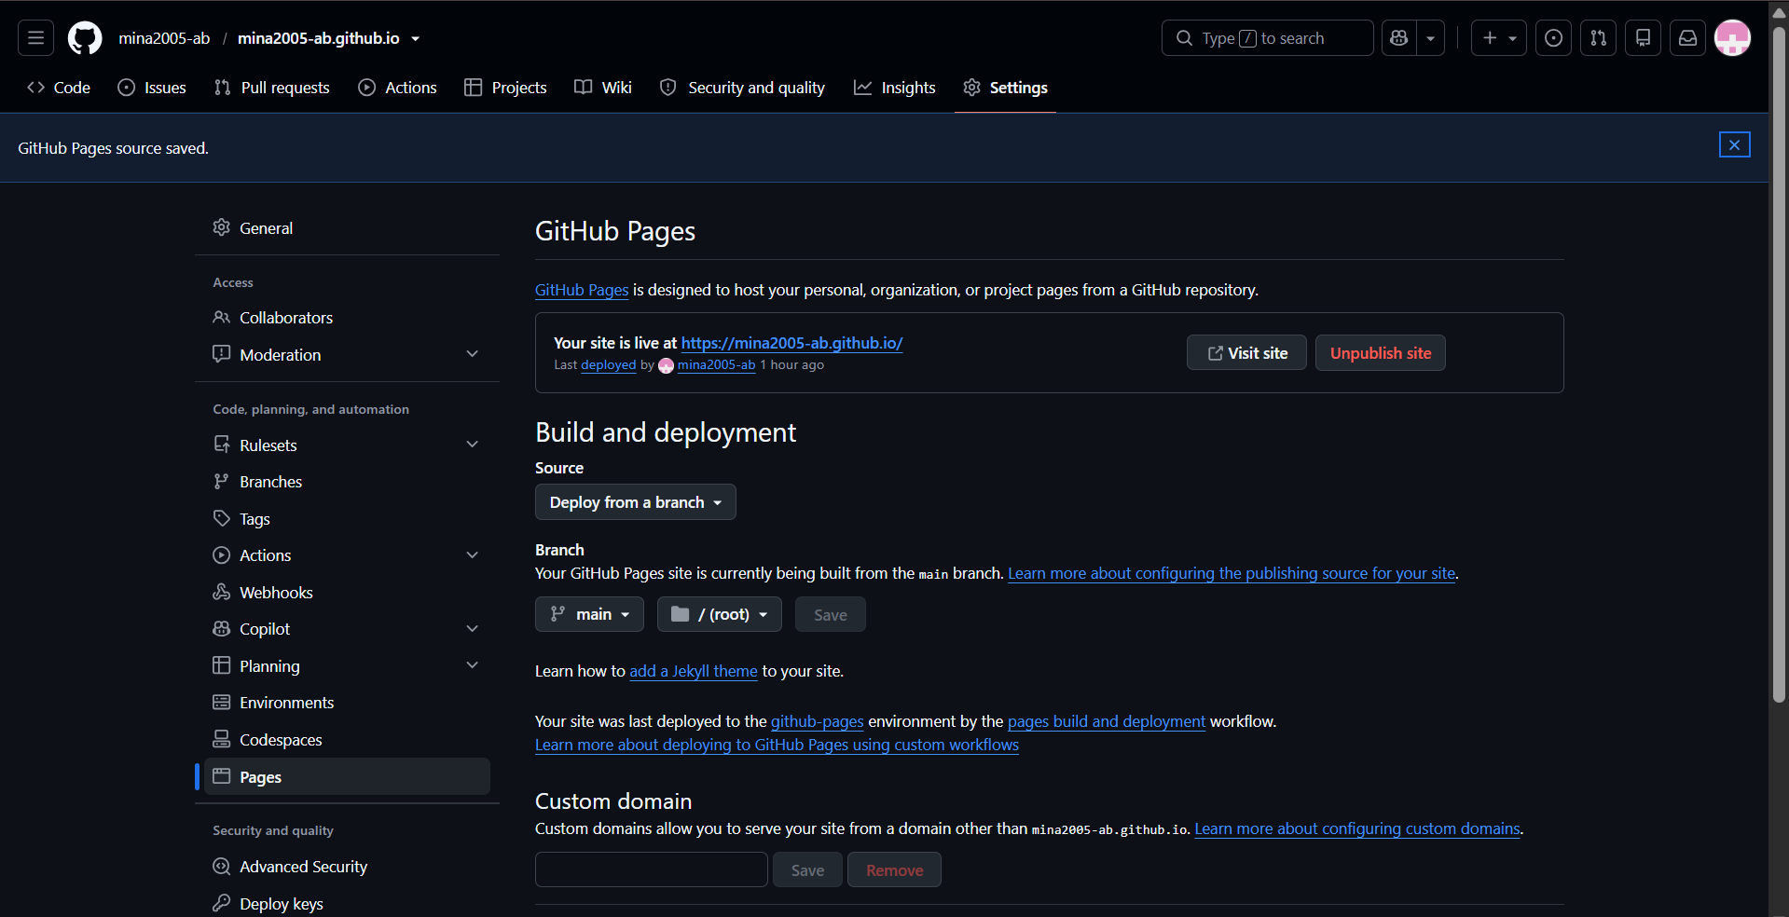

task4_portfolio_live.png
