FLAME Platform
Technical & Feature Documentation
For each feature: step-by-step usage with a screenshot, and the full implementation — frontend, API (request/response), database tables, and business rules — plus a typed database reference and an ERD.



1. Architecture Overview
Two-tier web application:
• Client — React 18 + Vite + Tailwind CSS (dev port 5173). react-router-dom routing; axios API client with a JWT interceptor; react-leaflet maps.
• Server — Node.js + Express REST API (port 4000). Prisma ORM over SQLite (swap provider to PostgreSQL for production). JWT auth (jsonwebtoken), bcrypt password hashing, Multer uploads (≤12MB PDF / ≤2MB other) served from /uploads.
Unified concept — Missions and MissionLogs are the same idea: creating a mission generates one MissionLog per visited school; the public dashboard reads these logs. School-level logs/tasks are the same MissionLog records created directly on a school.
Status model — Expected (not started) · Pending (in progress) · Completed. Dashboard date filters treat the end date as end-of-day so same-day entries always count.
Auth & roles — admin (full + the only one who manages users), content_editor, reviewer, form_manager. requireRole grants access if any of a user's roles is permitted.

2. Features
2.1 🔥 Public Home & Video Hero
Landing page introducing the FLAME service with an intro video, animated hero, quick links, and an Apply call-to-action.
How to use it
- Open the site root (/) in a browser.
- The hero plays intro.mp4 with Pause / Sound controls.
- Use the navbar to reach Dashboard, Missions, Activities, News, Curriculum, Birthdays, or Map.
- Click 'Apply' to open the dynamic application form popup.
- Fill the fields rendered from the admin-defined form and submit.
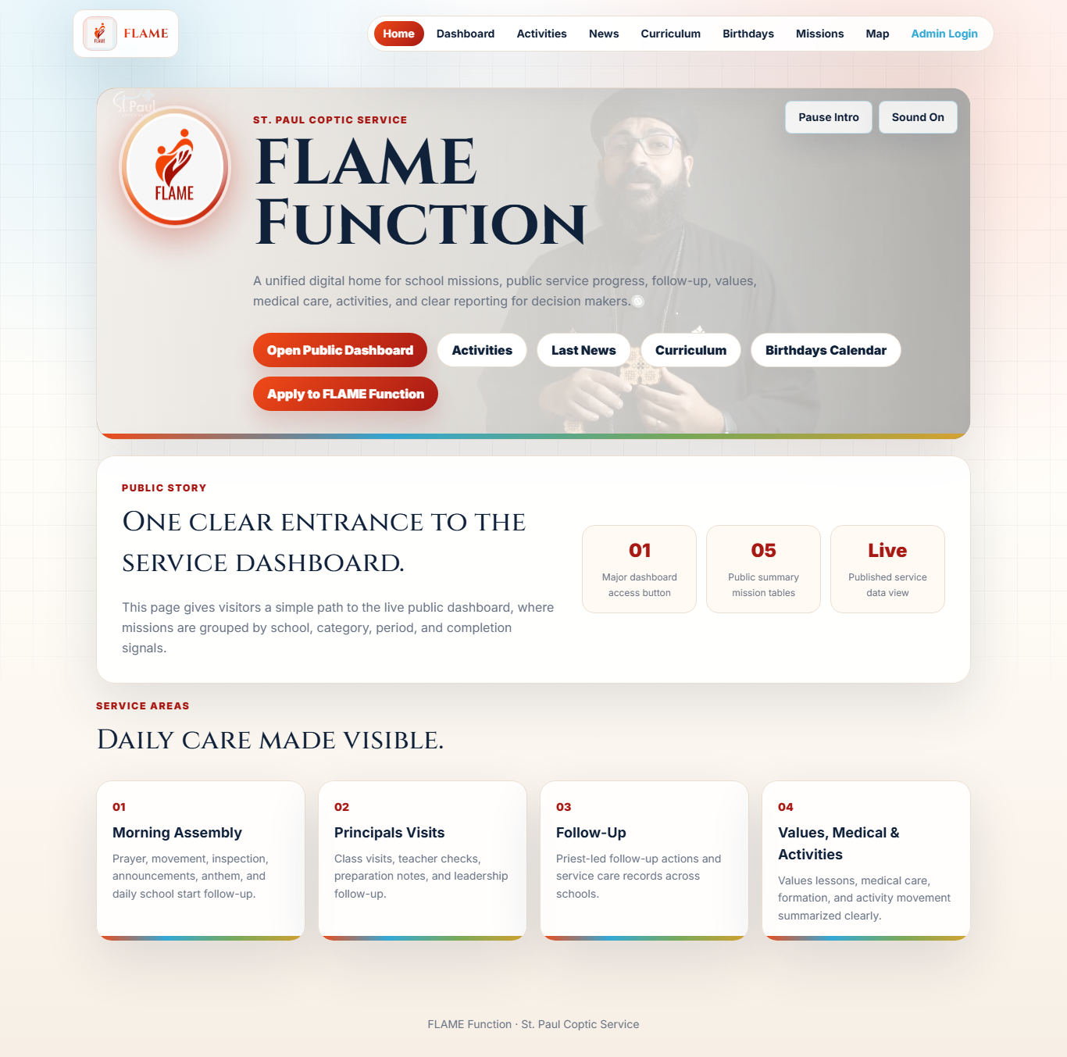
Business rules
- The Apply form is fully data-driven: fields come from FormField records ordered by `order` where `active = true`.
- A submission stores all answers as a JSON blob in Application.values.
Frontend
React page pages/public/Home.jsx composes components/VideoHero.jsx (HTML5 video + play/mute state) and components/ApplyModal.jsx. Styling: Tailwind utility classes + CSS design tokens in index.css (Cinzel/Inter fonts, glass-morphism cards, fade-up keyframe animations). Routing by react-router-dom.
API
GET /api/form-fields
List active form fields for the Apply popup.
Response
[ { id, label, key, type, options, required, order, active } ]
POST /api/applications
Submit the Apply form.
Request
{ "values": { "name": "...", "country": "...", "role": "..." } }
Response
201 { id, values, submittedAt }
Database tables used
FormField, Application

2.2 📊 Public Missions Dashboard
Live public story of the service: KPIs, Schools×Missions summary, per-school drill-down of tasks performed vs. not performed, and category totals — all driven by the date range and filters.
How to use it
- Open /dashboard.
- Set Period or From/To dates — the whole dashboard reloads automatically.
- Filter by Log Type, School, or Status (Completed / Expected / Pending).
- Read the KPI strip: Total Missions, Active Schools, Completed, Expected, Pending.
- Open any school to drill into task records grouped by log type.

Business rules
- The `to` date is treated as end-of-day (23:59:59.999) so same-day logs are always included.
- Total Missions counts DISTINCT real missions (by the mission id tagged in a log's notes); a mission visiting N schools counts once but shows activity in all N schools.
- A unit is Completed if its tasks are all performed or status = completed; Expected if status = expected; otherwise Pending.
Frontend
pages/public/Dashboard.jsx — a useEffect keyed on every filter (from/to/period/type/school/status) reloads the data; KpiCard.jsx cards; nested <details> drill-down per school and per log type.
API
GET /api/dashboard/summary
Aggregated KPIs + per-school + per-category.
Request
query: from, to, schoolId?, typeId?, status?
Response
{ range, kpis:{ totalMissions, activeSchools, completionSignal, completed, pending, expected }, bySchool:[...], byCategory:[...] }
GET /api/logs
Raw logs for the detailed story.
Request
query: from, to, schoolId?, typeId?, status?
Response
[ { id, logTypeId, schoolId, logDate, status, notes, tasks:[...] } ]
Database tables used
MissionLog, TaskRecord, LogType, School

2.3 🚑 Missions (Admin): Status, Dates & Editing
Create missions (Medical / Follow-ups / Activities / Values / Formation / Other) with mandatory status, start/end dates and at least one school. Each mission auto-generates dashboard logs and is fully editable.
How to use it
- Admin → Missions.
- Enter a title; pick type and status (Expected / Pending / Completed).
- Set mandatory start and end dates; select at least one school.
- Add countries (per-country dates), people and medical team — availability is shown.
- Create — one dashboard log per visited school is generated concurrently.
- Use Edit to change status/dates/summary; members become unavailable while a mission is Pending and free again when Completed or deleted.
Business rules
- Server-side validation: title, status, startDate, endDate and ≥1 school are required; endDate must be ≥ startDate (HTTP 400 otherwise).
- Generated MissionLog.logDate uses the mission startDate; log status mirrors the mission status.
- Mission type maps to a dashboard LogType (Medical→medical_log, Follow-ups→follow_up, Activities→activities, Values→values_class, Formation→formation); 'Other' creates no dashboard log.
- Deleting a mission cascades to its MissionCountry/School/Person/Medical rows and removes its generated logs + task records.
- The list endpoint returns country names + counts only (not the full nested graph) to keep it fast under load.
Frontend
components/admin/MissionsAdmin.jsx — create form (status dropdown, date pickers, country rows, school/person/medic pickers with availability badges) + inline Edit panel.
API
GET /api/missions
List (type filter optional). Returns counts + country names.
Request
query: type?
Response
[ { id, title, type, status, startDate, endDate, summary, anonymousCount, countries:[{country:{name}}], schools:[len], people:[len], medicalTeam:[len] } ]
POST /api/missions
Create a mission (+ generate logs).
Request
{ title, type, status, startDate, endDate, summary, numPeople, durationDays, anonymousCount, countries:[{countryId,startDate,endDate}], schoolIds:[], personIds:[], medicalMemberIds:[] }
Response
201 { ...mission with nested relations }
PATCH /api/missions/:id
Edit status/dates/summary/counts; syncs logs + availability.
Request
{ status?, startDate?, endDate?, summary?, numPeople?, ... }
Response
200 { ...mission }
DELETE /api/missions/:id
Delete mission + generated logs; frees members.
Response
204
Database tables used
Mission, MissionCountry, MissionSchool, MissionPerson, MissionMedical, MissionLog, TaskRecord

2.4 🏫 School Task Board (Logs, Visits, Content)
Per-school hub: create medical logs / principal visits / tasks (summary + date mandatory), assign people with roles, and track assigned curriculum/values/formation with a status.
How to use it
- Admin → Database → Schools → expand a school.
- 'Add Log / Task': choose a type, set date, write a summary (both required), pick a status.
- For a Values Class, select which values class from the extra selector that appears.
- 'People & Roles': assign an existing person as Principal / Worker / Resident / Teacher / Priest, change a role, or remove from the school.
- Update any log or assigned-content status (Expected / Pending / Completed) inline.
- Manage Classes and add Students (linked to a class) in the same panel.
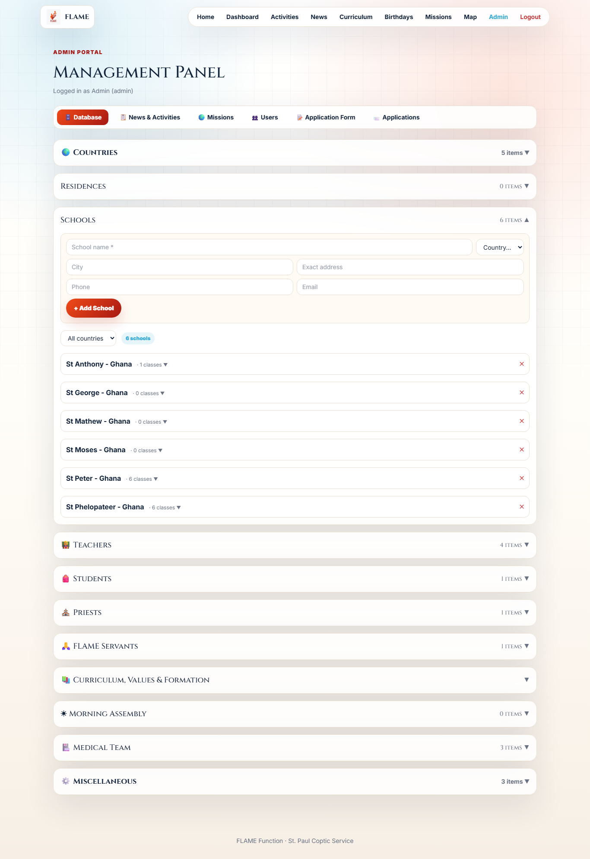
Business rules
- School-level logs require a non-empty summary and a date (HTTP 400 otherwise). The summary is stored in MissionLog.notes and mirrored as a TaskRecord 'Summary: ...'.
- Logging a Values Class also assigns it to the school (if not already) and syncs the per-school status.
- Assigning a person sets Person.schoolId and Person.position; removing clears schoolId.
- GET /schools/:id/tasks aggregates MissionLogs + CurriculumSchool + ValuesClassSchool + FormationSchool with their statuses.
Frontend
components/admin/SchoolManager.jsx (SchoolDetail): task board, Add Log/Task form with conditional values-class selector, People & Roles, Classes + StudentForm.
API
GET /api/schools/:id/tasks
Everything happening at a school, with statuses.
Response
{ logs:[{id,title,logDate,status,notes}], curriculum:[{id,title,status}], values:[...], formation:[...] }
POST /api/logs
Create a school-level log/task.
Request
{ schoolId, logTypeId, summary, logDate, status, responsiblePersonId? }
Response
201 { ...log }
PATCH /api/logs/:id
Edit a log (summary/date/status/type).
Request
{ summary?, logDate?, status?, logTypeId? }
Response
200 { ...log }
GET /api/logs/types/school
Creatable school log types.
Response
[ { id, label, icon } ]
Database tables used
School, MissionLog, TaskRecord, Person, ClassLevel, Student, CurriculumSchool, ValuesClassSchool, FormationSchool

2.5 📚 Curriculum, Values & Formation
Upload PDF documents (≤12MB) and assign them to multiple schools and classes (classes scoped to the chosen schools). Public visitors browse them by tab and open the PDFs.
How to use it
- Admin → Database → Curriculum, Values & Formation.
- Enter a title + language and upload a PDF.
- Select schools; the class picker then only lists classes in those schools.
- Use 'Edit assignments' on an existing item to re-assign schools/classes later.
- Public users open /curriculum, switch tabs, and open the PDFs.
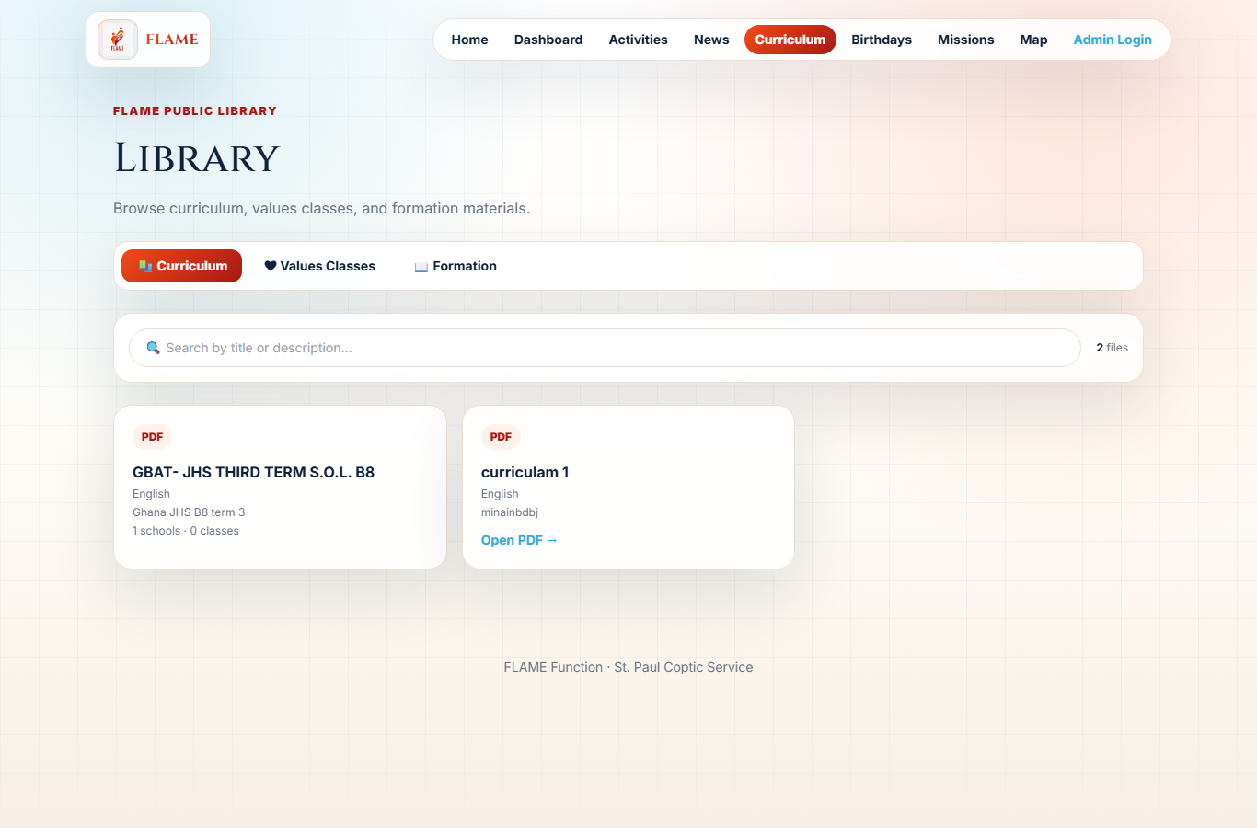
Business rules
- Uploads are limited to 12MB (PDF) and stored on disk; the public URL is /uploads/<uuid>.pdf (proxied in dev, served statically in prod).
- A school assignment carries a status (expected|pending|completed) updatable per school.
- Deleting a document cascades to its class/school join rows.
Frontend
components/admin/DocumentsAdmin.jsx (reusable DocManager used for all three) + public pages/public/Curriculum.jsx (Curriculum / Values / Formation tabs). Uploads via multipart/form-data.
API
GET /api/curriculum-docs
List with classes + schools.
Response
[ { id, title, language, fileUrl, classes:[...], schools:[{schoolId,status,school}] } ]
POST /api/curriculum-docs
Upload + assign (multipart).
Request
form-data: title, description, language, file, schoolIds(JSON), classIds(JSON)
Response
201 { ...curriculum }
PATCH /api/curriculum-docs/:id
Edit meta + re-assign schools/classes.
Request
{ title?, schoolIds?, classIds? }
Response
200 { ...curriculum }
PATCH /api/curriculum-docs/:id/school/:schoolId
Set per-school status.
Request
{ status }
Response
200 { ...join }
Database tables used
Curriculum, CurriculumClass, CurriculumSchool, ValuesClass, ValuesClassClass, ValuesClassSchool, Formation, FormationSchool

2.6 👥 People: Teachers, Students, Priests, Servants
A single reusable Person model powers teachers, priests, servants and school staff; Students are separate and belong to a class. Birthdate cannot be in the future. Country/school filters with live counts and full inline editing.
How to use it
- Admin → Database → Teachers / Students / Priests / Servants.
- Create a record (name required; students need a school + class).
- Filter by country and school; the section header shows the live count.
- New records appear instantly — filters auto-clear on create.
- Use Edit on any row to update details; birthdate pickers block future dates.
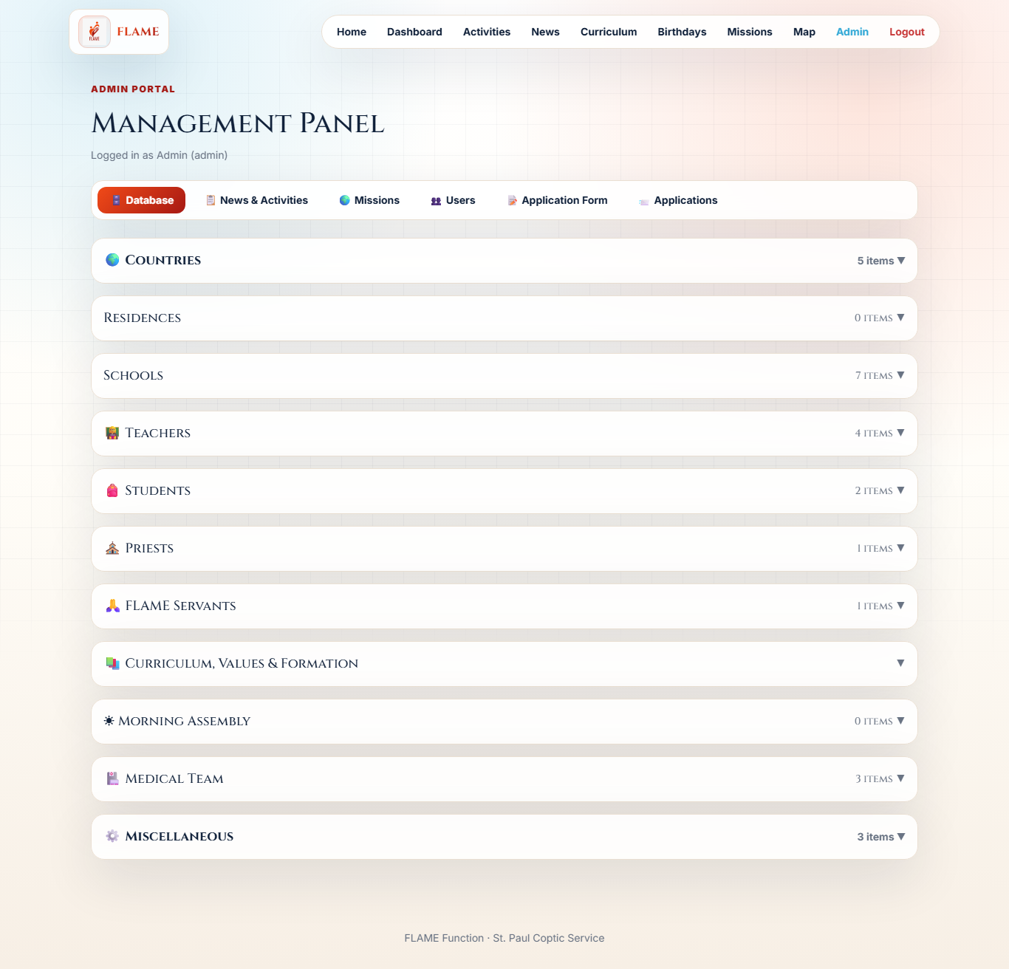
Business rules
- Person.fullName is the only required field; a Person is reusable across schools, residences and missions.
- Server rejects future birthdate/dob (HTTP 400).
- People filter: ?type=<position>, ?isPriest=true, ?schoolId=, ?countryId= (matches school's country OR priest's assigned country).
- Student must link to a class (and therefore a school).
- Person.available drives the busy/free marker used in mission selection.
Frontend
TeachersAdmin.jsx, StudentsAdmin.jsx, PriestsAdmin.jsx, ServantsAdmin.jsx, PersonPicker.jsx. Counts rendered via Collapsible countEndpoint.
API
GET /api/people
List/filter people.
Request
query: type?, isPriest?, schoolId?, countryId?, available?
Response
[ { id, fullName, birthdate, position, isPriest, available, school, priestCountry, residence, classesTaught } ]
POST /api/people
Create a person.
Request
{ fullName, position?, birthdate?, schoolId?, priestCountryId?, isPriest? }
Response
201 { ...person }
PATCH /api/people/:id
Edit / assign to school / change role.
Request
{ schoolId?, position?, available?, ... }
Response
200 { ...person }
GET/POST/PATCH/DELETE /api/students
Student CRUD.
Request
{ fullName, classId, birthday?, phone?, fatherName?, ... }
Response
{ ...student }
Database tables used
Person, Student, ClassLevel, School, Country, Residence

2.7 🏥 Medical Team & Availability
Medical team members with specialty and availability. Availability is surfaced when selecting members for medical missions and flips automatically while a mission is in progress.
How to use it
- Admin → Database → Medical Team.
- Add a member (name, specialty, contact, email).
- Toggle availability or Edit the member inline.
- When creating a Medical mission, members show a green/red availability marker.
Business rules
- A Medical mission set to Pending marks its selected medics unavailable; Completed/Delete frees them.
- MissionMedical is a composite-key join (missionId + memberId).
Frontend
components/admin/MedicalTeamAdmin.jsx (availability toggle + inline edit); consumed by MissionsAdmin.jsx.
API
GET /api/medical-team
List members.
Response
[ { id, fullName, specialty, contact, email, available } ]
POST /api/medical-team
Add a member.
Request
{ fullName, specialty?, contact?, email? }
Response
201 { ...member }
PATCH /api/medical-team/:id
Edit / toggle availability.
Request
{ available? , ... }
Response
200 { ...member }
Database tables used
MedicalTeamMember, MissionMedical, Mission

2.8 📝 Dynamic Application Form
Admins define the Apply form fields (text / number / dropdown / toggle / rating 1–10). Visitors submit via a popup; admins review all submissions.
How to use it
- Admin → Application Form.
- Add fields and pick a type; for dropdown provide the option values.
- Mark required, set order, or remove fields.
- Visitors click Apply on Home and submit.
- Admin → Applications to review every submission.
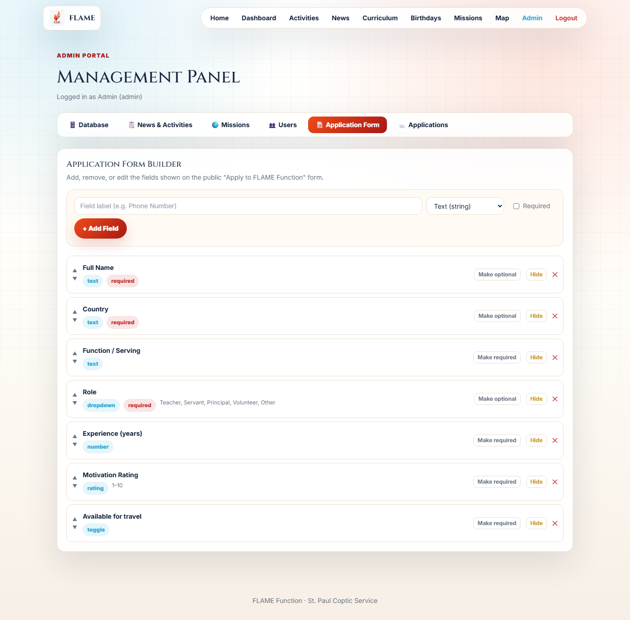
Business rules
- FormField.key is unique; type ∈ {text, number, dropdown, toggle, rating}; dropdown options stored in `options`.
- Only active fields render on the public form, ordered by `order`.
- Application.values is a JSON string of answers keyed by field key.
Frontend
components/admin/FormBuilder.jsx, components/ApplyModal.jsx, components/admin/ApplicationsAdmin.jsx.
API
GET /api/form-fields
List fields.
Response
[ { id, label, key, type, options, required, order, active } ]
POST/PATCH/DELETE /api/form-fields
Manage fields.
Request
{ label, key, type, options?, required?, order? }
Response
{ ...field }
GET /api/applications
List submissions (reviewer/admin).
Response
[ { id, values, submittedAt } ]
POST /api/applications
Submit (public).
Request
{ values:{...} }
Response
201 { id, submittedAt }
Database tables used
FormField, Application

2.9 🔐 Users, Roles & Permissions
Multi-role access control via JWT. Admin is the only role that manages users. Roles: admin, content_editor, reviewer, form_manager.
How to use it
- Log in as admin (POST /api/auth/login returns a JWT).
- Admin → Users.
- Create a user and assign one or more roles (stored comma-separated).
- Each role grants scoped access, enforced by requireRole on the server.
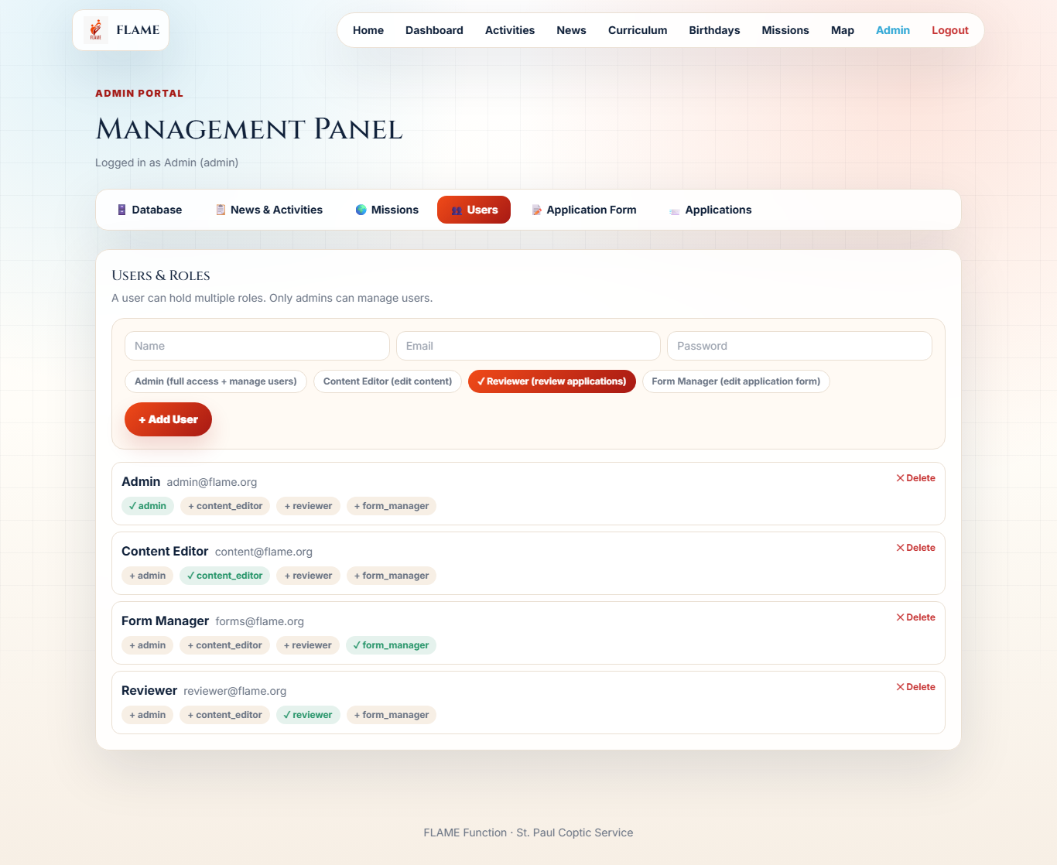
Business rules
- CAN_EDIT_CONTENT = admin, content_editor. CAN_REVIEW_APPLICATIONS = admin, reviewer. CAN_MANAGE_FORM = admin, form_manager. CAN_MANAGE_USERS = admin only.
- requireRole grants access if ANY of the user's roles is permitted.
- The JWT carries the roles array; the client attaches it as Authorization: Bearer <token>.
- Seed users: admin@flame.org / Flame@Admin2026 (and content@, reviewer@, forms@).
Frontend
components/admin/UsersAdmin.jsx, auth context lib/auth.jsx, components/ProtectedRoute.jsx, axios interceptor in api/client.js.
API
POST /api/auth/login
Authenticate.
Request
{ email, password }
Response
200 { token, user:{ id, name, roles } }
GET/POST/PATCH/DELETE /api/users
Manage users (admin only).
Request
{ name, email, password, role }
Response
{ ...user }
Database tables used
User

2.10 🗺️ World Mission Map
Leaflet map of school locations with mission and people counts, filterable by country and city — filtering handled server-side.
How to use it
- Open /map.
- Browse pins for each geolocated school (lat/lng) with mission + people counts.
- Filter by country or city.
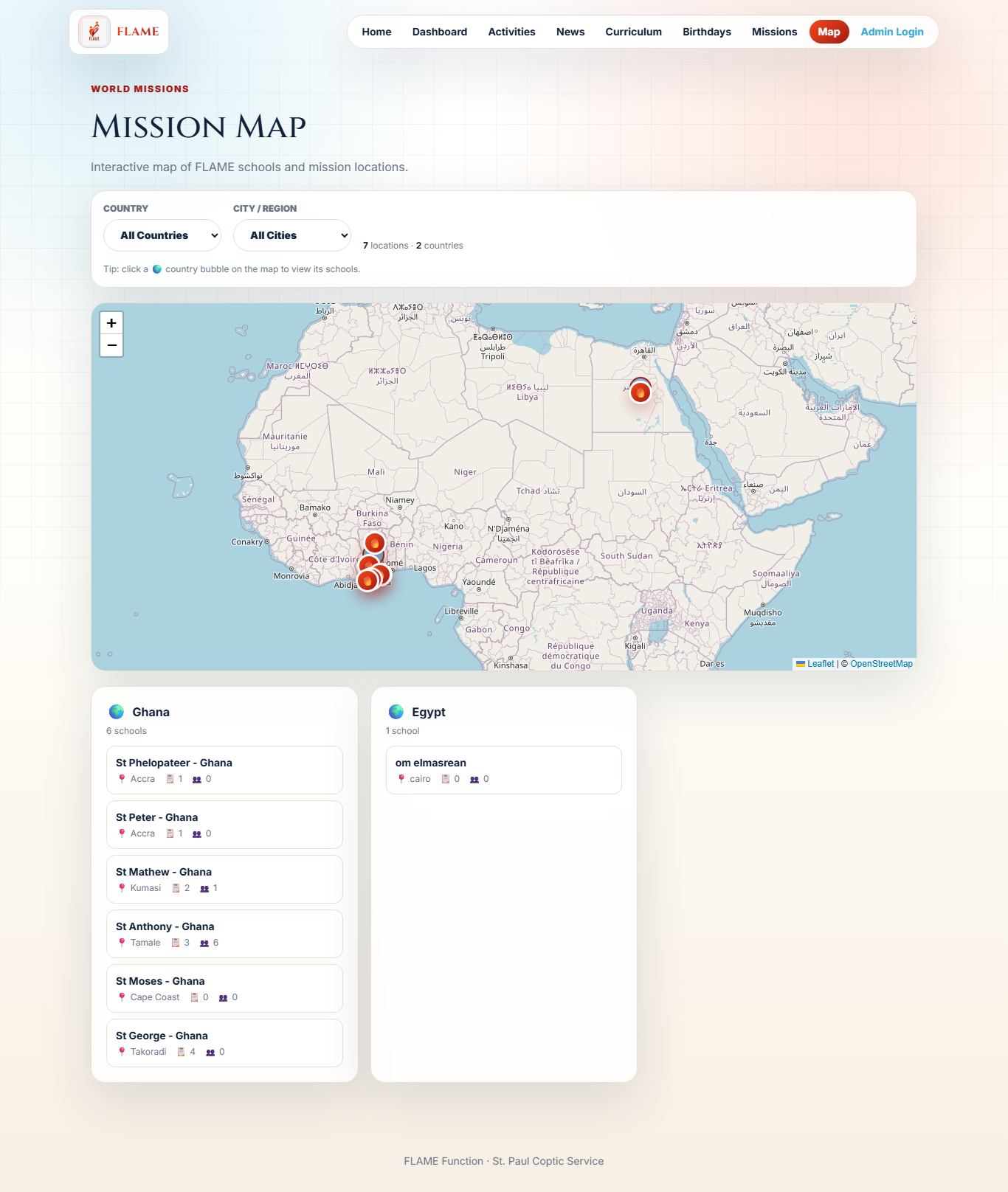
Business rules
- Only schools with latitude and longitude set appear as pins.
- Counts come from Prisma _count on missionLogs and people; results are grouped by country for the sidebar.
Frontend
pages/public/WorldMap.jsx using react-leaflet@4 (React 18 compatible).
API
GET /api/map/locations
Geolocated schools + counts.
Request
query: country?, city?
Response
{ locations:[{id,name,country,city,lat,lng,missions,people}], byCountry, total }
GET /api/map/filters
Distinct countries + cities.
Response
{ countries:[...], cities:[...] }
Database tables used
School, MissionLog

2.11 ✨ Platform UX: Friendly Date Picker & Brand
A custom, responsive calendar date picker replaces the native input everywhere, and the FLAME logo has an enhanced animated brand treatment.
How to use it
- Click any date field (dashboard range, mission dates, birthdays, logs).
- A calendar popover opens with month/year quick-select and ‹ › navigation.
- Pick a day, or use Today / Clear; disabled days respect min/max.
- On mobile the picker becomes a centered sheet with a dimmed backdrop.
Business rules
- The picker renders with fixed positioning so it never gets clipped by card overflow, flips above when space is tight, and clamps to the viewport.
- Values use the ISO YYYY-MM-DD format, so it is a drop-in replacement for the native date input across all forms.
- Animations respect prefers-reduced-motion.
Frontend
components/DateField.jsx (self-contained, no external library) used by Dashboard, MissionsAdmin, SchoolManager, Teachers/Students, PersonPicker, Morning Assembly. Logo treatment via .flame-logo-hero / .flame-logo-nav in index.css.
API
— (client-only)
No API; pure UI component and styling.
Database tables used

2.12 🎉 Activities, News & Birthdays
Admin-managed content surfaced to the public: activities (school / local_flame / other), news posts, and a birthday calendar aggregating people and students — each birthday showing a copyable contact number.
How to use it
- Admin manages Activities and News under News & Activities.
- Birthdays are computed from Person.birthdate (or legacy dob) and Student.birthday.
- Public users open /activities, /news, /birthdays.
- In Birthdays, click the 📞 contact chip to copy the number to the clipboard.
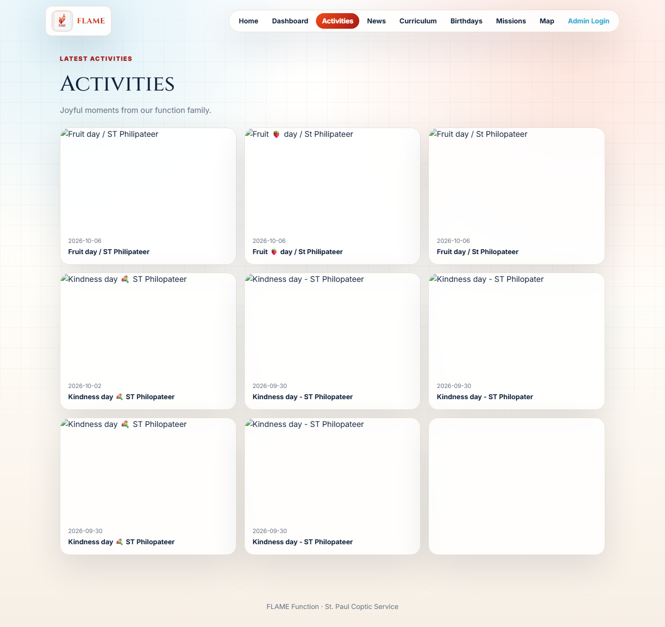
Business rules
- Activity.scope ∈ {school, local_flame, other}; may link to a school.
- Birthdays endpoint merges Person and Student records and sorts by month/day.
- Each birthday carries a contact: a person's contact, or a student's phone / parent contact (labelled).
Frontend
pages/public/Activities.jsx, News.jsx, Birthdays.jsx; admin CrudSections + news admin.
API
GET/POST /api/activities
Activities feed.
Request
{ caption, activityDate, scope, summary, schoolId? }
Response
{ ...activity }
GET/POST /api/news
News posts.
Request
{ title, body, postDate }
Response
{ ...post }
GET /api/birthdays
Merged birthday calendar.
Response
[ { name, date, source } ]
Database tables used
Activity, NewsPost, Person, Student

3. Database Reference
Every table with typed columns. Key = PK (primary key) / FK→Target (foreign key). '?' marks a nullable column.
User
Admin/staff accounts. Roles stored comma-separated.
Column | Type | Key / Constraint | Notes
id | String | PK | uuid
name | String
email | String | UNIQUE
passwordHash | String |  | bcrypt
role | String |  | CSV of roles, default 'reviewer'
createdAt | DateTime |  | now()

Country
Top of the geography tree.
Column | Type | Key / Constraint | Notes
id | String | PK | uuid
name | String | UNIQUE
code | String? |  | e.g. GH
active | Boolean |  | default true
createdAt | DateTime

Residence
A residence belongs to a country; houses people.
Column | Type | Key / Constraint | Notes
id | String | PK
name | String
city | String?
address | String?
countryId | String? | FK→Country
createdAt | DateTime

School
A school in a country; owns classes, staff, logs, content.
Column | Type | Key / Constraint | Notes
id | String | PK
name | String
city | String?
address | String?
phone | String?
email | String?
countryId | String? | FK→Country
region | String? |  | holds city for map
workingDays | String |  | default '1,2,3,4,5'
latitude | Float?
longitude | Float?
active | Boolean |  | default true

Person
Central reusable person: teacher/priest/worker/resident/servant.
Column | Type | Key / Constraint | Notes
id | String | PK
fullName | String | REQUIRED | only mandatory field
birthdate | DateTime? |  | no future dates
nationality | String?
position | String? |  | Principal|Teacher|Worker|Resident|Priest|Servant|Other
contact | String?
email | String?
isPriest | Boolean |  | default false
available | Boolean |  | default true
dob | DateTime? |  | legacy birthday
schoolId | String? | FK→School
residenceId | String? | FK→Residence
priestCountryId | String? | FK→Country

ClassLevel
A class within a school with one teacher.
Column | Type | Key / Constraint | Notes
id | String | PK
name | String
stage | String?
order | Int |  | default 0
schoolId | String? | FK→School
teacherId | String? | FK→Person
active | Boolean |  | default true

Student
A student belonging to a class (and thus a school).
Column | Type | Key / Constraint | Notes
id | String | PK
fullName | String | REQUIRED
birthday | DateTime? |  | no future
phone | String?
fatherName | String?
fatherContact | String?
motherName | String?
motherContact | String?
classId | String? | FK→ClassLevel

MedicalTeamMember
Selectable in medical missions; has availability.
Column | Type | Key / Constraint | Notes
id | String | PK
fullName | String | REQUIRED
specialty | String?
contact | String?
email | String?
available | Boolean |  | default true

Curriculum
PDF curriculum (≤12MB), multi-assignable.
Column | Type | Key / Constraint | Notes
id | String | PK
title | String
description | String?
language | String? |  | ar|en|fr
fileUrl | String? |  | /uploads/..pdf

CurriculumClass
Curriculum ↔ Class (M:N).
Column | Type | Key / Constraint | Notes
curriculumId | String | PK/FK→Curriculum
classId | String | PK/FK→ClassLevel

CurriculumSchool
Curriculum ↔ School with per-school status.
Column | Type | Key / Constraint | Notes
curriculumId | String | PK/FK→Curriculum
schoolId | String | PK/FK→School
status | String |  | expected|pending|completed

ValuesClass
Values-class PDF (same model as curriculum).
Column | Type | Key / Constraint | Notes
id | String | PK
title | String
description | String?
language | String?
fileUrl | String?

ValuesClassClass
ValuesClass ↔ Class (M:N).
Column | Type | Key / Constraint | Notes
valuesClassId | String | PK/FK
classId | String | PK/FK→ClassLevel

ValuesClassSchool
ValuesClass ↔ School with status.
Column | Type | Key / Constraint | Notes
valuesClassId | String | PK/FK
schoolId | String | PK/FK→School
status | String |  | expected|pending|completed

Formation
Formation files, multi-school.
Column | Type | Key / Constraint | Notes
id | String | PK
title | String
description | String?
fileUrl | String?

FormationSchool
Formation ↔ School with status.
Column | Type | Key / Constraint | Notes
formationId | String | PK/FK
schoolId | String | PK/FK→School
status | String |  | expected|pending|completed

Mission
A field mission; generates dashboard logs.
Column | Type | Key / Constraint | Notes
id | String | PK
title | String
type | String |  | Medical|Follow-ups|..
status | String |  | expected|pending|completed
startDate | DateTime? |  | required by API
endDate | DateTime? |  | required by API, ≥ start
summary | String?
numPeople | Int?
durationDays | Int?
anonymousCount | Int |  | default 0

MissionCountry
Mission ↔ Country with per-country dates.
Column | Type | Key / Constraint | Notes
id | String | PK
missionId | String | FK→Mission (cascade)
countryId | String | FK→Country
startDate | DateTime?
endDate | DateTime?

MissionSchool
Mission ↔ School visited (composite PK).
Column | Type | Key / Constraint | Notes
missionId | String | PK/FK (cascade)
schoolId | String | PK/FK→School

MissionPerson
Mission ↔ Person (team).
Column | Type | Key / Constraint | Notes
missionId | String | PK/FK (cascade)
personId | String | PK/FK→Person

MissionMedical
Mission ↔ MedicalTeamMember.
Column | Type | Key / Constraint | Notes
missionId | String | PK/FK (cascade)
memberId | String | PK/FK→MedicalTeamMember

MorningAssembly
Six sections, each text OR an uploaded file.
Column | Type | Key / Constraint | Notes
id | String | PK
schoolId | String? | FK→School
date | DateTime?
openingPrayer(+File) | String?
physicalExercise(+File) | String?
radio(+File) | String?
nationalAnthem(+File) | String?
inspection(+File) | String?
announcement(+File) | String?

LogType
Dashboard category for logs.
Column | Type | Key / Constraint | Notes
id | String | PK | e.g. medical_log
key | String | UNIQUE
label | String
icon | String?
expectedPerWorkingDay | Int |  | default 0

MissionLog
The dashboard record; unifies missions and school tasks.
Column | Type | Key / Constraint | Notes
id | String | PK
logTypeId | String | FK→LogType
schoolId | String | FK→School
responsiblePersonId | String? | FK→Person
logDate | DateTime
status | String |  | expected|pending|completed
notes | String? |  | holds 'mission:<id>' tag or summary
createdById | String? | FK→User

TaskRecord
Granular performed/not-performed items under a log.
Column | Type | Key / Constraint | Notes
id | String | PK
missionLogId | String | FK→MissionLog (cascade)
question | String
performed | Boolean |  | default false
responsible | String?
recordedDate | DateTime?

Activity
Public activity feed item.
Column | Type | Key / Constraint | Notes
id | String | PK
caption | String?
activityDate | DateTime?
scope | String |  | school|local_flame|other
summary | String?
schoolId | String? | FK→School
imageUrl | String?

NewsPost
Public news post.
Column | Type | Key / Constraint | Notes
id | String | PK
title | String
body | String?
postDate | DateTime?
imageUrl | String?

FormField
A field in the dynamic Apply form.
Column | Type | Key / Constraint | Notes
id | String | PK
label | String
key | String | UNIQUE
type | String |  | text|number|dropdown|toggle|rating
options | String? |  | dropdown values
required | Boolean |  | default false
order | Int |  | default 0
active | Boolean |  | default true

Application
A submitted Apply form.
Column | Type | Key / Constraint | Notes
id | String | PK
values | String |  | JSON of answers
submittedAt | DateTime

MiscEntry
Generic reference/lookup entries.
Column | Type | Key / Constraint | Notes
id | String | PK
category | String
label | String
value | String?
notes | String?

4. Entity-Relationship Diagram
Tables grouped by domain (Geography & People · Content · Missions & Logs · Feed & Admin) with their relationships. PK in red, FK in blue.
