ماده 23 ............................................................................................................................. ............................................................................. ...... .................................................. .......................................................................................................................................

1. ...........................................................................................................
2. ............................................................................................................
3. ............................................................................................................
4. ............................................................................................................

ماده یا تبصره...............

1. ............................................................................................................

\*1- ................................................................................................

\*2-.................................................................................................

\*3-.................................................................................................

1. ............................................................................................................
2. ............................................................................................................

تبصره 2............................................................................................................................. ............................................................................. ...... .................................................. .......................................................................................................................................

1. ...........................................................................................................
2. ............................................................................................................
3. ............................................................................................................
4. ............................................................................................................

تبصره 23............................................................................................................................. ............................................................................. ...... .................................................. .......................................................................................................................................

الف)...........................................................................................................

ب)‌ ............................................................................................................

ج)‌ ............................................................................................................

د)............................................................................................................

ماده ...................................................................................................................................

........................................................................................................................................

1-...............................................................................................................................

2-...............................................................................................................................

3-.............................................................................................................................

تبصره...................................................................................................................................

..........................................................................................................................................

الف)...........................................................................................................

ب)‌ .............................................................................................................

ج)‌ .............................................................................................................

\*1- ................................................................................................

\*2-.................................................................................................

\*3-.................................................................................................

د)...............................................................................................................

1. انتهای هر بخش (ماده- تبصره- بند) با enter از هم جدا شده باشند.
2. بند ها در صورت امکان باحروف "ابجد" ترتیب گذاری شوند.
3. ترجیحا بند های تودرتو یکی با حرف "ابجد" و دیگری توسط اعداد ترتیب گذاری شوند
4. درصورت داشتن بند های تودرتو اگر هردو بخش توسط اعداد شماره گذاری شده باشند بند داخلی باعلامت \* متمایز شده باشند.

حالات قابل قبول:

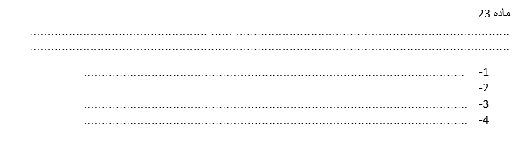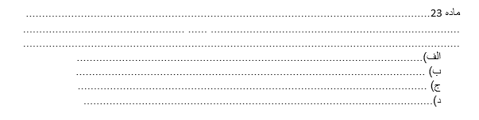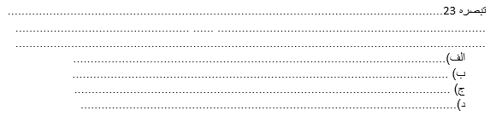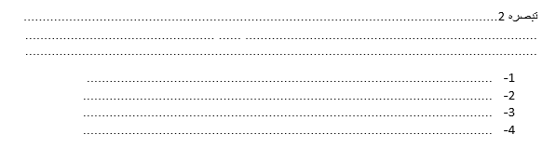

ترتیب گذاری صحیح بند های تودرتو :

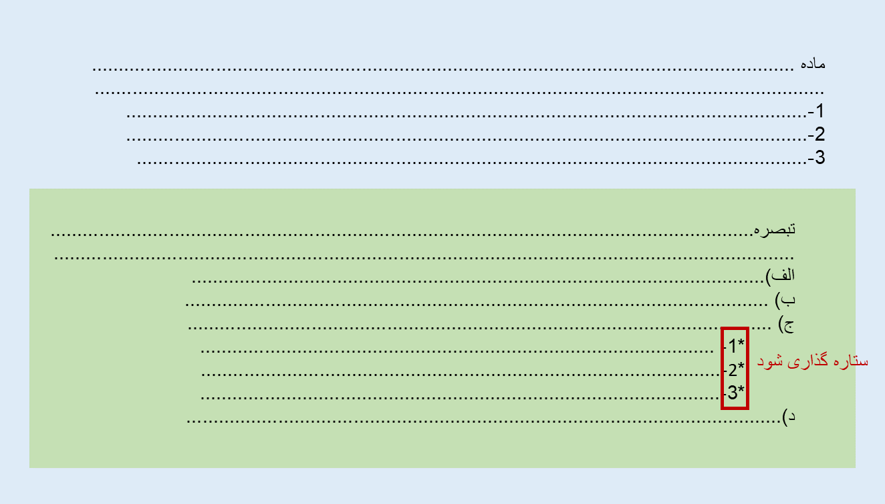

راهنمای ستاره (\*) گذاری :

