

Cairo University

Faculty of Computers and Artificial Intelligence

Digital Signals Processing

Assignment 2 Report

|  |  |
| --- | --- |
| Name**:** | ID**:** |
| **1. Nada Mohamed** | **20201193** |
| **2. Mina Albert Saeed** | **20210417** |

Question 1

Plot of Impulse Response h[n]:

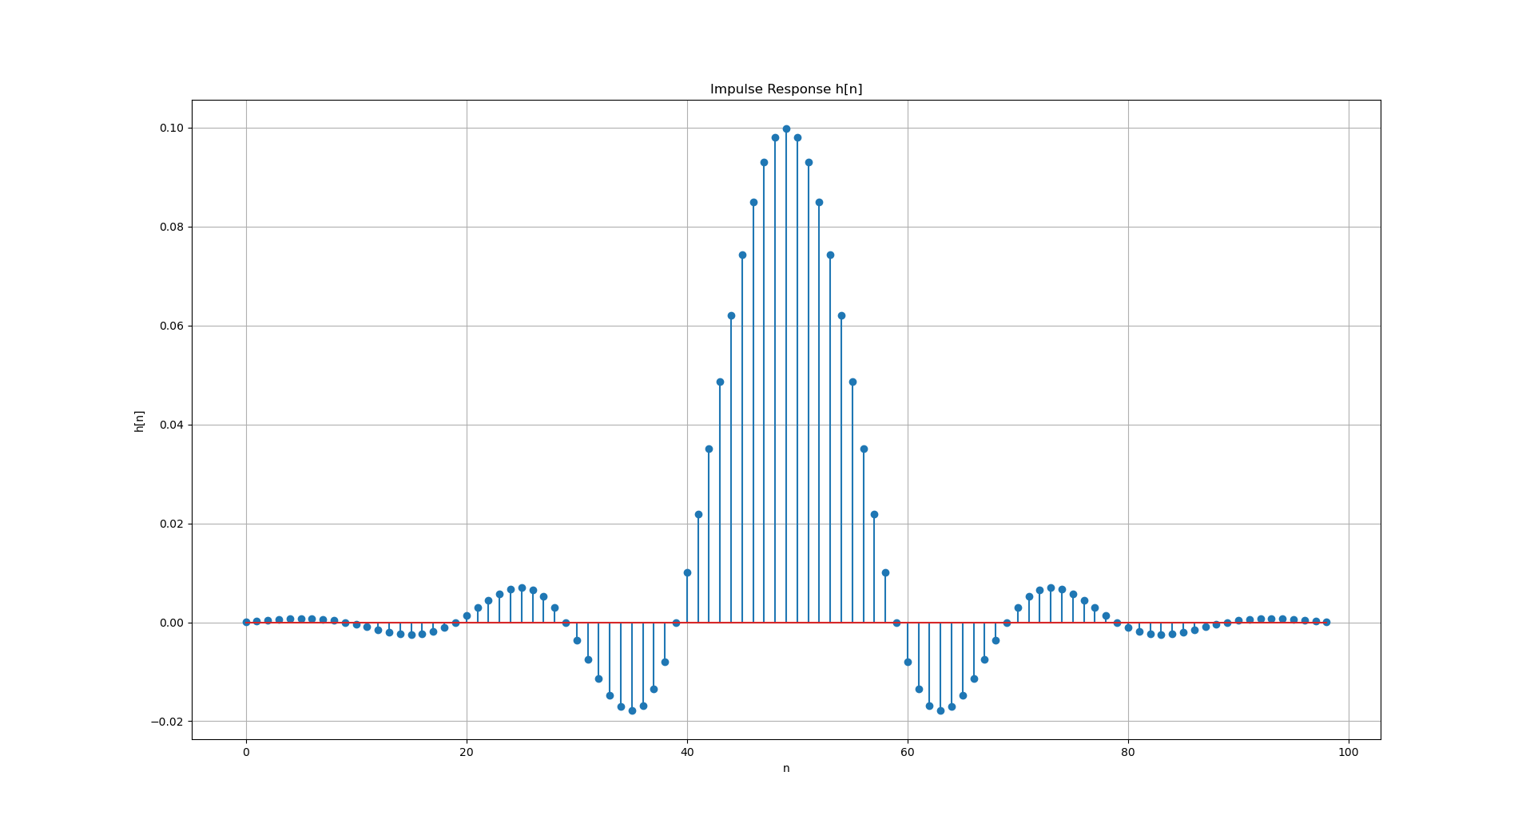

Question 2

1-Code is provided at the **low_pass_filter_test.py** file in a function called ***manual_convolve()***

What should the output of your program be in response to this signal? Why?

2 -Since the input signal **x[n]** is an impulse at **n=0** (i.e., **x[n]=1** for **n=0** and **x[n]=0** otherwise), the output of the convolution will be exactly the same as the impulse response of the filter. Convolution with an impulse signal effectively reproduces the filter's impulse response, so the output y[n] will match h[n] exactly.

Question 3

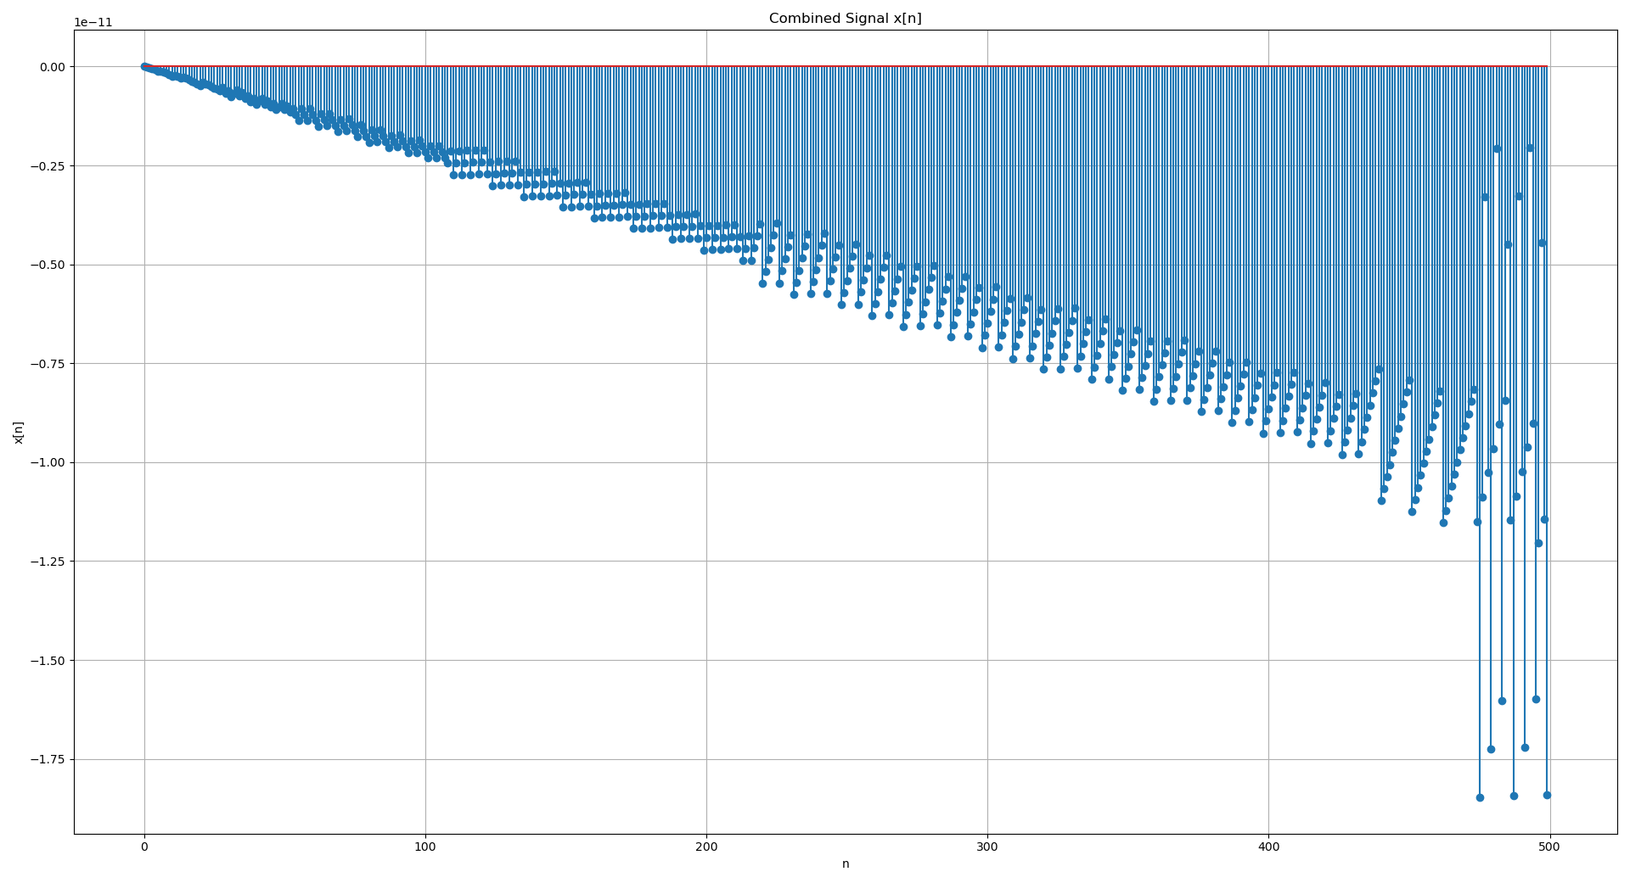Plot of Complicated Singal x[n]:

Question 4

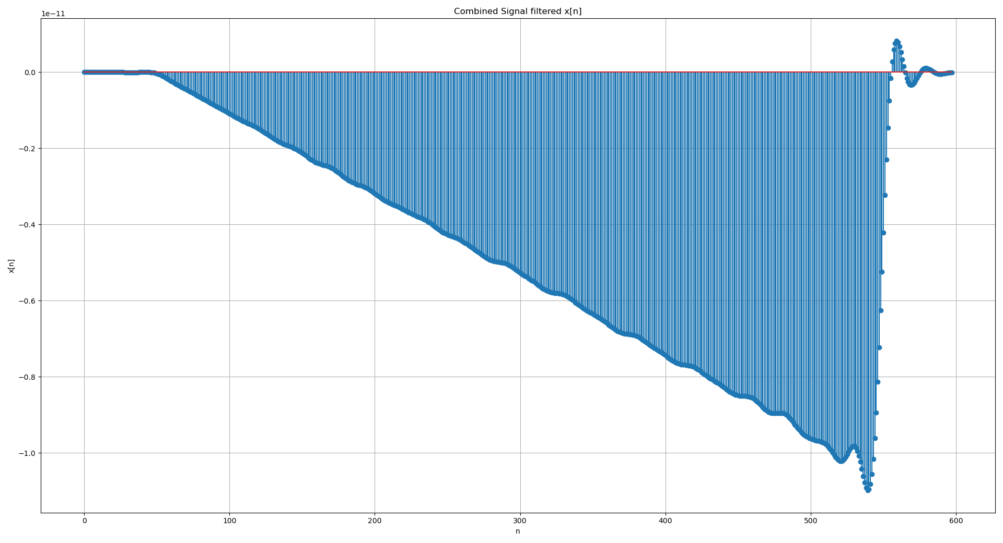Plot of Response y[n] = x[n] * h[n]:

As noticed, the filtered signal reveals that the lower frequency component 0.075 (6 cycles) is allowed through, while the higher frequency component 0.552 (44 cycles) is diminished. This demonstrates the filter's efficiency in blocking frequencies above its cut-off frequency (0.3141), effectively passing signals below this threshold while attenuating higher frequencies.