Windows Server 2016 Documentation
Active Directory, DNS, File Sharing, Group Policy, Security & Backup Configuration

1. Introduction
Windows Server 2016 was deployed as the centralized management server for the enterprise network. It provides authentication, authorization, name resolution, file sharing, security policy enforcement, remote administration, auditing, and system backup services.
The following sections document, step by step, every component that was installed and configured on the server, supported by screenshots taken directly from the live environment.
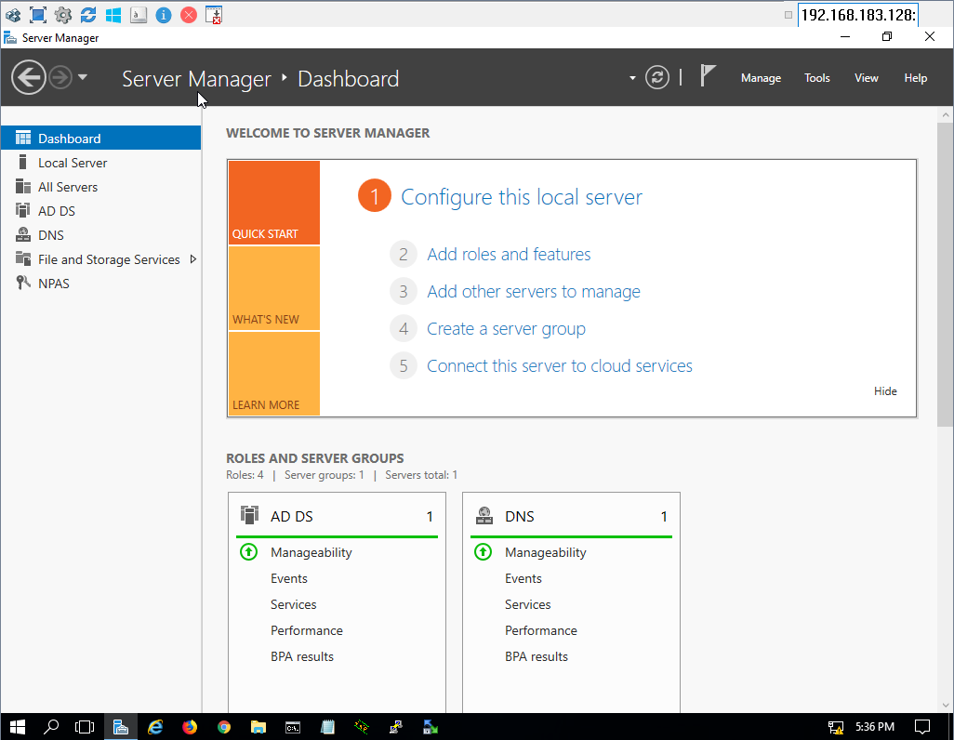
Figure 1.1: Server Manager Dashboard showing the installed roles (AD DS, DNS, File and Storage Services, NPAS).

2. Active Directory Domain Services (AD DS)
Active Directory Domain Services (AD DS) was installed and configured to provide centralized identity and access management across the enterprise network. The Domain Controller authenticates users, authorizes access to network resources, and centrally manages users, computers, and security policies.
Parameter | Value
Server Name | WINSERVER
Domain Name | uni.local
Forest Functional Level | Windows Server 2016
Domain Functional Level | Windows Server 2016
How it was implemented – step by step:
- Opened Server Manager → Dashboard → clicked “Add roles and features.”
- Followed the wizard: Installation Type → “Role-based or feature-based installation.”
- Selected the local server (WINSERVER) as the destination server.
- From the Server Roles list, checked “Active Directory Domain Services” and accepted the required management tools that were added automatically.
- Clicked Next through Features and confirmation, then clicked Install and waited for the role installation to finish.
- After installation, clicked the notification flag in Server Manager and selected “Promote this server to a domain controller.”
- In the Deployment Configuration step, selected “Add a new forest” and typed the root domain name “uni.local.”
- In Domain Controller Options, set the Forest/Domain functional level to “Windows Server 2016”, enabled DNS server, and set the Directory Services Restore Mode (DSRM) password.
- Completed the wizard (NetBIOS name, paths, review options, prerequisites check) and clicked Install; the server rebooted automatically and came back up as a Domain Controller for uni.local.

3. DNS Server Configuration
The DNS Server role was installed and integrated with Active Directory. It provides internal hostname resolution, Active Directory service location, domain authentication support, and name resolution for all domain-joined clients. All client devices use the Windows Server as their primary DNS server.
Steps performed:
- Installed the DNS Server role from Server Manager during the AD DS promotion.
- Verified the automatic creation of the Forward Lookup Zone “uni.local”.
- Reviewed Host (A) records for the server and for every client/department workstation (Student, Staff, Management, Domain Controller).
- Configured the Reverse Lookup Zone to allow IP-to-hostname resolution and verified the Pointer (PTR) record for the server.
How it was implemented – step by step:
- Opened Server Manager → Tools → DNS Manager.
- Expanded WINSERVER → Forward Lookup Zones → confirmed that “uni.local” was created automatically when AD DS was promoted (it is created together with the domain, no manual step needed).
- Inside the “uni.local” zone, right-clicked → “New Host (A or AAAA)” and added a static Host (A) record for the server itself (winserver → 30.0.0.20).
- Repeated the same “New Host” step for every client device (Student-one-Vlan10, Student-two-V10, Staff-1-V30, Staff-2-V30, Staff-3-V60, Management-one-V20, Management-2-V20, Management-3-V50, DESKTOP-M65LJ28), typing the hostname and its IP address each time.
- Right-clicked “Reverse Lookup Zones” → “New Zone” → chose “Primary Zone”, “To all DNS servers running on domain controllers in this domain”, and entered the Network ID (30) to create the “30.in-addr.arpa” zone.
- Checked the box “Create associated pointer (PTR) record” when creating the server’s Host (A) record, so the PTR record (WinServer.uni.local) was generated automatically inside the reverse zone.
- On every client computer, set the Preferred DNS server (in the network adapter’s IPv4 properties) to the server’s IP address (30.0.0.20) so all clients resolve names through this DNS server.
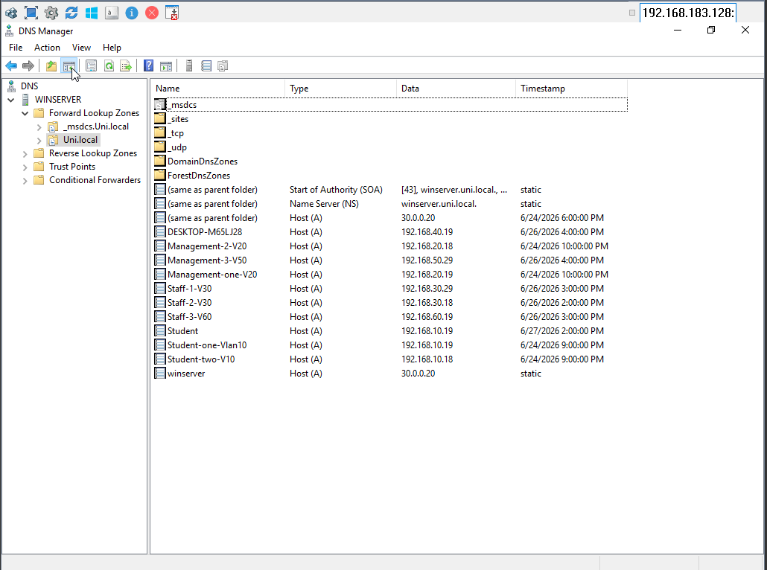
Figure 3.1: DNS Manager – Forward Lookup Zone “uni.local” showing Host (A) records for the domain controller and all department workstations.
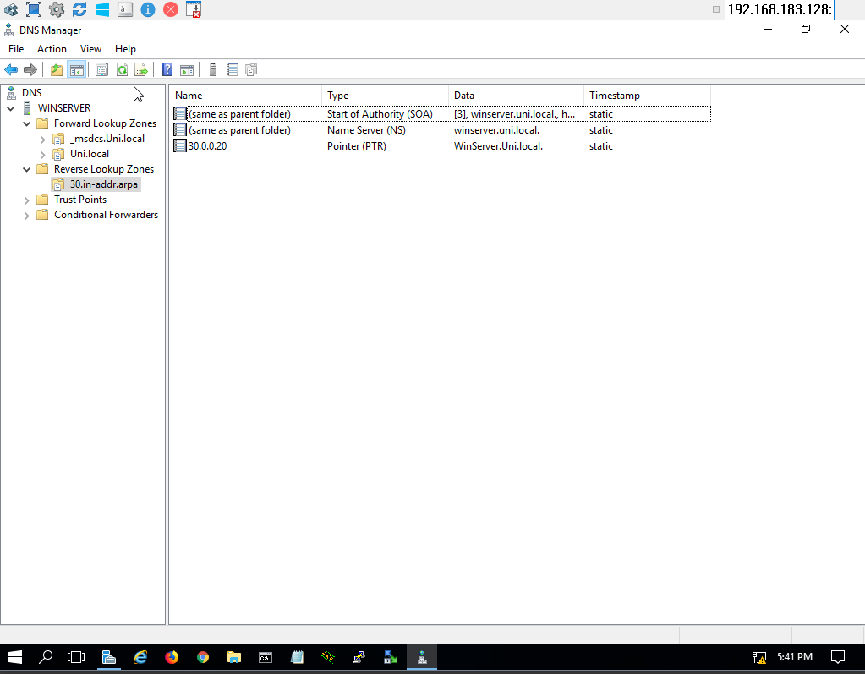
Figure 3.2: DNS Manager – Reverse Lookup Zone with the Pointer (PTR) record resolving the server’s IP address back to its hostname.

4. Organizational Unit (OU) Structure
To simplify administration and apply department-specific security policies, the Active Directory environment was organized into the following Organizational Units:
- uni_Students
- uni_Staff
- uni_Management
This structure enables centralized management while allowing different Group Policies to be applied to each department independently.
How it was implemented – step by step:
- Opened Server Manager → Tools → Active Directory Users and Computers.
- Right-clicked the domain “Uni.local” → New → Organizational Unit.
- Typed the OU name (“uni_Student”), left “Protect container from accidental deletion” checked, then clicked OK.
- Repeated the same New → Organizational Unit steps to create “uni_Staff” and “uni_Management” directly under the domain root.
- Inside uni_Student, created the sub-containers used to organize users/computers/groups (Users, Computers, Groups) by right-clicking the OU → New → the relevant object type, or simply created user/computer/group objects directly inside the OU as shown in the screenshot below.
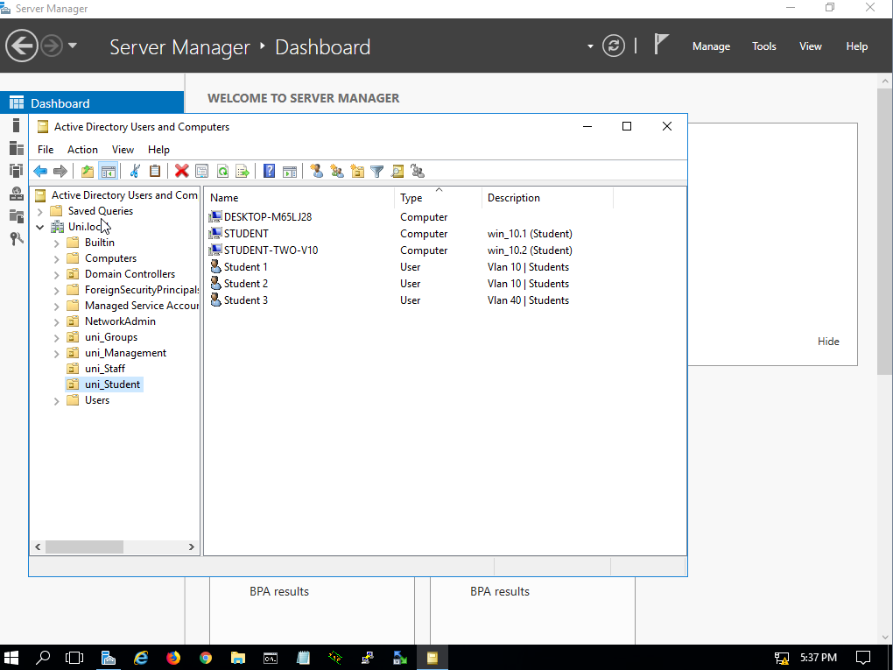
Figure 4.1: Active Directory Users and Computers – the uni_Student Organizational Unit, showing its joined computers and user accounts.

5. User Management
User accounts were created for each department within their corresponding Organizational Units. Each account includes a username, an initial password, a department assignment, and domain authentication. Users can authenticate from any domain-joined workstation using their domain credentials.
In the example above, the Students OU contains the accounts Student 1, Student 2, and Student 3, each tagged with their VLAN/department description (e.g., “Vlan 10 | Students”).
How it was implemented – step by step:
- In Active Directory Users and Computers, right-clicked the target OU (e.g., uni_Student) → New → User.
- Entered the First name and Logon name (e.g., “Student 1”) and clicked Next.
- Set an initial password, then configured the password options (e.g., “User must change password at next logon” or “Password never expires” depending on the account type) and clicked Next → Finish.
- Opened the new user’s Properties → General/Organization tabs and filled in the Description field with the department/VLAN tag (e.g., “Vlan 10 | Students”) for easy identification.
- Repeated the same New → User steps for every account needed in each OU (Staff and Management accounts were created the same way inside uni_Staff and uni_Management).

6. Computer Management
Windows 10 client computers were successfully joined to the Active Directory domain. Each computer account was placed inside its corresponding Organizational Unit according to its department, which allows computer and user policies to be managed efficiently.
How it was implemented – step by step:
- On each client machine: Right-clicked “This PC” → Properties → “Change settings” → “Change…” next to the computer name.
- Selected “Domain” under “Member of” and typed the domain name “uni.local”, then clicked OK.
- Entered domain administrator credentials when prompted, confirmed the “Welcome to the uni.local domain” message, and restarted the computer to apply the change.
- Back on the server, opened Active Directory Users and Computers and located the newly joined computer object (created by default inside the “Computers” container).
- Dragged-and-dropped (or used “Move…” from the right-click menu) each computer object from the default “Computers” container into its correct department OU (e.g., uni_Student) so the right Group Policies apply to it.
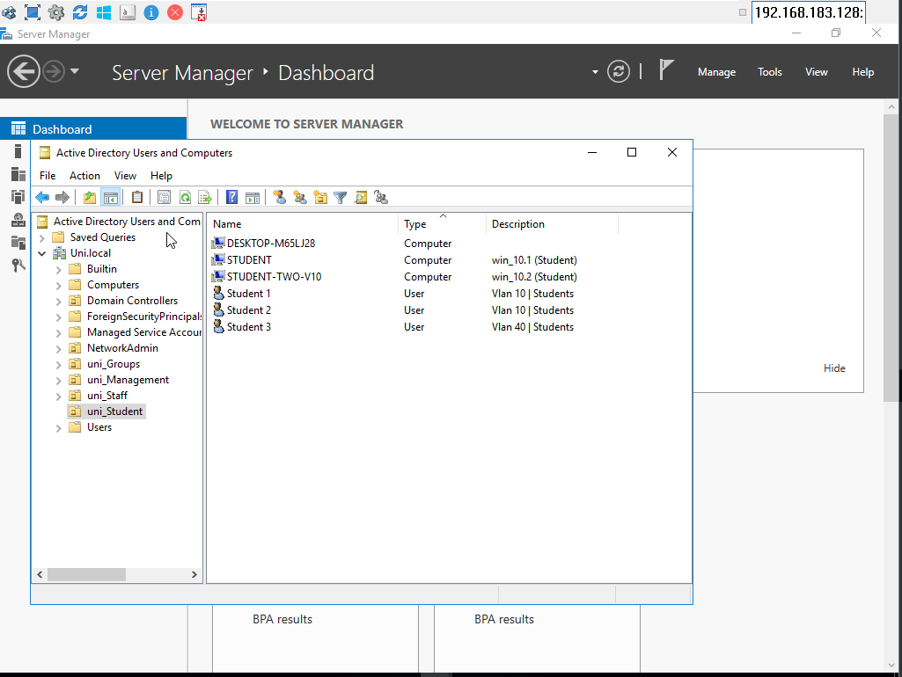
Figure 6.1: Active Directory Users and Computers – domain-joined client computers (e.g., DESKTOP-M65LJ28, STUDENT, STUDENT-TWO-V10) listed inside the uni_Student OU.

7. Security Groups
To implement Role-Based Access Control (RBAC), the following Global Security Groups were created:
- Students-GRP
- Staff-GRP
- Management-GRP
Permissions are assigned to these security groups rather than to individual users, which simplifies administration and improves overall security management when granting access to shared resources.
How it was implemented – step by step:
- In Active Directory Users and Computers, right-clicked the “uni_Groups” container (or the relevant OU) → New → Group.
- Typed the group name (e.g., “Students-GRP”), set Group scope to “Global” and Group type to “Security”, then clicked OK.
- Repeated the same New → Group steps to create “Staff-GRP” and “Management-GRP.”
- Opened each group’s Properties → Members tab → Add…, and typed/selected the user accounts that belong to that department so they became members of the group.

8. File Server Configuration
A centralized file server was implemented by creating a shared directory named “Uni Shared Folder” on the server. Inside it, a dedicated folder was created for each department:
- Shared-Students
- Shared-Staff
- Shared-Management
These folders provide centralized, organized storage for each department.
How it was implemented – step by step:
- On the server, created a new folder on the Desktop (or a chosen drive) and named it “Uni Shared Folder.”
- Inside it, created three sub-folders: “Shared-Students”, “Shared-Staff”, and “Shared-Management” (right-click → New → Folder for each).
- Right-clicked the parent folder “Uni Shared Folder” → Properties → Sharing tab → Advanced Sharing…
- Checked “Share this folder”, kept the share name, then clicked Permissions and configured the share-level access (see Section 9.2).
- Clicked OK/Apply to publish the folder on the network, making it reachable from clients via \\30.0.0.20\Uni Shared Folder.
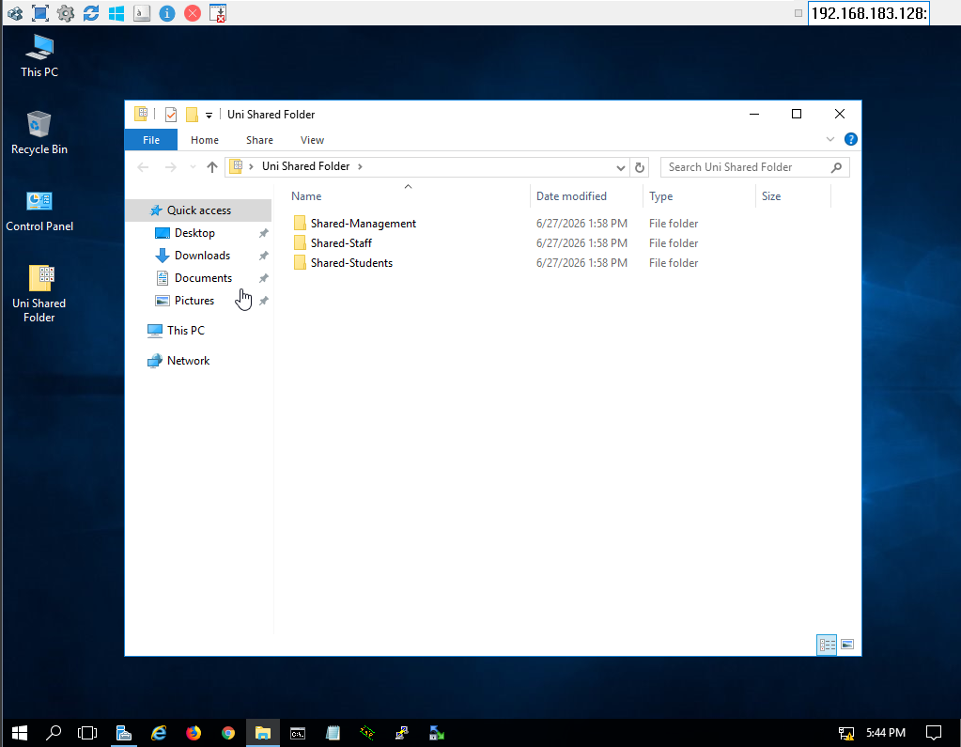
Figure 8.1: “Uni Shared Folder” directory structure containing the Shared-Management, Shared-Staff, and Shared-Students folders.

9. File Sharing and NTFS Permissions
The shared directory was published on the network using Windows File Sharing. NTFS permissions were then configured according to the Principle of Least Privilege, so that each department can access only its own files.
Folder | Authorized Group
Shared-Students | Students-GRP
Shared-Staff | Staff-GRP
Shared-Management | Management-GRP
Administrative accounts retain Full Control permissions over all shared resources.

9.1 NTFS (Security) Permissions
Configured from the folder Properties → Security tab, granting Read & Execute, List Folder Contents, and Read permissions to Authenticated Users, with Full Control reserved for the Administrators group and SYSTEM.
How it was implemented – step by step:
- Right-clicked the “Uni Shared Folder” (and each department sub-folder) → Properties → Security tab.
- Clicked “Edit…” (or “Advanced” for finer control) to change permissions.
- Clicked “Add…”, typed the relevant security group name (e.g., “Students-GRP” for the Shared-Students folder, “Staff-GRP” for Shared-Staff, “Management-GRP” for Shared-Management), then clicked “Check Names” → OK.
- Selected the newly added group and checked the Allow boxes for “Read & Execute”, “List folder contents”, and “Read” (and “Modify” where write access was required).
- Confirmed that the “Administrators” group and “SYSTEM” already had Full Control, leaving them untouched so administrators always retain full access.
- Clicked Apply → OK to save the NTFS permissions.
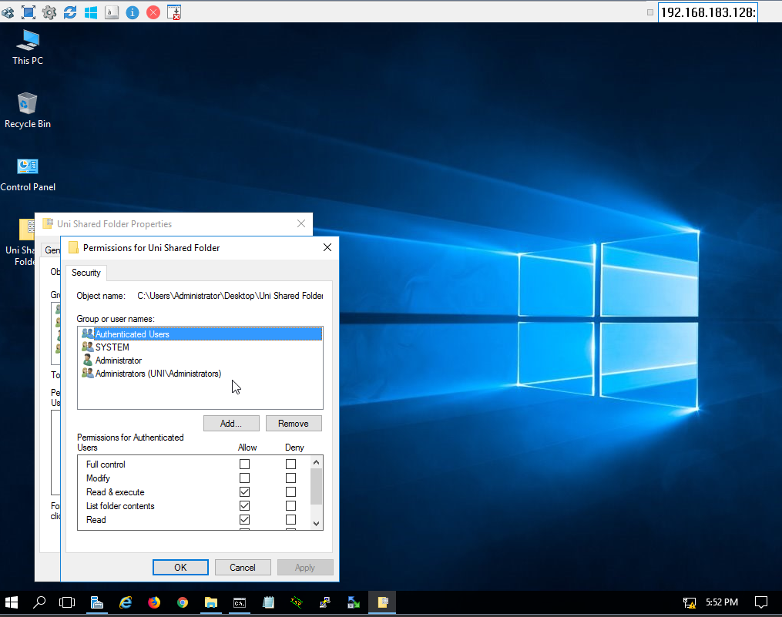
Figure 9.1: NTFS Security permissions on the “Uni Shared Folder”, showing the assigned groups (Authenticated Users, SYSTEM, Administrator, Administrators).

9.2 Share Permissions
Configured from Properties → Sharing → Advanced Sharing → Permissions, granting Full Control, Change, and Read at the share level.
How it was implemented – step by step:
- Right-clicked the folder → Properties → Sharing tab → “Advanced Sharing…”
- Clicked “Permissions” in the Advanced Sharing dialog.
- Selected the “Authenticated Users” group (or the specific department group) and checked the Allow boxes for “Full Control”, “Change”, and “Read” as appropriate.
- Clicked Apply → OK, then OK again to close Advanced Sharing.
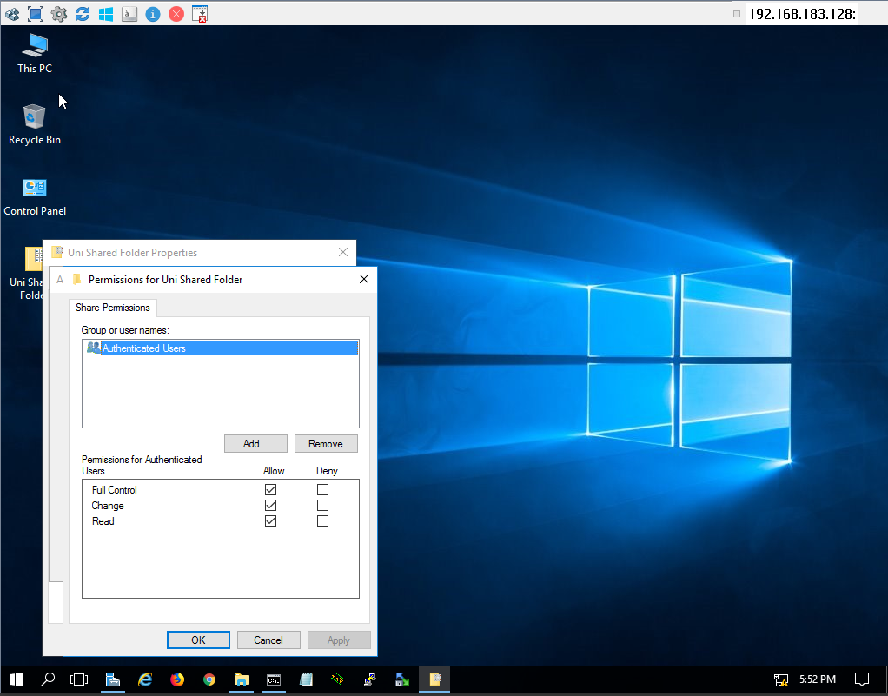
Figure 9.2: Share Permissions for the “Uni Shared Folder” network share.

9.3 Access Control Verification
To confirm that the Least Privilege model is correctly enforced, a Student account attempted to open the Shared-Staff folder over the network and received an Access Denied error, proving that cross-department access is properly restricted.
How the verification was performed:
- Logged in on a client workstation using a Student domain account.
- Opened File Explorer and navigated to \\30.0.0.20\Uni Shared Folder.
- Successfully opened “Shared-Students”, confirming the Students-GRP permissions were applied correctly.
- Attempted to open “Shared-Staff” and received the “Windows cannot access … You do not have permission to access” error, confirming that NTFS/Share permissions correctly blocked cross-department access.
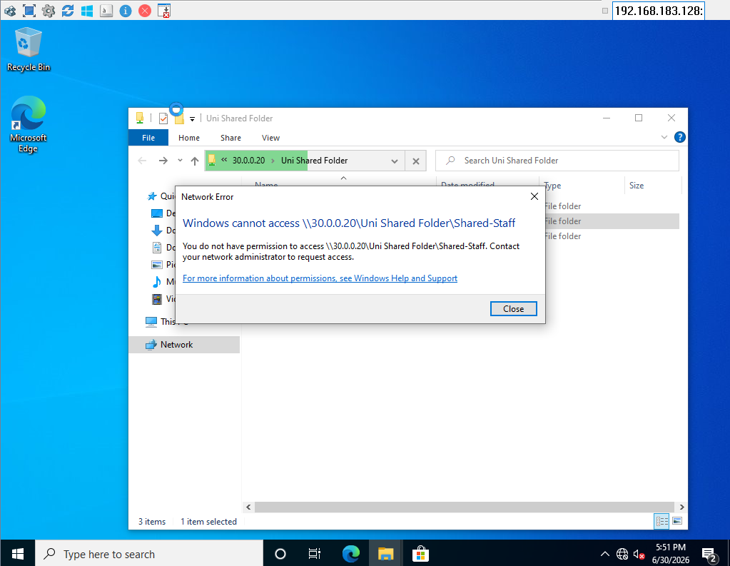
Figure 9.3: A Student account is denied access to the Shared-Staff folder, confirming that NTFS/Share permissions are correctly enforced.

10. Group Policy Management
Multiple Group Policy Objects (GPOs) were created and linked to the appropriate Organizational Units to enforce organizational security requirements for each department.

10.1 Students Security Policy
The Students Organizational Unit is the most restricted environment. The following policies were created and linked to uni_Student:
- Close Control Panel
- Prevent Registry editor
- Prevent access to Task Manager
- No Wallpaper
- USB lock
- Hide Drivers
- Can't change Password
- Prevent Access to shutdown
- Hide Network
- Login Banner
- Prevent Access of date and time
- CMD (Disable Command Prompt)
- Logon Hours
- Close PowerShell
How a GPO is created and linked – general procedure followed for every policy:
- Opened Server Manager → Tools → Group Policy Management.
- Expanded Forest: Uni.local → Domains → Uni.local → right-clicked the target OU (e.g., “uni_Student”) → “Create a GPO in this domain, and Link it here…”
- Typed a descriptive name for the policy (e.g., “Close Control Panel”, “CMD”, “Logon Houres”) and clicked OK; the new GPO appeared linked to the OU with “Link Enabled = Yes.”
- Right-clicked the new GPO → “Edit…” to open the Group Policy Management Editor.
- Navigated to the correct settings node depending on the restriction (mostly under User Configuration → Policies → Administrative Templates, with a few under Computer Configuration), located the specific setting, double-clicked it, set it to “Enabled”, and clicked Apply → OK.
- Closed the editor; the policy applies automatically to all users/computers inside uni_Student the next time they refresh Group Policy (gpupdate) or log on.
Specific settings used for each Students policy:
- Close Control Panel → User Configuration → Administrative Templates → Control Panel → “Prohibit access to Control Panel and PC settings” → Enabled.
- Prevent Registry editor → User Configuration → Administrative Templates → System → “Prevent access to registry editing tools” → Enabled.
- Prevent access to Task Manager → User Configuration → Administrative Templates → System → Ctrl+Alt+Del Options → “Remove Task Manager” → Enabled.
- No Wallpaper → User Configuration → Administrative Templates → Desktop → Desktop → “Desktop Wallpaper” → Enabled, with the wallpaper path left empty.
- USB lock → Computer Configuration → Administrative Templates → System → Removable Storage Access → “All Removable Storage classes: Deny all access” → Enabled.
- Hide Drivers → User Configuration → Administrative Templates → Windows Components → File Explorer → “Hide these specified drives in My Computer” → Enabled, drive set selected.
- Can't change Password → User Configuration → Administrative Templates → System → Ctrl+Alt+Del Options → “Remove Change Password” → Enabled.
- Prevent Access to shutdown → User Configuration → Administrative Templates → System → Ctrl+Alt+Del Options → “Remove Shut Down, Restart, Sleep, and Hibernate” → Enabled (also mirrored on the Start Menu via the equivalent policy).
- Hide Network → User Configuration → Administrative Templates → Network → Network Connections → “Prohibit access to properties of a LAN connection” / hide the Network icon → Enabled.
- Login Banner → Computer Configuration → Policies → Windows Settings → Security Settings → Local Policies → Security Options → “Interactive logon: Message title for users attempting to log on” and “Message text for users attempting to log on” → filled with the warning title/text.
- Prevent Access of date and time → User Configuration → Administrative Templates → Control Panel → “Hide Date and Time icon” / Personalization restriction → Enabled.
- CMD → User Configuration → Administrative Templates → System → “Prevent access to the command prompt” → Enabled (also disables CMD-based batch files when set to full).
- Logon Hours → enforced both centrally (Default Domain Policy / dedicated GPO) and per-user via Active Directory Users and Computers → user Properties → Account → Logon Hours (see Section 14).
- Close PowerShell → User Configuration → Administrative Templates → System → “Don't run specified Windows applications” (powershell.exe added to the list) or “Prevent access to the command prompt” with “Also disable the command prompt script processing” → Enabled.
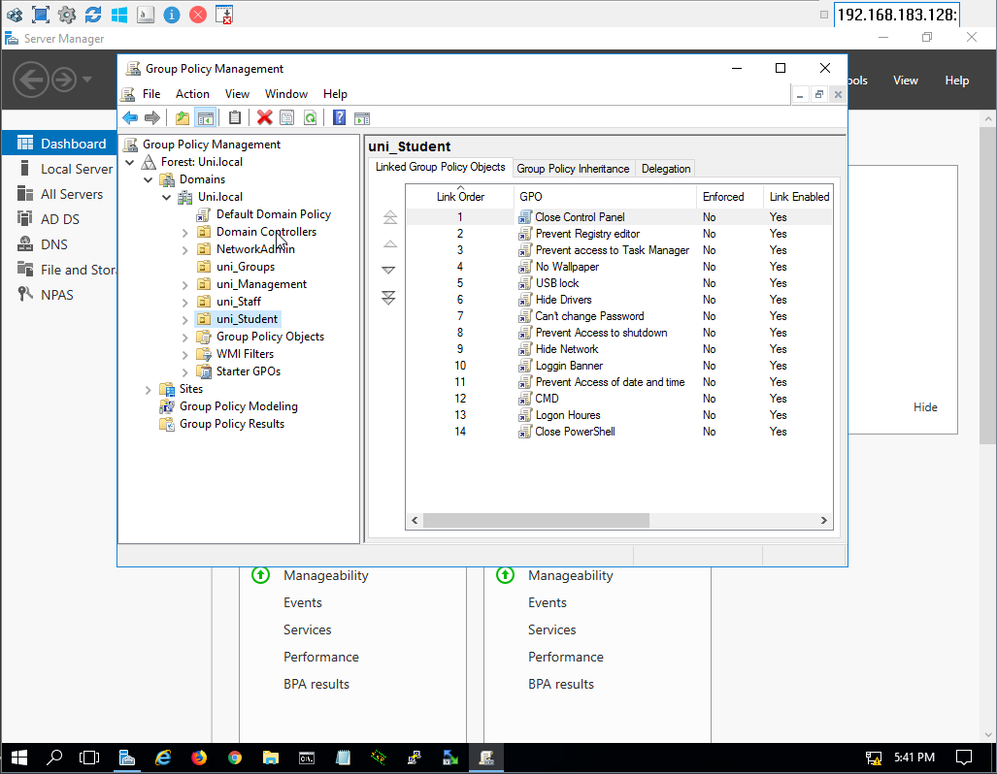
Figure 10.1: Group Policy Management – GPOs linked to the uni_Student OU.
Verification: when a Student attempts to run a restricted tool (e.g., Command Prompt) on a domain-joined workstation, Windows blocks the action with a Restrictions message, confirming that the policy is applied and enforced.
How the verification was performed:
- Logged on to a domain-joined client with a Student account.
- Ran “gpupdate /force” (or simply waited for the periodic background refresh) to make sure the latest GPO settings were applied.
- Tried to open Command Prompt / Control Panel from the Start Menu.
- Windows displayed the “Restrictions” dialog (“This operation has been cancelled due to restrictions in effect on this computer”), confirming the policy is active and enforced.
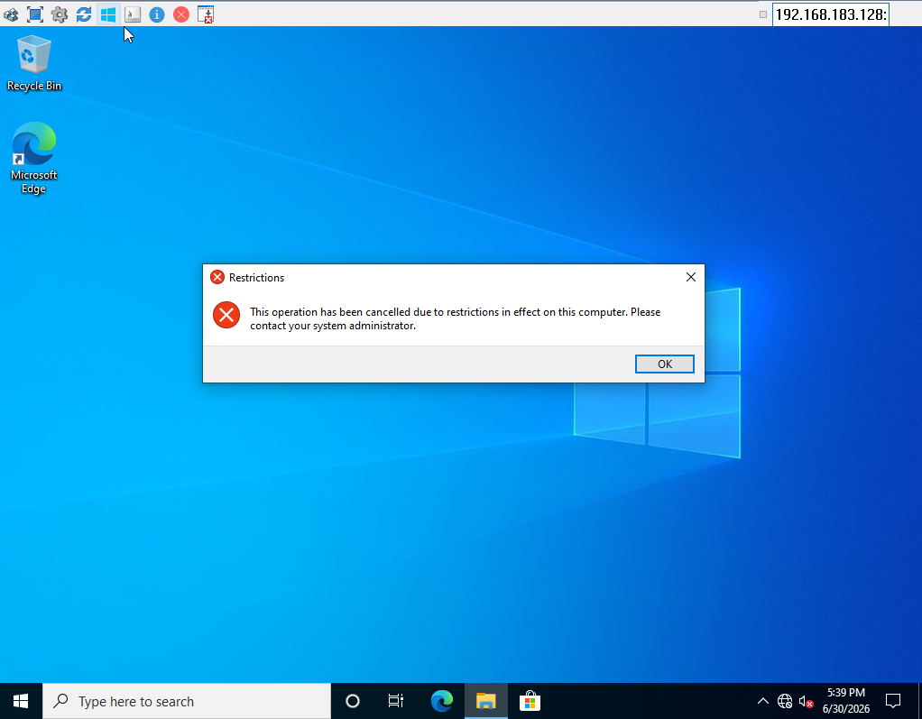
Figure 10.2: Policy enforcement verification – a Student account is blocked from running a restricted operation (“This operation has been cancelled due to restrictions in effect on this computer”).

10.2 Staff Security Policy
Faculty/staff members were assigned a dedicated security policy that balances usability and security. The following GPOs are linked to uni_Staff:
- Can't change Password
- Close PowerShell
- Close Control Panel
- Logon Hours
- Prevent Registry editor
- Prevent access to Task Manager
- Hide Network
- Login Banner
The same general GPO creation procedure described in Section 10.1 was followed (Group Policy Management → right-click uni_Staff → Create a GPO in this domain, and Link it here → Edit → enable the relevant Administrative Templates / Security Options settings), reusing similar settings to the Students policies but excluding the heavier restrictions (no USB lock, no wallpaper lock, no drive hiding), since Staff need more usability.
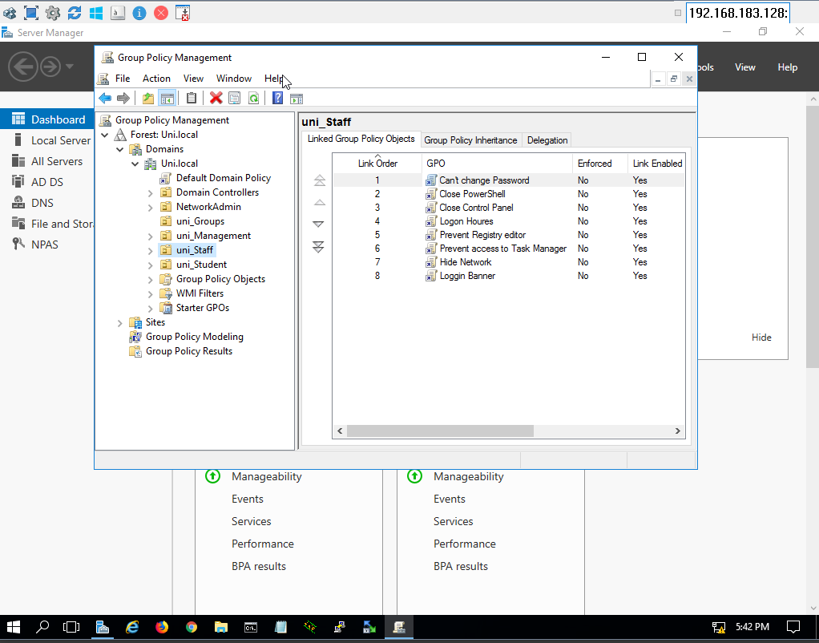
Figure 10.3: Group Policy Management – GPOs linked to the uni_Staff OU.

10.3 Management Security Policy
Administrative employees were assigned a dedicated Group Policy with the following links on uni_Management:
- Can't change Password
- Hide Network
- Login Banner
- USB lock
- Prevent Registry editor
- Prevent Access of date and time
- Logon Hours
Created and linked using the same procedure (Group Policy Management → right-click uni_Management → Create a GPO in this domain, and Link it here → Edit → enable the matching settings), keeping the policy set close to Staff but adding USB lock, since Management workstations also handle sensitive administrative data.
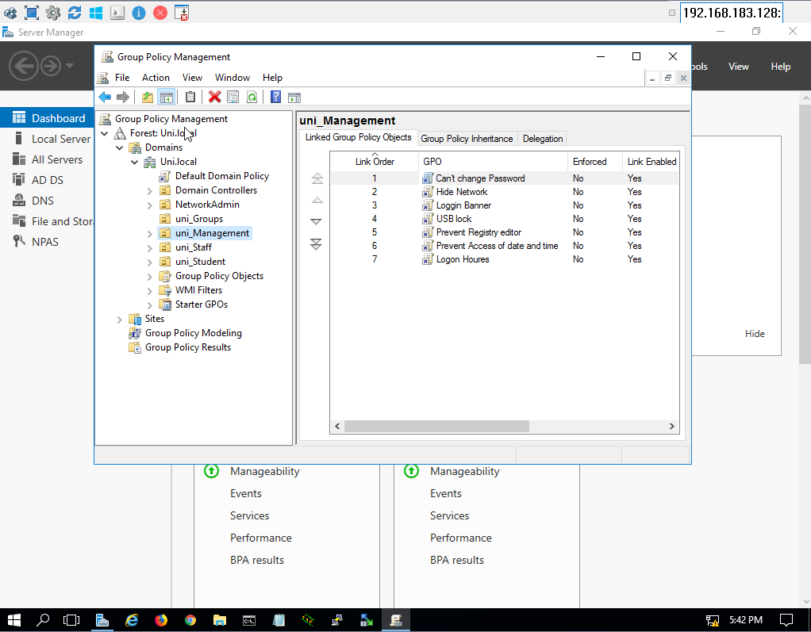
Figure 10.4: Group Policy Management – GPOs linked to the uni_Management OU.

11. Password Policy
A domain-wide password policy was configured under Default Domain Policy → Password Policy to improve account security. Configured settings include:
- Enforce Password History
- Minimum Password Length
- Password Complexity Requirements
- Maximum Password Age
These settings help protect user accounts against weak passwords and password reuse.
How it was implemented – step by step:
- Opened Group Policy Management → expanded Domains → Uni.local → right-clicked “Default Domain Policy” → Edit…
- Navigated to Computer Configuration → Policies → Windows Settings → Security Settings → Account Policies → Password Policy.
- Double-clicked “Enforce password history” and set the number of remembered passwords.
- Double-clicked “Minimum password length” and set the required number of characters.
- Double-clicked “Password must meet complexity requirements” and set it to Enabled.
- Double-clicked “Maximum password age” and set the number of days before a password expires, then clicked Apply → OK for each setting.

12. Account Lockout Policy
An Account Lockout Policy was configured under Default Domain Policy → Account Lockout Policy to mitigate brute-force password attacks. After a predefined number of failed authentication attempts, the user account is automatically locked for a specified period.
How it was implemented – step by step:
- In the same Default Domain Policy editor, navigated to Computer Configuration → Policies → Windows Settings → Security Settings → Account Policies → Account Lockout Policy.
- Double-clicked “Account lockout threshold” and set the number of invalid logon attempts allowed before lockout, then clicked OK (Windows auto-suggests matching values for the other two settings).
- Confirmed/adjusted “Account lockout duration” (how long the account stays locked) and “Reset account lockout counter after” (the time window for counting failed attempts), then clicked Apply → OK.

13. Security Logon Banner
A security warning banner (“Login Banner” GPO) was configured to appear before user authentication on every domain-joined workstation. The banner informs users that the system is restricted to authorized users, that user activities are monitored, and that unauthorized access is prohibited.
How it was implemented – step by step:
- Opened Group Policy Management → created/edited the “Login Banner” GPO linked to the relevant OUs (or Default Domain Policy for a domain-wide banner).
- Navigated to Computer Configuration → Policies → Windows Settings → Security Settings → Local Policies → Security Options.
- Double-clicked “Interactive logon: Message title for users attempting to log on”, enabled it, and typed the warning title (e.g., “Authorized Users Only”).
- Double-clicked “Interactive logon: Message text for users attempting to log on”, enabled it, and typed the full warning message explaining that access is monitored and restricted to authorized users.
- Clicked Apply → OK; the banner now appears on the logon screen of every machine the policy applies to, before the user can enter credentials.

14. Logon Hours
Logon Hours were configured per user, under User Properties → Account → Logon Hours, to limit authentication to authorized working hours. Users are prevented from logging in outside the configured schedule, and the same restriction is also enforced through the “Logon Houres” GPO linked to each OU.
How it was implemented – step by step:
- Opened Active Directory Users and Computers → located the user account (e.g., Student 1) → right-clicked → Properties.
- Opened the Account tab and clicked the “Logon Hours…” button.
- In the grid (days vs. hours), selected the time blocks to restrict and chose “Logon Denied” for those blocks, leaving the permitted hours selected with “Logon Permitted.”
- Clicked OK to save, then OK again to close the user Properties window; the user can now only log on during the permitted hours.
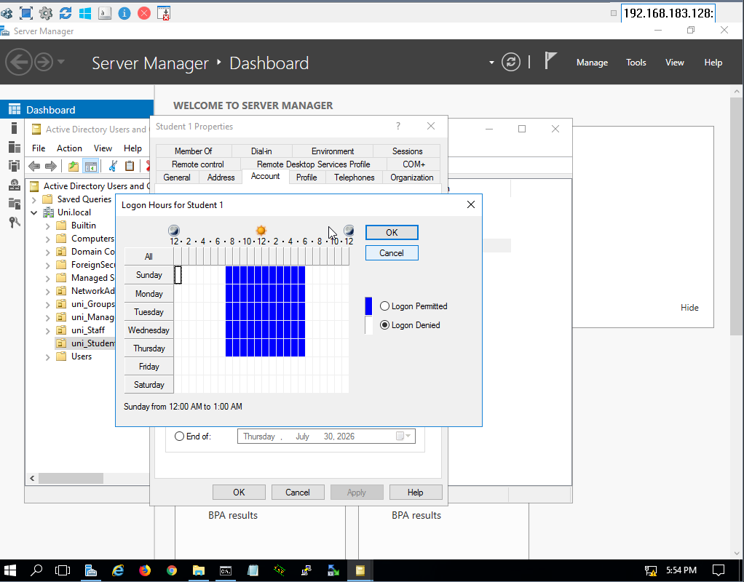
Figure 14.1: Logon Hours configuration for Student 1, restricting domain logon to the authorized time window.

15. Windows Security Auditing
Advanced Audit Policies were enabled to monitor important security events across the domain. Audited events include:
- Successful Logon
- Failed Logon
- User Account Management
- Security Group Management
- Computer Account Management
- File System Access
- Security Policy Changes
These audit logs improve security visibility and accountability across the environment.
How it was implemented – step by step:
- Opened the Default Domain Policy (or a dedicated Audit GPO) in the Group Policy Management Editor.
- Navigated to Computer Configuration → Policies → Windows Settings → Security Settings → Advanced Audit Policy Configuration → Audit Policies.
- Opened the “Logon/Logoff” category and enabled “Audit Logon” and “Audit Logoff” for both Success and Failure.
- Opened the “Account Management” category and enabled auditing for “User Account Management”, “Security Group Management”, and “Computer Account Management” (Success and Failure).
- Opened the “Object Access” category and enabled “Audit File System” and “Audit File Share” for tracking access to the shared folders.
- Opened the “Policy Change” category and enabled auditing for changes to the audit policy and security settings.
- On the shared folders themselves, added a System Access Control List (SACL) via Properties → Security → Advanced → Auditing tab, so that File System auditing actually generates events for those folders.
- Closed the editor and ran “gpupdate /force” on the domain controller/clients to apply the audit settings immediately.

16. Event Logging
Windows Event Viewer records all configured security events, providing detailed logs for troubleshooting, auditing, and security investigations. The Security log captures events such as Event ID 4624 (Successful Logon), 4625 (Failed Logon), 4634 (Logoff), and 5140 (File Share access).
How it was reviewed – step by step:
- Opened Server Manager → Tools → Event Viewer.
- Expanded Windows Logs → Security.
- Used the “Filter Current Log…” action and entered the Event IDs of interest (4624, 4625, 4634, 4656, 5140) to narrow down the relevant logon/file-access events.
- Double-clicked individual events to open the General/Details tabs and review who performed the action, when, and the result (Success/Failure).
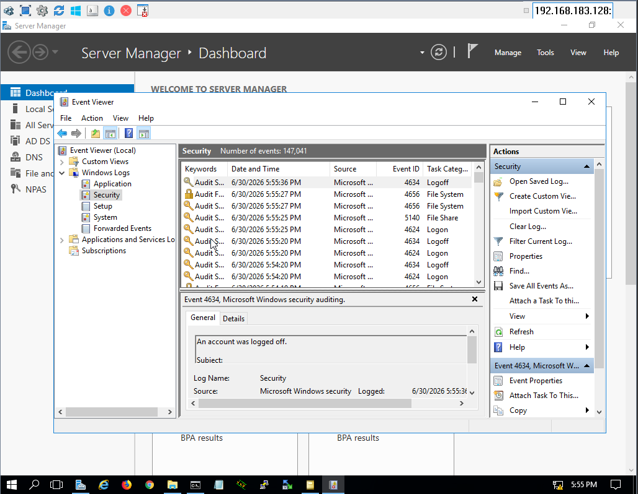
Figure 16.1: Event Viewer – Security log showing recorded logon, logoff, and file-share access events (Event IDs 4624, 4634, 4656, 5140).

17. Remote Desktop Configuration
Remote Desktop Protocol (RDP) was enabled under System Properties → Remote → Allow Remote Connections, to allow secure remote administration of the Windows Server. Authorized administrators can remotely manage the server without requiring physical access.
How it was implemented – step by step:
- On the server, right-clicked “This PC” → Properties → “Advanced system settings” → Remote tab.
- Under “Remote Desktop”, selected “Allow remote connections to this computer” (and kept “Allow connections only from computers running Remote Desktop with Network Level Authentication” checked for extra security).
- Clicked “Select Users…” to add the specific administrator accounts allowed to connect remotely, then clicked Apply → OK.
- Verified that the Windows Firewall rule group “Remote Desktop” was enabled (it is enabled automatically when RDP is turned on) so inbound RDP traffic (port 3389) is permitted.

18. Windows Server Backup
The Windows Server Backup feature was installed from Server Manager → Add Roles and Features and configured to provide backup and recovery capabilities. A backup was created to protect critical server components and ensure system recoverability in the event of hardware failure, accidental deletion, or system corruption.
Steps performed:
- Installed the Windows Server Backup feature.
- Launched the Backup Once Wizard and selected the system state for backup.
- Selected the destination drive and started the backup process.
- Monitored the backup progress until completion.
- Verified the backup result and reviewed the generated backup files.
How it was implemented – step by step:
- Opened Server Manager → “Add roles and features” → advanced to the Features page.
- Checked “Windows Server Backup” in the Features list and completed the wizard (Next → Install) to install the feature.
- Opened Server Manager → Tools → Windows Server Backup.
- In the Actions pane, clicked “Backup Once…” to start the Backup Once Wizard.
- On the Backup Options page, selected “Different options” (or “Scheduled backup options” settings) to control exactly what gets backed up.
- On “Select Backup Configuration”, chose “Custom”, then on “Select Items for Backup”, checked “System state” (and any additional volumes needed).
- On “Specify Destination Type”, selected “Local drives” and chose the destination drive (e.g., drive M:) from “Select Backup Destination.”
- Reviewed the Confirmation page and clicked “Backup” to start the job; the wizard switched to the “Backup Progress” page showing the live status and amount of data transferred.
- Waited for the backup to reach 100% and confirmed the “Backup Completed Successfully” status on the Local Backup dashboard.
- Browsed to the backup destination in File Explorer to confirm the Hard Disk Image File and the supporting XML metadata files (BackupSpecs.xml, etc.) were created.
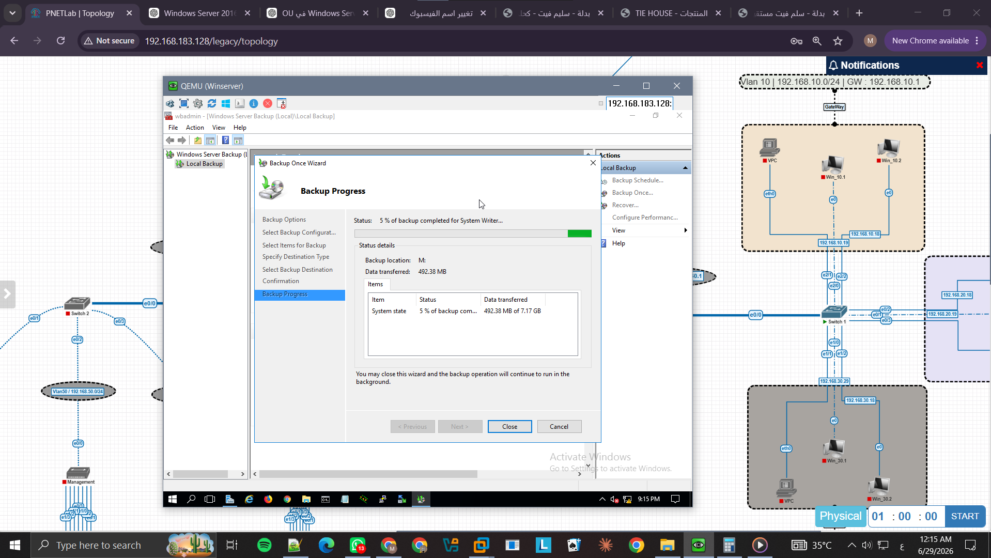
Figure 18.1: Backup Once Wizard – backup in progress, showing the data transferred for the System State backup.
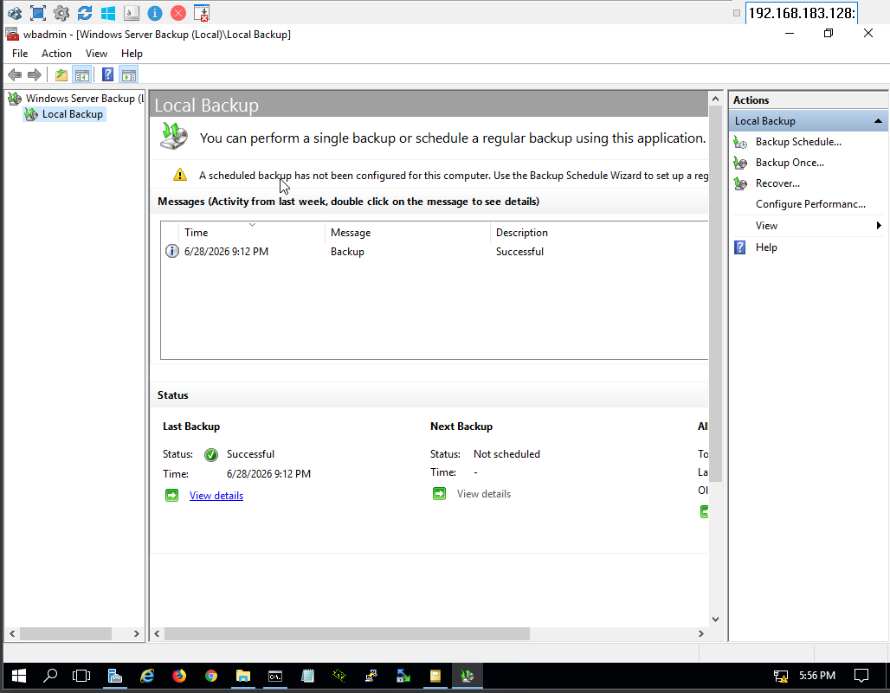
Figure 18.2: Windows Server Backup – Local Backup status showing the last backup completed Successfully.
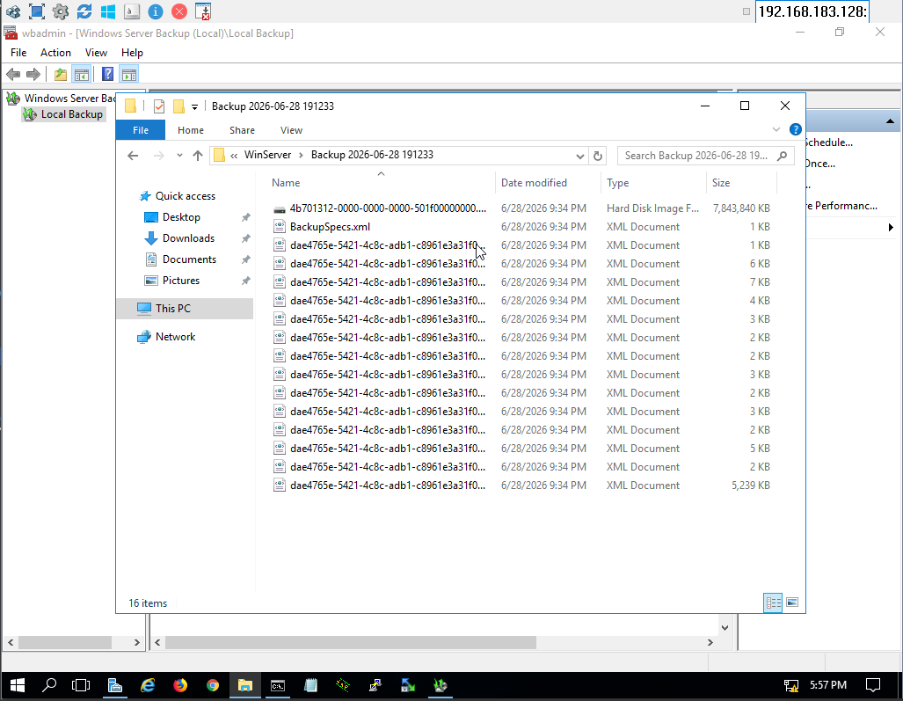
Figure 18.3: Backup destination folder contents, including the Hard Disk Image File and the backup’s XML metadata documents.

19. Conclusion
The Windows Server 2016 environment was successfully deployed as the centralized identity, security, and management platform of the enterprise network. The implementation includes Active Directory Domain Services, DNS, Organizational Unit design, user and computer management, security groups, Group Policy Objects, secure file sharing, password and account security policies, auditing, Remote Desktop administration, and Windows Server Backup.
The deployed infrastructure follows enterprise best practices by implementing centralized authentication, role-based access control (RBAC), endpoint hardening through Group Policy, secure resource sharing, comprehensive security auditing, and centralized log monitoring. This architecture provides a scalable, manageable, and secure foundation suitable for modern enterprise environments.

