SAP Basics

**Mina Bahgat**

**12 April 2020**

[**mina.bahgat.zarif@gmail.com**](mailto:mina.bahgat.zarif@gmail.com) **+201288299072**

**Contents**

**SAP overview 3**

**What is SAP Business Suite? 8**

**SAP Modules 11**

**SAP HANA Module 19**

**SAP S/4 HANA Suite 19**

**SAP NetWeaver 20**

**SAP: 3-tier Architecture 22**

**What is a SAP Consultant? 22**

**Useful Links 24**

**Simple SAP implementation 25**

## **SAP overview**

### What is SAP?

**SAP** stands for Systems Applications and Products in Data Processing. SAP, by definition, is also the name of the ERP (Enterprise Resource Planning) software as well as the name of the company. SAP Software is a European multinational, founded in 1972 by Wellenreuther, Hopp, Hector, Plattner, and Tschira. They develop software solutions for managing business operations and customer relationships.

SAP system consists of a number of fully integrated modules, which covers virtually every aspect of business management.

SAP is #1 in the ERP market. As of 2010, SAP has more than 140,000 installations worldwide, over 25 industry-specific business solutions and more than 75,000 customers in 120 countries

Other Competitive products of SAP Software in the market are Oracle, Microsoft Dynamics, etc.

### What is SAP ERP? Why is it Required?

The very fundamental question for any beginners is why Enterprise Resource Planning also called ERP, is required? To answer this, let’s examine this typical business scenario.

Suppose a client approaches a sales team asking for a particular product. The sales team contacts the inventory department to check the availability of the product. To their surprise, the sales team found out that the product is out of stock. So next time this doesn’t happen, they have to introduce an SAP ERP tool.

Before we actually see in detail, what ERP is and how ERP can help in your business process, we will understand how different departments are involved in the whole business process, right from the ordering of the raw material – to manufacturing goods – to delivering final products to the customer.

### Why SAP?

SAP (Systems Applications and Products) is the world's leading provider of business software which specializes in industry specific Enterprise Resource Planning (ERP) solutions.

SAP is implemented in 9 out of every 10 Fortune 500 company.

SAP consultants enjoy a **premium remuneration** over their IT counterparts working in other technologies like Java, .net etc.

### The Whole Business Process

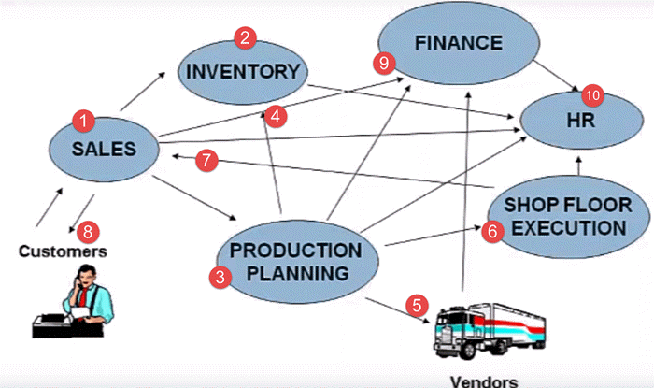

**Here is the whole process that is followed by any business unit.**

1. Client contacts the sales team to check the availability of the product
2. Sales team approaches the Inventory department to check for the availability of the product
3. In case the product is out of stock, the sales team approaches the Production Planning Department to manufacture the product
4. The production planning team checks with inventory department for availability of raw material
5. If the raw material is not available with inventory, the Production Planning team buys the raw material from the Vendors
6. Then Production Planning forwards the raw materials to the Shop Floor Execution for actual production
7. Once ready, the Shop Floor Team sends the goods to the Sales Team
8. Sales Team who in turn deliver it to the client
9. The sales team updates the finance with revenue generated by the sale of the product. Production planning team update the finance with payments to be made to different vendors for raw materials.
10. All departments approach the HR for any Human Resource related issue.

That is a typical business process for any manufacturing company. Some key inferences one could derive from the scenario would be.

* It has many departments or business units
* These departments or business units continuously communicate and exchange data with each other
* The success of any organization lies in effective communication, and data exchange, within these departments, as well as associated third party such as vendors, outsourcers, and customers.

### Enterprise Systems Classification

Based on the manner in which communication and data exchanged is managed. Enterprise systems can be broadly classified as

**1)**[**Decentralized System**](https://www.guru99.com/what-is-sap-definition-of-sap-erp-software.html#1)

**2)**[**Centralized System which is also called as ERP.**](https://www.guru99.com/what-is-sap-definition-of-sap-erp-software.html#2)

#### Decentralized System

Let's look at Decentralized system first, in a company with Decentralized System of Data Management. There are two major problems –

* **Data is maintained locally at the individual departments**
* **Departments do not have access to information or data from other departments**

To identify issues arising due to decentralized Enterprise management system lets look at the same business process again. The customer approaches the sales team for a product, but this time around, he needs the product, on an urgent basis.

Since it is a decentralized process, the Sales Team do not have any real-time information access to the product availability. So they approach the Inventory department to check the availability of the product. This process takes time, and the customer chooses another vendor leading to loss of revenue and customer dissatisfaction.

Now, suppose the product is out of stock, and the Sales Team approaches the Production Planning team to manufacture the product for future use. Production Planning Team checks the availability of the raw materials required.

In a decentralized system, raw material information is stored separately by Production Planning as well as the Inventory Department. Thus, data maintenance cost (in this case, Raw Material) goes up.

The raw material information is available in two different departments Inventory as well as Production Planning. When sales team check a particular raw material required to manufacture the product, it shows the raw material is available as per the inventory, but as per the database of the production planning team, the raw material is out of stock.

So, they go ahead and buy the raw material. Thus, material, as well as inventory cost, goes up.

Once the raw material is available, the shop floor department suddenly realizes they are short of workers. They approach the HR, who in turn hire temporary employees at higher than market rates. Thus LABOR Cost Increases.

The production planning department fails to update the finance department on the materials they have purchased. The finance department defaults the payment deadline set by the vendor causing the company loss of its reputation and even inviting a possible legal action.

These are just a few of many problems with decentralized systems.

Some Major problems with the decentralized system are –

* Numerous disparate information systems created individually over time which are difficult to maintain
* Integrating the data is time and money consuming
* Inconsistencies and duplication of data
* Lack of timely information leads to customer dissatisfaction, loss of revenue and reputation
* High Inventory, material, and human resource cost.

These are some major drawbacks for which we need a solution. Well, the Solution lies in **Centralized Systems i.e., ERP.**

#### Centralized System

In a company, with a Centralized System of Information and Data Management.

**1) Data is maintained at a central location and is shared with various Departments**

**2) Departments have access to information or data from other Departments**

Let’s look at the same business process again to understand how a Centralized Enterprise System helps to overcome problems posed by a Decentralized Enterprise System.

In this case, all departments update a Central Information System.

* When Customer approaches the sales team to buy a product on an urgent basis. The Sales Team has real-time information access to the products in inventory which is updated by the Inventory Department in the Centralized System
* Sales Team respond to customer request on time, leading to Increased Revenue and Customer Delight.
* In case, manufacturing is required the Sales Team update the Centralized Database, so that all the department remain informed about the product status.
* Production Planning Department is **auto updated** by the Centralized Database for requirements. Production Planning Team checks the availability of the raw materials required via the Central Database, which is updated by the Inventory Department.
* Thus, Data Duplication is avoided, and accurate data is made available. The Shop Floor Team update their Man Power Status regularly in the Central Database, which can be accessed by the HR department.
* In case of shortage of workforce, HR team starts the recruitment process with considerable lead time to hire a suitable candidate at market price. Thus labor cost goes down.
* While vendors can directly submit their invoices to the Central Enterprise System, which can be accessed by the finance department. Thus, payments are made on time, and possible legal actions are avoided
* SAP software is a type of Centralized System. SAP Systems are the most popularly used in ERP software.

#### Key benefits of the centralized system are:

* It eliminates the duplication, discontinuity, and redundancy in data
* Provides information across departments in real time.
* SAP Company provides control over various business processes
* Increases productivity, better inventory management, promotes quality, reduced material cost, effective human resources management, reduced overheads boosts profits
* Better customer interaction and increased throughput. It also improves customer service
* Hence, a centralized enterprise management system is required.
* SAP Software is a centralized enterprise management system, also known as Enterprise Resource Planning.
* The abbreviation of SAP is Systems Applications and Products in Data Processing.

## What is SAP Business Suite?

Business Suite in SAP is collection of fully integrated applications such as SAP customer relationship management (CRM), SAP Enterprise Resource Planning (ERP), SAP product lifecycle management (PLM), SAP supplier relationship management (SRM), and SAP supply chain management (SCM) modules.

Most people relate SAP with its ERP offering. But SAP ERP Business suite now offers variety of products to address varied needs of an organization. Let’s have a look at various SAP ERP business Suite applications.

### SAP HANA

High Performance Analytic Appliance uses in-memory computing, a breakthrough technology that enables analysis of very large, non-aggregated data at unprecedented speed in local memory (vs. disk-based database) enabling complex analyses, plans and simulations on real-time data. SAP business suite on HANA also provides multi-model processing and advanced analytics.

### SAP Convergent Charging

SAP Convergent Charging provides a rating and charging solution for high-volume processing in service industries. It delivers pricing design capabilities, high performance rating and convergent balance management.

### Customer Relationship Management

Unlike other CRM software, the SAP Customer Relationship Management (SAP CRM) application, part of the Business Suite in SAP, not only helps you address your short-term imperatives – to reduce cost and increase your decision-making ability – but can also help your company achieve differentiated capabilities in order to compete effectively over the long term.

### Enterprise Resource Planning

A sound foundation is necessary to compete and win in the global marketplace. The SAP ERP application supports the essential functions of your business processes and operations efficiently and are tailored to specific needs of your industry like SAP ERP Financials, SAP ERP Human capital management,SAP ERP Operations,SAP ERP corporate services.

### SAP Environment, Health, and Safety Management

It supports environmental, occupational and product safety processes, regulatory compliance, and corporate responsibility. This is accomplished by embedding corporate policies, compliance, and environmental, health and safety capabilities with global business processes for human resources, logistics, production and finance.

### SAP Global Batch Traceability

It allows you to completely trace tracked objects, for example, a batch, across both SAP systems and non-SAP systems. In the event of a recall or withdrawal, SAP GBT ensures the timely compliance with legal reporting timelines. Furthermore, it helps you to minimize cost and corporate risk exposure. You can also analyze multiple objects, for example, batches, in one run.

### SAP Product Life Cycle Management

To survive in an ever-changing global environment, creating and delivering innovative and market differentiating products and services is what distinguishes your company from the competition. The SAP Product Lifecycle Management (SAP PLM) application provides you with a 360-degree-support for all product-related processes – from the first product idea, through manufacturing to product service

### SAP Supplier Life Cycle Management

SAP Supplier Lifecycle Management is a holistic approach to managing supplier relationships. It deals with the supply base as a whole to constantly determine the right mix of suppliers. It covers the lifecycle of individual suppliers ? from onboarding to a continuous development.

### Supply Chain Management

You face enormous pressure to reduce costs while increasing innovation and improving customer service and responsiveness. SAP Supply Chain Management (SAP SCM) enables collaboration, planning, execution, and coordination of the entire supply network, empowering you to adapt your supply chain processes to an ever-changing competitive environment.

### Supplier Relationship Management

With SAP SRM you can examine and forecast purchasing behavior, shorten procurement cycles, and work with your partners in real time. This allows you to develop long-term relationships with all those suppliers that have proven themselves to be reliable partners.

### Governance, Risk and Compliance

Risk is unavoidable, but it can be managed. With governance, risk, and compliance (GRC), businesses can strategically balance risk and opportunity.

### Sales and operations planning

SAP Sales and Operations Planning enables you to optimally and profitably meet long-term future demand. Typically, this process repeats every month and involves many participants including Sales, Marketing, Finance, Demand Planning, and Supply Chain Planning.

### SAP Transportation Management

It supports you in all activities connected with the physical transportation of goods from one location to another.

### Extended Warehouse Management

SAP Extended Warehouse Management gives you the option of mapping your entire warehouse complex in detail in the system, down to the storage bin level. Not only does this give you an overview of the total quantity of a product in the warehouse, but you can also always see exactly where a specific product is, at any time, in your warehouse complex. With EWM, you can optimize the use of various storage bins and stock movements, and can combine the storage of stocks from several plants in randomly-managed warehouses.

### Mobile Apps

[Mobile](https://www.guru99.com/mobile-testing.html)devices can also access SAP system.

## SAP Modules

SAP Modules can be categorized into

* SAP Functional Modules
* SAP Technical Modules

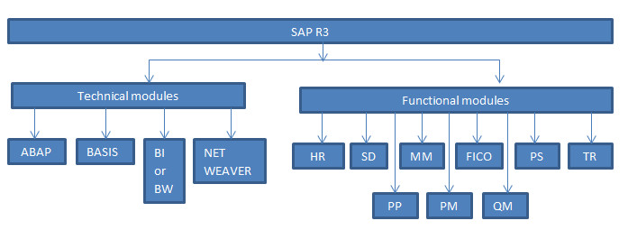

It’s important to understand what is meant by functional module and technical module, how functional module is different from technical module.

**SAP functional module:** In order to replicate and enable business process, SAP offers various predefined or standard functionality to help departments in performing various business activities. The SAP modules which provide predefined standard functionality to replicate actual business activity are called functional module. A functional consultant has to understand the business requirement and use the standard functionality provided by SAP.

**SAP technical module:** These modules do not directly replicate actual business activity but provide needed support to functional modules.

### Functional Modules

*Let’s first understand functional modules.*

In an enterprise, different activities are performed by various departments.

**Production department**:  Responsible for making sure that raw material is converted into finished goods in cost effective manner and adhering to production schedule. The production department uses material, labor, machinery and a variety of techniques to be able to produce finished goods. Production department relies on the purchasing department (material department) to get the materials and accessories that are necessary for the production of goods.

**Plant maintenance department:**In a plant there are machines and equipment which are subject to wear & tear and might lead to production break down impacting productivity. Hence in order to keep the factory/ plant running efficiently regular check-ups, cleaning, repairing & maintenance activities are required. If production breakdown occurs, plant maintenance department is responsible to reduce the down time and hence improve productivity. For proper planning of maintenance activities maintenance department has to coordinate with material department and production department.

**Materials department:** Responsible for ensuring adequate supply base to production department. It takes care of movement of materials including purchasing of material and services. Material department covers purchasing activities and hence responsible for maintaining relationship/ agreement with supplier to ensure continuous supply in cost effective manner.

**Quality department:**The product/ services offered by company have to meet certain standards of quality. This department is concerned not just with quality of end deliverable but also with quality of input materials and quality of process. If quality of materials purchased from vendor/ subcontractor does not match quality standards then material is rejected. If finished goods produced do not match quality standards, goods are either issued for rework or scraped. Sold goods returned from customer are tested for quality and decision is taken either to scrap or rework.

Quality department works in coordination with material department and production department.

**Human resource department:**Responsible for recruitment, training, manpower planning, Firing & layoff. This department closely interacts with finance department for payroll processing and manpower planning.

**Sales & Distribution department**: Responsible for meeting sales target by bringing sales orders. Sales department is responsible for managing relationship with customers. Distribution department ensures that once sales order is received from customer then goods or services should be delivered to customer on schedule through proper channel and in cost effective manner.

**Finance department:**  Responsible for book keeping, recording all financial transactions done by company, generate financial reports for statutory/ legal purposes as well as providing reports to management for better decision making.

**Project Planning:**when an organization takes up project like construction of building/ bridge, production, investment or any other complex project which runs for longer period of time and consumes huge amount of resources (men/ material/ machine/ money/ time). Such projects often run behind schedule and lead to big financial loss due to cost overrun.

So what needs to be done to complete such big projects successfully within schedule and within budget?

Big project is broken down into various activities (Work is broken down). These activities might be interdependent (start of one activity might depend upon completion of previous activity). Each activity is broken down into various well defined tasks. For each activity, date scheduling is done, resources are planned, budget is allocated and a designated person is responsible for successful completion of that activity.

Well defined milestones with proper deadline dates are set.

Each activity is monitored for cost and schedule so that project remains on track. If each activity is executed successfully then entire project get executed successfully.

#### Example

*Let’s take an example of Delhi Metro project understand the concept better:*

Project would have been schedules for few years. Entire project might have been broken down into well-defined activities; activities might have been broken down into well-defined task. For each activity: date scheduling would have been done, resources would have been planned, money would have been budgeted and a person responsible would have been designated.

Actual cost incurred in each activity would have been recorded and compared with budgeted. Any variance would have been analysed for root cause and corrective action would have been taken.

Hence key to successful execution of a big complex project is to break down complex project into smaller well defined manageable activities and monitoring each activity closely.

This requires close coordination between planning department and other departments especially with finance department.

SAP PS module enables organization to list down entire project into broken down activities, date scheduling considering dependency between activities, planning of resources, budgeting of money and designated person responsible. Each and every cost incurred is recorded, any deviation from budget is analysed and corrective action is taken hence enables proper cost monitoring. SAP PS module closely interacts with SAP FICO module.

**Treasury department:**Treasury department is responsible managing liquidity of business which involves knowing exact cash position and forecasting future cash flows. It is also responsible for investing excess cash and hedging activities as per company investment policy.

Challenges faced by treasury department: number of subsidiaries which deals with various banks, large number of transactions with customer (account receivable) and vendor (account payable), investment into various securities like debt/ equity/ commodity/ derivatives which are subject to risk, weak IT system due to use of multiple software with weak interface between them.  Hence knowing exact cash position and forecasting future cash flows becomes very difficult.

In order to perform duty treasury department has to work in close coordination with finance department. Treasury department has to enable and closely monitor accounts receivable and account payable.

Hence a system is required which can overcome above challenges (where all details can be put together for a comprehensive view and analysed for better decision making).

SAP treasury module enables the organization to overcome the challenges faced by treasury department. Treasury department works in close coordination with finance. SAP treasury module also keeps the system audit-able hence legal/ regulator friendly.

**To fulfill business activity, these departments interact with each other. SAP is software which is to replicate actual business structure. SAP modules are designed in such a way that each module can replicate the activities performed by respective department.**

SAP PP- Production Planning

SAP PM- Plant Maintenance

SAP MM- Material Management

SAP QM- Quality Management

SAP HR- Human Resource

SAP SD – Sales & Distribution

SAP FICO – Finance & Controlling

SAP PS – Project system

SAP TR – Treasury

### Technical Modules

*Let’s understand technical modules.*

**SAP BASIS:** This team is responsible to install, configure, update, patch, migrate, troubleshoot any technical problem on SAP system to ensure system runs smoothly.

BASIS is basically concerned with application layer of the three layers of R/3. (Presentation layer, Application layer and Server layer). Hence basis basically emphasizes the administration of RDBMS (Relational Database Management System – or simply the database sap system is using), client-server architecture and the SAP GUI.

Hence BASIS team is basically system administrator.

SAP Basis is now called SAP Netweaver Application server. SAP basis is part of netweaver.  
If you consider netweaver as an apple(fruit), SAP basis is the core part.  
SAP netweaver is the technology and Integration platform of SAP solutions.

**SAP ABAP:** SAP offers predefined functionality to meet business requirement. But predefined functionality may not suffice to fulfill business requirement hence customization is needed. Standard or predefined functionality is basically set of codes which are already developed by SAP hence when customization is required to meet requirement either new codes are developed or existing standard code is copied and edited.

ABAP stands for Advanced Business Application Programming. It’s a programming language in which codes are written. ABAP runs on the application layer of R/3 system.

**E.g.**Boss’s need various reports to make decision hence SAP offer a large number of predefined reports. But in case, exiting report is not able to fulfill requirement then new report is to be developed. Report can be developed either by copying existing code and editing or by developing entirely new codes.

**SAP BI & SAP BW:**In big organizations everyday huge amount of data is generated. In order to make strategic business decision, bosses need to analyse the performance/ position of business (backed by data). Data needs to be collected at one place and analysed to derive meaning full information out of it.

But organizations face challenges like: data is generated globally, data is originated from various sources, data may not be uniform, data may be redundant/ duplicate as well.

SAP BW/ BI offer solution to above problems.

Data across geographies/ sources are collected at one place called data warehouse (BW). BW is basically home to all data and hence BW stands for business warehouse.

Data is then cleansed to remove redundancy/ duplicity and data is aggregated and made uniform which can be used for generating meaning full report out of it. These reports provide meaning full information or intelligence and hence BI stands for business intelligence.

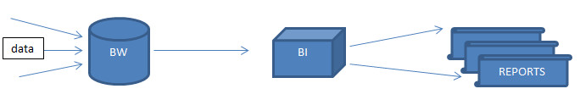

**SAP NET WEAVER:**Organizations have become big and robust. Organization might be using various SAP applications as well as non-SAP applications (other than SAP). In order to run business effectively various applications and servers need to interact with each other. SAP NET WEAVER provides a common platform where various applications/ servers can be integrated.

*Example*: consider an e-commerce company using SAP applications. Customer can order product online (website). Website might be based on JAVA application. Company is using SAP to streamline internal business process and JAVA is being used for website. Hence data needs to be exchanged between both java server and SAP server. Here the challenge is integration of various applications/ servers. This module overcomes the challenge by bringing all application/ servers on a common technology platform and hence called NET WEAVER.

### Key SAP Modules list

These functional and technical modules in SAP are tightly coupled.   
Below is a key SAP Modules list

1. **SAP FI Module -**FI stands for Financial Accounting

SAP FI module is very robust and covers almost all financial business process encountered in various industries. It is one of the widely implemented SAP ERP modules. Learn more about [SAP FI](https://www.guru99.com/sap-fico-training-tutorials.html)

1. **SAP CO Module -**CO stands for Controlling

Cost[Accounting](https://www.guru99.com/accounting.html)(CO) module of SAP provides information to managers decision makers to understand where the company's money is being spent. CO helps them to optimize business costs.

1. **SAP HCM Module -**HR stands for Human Resources

SAP Human Capital Management (HCM) is also called SAP-HR. SAP HCM consists of sub-modules like Personnel Administration (PA), Organizational Management (OM), Time,[Payroll](https://www.guru99.com/sap-payroll.html)that help in employee management. Learn more about [SAP HCM](https://www.guru99.com/sap-hcm.html)

1. **SAP MM Module -**MM is Materials Management

Materials Management module in SAP consists of several components and sub-components including Master Data, Purchasing, and Inventory. Learn more about [SAP MM](https://www.guru99.com/sap-mm-training-tutorials.html)

1. **SAP QM Module -**QM stands for Quality Management

SAP QM (Quality Management) is an integral part of several key business processes of SAP like production, sales, procurement, material management, etc. Learn more about [SAP QM](https://www.guru99.com/sap-quality-management-qm-tutorial.html)

1. **SAP PP Module -**PP is Production Planning

SAP PP ( Production Planning) is a SAP module, specially designed for integrating different department involved in production and manufacturing. It has various components like Data Center, BOM, Work Center, CRP etc. Learn more about [SAP PP](https://www.guru99.com/sap-pp-tutorials.html)

1. **SAP SD Module -**SD is Sales and Distribution

SAP Sales and Distribution (SD) is an important module of SAP ERP consisting of business processes required in selling, shipping, billing of a product. The module is tightly integrated with SAP MM & SAP PP. Key sub-modules of SAP SD are Customer and Vendor Master Data, Sales, Delivery, Billing, Pricing and Credit Management. Learn more about [SAP SD](https://www.guru99.com/free-sap-sd-training-course.html)

1. **SAP BW Module -**where BW stands for Business (Data) Warehouse

SAP BI (Business Intelligence) or SAP BW is a leading data warehousing and reporting tool. It helps convert raw data into information and insights that help improve business margins. Learn more about [SAP BW](https://www.guru99.com/sap-bi.html)

1. **SAP Basis -**

SAP Basis is a set of programs and tools that act as an interface with Database, Operating system, communication protocols and other SAP modules like FI,HCM, SD etc. Learn more about [SAP Basis](https://www.guru99.com/sap-basis-training-tutorials.html)

1. **SAP ABAP -**

ABAP (**A**dvanced **B**usiness **A**pplication **P**rogramming) is the default programming language for SAP applications. You can also use[Java](https://www.guru99.com/java-tutorial.html)to code in SAP. Learn more about [SAP ABAP](https://www.guru99.com/abap-tutorial.html)

1. **SAP CRM -**where CRM stands for Customer Relationship Management

SAP CRM is the Market Leader in Customer Relationship Management Software. SAP CRM plays a pivotal role in strengthening customer relationships. Learn more about [SAP CRM](https://www.guru99.com/sap-crm-training.html)

1. **SAP HANA -**where[Hana](https://www.guru99.com/sap-hana-tutorial.html)stands for High-performance Analytic Appliance.

SAP HANA is an in-memory computing platform that allows real-time data analysis. Its currently the market leader in BI.Learn more about [SAP HANA](https://www.guru99.com/sap-hana-tutorial.html)

1. **SAP EC Module -**where EC stands for Enterprise Controlling
2. **SAP TR Module -**where TR stands for Treasury
3. **SAP IM Module -**where IM stands for Investment Management
4. **SAP IS -**where IS stands for Industries Specific Solution
5. **SAP PS Module**- and PS is Project Systems
6. **SAP CAC - Cross Application Components**
7. **SAP SCM-**where SCM stands for Supply Chain Management
8. **SAP PLM-**where PLM stands for Product LifeCycle Management
9. **SAP SRM-**where SRM stands for Supplier Relationship Management
10. **SAP CS-**where CS stands for Customer Service
11. **SAP SEM -**where SEM stands for STRATEGIC ENTERPRISE MANAGEMENT
12. **SAP RE -**where RE stands for Real Estate
13. **SAP PM Module**- where Plant Maintenance is the PM
14. **SAP Security**Learn more about [SAP Security](https://www.guru99.com/overview-of-sap-security.html)
15. **SAP FSCM -** where FSCM stands for Financial Supply Chain Management
16. **SAP NetWeaver**
17. **SAP IS -** where IS stands for Industry Specific Solution
18. **SAP XI -** where XI stands for Exchange Infrastructure
19. **SAP Solution Manager –** Learn more about [Solution Manager](https://www.guru99.com/overview-of-sap-solution-manager.html)
20. **SAP LE -**where LE stands for Logistics Execution
21. **SAP APO-** where [APO](https://www.guru99.com/overview-of-sap-apo.html) stands for Advanced Planning and Optimization
22. **SAP AFS -** where AFS stands for Apparel and Footwear Solution
23. **SAP CC -** where CC stands for Convergent Charging
24. **SAP ITS -** where ITS stands for Internet Transaction Server
25. **SAP ICM -** where ICM stands for Incentive and Commission Management
26. **SAP KW -** where KW stands for Knowledge Warehouse
27. **SAP MDM -** where MDM stands for Master Data Management

## **SAP HANA Module**

A common confusion that has been in discussion with all SAP ERP users is the difference between SAP and SAP HANA

The Systems, Applications & Products implementation which is popularly known as SAP is an application that is designed to run an SAP HANA database.

SAP HANA, on the other hand, is an in-memory database. It is a column-based Relational Database Management System that is designed to store, retrieve and process all business activities and data. SAP HANA is not empowered to run or determine any activity. It can simply store all the data. While it is the job of SAP to run all activities and maintain smooth management of all business activities.

SAP HANA is the latest technology that is designed to reduce memory usage by a factor of 10 which in turn helps run real-time analytics, crunching data almost instantaneously. In short, SAP is the platform for the SAP HANA database to run.

* + - In memory database.
    - Installed on 2 nodes (HA, Active/Passive).
    - Replication is set between the 2 nodes.
    - You have one SAP HANA system, you can create more than one instance.
    - Connect each instance to SAP Application cluster using System ID (SID, ex: HKP).
    - Installed on SSD, for high performance.

You can create a scale-out database if you need to distribute the database over different nodes for high performance SAP.

## **SAP S/4 HANA Suite**

Launched in February 2015, SAP S/4 HANA is SAP’s next-generation business suite designed only to run on SAP HANA. S/4 HANA stands for SAP Business Suite 4 SAP HANA. SAP S/4 HANA is the fourth business suite version coming after SAP R/3. Also, by making it solely compatible with SAP HANA system at its backend, SAP replaces the old SAP ECC/ERP system with SAP HANA. However, S/4 HANA is based around its successor i.e. ECC (ERP Control Center) solution and treats it as its core technology.

SAP S/4 HANA is a new Enterprise Resource Planning (ERP) solution with simplified data, a simple tool design, agile, easier to use, perform complex calculations, and handling greater amounts of data. It can be deployed on-premise, on-cloud or as a hybrid system.

S/4 HANA does not support batch processing for its data which makes retrieval and processing of data very fast and that too in real-time. Real-time analytics makes it possible to use S/4 HANA powered by SAP HANA to process and analyze data from the Internet of Things (IoT) or big data sources.

To understand the basic difference between the two, read the points below.

SAP HANA is an in-memory database technology which acts as the core technology for a lot of other SAP or non-SAP applications whereas SAP S/4 HANA is a new generation ERP solution which runs on SAP HANA database architecture.

S/4 HANA is a business suite launched as a robust ERP solution having both ERP and BI capabilities utilizing HANA’s in-memory computing power. It is an in-memory version of the ERP Business Suite as it only runs on SAP HANA.

Before SAP S/4 HANA was introduced as the new generation ERP solution, SAP ECC6, Suite on HANA, etc were used as ERP business suite solutions.

There are two functional versions of SAP S/4 HANA; S/4 HANA Finance and S/4 HANA Enterprise Management (EM).

## **SAP NetWeaver**

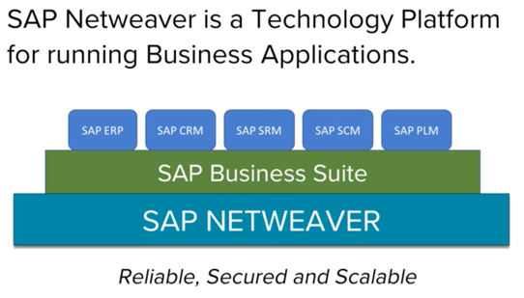

NetWeaver is SAP's **integrated technology platform and is not a product in itself**.   
In fact, the new version of basis is called the Netweaver.

It is the underlying technology for all the products in the mySAP suite.

All the products in mySAP suite can run on a single instance of NetWeaver's, SAP Web Application Server, also know as "SAP WEBAs."

**Netweaver makes possible access to SAP data using simple HTTP protocol or even mobile.**   
This eliminates the need for installing and more importantly training in SAP's client-side software.

The core capabilities of SAP NetWeaver are the integration of people, information, and process

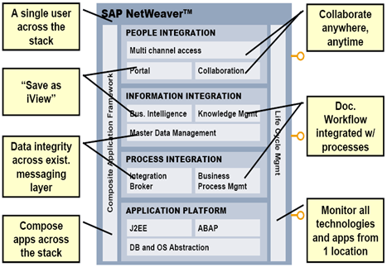

### People integration

It simply means that it enables you to bring people together and help them work more efficiently.

**Examples: -**

**Portal:**- provides industry leading portal technology that delivers unified, personalized, and role-based user access

**Collaboration:** - Collaboration promotes cooperation in enterprises using virtual team rooms (Collaboration Rooms), real-time communication (chat and application sharing) and the use of third-party groupware and synchronous collaboration tools (for example, Microsoft Exchange, Lotus Notes, and WebEx)

**Multi-Channel Access: -**With Multi-Channel Access, you can connect to enterprise systems through web-based, voice, mobile, messaging, or radio-frequency technology.

### Information integration

It means you can bring together information from a variety of locations and have it makes sense in the context of what your folks do every day!

**Examples: -**

**Business Intelligence**: - It provides you with reliable tools for creating individual and interactive reports and applications.

**BI Content & BI Content Extensions**: - Enables quicker implementation using pre-configured role and task-oriented information models in SAP Business Intelligence.

**Knowledge Management**: - Allows common access to unstructured information and documents in a distributed storage landscape like **Search, Classification, Subscription, Versioning, etc...**

**Search and Classification (TREX): -**Provides SAP applications with numerous services for searching, classifying, and text-mining in large collections of documents (unstructured data) as well as for searching in and aggregating business objects (structured data).

### Process integration

It means coordinating the flow of work across departments, divisions, and between companies. Usage type process integration includes all functions previously covered by SAP NetWeaver Exchange Infrastructure that you use to realize cross-system business processes. This SAP NetWeaver usage type enables different versions of SAP and non-SAP systems from different vendors running on different platforms (for example, Java ABAP, and so on) to communicate with each other. SAP NetWeaver is based on an open architecture, primarily uses open standards (in particular those from the XML and Java environments), and provides services that are essential in a heterogeneous and complex system landscape. These include a runtime infrastructure for exchanging messages, configuration options for managing business processes and the flow of messages, as well as options for mapping messages before they reach the receiver.

### Application Platform

SAP Web Application Server provides a complete development infrastructure on which you can develop, distribute, and execute platform-independent, robust, and scalable[Web services](https://www.guru99.com/web-services-tutorial.html)and business applications.   
SAP Web Application Server supports ABAP, Java, and Web services.

## **SAP: 3-tier Architecture**

With SAP R/3, SAP ushers in a new generation of enterprise software — from mainframe computing (client-server architecture) to the three-tier architecture of database, application, and user interface.

You can have many clients, connecting different Servers in the Apllication layer “for load-balancing”, but all the application servers are connected to one HA DB layer.

### Presentation Servers

Presentation servers contain systems capable of providing a graphical interface.

* Presentation Layer is also known as client Layer
* 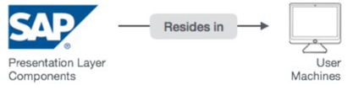Presentation Layer is a user interaction
* In SAP-User interaction purpose we use GUI
* GUI stands for Graphical user interface
* Example − Desktop, Mobile Devices, laptops

If you are itegration other systems with SAP, you can use RFC (Remote Function Call “API”)

### Application Servers

Application servers include specialized systems with multiple CPUs and a vast amount of RAM.

* Application Layer is also known as Kernel Layer and Basic Layer.
* SAP application programs are executed in Application Layer.
* Application Layer serves as a purpose of a communicator between Presentation and Database Layer.
* Application server is where the dispatcher distributes the workload to the different work processes makes the job done.

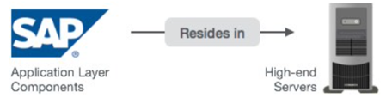

### Database Servers

Database servers contain specialized systems with fast and large hard-drives.

* Database layer stores the data
* Data store can be Business data, SAP system data, SAP tables, Programs.
* Examples − Oracle, Microsoft SQL Server, IBM DB/2, Siebel, Sybase, etc.

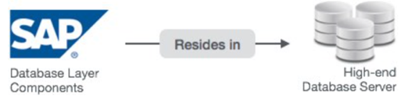

## What is a SAP Consultant?

SAP Consultant is a Subject Matter Expert (SME) either on the

* Business/ sales
* Functional
* Development or
* Basis

domains of SAP. The consultant provides advisory, recommendations, guidance, implementation help in their respective SAP domains.

**Technical SAP consultants** are generally either programmers or systems administrators, whereas **functional consultants** bring value by combining particular business process knowledge, such as financial knowledge, with the "know-how" of configuring the aspect of SAP that pertains to that process knowledge. So for example, a functional SAP FI consultant generally has a financials background, and understands how to configure the FI tables in accordance with a user's business processes.

### Types of SAP Consultant

**1) Business/Sales Consultant** - They try to win projects at customer end - without knowing much about SAP and without having much SAP skills:-)  
  
**2) SAP Functional Consultant** - They are responsible for customizing SAP as per customer demand. They talk with developers to code custom ABAP programs as per client requirements.    
  
**3) Developer Consultant** - They are responsible for coding ABAP/Java Programs    
  
**4) SAP Basis Consultant** - They help in installing, maintenance and performance tuning of SAP servers and databases

Above are the major consulting roles found in almost all SAP projects. Depending on the nature and size of the project there may be other consulting roles as well such as SAP security consultant, SAP Techno-functional consultants, etc.

### Skills required in becoming a SAP Functional Consultant

The skills expected of a SAP specialist Functional consultant vary with experience. But a fresher SAP consultant must have following skills that almost all employers look for -

* + Extensive **SAP (module specific) knowledge**.
  + Good **Domain (Banking, Telecommunication, etc. ) knowledge**
  + **Good Communication and presentation skills**. SAP consultants are often required to interface with the client and understand client's requirements. A SAP consultant should be good in explaining technical information to non-technical people
  + Ability to **work in Teams and good interpersonal skills**.

### Academic Background

* + Academic qualification required to become a SAP consultant -- Any Under Graduate Course like Bcom, B.E., BSc etc.  with  any Specialization
  + Any Post Graduate Course like MTech, MBA, etc. with any Specialization

### How to become a SAP consultant

From time to time we get emails asking "How do I become a SAP consultant." Obviously, there is no one answer.  There are many ways to enter the SAP market. Here are a few we can conjure ...   **Obtain**[**SAP Training & Certification**](https://www.guru99.com/how-to-get-a-sap-certification.html)**.** Choose a SAP module or SAP consultant course and get a certification from an authorized SAP training partner. SAP training is expensive, but it's worth the investment  
  
**Join a consulting company** If you have good business/domain knowledge (and want to learn SAP ?), you could consider joining an IT consultancy company like IBM, Deloitte, Infosys. etc  as a junior SAP consultants job.  
  
**Join as a Trainee or in SAP support** You can consider joining a company which has SAP implemented and work as a Trainee or support personnel. The company may later sponsor your SAP certification and training. The trick here is to find such a company and convince them to hire you.  
  
**Join SAP Project as a non-SAP person.** Many SAP projects require skills outside of SAP. For instance, lots of projects require a data conversion individual. If you are good in database and SQL, you might consider joining the project and later teach yourself SAP.

## **Useful Links**

<https://www.guru99.com/sap-training-hub.html?fbclid=IwAR0fXjrPfrOrgdEmD_A_tAnQsjORSvitA0Mip8qENVxysG2Flh3kEZG2A-8>

<https://www.tutorialspoint.com/sap/index.htm>

<https://data-flair.training/blogs/sap-hana-tutorial/>

## **SAP HA**

<https://blogs.sap.com/2016/08/05/high-availability-explained/>

## **Simple SAP implementation**

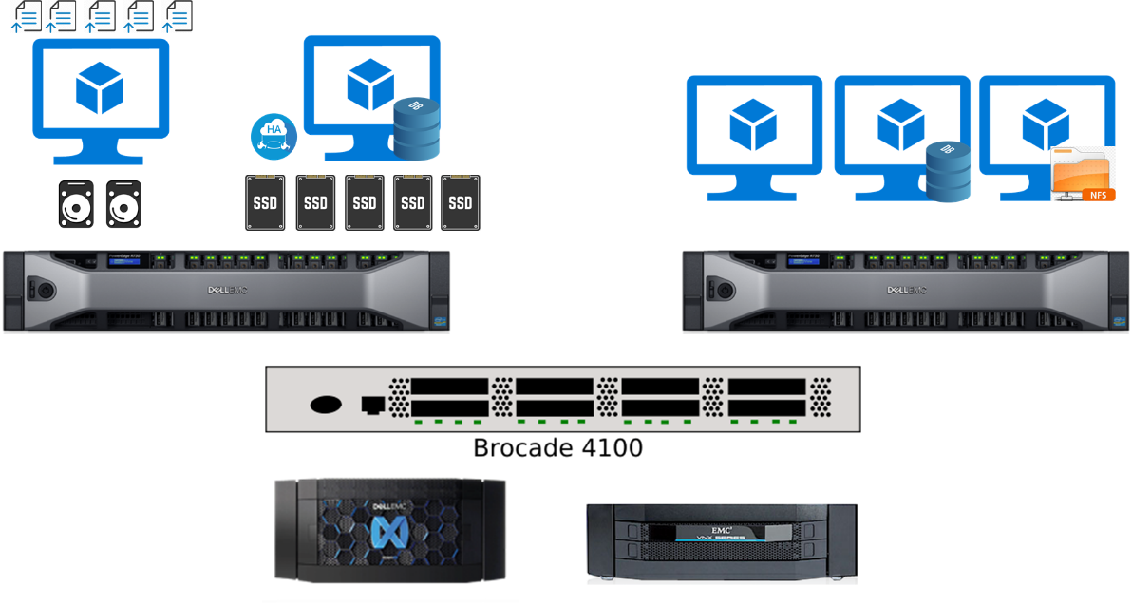

In order to implement the simplest S/4 HANA Suite, here is the basic architecture:  
- 2 Nodes acting as SAP Application side (HA).  
- 2 Nodes acting as SAP HANA DB side (HA, Active/Passive), with Replication between them.  
- Nodes running on different servers, backed on different storage systems, with redundancy in network.

### Detailed information

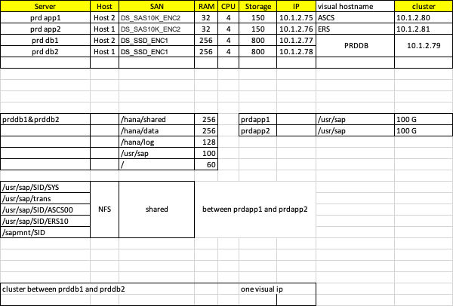

**NB:** NFS share sizes around 20 GB

## **SAP on Azure**

<https://docs.microsoft.com/en-us/azure/virtual-machines/workloads/sap/get-started>

<https://docs.microsoft.com/en-us/azure/architecture/reference-architectures/sap/sap-overview>

<https://docs.microsoft.com/en-us/learn/paths/plan-azure-sap-workloads/>

Azure supports SAP applications on Linux and Windows across development, test, and production environments.   
Our customers run SAP deployments of all sizes on Azure—including SAP NetWeaver, SAP S/4HANA, SAP BW/4HANA, SAP BI, and SAP HANA in scale-up and scale-out scenarios.

### SAP NetWeaver with AnyDB on Azure VMs

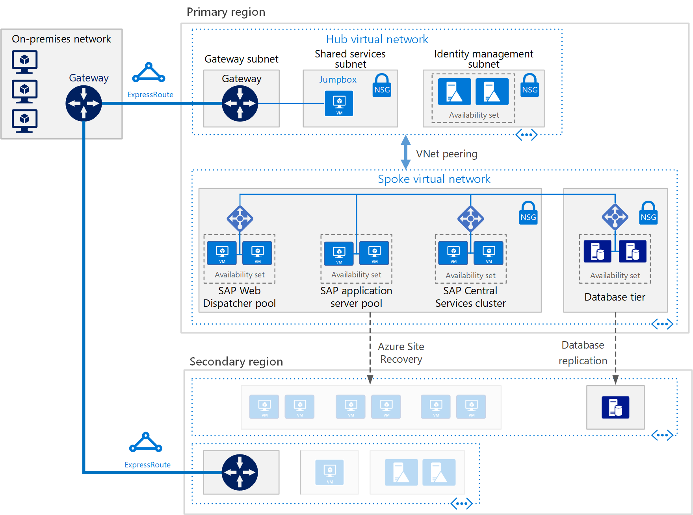

The virtual network also connects to an on-premises environment via virtual gateway provisioned as part of ExpressRoute or Site-to-Site connection.

There are NetWeaver certified VM types.

* + - SAP Web Dispatcher pool: The Web Dispatcher component is used as a load balancer for SAP traffic among the SAP application servers. To achieve high availability for the Web Dispatcher component, Azure Load Balancer is used to implement the parallel Web Dispatcher setup. Web Dispatcher uses in a round-robin configuration for HTTP(S) traffic distribution among the available Web Dispatchers in the load balanced backend pool.

For traffic from SAP GUI clients via DIAG protocol or Remote Function Calls (RFC), the Central Services message server balances the load through SAP application server logon groups, so no additional load balancer is needed.

* + - SAP Central Services cluster: The Central Services is a potential single point of failure (SPOF) when deployed to a single VM — a typical deployment when high availability is not a requirement. To implement a high availability solution, deploy multiple Central Services instances and configure them as members of a failover cluster with a shared disk or a file share providing highly available storage accessible by all cluster nodes.

Azure does not support natively shared disks, but you can use third party solutions (such as SIOS DataKeeper Cluster Edition, which replicates synchronously independent disks owned by individual cluster nodes) to implement this functionality on Azure VMs running Linux or Windows Server.  
SAP has recently modified the Central Services deployment process to allow the use of /sapmnt global directories via a UNC path. This change removes the requirement for SIOS or other shared disk solutions on the Central Services VMs. It is still recommended to ensure that the /sapmnt UNC share is highly available. This can be done on the Central Services instance by using Windows Server Failover Cluster with Scale Out File Server (SOFS) and the Storage Spaces Direct (S2D) feature in Windows Server 2016. For Linux accessible shares, you can use highly available NFS deployment of Azure VMs.

#### SAP NetWeaver on Azure sample workflow

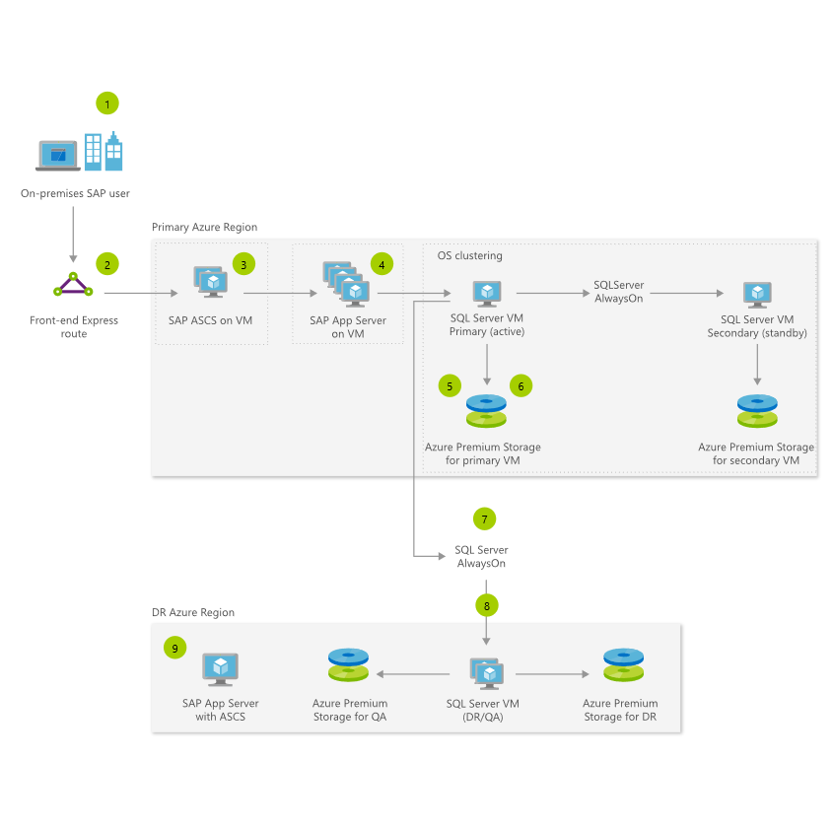  
<https://docs.microsoft.com/en-us/learn/modules/utilize-azure-sap-workloads-reference-architecture/3-sap-netweaver-azure-sample-workflow>

### SAP S4 HANA on Azure VMs

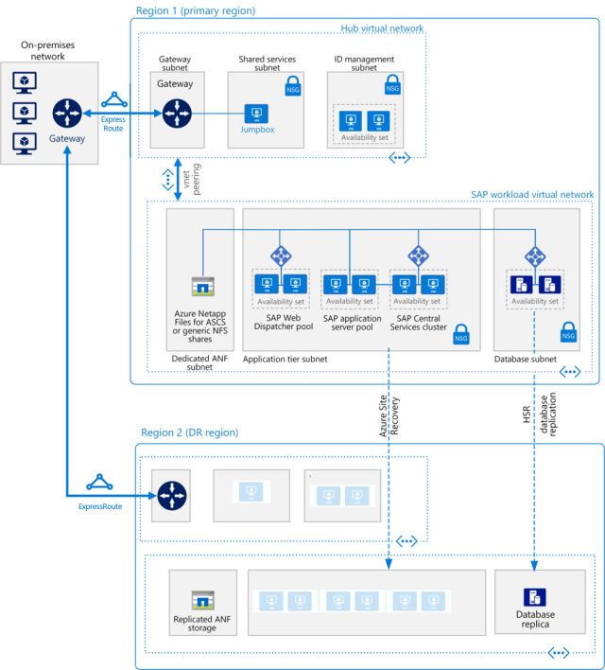

* + - Application tier: Includes the Fiori Front-end Server pool, SAP Web Dispatcher pool, application server pool, and SAP Central Services cluster. For high availability of Central Services on Azure running in Linux virtual machines, a highly available network file share service is required, such as Azure NetApp Files, clustered Network File Shares (NFS) servers, or SIOS DataKeeper. To set up a highly available file share for the Central Services cluster on Red Hat Enterprise Linux, GlusterFS can be configured on Azure virtual machines running Red Hat Enterprise Linux.
    - SAP HANA: The database tier uses two or more Linux virtual machines in a cluster to achieve high availability in a scale-up deployment. HANA System Replication (HSR) is used to replicate contents between primary and secondary HANA systems. Linux clustering is used to detect system failures and facilitate automatic failover. A storage-based or cloud-based fencing mechanism must be used to ensure the failed system is isolated or shut down to avoid the cluster split-brain condition. In HANA scale-out deployments, database high availability is achieved by configuring standby nodes without the need of the Linux clustering component.

The SAP Certified and Supported SAP HANA Hardware Directory has a list of certified Azure virtual machines for the HANA database.

[Configure SAP S4 HANA on Azure VMs - Learn | Microsoft Docs](https://docs.microsoft.com/en-us/learn/modules/utilize-azure-sap-workloads-reference-architecture/4-configure-sap-s4-hana-azure-vms)

#### SAP HANA on Azure sample workflow

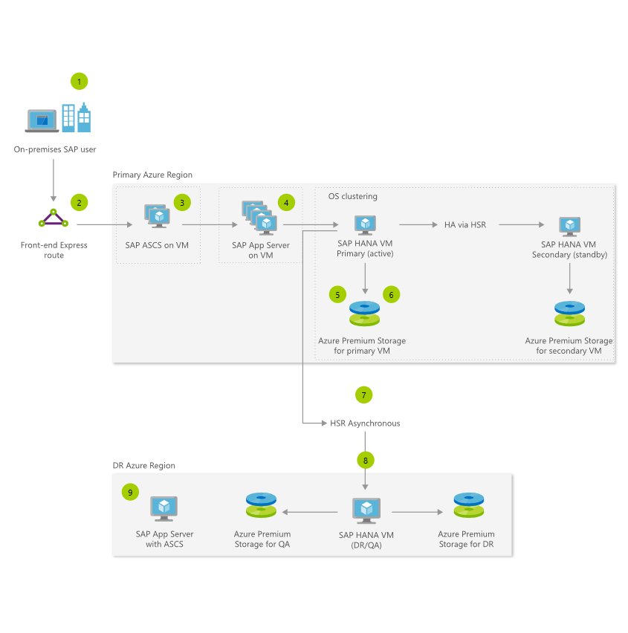

[SAP HANA on Azure sample workflow - Learn | Microsoft Docs](https://docs.microsoft.com/en-us/learn/modules/utilize-azure-sap-workloads-reference-architecture/5-sap-hana-azure-sample-workflow)

### HANA Large Instances (HLI)

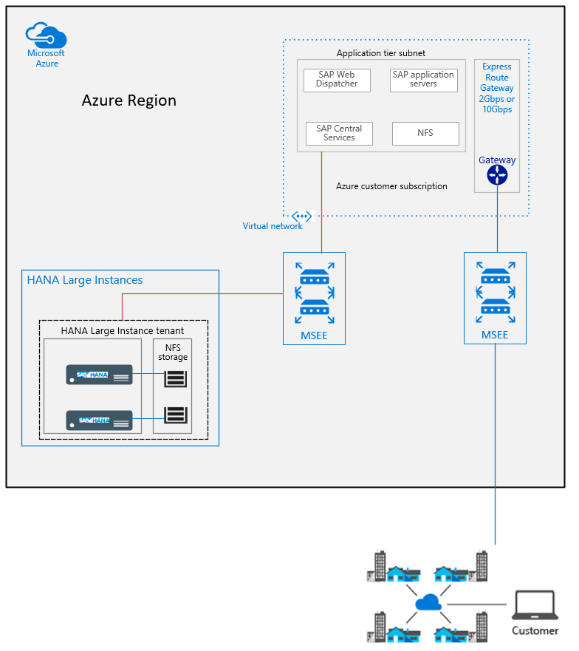

The SAP HANA on Azure (Large Instances) solution builds on non-shared host/server bare-metal hardware that is assigned to you. The server hardware is embedded in larger stamps that contain compute/server, networking, and storage infrastructure. As a combination, it's HANA tailored data center integration (TDI) certified. SAP HANA on Azure (Large Instances) offers different server SKUs or sizes. Units can have 36 Intel CPU cores and 768 GB of memory and go up to units that have up to 480 Intel CPU cores and up to 24 TB of memory.

A physical server certified to meet SAP HANA Tailored Datacenter Integration (TDI) standards runs SAP HANA. This architecture uses two HANA Large Instances: a primary and a secondary compute unit. High availability at the data layer is provided through HANA System Replication (HSR).

SAP application layer hosted on Azure VMs and the database layer residing on SAP TDI-configured hardware located in a Microsoft-hosted Large Instance stamp in the same Azure region. Latency is the primary factor on imposing restrictions on supportability in cross-premises and cross-Azure region scenarios. There are, however, some exceptions to these rules. If the latency stays within the range of 2 milliseconds, the cross-premises restrictions do not apply. Such latency can be achieved with on-premises locations in physical proximity to Azure data centers and connected to them via ExpressRoute.

In general, SAP does not support hosting some components of the same SAP system in Azure and others on-premises – for example, splitting instances of the SAP application layer between your on-premises environment and Azure VMs or running the database tier on-premises with the SAP application tier in Azure or vice versa. Similarly, it is not supported to host VMs running components of the same SAP system across multiple Azure regions.

Sizing for HANA Large Instance is no different than sizing for HANA in general. For existing and deployed systems that you want to move from other RDBMS to HANA, SAP provides several reports that run on your existing SAP systems. If the database is moved to HANA, these reports check the data and calculate memory requirements for the HANA instance.

For green field implementations, SAP Quick Sizer is available to calculate memory requirements of the implementation of SAP software on top of HANA.

Memory requirements for HANA increase as data volume grows. Identify your current memory consumption to help you predict what it's going to be in the future. Based on memory requirements, you then can map your demand into one of the HANA Large Instance SKUs.

#### Storage

HANA Large Instances come with a specific storage configuration for the standard TDI specifications. You can add storage to existing instances in 1-TB units. This added storage can be added as an additional volume. It also can be used to extend one or more of the existing volumes. Decreasing the original volume size isn't possible. It also isn't possible to change the names of the volumes or mount names.

The HANA Large Instance of the Type I class comes with four times the memory volume as storage volume. This is not the case for the Type II class of HANA Large Instance units.

The NFS storage server for HANA Large Instances is hosted in a multi-tenant environment, where tenants are segregated and secured using compute, network, and storage isolation. The storage volumes are attached to the HANA Large Instance units as NFS4 volumes.

To support high availability at the primary site, use different storage layouts. For example, in a multi-host scale-out, the storage is shared. Another high availability option is application-based replication such as HSR. For DR, however, a snapshot-based storage replication is used.

It's possible to host more than one active SAP HANA instance on HANA Large Instance units. To provide the capabilities of storage snapshots and disaster recovery, such a configuration requires a volume set per instance.

#### Networking

It's likely that not all IT systems are in Azure. Your SAP landscape is often hybrid as well from a DBMS point and SAP application point of view using a mixture of NetWeaver, and S/4HANA, SAP HANA, and another DBMS. Azure offers different services that allow you to run the different DBMS, NetWeaver, and S/4HANA systems in Azure. Azure also offers you network technology to make Azure look like a virtual data center to your on-premises software deployments

* + - An ExpressRoute circuit that connects on-premises to Azure, with bandwidth of 1 Gbps or higher. The available bandwidth must allow for transfer of data between on-premises systems and systems on Azure VMs and must facilitate connectivity to Azure VMs from on-premises users. This ExpressRoute circuit is fully paid by you as a customer.
    - An ExpressRoute circuit that connects SAP HANA Large Instances into the Azure data center network fabric. This circuit is deployed and handled by Microsoft. All you need to do is provide IP address ranges after the deployment of your assets in HANA Large Instance connect the ExpressRoute circuit to the virtual networks. There is no additional fee for you as a customer for the connectivity between the Azure data center network fabric and HANA Large Instance units.
    - An Azure ExpressRoute gateway that connects a virtual network to ExpressRoute circuits. An Azure ExpressRoute gateway is used with ExpressRoute to an infrastructure outside of Azure or to an Azure Large Instance stamp. You can connect the Azure ExpressRoute gateway to a maximum of four different ExpressRoute circuits if those connections come from different Microsoft enterprise edge routers.

The maximum throughput you can achieve with an ExpressRoute gateway is 10 Gbps. Copying files between a VM that resides in a virtual network and a system on-premises (as a single copy stream) doesn't achieve the full throughput of the different gateway SKUs. To leverage the complete bandwidth of the ExpressRoute gateway, use multiple streams.  
  
The Azure ExpressRoute gateway has at least two ExpressRoute circuits: one circuit that is connected from on-premises and one that is connected from HANA Large Instances. This leaves only room for another two additional circuits from different MSEEs to connect to on ExpressRoute Gateway. All the connected circuits share the maximum bandwidth for incoming data of the ExpressRoute gateway.

Given the overall network traffic between the SAP application and database layers, only the HighPerformance or UltraPerformance gateway SKUs are supported for connecting to SAP HANA on Azure (Large Instances). For HANA Large Instance Type II SKUs, only the UltraPerformance gateway SKU is supported as an ExpressRoute gateway. Exceptions apply when using ExpressRoute Fast Path.

Multiple SAP systems or large SAP systems deployed to connect to SAP HANA on Azure (Large Instances), could cause the throughput of the ExpressRoute gateway to become a bottleneck. You might also need to isolate production and non-production systems. You can split the application layers into multiple virtual networks. You might also want to create a special virtual network that connects to HANA Large Instance

##### ER Fast path

Microsoft offers ExpressRoute Fast Path to optimize connectivity of HANA Large Instances to Azure virtual networks that host the SAP application VMs. Its major benefit is data flows between VMs and HANA Large Instances are not routed through the ExpressRoute gateway anymore. Instead the VMs assigned in the subnet(s) of the Azure virtual network are directly communicating with the dedicated enterprise edge router.

The ExpressRoute Fast Path functionality requires that the subnets running the SAP application VMs are in the same Azure virtual network connected to the HANA Large Instances. VMs located in Azure virtual networks that are peered with the Azure virtual network connected directly to the HANA Large Instance units are not benefiting from ExpressRoute Fast Path. As a result, traditional typical hub and spoke virtual network designs, where the ExpressRoute circuits are connecting against a hub virtual network and virtual networks containing the SAP application layer (spokes) are getting peered, are not capable of taking advantage of the optimization by ExpressRoute Fast Path. In addition, ExpressRoute Fast Path does not support user defined routing rules (UDR) today. ExpressRoute Fast Path requires an UltraPerformance ExpressRoute gateway.

##### Routing

* + - By default, SAP HANA on Azure (Large Instances) cannot be accessed directly from on-premises. Connections are established through Azure VMs within the same SAP HANA on Azure (Large Instances) VNet and through using a dedicated ExpressRoute connection. Administration clients and any applications that need direct access, such as SAP Solution Manager running on-premises, can't connect to the SAP HANA on Azure (Large Instances) database by default.
    - If you have HANA Large Instance units deployed in two different Azure regions for disaster recovery, the transient routing restrictions apply. IP addresses of a HANA Large Instance unit in one region isn’t directly routed to a HANA Large Instance unit deployed in another region. The restriction is independent of the use of Azure network peering across regions or cross connecting the ExpressRoute circuits that connect HANA Large Instance units to virtual networks. This restriction, which comes with the deployed architecture, prohibits the immediate use of HANA System Replication as disaster recovery functionality.
    - SAP HANA on Azure (Large Instances) units have an assigned IP address from the server IP pool address range that you submit when requesting the HANA Large Instance deployment. This IP address is accessible through Azure subscriptions and the circuit that connects Azure virtual networks to HANA Large Instances. The IP address assigned out of that server IP pool address range is directly assigned to the hardware unit. It's not assigned through NAT anymore, as was the case in the first deployments of this solution.

There are several possibilities to enable such a transitive routing.

* + - ExpressRoute Global Reach can also be used to connect HANA Large Instance tenants deployed in two different regions. This connectivity leverages the ExpressRoute circuits that your HANA Large Instance tenants are using to connect to Azure in both regions. There are no additional charges for connecting two HANA Large Instance tenants that are deployed in two different regions.

The data flow and control flow of the network traffic between different HANA Large instance tenants will not be routed through Azure virtual networks. As a result, you can't use Azure NSGs to apply connectivity restrictions between your two HANA Large Instances tenants.

Different Large Instance stamps within one geo-political region are connected to each other. For example, HANA Large Instance Stamps in US West and US East are connected through a dedicated network link for disaster recovery replication.

* + - A reverse-proxy to route data, to and from SAP HANA on Azure (Large Instances). This can be, for example, F5 BIG-IP or NGINX with Traffic Manager deployed in the Azure virtual network.
    - IPTables rules in a Linux VM to enable routing between on-premises locations and HANA Large Instance units, or between HANA Large Instance units in different regions. The VM running IPTables needs to be deployed in the Azure virtual network that connects to HANA Large Instances and to on-premises network. You'll need to size the VM to meet the expected network traffic.
    - Azure Firewall to direct traffic between on-premises and HANA Large instance units.

With a reverse-proxy, IPTables, and Azure Firewall, traffic routed through an Azure virtual network can be further filtered by Azure Network Security Groups. Certain IP addresses or IP address ranges from on-premises can be blocked or explicitly allowed to access HANA Large Instances. Implementation and support for custom solutions involving third-party network appliances or IPTables isn't provided by Microsoft. Support must be provided by the vendor of the component used or the integrator.

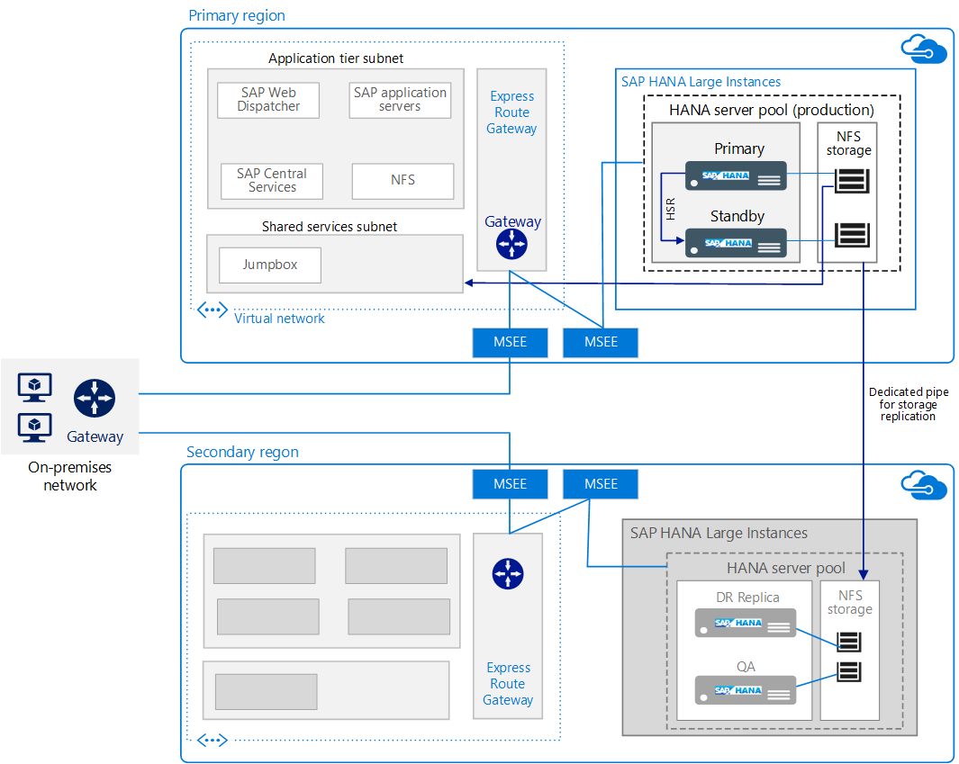

#### SAP on Azure HANA Large Instances sample workflow

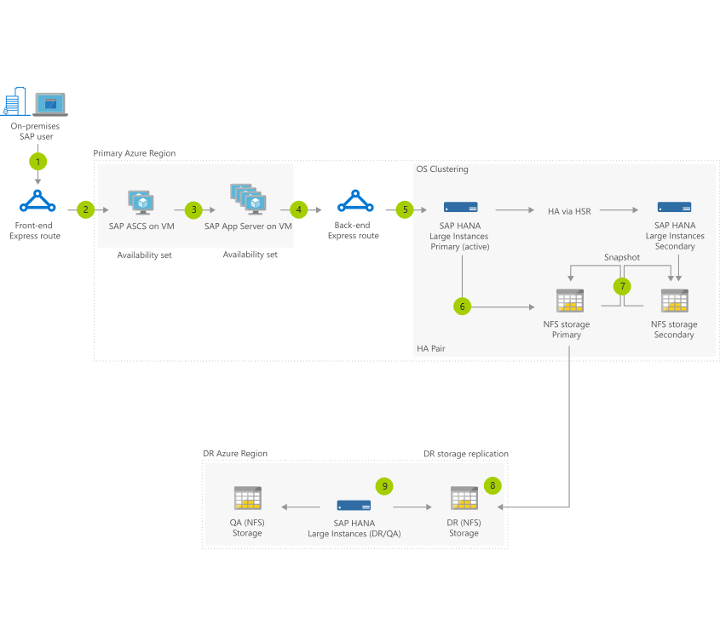

1. Persistent data volume on secondary storage is replicated to dedicated DR system through a dedicated backbone network for HANA storage replication.

[SAP on Azure HANA Large Instances sample workflow - Learn | Microsoft Docs](https://docs.microsoft.com/en-us/learn/modules/utilize-azure-sap-workloads-reference-architecture/8-sap-azure-hana-large-instance-sample-workflow)

#### Supported Scenarios

<https://docs.microsoft.com/en-us/learn/modules/sap-hana-azure-compute-network-storage/9-supported-scenarios>

### Implement SAP on Azure Tips

#### Compute

In case of large VMs, like M128s or M128ms, or ES64v3 the VM is the only VM running on a host. As a result, it benefits from the complete network and storage bandwidth the host has available. In the case of smaller VMs, the network and storage bandwidth need to be divided across multiple VMs. Especially for SAP HANA, but also for SAP NetWeaver, it is vitally important that a VM running intensive workload does not affect CPU, memory, network, and storage bandwidth capacity of other VMs running on the same host. As a result, in sizing a VM, you also need to consider the required network and storage bandwidth.

There are several approaches to sizing SAP systems:

Reference-Based Sizing – ST03 and EarlyWatch data is analyzed and compared to another known customer with similar workload and a known hardware configuration

SAP Quicksizer – SAP tool that calculates SAPS, DB size, and RAM based on many inputs including business document volumes and number of users

T-Shirt – sizing based on the anticipated number of SAP users where precise information is unavailable

#### Storage

For SAP application servers, including the Central Services virtual machines, you could potentially use Azure Standard Storage to reduce cost, because application execution takes place in memory and uses disks for logging only. However, as explained earlier, Standard Storage is only certified for unmanaged disks. Since application servers do not host any data, you can also use the smaller P4 and P6 Premium Storage disks to help minimize cost.

UltraSSD gives you the possibility to define a single disk that fulfills your size, IOPS and disk throughput range, rather than using logical volume managers like LVM or MDADM on top of Azure Premium Storage to construct volumes that fulfill IOPS and storage throughput requirements. You have the option of attaching both UltraSSD and Premium Storage disks to the same Azure VMs. As a result, you can restrict the usage of UltraSSD for the performance critical /hana/data and /hana/log volumes and implement other volumes with Premium Storage

SAP HANA Dynamic Tiering 2.0 (DT 2.0) offers the ability to offload less frequently access data from memory into extended storage. SAP HANA Dynamic Tiering 2.0 isn't supported by SAP BW or S4HANA. Its primary use cases consist of native HANA applications.

#### Network

Keep in mind that configuring network virtual appliances in the communication path between the SAP application and the DBMS layer of an SAP NetWeaver-, Hybris-, or S/4HANA-based SAP system isn't supported. This restriction is for functionality and performance reasons. The communication path between the SAP application layer and the DBMS layer must be a direct one. The restriction doesn't include application security group (ASG) and NSG rules if those ASG and NSG rules allow a direct communication path.

Azure VMs can benefit from Accelerated Networking and Proximity Placement Groups. Use them when you deploy Azure VMs for an SAP workload, especially for the SAP application layer and the SAP DBMS layer.

SAP application server to database server latency can be tested with ABAP report /SSA/CAT -> ABAPMeter

#### HA & Backup

SAP application, no need for OS clustering, but SAP ACSC needs OS clustering.

SAP application workloads using Azure backup, may be using app-consistant (for windows & linux).  
DB backup depends on the DB type, for non-HANA, you need to backup Database+transaction log, for HANA it has it’s procxedure.

#### Monitor

Monitoring is depending on SAP, so install SAP monitoring tools, Just install Azure Monitor Extension for SAP on Windows and Linux Azure VMs to provide the needed info to SAP tools.

#### Migrate SAP to Azure

The number of greenfield deployments is relatively small.

With the Classical Migration option, SAP’s Software Provisioning Manager (SWPM) is used as the Software Logistics (SL) tool and is exclusively for database migrations. SWPM exports from data from a source system and imports it to a target system where the target can be anyDB (SQL server, Oracle, or DB2). This method in particular uses a file-based approach.

SAP Database Migration Option (DMO) facilitates both an SAP upgrade and a database migration to the SAP HANA database using one tool. As both steps are handled at once, the DMO process is often referred to as a one-step migration. In comparison, Classical Migration uses a heterogenous system copy approach (thus garnering it the title of a two-step migration) with the first step being that of a migration followed by a second step facilitating an SAP upgrade.

Steps for Data Migration Option (DMO) with System Move to Microsoft Azure:

* + - Ensure connectivity to Azure is available via Express Route (highly recommended and with higher-speed connectivity) or Virtual Private Network (VPN) into Azure
    - Provision the target infrastructure in Azure that includes SAP NetWeaver and SAP HANA database servers. The Azure infrastructure can be rapidly deployed using predefined Azure Resource Manager (ARM) templates.
    - SUM is started on the on-premises source SAP application server.
    - Uptime activities are executed from the on-premises SAP application server and the shadow repository is created.
    - As part of the downtime phase, export files are generated on the source system and these files are then transferred to Azure via Express Route or VPN.
    - File transfers can occur in “Sequential Data Transfer” or “Parallel Data Transfer” mode

##### Very Large Databases (VLDB)

Very Large Databases (VLDB) are now commonly moved to Azure. Database sizes over 20 TB require additional techniques and procedures to achieve a migration from on-premises to Azure within an acceptable downtime and a low risk.

A fully optimized VLDB migration should achieve around 2 TB per hour migration throughput or more. The data transfer component of a 20-TB migration can be done in approximately 10 hours.

Splitting a large table into more than 50 parallel exports may decrease the time taken to Export a table. However, too many Table Splits may result in increased Import times. Therefore, the net impact of table splitting must be calculated and tested.

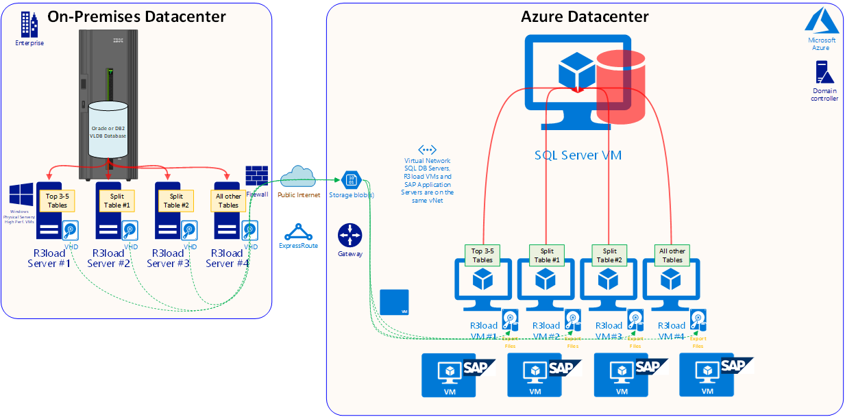

[Implement Very Large Database migration to Azure for SAP workloads - Learn | Microsoft Docs](https://docs.microsoft.com/en-us/learn/modules/migrate-sap-workloads-azure/5-implement-large-database-migration-azure)