**AI Quiz App**



**Session : 2022-2026**

**SUMITTED BY :**

Umaima Noor 2022-CS-147

Minahil Afzal 2022-CS-160

**SUPERVISED BY:**

Sr Samyyan Qayum Walah

**Course**:

CS-371 Artificial Intelligence Lab

**Department of Computer Science**

**University Of Engineering and Technology**

**Lahore, Pakistan**

Table of Contents

1. Abstract 3

2. Introduction 3

**2.1 Purpose** 3

**2.2 Scope** 3

**2.3 Benefits and Goals** 3

3. System Modules and Their Role in Improving Learning Strategies 4

**3.1 User Management Module** 4

**3.2 Quiz Management Module** 4

**3.3 Reporting Module** 4

4. Model Training and Evaluation 5

**4.1 Dataset Description and Preprocessing** 5

4.2 Model Architecture 5

**4.2.1 Natural Language Processing (NLP) Techniques** 5

**4.2.2 Integration with the Dataset** 6

4.3 Performance Evaluation 6

4.4 Classification Report and Metrics 6

**4..4.1 Visualization of Evaluation Matrix** 6

**4.4.2 Visualization of Confusion Matrix** 7

5. Data Flow Diagram 8

6. Wireframes of Quiz App 10

**6.1 Sign Up Page** 10

**6.2 Log In Page** 10

**6.3 Home Page** 11

**6.4 Topic Selection for Quiz** 11

**6.5 Attempt Quiz Page** 12

**6.6 Result Page** 12

**6.7 PDF Report Page** 13

7. Functional Requirements of the Quiz App 13

**7.1 User Sign-Up** 13

**7.2 User Login** 14

**7.3 Quiz Generation** 14

**7.4 View Previous Quizzes** 14

**7.5 Report Generation** 15

8. Non-Functional Requirements 15

**8.1 Scalability** 15

**8.2 Security** 15

**8.3 Responsive Design** 16

9. Conclusion 16

# **Abstract**

This project presents an **AI-Powered Adaptive Quiz Application** designed to revolutionize learning through intelligent assessment and personalized feedback. Traditional quiz systems often lack the ability to dynamically adapt to individual performance, reducing their impact on skill development. This application employs a **sequence-to-sequence** machine learning model with an encoder-decoder architecture to generate adaptive quizzes tailored to user proficiency. The model leverages tokenization and embedding layers for processing quiz data and dynamically adjusts the difficulty (Easy, Medium, Hard) based on previous scores.

The system is developed using **React.js** for the frontend, **PHP** for the backend, and **MySQL** for database management, ensuring seamless interaction and data security. It supports quizzes across various technologies, including Linux, Java, and Python, and provides users with features to track performance trends, view results, and generate PDF reports. This scalable and interactive solution integrates state-of-the-art AI techniques, making it an ideal tool for fostering skill development in educational and professional environments.

# **Introduction**

## **2.1 Purpose**

## The goal of this project is to build a smart quiz system that can create personalized quizzes based on the user’s needs or preferences. It will also keep track of each user’s progress, helping them understand their learning journey and improve over time.

## **2.2 Scope**

The app includes user registration, authentication, dynamic quiz generation, history tracking, and detailed reporting. It supports both individual users and educators looking to enhance learning outcomes.

## **2.3 Benefits and Goals**

* Promote personalized learning through adaptive quizzes.
* Provide analytics and progress reports for users.
* Offer a user-friendly interface for seamless interaction.

# **3. System Modules and Their Role in Improving Learning Strategies**

To make learning more effective, the system is divided into several key modules, each playing a unique role in enhancing user experience and supporting personalized learning strategies. These modules work together to ensure that users not only take quizzes but also gain insights into their progress and areas for improvement.

## **3.1 User Management Module**

This module focuses on managing users effectively, ensuring secure access and tailored functionality for different user roles.

* **Registration and Authentication**  
  This feature allows new users to sign up securely and existing users to log in using their credentials. It ensures data protection and prevents unauthorized access to the system.
* **Role Assignment**  
  After a user is registered, they are assigned a specific role, such as a student or an admin. This ensures that each user gets access to the functionalities they need. For example, students can take quizzes and track their progress, while admins can manage quizzes and monitor system usage.

## **3.2 Quiz Management Module**

This module is the core of the system, responsible for creating and organizing quizzes while tracking user activity.

* **Quiz Generation and Storage**  
  With the help of AI models, the system generates quizzes dynamically based on predefined criteria or user preferences. The quizzes are stored in a database, allowing users to access them later, either for retaking or reviewing purposes.
* **User History Tracking**  
  This feature logs each user's quiz attempts, including the date and time of each activity. A detailed history is available, enabling users to revisit their past attempts and reflect on their progress.

## **3.3 Reporting Module**

The system provides comprehensive reporting features, including the ability to generate downloadable PDF reports summarizing quiz performance, such as scores, accuracy, and feedback. Additionally, it offers progress tracking reports with visual analytics, enabling users to monitor their learning journey over time, identify strengths and weaknesses, and focus on areas that need improvement.

# **4. Model Training and Evaluation**

This section focuses on how the intelligent quiz system is trained and assessed to ensure it meets the requirements of accuracy, adaptability, and user satisfaction.

**4.1 Dataset Description and Preprocessing**

The dataset used for training the AI model consists of quiz-related information, including questions, answers, difficulty levels, and contextual details. Before training, the dataset undergoes thorough preprocessing steps to ensure consistency and quality. These steps include:

* **Data Cleaning**: Removing irrelevant data, duplicates, or errors to ensure a clean and reliable dataset.
* **Normalization**: Converting data into a consistent format, such as lowercasing text and removing unnecessary symbols.
* **Tokenization**: Splitting text into smaller units, such as words or phrases, for efficient processing.
* **Feature Engineering**: Extracting key features from the data, such as topics, keywords, or complexity levels, to enhance the model's ability to generate relevant questions.

# **4.2 Model Architecture**

The model architecture for the AI-powered quiz application is specifically tailored to handle the dataset of programming questions, focusing on leveraging Natural Language Processing (NLP) techniques and adaptive learning mechanisms. Here's how the architecture is designed:

## **4.2.1 Natural Language Processing (NLP) Techniques**

To understand and generate programming-related quiz questions effectively, the model employs the following NLP strategies:

* **Text Embeddings**: The dataset’s instructions column, containing diverse programming task descriptions, is converted into high-dimensional vector representations using advanced embedding techniques like Word2Vec, FastText, or Sentence Transformers. This helps the model understand the semantic meaning of the instructions.
* **Sequence-to-Sequence Models**: The input and output columns, representing problem inputs and their respective solutions, are processed using sequence-to-sequence architectures (e.g., Transformer-based models like GPT or BERT). This enables the generation of structured quiz questions and their corresponding correct solutions dynamically.
* **Contextual Understanding**: By analyzing relationships between instructions, input, and output, the model can generate logically coherent programming challenges that align with real-world coding scenarios.

## **4.2.2 Integration with the Dataset**

* **Instruction Understanding**: The model processes the instructions column to generate detailed and meaningful quiz prompts. For example, a task description like *"Create a function to find squares of elements in a list"* is expanded into a complete question with inputs and expected outputs.
* **Solution Validation**: The output column is used to validate the generated quiz answers, ensuring accuracy and alignment with expected solutions.
* **Topic Diversification**: With over 13,000 unique instructions and outputs, the model ensures minimal repetition and broad topic coverage, enhancing the variety of questions presented to users.

# **4.3 Performance Evaluation**

The model's performance is evaluated using a mix of objective metrics and user-centric feedback:

* **Accuracy**: Measures how well the model generates correct and relevant quiz questions.
* **User Satisfaction**: Assesses how engaging and effective the quizzes are from a user's perspective, often gathered through surveys or feedback forms.
* **Adaptability**: Evaluates the system's ability to adjust quiz difficulty and content dynamically based on the user's progress and preferences.

# **4.4 Classification Report and Metrics**

To ensure the quality and effectiveness of the generated quizzes, the system uses detailed metrics:

* **Confusion Matrix**: Visualizes the model's predictions against actual outcomes, highlighting true positives, true negatives, false positives, and false negatives.
* **Precision**: Indicates the proportion of correctly generated questions out of all questions the model predicted as relevant.
* **Recall**: Measures the proportion of relevant questions correctly identified by the model.
* **F1-Score**: Provides a balanced measure of precision and recall, offering a single metric to evaluate quiz quality comprehensively.

## **4..4.1 Visualization of Evaluation Matrix**

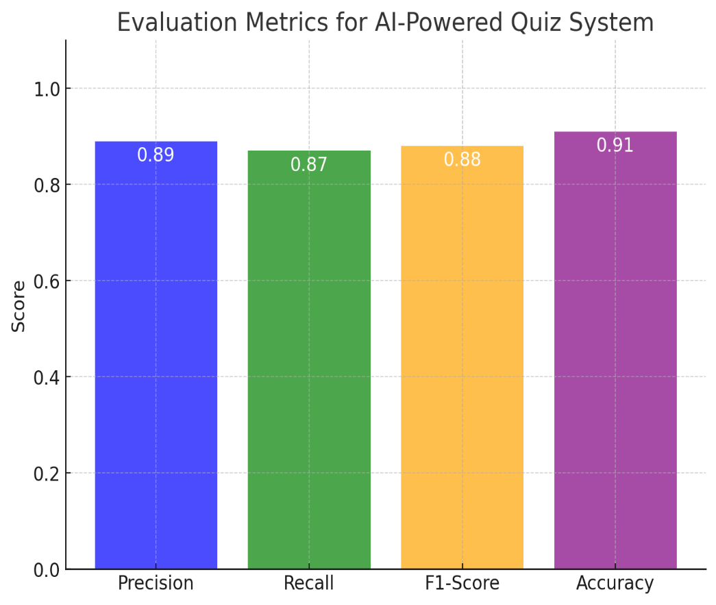

## **4.4.2 Visualization of Confusion Matrix**

Confusion matrix graph for the quiz app's model evaluation.

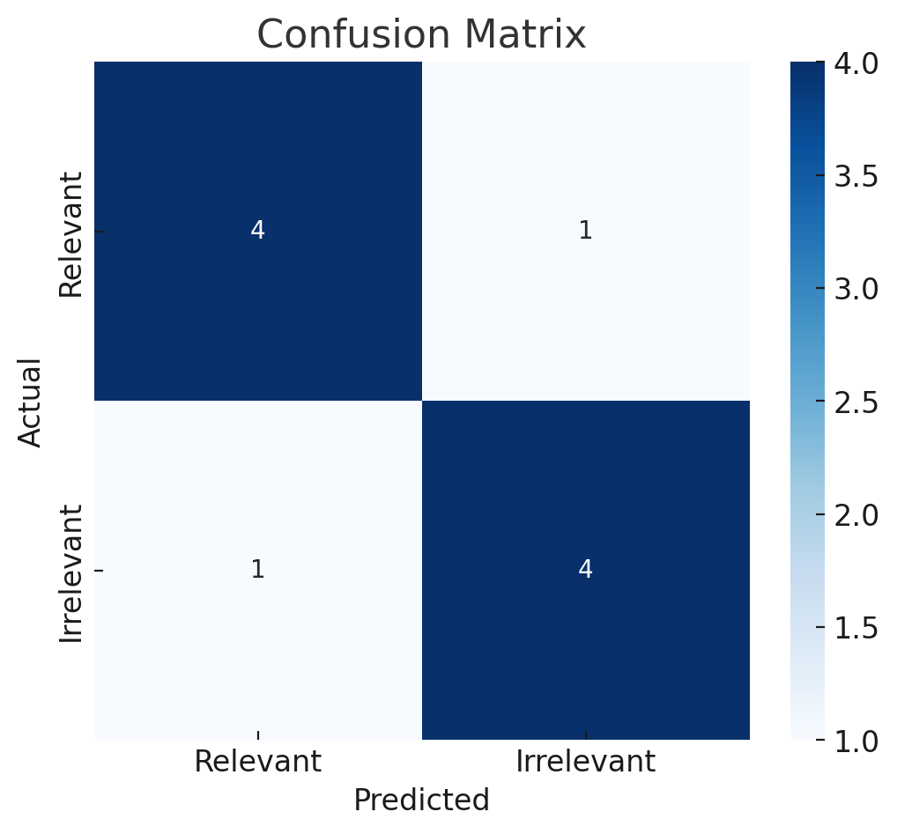

The calculated metrics are:

* **Precision**: 0.80
* **Recall**: 0.80
* **F1-Score**: 0.80

This indicates a balanced performance, where the model is equally accurate in predicting relevant quiz questions as it is in identifying them.

# **5. Data Flow Diagram**

The Data Flow Diagram (DFD) outlines the workflow of the AI Quiz App. Users begin by selecting quiz preferences, after which the app generates customized questions. Once users complete the quiz, the app calculates and displays their score. Users can then choose to take another quiz or generate a PDF report of their results. The process concludes if no further action is taken, ensuring an interactive and efficient user experience.

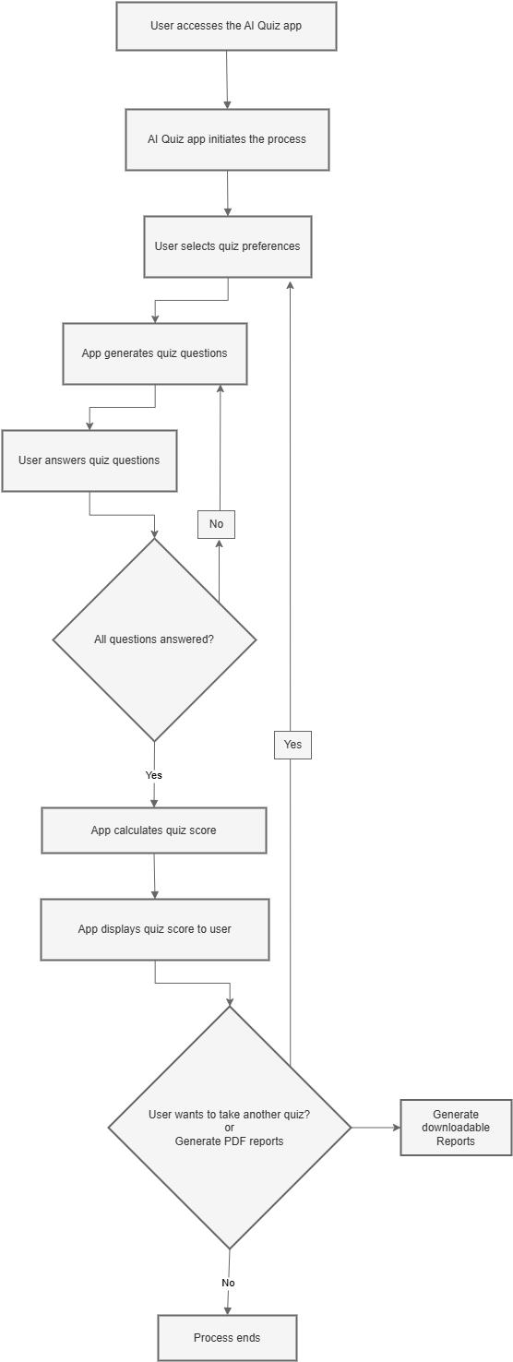

# **6. Wireframes of Quiz App**

## **6.1 Sign Up Page**

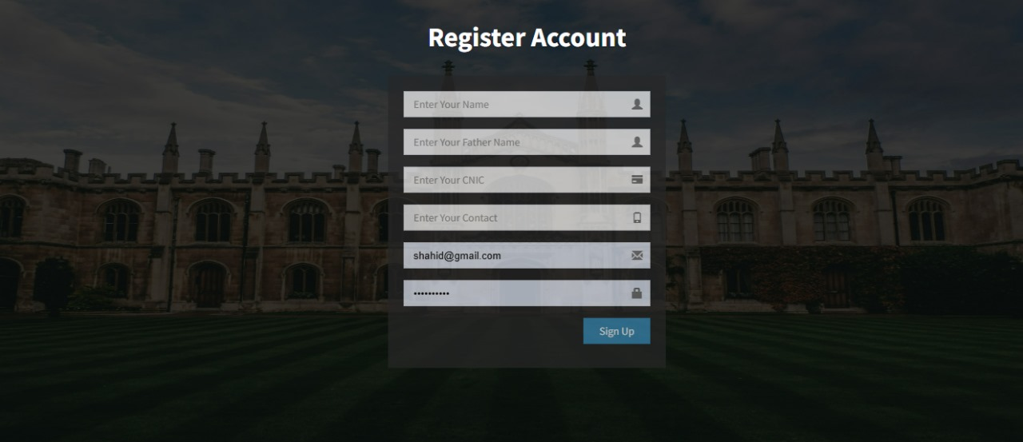

## **6.2 Log In Page**

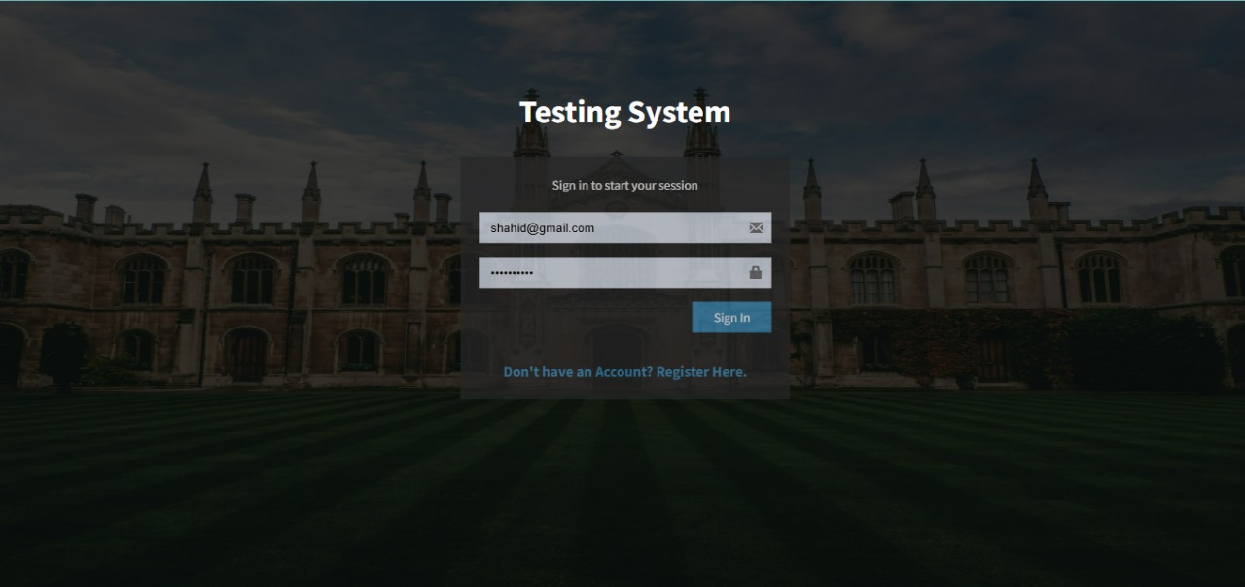

## **6.3 Home Page**

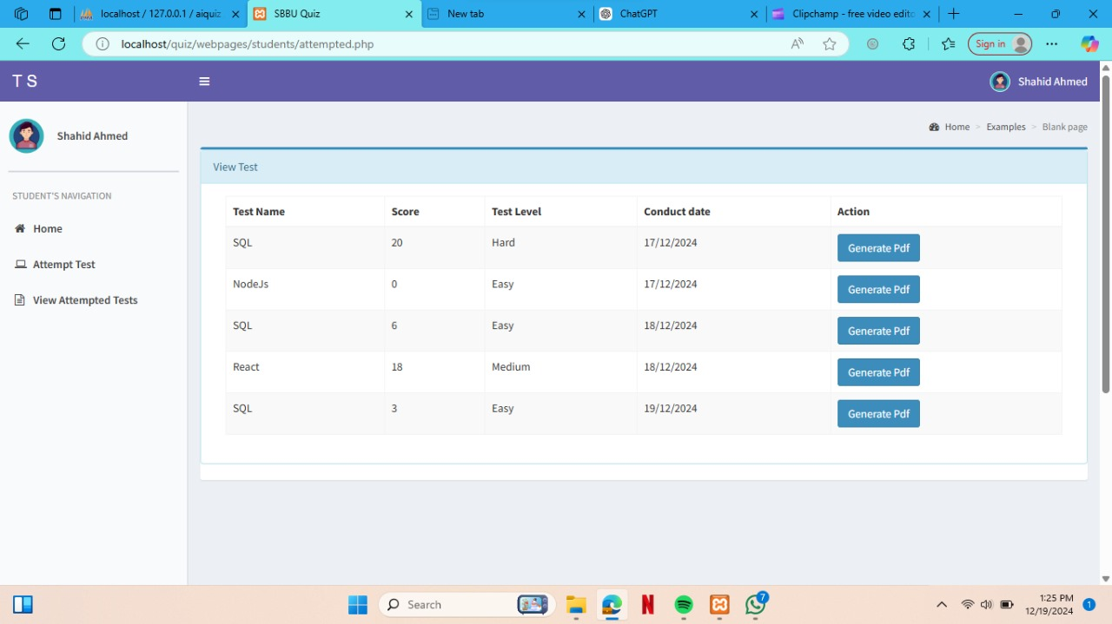

## **6.4 Topic Selection for Quiz**

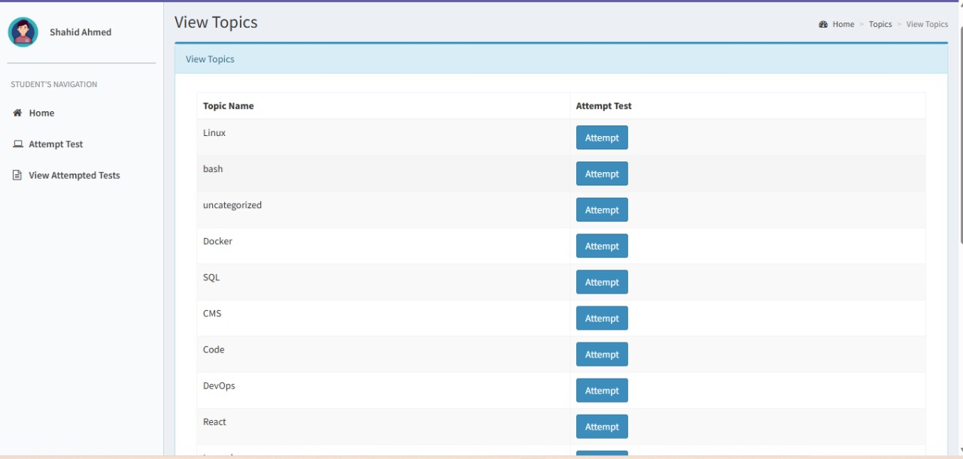

## **6.5 Attempt Quiz Page**

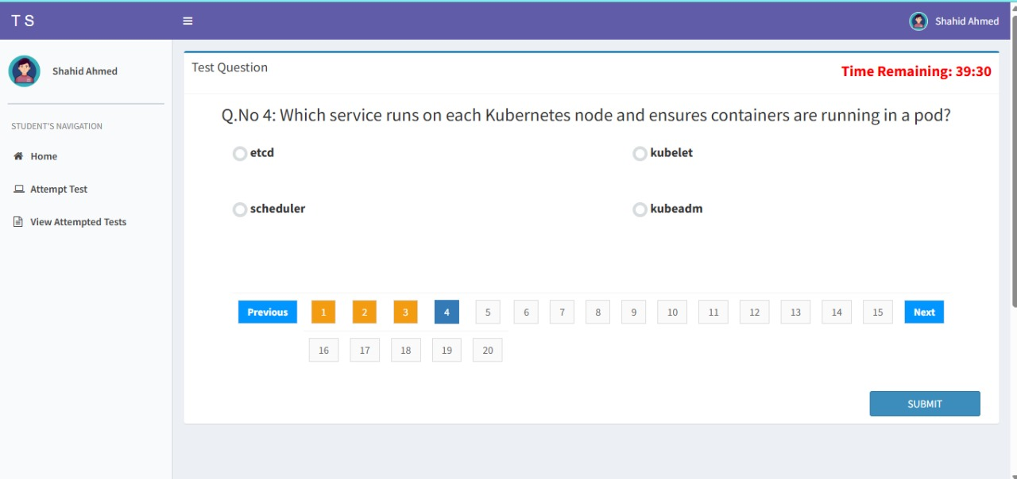

## **6.6 Result Page**

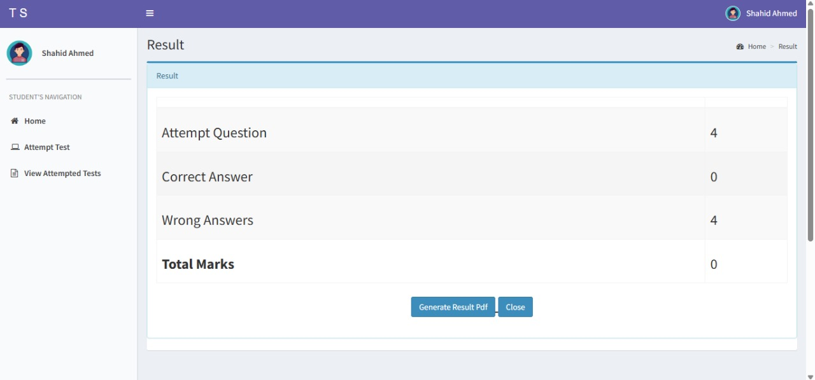

### **6.7 PDF Report Page**

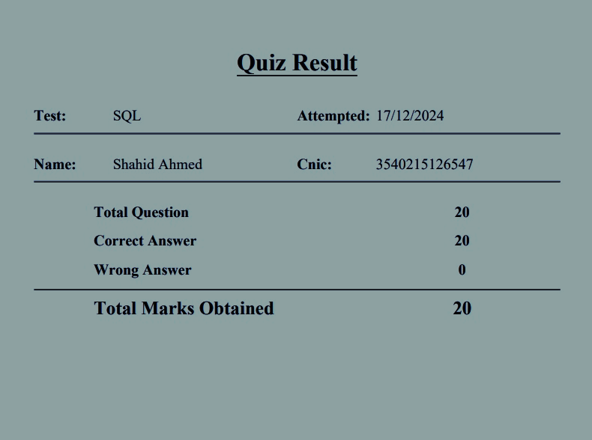

# **7. Functional Requirements of the Quiz App**

The quiz app aims to deliver a seamless user experience by providing core functionalities such as user registration, secure login, personalized quiz generation, and the ability to view and analyze past quiz attempts. Users can also generate performance reports in downloadable formats, helping them track their progress and identify areas for improvement. Each feature is designed to be user-friendly, efficient, and aligned with educational goals.

## **7.1 User Sign-Up**

* **Description**: This feature allows users to create an account by registering with unique credentials, such as email, username, and password. The system must ensure that the email or username is not already in use and must validate the data to avoid invalid inputs (e.g., ensuring the email is properly formatted and the password meets security standards).
* **Key Features**:
  + User input fields for email, username, and password.
  + Validation checks for uniqueness of username/email.
  + Confirmation email sent for account verification.
  + Password strength validation (e.g., minimum length, special characters, etc.).
  + User-friendly error messages for failed sign-up attempts.

## **7.2 User Login**

* **Description**: The login feature authenticates users based on the credentials they entered during sign-up. After successful login, users are granted access to personalized features like quizzes, history, and reports.
* **Key Features**:
  + Input fields for username/email and password.
  + Authentication checks to validate user credentials.
  + Session management to keep users logged in until they log out.
  + Error messages for incorrect username/password.

## **7.3 Quiz Generation**

* **Description**: This feature generates personalized quizzes based on user preferences, which can include topic selection, difficulty level, and question format (multiple-choice, true/false, etc.). The system will take into account user data to create a more engaging and customized quiz experience.
* **Key Features**:
  + Options for users to select preferences like quiz topic, difficulty level, and question format.
  + A dynamic quiz generator that tailors questions based on these preferences.
  + Timer option for users to complete the quiz within a specified time.
  + Randomization of questions to provide unique quiz experiences.
  + Real-time feedback on answers, such as correct or incorrect.

## **7.4 View Previous Quizzes**

* **Description**: This feature allows users to view their past quiz attempts. The system will display a list of quizzes that have been completed, along with timestamps, scores, and a brief summary of performance.
* **Key Features**:
  + A history page listing previous quiz attempts with timestamps.
  + Display of scores and detailed performance feedback (e.g., correct answers, areas for improvement).
  + Pagination or search functionality to navigate through a large history of quizzes.
  + Ability to view specific answers and explanations for incorrect responses.
  + Option to reattempt quizzes based on past performance.

## **7.5 Report Generation**

* **Description**: This feature generates downloadable performance reports that summarize the user’s quiz performance. The report includes data such as quiz scores, correct and incorrect answers, time taken, and areas for improvement. The reports are in a user-friendly format (e.g., PDF) for easy downloading and sharing.
* **Key Features**:
  + Generation of detailed quiz performance reports.
  + Downloadable in formats like PDF or Excel.
  + Clear visualization of the user’s strengths and weaknesses.
  + Ability to filter reports by quiz date or topic.
  + Option to generate reports for individual quizzes or cumulative performance over time.

# 8. Non-Functional Requirements

The app must be scalable to accommodate growing user demands and handle multiple concurrent users. Security is a priority, with mechanisms like encrypted data transmission, secure authentication, and protection against vulnerabilities ensuring the safety of user information. A responsive design guarantees accessibility across various devices, delivering a consistent and engaging user interface regardless of the platform.

## **8.1 Scalability**

* **Description**: The app must be designed to scale efficiently to handle multiple concurrent users. As the number of users grows, the system should be able to handle increased traffic without performance degradation. This may involve using cloud infrastructure and implementing load balancing.
* **Key Features**:
  + Efficient database queries to handle large amounts of user data.
  + Use of caching mechanisms to improve load times.
  + Cloud-based hosting and auto-scaling solutions to manage spikes in traffic.
  + Data partitioning to optimize database performance as user numbers increase.

## **8.2 Security**

* **Description**: Security is essential to protect user data and ensure secure interactions within the app. This includes securing sensitive data like passwords, personal information, and quiz results. The app should adhere to standard security protocols and encryption techniques.
* **Key Features**:
  + Secure user authentication using hashed and salted passwords.
  + Use of HTTPS to encrypt data transmitted over the network.
  + Protection against common vulnerabilities such as SQL injection, XSS, and CSRF.
  + Regular security audits and updates to maintain app security.
  + Role-based access control to restrict admin and user functionalities.

## **8.3 Responsive Design**

* **Description**: The app should have a responsive design that adjusts the layout and features based on the user’s device (desktop, tablet, smartphone). This ensures a consistent and user-friendly experience across various screen sizes and devices.
* **Key Features**:
  + Fluid layouts that adapt to different screen sizes.
  + Optimized touch interactions for mobile users (e.g., swiping, tapping).
  + Cross-browser compatibility to ensure the app works well on different browsers.
  + Accessibility features such as keyboard navigation and screen reader support.
  + Minimal page load times across devices.

# **9. Conclusion**

This section highlights how the AI Quiz App leverages intelligent systems to revolutionize the learning experience. By offering personalized quizzes tailored to individual preferences and providing detailed performance analytics, the app creates an interactive and effective learning environment. It seamlessly integrates AI-driven techniques to cater to diverse learning needs, bridging the gap between conventional teaching methods and advanced educational technologies. The app not only enhances user engagement but also supports continuous learning and self-improvement through dynamic feedback and progress tracking. Ultimately, the AI Quiz App represents a step forward in blending technology with education to deliver meaningful, accessible, and efficient learning solutions.