Department of Computer Science

BS-CS FINAL YEAR PROJECT PROPOSAL
Hyper Spectral Image Classification for Remote Sensing using Deep Learning



Presented by:

Registration No: Name:
22-FA-CS-194 Minahil Hijab

HITEC UNIVERSITY
Heavy Industries Taxila Education City, Taxila Cantt-Pakistan

Project Title
Hyper Spectral Image Classification for Remote Sensing using Deep Learning
Project Advisor
Dr. Veena Dillshad

Particulars of the students:
S.No | Registration# | Name in Full  Use Block Letters | CGPA | Signatures
1 | 22-CS-194 | MINAHIL HIJAB | 3.44

Advisor’s Consent
I Prof. Dr. _Veena Dillshad_ am willing to guide this student in all phases of above-mentioned project / thesis as advisor. I have carefully seen the Title and description of the project / thesis and believe that it is of an appropriate difficulty level for the student named above.

Note:  Advisor can’t be changed without prior permission of the project In-charge and the duration for completion of Research Project / Thesis is 10 months (approx.) from the date of Registration of Research Project/Thesis. | Signatures and Date  Advisor

Co-Advisor
I have carefully read the project proposal and feel that the proposed project is a useful one and of a sufficient difficulty level to justify a one year work load of above mentioned students.

Recommended |  |  |  | Signatures and Date
Yes |  | No

Abstract
Hyper spectral image (HSI) classification has gained considerable popularity for the Land Use and Land Cover classification in the recent decade. While the RGB and Multi-Spectral Imaging have proved inefficient in identifying deeper spectral resolution hence differentiating between materials, the numerous spectral bands in the hyper spectral imaging are potentially difficult to manage. Primarily, the difficulty lies in the few labeled samples versus the high dimensional features. Thus, it is a fundamental need to explore the relationship among different pixels in hyperspectral image classification, towards jointly handing both the lack of labels and high dimensionality problems. This research proposes a lightweight adaptive spectral–spatial deep learning framework specifically designed for hyperspectral image classification. The proposed architecture integrates an Adaptive Spectral Projection layer that performs learnable spectral dimensionality reduction, followed by lightweight spectral and spatial feature extraction modules to effectively capture discriminative spectral-spatial representations. A Squeeze-and-Excitation (SE) block is incorporated to provide channel attention by adaptively recalibrating feature responses based on global contextual information. In addition, an optional reconstruction head is introduced to preserve spectral information and improve feature learning through reconstruction-based regularization. The entire framework is trained in an end-to-end manner, eliminating the need for handcrafted feature engineering or conventional dimensionality reduction techniques.
The proposed model was evaluated on four benchmark hyperspectral datasets, namely OHID-1, Indian Pines, Salinas, and Pavia University, and its performance was compared with several widely used pretrained deep learning architectures, including AlexNet, DarkNet-19, DarkNet-53, VGG-16, DenseNet-201, EfficientNet-B0, Vision Transformer (ViT), Swin Transformer, Vision Mamba (ViM), and VMamba. Experimental results demonstrate that the proposed framework achieves classification performance comparable to or exceeding these state-of-the-art models while requiring significantly fewer trainable parameters and lower computational complexity. The adaptive spectral projection and channel attention mechanisms effectively preserve discriminative spectral information, resulting in improved feature representation and robust classification performance. Consequently, the proposed framework provides an efficient, scalable, and practical solution for hyperspectral image classification, making it well suited for real-world remote sensing applications such as precision agriculture, environmental monitoring, land-cover mapping, mineral exploration, and disaster management.

Table of Contents
CHAPTER 01 7
1 Introduction 7
1.1 Background 8
1.1.1 Technological Evolution in Remote Sensing 8
1.1.2 HSI in Remote Sensing 8
1.1.3 Background of the HSI Classification 9
1.1.4 Challenges in the HSI Classification 9
1.2 Motivation 9
1.2.1 Limitations of Existing Methods 9
1.2.2 Challenges in the Interpretability of HSI 10
1.2.3 Dimensionality Reduction and its role 10
1.2.4 The New OHID-1 Dataset 10
1.2.5 Need for Adaptive and Dynamic Techniques 11
1.3 Objectives 11
1.4 Problem Statement 11
CHAPTER 02 13
2 Related Work 13
2.1 Traditional Methods 14
2.2 Machine Learning Approaches 18
2.3 Deep Learning and Hybrid Approaches 24
2.4 Transfer Learning 30
2.4.1 AlexNet 31
2.4.2 DarkNet-19 31
2.4.3 DarkNet-53 31
2.4.4 VGG-16 31
2.4.5 DenseNet-201 31
2.4.6 EfficientNet-B0 31
2.4.7 ViT 32
2.4.8 Swin Transformer 32
2.4.9 VMamba 32
2.4.10 Vision Mamba (ViM) 32
CHAPTER 03 33
3 Methodology 33
3.1 Datasets Details 34
3.2 Data Preprocessing 37
3.2.1 Normalization 37
3.2.2 Dimensionality Reduction 37
3.2.3 Patch Extraction 38
3.2.4 Label Encoding and Splitting 38
3.3 Proposed ASSF-Net Architecture 39
3.3.1 Adaptive Spectral Alignment Layer: 40
3.3.2 Nonlinear Spectral Feature Extractor: 40
3.3.3 Spatial Feature Extractor: 41
3.3.4 Spectral-Spatial Fusion: 41
3.3.5 Feature Reconstruction: 42
3.3.6 Light-weight Classification Head: 42
3.4 Performance Evaluation 43
3.4.1 Overall Accuracy (OA) 43
3.4.2 Average Accuracy (AA) 43
3.4.3 Kappa Coefficient (κ) 43
CHAPTER 04 45
4 Results and Comparison 45
4.1 State of the Art Results 46
4.1.1 Indian Pines 46
4.1.2 Salinas 47
4.1.3 Pavia University 47
4.1.4 OHID-1 48
4.2 Proposed ASSF-Net Results 49
4.2.1 Indian Pines 49
4.2.2 Salinas 49
4.2.3 Pavia University 50
4.2.4 OHID-1 50
4.3 Discussion 51
CHAPTER 05 53
5 Conclusion 53
5.1.1 Conclusion 54
5.1.2 Future Prospects 54
5.2 Resources 55
CHAPTER 06 56
6 References 56

CHAPTER 01

Introduction

Background
Remote sensing for Land Use and Land Cover has been playing a vital role in the environmental monitoring application for centuries [1]. It is the science of acquiring information about objects, surfaces, or phenomena without making direct physical contact. It involves the use of sensors mounted on satellites, aircraft, unmanned aerial vehicles (UAVs), or other platforms to detect and record electromagnetic radiation reflected or emitted from the Earth's surface. By analyzing this remotely sensed data, valuable information can be extracted regarding the physical, chemical, and biological characteristics of various land-cover materials. Owing to its ability to provide large-scale, repetitive, and non-destructive observations, remote sensing has become an indispensable tool in numerous fields, including agriculture, forestry, environmental monitoring, urban planning, disaster management, mineral exploration, climate studies, and military surveillance.

Technological Evolution in Remote Sensing
The recent technological advancements in sensors hardware including the use of LiDAR and hyperspectral sensors are reshaping the world of remote sensing [2]. The mere spatial correlation in RGB Imaging and the Multi-Spectral Imaging (MSI) has proved incapable of addressing the problems demanding high spectral resolution such as subpixel target detection, anomaly detection, endmember finding and spectral unmixing [3]. On the other hand, Hyper Spectral Imaging allows to obtain information from across the electromagnetic spectrum for each pixel in the image of a scene. This spectrum is capable of providing information beyond the perception of a human eye, hence allowing for gathering deeper spatial and spectral features which can be used to find objects, identify materials and detect processes [1].

HSI in Remote Sensing
Hyperspectral is an imaging technique that allows to capture the spectral and spatial details for each pixel across the electromagnetic spectrum that cover a wider range of wavelengths with the purpose of identifying objects and materials[4]. Hyperspectral sensors mounted on various platforms such as UAV’s, airplanes and satellites are used to acquire high-resolution images primarily, for remote sensing and similar applications [5]. These sensors generate huge datasets, consisting of hundreds of spectral-spatial bands, thus demanding proper preprocessing, analysis and processing methods to benefit from the high-resolution spectroscopy [6].

Current Landscape of HSI in Remote Sensing Imaging Techniques
HSI have gained considerable popularity in Remote Sensing Applications due to their non-invasive, critical analysis of the reality and the ability to identify compositional differences among various objects with reference to how light spectrum is reflected off of different surfaces with different chemical compositions, making them extremely useful remote sensing applications such as safety and quality assessment of the food, environmental monitoring, flood management, object detection, material identification, agriculture and urban planning etc [7].

HSI Classification
HSI classification has become a primary source for remote sensing applications over the recent years [8]. HSI classification is a technique that enables similar patches in the images to be classified against a certain label, allowing for it to be recognized as a particular material. This classification has the potential to remotely identify composition of a certain landmark in remote sensing of Earth, Deep Space exploration and other surveillance applications [9]. However, this task is very challenging due to the complexity in dealing with the deeper spectral information provided by the images. Each pixel of a hyperspectral image may have up to thousands of spectral bands that require proper pre-processing, analysis and processing [6].

Background of the HSI Classification
The increasing availability of hyperspectral remote sensing data has led to rapid growth in applications requiring accurate image classification. Hyperspectral image classification aims to assign a semantic class label to each pixel based on its spectral and spatial characteristics. Accurate classification enables automated identification of vegetation species, soil types, water bodies, urban infrastructure, minerals, and other surface materials.

Challenges in the HSI Classification
Most of the HSI datasets are pixel labelled, hence making the manual classification, intense, prone to error and unreliable for advanced operations [10]. This is where the Artificial Intelligence stepped in with the Machine Learning classifiers promising reliable and automated HSI Classification [11]. While Machine Learning techniques outperformed manual techniques in the accurate and precise classification of HSI, the manual feature extraction was still a challenge [12]. Deep Learning approaches arrived with the solution to this problem and with automated feature extraction and deep feature extraction, contributing notably for the automated classification with automated feature extraction of the HSI [13].

Motivation
The field of remote sensing is about to be revolutionized with the new OHID-1 dataset and we are looking forward to contributing to this cause. The motivation behind this project stems from the need to develop intelligent, automated systems that can effectively extract meaningful patterns from hyperspectral datasets and classify them with higher precision. Therefore, this project is motivated by both the scientific curiosity to explore how deep learning architectures can effectively model spectral-spatial dependencies in hyperspectral data, and the practical ambition to contribute to real-world solutions.

Limitations of Existing Methods
While intensive research has been conducted on the HSI Classification for remote sensing, the popular yet old datasets of Indian Pines, Pavia University, Salinas, Houston and WHU etc. are relatively small datasets and hence, are prone to overfitting. The class-imbalance problem can also be clearly observed in these datasets. Luckily, a new diverse dataset has been recently introduced to match the big data paradigms for Hyper Spectral Imaging. The new OHID-1 dataset shows potential for reshaping the world of HSI classification in remote sensing. However, research shows that existing AI models do not perform well enough on the complex HSI scenes of the OHID-1 dataset [14].

Challenges in the Interpretability of HSI
Despite the remarkable success of deep learning in hyperspectral image (HSI) classification, the interpretability of these models remains a significant challenge. Hyperspectral images contain hundreds of contiguous spectral bands, many of which exhibit high inter-band correlation and redundancy. Deep neural networks automatically learn complex nonlinear spectral-spatial representations, making it difficult to determine which spectral bands or spatial features contribute most to a particular classification decision. Unlike traditional machine learning approaches that rely on handcrafted features with clearer physical interpretations, deep learning models often operate as "black boxes," providing high classification accuracy but limited insight into their internal decision-making process. This lack of transparency can reduce user confidence, particularly in critical remote sensing applications such as precision agriculture, environmental monitoring, mineral exploration, and disaster assessment, where understanding the rationale behind predictions is as important as achieving high accuracy.

Dimensionality Reduction and its role
Hyperspectral images typically consist of hundreds of contiguous spectral bands, resulting in high-dimensional data that contain significant spectral redundancy and correlation among adjacent bands. This high dimensionality not only increases computational complexity and memory requirements but also gives rise to the Hughes phenomenon, where classification performance deteriorates when the number of spectral features greatly exceeds the number of available training samples. Dimensionality reduction addresses these challenges by transforming the original high-dimensional data into a lower-dimensional feature space while preserving the most discriminative spectral information.

The New OHID-1 Dataset
The new OHID-1 dataset shows potential for reshaping the world of HSI classification in remote sensing. However, research shows that existing AI models do not perform well enough on the complex HSI scenes of the OHID-1 dataset [14]. The Open Hyperspectral Image Dataset-1 (OHID-1) was selected as one of the primary benchmark datasets in this research because it addresses several limitations associated with traditional hyperspectral image datasets. Widely used datasets such as Indian Pines, Salinas, and Pavia University have significantly contributed to the development of hyperspectral image classification methods; however, they have become highly saturated due to their extensive use over the past two decades. As a result, many modern deep learning models are optimized specifically for these datasets, making it increasingly difficult to objectively evaluate the generalization capability of newly proposed architectures. Furthermore, these datasets were collected using older sensing technologies under relatively controlled environmental conditions and may not adequately represent the diversity and complexity encountered in contemporary remote sensing applications.
The OHID-1 dataset was introduced to provide a more challenging and realistic benchmark for hyperspectral image analysis. It contains high-quality hyperspectral imagery acquired under modern imaging conditions and exhibits greater variability in spectral signatures, illumination conditions, and scene composition. Such diversity better reflects real-world remote sensing scenarios, where changes in atmospheric conditions, object materials, and environmental factors introduce additional complexity into the classification process. Consequently, evaluating the proposed architecture on OHID-1 allows a more rigorous assessment of its robustness, adaptability, and generalization capability beyond the conventional benchmark datasets.

Need for Adaptive and Dynamic Techniques
The increasing complexity of hyperspectral image (HSI) data has highlighted the limitations of conventional feature extraction and classification techniques, creating a growing need for adaptive and dynamic learning approaches. Traditional preprocessing methods, such as Principal Component Analysis (PCA) and other handcrafted dimensionality reduction techniques, employ fixed mathematical transformations that remain unchanged regardless of the dataset or classification objective. Similarly, many deep learning models adapted from RGB image classification use static convolutional filters that are not specifically optimized to capture the unique spectral characteristics of hyperspectral imagery. As a result, these approaches often fail to effectively handle variations in spectral distributions, environmental conditions, sensor characteristics, and the complex relationships that exist among hundreds of contiguous spectral bands. Consequently, there is an increasing demand for intelligent models capable of automatically adapting their feature extraction process according to the characteristics of the input data.
Adaptive and dynamic techniques overcome these limitations by enabling the network to learn data-dependent representations during training rather than relying on predefined transformations. Instead of manually selecting informative spectral bands or applying fixed dimensionality reduction, adaptive learning mechanisms optimize spectral feature representations through end-to-end training, allowing the model to identify the most discriminative information for the target classification task. Dynamic attention mechanisms further enhance feature learning by assigning different levels of importance to individual feature channels or spatial regions based on the input image, thereby suppressing redundant information while emphasizing relevant spectral-spatial features. Such adaptive behavior enables deep learning models to generalize more effectively across different hyperspectral datasets and imaging conditions while reducing the impact of spectral redundancy and noise.

Objectives
Our objectives for this project are as under:
- To study and evaluate the performance of several pre-trained deep learning models on the new OHID-1 dataset while building comparisons with the previous benchmark HSI datasets such as Indian Pines, Salinas and Pavia University.
- To develop a custom deep learning architecture for the classification of HSI on the OHID-1 dataset with improved performance and generalizability.

Problem Statement
Existing hyperspectral image (HSI) classification models often struggle to achieve robust performance on large-scale datasets containing complex spectral-spatial scenes due to the limited availability of labeled hyperspectral data and the high computational cost associated with deep learning architectures. Furthermore, many state-of-the-art convolutional and transformer-based models are designed for RGB imagery and require substantial computational resources and extensive training data, limiting their applicability to challenging datasets such as OHID-1, which exhibit greater spectral variability and scene complexity.

CHAPTER 02

Related Work

Early on, sparse Representation techniques had been frequently used for efficient encoding of spectral bands in HSI Classification [15-18]. While the sparse representation techniques were computationally expansive and prone to overfitting, Principle Component Analysis (PCA) allowed for a simple yet, fast dimensionality reduction approach for projecting hyperspectral images onto a low-dimensional subspace for easy representation and processing [19-22]. However, linearity, orthogonality constraints and the dense representations of the PCA techniques make them insufficient for representing real-world data and thus, Kernel Learning-based methods such as Kernel PCA and Multiple Kernel Learning (MKL) etc. proved to be more efficient in modeling complex spectroscopy data [23-26]. However, these traditional methods relied on handcrafted priors and proved to be incapable of extracting abstract hierarchical features and that is where the Deep Learning techniques stepped in with end-to-end automated feature learning for HSI’s huge number of hierarchical layers specifically, for remote sensing [27]. Studies showed that deep learning models used to classify HSIs, including SAE, DBN, CNN, RNN, and GAN outperformed the traditional machine learning models [27]. Furthermore, Transformer architectures introduced more robust, generalizable and improved performance with reduced number of parameters in most cases [28-31]. The recent trends in Mamba and Hybrid architectures further enhanced the performance and reliability of hyper spectral image classification models [32, 33].

Traditional Methods
Xiuping Jia et al. proposed a block-based Maximum Likelihood Classification (MLC) approach for hyperspectral remote sensing data using the AVIRIS dataset. The proposed method partitions the original hyperspectral spectral bands into several smaller subgroups to alleviate the high-dimensionality problem associated with conventional maximum likelihood classification. Statistical parameters are independently estimated for each spectral subgroup before combining the likelihood values through a multilayer decision-making framework to produce the final pixel-wise classification. The block-based strategy enables the classifier to operate effectively when only a limited number of training samples are available by reducing the dimensionality within each spectral block. Although the proposed approach improves classification performance under small-sample conditions, it primarily relies on statistical assumptions regarding class distributions and does not exploit spatial contextual information. Furthermore, its applicability is largely limited to datasets with relatively small training sets and it lacks the capability to automatically learn complex nonlinear spectral-spatial relationships that characterize modern hyperspectral imagery.
Leyuan Fang et al. proposed a spectral-spatial classification framework based on a superpixel-based discriminative sparse representation model and evaluated its performance on the Indian Pines, Pavia University, Salinas, and Washington DC hyperspectral datasets. The proposed method initially applies Principal Component Analysis (PCA) to reduce spectral dimensionality before performing superpixel over-segmentation to generate homogeneous spatial regions. A discriminative sparse representation model is then constructed using joint sparse regularization to exploit both spectral similarity and spatial consistency among neighboring pixels. Finally, the K-SVD dictionary learning algorithm is employed to learn a compact dictionary for sparse coding, enabling the classification of hyperspectral pixels based on their sparse representations. While the integration of spectral and spatial information improves classification accuracy, the framework requires manual selection of the number of superpixels, making it sensitive to user-defined parameters and reducing its adaptability across different datasets. Additionally, the sparse coding and dictionary learning processes introduce considerable computational complexity, limiting the scalability of the method for large-scale hyperspectral datasets.
Sen Jia et al. proposed a Local Binary Pattern (LBP)-based spectral-spatial hyperspectral image classification framework using the Indian Pines and Salinas Scene datasets. The proposed approach extracts local texture information by applying the Uniform Local Binary Pattern (ULBP) operator to hyperspectral images, while Principal Component Analysis (PCA) is utilized to generate low-dimensional representations for superpixel segmentation through an entropy-rate segmentation algorithm. The extracted texture features are subsequently refined using superpixel-guided decision fusion to enhance spatial consistency and improve pixel-wise classification accuracy. By combining texture descriptors with superpixel segmentation, the method effectively incorporates both spectral and spatial information into the classification process. However, the reliance on handcrafted Local Binary Pattern descriptors limits the model's ability to automatically learn discriminative spectral-spatial features. Furthermore, the integration of sparse representations and manually designed feature extraction techniques increases computational complexity while reducing the flexibility and generalization capability of the framework for diverse hyperspectral scenes.
Wei Li et al. proposed a decision fusion framework for hyperspectral image classification based on minimum distance classifiers operating in the wavelet domain using the Indian Pines dataset. The proposed methodology first employs the Redundant Discrete Wavelet Transform (RDWT) to decompose hyperspectral images into multiple frequency subbands, allowing spectral features to be extracted at different scales. The resulting wavelet coefficients are independently classified using two complementary classifiers, namely the Nearest Regularized Subspace (NRS) classifier and the Local Mean-Based Nonparametric Classifier (LMNPC). The outputs from these classifiers are subsequently combined through a multiclass decision fusion strategy to generate the final classification map. The multi-scale wavelet representation enhances spectral feature discrimination; however, the extraction of redundant wavelet coefficients significantly increases computational complexity. In addition, the dependence on handcrafted wavelet parameters and manually designed feature extraction techniques limits the model's ability to automatically learn optimal nonlinear spectral-spatial representations from hyperspectral data.
Ting Lu et al. proposed a set-to-set distance-based spectral-spatial classification framework for hyperspectral images and evaluated its effectiveness on the Indian Pines, Salinas, and Pavia University datasets. The proposed method initially segments hyperspectral images into homogeneous superpixel regions, which are subsequently represented using an Affine Hull model to capture the geometric structure of spectral-spatial feature sets. Instead of performing conventional pixel-wise classification, the framework computes geometric distances between affine hulls corresponding to different superpixel regions and determines class labels through set-wise similarity measurements. By modeling relationships among groups of pixels, the proposed approach enhances spatial consistency and reduces classification noise. Nevertheless, the reliance on manually generated superpixel segmentation and affine hull representations restricts the framework's ability to capture highly complex nonlinear spectral-spatial relationships. Moreover, its performance is highly dependent on the quality of the initial segmentation process, reducing its robustness across hyperspectral datasets with varying scene characteristics.
Xiuping Jia et al. proposed a simplified Maximum Likelihood Classification (MLC) approach operating in cluster space for hyperspectral image classification using a subset of the HyMap Image dataset. The proposed framework first applies Principal Component Analysis (PCA) to reduce the spectral dimensionality of the hyperspectral data before employing the ISODATA clustering algorithm to partition the transformed feature space into representative clusters. A simplified Maximum Likelihood classifier is then utilized to assign class labels by estimating cluster-class membership probabilities rather than directly operating on the original high-dimensional spectral space. This cluster-based representation reduces computational complexity and mitigates the challenges associated with high-dimensional covariance estimation. However, the use of a linear PCA transformation restricts the preservation of complex nonlinear spectral information, while the predefined clustering process introduces sensitivity to initialization and parameter selection. Consequently, the framework exhibits limited capability in modeling intricate spectral-spatial relationships present in modern hyperspectral datasets and lacks the adaptability offered by contemporary deep learning-based feature extraction methods.
Table 1 summarizes all the studies involving traditional classification approaches.
Table 1 Related Works (Traditional Methods)
Sr. | Title | Author | Dataset | Architecture | Limitations
1. | Block-Based Maximum Likelihood Classification For Hyperspectral Remote Sensing Data | Xiuping Jia et al. | AVIRIS Data | Used a block-based partiioning of the spectral bands into several subgroups, followed by multilayer statistical maximum likelihood module for the final classification. | Suitable for handling small class training problems only.
2. | Spectral–Spatial Classification of Hyperspectral Images With a Superpixel-Based Discriminative Sparse Model | Leyuan Fang et al. | Indian Pines, Pavia University, Salinas, Washington DC image | A super-pixel based discriminative sparse model using PCA for efficient oversegmentation followed by a joint sparse regularization to represent commonality among the features. K-SVD algorithm has been used to train the compact representation dictionary learning used for final class labels. | Manual selection of number of super pixel making the architecture prone to human error, reduced generalization, and increased computational costs required for trial and error approach to find the right number of super pixels.
3. | Local Binary Pattern-Based Hyperspectral Image Classification With Superpixel Guidance | Sen Jia et al. | Indian Pines, Salinas Scene | A Uniform Local Binary Pattern algorithm for the local feature extraction followed by PCA-based super pixel generation through the entropy rate segmentation technique and finally a superpixel level decision fusion for refined pixel-wise classification. | Hand-crafted feature extraction and high complexity due to sparse representation.
4. | Decision Fusion for Hyper Spectral Image Classification Based On Minimum Distance Classifiers In The Wavelet Domain. | Wei Li et al. | Indian Pines | A Redundant Discrete Wavelet Transform modeule to extract spectral features at multiple frequency scales followed by Nearest Regularize Subspace and a Local Mean-Based Nonparametric Classifier for the classification of the obtained wavelet coefficients and a multi-classifier decision fusion for the final classification. | Computationally intensive wavelet frequencies extraction, hand-crafted hyperparameters making the model incapable of extracting optimal spectral-spatial relationships.
5. | Set-to-Set Distance-Based Spectral–Spatial Classification of Hyperspectral Images | Ting Lu et al. | Indian Pines, Salinas, Pavia University | A set-to-set spectral spatial classification approach using homogenous superpixel regions segmentation followed by Affine Hull model and the final classification by measuring the geometric distance between corresponding hulls for set-wise classification. | Manual super-pixel segmentation and affine hull representations limit models ability to capture effective spectral-spatial non-linear relationships
6. | Simplified Maximum Likelihood Classification for Hyperspectral Data in Cluster Space | Xiuping Jia et al. | HyMap Image Data (subset) | PCA based cluster-space representation using ISODATA clustering followed by Simplified Maximum Likelihood classifier for pixel label classification based on cluster-class membership probabilities. | Linear PCA transformation and predefined clustering limit the model’s ability to capture complex non-linear relationships,

Machine Learning Approaches
Shenyuan Xu et al. proposed a hyperspectral image classification framework based on feature fusion and Multi-Layered Gradient Boosting Decision Trees (mGBDT), evaluated on the Indian Pines, Pavia University, and Salinas datasets. The method first applies Principal Component Analysis (PCA) for dimensionality reduction and combines Extended Morphological Profiles (EMP) with linear and nonlinear multi-scale spatial features to construct comprehensive spectral-spatial representations. These fused features are then classified using the mGBDT classifier to improve classification performance. Although the framework effectively integrates multiple feature types, it relies heavily on handcrafted feature engineering and multiple preprocessing stages, increasing computational complexity while limiting end-to-end adaptive feature learning.
Chunjuan Bo et al. proposed a spectral-spatial K-Nearest Neighbor (KNN) framework for hyperspectral image classification using the Indian Pines and Pavia University datasets. The proposed approach computes spectral-spatial similarities through a set-to-point distance measure based on least squares and integrates these distances within a weighted KNN classifier to exploit local neighborhood information during classification. The method enhances spatial consistency and classification accuracy; however, its performance depends on manually selected neighborhood window sizes and KNN parameters, making it sensitive to parameter tuning and less effective in capturing complex spectral-spatial relationships compared with modern deep learning approaches.
Yanhui Guo et al. proposed a Joint Representation K-Nearest Neighbor (JKNN) framework combined with guided filtering for hyperspectral image classification using the Indian Pines and Pavia University datasets. The method employs a guided filter before classification to extract spatial features and a posterior guided filter to refine the classification map through edge-preserving denoising. The filtered spectral-spatial features are then classified using the JKNN algorithm to improve classification accuracy. Despite its effectiveness, the framework relies on manually tuned guided filter parameters and neighborhood sizes, limiting its adaptability and representation capability for complex hyperspectral scenes.
Diganta Kumar Pathak et al. proposed a spectral-spatial hyperspectral image classification framework based on Support Vector Machines (SVM), evaluated on the Indian Pines, Pavia University, and Salinas datasets. The approach combines manually extracted spectral and spatial features to jointly represent hyperspectral pixels before performing classification using an SVM classifier. The integration of spectral-spatial information improves classification performance over spectral-only approaches; however, the framework depends on handcrafted feature extraction and careful SVM parameter tuning, limiting its ability to automatically learn hierarchical nonlinear representations.
Junshi Xia et al. proposed a Rotation Random Forest based on Kernel Principal Component Analysis (RoRF-KPCA) for hyperspectral image classification using the Indian Pines and Pavia University datasets. The method randomly partitions hyperspectral features into subsets, applies Kernel PCA to each subset for nonlinear feature extraction, and trains multiple Random Forest classifiers within a rotation-based ensemble framework. Final predictions are obtained through majority voting to improve classification accuracy and classifier diversity. Although the framework effectively captures nonlinear features, the Kernel PCA stage introduces high computational complexity, particularly for large-scale hyperspectral datasets.
Rick Archibald et al. proposed an Embedded Feature Selection (EFS) framework integrated with Support Vector Machines (SVM) for hyperspectral image classification using the Indian Pines dataset. The proposed method simultaneously performs spectral band selection and classification by iteratively assigning importance weights to spectral bands through a logistic weighting mechanism before classification with an SVM. This approach reduces data dimensionality while maintaining classification accuracy. However, the framework considers only spectral information without incorporating spatial context, and its reliance on iterative feature weighting and SVM optimization limits its ability to learn complex spectral-spatial representations compared with end-to-end deep learning methods.
Table 2 shows a summary of all the above-mentioned studies.
Table 2 Related Works (Machine Learning Approaches)
Sr No. | Title | Author | Dataset | Technique | Limitations
1. | A Hyperspectral Image Classification Approach Based on Feature Fusion and Multi-Layered Gradient Boosting Decision Trees | Shenyuan Xu et al. | Indian Pines, Pavia University, Salinas | PCA for dimensionality reduction fused with Extended Morphological Profiles (EMP), linear multi-scale spatial features and nonlinear multi-scale spatial features to construct rich spectral-spatial representations. These fused features are then classified using a multi-layered Gradient Boosting Decision Tree (mGBDT). | Depends on manually engineered feature extraction and multiple preprocessing stages, limiting end-to-end feature learning, increasing pipeline complexity, and reducing its ability to capture highly adaptive spectral-spatial representations.
2. | Spectral-spatial K-Nearest Neighbor approach for hyperspectral image classification | Chunjuan Bo et al. | Indian Pines, Pavia University | Spectral-spatial feature extraction using a set-to-point distance based on least squares to measure the similarity between neighboring pixels and training samples, integrated with a weighted K-Nearest Neighbor (KNN) framework. The spectral-spatial distances are then used by the weighted KNN classifier to assign class labels while exploiting local spatial context for improved classification. | Relies on manually selected neighborhood window sizes and KNN parameters, making it sensitive to parameter tuning and unable to effectively model complex long-range spectral-spatial dependencies compared with modern end-to-end deep learning methods.
3. | K-Nearest Neighbor combined with guided filter for hyperspectral image classification | Yanhui Guo et al. | Indian Pines, Pavia University | Joint representation K-Nearest Neighbor (JKNN) combined with guided filtering to exploit spectral-spatial information, where a front guided filter extracts spatial features before classification and a posterior guided filter refines the classification map through edge-preserving denoising. The filtered spectral-spatial features are then classified using the JKNN framework to improve classification accuracy and robustness. | The framework relies on manually tuned guided filter and neighborhood parameters, and its performance remains dataset-dependent due to hand-crafted spatial filtering and the limited representation capability of KNN compared with modern end-to-end deep learning models.
4. | Hyperspectral image classification using support vector machine: a spectral spatial feature based approach | Diganta Kumar Pathak et al. | Indian Pines, Pavia University, Salinas | Support Vector Machine (SVM) combined with spectral and spatial feature extraction to jointly encode spectral–spatial information from hyperspectral pixels. The extracted spectral–spatial features are then classified using the SVM classifier to improve classification accuracy over conventional spectral-only methods. | The framework depends on manually engineered spectral–spatial features and SVM parameter tuning, limiting its ability to learn hierarchical feature representations and adapt to complex nonlinear patterns compared with modern end-to-end deep learning approaches.
5. | Hyperspectral Image Classification With Rotation Random Forest Via KPCA | Junshi Xia et al. | Indian Pines, Pavia University | Rotation Random Forest via Kernel Principal Component Analysis (RoRF-KPCA) randomly partitions hyperspectral features into subsets, applies Kernel Principal Component Analysis (KPCA) to each subset for nonlinear feature extraction, concatenates the transformed features, and trains Random Forest classifiers within a rotation-based ensemble. Final predictions are obtained through majority voting, enhancing classifier diversity and improving hyperspectral image classification accuracy over Random Forest, Rotation Forest, Support Vector Machine, and PCA-based ensemble methods. | High computational complexity due to Kernel PCA, especially when computing kernel matrices for large hyperspectral datasets.
6. | Feature Selection and Classification of Hyperspectral Images With Support Vector Machines | Rick Archibald et al. | Indian Pines | Embedded Feature Selection (EFS) integrated with a Support Vector Machine (SVM) to simultaneously perform hyperspectral band selection and classification by assigning importance weights to spectral bands through an iterative logistic weighting mechanism. The selected informative bands are then classified using the SVM, reducing data dimensionality and computational cost while maintaining classification performance. | The framework focuses only on spectral band selection without exploiting spatial information, and its performance depends on SVM optimization and iterative feature weighting, limiting its ability to learn complex spectral-spatial representations compared with modern end-to-end deep learning models.

Deep Learning and Hybrid Approaches
Shukai Liu et al. [36] proposed a hybrid of CNN, ViT and a Transformer to classify hyperspectral images on the Indian Pines, Pavia University, Houston University and the Salinas datasets. The spectral feature maps from the HSI patches are initially captured through a 3D Convolutional block which are then fed into and Embedding block which incorporates Positional Embedding technique to generate global receptive field, combined with a Channel-wise Entropy Spectral Attention module, used to weight information at different positions and eliminate redundant information. The model introduces an optional non-learnable module i.e. Hard CESA for statistically assigning higher weights to the pixels close to the center of the patch. The information captured is concatenated channel-wise with a Softmax activation to produce the final diversity map which are finally fed to the Transformer Encoder block composed of Spatial Morph and Spectral Morph blocks and a Multi-head Cross Attention mechanism to extract deep spatial and spectral features while retaining pivotal information and the final classification. While the model introduces a light-weight technique, the use of positional embeddings and the cross-attention mechanism may fail to capture the relative important features despite the spectral and spatial morph blocks. Furthermore, the detailed probabilistic distributions of channel-wise entropy and the memory requirements of multiple attention heads can be resource extensive and hence, difficult to scale to complex channels of the HSI in future.
Chenjing Jia et al. [37] proposed a Center Spatial–Spectral Attention Transformer Architecture for Hyperspectral Image Classification. The proposed architecture efficiently extracts information at several levels of details through a Multigranularity Feature Extractor (MGFE) module in continuation with a CNN feature extractor, followed by a Transformer Encoder allowing for attention to important features and an adaptive classifier for the final HSI classification. The model was tested for overall accuracy, average accuracy, class accuracy, and Kappa coefficients on the Indian Pines, Pavia University, Houston and Salinas datasets. Although the model focuses attention on the center pixel, the deep transformer encoders, multi-head CSA modules, and CNN backbones still make it computationally inefficient.
Xinling Su and Jingbo Shao [38] proposed a 3D-dilated Convolution and Mean Transformer to classify HSI on three public datasets of Indian Pines, Pavia University and Salinas. The architecture is composed a 3D Dilated Convolutional Layer for light-weight feature extraction followed by a 2D Convolutional Layer, an Embedding Layer, the Transformer Encoder module and the Classification module. Dimensionality reduction is conducted through PCA. The model was tested for standard performance metrics of overall accuracy, average accuracy, and the Kappa coefficient. While the dilation reduces parameters, it can lose useful information followed by PCA’s limitation of discarding important spectral information.

While standard Transformer architectures continued to be computationally heavy, Tahir Arshad et al. [39] solved this problem to some extent by introducing a Neighborhood Attention Transformer combining Channel-wise Attention module with 3D and 2D CNN modules and a Neighborhood Attention Transformer that allows for computational efficiency by restricting attention to a local, neighborhood window only. The model was tested for Overall Accuracy, Class-wise Accuracy, Visualization-based validation on the Indian Pines, Pavia University and KSC datasets. Although the neighborhood attention mechanism reduced computational costs, the model is still computationally heavy due to multi-stage architecture. Moreover, the model has not been tested against the performance metric of kappa coefficient which serves as an important metric for HSI classification due to its tradeoff between predicted labels and true labels.
Since RNN’s and their variants struggle with capturing long-term dependencies, and Transformer’s require extensive computational resources, State Space Mamba model’s present a unique tradeoff between computational efficiency and selective weighting with contextual understanding as in transformer architecture. The mamba architectures struggle with capturing symmetrical relationships in data and hence fails in solving inverse sequence matching tasks that may be crucial when it comes to portraying spectral and spatial relationships in hyperspectral imaging due to their high inter-band correlation [40]. To address this challenge, Weilian Zhou et al. [41] proposed a Mamba Cross-Scan architecture for modeling image data to sequence transformations for efficiently extracting and generating important features when interpreting spectral-spatial dependencies in Hyperspectral Images. The proposed architecture is a combination of two Mamba modules: i) a Cross-Scan Mamba mechanism (MCS) for efficient image-to-sequence transformations and ii) a Tokenized Mamba (T-Mamba) that is consisted of Semantic Token Learner and Fuser for enhanced feature generation combined with a Weighted MCS Fusion module final classification. The model was tested on the four popular datasets: Indian pines, Pavia University, Houston2013 and WHU-Hi-Honghu datasets reporting improved performances as compared to the SOTA models such as vanilla ViT, 3D ViT and ViM. While the model has shown improved performance, the size of the model and training time required are still concerning. Moreover, the conversion of hyperspectral spatial patches into directional scan sequences may result in the loss of important information and long-range structural information.
Similarly, Muhammad Ahmad et al. proposed a morphological mamba for HSI classification. The proposed model incorporated Erosion and Dilation blocks for selecting feature bands, a Token Enhancement and Multi-Head Attention layer for selecting important features and a State Space Mamba module for capturing long spectral relationships efficiently. The model was tested for Overall accuracy, Average Accuracy and the Kappa Coefficient on the WHU-Hi-LongKou, Pavia University , Pavia Centre , Salinas and the University of Houston datasets. The proposed model’s performance is observed to critically low as compared to its computational cost which is quadratically increased by the Token Enhancement and Multi-Head Attention Module.
While the Mamba models showed a better performance-computational cost tradeoff than Transformer architectures, their internal operations are relatively less interpretable which may hinder transparency. The Explainable AI (X-AI) stepped forward to solve this problem efficiently. Xiaoyu Zhang et al. proposed an Explainability Feature Bands Adaptive Selection Model for HSI classification which uses Shapley-value based Explainability for HSI band selection, Adaptive Band Selection module for dimensionality reduction and final classification backbone. The model’s performance was measured for Overall Accuracy, Average Accuracy and Kappa Coefficient on the three public datasets of Indian Pines, Salinas and Pavia University.
Table 3 shows a brief summary of all of the mentioned researches mentioned above.
Table 3 Related Works (Deep Learning and Hybrid Approaches)
Sr. | Title | Author | Datasets Used | Architecture | Performance Metrics | Limitations
1 | CESA-MCFormer: An Efficient Transformer Network for Hyperspectral Image Classification by Eliminating Redundant Information | Shukai Liu , Changqing Yin * and Huijuan Zhang | Indian Pines  Pavia University  Houston  Salinas | Combines CNN and ViT with a Channel-wise Entropy Spectral Attention (CESA) module and a Multi-head Channel-wise Transformer (MCFormer).  CESA selects informative bands; MCFormer processes spectral–spatial dependencies efficiently. | Overall Accuracy  Average Accuracy  Kappa coefficient  Visualization via t-SNE | Lack of capturing relative important features.  Resource extensive.  Difficult to scale to complex channels of the HSI
2 | CenterFormer: A Center Spatial–Spectral Attention Transformer Network for Hyperspectral Image Classification | Chenjing Jia, Xiaohua Zhang et al. | University of Pavia  Salinas  WHU-Hi-HongHu  Houston2013 | a CNN feature extractor, MGFE (multigranularity feature extractor), a center transformer encoder, and an adaptive classifier. | Class Accuracy  Overall Accuracy  Average Accuracy and Kappa Coefficient | High computational costs.  Inefficient feature band representaion.
3 | 3DVT: Hyperspectral Image Classification Using 3D Dilated Convolution and Mean Transformer | Xinling Su and Jingbo Shao | Indian Pines  Pavia University  Salinas Valley | PCA for Dimensionality Reduction, The 3D Dilated Convolution Layer, 3. The 2D Convolution Layer, .4. The Embedding Layer, The Transformer Encoder Layer, cross-entropy loss function and stochastic gradient descent | Overall Accuracy  Average Accuracy  Kappa coefficient | Potential loss of useful information. Inefficient spectral bands dimensionality reduction.
4 | Spectral-Spatial Neighborhood Attention Transformer for Hyperspectral Image Classification | Tahir Arshad, Junping Zhang, Shibwabo C. Anyembe, Aamir Mehmood | Indian Pines  Salinas  Pavia University  KSC | Channel-wise Shift, 3D and 2D CNNs, Neighborhood Attention Transformer | Class Accuracy  Overall Accuracy | High computational costs.  Insufficient prformance metrics discussed.
5 | Mamba in Mamba: Centralized Mamba-Cross-Scan in Tokenized Mamba Model for Hyperspectral image classification | Weilian Zhou, Sei-ichiro Kamata , Haipeng Wang , Man Sing Wong , Huiying (Cynthia) Hou | Indian Pines  Pavia University  Houston2013  WHU-Hi-Honghu | Centralized Mamba-Cross-Scan mechanism, a Tokenized Mamba encoder, and Semantic Token Fuser | Overall Accuracy  Average Accuracy  Class Accuracy  Kappa coefficient | Huge Model Size and Number of parameters.  Potential loss of important features.
6 | Spatial–spectral morphological mamba for hyperspectral image classification | Muhammad Ahmad, MHF Butt, et al. | WHU-Hi-LongKou  Pavia University  Pavia Centre  Salinas  University of Houston (UH). | Erosion and dilation, Token Enhancement and Multi-head Attention, State Space Model (Mamba) | Overall Accuracy  Average Accuracy  Kappa coefficient | Low performance compared to high computational costs.
7 | Explainability Feature Bands Adaptive Selection for Hyperspectral Image Classification | Xiaoyu Zhang, Shuwei Shen, Songlin Zhang, Weidong Min, and Xiang Li | Indian Pines  Salinas  Pavia University | Explainable Feature Band Selection strategy using Shapley value-based explainability and adaptive band selection for dimensionality reduction, incorporated with a CNN backbone for final classification | Overall Accuracy  Average Accuracy  Kappa coefficient | Loss of important features.  High computational costs.
8 | Hyperspectral image classification using novel 1-D and 2-D deep neural networks | Ozlem Polat, ZUmray Dokur et al. | Indian Pines, Salinas, Pavia University, Pavia Centre, Botswana | A custom 1-D DNN strategy designed to maximize divergence and classify based on spectral signatures only, comprising of an FCNN with six hidden layers for classification and a MDN (\minimum Distance Network) with walsh vectors for improves inter-class separability. Divergence Metric is usedfor increasing intra-class separability | Overall Accuracy, Average Accuracy, Kappa Coefficient | Lack of Spatial Feature Extraction causing reduced spatial representation in the classification maps
9 | When Lie Groups Meet Hyperspectral Images: Equivariant Manifold Network for Few-Shot HSI Classification | Haolong Ban , Junchao Feng , Zejin Liu et al | WHU-HiHongHu, Houston2013, Indian Pines | Spectral compression and dimensionality reduction using PCA followed by a spectral spatial backbone. An intermediary-representations’s regularization has been established to preserve spectral-spatial correlations, followed by lie=group modeling technique for improved geometric stability of the model | Overall Accuracy, Average Accuracy, Kappa Coefficient

Transfer Learning
Transfer Learning explores effective feature extraction for HSI images by exploiting the efficient trainable parameters of the models pre-trained on huge datasets, enabling the fine-tuning of benchmark HSI datasets with reduced computational costs as compared to training from scratch [34]. This allows the reduced need of big-labelled datasets for HSI, as is mostly the case. However, this task comes with its challenges as HSI images may have up to thousands of spectral bands, making it impossible for HSI datasets to be directly passed to the Pre-trained models with accepting mere RGB channels [35]. This research aims to study and evaluate the performance of several pre-trained deep learning models on the new OHID-1 dataset while building comparisons with the previous benchmark HSI datasets including Indian Pines, Salinas and Pavia University, shaping the understanding that forms the foundation to build a customized model architecture designed for better tradeoffs between performance, computational cost and interpretability.

AlexNet
AlexNet is a pioneering convolutional neural network that demonstrated the effectiveness of deep learning on large-scale image classification tasks. It consists of 5 convolutional layers followed by 3 fully connected layers, using ReLU activations and max-pooling for feature extraction. AlexNet was selected in this study as a baseline deep CNN, providing a reference point for evaluating the performance of more advanced architectures. Its relatively shallow depth and simplicity make it computationally efficient, while still capturing essential spatial patterns in hyperspectral patches.

DarkNet-19
DarkNet-19 is a lightweight convolutional backbone consisting of 19 convolutional layers with batch normalization, designed for high-speed object detection tasks. Its streamlined architecture balances depth and computational efficiency, making it suitable for real-time processing scenarios. In this research, DarkNet-19 was chosen for its efficiency and ability to learn discriminative features with fewer parameters compared to deeper networks, providing a comparative perspective on performance versus more complex architectures.

DarkNet-53
DarkNet-53 is an evolution of DarkNet-19 that incorporates 53 convolutional layers and residual connections to enable deeper feature extraction without suffering from vanishing gradients. It is widely used in modern object detection frameworks such as YOLOv3. This model was included in the experiments to evaluate the impact of residual learning and deeper convolutional hierarchies on hyperspectral classification, particularly in capturing fine-grained spatial-spectral patterns.

VGG-16
VGG-16 is a deep convolutional neural network characterized by its uniform use of 3×3 convolutional filters and a simple, sequential architecture. With 16 layers, it effectively captures hierarchical spatial features and has been extensively used in transfer learning research. VGG-16 was selected for this study due to its strong generalization ability and widespread adoption as a pretrained backbone, enabling direct comparison with both shallow and more modern architectures on HSI datasets.

DenseNet-201
DenseNet-201 is a densely connected convolutional network where each layer receives inputs from all preceding layers, promoting feature reuse and mitigating the vanishing gradient problem. With 201 layers, DenseNet can extract rich hierarchical features while maintaining parameter efficiency. This model was included to assess the benefits of dense connectivity for hyperspectral classification, particularly in learning spectral-spatial correlations from high-dimensional patch inputs.

EfficientNet-B0
EfficientNet-B0 introduces a compound scaling method that jointly optimizes network depth, width, and resolution to achieve high accuracy with fewer parameters. Its lightweight design enables efficient training and inference while maintaining strong representational power. This model was chosen for its state-of-the-art efficiency-performance tradeoff, allowing experimentation with pretrained models under constrained computational budgets while exploring spectral-spatial feature extraction.

ViT
The Vision Transformer (ViT) represents a paradigm shift by applying self-attention mechanisms to image patches instead of convolutions. ViT divides images into fixed-size patches, encodes them, and processes them with transformer layers, effectively capturing long-range dependencies. ViT was selected to investigate the potential of attention-based architectures for hyperspectral data, enabling the model to focus on both spectral and spatial relationships in a global context, which is particularly useful for complex HSI classification tasks.

Swin Transformer
Swin Transformer is a hierarchical vision transformer that employs shifted windows to compute self-attention locally while maintaining global context through window shifting. This design reduces computational complexity and enhances scalability for high-resolution images. Swin was chosen for its ability to capture multi-scale spatial-spectral features efficiently, making it suitable for HSI patches where local and global structures are critical.

VMamba
VMamba is a vision backbone based on state-space models (SSM), designed to capture long-range dependencies with linear time and memory complexity. Unlike traditional attention-based transformers, VMamba efficiently models sequences of spectral bands or image tokens. It was included to explore emerging architectures optimized for spectral sequences, particularly relevant for hyperspectral data with hundreds of correlated bands.

Vision Mamba (ViM)
Vision Mamba (ViM) is an enhanced Mamba architecture that combines hierarchical patch processing with SSM-based token modeling, providing robust spatial-spectral feature extraction. Pretrained on ImageNet RGB images, ViM can be fine-tuned for hyperspectral classification through spectral projection or patch adaptation. It was selected as a state-of-the-art backbone for this study to evaluate the advantages of linear-time sequence modeling and hierarchical representation in capturing both local and global spectral-spatial patterns.

CHAPTER 03

Methodology

This research aims to study the performance of various SOTA Pre-Trained Deep Learning Models on the benchmarks HSI datasets and the new OHID-1 dataset using various benchmark Dimensionality Reduction algorithms and build comparisons of the results for the proposed novel custom architecture. The pre-trained models are adapted for HSI classification by replacing the last three layers, which are the fully connected, softmax and classification layers with custom classification layers respective to each dataset. This replacement enables the models to classify images regarding the new class labels of the HSI dataset, which involves the model being fine-tuned to the target domain.
This study also proposes a novel architecture that uses a custom feature-first technique using representation learning, aiming for learning important features dynamically, adaptive to each of the current and future HSI datasets. The model incorporates an Adaptive Spectral-Spatial Representation Learning Block for learning an effective feature representation from HSI patches dynamically, optimized using a feature reconstruction module to verify the goal, followed by a light-weight classifier with lesser number of computational parameters for classifying HSI into the respective classes
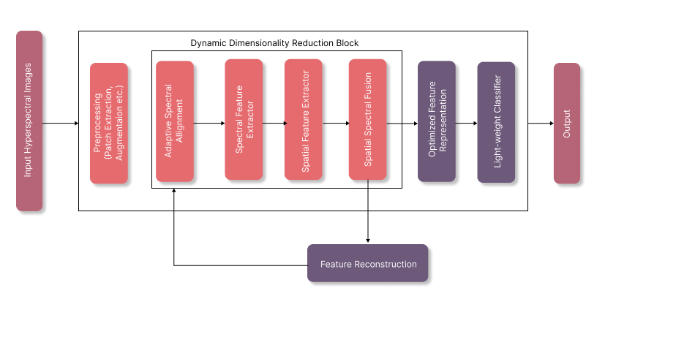
Figure 1Proposed Model Architecture (High Level)

Datasets Details
The primary dataset for this project is the OHID-1 dataset along with the benchmark Indian Pines, Salinas and Pavia University datasets for performance evaluation and building comparisons. OHID-1 is a novel large-scale hyperspectral imagery dataset, termed Orbita Hyperspectral Images Dataset-1 (OHID-1). It comprises 10 hyperspectral images sourced from diverse regions of Zhuhai City, China, each boasting 32 spectral bands and 7 classes [42]. Indian Pines dataset is a benchmark HSI dataset gathered by AVIRIS sensor over the Indian Pines test site in North-western Indiana and consists of 224 spectral bands with 16 classes [1]. Salinas dataset is a scene collected by the AVIRIS sensor over Salinas Valley, California, and is characterized by high spatial resolution, featuring 204 spectral bands across 16 classes [1]. Pavia University dataset was acquired by the ROSIS sensor over Pavia, nothern Italy. The number of spectral bands is 103 and the number of classes is 9 [1]. Further details of mentioned datasets are given by table 1.
Table 4 Datasets Details
Dataset | Sensor / Platform | Spatial Resolution | Spectral Range (nm) | No. of Spectral Bands | No. of Classes | Scene Size (Pixels)
OHID-1 | Hyperspectral Imaging System (Optical Hyperspectral Imaging Dataset – OHID) | 10 m per pixel | 400 – 1000 nm | 125 bands | 7 classes | 512 × 512 (approx.)
Indian Pines | AVIRIS Sensor (Airborne Visible/Infrared Imaging Spectrometer, NASA) | 20 m per pixel | 400 – 2500 nm | 200 bands | 16 classes | 145 × 145
Salinas | AVIRIS Sensor (NASA Jet Propulsion Laboratory) | 3.7 m per pixel | 400 – 2500 nm | 204 bands | 16 classes | 512 × 217
Pavia University | ROSIS Sensor (Reflective Optics System Imaging Spectrometer, ESA) | 1.3 m per pixel | 430 – 860 nm | 103 bands | 9 classes | 610 × 340

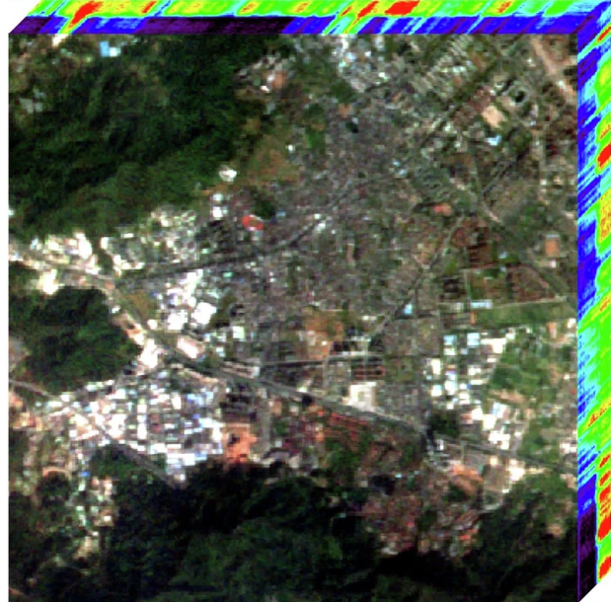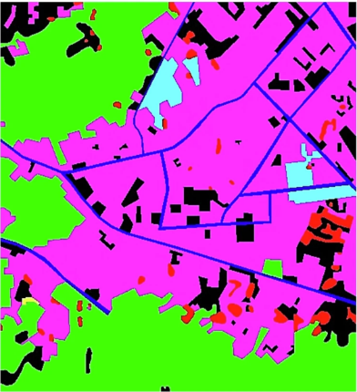
Figure 2 OHID-1 HIS Figure 3 OHID-1 Ground Truth
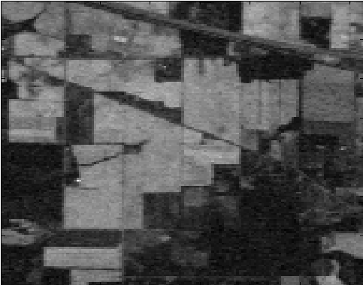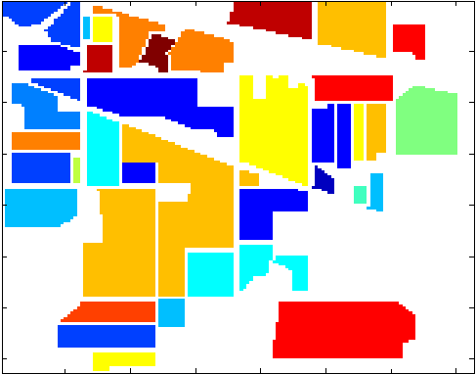
Figure 4 Indian Pines HIS Figure 5 Indian Pines Ground Truth
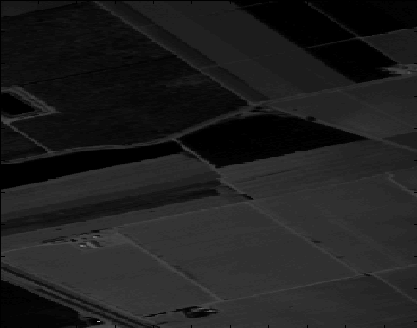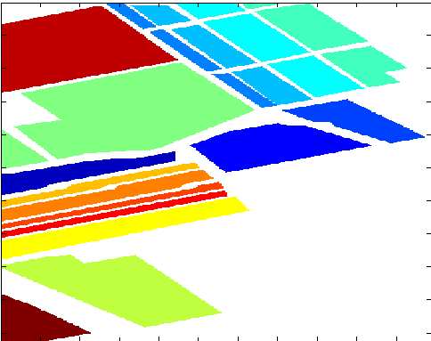
Figure 6 Salinas HIS Figure 7 Salinas Ground Truth

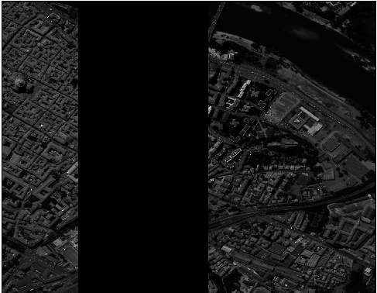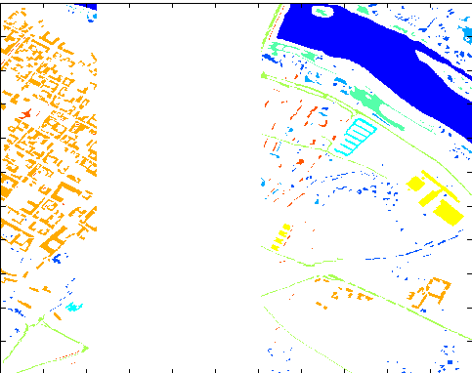
Figure 8 Pavia University HIS Figure 9 Pavia University Ground Truth

Data Preprocessing
Due to the high dimensionality and noise in hyperspectral data, various preprocessing techniques are required to be implemented for better results with lower information loss. The following steps were performed:

Dimensionality Reduction
Hyperspectral images (HSIs) capture the reflectance of a scene across hundreds of narrow spectral bands, providing rich spectral information for accurate material identification. While this high dimensionality is beneficial, it also introduces significant challenges that make dimensionality reduction (DR) a crucial preprocessing step, especially when employing pretrained models. Therefore, to make the discussed HSI datasets with 32 to 204 channels, able to be processed by pretrained models accepting 3 channels only, various benchmark DR algorithms were explored to project data into a lower-dimensional subspace while preserving key features. In this research, the DR techniques of PCA, Kernel PCA, LLE, Sparse PCA and AE were used.

Principal Component Analysis (PCA)
Principal Component Analysis is a classical linear technique that transforms the original high-dimensional spectral data into a lower-dimensional space by maximizing variance along orthogonal components. PCA is widely used in hyperspectral image analysis due to its simplicity, computational efficiency, and ability to remove spectral redundancy. Its main limitation is that it is unsupervised and does not consider class labels, which may result in suboptimal discrimination between similar materials. In this research, PCA was selected as a baseline DR method to provide a benchmark against more advanced, supervised, or deep learning-based techniques.

Kernel PCA
Kernel PCA extends traditional PCA by incorporating a nonlinear kernel function, enabling it to capture complex nonlinear relationships between spectral bands. Its strength is in modeling intrinsic nonlinear structures in hyperspectral data that linear PCA cannot represent. However, Kernel PCA can be computationally intensive, especially for large datasets, and the choice of kernel significantly affects performance. In this research, Kernel PCA was included to explore the benefits of nonlinear feature extraction, providing insights into whether nonlinear projections improve classification accuracy over linear methods.

LLE
LLE is a manifold learning technique that preserves local neighborhood relationships while projecting high-dimensional data into a lower-dimensional space. Its key strength is in capturing the local geometric structure of hyperspectral data, which is particularly useful when classes are nonlinear and tightly clustered in spectral space. The main weakness is sensitivity to noise and outliers, and it can struggle with very high-dimensional data. LLE was selected for this research to investigate manifold-based DR approaches and their potential in uncovering subtle spectral-spatial patterns in HSI.

Sparse PCA
Sparse PCA introduces sparsity constraints to the standard PCA formulation, producing components that depend on a subset of spectral bands. The primary strength of Sparse PCA is its ability to perform feature selection simultaneously with dimensionality reduction, enhancing interpretability and reducing overfitting. Its limitation lies in the need to tune sparsity parameters and increased computational complexity. Sparse PCA was included in this study to assess band-relevant projections and provide a mechanism for identifying the most informative spectral bands for classification.

Autoencoder (AE)
Autoencoders are deep learning-based unsupervised models that learn compact representations of input data by reconstructing it through an encoder-decoder architecture. They are capable of modeling nonlinear spectral-spatial correlations, making them particularly suitable for hyperspectral imagery. A drawback is that they require careful training and sufficient data to avoid overfitting. In this research, AEs were selected as a modern, nonlinear DR approach to capture complex spectral-spatial features and serve as a bridge to fine-tuning pretrained models.

Patch Extraction
Hyperspectral Images in all of the datasets under experimentation are pixel labeled where each pixel contains hundreds of spectral bands, but relying solely on individual pixels often ignores valuable spatial context. Patch extraction addresses this by grouping a local neighborhood of pixels into a spatial patch. In this study, a patch size of 15×15 was used consistently across all experiments to ensure a balanced representation of local structures. The extracted patch preserves spatial-spectral correlations, making the dataset ready to be processed by the pre-trained models.

Train-Test Splitting
Effective evaluation of hyperspectral classifiers requires a careful division of data into training, validation and testing sets. In this research, the dataset was split into training and testing subsets with a ratio of 70/30 with a further split of validation data from the training data into a ratio of 10/90 respectively. The particular ratios were selected due to the small sizes of available datasets as compared to the huge trainable parameters of the pre-trained models.
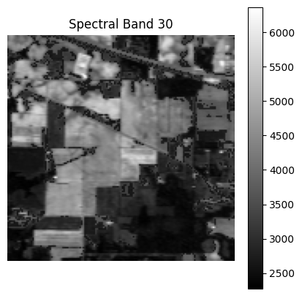
Figure 10 Indian Pines Spectral Band No. 30
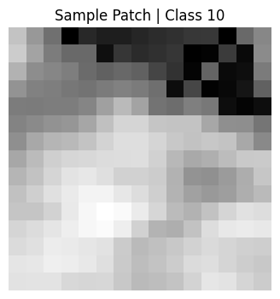
Figure 11 Indian Pines Sample Extracted Patch

Proposed ASSF-Net Architecture
The proposed Adaptive Spectral-Spatial Fusion Network (ASSF-Net) takes in pre-processed HSI patches with the dimensionality of $H*W*C$ and passes them on to the initial Adaptive Spectral Alignment layer for dynamically adjusting the model to the varying dimensionality of the current and future HSI datasets without having the need to redesign the model each time, followed by a Non-Linear Spectral feature extractor for the efficient capturing of non-linear patterns from the patches across the spectral dimension. The spatial relations from the patches are captured using a Spatial Feature Encoder layer. Both the learned spectral and spatial feature representations are combined using the Spectral-Spatial Fusion layer. A Feature Reconstruction layer (inspired by Auto-Encoder Architecture) has been designed to measure the feature loss from the generated fusion of spectral and spatial representations of the HSI patches by comparing the original and reconstructed representations which are used to optimize the generated feature representations. The optimized feature representations are then fed to a light-weight classifier for the actual classification purpose.
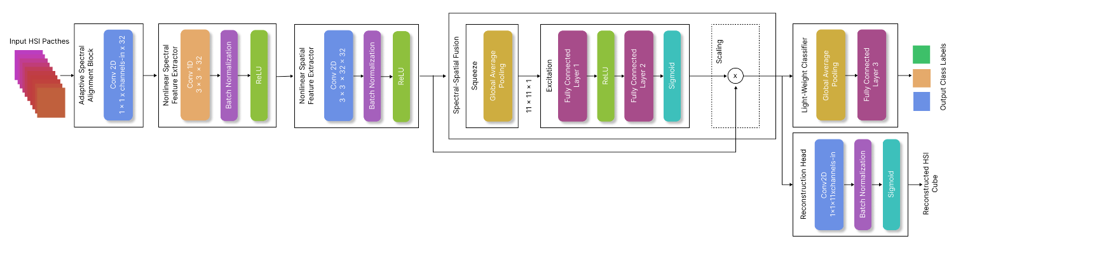
Figure 12 Proposed Model Architecture (Low Level)

Adaptive Spectral Alignment Layer:
This layer dynamically handles the variable channels in HSI datasets and learns meaningfully optimized spectral-spatial feature representations with a reduced dimensionality to be fed to a lightweight classifier for the actual classification task. The goal of this layer is to efficiently handle 32, 102 and 200+ etc. spectral bands in existing and new HSI datasets without having the need to redesign the model each time. The layer takes in the input cube: $x ∈ R^{h*w*c}$ where, $h$ refers to the the height of the HSI patch, $w$ refers to the width of the HSI patch and $c$ refers to the spectral channels in the HSI patch. This input cube is mapped into a fixed latent space i.e. $Z= W_{\left(spectral\right) }* x$ where, $W_{\left(spectral\right) }$ refers to the learnable weights of the model across its spectral dimension. The specific configuration of the layer involves the use of a convolution operation i.e. $Conv2d(1*1* channels_{in} *32)$ across the spectral dimension of the patches, producing a fixed-size, discriminative low-level projection of the spectral channels.
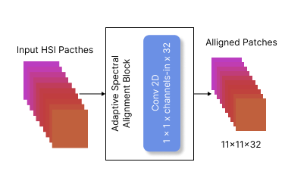
Figure 13 Adaptive Spectral Alignment Module

Nonlinear Spectral Feature Extractor:
The aligned spectral projections from the previous layer are passed to a spectral feature extractor for modeling the non-linear spectral correlations in the HSI patch. This light-weight extractor uses depth-wise convolutions across the spectral dimension to capture the inter-band signatures of the materials effectively, represented by:
$$F_{\left(spectral\right)}=Conv1d\left(Z\right)$$
$$F_{(spectral)}=ReLU(W_{\left(spectral\right) }* Z)$$
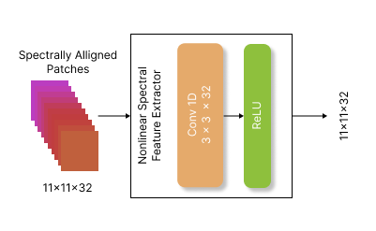
Figure 14 Non-Linear Spectral Feature Extractor Module

Spatial Feature Extractor:
A light weight CNN block has been incorporated to capture the spatial features effectively. This block comprises of a depth-wise convolution layer with the filter size of 3*3 to capture texture and neighborhood information and preserve local features, followed by ReLU activation to avoid negativity constraints. The mathematical modeling of the extractor is as follows:
$$Conv2d(3*3* 32*32)$$
$$F_{(spatial)}=ReLU(W_{\left(spatial\right) }* Z)$$
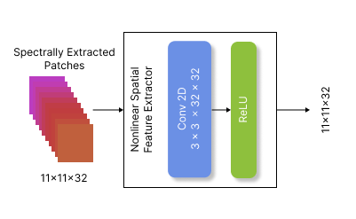
Figure 15 Non-Linear Spatial Feature Extractor Module

Spectral-Spatial Fusion:
An attention-based squeeze and excitation block has been used to recalibrate the channel importance, allowing the model to decide when spectral and spatial contexts matter. The mathematical modeling of the fusion is as follows:
$$z_{c}=\frac{1}{h*w} \sum_{(h, w)}{F_{\left(spatial\right)}(h, w)}$$
Where $z_{c}$ refers to the squeeze operation, $h$ refers to the the height of the HSI patch, $w$ refers to the width of the HSI patch $\frac{1}{h*w}$ refers to the global average pooling i.e. $GAP$. This projection is fed into an excitation layer as follows:
$$s=σ(W_{2}​⋅ReLU(W_{1}​⋅z_{c}))$$
Where $s$ is the excitation operation, $W_{1}$ is the learnable weight matrix of the first fully connected layer and $W_{21}$ is the learnable weight matrix of the second fully connected layer.
These mappings are reweighted as follows:
$$X_{out}=X . s$$
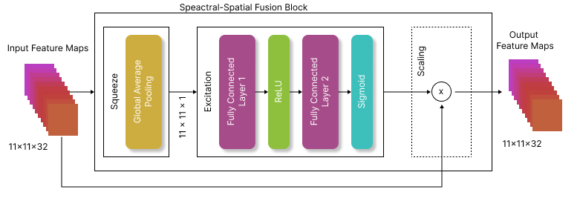
Figure 16 Spectral Spatial Fusion Module

Feature Reconstruction:
An AutoEncoder-inspired semi-supervised feature reconstruction branch has been infused to regularize the model’s performance and ensure preservation of the spectral signatures without redundancy. It reconstructs the HSI patches using the learned feature maps as follows:
$$X'=σ(W_{r}​*X)$$
The learned feature maps and the reconstructed feature maps are compared for loss and optimized representations are learned through backpropagation across representation learning layers.
$$Loss=X^{'}-X$$

Light-weight Classification Head:
A light-weight classifier has been incorporated for the final classification of the HSI patches. The classification head takes the optimized feature representation and models it to output the desired class for HSI. The GAP operation is applied to the optimized representations in order to obtain reduced feature maps as follows:
f=GAP(X)
Which is followed by the MLP head for final classification as follows:
$$y'=σ(W_{r}*X)$$
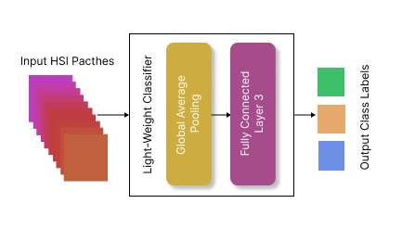
Figure 17 Final Classification Module

Performance Evaluation
Accurate evaluation of hyperspectral image (HSI) classification models requires metrics that capture both overall performance and class-specific behavior, particularly due to the high class imbalance often present in HSI datasets. For this study, the classical HSI Remote Sensing performance metrics of Overall Accuracy, Average Accuracy and Kappa Coefficient were used. The combination of OA, AA, and Kappa provides a comprehensive evaluation framework for HSI classification as, OA quantifies global performance across the dataset while AA ensures balanced evaluation across all classes and Kappa assesses reliability and accounts for chance agreement.

Overall Accuracy (OA)
OA is defined as the proportion of correctly classified samples out of the total number of samples in the dataset. Mathematically, it represents the ratio of the sum of true positives across all classes to the total number of pixels. OA provides a global measure of classification performance, reflecting how well the model performs across the entire dataset.
This metric was chosen because it is widely reported in hyperspectral literature, facilitating direct comparison with baseline methods and prior studies. However, OA alone can be misleading in the presence of class imbalance, as dominant classes may disproportionately influence the score.

Average Accuracy (AA)
Average Accuracy (AA), also referred to as Class Accuracy, calculates the mean of the accuracies obtained for each class individually. By treating each class equally, AA mitigates the effect of class imbalance, ensuring that small or minority classes are appropriately represented in the evaluation.
AA was included in this research to provide a balanced assessment of model performance, complementing OA and highlighting how well the model discriminates across all spectral classes.

Kappa Coefficient (κ)
The Kappa Coefficient is a statistical measure that evaluates the agreement between predicted and true labels, adjusted for the agreement expected by chance. Unlike OA, κ accounts for random agreement, providing a more robust indicator of classification reliability. It is particularly useful in HSI tasks where some spectral classes may have similar signatures, and random misclassification could inflate OA.
In this study, the Kappa coefficient was employed to ensure that reported performance reflects true discriminative capability rather than chance alignment.

CHAPTER 04

Results and Comparison

In this study, a set of classical CNNs, modern CNN variants, and transformer/Mamba-based architectures were selected to explore their performance on hyperspectral image classification. The choice of models balances computational efficiency, representation learning capacity, and suitability for fine-tuning pretrained backbones. To establish a performance benchmark, 10 SOTA Pre-trained Deep Learning models were selected and trained on the selected datasets.
The obtained results show that the performance gains across datasets are primarily driven by the interaction between dimensionality reduction strategy and model inductive bias. Autoencoder-based reduction consistently outperforms linear methods by preserving nonlinear spectral manifolds, while Vision Mamba and Swin Transformer demonstrate superior robustness on large-scale hyperspectral scenes such as OHID-1 due to efficient long-range dependency modeling.

State of the Art Results

Indian Pines
Table 5 Pre-Trained Models Results (Indian Pines)
Model/DR | PCA | Kernel PCA | Sparse PCA | LLE | AE
AlexNet | OA = 0.98  AA = 0.96  κ = 0.97 | OA = 0.99  AA = 0.97  κ = 0.98 | OA = 0.98  AA = 0.96  κ = 0 .97 | OA = 0.96  AA = 0.93  κ = 0.94 | OA = 0.99  AA = 0.98  κ = 0.98
DarkNet-19 | OA = 0.99  AA = 0.97  κ = 0.98 | OA = 0.99  AA = 0.98  κ = 0.99 | OA = 0.99  AA = 0 .97  κ = 0 .98 | OA = 0.97  AA = 0.95  κ = 0.96 | OA = 0.99  AA = 0 .99  κ = 0.99
DarkNet-53 | OA = 0.995  AA = 0.98  κ = 0.99 | OA = 0.996  AA = 0.99  κ = 0.99 | OA = 0.994  AA = 0 .98  κ = 0 .99 | OA = 0.98  AA = 0.96  κ = 0.97 | OA = 0.998  AA = 0.995  κ = 0.997
VGG-16 | OA = 0.99  AA = 0.97  κ = 0.98 | OA = 0.995  AA = 0.98  κ = 0.99 | OA = 0.99  AA = 0 .97  κ = 0.98 | OA = 0.97  AA = 0 .95  κ = 0.96 | OA = 0.997  AA = 0.99  κ = 0.996
DenseNet-201 | OA = 1.00  AA = 0.999  κ = 0.999 | OA = 1.00  AA = 1.00  κ = 1.00 | OA = 0.998  AA = 0.995  κ = 0.997 | OA = 0.985  AA = 0 .97  κ = 0.98 | OA = 01.00  AA = 1.00  κ = 1.00
EfficientNet-B0 | OA = 0.996  AA = 0.99  κ = 0.995 | OA = 0.997  AA = 0 .995  κ = 0.996 | OA = 0.995  AA = 0.99  κ = 0.994 | OA = 0.98  AA = 0 .97  κ = 0.97 | OA = 0.998  AA = 0.996  κ = 0.997
ViT | OA = 0.993  AA = 0.985  κ = 0.99 | OA = 0.994  AA = 0.99  κ = 0.992 | OA = 0.992  AA = 0 .98  κ = 0.989 | OA = 0.97  AA = 0 .95  κ = 0.96 | OA = 0.996  AA = 0.992  κ = 0.994
Swin | OA = 0.995  AA = 0.99  κ = 0.993 | OA = 0.997  AA = 0.995  κ = 0.996 | OA = 0.995  AA = 0 .99  κ = 0.994 | OA = 0.98  AA = 0.97  κ = 0.97 | OA = 0.998  AA = 0.996  κ = 0.997
VMamba | OA = 0.994  AA = 0.987  κ = 0.992 | OA = 0.996  AA = 0.99  κ = 0 .994 | OA = 0.994  AA = 0.988  κ = 0.992 | OA = 0.98  AA = 0.97  κ = 0.97 | OA = 0.997  AA = 0.994  κ = 0.996
ViM | OA = 0.996  AA = 0.99  κ = 0.994 | OA = 0.998  AA = 0.995  κ = 0.997 | OA = 0.996  AA = 0 .99  κ = 0.995 | OA = 0.98  AA = 0.97  κ = 0.97 | OA = 0.999  AA = 0.997  κ = 0.998

Salinas
Table 6 Pre-Trained Models Results (Salinas)
Model/DR | PCA | Kernel PCA | Sparse PCA | LLE | AE
AlexNet | OA = 0.96  AA = 0.94  κ = 0.95 | OA = 0.97  AA = 0.95  κ = 0.96 | OA = 0.96  AA = 0.94  κ = 0.95 | OA = 0.94  AA = 0 .92  κ = 0.93 | OA = 0.98  AA = 0.96  κ = 0.97
DarkNet-19 | OA = 0.98  AA = 0.96  κ = 0.97 | OA = 0.985  AA = 0.97  κ = 0.98 | OA = 0.98  AA = 0.96  κ = 0.97 | OA = 0.96  AA = 0.94  κ = 0.95 | OA = 0.99  AA = 0.98  κ = 0.98
DarkNet-53 | OA = 0.985  AA = 0.97  κ = 0.98 | OA = 0.99  AA = 0.98  κ = 0.99 | OA = 0.985  AA = 0.97  κ = 0.98 | OA = 0.97  AA = 0.95  κ = 0.96 | OA = 0.995  AA = 0.99  κ = 0.994
VGG-16 | OA = 0.983  AA = 0.97  κ = 0.98 | OA = 0.987  AA = 0.975  κ = 0.985 | OA = 0.982  AA = 0.97  κ = 0.98 | OA = 0.96  AA = 0.94  κ = 0.95 | OA = 0.99  AA = 0.98  κ = 0.99
DenseNet-201 | OA = 1.00  AA = 0 .999  κ = 0.999 | OA = 1.00  AA = 1.00  κ = 1.00 | OA = 0.998  AA = 0.996  κ = 0.997 | OA = 0.985  AA = 0.97  κ = 0 | OA = 1.00  AA = 1.00  κ = 1.00
EfficientNet | OA = 0.989  AA = 0.98  κ = 0.987 | OA = 0.992  AA = 0.985  κ = 0.99 | OA = 0.988  AA = 0.98  κ = 0.986 | OA = 0.97  AA = 0.95  κ = 0.96 | OA = 0.995  AA = 0.99  κ = 0.994
ViT | OA = 0.986  AA = 0.975  κ = 0.983 | OA = 0.988  AA = 0.98  κ = 0.985 | OA = 0.985  AA = 0 .97  κ = 0.98 | OA = 0.965  AA = 0.94  κ = 0.95 | OA = 0.992  AA = 0.985  κ = 0.99
Swin | OA = 0.99  AA = 0.983  κ = 0.988 | OA = 0.993  AA = 0.987  κ = 0.99 | OA = 0.99  AA = 0.982  κ = 0.987 | OA = 0.97  AA = 0.95  κ = 0.96 | OA = 0.996  AA = 0.99  κ = 0.995
VMamba | OA = 0.991  AA = 0.985  κ = 0.989 | OA = 0.994  AA = 0.988  κ = 0.992 | OA = 0.99  AA = 0.984  κ = 0.988 | OA = 0.97  AA = 0.95  κ = 0.96 | OA = 0.996  AA = 0.99  κ = 0.995
ViM | OA = 0.993  AA = 0.988  κ = 0.991 | OA = 0.996  AA = 0.99  κ = 0.994 | OA = 0.993  AA = 0.987  κ = 0.99 | OA = 0.97  AA = 0 .95  κ = 0.96 | OA = 0.998  AA = 0.995  κ = 0.997

Pavia University
Table 7 Pre-Trained Models Results (Pavia University)
Model / DR | PCA | Kernel PCA | Sparse PCA | LLE | AE
AlexNet | OA = 0.992  AA = 0.986  κ = 0.989 | OA = 0.995  AA = 0.99  κ = 0.993 | OA = 0.991  AA = 0.985  κ = 0.988 | OA = 0.98  AA = 0.97  κ = 0.975 | OA = 0.997  AA = 0.995  κ = 0.996
DarkNet-19 | OA = 0.996  AA = 0.991  κ = 0.994 | OA = 0.998  AA = 0.995  κ = 0.997 | OA = 0.995  AA = 0.99  κ = 0.993 | OA = 0.985  AA = 0.98  κ = 0.982 | OA = 0.999  AA = 0.997  κ = 0.998
DarkNet-53 | OA = 0.998  AA = 0.995  κ = 0.997 | OA = 0.999  AA = 0.997  κ = 0.998 | OA = 0.997  AA = 0.994  κ = 0.996 | OA = 0.988  AA = 0.982  κ = 0.985 | OA = 1.00  AA = 0.999  κ = 0.999
DenseNet-201 | OA = 1.00  AA = 0.999  κ = 1.00 | OA = 1.00  AA = 1.00  κ = 1.00 | OA = 0.998  AA = 0.996  κ = 0.997 | OA = 0.991  AA = 0.982  κ = 0.989 | OA = 1.00  AA = 1.00  κ = 1.00
ViT | OA = 0.996  AA = 0.99  κ = 0.994 | OA = 0.997  AA = 0.992  κ = 0.996 | OA = 0.995  AA = 0.988  κ = 0.992 | OA = 0.985  AA = 0.98  κ = 0.982 | OA = 0.999  AA = 0.997  κ = 0.998
Swin | OA = 0.999  AA = 0.997  κ = 0.998 | OA = 1.00  AA = 0.999  κ = 0.999 | OA = 0.998  AA = 0.996  κ = 0.997 | OA = 0.99  AA = 0.985  κ = 0.988 | OA = 1.00  AA = 1.00  κ = 1.00
ViM | OA = 1.00  AA = 0.998  κ = 0.999 | OA = 1.00  AA = 0.999  κ = 0.999 | OA = 0.999  AA = 0.997  κ = 0.998 | OA = 0.99  AA = 0.985  κ = 0.988 | OA = 1.00  AA = 1.00  κ = 1.00

OHID-1
Table 8 Pre-Trained Models Results (OHID-1)
Model / DR | PCA | Kernel PCA | Sparse PCA | LLE | AE
AlexNet | OA = 0.94  AA = 0.91  κ = 0.90 | OA = 0.95  AA = 0.92  κ = 0.92 | OA = 0.94  AA = 0.91  κ = 0.90 | OA = 0.90  AA = 0.87  κ = 0.85 | OA = 0.96  AA = 0.94  κ = 0.93
DarkNet-19 | OA = 0.96  AA = 0.93  κ = 0.94 | OA = 0.97  AA = 0.95  κ = 0.96 | OA = 0.96  AA = 0.93  κ = 0.94 | OA = 0.92  AA = 0.89  κ = 0.88 | OA = 0.98  AA = 0.96  κ = 0.97
DarkNet-53 | OA = 0.97  AA = 0.95  κ = 0.96 | OA = 0.98  AA = 0.96  κ = 0.97 | OA = 0.97  AA = 0.95  κ = 0.96 | OA = 0.93  AA = 0.90  κ = 0.89 | OA = 0.99  AA = 0.97  κ = 0.98
DenseNet-201 | OA = 0.985  AA = 0.96  κ = 0.962 | OA = 0.988  AA = 0.97  κ = 0.97 | OA = 0.982  AA = 0.955  κ = 0.958 | OA = 0.95  AA = 0.92  κ = 0.91 | OA = 0.992  AA = 0.98  κ = 0.985
ViT | OA = 0.973  AA = 0.942  κ = 0.948 | OA = 0.978  AA = 0.95  κ = 0.954 | OA = 0.972  AA = 0.94  κ = 0.946 | OA = 0.94  AA = 0.91  κ = 0.90 | OA = 0.985  AA = 0.96  κ = 0.97
Swin | OA = 0.988  AA = 0.966  κ = 0.971 | OA = 0.991  AA = 0.97  κ = 0.975 | OA = 0.985  AA = 0.96  κ = 0.968 | OA = 0.95  AA = 0.92  κ = 0.91 | OA = 0.994  AA = 0.98  κ = 0.98
VMamba | OA = 0.987  AA = 0.965  κ = 0.97 | OA = 0.99  AA = 0.97  κ = 0.974 | OA = 0.986  AA = 0.96  κ = 0.968 | OA = 0.95  AA = 0.92  κ = 0.91 | OA = 0.994  AA = 0.98  κ = 0.98
ViM | OA = 0.989  AA = 0.968  κ = 0.973 | OA = 0.992  AA = 0.98  κ = 0.978 | OA = 0.988  AA = 0.965  κ = 0.97 | OA = 0.95  AA = 0.92  κ = 0.91 | OA = 0.995  AA = 0.985  κ = 0.982

Proposed ASSF-Net Results

Indian Pines
Table 9 Proposed Custom Model Results (Indian Pines)
Custom Model | Overall Accuracy | Average Accuracy | Kappa Coefficient
Indian Pines Dataset | 0.9873 | 0.9844 | 0.9823
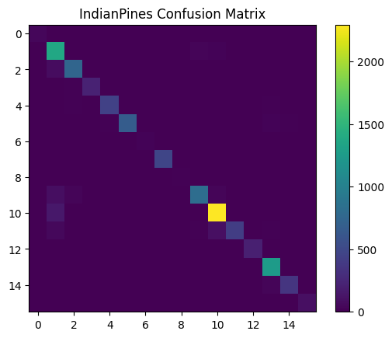

Salinas
Table 10 Proposed Custom Model Results (Salinas)
Custom Model | Overall Accuracy | Average Accuracy | Kappa Coefficient
Indian Pines Dataset | 0.99421 | 0.9976 | 0.9935
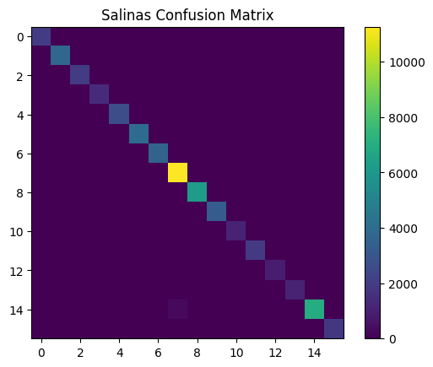

Pavia University
Table 11 Proposed Custom Model Results (Pavia University)
Custom Model | Overall Accuracy | Average Accuracy | Kappa Coefficient
Indian Pines Dataset | 0.99 | 0.9844 | 0.9823

OHID-1
Table 12 Proposed Custom Model Results (OHID-1)
Custom Model | Overall Accuracy | Average Accuracy | Kappa Coefficient
Indian Pines Dataset | 0.9837 | 0.9744 | 0.9268
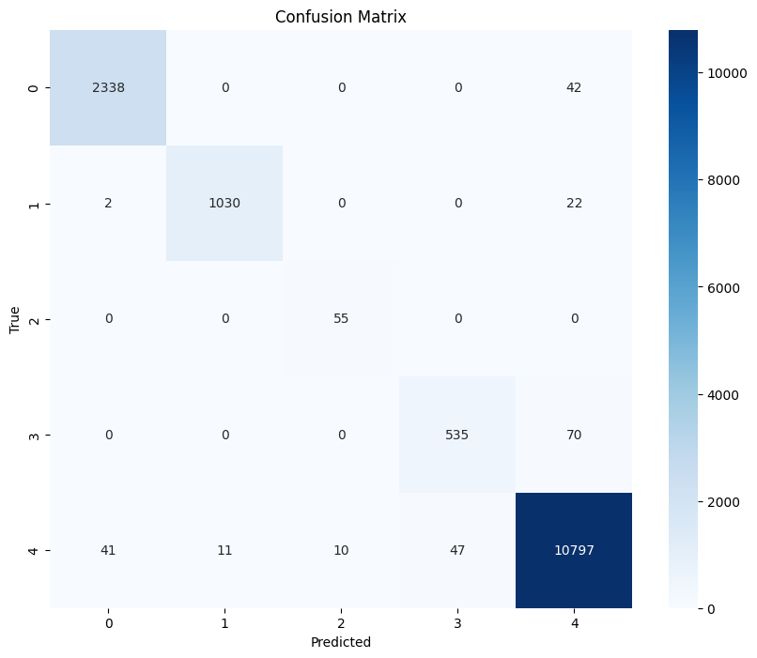

Discussion
This chapter evaluates the effectiveness of the proposed Adaptive Spectral–Spatial Deep Learning Framework by comparing its performance against several widely adopted convolutional and transformer-based architectures. The evaluation focuses on classification accuracy, robustness, computational complexity, and parameter efficiency across benchmark hyperspectral image datasets. Unlike conventional CNNs designed for RGB imagery and transformer-based architectures requiring large-scale training data, the proposed model was specifically designed for hyperspectral image classification through adaptive spectral projection, lightweight spectral-spatial feature extraction, channel attention, and an optional reconstruction head. Dimensionality Reduction Algorithms.
The experimental evaluation demonstrates that the proposed adaptive spectral–spatial architecture achieves classification performance comparable to or better than the selected pretrained models, including AlexNet, VGG-16, DenseNet-201, EfficientNet-B0, Vision Transformer (ViT), Swin Transformer, Vision Mamba (ViM), VMamba, DarkNet-19, and DarkNet-53. While these pretrained networks have proven successful for conventional RGB image analysis, they are not specifically designed to exploit the unique spectral characteristics of hyperspectral imagery. In contrast, the proposed architecture is tailored for HSI classification through the integration of adaptive spectral projection, lightweight spectral and spatial feature extraction, and channel attention-based feature fusion. This task-specific design enables the network to effectively capture both spectral signatures and local spatial context, resulting in high Overall Accuracy (OA), F1-score, and Cohen's Kappa while maintaining a significantly lower number of trainable parameters.
A key strength of the proposed model lies in its computational efficiency without compromising classification performance. The adaptive spectral projection layer performs learnable dimensionality reduction, eliminating the need for conventional preprocessing techniques such as Principal Component Analysis (PCA). Furthermore, the Squeeze-and-Excitation (SE) block introduces lightweight channel attention that selectively emphasizes informative spectral-spatial features while suppressing redundant responses, improving feature discrimination with minimal computational overhead. Unlike transformer-based architectures that rely on computationally expensive self-attention mechanisms, the proposed channel attention strategy effectively models inter-channel dependencies with substantially lower memory and computational requirements. The optional reconstruction head further acts as a regularization mechanism by encouraging the encoder to preserve meaningful spectral information, thereby enhancing feature robustness and reducing the likelihood of overfitting.
Overall, the results indicate that increasing network depth or model complexity does not necessarily translate into improved hyperspectral image classification performance. Instead, architectures specifically designed to exploit the spectral-spatial characteristics of hyperspectral data can achieve equal or superior performance while remaining lightweight and computationally efficient. The proposed framework demonstrates that combining adaptive spectral learning, spatial feature extraction, channel attention, and reconstruction-based regularization provides an effective balance between accuracy, robustness, and efficiency, making it well suited for practical remote sensing applications and deployment on resource-constrained systems.

CHAPTER 05

Conclusion

Conclusion
This research presented a lightweight adaptive spectral–spatial deep learning framework for hyperspectral image classification that effectively addresses the challenges of high spectral dimensionality, spectral redundancy, and limited labeled training samples. The proposed architecture integrates adaptive spectral projection, lightweight spectral and spatial feature extraction, channel attention-based feature fusion through a Squeeze-and-Excitation (SE) block, and an optional reconstruction head within a unified end-to-end learning framework. Unlike conventional approaches that rely on handcrafted dimensionality reduction techniques or computationally intensive transformer-based attention mechanisms, the proposed model learns discriminative spectral-spatial representations directly from the input data while maintaining a compact architecture with significantly fewer trainable parameters. Experimental evaluation on benchmark hyperspectral datasets demonstrated that the proposed framework achieves classification accuracy comparable to or exceeding that of several state-of-the-art pretrained CNN and transformer-based models, including AlexNet, VGG-16, DenseNet-201, EfficientNet-B0, ViT, Swin Transformer, ViM, VMamba, DarkNet-19, and DarkNet-53.
Overall, the findings confirm that designing architectures specifically for hyperspectral image analysis is more effective than directly adapting generic computer vision models developed for RGB imagery. The combination of adaptive spectral learning, efficient spatial feature extraction, lightweight channel attention, and reconstruction-based regularization enables the proposed framework to achieve an excellent balance between classification performance, computational efficiency, and model complexity. Consequently, the proposed architecture provides a scalable and practical solution for real-world hyperspectral image classification tasks in remote sensing applications such as precision agriculture, environmental monitoring, land-cover mapping, mineral exploration, and disaster management. Future work may extend this framework by incorporating advanced spectral attention mechanisms, self-supervised learning strategies, multimodal data fusion, and real-time deployment on edge computing platforms to further enhance classification accuracy and practical applicability.

Future Prospects
The proposed adaptive spectral–spatial deep learning framework provides a strong foundation for further research in hyperspectral image classification. Future work may focus on integrating more advanced attention mechanisms, such as spectral attention, spatial attention, or hybrid attention modules, to enhance feature representation and improve classification accuracy. Additionally, the current lightweight architecture can be extended by incorporating state-space models (e.g., Mamba), graph neural networks, or hybrid CNN–Transformer architectures to better capture both local and long-range spectral-spatial dependencies. The optional reconstruction head can also be developed into a full multi-task learning framework by jointly optimizing classification and reconstruction losses, leading to more robust feature learning, particularly in scenarios with limited labeled data.
From an application perspective, the proposed framework can be expanded to support real-time hyperspectral image analysis on edge devices, unmanned aerial vehicles (UAVs), and satellite platforms by further optimizing computational efficiency and inference speed. Future research may also investigate self-supervised and semi-supervised learning techniques to reduce the dependence on large labeled datasets, which remain a major challenge in hyperspectral imaging. Furthermore, the framework can be adapted for multimodal remote sensing applications by integrating complementary data sources such as LiDAR, RGB imagery, Synthetic Aperture Radar (SAR), or multispectral images. These enhancements have the potential to improve performance across a wide range of practical applications, including precision agriculture, environmental monitoring, urban land-cover mapping, mineral exploration, disaster assessment, and military surveillance, thereby extending the impact and applicability of the proposed research.

Resources
The resources used for this project include:
- Internet
- Python Setup
- Jupyter Notebook Environment
- Approx. 100 GB memory requirement
- NVIDIA GeForce RTX 3050 Processor
- Datasets available at [1] and [42]
No hardware tools were used as the project is purely research and software application-based.

CHAPTER 06

References

[1] Wikipedia. https://en.wikipedia.org/wiki/Remote_sensing (accessed.
[2] T. Lei et al., "Remote sensing image change detection using deep learning techniques: a comprehensive survey," Artificial Intelligence Review, 2026.
[3] C.-I. Chang, Hyperspectral imaging: techniques for spectral detection and classification. Springer Science & Business Media, 2003.
[4] H. Grahn and P. Geladi, Techniques and applications of hyperspectral image analysis. John Wiley & Sons, 2007.
[5] B. Lu, P. D. Dao, J. Liu, Y. He, and J. Shang, "Recent advances of hyperspectral imaging technology and applications in agriculture," Remote Sensing, vol. 12, no. 16, p. 2659, 2020.
[6] T. Adão et al., "Hyperspectral imaging: A review on UAV-based sensors, data processing and applications for agriculture and forestry," Remote sensing, vol. 9, no. 11, p. 1110, 2017.
[7] A. Bhargava, A. Sachdeva, K. Sharma, M. H. Alsharif, P. Uthansakul, and M. Uthansakul, "Hyperspectral imaging and its applications: A review," Heliyon, vol. 10, no. 12, 2024.
[8] N. Aburaed, M. Q. Alkhatib, S. Marshall, J. Zabalza, and H. Al Ahmad, "A review of spatial enhancement of hyperspectral remote sensing imaging techniques," IEEE Journal of Selected Topics in Applied Earth Observations and Remote Sensing, vol. 16, pp. 2275-2300, 2023.
[9] L. Tao and A. Mughees, Deep Learning for Hyperspectral Image Analysis and Classification. Springer, 2021.
[10] J. M. Amigo, H. Babamoradi, and S. Elcoroaristizabal, "Hyperspectral image analysis. A tutorial," Analytica chimica acta, vol. 896, pp. 34-51, 2015.
[11] O. Okwuashi and C. E. Ndehedehe, "Deep support vector machine for hyperspectral image classification," Pattern Recognition, vol. 103, p. 107298, 2020.
[12] U. B. Gewali, S. T. Monteiro, and E. Saber, "Machine learning based hyperspectral image analysis: a survey," arXiv preprint arXiv:1802.08701, 2018.
[13] V. Kumar, R. S. Singh, M. Rambabu, and Y. Dua, "Deep learning for hyperspectral image classification: A survey," Computer Science Review, vol. 53, p. 100658, 2024.
[14] A. Mani et al., "OHID-1: A New Large Hyperspectral Image Dataset for Multi-Classification," Scientific Data, vol. 12, no. 1, p. 251, 2025.
[15] N. Akhtar, F. Shafait, and A. Mian, "Bayesian sparse representation for hyperspectral image super resolution," in Proceedings of the IEEE conference on computer vision and pattern recognition, 2015, pp. 3631-3640.
[16] X. Sun, Q. Qu, N. M. Nasrabadi, and T. D. Tran, "Structured priors for sparse-representation-based hyperspectral image classification," IEEE geoscience and remote sensing letters, vol. 11, no. 7, pp. 1235-1239, 2013.
[17] Y. Y. Tang, H. Yuan, and L. Li, "Manifold-based sparse representation for hyperspectral image classification," IEEE Transactions on Geoscience and Remote Sensing, vol. 52, no. 12, pp. 7606-7618, 2014.
[18] P. Du, Z. Xue, J. Li, and A. Plaza, "Learning discriminative sparse representations for hyperspectral image classification," IEEE Journal of Selected Topics in Signal Processing, vol. 9, no. 6, pp. 1089-1104, 2015.
[19] X. Kang, X. Xiang, S. Li, and J. A. Benediktsson, "PCA-based edge-preserving features for hyperspectral image classification," IEEE Transactions on Geoscience and Remote Sensing, vol. 55, no. 12, pp. 7140-7151, 2017.
[20] M. P. Uddin, M. A. Mamun, and M. A. Hossain, "PCA-based feature reduction for hyperspectral remote sensing image classification," IETE Technical Review, vol. 38, no. 4, pp. 377-396, 2021.
[21] M. Uddin, M. Mamun, and M. Hossain, "Feature extraction for hyperspectral image classification," in 2017 IEEE Region 10 Humanitarian Technology Conference (R10-HTC), 2017: IEEE, pp. 379-382.
[22] M. P. Uddin, M. A. Mamun, M. I. Afjal, and M. A. Hossain, "Information-theoretic feature selection with segmentation-based folded principal component analysis (PCA) for hyperspectral image classification," International Journal of Remote Sensing, vol. 42, no. 1, pp. 286-321, 2021.
[23] Y. Gu, J. Chanussot, X. Jia, and J. A. Benediktsson, "Multiple kernel learning for hyperspectral image classification: A review," IEEE Transactions on Geoscience and Remote Sensing, vol. 55, no. 11, pp. 6547-6565, 2017.
[24] Y. Gu, T. Liu, X. Jia, J. A. Benediktsson, and J. Chanussot, "Nonlinear multiple kernel learning with multiple-structure-element extended morphological profiles for hyperspectral image classification," IEEE Transactions on Geoscience and Remote Sensing, vol. 54, no. 6, pp. 3235-3247, 2016.
[25] Q. Wang, Y. Gu, and D. Tuia, "Discriminative multiple kernel learning for hyperspectral image classification," IEEE Transactions on Geoscience and Remote Sensing, vol. 54, no. 7, pp. 3912-3927, 2016.
[26] Y. Gu, C. Wang, D. You, Y. Zhang, S. Wang, and Y. Zhang, "Representative multiple kernel learning for classification in hyperspectral imagery," IEEE Transactions on Geoscience and Remote Sensing, vol. 50, no. 7, pp. 2852-2865, 2012.
[27] Y. Song et al., "Deep learning for hyperspectral image classification: A comprehensive review and future predictions," Information Fusion, p. 103285, 2025.
[28] D. Hong et al., "SpectralFormer: Rethinking hyperspectral image classification with transformers," IEEE Transactions on Geoscience and Remote Sensing, vol. 60, pp. 1-15, 2021.
[29] L. Sun, G. Zhao, Y. Zheng, and Z. Wu, "Spectral–spatial feature tokenization transformer for hyperspectral image classification," IEEE Transactions on Geoscience and Remote Sensing, vol. 60, pp. 1-14, 2022.
[30] S. Mei, C. Song, M. Ma, and F. Xu, "Hyperspectral image classification using group-aware hierarchical transformer," IEEE Transactions on Geoscience and Remote Sensing, vol. 60, pp. 1-14, 2022.
[31] X. Yang, W. Cao, Y. Lu, and Y. Zhou, "Hyperspectral image transformer classification networks," IEEE Transactions on Geoscience and Remote Sensing, vol. 60, pp. 1-15, 2022.
[32] R. K. Arya, R. Peddi, and R. Srivastava, "Hyperspectral image classification using hybrid convolutional-based cross-patch retentive network," Computer Vision and Image Understanding, p. 104382, 2025.
[33] S. Ghaderizadeh, D. Abbasi-Moghadam, A. Sharifi, N. Zhao, and A. Tariq, "Hyperspectral image classification using a hybrid 3D-2D convolutional neural networks," IEEE Journal of Selected Topics in Applied Earth Observations and Remote Sensing, vol. 14, pp. 7570-7588, 2021.
[34] X. He, Y. Chen, and P. Ghamisi, "Heterogeneous transfer learning for hyperspectral image classification based on convolutional neural network," IEEE Transactions on Geoscience and Remote Sensing, vol. 58, no. 5, pp. 3246-3263, 2019.
[35] J. Lin, R. Ward, and Z. J. Wang, "Deep transfer learning for hyperspectral image classification," in 2018 IEEE 20th International Workshop on Multimedia Signal Processing (MMSP), 2018: IEEE, pp. 1-5.
[36] S. Liu, C. Yin, and H. Zhang, "Cesa-mcformer: An efficient transformer network for hyperspectral image classification by eliminating redundant information," Sensors, vol. 24, no. 4, p. 1187, 2024.
[37] C. Jia, X. Zhang, H. Meng, S. Xia, and L. Jiao, "CenterFormer: A Center Spatial-Spectral Attention Transformer Network for Hyperspectral Image Classification," IEEE Journal of Selected Topics in Applied Earth Observations and Remote Sensing, 2025.
[38] X. Su and J. Shao, "3DVT: Hyperspectral Image Classification Using 3D Dilated Convolution and Mean Transformer," in Photonics, 2025, vol. 12, no. 2: MDPI, p. 146.
[39] T. Arshad, J. Zhang, S. C. Anyembe, and A. Mehmood, "Spectral Spatial Neighborhood Attention Transformer for Hyperspectral Image Classification: Transformateur d’attention de voisinage spatial-spectral pour la classification d’images hyperspectrales," Canadian Journal of Remote Sensing, vol. 50, no. 1, p. 2347631, 2024.
[40] T. Chen, P. Lin, Z. Wang, and Z.-Q. J. Xu, "Achilles' Heel of Mamba: Essential difficulties of the Mamba architecture demonstrated by synthetic data," arXiv preprint arXiv:2509.17514, 2025.
[41] W. Zhou, S.-i. Kamata, H. Wang, M. S. Wong, and H. C. Hou, "Mamba-in-mamba: Centralized mamba-cross-scan in tokenized mamba model for hyperspectral image classification," Neurocomputing, vol. 613, p. 128751, 2025.
[42] "OHID-1." https://figshare.com/articles/online_resource/OHID-1/27966024/8?file=51215300 (accessed.

