EXPERIMENT-1 .
- AIM: To acquire data from multiple sources and perform data profiling using Microsoft Power BI in order to assess data quality, understand data structure, identify anomalies, and prepare data for further analytical processing.

- OBJECTIVES:
- To understand the basic concepts of Business Intelligence and data acquisition.
- To acquire data from multiple heterogeneous sources such as CSV, Excel, and SQL Server.
- To import and integrate different datasets into Microsoft Power BI.

- TOOLS / SOFTWARE REQUIRED:
  - Microsoft Power BI Desktop
  - Sample datasets: Sales_Data.csv, Employee_DB.xlsx, and a sample SQL database

- DATASET USED: Sales_Data.csv, Employee_DB.xlsx, Transactions.sql

- THEORY: Business Intelligence (BI) is essentially the set of tools and processes that help organizations gather raw business data, make sense of it, and turn it into insights that support smarter decisions. At its core, BI relies on several building blocks working together: data sources like databases, flat files, cloud platforms, and APIs that supply the raw information; an ETL pipeline that pulls this data out, cleans and reshapes it, and loads it into a usable format; and a data warehouse or data lake that stores this structured or unstructured information for later use. On top of this sits BI and reporting software, such as Microsoft Power BI, which handles data transformation and visualization, along with an analytics layer that enables four types of analysis, descriptive (what happened), diagnostic (why it happened), predictive (what might happen), and prescriptive (what should be done about it).
Before any of this analysis can happen, though, data first needs to be brought into the system through a process called data acquisition, essentially collecting and importing information from various sources into one common workspace. Power BI supports this through its "Get Data" feature, which lets users pull in data from CSVs, Excel files, SQL Server databases, cloud services, and even web sources. Once the data is acquired, it's important to check its quality before diving into analysis, and that's where data profiling comes in, the practice of examining a dataset to understand how it's structured, what it contains, and how reliable it is, based on dimensions like completeness, uniqueness, validity, consistency, accuracy, and timeliness. Power BI makes this easy through its Power Query Editor, which offers three built-in profiling tools: Column Quality, which shows the percentage of valid, empty, and erroneous values in a column; Column Distribution, which reveals how frequently values appear along with distinct and unique counts; and Column Profile, which provides deeper statistical detail like the minimum, maximum, mean, median, and standard deviation for a chosen column.

- PROCEDURE:

A - Software Setup and Data Acquisition
Step 1: Install the required software: Download and set up Microsoft Power BI Desktop, along with SQL Server and SQL Server Management Studio (SSMS). Once installed, open SSMS and confirm that the SQL Server instance is running and accessible so the transaction database can be connected later.
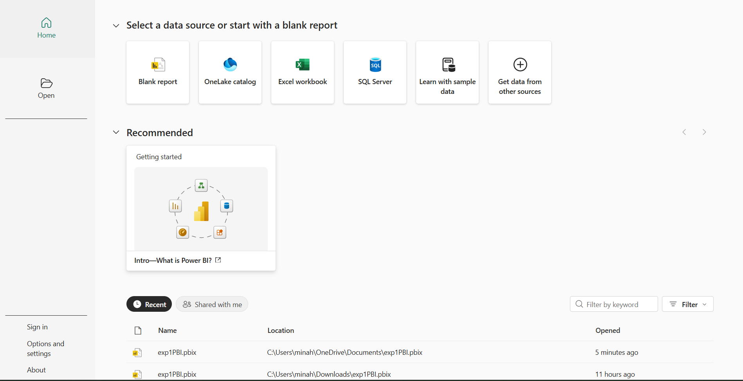
Step 2: Import the CSV file: In Power BI Desktop, go to Home > Get Data > Text/CSV, browse to Sales_Data.csv, and load it.
Step 3: Import the Excel file: Go to Home > Get Data > Excel Workbook, browse to Employee_DB.xlsx, choose the correct sheet, and load it.
Step 4: Connect to the SQL database: Go to Home > Get Data > SQL Server, enter the server and database details, select the Transactions table, and load it. Once done, check the Data pane on the right to confirm all three sources (CSV, Excel, and SQL) have been successfully imported.
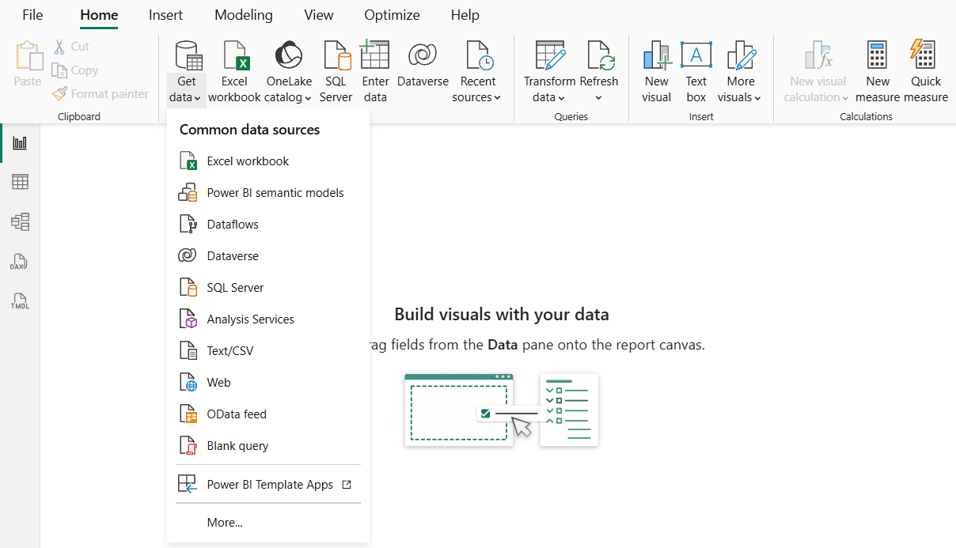
B - Data Profiling in Power Query Editor
Step 5: Open Power Query Editor: Navigate to Home > Transform Data.
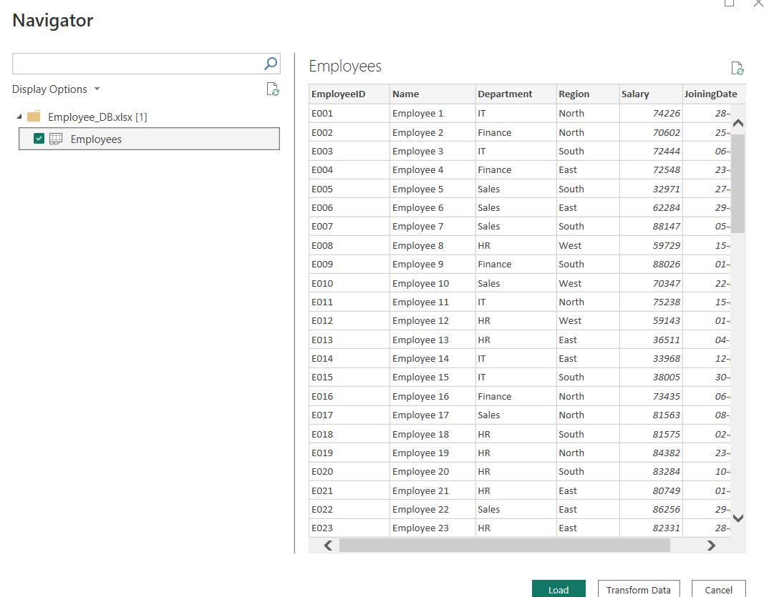
Step 6: Turn on profiling tools: Under the View tab, enable Column Quality, Column Distribution, and Column Profile. Then click through each column one at a time to review the statistics that appear below the data preview grid.
Step 7: Record your observations: For every column across all three datasets, note the data type and row count, the null/empty percentage (from Column Quality), the distinct and unique value counts (from Column Distribution), and — for numeric columns — the minimum, maximum, mean, and standard deviation (from Column Profile). Also flag any errors, mismatched data types, or unexpected values along the way.

C - Identify and Document Data Quality Issues
Step 8: Spot the issues: Review the profiling results for common red flags — high null/empty counts in key columns, columns with only one unique value, numeric fields that contain text, dates that fall outside a reasonable range (or in the future), and low uniqueness suggesting duplicate records.
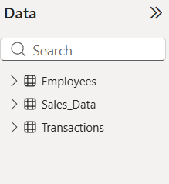

- LEARNING OUTCOMES
  - Understood the concept of Business Intelligence and its role in data-driven decision-making.
  - Learned how to acquire data from different heterogeneous sources.
  - Learned how to import CSV, Excel, and SQL Server data into Power BI.
  - Gained practical experience with Microsoft Power BI Desktop.
  - Learned how to use SQL Server Management Studio for working with SQL-based data.
  - Learned how to use Power Query Editor for data profiling.

