EXPERIMENT 3 .
- AIM:
To develop a Star Schema-based dimensional model in Microsoft Power BI by restructuring the Global Superstore transactional dataset into Fact and Dimension tables, facilitating efficient analytical processing and reporting.

- OBJECTIVES:
- To understand the concepts of Dimensional Modeling and Star Schema.
- To differentiate between Fact Tables and Dimension Tables.
- To transform transactional data into a structured dimensional model using Power BI.
- To establish relationships between Fact and Dimension tables.
- To create DAX measures for analytical reporting.

- TOOLS / SOFTWARE REQUIRED: Microsoft Power BI Desktop, Global Superstore Dataset.xlsx, Power Query Editor, DAX (Data Analysis Expressions)

- DATASET USED: Global Superstore Dataset.xlsx.

- THEORY:
Dimensional Modeling is a data warehouse design technique used in Business Intelligence systems to organize data for analytical processing and reporting. Within this model, Fact Tables contain measurable business events and numerical values such as Sales, Profit, Quantity, and Discount, while Dimension Tables contain descriptive attributes used to analyse these facts, such as Customer, Product, Region, and Date. The Star Schema is a widely used dimensional model in which a central Fact Table is connected to multiple Dimension Tables; this structure simplifies reporting, improves analytical query performance, and provides a well-organized model for BI analysis. In this experiment, the transactional Orders data is transformed into a central Fact_Sales table, while the associated descriptive information is organized into separate dimension tables, namely Dim_Customer, Dim_Product, Dim_Region, and Dim_Date. Additionally, DAX (Data Analysis Expressions) is used in Power BI to create analytical measures such as Total Sales, Total Profit, Profit Margin, and Average Order Value, enabling deeper insights from the structured data model.

- PROCEDURE:
A: Load Dataset
Step 1: Import the Global Superstore dataset.
Open Power BI Desktop → Home > Get Data > Excel Workbook → select Global Superstore Dataset.xlsx → import the Orders, Returns, and People worksheets → click Load and verify the tables appear in Power BI.
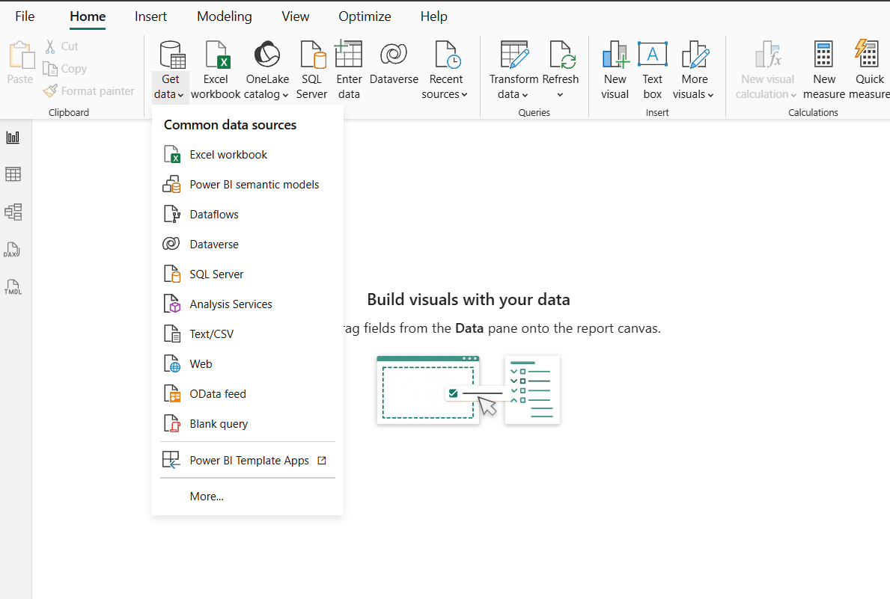

B: Identify Fact and Dimension Tables
Step 2: Analyse the data and classify attributes.
Examine the Orders table and identify measurable business attributes (Sales, Profit, Quantity, Discount) suitable for the Fact Table, and descriptive attributes (Customer, Product, Region, Date) suitable for Dimension Tables. Categorize these into one Fact Table — Fact_Sales — and four Dimension Tables — Dim_Customer, Dim_Product, Dim_Region, Dim_Date — forming the basis of the Star Schema.

C: Create Dimension Tables
Step 3: Create the dimension tables in Power Query Editor.
Open Home > Transform Data, then create:
- Dim_Customer — Customer ID, Customer Name, Segment
- Dim_Product — Product ID, Product Name, Category, Sub-Category
- Dim_Region — Region, Country, State, City
- Dim_Date — Order Date, Year, Quarter, Month (ensure correct date formatting)

Step 4: Remove duplicate records.
Remove duplicates from all four-dimension tables and verify that key fields contain unique values.

D: Create Fact Table
Step 5: Create Fact_Sales and verify key columns.
Create the central Fact_Sales table containing Order ID, Customer ID, Product ID, Region, Order Date, Sales, Quantity, Profit, and Discount. Verify that all key columns needed to establish relationships with the Dimension Tables are present and correctly formatted.
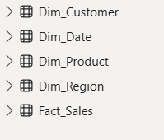
E: Build Star Schema
Step 6: Create and configure relationships in Model View.
Open Model View → create relationships between Fact_Sales and each of Dim_Customer, Dim_Product, Dim_Region, and Dim_Date. Set each relationship as Many-to-One, with Fact_Sales on the many side and the Dimension Table on the one side.
Step 7: Arrange the model into a Star Schema layout.
Arrange the tables visually with Fact_Sales at the centre and Dim_Customer, Dim_Product, Dim_Region, and Dim_Date surrounding it:
Dim_Customer
│
Dim_Product ── Fact_Sales ── Dim_Region
│
Dim_Date
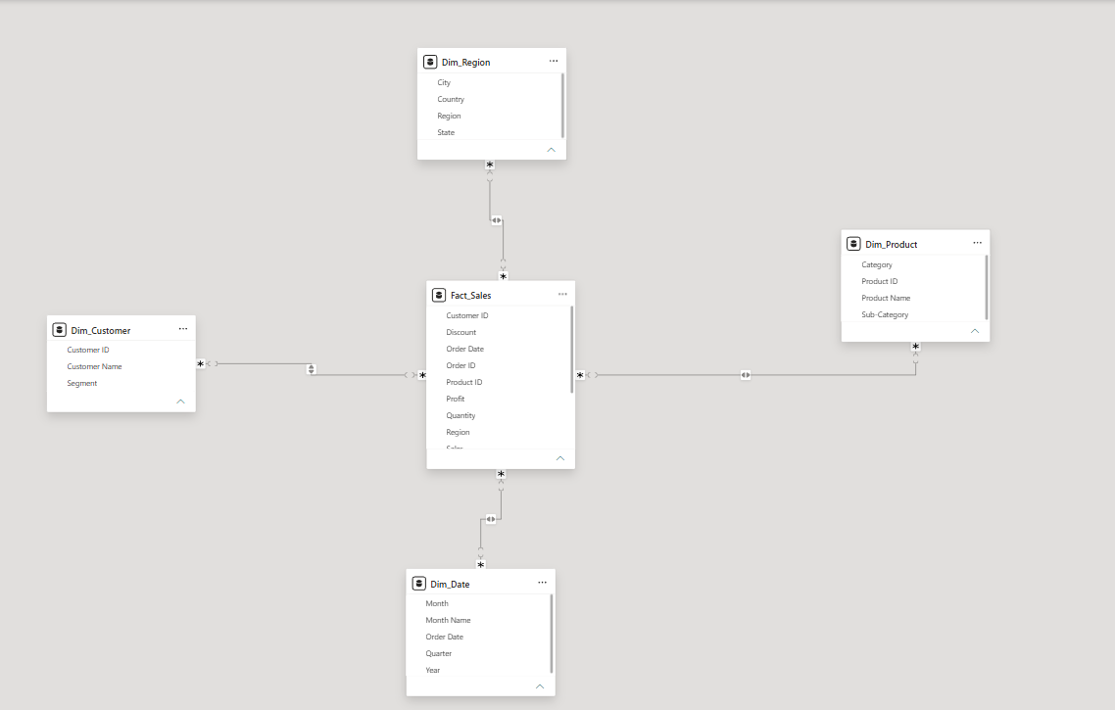
F: Validate Model and Create DAX Measures
Step 8: Create visualizations to validate the model.
Build visuals such as Sales by Category, Profit by Region, and Sales Trend by Year using the dimensional model.
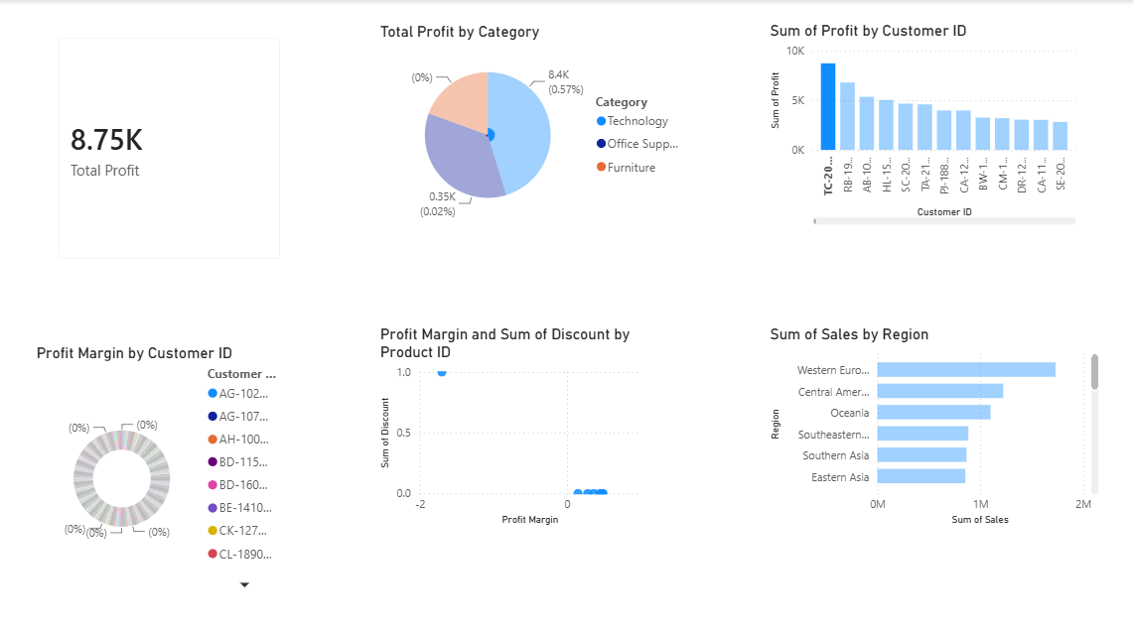
Step 9: Create DAX measures.
- Total Sales = SUM(Fact_Sales[Sales])
- Total Profit = SUM(Fact_Sales[Profit])
- Profit Margin = DIVIDE(SUM(Fact_Sales[Profit]), SUM(Fact_Sales[Sales]))
- Average Order Value = DIVIDE([Total Sales], DISTINCTCOUNT(Fact_Sales[Order ID]))
Step 10: Validate the Star Schema.
Use the Dimension Tables to filter the Fact Table and confirm relationships work correctly — verify that changes in Customer, Product, Region, and Date filters correctly affect Fact Table data and dashboard visualizations.

- LEARNING OUTCOMES
- Understood the ETL process and its role in Business Intelligence.
- Learned how to extract data from a real-world business dataset using Power BI.
- Gained practical experience with Power Query Editor.
- Learned how to clean, filter, transform, and merge datasets.
- Learned how to handle duplicate records, blank values, and data type inconsistencies.
- Learned how to create relationships between multiple tables in Power BI.
- Learned how to create analytical measures using DAX.
- Understood the use of Total Sales, Total Profit, Profit Margin, and Total Orders measures.
- Learned how to create BI visualizations and dashboards for business analysis.
- Gained practical experience in preparing transformed data for reporting and decision-making.

