EXPERIMENT-4

1. Aim
To perform Online Analytical Processing (OLAP) operations using Microsoft Power BI by creating multidimensional reports and applying Slice, Dice, Drill-down, and Drill-up operations on the Global Superstore dataset for analytical decision-making.

2. Tools / Software Required: Microsoft Power BI Desktop, Global Superstore Dataset.xlsx, Power Query Editor, DAX (Data Analysis Expressions).

3. Theory: Online Analytical Processing (OLAP) is a Business Intelligence (BI) technique used for multidimensional analysis of large volumes of business data. It allows users to examine data from different perspectives and dimensions, such as time, product, customer, region, sales, and profit. OLAP is mainly used for analysis, reporting, decision-making, and identifying trends and patterns rather than for processing daily transactions. In OLAP, business data is organized into multiple dimensions and measures. Dimensions describe the context of the data, such as Product, Region, Customer, and Time, while measures represent numerical values that can be analyzed, such as Sales, Quantity, Revenue, Cost, and Profit. This multidimensional structure allows users to view the same data in different ways. For example, a company's sales data can be analyzed based on year, month, region, and product category. A manager can first view total yearly sales, then drill down to a particular region, month, or product to understand the reasons behind the sales performance.

Common OLAP Operations
1.Slice:
Slice selects a single value from one dimension while keeping other dimensions available for analysis. For example, selecting only the 2025 year from a sales dataset to analyze sales for that particular year.
2.Dice:
Dice selects multiple values from multiple dimensions to create a smaller subset of data. For example, selecting sales for 2025 and 2026, for the North and South regions, and for selected product categories.
3.Drill-down:
Drill-down moves from summarized data to more detailed data. For example, a user can start with Year → Quarter → Month → Day to examine sales at an increasingly detailed level.

4. Procedure / Implementation Steps

Step 1: Load Dataset
- Open Microsoft Power BI Desktop.
- Select Home → Get Data → Excel Workbook.
- Select Global Superstore Dataset.xlsx.
- In the Navigator window, select the Orders, Returns, and People worksheets.
- Click Load and verify that the imported tables appear in Power BI.
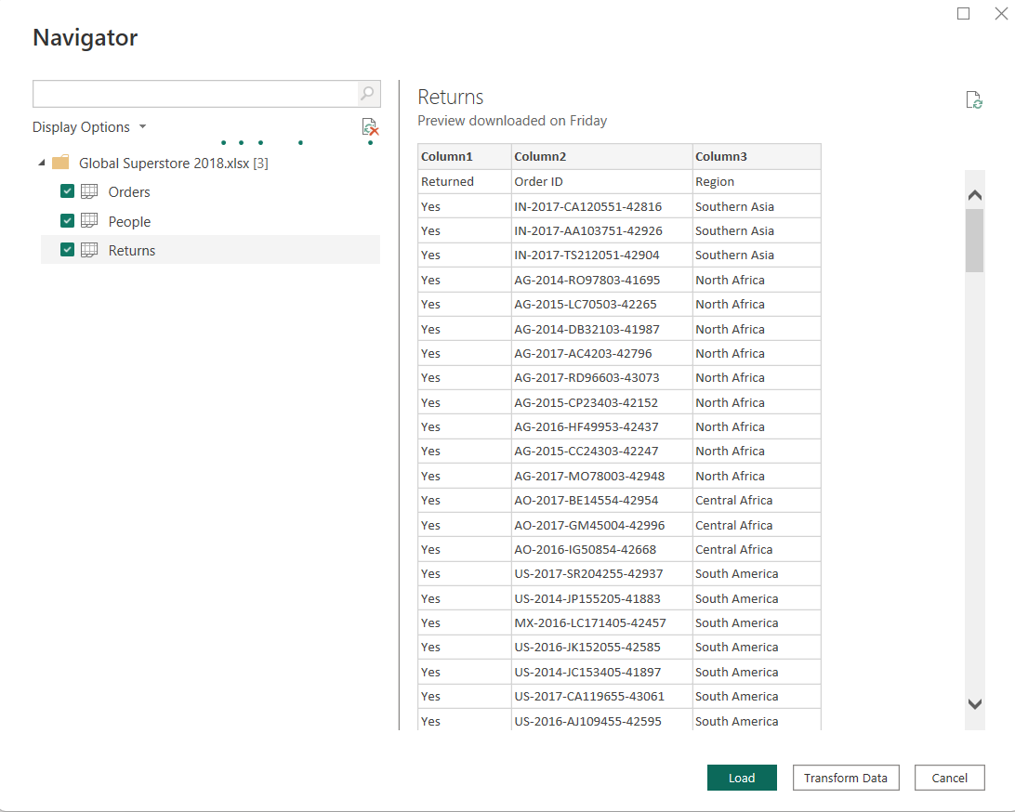

Step 2: Open Power Query
- Select Home → Transform data → Transform data to open Power Query Editor.
- The Queries pane should contain Orders, Returns, and People.

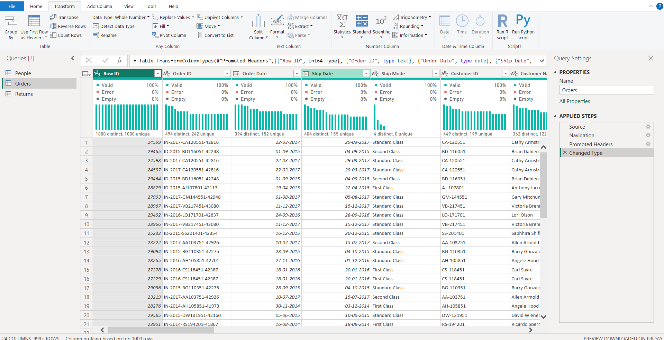

Step 3: Create Dim_Customer
- Right-click the Orders query and select Reference.
- Rename the new query to Dim_Customer.
- Keep only Customer ID, Customer Name, and Segment.
- Select Customer ID → Home → Remove Rows → Remove Duplicates.
- Verify that each Customer ID occurs only once in Dim_Customer.

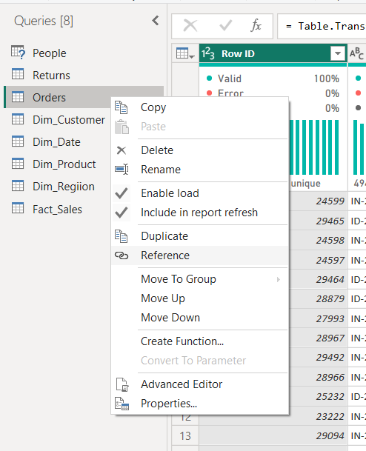

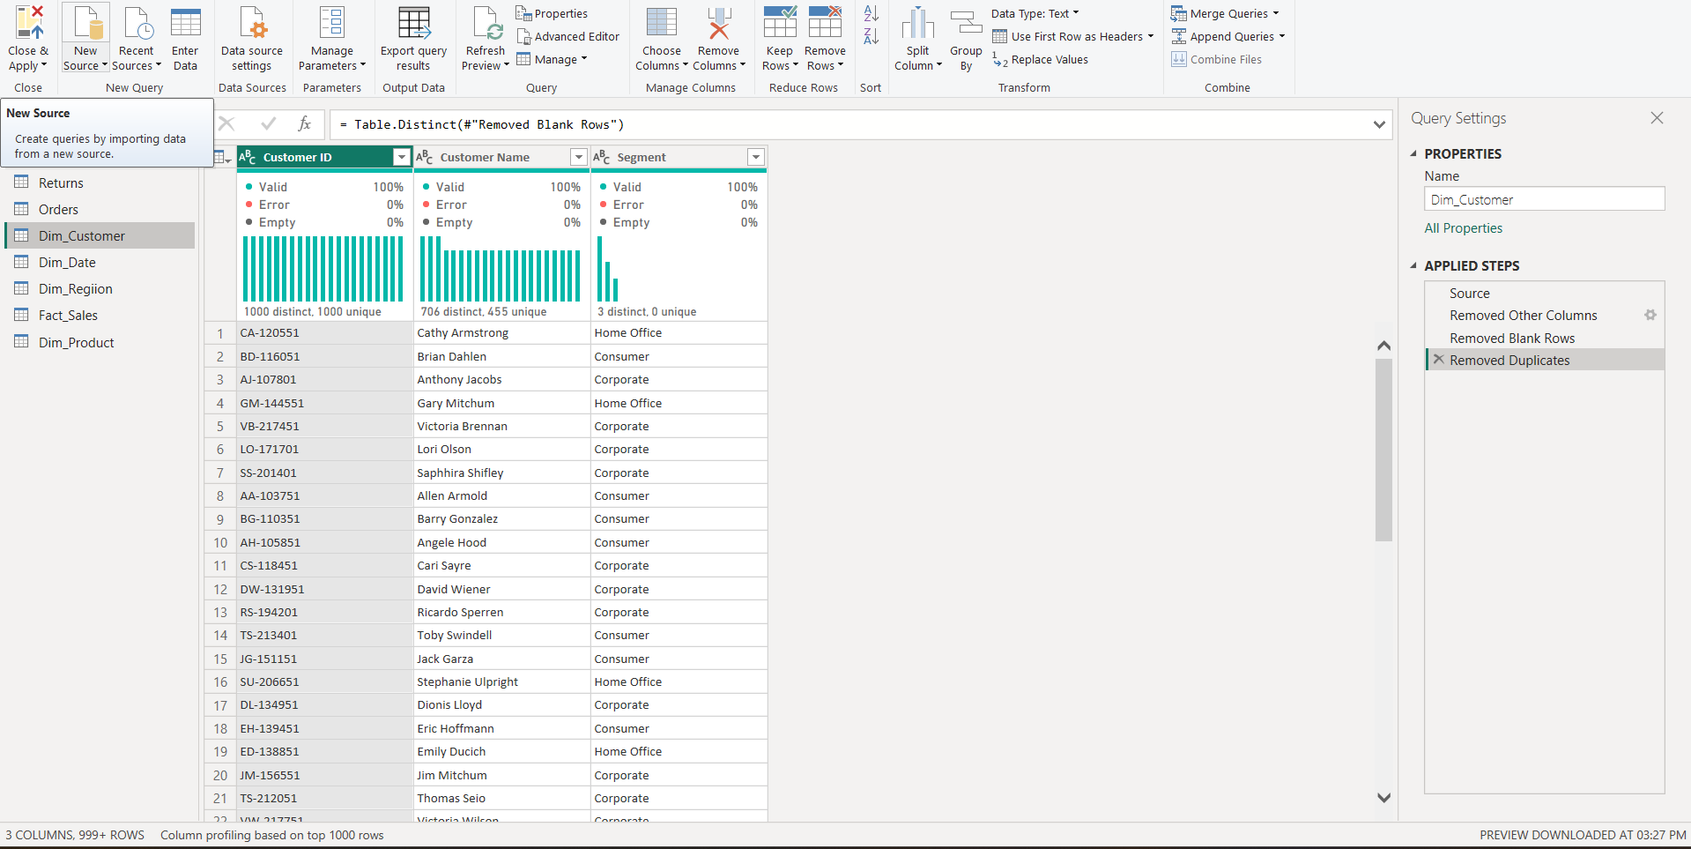

Step 4: Create Dim_Product
- Right-click Orders → Reference.
- Rename the new query to Dim_Product.
- Keep Product ID, Product Name, Category, and Sub-Category.
- Select Product ID → Remove Rows → Remove Duplicates.
- Verify that Product ID is unique in Dim_Product.
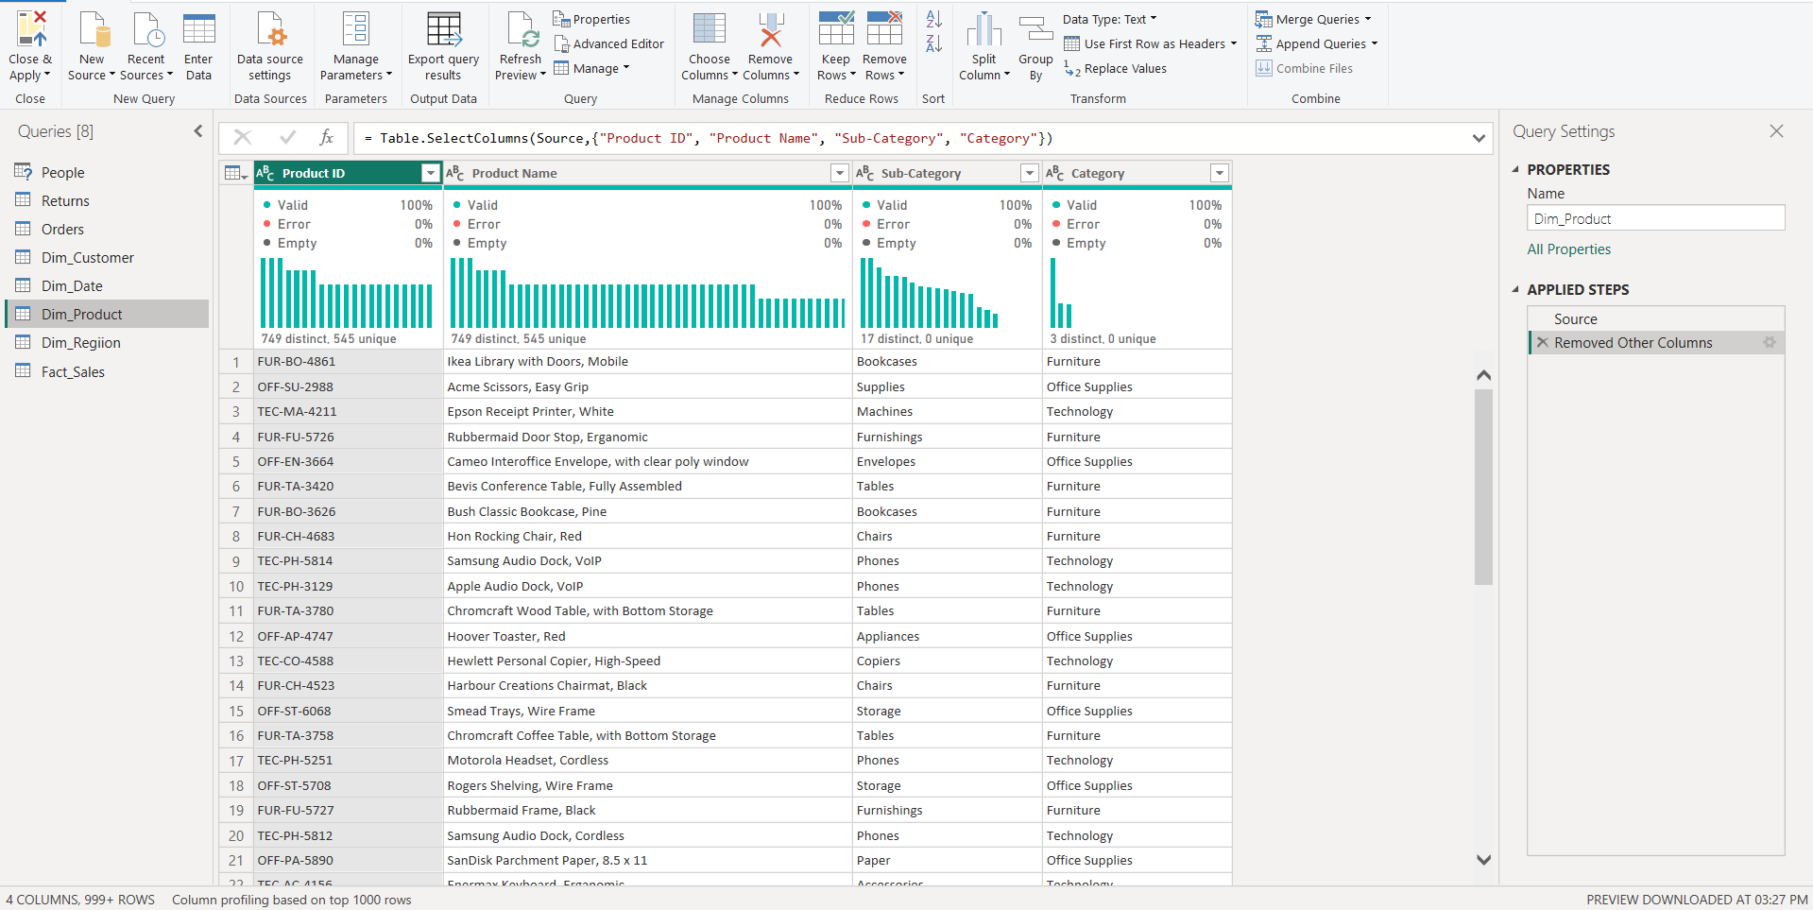

Step 5: Create Dim_Region
- Right-click Orders → Reference.
- Rename the query to Dim_Region.

- Keep the Region column for the simple Region-based star-schema relationship used in this experiment.
- Select Region → Remove Rows → Remove Duplicates.
- Verify that each Region occurs only once.

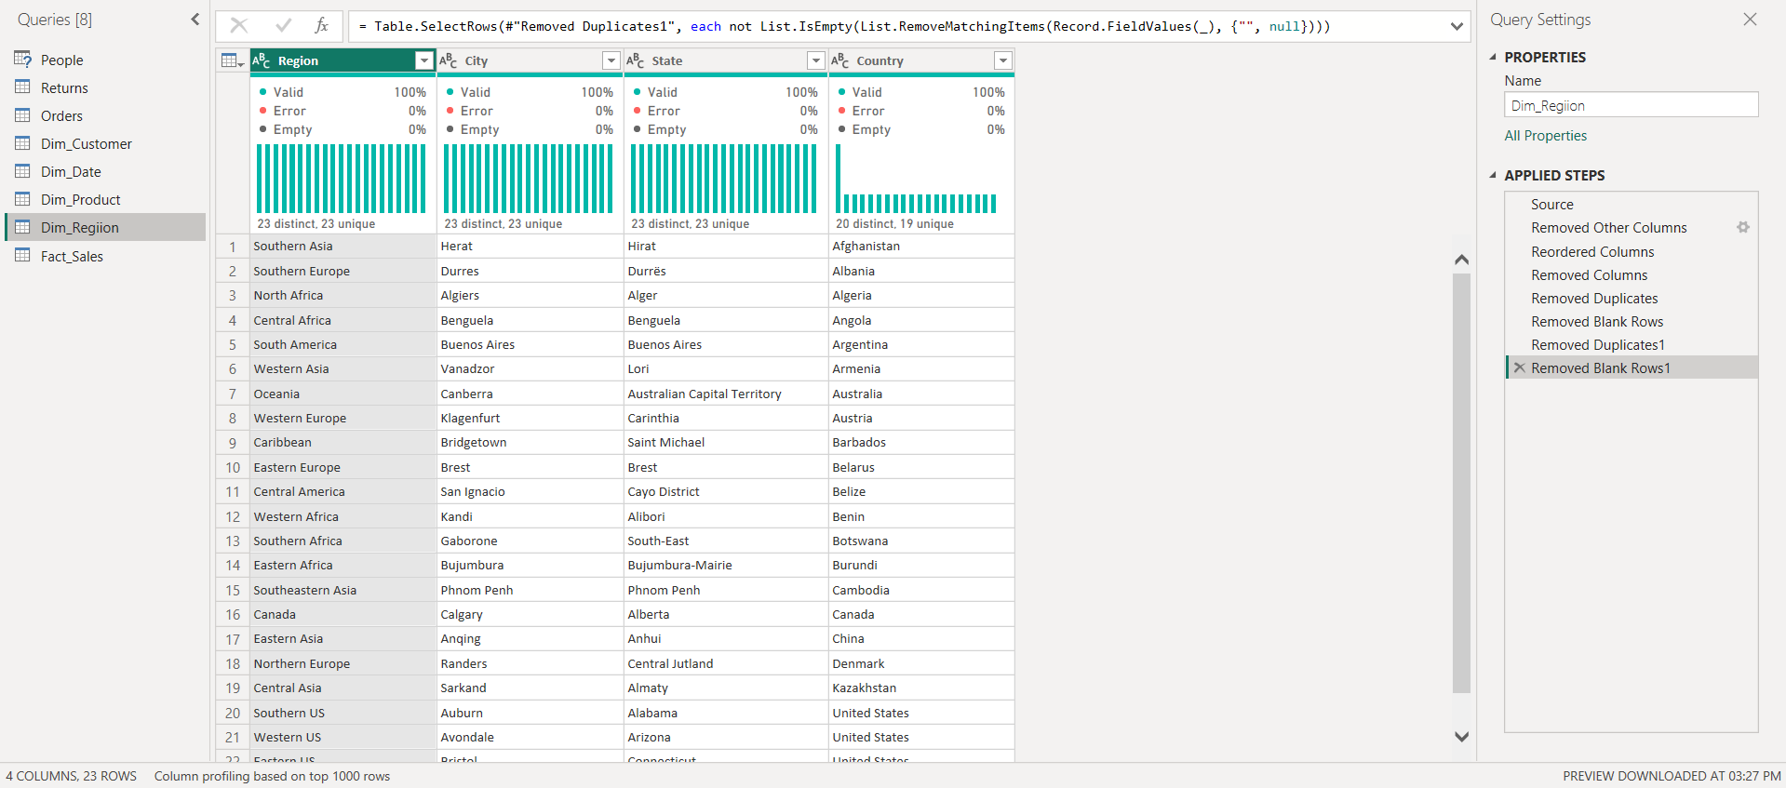

Step 6: Create Fact_Sales
- Right-click Orders → Reference.
- Rename the new query to Fact_Sales.
- Keep Order ID, Customer ID, Product ID, Region, Order Date, Sales, Quantity, Profit, and Discount.
- Remove all other unnecessary columns.
- Check the data types: IDs and Region as Text, Order Date as Date, Sales/Profit/Discount as Decimal Number, and Quantity as Whole Number.

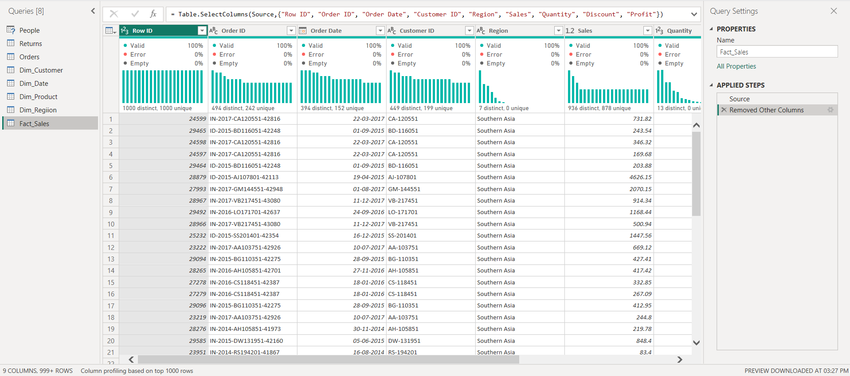

Step 7: Apply Power Query Changes
- Select Home → Close & Apply.
- Wait for Power BI to load the transformed tables.
- Verify that Dim_Customer, Dim_Product, Dim_Region, and Fact_Sales are available in the model.

Step 8: Create Dim_Date using DAX
Go to Modeling → New Table and enter:
Dim_Date =
CALENDAR(
MIN(Fact_Sales[Order Date]),
MAX(Fact_Sales[Order Date])
)
Create the following calculated columns using Modeling → New Column:
Year: Year = YEAR(Dim_Date[Date])

Quarter: Quarter = "Q" & FORMAT(Dim_Date[Date], "Q")

Month: Month = FORMAT(Dim_Date[Date], "MMMM")’

Month Number: Month_Number = MONTH(Dim_Date[Date]

To display months chronologically, select Dim_Date[Month] → Column tools → Sort by column → Month_Number.
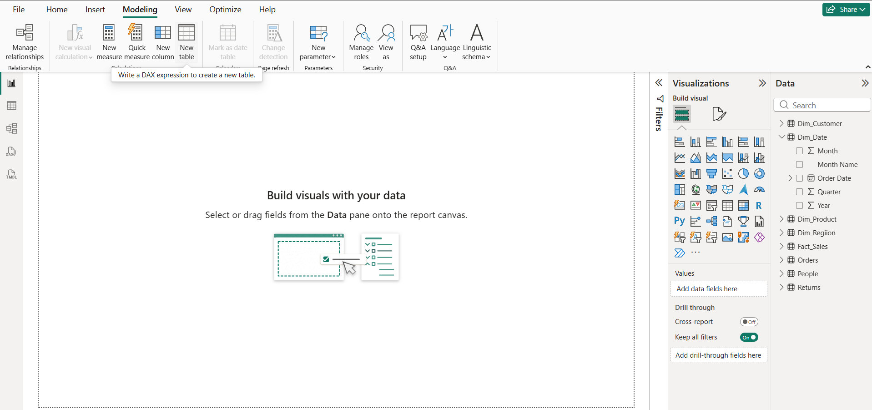

Step 9: Build the Star Schema
Open Model View. Arrange Fact_Sales in the center and place the dimension tables around it.
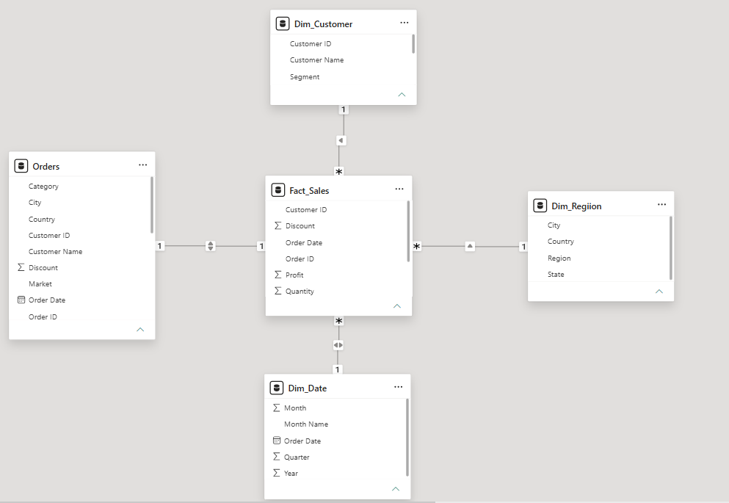

Step 10: Create Relationships
Dimension | Dimension Column | Fact Table | Fact Column | Relationship
Dim_Customer | Customer ID | Fact_Sales | Customer ID | 1 : *
Dim_Product | Product ID | Fact_Sales | Product ID | 1 : *
Dim_Date | Date | Fact_Sales | Order Date | 1 : *
Dim_Region | Region | Fact_Sales | Region | 1 : *

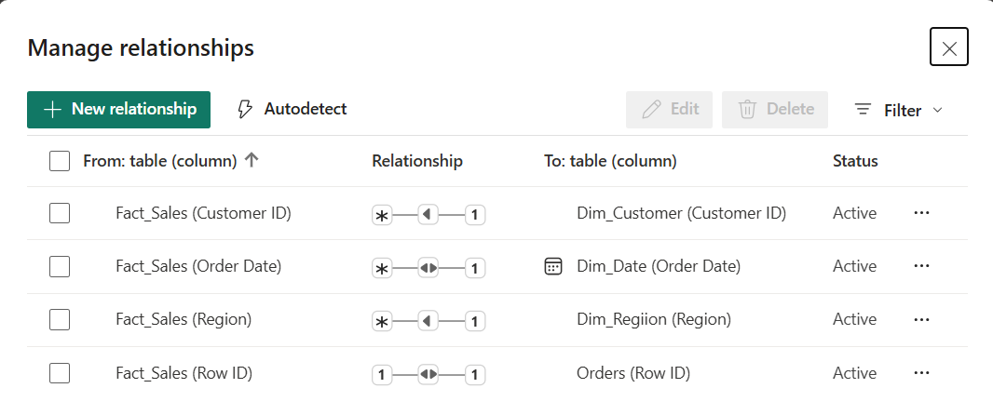

Step 11: Create DAX Measures
Total Sales
Total Sales = SUM(Fact_Sales[Sales])
Total Profit
Total Profit = SUM(Fact_Sales[Profit])
Profit Margin
Profit Margin = DIVIDE( [Total Profit], [Total Sales], 0)
Average Order Value
Average Order Value = DIVIDE( [Total Sales], DISTINCTCOUNT(Fact_Sales[Order ID]), 0)
Create Total Sales and Total Profit before creating Profit Margin because Profit Margin uses those measures. Format Profit Margin as Percentage using Measure tools → Format → Percentage.
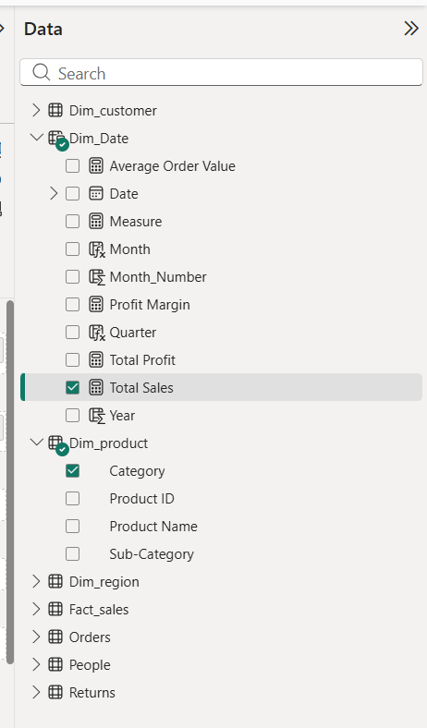

Step 12: Create Visualizations
- Sales by Category: Insert a Clustered Column Chart. Use Dim_Product[Category] on the X-axis and [Total Sales] as Values.
- Profit by Region: Insert a Bar Chart. Use Dim_Region[Region] as the category and [Total Profit] as Values.
- Sales Trend by Year: Insert a Line Chart. Use Dim_Date[Year] on the X-axis and [Total Sales] as Values.
- Create Card visuals for Total Sales, Total Profit, Profit Margin, and Average Order Value.
- Add slicers such as Dim_Date[Year], Dim_Region[Region], and Dim_Product[Category] for interactive filtering.

Step 13: Slice Operation
- Add a Slicer visual using Region.
- Select a single Region, such as West.
- Observe the changes in Sales, Profit, and Orders.
- Record the observations and capture a screenshot as evidence of the Slice operation.
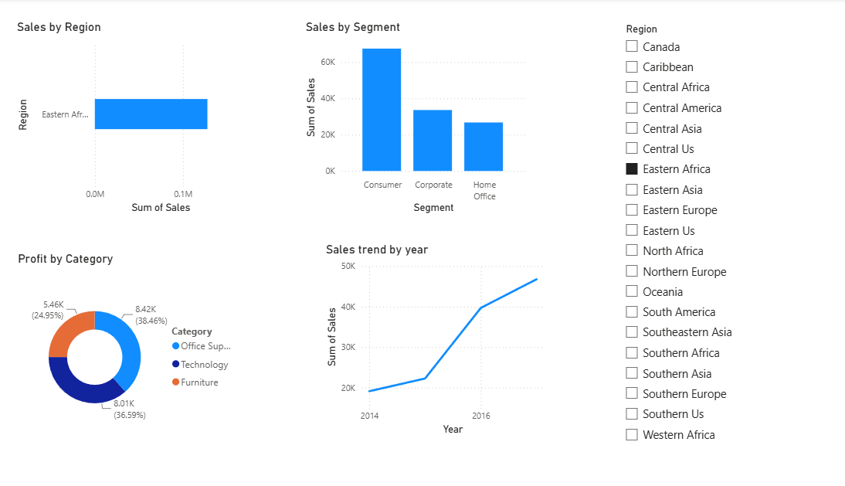

Step 14: Hierarchy Operation
- Go to Report View.
- In the Data pane, find the table containing:
- Region
- State
- City
- Right click Region
- Select New hierarchy
- Rename it to Region, State, City
- Drag State into the hierarchy
- Drag city into the hierarchy
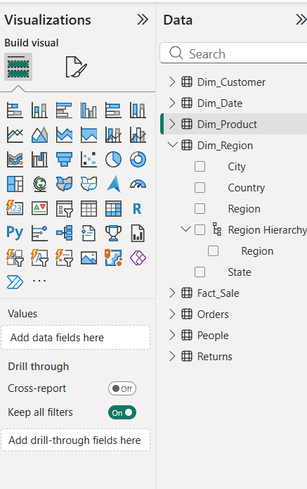

Step 15: Dice Operation
- Go to Report View in Power BI.
- Add a Slicer visual for Region.
- Select West from the Region slicer.
- Add another Slicer visual for Category.
- Select Technology from the Category slicer.
- Add another Slicer visual for Year.
- Select 2022 from the Year slicer.
- Verify that all three filters are applied simultaneously.
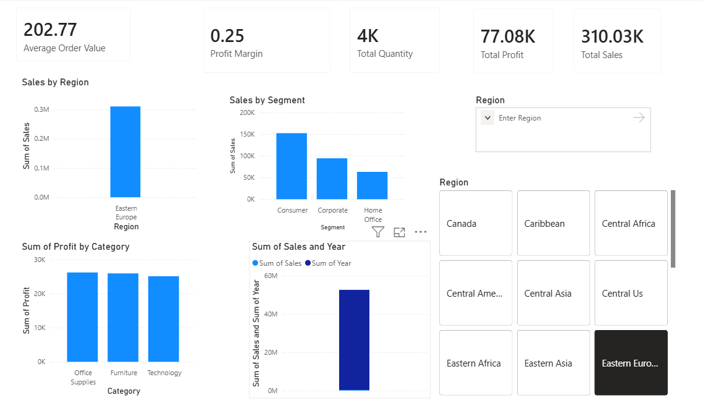
Step 16: Drill Down
- Create a visual with a hierarchy field.
- Enable the drill-down icons.
- Hover over the visual — the drill icons (double downward arrow, single downward arrow, up arrow) appear in the top-left corner of the visual.
- Click the drill-down arrow.
- Click the single downward arrow (Drill Down) icon on the visual toolbar.
- Click on a specific data point.
- Click on any bar, segment, or data point in the visual.
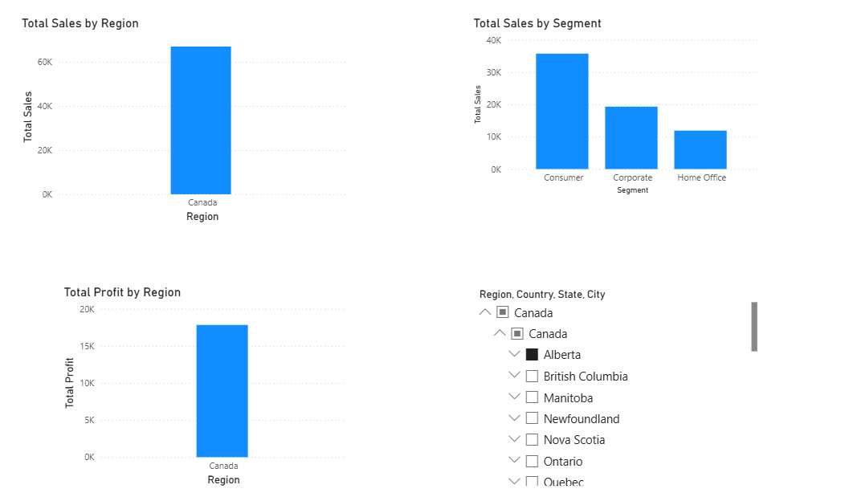
Step 17: Drill Up
- Locate the Drill Up icon.
- On the same visual (already drilled down to a lower level), hover to reveal the toolbar icons.
- Click the upward arrow (Drill Up) icon.
- Click the single upward arrow icon on the visual toolbar.
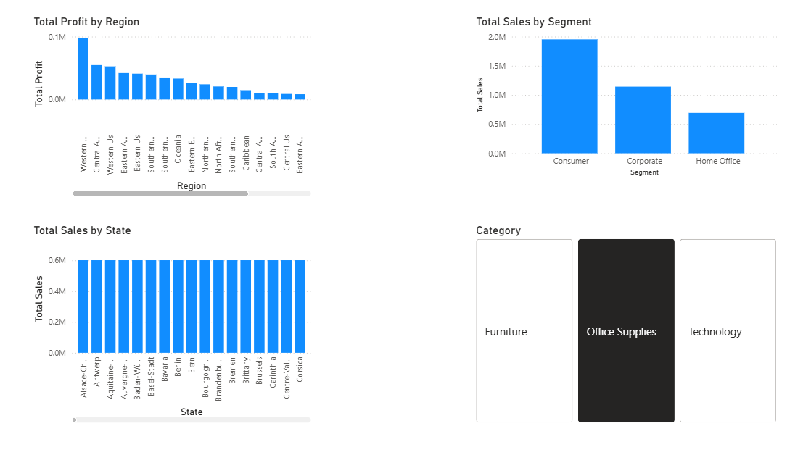

6. Learning Outcomes
- Explain dimensional modeling concepts and Star Schema architecture. (CO2-BT4)
- Differentiate between Fact and Dimension tables. (CO2-BT4)
- Design dimensional models using real-world business datasets. (CO5-BT6)
- Create and validate Star Schemas in Power BI. (CO5-BT6)
- Develop DAX measures for analytical reporting. (CO5-BT6)

