EXPERIMENT-7

Aim: To integrate advanced analytics with Business Intelligence reports using Microsoft Power BI and generate business insights, strategic recommendations, and executive presentations.
Objectives:
- Analyze business performance using BI dashboards.
- Identify strengths, weaknesses, and opportunities.
- Generate data-driven business recommendations.
- Prepare professional analytical reports and presentations.

Theory: Advanced Analytics transforms business data into meaningful insights for decision-making. Power BI supports trend analysis, comparative analysis, KPI evaluation, ranking, and segmentation. Analytical findings help identify business problems, discover opportunities, and develop strategic recommendations.

Dataset Used: Global Superstore Dataset (Excel), containing sales, profit, customer, product, regional, and order information.

Procedure:
- Open the Power BI reports created in Experiments 6.
- Analyze regional sales, category profitability, customer segments, and monthly and yearly sales trends.
Analysis- “Western Europe recorded the highest sales, while several other regions showed comparatively lower sales.”
- Record significant observations using charts, KPIs, and dashboards.
- Western Europe recorded the highest regional sales.
- Technology generated the highest category sales.
- Consumer segment contributed the highest sales.
- Yearly sales increased from 2014 to 2017.
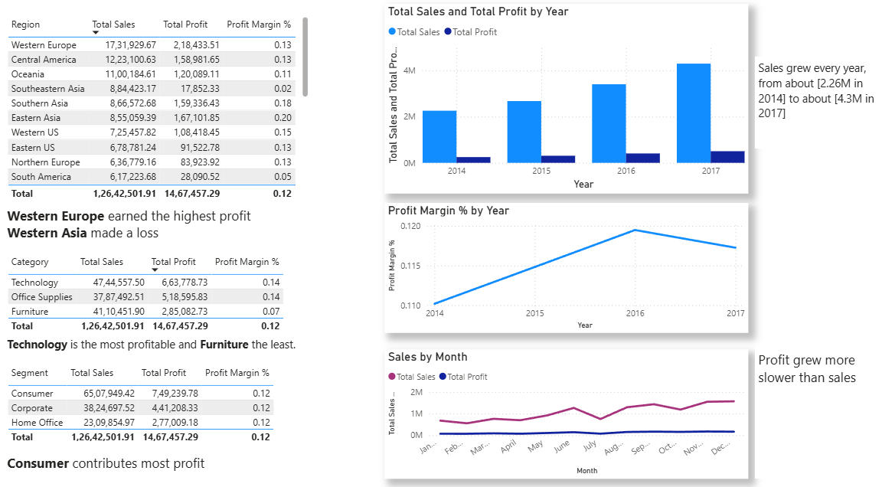
- Identify at least two business strengths, two weaknesses, and two opportunities.
- Prepare a Business Insight Report containing objectives, findings, strengths, weaknesses, opportunities, recommendations, and conclusion.
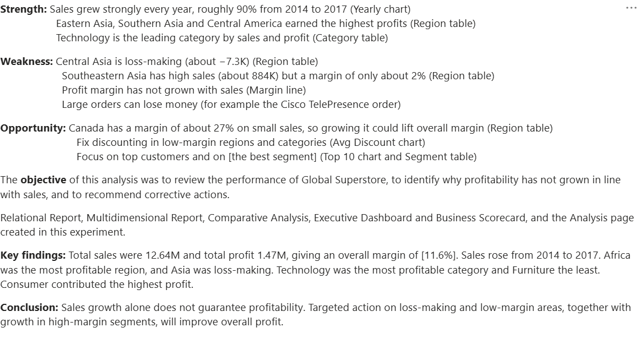
- Include relevant Power BI report and dashboard screenshots in the report.
- Prepare an Executive Presentation consisting of 5–7 slides covering dashboard overview, findings, business issues, recommendations, and conclusion.
- Prepare a Recommendation Summary Sheet highlighting proposed business improvements.
- Save the final Power BI file and submit all deliverables.

Result: Advanced analytics was integrated with Power BI reports to identify business strengths, weaknesses, and opportunities. A Business Insight Report, Executive Presentation, and Recommendation Summary were prepared to support strategic decision-making.
Learning Outcomes:
- Analyzed organizational performance using BI dashboards.
- Identified business insights through analytical reports.
- Developed data-driven strategic recommendations.
- Prepared professional business reports and presentations.

