EXPERIMENT-8

Aim: To design report scheduling, automated distribution and KPI alert mechanisms using Microsoft Power BI for business monitoring and decision-making.

Objectives:
- Prepare scheduled reporting plans.
- Design automated report distribution.
- Configure KPI alert conditions.
- Analyze business monitoring scenarios.
- Recommend corrective business actions.

Theory: Power BI supports automated report delivery and business performance monitoring. Scheduled refreshes help keep reports updated, while subscriptions distribute reports to users through email. KPI alerts notify users when important performance values cross defined thresholds. These features help organizations monitor business activities and take timely corrective actions.

Tools / Software Required: Microsoft Power BI Desktop, Microsoft Power BI Service, Global Superstore Dataset.xlsx, Microsoft Excel.

Dataset Used: Global Superstore Dataset containing sales, profit, returns, customer, product and regional information.

Procedure:
- Open the Global Superstore report in Power BI and review the existing dashboard.
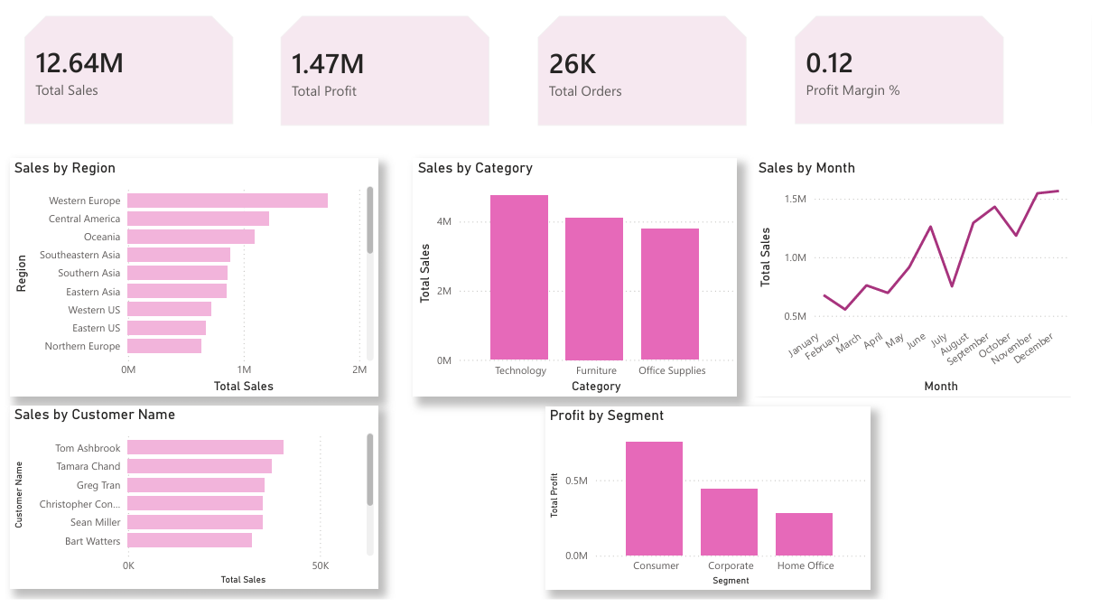
- Prepare a scheduled reporting plan for daily sales, weekly profit and monthly executive reports.
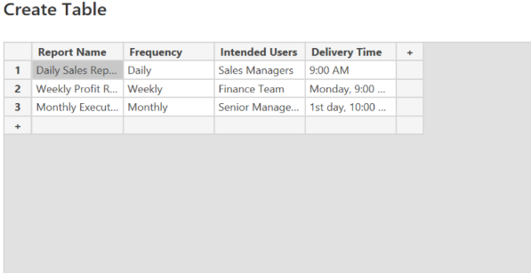
- Identify the intended users and reporting frequency for each report.
- Create a Report Distribution Matrix specifying user groups, reports, frequency and delivery methods.
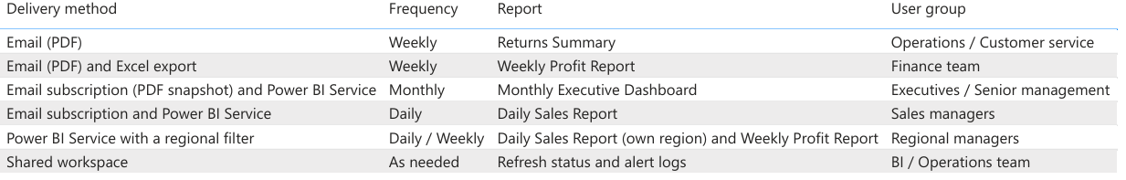
- Define KPI alert conditions for profit margin, sales decline and returns increase.
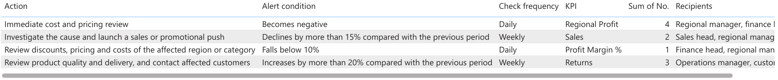
- Specify alert recipients and suitable actions for each KPI condition.
- Analyze a regional profitability decline scenario and identify possible alert triggers.
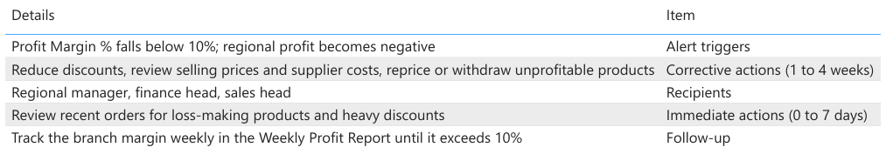
- Recommend corrective actions to improve regional business performance.
- Prepare the Monitoring and Recommendation Report and include the required dashboard screenshot.
- Save all prepared schedules, matrices, alert configurations and reports.

Result: A scheduled reporting plan, report distribution matrix and KPI alert strategy were designed. Business monitoring scenarios were analyzed and corrective recommendations were prepared.

Learning Outcomes:
- Applied report scheduling concepts.
- Designed automated report distribution strategies.
- Identified important KPI alert conditions.
- Evaluated business monitoring scenarios.
- Developed corrective business recommendations.

