EXPERIMENT-9

Aim: To understand and design BI security mechanisms using authentication, authorization, role-based access control and Row-Level Security in Microsoft Power BI.

Objectives:
- Identify organizational users and security roles.
- Analyze authentication methods in Power BI.
- Design role-based access permissions.
- Prepare Row-Level Security strategies.
- Identify security risks and preventive measures.

Theory: Business Intelligence systems store important organizational data that must be protected from unauthorized access. Authentication verifies the identity of users, while authorization determines their access permissions. Power BI provides security features such as workspace roles, sharing permissions and Row-Level Security (RLS). These mechanisms ensure that users can access only the information required for their responsibilities.

Tools / Software Required: Microsoft Power BI Desktop, Microsoft Power BI Service, Global Superstore Dataset.xlsx, Microsoft Excel.

Dataset Used: Global Superstore Dataset containing sales, profit, customer, product and regional information.

Procedure:
- Open the existing Global Superstore Power BI report and identify organizational users such as CEO, Sales Manager, Finance Manager and Regional Manager.
- Define the information requirements of each user and prepare a Role and Permission Matrix.
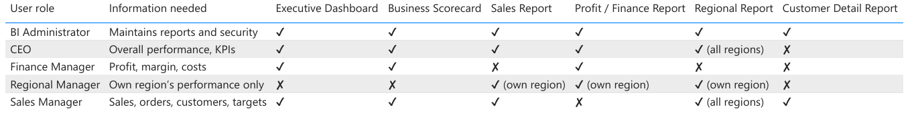
- Study authentication methods including username-password authentication, organizational accounts and multi-factor authentication.
- Compare authentication methods and document their security advantages.
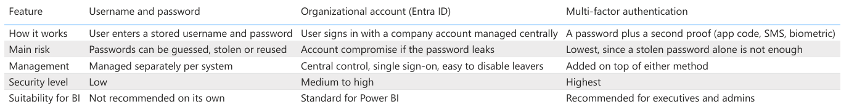
- Prepare an Access Control Matrix using View, Edit, Share and Admin permissions.
- Assign appropriate permissions to different organizational roles based on their responsibilities.
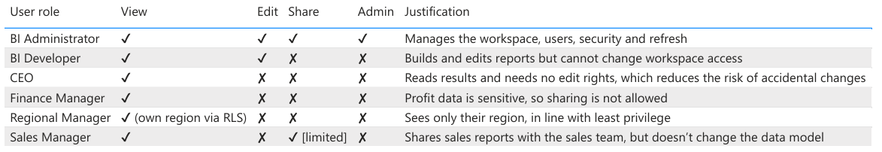
- Design a Row-Level Security strategy for North and South regional managers.
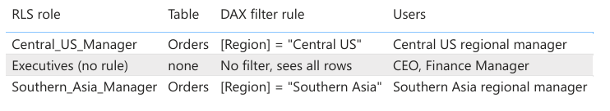
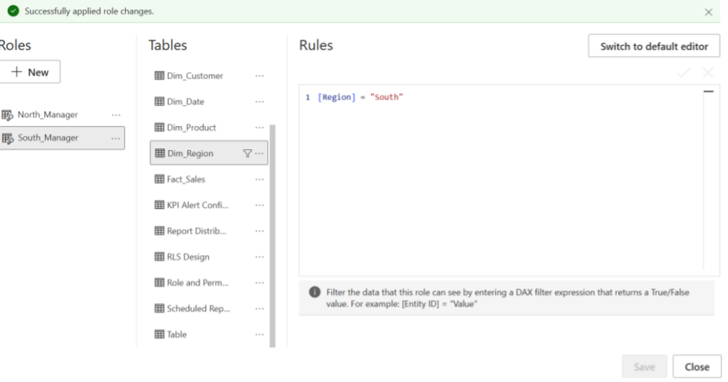
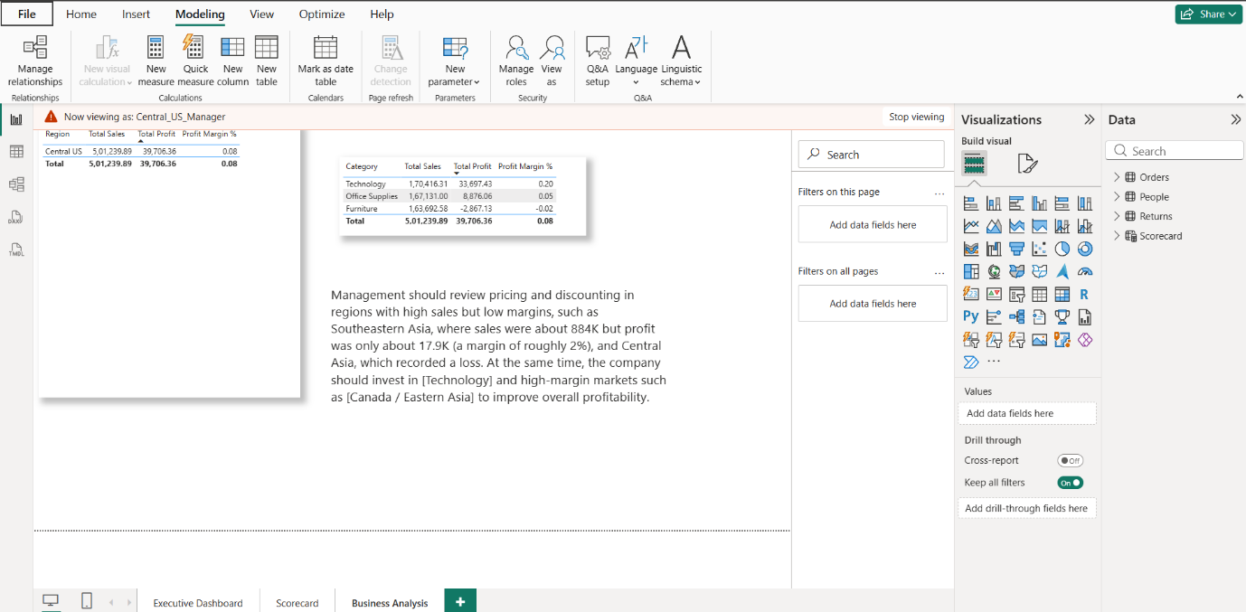
- Identify security risks such as unauthorized access, excessive permissions, data leakage and weak authentication.
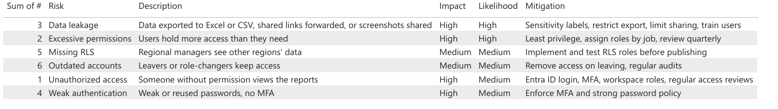
- Recommend suitable security controls and mitigation measures.
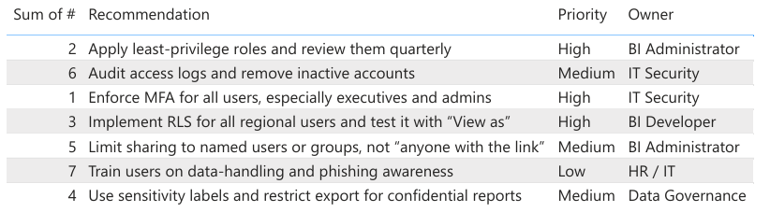
- Prepare the Security Risk Assessment Report, RLS Design Document and Security Recommendations Sheet.

Result: A secure BI access strategy was designed using authentication, authorization and access control concepts. User roles, permissions, RLS strategies and security recommendations were prepared.

Learning Outcomes:
- Explained authentication and authorization concepts.
- Identified organizational security requirements.
- Analyzed role-based access permissions.
- Designed Row-Level Security strategies.
- Evaluated BI security risks and controls.

