Association Between AR CAG Repeat Measurement
and Hirsutism Severity in Women
A Cross-Sectional Correlational Study (n = 106)
August 2026

1. Abstract
Hirsutism is a clinical condition characterized by excessive terminal hair growth in women within androgen-dependent body areas. While androgen receptor activity mediates androgen action in hair follicles, the degree to which genetic variation in the androgen receptor (AR) gene influences clinical hirsutism remains an active area of investigation. This study evaluated the cross-sectional association between the AR CAG repeat measurement provided in the dataset (CALCUL) and average hirsutism score (AVGH) in a sample of 106 women with complete data. Because both variables exhibited non-normal distributions, Spearman's rank correlation was employed as the primary non-parametric statistical test, supplemented by a 2,000-replicate percentile bootstrap for 95% confidence interval estimation.
The analysis revealed a statistically significant, negative association between AR CAG repeat measurement and average hirsutism score (ρ = -0.244, p = 0.0116, 95% bootstrap CI: -0.421 to -0.058). Supporting linear correlation analysis yielded a consistent negative trend (r = -0.306, p = 0.001437). These findings indicate that higher AR CAG repeat measurements were modestly associated with lower hirsutism severity scores in this cohort. The null hypothesis was rejected. Given the modest correlation strength and observational design, these results do not establish a causal mechanism or account for potential confounding hormonal or metabolic factors.

2. Introduction
Hirsutism is defined as the presence of excessive terminal hair in women following a male-type distribution pattern. The condition primarily affects androgen-sensitive regions, including the chin, chest, upper abdomen, lower abdomen, and back. Clinical expression is governed by complex interactions involving circulating free androgen concentrations, local cutaneous 5α-reductase enzyme activity, hair follicle sensitivity, and androgen receptor responsiveness.
The androgen receptor (AR) mediates the cellular action of dihydrotestosterone and testosterone in responsive target tissues. The amino-terminal domain of the AR gene contains a polymorphic cytosine-adenine-guanine (CAG) trinucleotide repeat sequence. Variations in the length of this CAG repeat region have been studied regarding their potential impact on receptor transactivation efficiency and downstream target tissue responses. This project examines whether the AR CAG repeat measurement recorded in the dataset (CALCUL) demonstrates a statistically significant association with clinical hirsutism severity as quantified by the average hirsutism score (AVGH).

3. Research Question
Is the AR CAG repeat measurement (CALCUL) associated with hirsutism severity (AVGH) in women?

4. Objective
To determine whether there is a statistically significant association between the AR CAG repeat measurement (CALCUL) and the average hirsutism score (AVGH) among women in the complete-case dataset.

5. Hypotheses
Null Hypothesis (H0): There is no statistically significant association between AR CAG repeat measurement (CALCUL) and average hirsutism score (AVGH) in women (ρ = 0).
Alternative Hypothesis (H1): There is a statistically significant association between AR CAG repeat measurement (CALCUL) and average hirsutism score (AVGH) in women (ρ ≠ 0).
Note: A two-sided statistical test was selected prior to primary correlation evaluation to allow detection of an association in either direction.

6. Materials and Methods

6.1 Dataset Description
The original dataset comprised clinical, anthropometric, biochemical, and genetic records for N = 109 women. Recorded metrics included participant serial number (N), age (age), coded hirsutism group (ATHg), height (HT), weight (WT), body mass index (BMI), regional hirsutism scores (CHIN, CHES, ABDO), average hirsutism score (AVGH), serum testosterone (TES), allele measurements (Allele1, Allele2), initial CAG repeat length determinations (CAGI, CAGII), and a calculated AR CAG repeat variable (CALCUL).

6.2 Variable Definitions
CALCUL: The primary genetic exposure variable, representing the AR CAG repeat measurement provided within the dataset.
Note on Variable Classification: Empirical comparison confirms that CALCUL is not equivalent to the simple arithmetic mean of CAGI and CAGII. For instance, in a sample observation where CAGI = 12 and CAGII = 23, CALCUL = 12.77. Consequently, no explicit mathematical derivation formula is assumed, and the metric is evaluated as provided.
AVGH: The primary clinical outcome variable, representing the participant's average hirsutism score across evaluated anatomical regions.
ATHg: A categorical hirsutism classification variable containing coded values 1, 2, and 3. Because category definitions were not independently verified from original codebooks, this variable was excluded from primary hypothesis testing.

6.3 Data Cleaning and Complete-Case Sample
The original sample of 109 observations contained missing data in the primary variables of interest (n = 3 missing entries for CALCUL, along with incomplete records for AVGH). A complete-case analysis approach was applied, retaining observations with complete measurements for both CALCUL and AVGH. The final complete-case dataset comprised n = 106 women. The cleaned analytical dataset was exported as AR_CAG_Hirsutism_Analysis.csv.
- Original sample size (N): 109
- Missing primary metrics: 3
- Final complete-case sample (n): 106

6.4 Statistical Methodology
- Descriptive statistics: n, mean, SD, median, Q1, Q3, minimum, and maximum for continuous variables.
- Distributional assessment: histograms and boxplots in R to evaluate normality, symmetry, and outliers.
- Primary test: Spearman's rank correlation (ρ), pre-specified given skewed distributions.
- Interval estimation: percentile bootstrap (2,000 resamples) for the 95% CI of Spearman's ρ.
- Supporting analysis: Pearson's product-moment correlation (r) as a parametric comparison.
- Software: R. Significance threshold α = 0.05 (two-tailed).

7. Results

7.1 Descriptive Statistics
Summary statistics for the complete-case dataset (n = 106) are presented in Table 1.
Variable | n | Mean | SD | Median | Q1 | Q3 | Range (Min–Max)
CALCUL (AR CAG Repeat Measurement) | 106 | 21.58 | 2.43 | 21.50 | 20.36 | 23.12 | 12.56 – 27.00
AVGH (Average Hirsutism Score) | 106 | 0.75 | 0.80 | 0.50 | 0.00 | 1.33 | 0.00 – 3.00
Table 1. Descriptive statistics for AR CAG repeat measurement and average hirsutism score (n = 106).
Across the sample, CALCUL demonstrated a mean of 21.58 ± 2.43 with a median of 21.50. The average hirsutism score (AVGH) yielded a mean of 0.75 ± 0.80 and a median of 0.50.
Optional categorical distribution (ATHg): among participants with recorded group codes (n = 108), Group 1 represented 45.37% (n = 49), Group 2 represented 25.00% (n = 27), and Group 3 represented 29.63% (n = 32).

7.2 Distributional Evaluation
The histogram for CALCUL revealed a unimodal, left-skewed (negatively skewed) distribution. The majority of measurements clustered between approximately 20 and 22, with a longer tail extending toward lower values (minimum = 12.56).
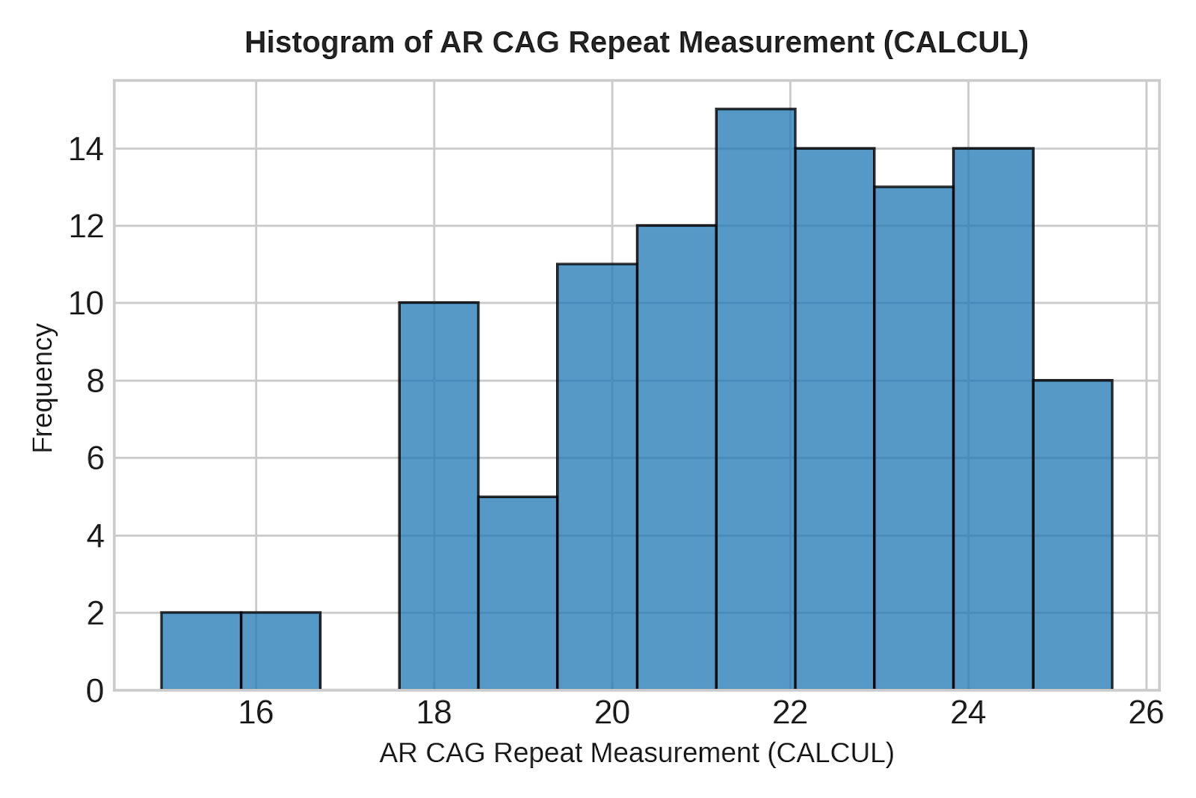
Figure 1. Distribution of AR CAG repeat measurement (CALCUL).
The histogram for AVGH demonstrated a unimodal, strongly right-skewed (positively skewed) distribution. Most observations were concentrated at lower scores (Q1 = 0.00, median = 0.50), with a sparse upper tail reaching 3.00.
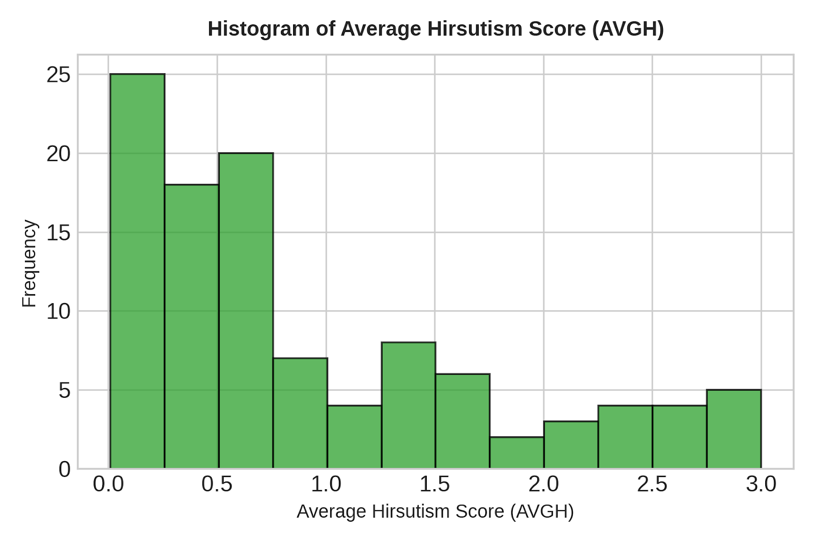
Figure 2. Distribution of average hirsutism score (AVGH).
A boxplot of CALCUL was generated to inspect data boundaries. No severe isolated outlier points were observed outside the nominal boxplot whiskers, indicating that the skewness reflected continuous distributional properties rather than erroneous data points.

7.3 Primary Correlation Analysis (Spearman's Rank Correlation)
Because both CALCUL and AVGH deviated from a normal distribution, Spearman's rank correlation was conducted as the primary statistical test.
- Spearman's rho (ρ): -0.244 (ρ = -0.2442326)
- p-value: p = 0.0116 (p = 0.01163)
- 95% bootstrap confidence interval (2,000 replicates): -0.421 to -0.058
Because p = 0.0116 is less than the standard significance threshold of α = 0.05, the null hypothesis is rejected. The 95% bootstrap confidence interval entirely excludes zero, confirming a statistically significant negative association between the AR CAG repeat measurement and average hirsutism score.

7.4 Scatterplot and Relationship Analysis
A scatterplot of CALCUL against AVGH was constructed to inspect bivariate structure.
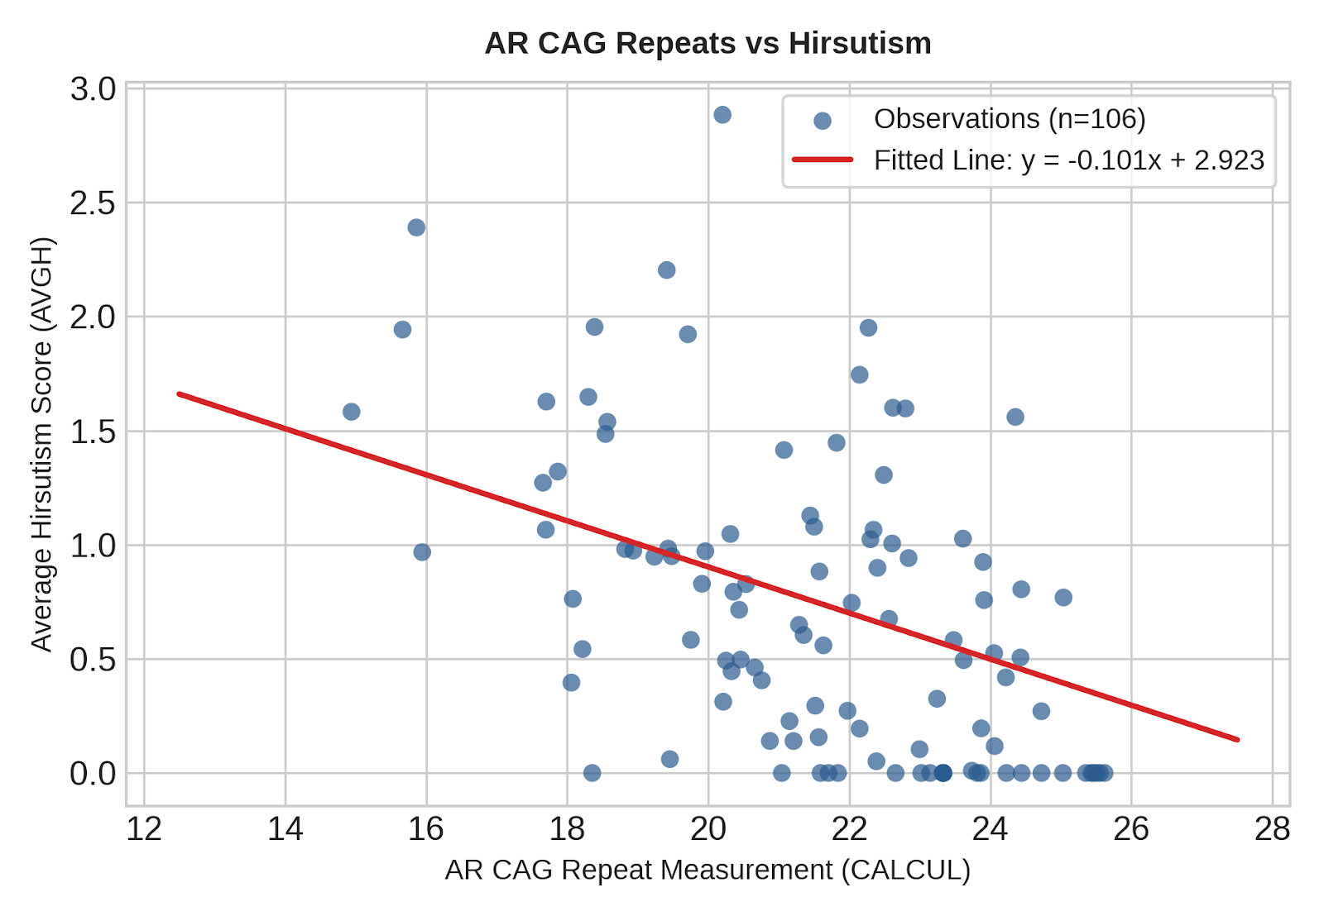
Figure 3. Association between AR CAG repeat measurement and average hirsutism score, with fitted OLS line.
Visual assessment reveals substantial scatter around the descriptive linear fit. The fitted ordinary least squares (OLS) regression line from the scatterplot is parameterized as:
AVGH = -0.101 × CALCUL + 2.923
This linear equation is provided solely as a descriptive overlay for the scatterplot visualization and does not constitute a parametric predictive model.

7.5 Supporting Parametric Analysis (Pearson Correlation)
Parametric correlation was conducted to evaluate consistency across statistical methodologies.
Method | Coefficient | p-value | Significant (α=0.05) | Role
Spearman Rank | ρ = -0.244 | 0.0116 | Yes | Primary analysis
Pearson Product-Moment | r = -0.306 | 0.001437 | Yes | Supporting analysis
Table 2. Statistical correlation comparison (n = 106).
Both statistical procedures demonstrate agreement in direction (negative association) and statistical significance (p < 0.05). Spearman's rank correlation remains the authoritative primary result due to distributional skewness.

8. Summary Statement of Results
Among 106 women with complete data for AR CAG repeat measurement and average hirsutism score, the mean AR CAG repeat measurement was 21.58 ± 2.43, while the mean average hirsutism score was 0.75 ± 0.80. Both variables demonstrated non-normal, skewed distributions; therefore, Spearman's rank correlation was used as the primary analysis. A statistically significant negative association was observed between AR CAG repeat measurement and average hirsutism score (ρ = -0.244, p = 0.0116; 95% bootstrap CI: -0.421 to -0.058). This indicates that higher AR CAG repeat measurements were generally associated with lower hirsutism scores in this dataset.

9. Discussion
This study evaluated the relationship between an AR CAG repeat measurement (CALCUL) and clinical hirsutism severity (AVGH). The primary statistical analysis confirmed a statistically significant, negative rank correlation (ρ = -0.244, p = 0.0116).
From a physiological perspective, the androgen receptor regulates target tissue sensitivity to circulating active androgens. Variations in CAG trinucleotide repeat numbers in the AR gene have been postulated to modulate receptor transactivation capacity. In biological systems, shorter CAG repeat lengths have sometimes been linked in clinical literature to enhanced receptor transactivation, which could theoretically heighten target cell responsiveness to baseline androgen levels. Conversely, longer CAG repeat sequences may correspond to diminished transactivation capacity. The negative correlation observed here — wherein higher CAG repeat measurements tended to co-occur with lower average hirsutism scores — is compatible with this broad hypothesis.
However, the magnitude of the correlation coefficient (ρ = -0.244) reflects a modest effect size. The coefficient of determination derived from simple linear modeling (R² ≈ 0.093) indicates that CALCUL accounts for less than 10% of the variance observed in AVGH. Hirsutism is a highly complex, multifactorial clinical phenotype governed by multiple interacting pathways, including:
- Circulating bioavailable androgen concentrations (e.g., total testosterone, free testosterone, and dihydrotestosterone).
- Local enzymatic conversion rates via cutaneous 5α-reductase activity in dermal papilla cells.
- Concurrent endocrine or metabolic factors, such as insulin resistance, hyperinsulinemia, and sex hormone-binding globulin (SHBG) levels.
- Additional polygenic modulators of hair follicle growth dynamics.
Crucially, statistical association does not equal clinical causality. The observed negative relationship indicates co-variation within this sample but does not prove that variations in CALCUL directly cause changes in terminal hair growth.

10. Limitations
- Sample size: the complete-case sample size (n = 106) provides sufficient statistical power to detect modest correlations but limits extensive subgroup analyses.
- Observational design: the study is observational; causality cannot be inferred from correlation metrics.
- Uncontrolled confounders: primary analysis did not adjust for serum testosterone, age, BMI, or metabolic biomarkers.
- Distributional skew: primary variables displayed non-normal distributions, requiring non-parametric methods.
- Missing data: three participants were excluded due to missing CALCUL values, along with incomplete cases for AVGH.
- Variable construction: the exact algorithm for CALCUL was not independently reconstructed from source documentation.
- Single cohort scope: observations are derived from a single dataset and require verification across broader, multi-center populations.
- Analytical scope: multivariable modeling (e.g., adjusted rank regression or multiple linear regression) was deliberately omitted to maintain a focused, entry-level statistical framework.

11. Conclusion
This statistical investigation demonstrates a significant negative association between the AR CAG repeat measurement (CALCUL) and average hirsutism score (AVGH) in a sample of 106 women (ρ = -0.244, p = 0.0116, 95% bootstrap CI: -0.421 to -0.058). The null hypothesis was rejected. Higher CALCUL values were modestly associated with lower hirsutism scores. Because the observed relationship is modest and non-causal, CALCUL alone is insufficient to explain overall clinical variation in hirsutism. Future investigations incorporating larger sample sizes, prospective designs, and multivariable models controlling for serum androgen concentrations and metabolic markers are recommended.

12. Final Statistical Summary
Original dataset sample size | N = 109 women
Complete-case sample size | n = 106 women
Primary exposure variable | AR CAG repeat measurement (CALCUL)
Primary outcome variable | Average hirsutism score (AVGH)
CALCUL descriptive metrics | Mean ± SD: 21.58 ± 2.43 (Median 21.50, Range 12.56–27.00)
AVGH descriptive metrics | Mean ± SD: 0.75 ± 0.80 (Median 0.50, Range 0.00–3.00)
Primary statistical test | Spearman's rank correlation (ρ)
Primary correlation coefficient | ρ = -0.244
Primary p-value | p = 0.0116
95% bootstrap confidence interval | -0.421 to -0.058 (2,000 replicates)
Supporting parametric test | Pearson's correlation (r = -0.306, p = 0.001437)
Direction of association | Negative
Statistical decision | Reject null hypothesis (H0) at α = 0.05
Core interpretation | Higher CALCUL values are significantly associated with lower AVGH scores
Table 3. Comprehensive statistical summary of primary findings.

13. Reproducibility
All analyses were conducted in R using cor.test() for Spearman and Pearson correlations and a manual percentile bootstrap (2,000 resamples, seed = 123) for the 95% confidence interval of ρ. The complete analysis script is available on request or alongside this report to allow independent verification of every reported statistic.

