1. When you log in, the following window appears. You can have the launcher from the + at the left corner too.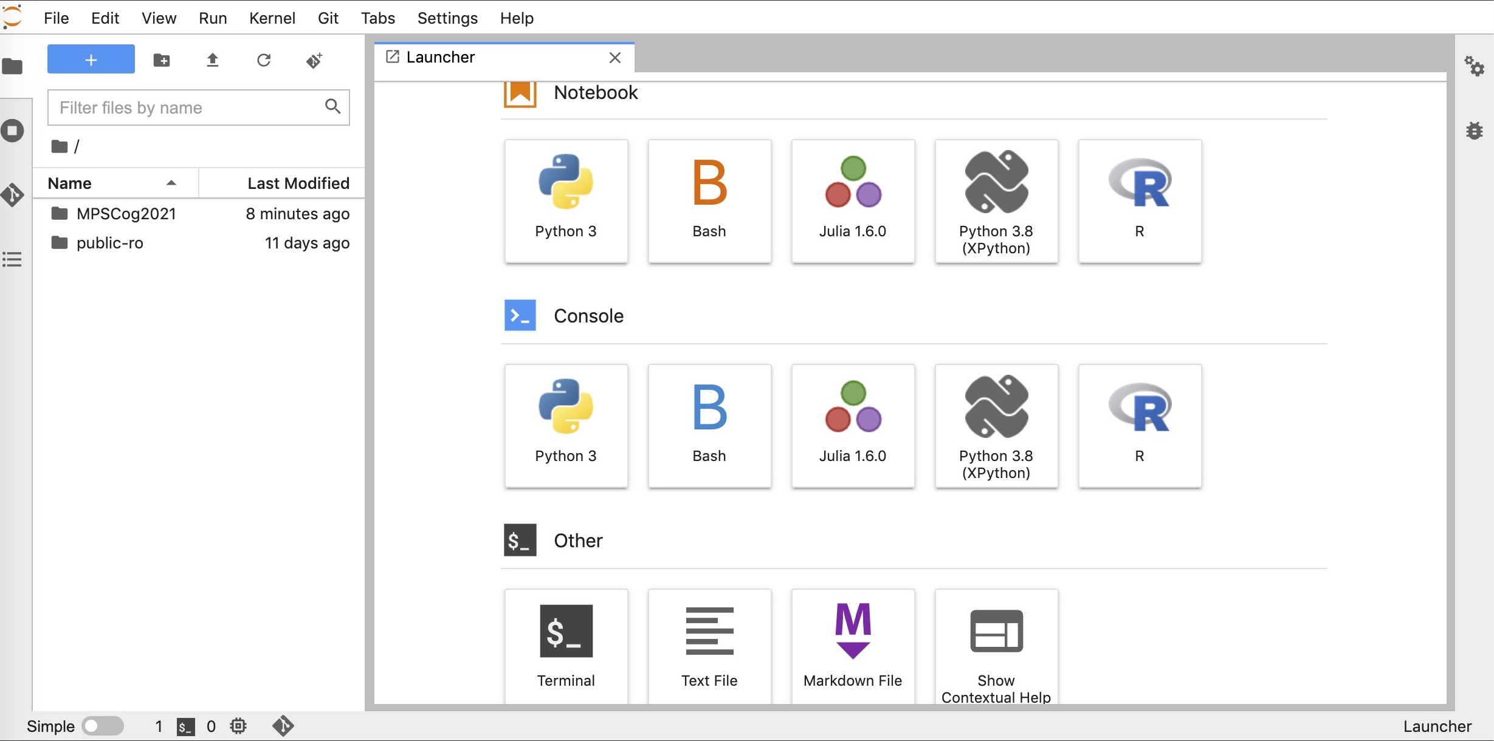

2. Open a new ‘Terminal’:

2.1 In order to get the folder of tutorial materials (MPSCog2021 folder on the left panel), type:

git clone https://github.com/minajamshidi/MPSCog-MCN2022.git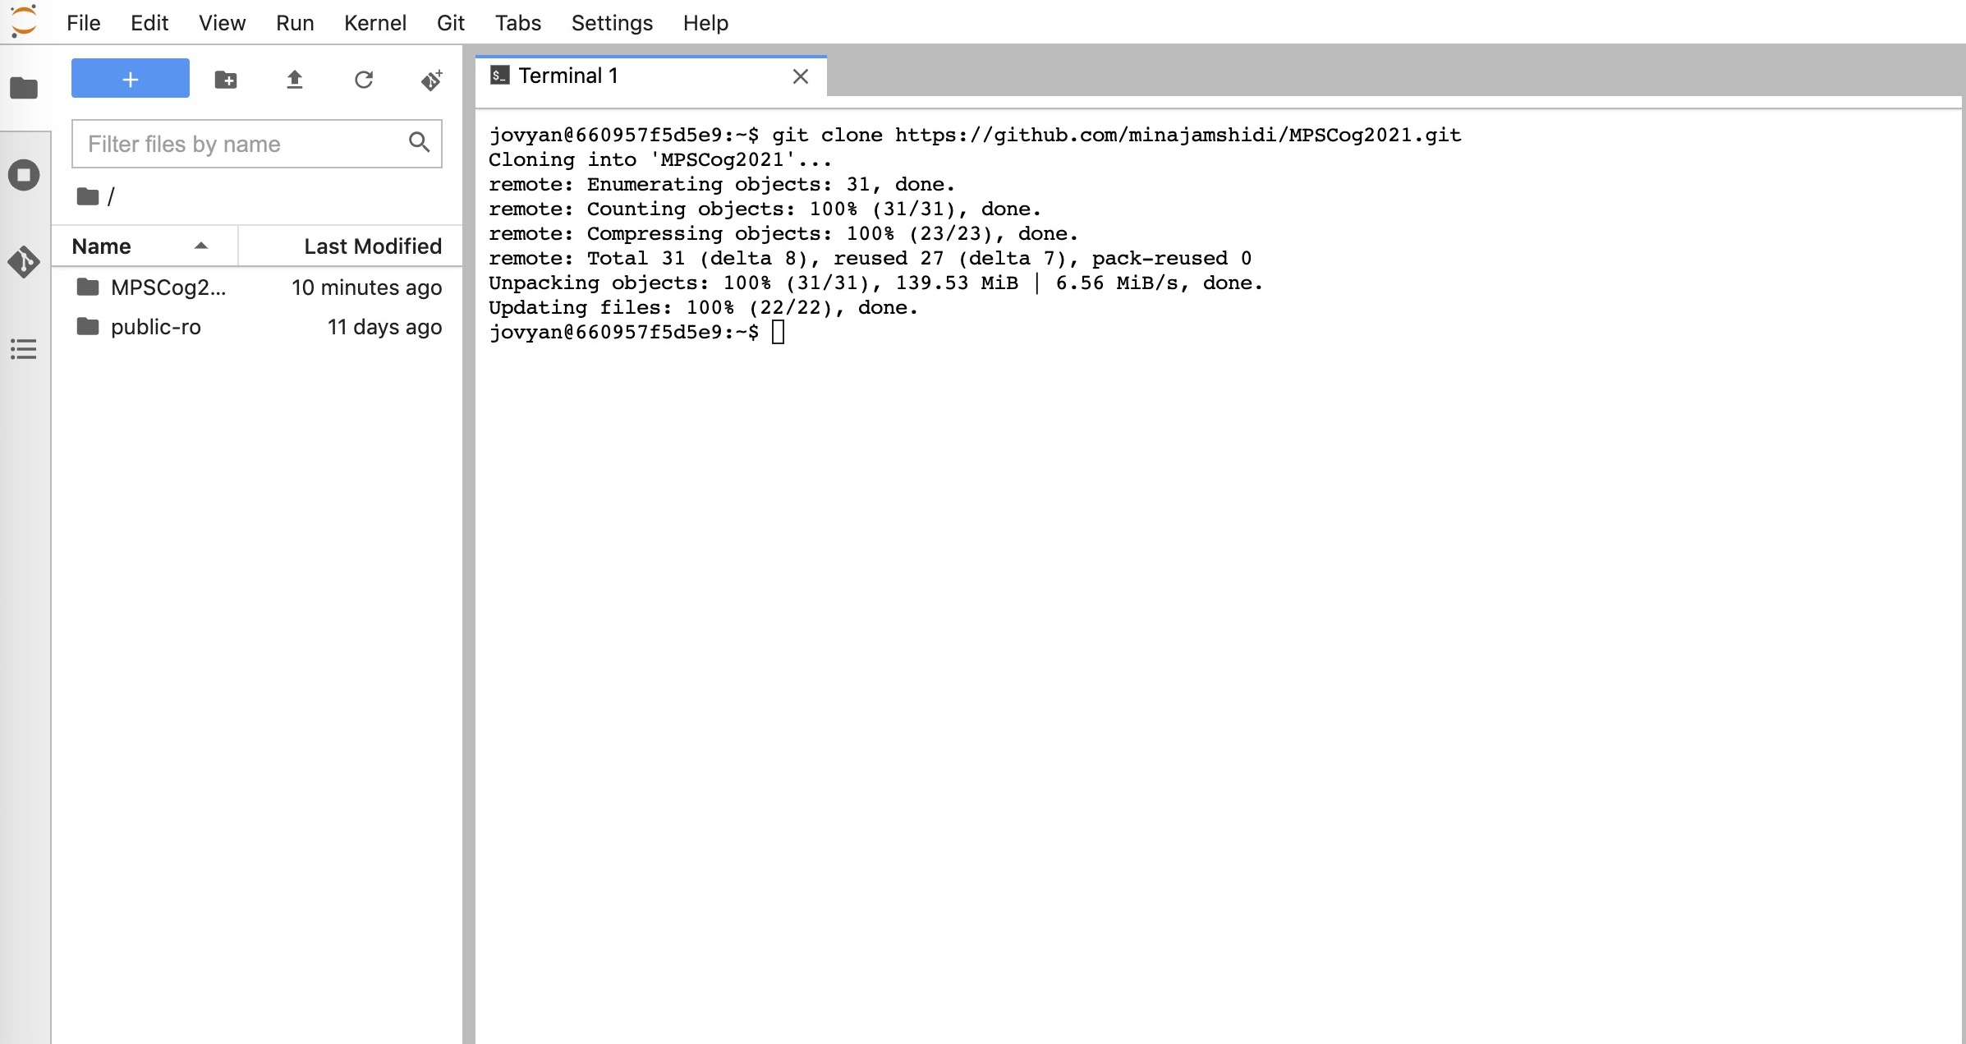

2.2 Install mne:

pip install —user mne

You will (most probably) get the following warning:

“WARNING: The script mne is installed in '/home/jovyan/.local/bin' which is not on PATH.

Consider adding this directory to PATH or, if you prefer to suppress this warning, use —no-warn-script-location.”

The path name may differ (“jovyan”)

type (using your path name in the warning):

export PYTHONPATH=“${PYTHONPATH}:/home/jovyan/.local/bin”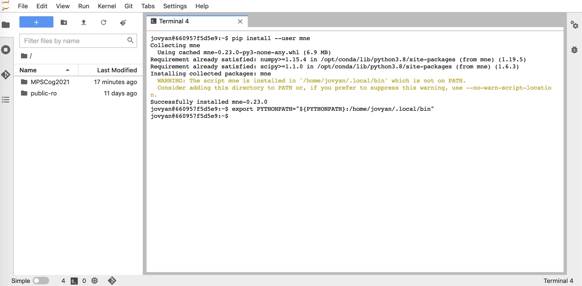

2.3. Install ipympl for having interactive figures. Type:

pip install ipympl

3. Download the data based on the instruction on EEG_tutorial_part1 notebook and place data in the proper folder.