Smart Campus Classroom Management System
Build With AI: DevOps 2026 | GDG on Campus, DDUGU
Team name: Spiderr Members: Minakshi Pandey and Shraddha Agrahari.
Live prototype: https://claude.ai/artifact/1Pa8UGsoeoHGK9PsZwWRrK

1. The idea in one paragraph
We want to build one single source of truth for every room and every schedule change at IET and Deeksha Bhawan. Faculty see which room is genuinely free, book it in a few clicks, and the system physically refuses any booking that overlaps with another one. The moment anything is booked, moved, cancelled or declared an exam, exactly the students affected (and nobody else) are told, and they have to see it, not just receive it. Every change leaves a permanent trail so any "I was never told" dispute can be settled in seconds.
Working name: RoomSync (placeholder, rename as you like).

2. Working prototype and blueprint
Try it here: https://claude.ai/artifact/1Pa8UGsoeoHGK9PsZwWRrK
It is one web page that runs in the browser on sample data. Everything in it is marked TEST DATA, as the problem statement asks. It uses the IET and Deeksha Bhawan layouts from the blueprints and the branch, year and section structure from the problem text.

What already works
- Both buildings as clickable floor plans: IET (ground, first, second floor) and Deeksha Bhawan (ground, first floor), coloured live as free, busy or too small for any date, time and seat count.
- Room search by building, floor, date, start time, duration, seats and room type, plus a one-line "describe what you need" box.
- Booking for extra class, minor exam, practical or event. It checks room, student group and teacher clashes, room type (practicals only in labs), capacity, and walking time between the two buildings.
- When a booking is refused: the reasons, ranked free rooms, and other start times that suit the room, the students and the teacher. One tap books the alternative, and it is checked again.
- Approval: events in the Library or Seminar Hall wait for an administrator.
- Move and cancel (own bookings only). Students get a notice saying exactly what changed, and the older notice is marked superseded.
- Notices targeted by branch, year and section, with an "I have seen this" button and acknowledgement counts for faculty and admins.
- Student view: a read-only schedule for their own group, and a Report a problem button that never edits the booking (it only adds an Under review badge).
- Admin view: approvals, open student reports, mark a room unavailable and get replacement suggestions for every affected booking.
- Audit trail with a hash chain and a Verify button.

Two-minute walkthrough
- Open Find rooms as Faculty (Dr. M. Pandey). Friday 6 Nov, 11:00, 70 seats is already set, and the map shows what is free.
- Click IET17 (red, busy), press Book, then Check and book. The system refuses and says why, then lists free rooms.
- Press Book this instead on IET20. It is booked and the AI ML Year 4 Sec A students are notified.
- Open Schedule and move that class. Then open Notices and see the old notice marked superseded by version 2.
- Switch Viewing as to Student (CSE Year 3 Sec A). Notices shows what must be acknowledged. Press Report a problem on any class.
- Switch to Admin, see the report, mark a room unavailable, then open Audit trail and press Verify chain.
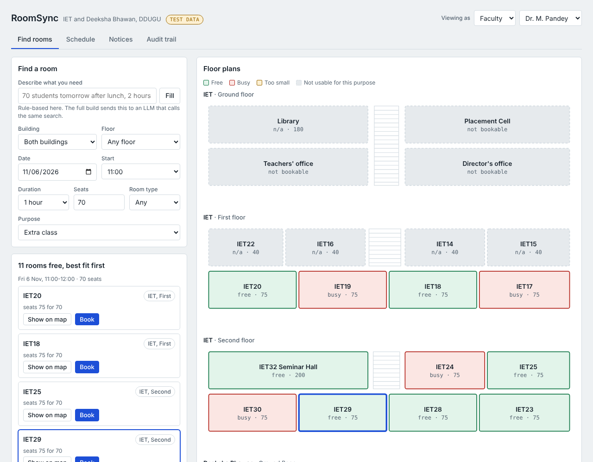
Floor plans coloured for Friday 6 Nov, 11:00, 70 seats. Room details and day timeline open below the map.
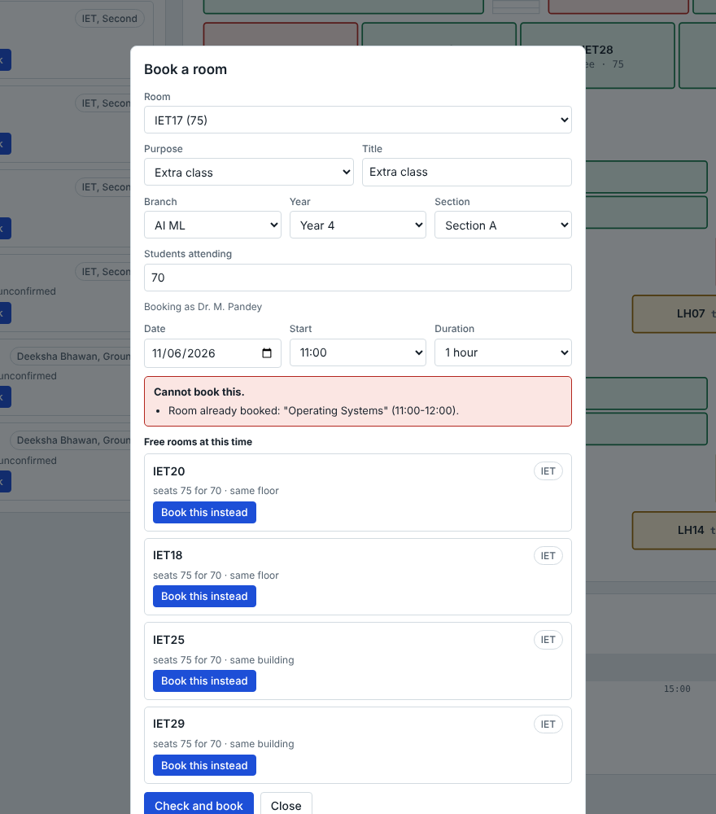
A clashing booking is refused with the reason, and free rooms are offered with one-tap re-booking.

How it was tested
The booking logic behind the page was run against a test script. Double booking by room, by student group and by teacher is refused. A practical in a classroom is refused. Capacity limits hold. Library bookings need approval. Moves and cancellations replace the older notice. Fifty simultaneous attempts at the same slot produced exactly one booking. The page itself was clicked through in a browser for these flows and checked at phone width.

What is not built yet
- It runs in the browser only. There is no server, real database or Google sign-in yet, and the data resets when the page reloads. Section 11 describes the real build.
- The no-overlap guarantee in the prototype comes from the engine's checks. In the real build the PostgreSQL exclusion constraint (section 7) adds a second, database-level guarantee.
- "Describe what you need" is a simple rule-based reader here. The full build would use an LLM that calls the same search and booking functions and never decides availability itself.
- Capacities for Deeksha Bhawan rooms, the labs and the rooms that appear only on the blueprint are placeholders marked to confirm.
- Teacher names are made up, and each branch section is modelled as a group of 75 students.

Blueprint
The first picture shows the whole system I would build. The second follows one booking from request to acknowledgement.
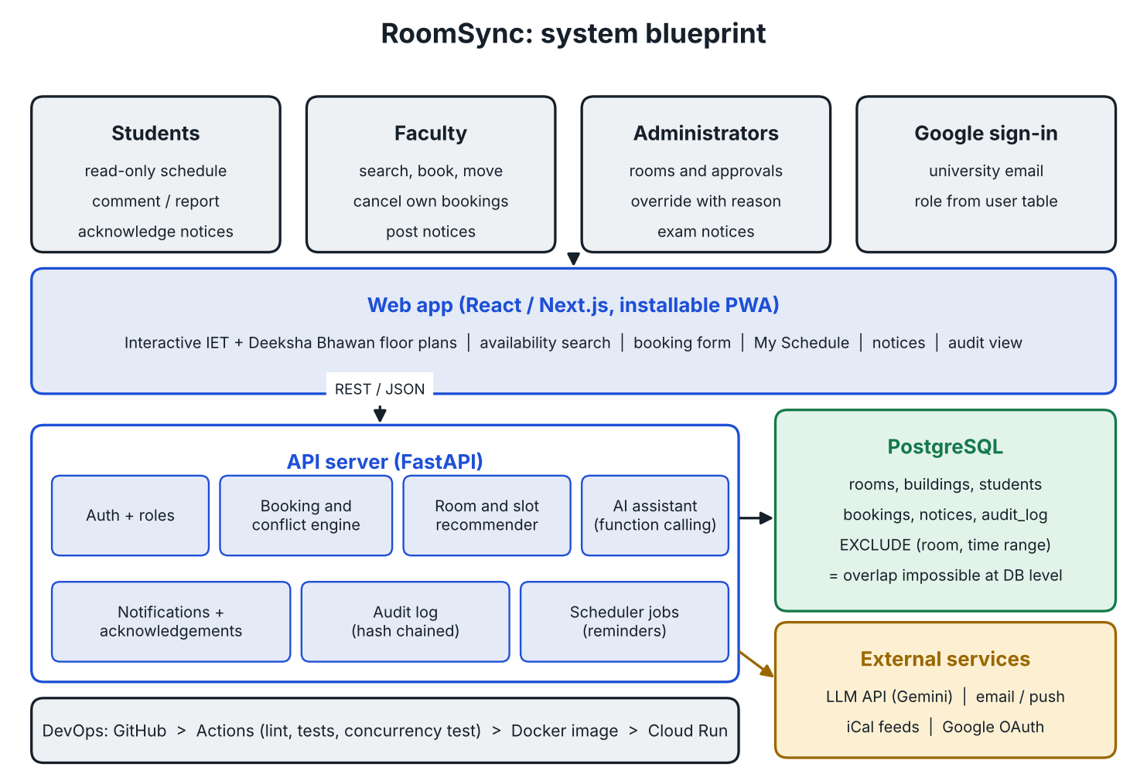
System blueprint: web app, API server, PostgreSQL, external services and the DevOps pipeline.
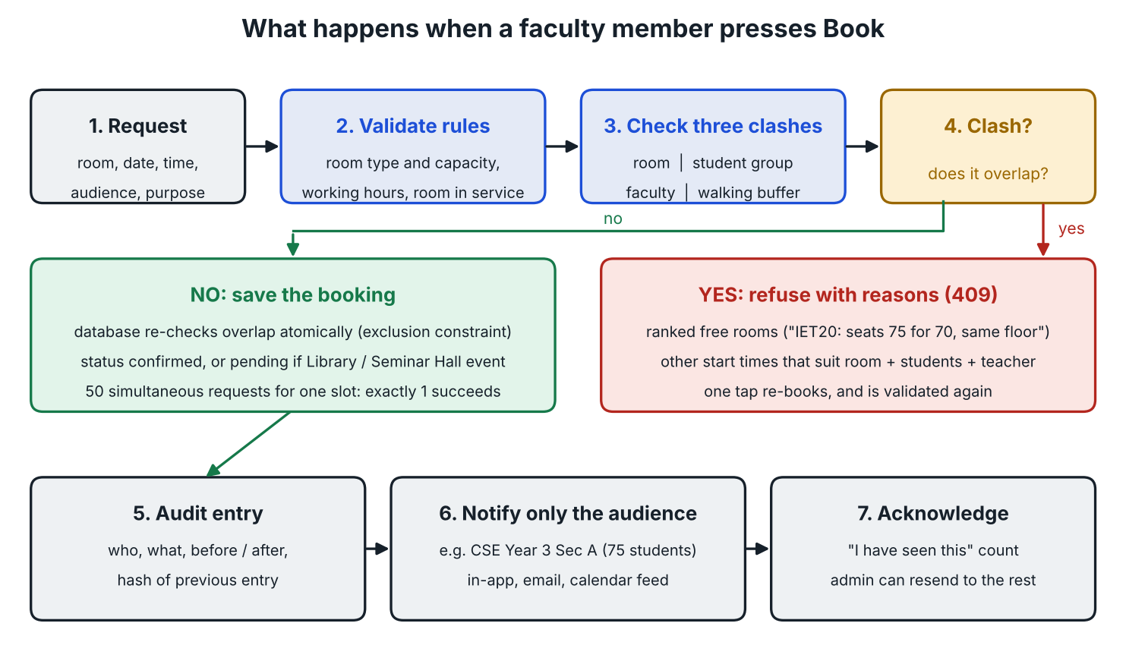
Booking flow: validate, check three kinds of clash, then either refuse with alternatives or save, audit, notify and collect acknowledgements.

3. How I understand the problem
Reading the problem statement carefully, the pain is not really "booking rooms". It is three separate failures that happen together:
- No shared truth. Bookings live in people's heads, WhatsApp groups and paper notices, so two faculty members can unknowingly take the same room.
- Discovery is slow. A faculty member who needs an extra lecture has to walk around or phone around to find a vacant room, and has no idea about Deeksha Bhawan unless they already know it is free.
- Communication is broken at the last mile. The NSS minor exam incident shows the worst case: a student did not get correct, complete information about the exam arrangement and missed it. The fix is not just publishing information, it is making sure the right student receives the right, current version and can verify it.
So the design principle is: prevent conflicts at the source, and make wrong or stale information impossible to miss.

4. Who uses it (roles)
- Student: read-only. Sees the schedule for their own branch, year, section and batch, exam venues, and announcements. Can comment on or report a problem (for example "this room is already in use" or "this notice is outdated") but can never change a booking.
- Faculty: search rooms, book, edit or cancel only their own bookings, post announcements for the classes they teach, see their own history.
- Administrator (IET office / exam cell): manages buildings, rooms, capacities, lab rules, timetable import, user accounts, can override or cancel any booking (with a mandatory reason), resolves student reports, publishes official exam notices.
Login through university email (Google sign-in fits well with a GDG event), and the role is assigned from a user table. A student can never self-promote to faculty.

5. Modelling the real campus (using the blueprints and datasets)
The prototype must be built on the actual infrastructure, so the building model comes straight from the supplied blueprints and text:

IET
- Ground floor: Library (150-180 students, sometimes used for exams), faculty cabins/teachers' office, Director's office, administrative office, Placement Cell. Only the Library is bookable (for exams), the rest are marked non-bookable.
- First floor: four labs (CSE, ME, ECE, IT) plus classrooms IET17, IET18, IET19, IET20, about 75 students each.
- Second floor: Seminar Hall IET32 (about 200 students) plus classrooms IET24, IET25, IET28, IET29, IET30.

Deeksha Bhawan
- Separate building, about 100 m from IET. Classrooms LH01 to LH12, also used for exams. Ground floor and first floor.

Students
- Six branches across four years: CSE (about 150, Sections A and B), AI ML (about 150, Sections A and B), AI DS, ECE, ME and IT (about 75 each).
- Every student record maps to branch, year, section and practical batch, so a notice can be targeted precisely.

Things I noticed in the supplied material (and how the system handles them)
- The floor plan shows rooms that the text does not list: IET14, IET15, IET16, IET22 on the first floor (probably the four labs) and IET23 on the second floor. It also draws LH01 to LH14 in Deeksha Bhawan while the text says LH01 to LH12.
- Rather than guess, every room is a database record with a type, capacity, permitted uses and an "active/needs confirmation" flag. The admin can correct it from the UI without touching code. The problem statement itself says capacities and permitted uses should be configurable wherever exact data is missing.
- A single section of 75 students in a classroom of about 75 leaves zero headroom. The system should warn ("fits, but 100% full") and the recommender should prefer a slightly larger room when one is free. A full CSE or AI ML year of 150 students does not fit any one classroom, so it needs IET32, the Library, or two rooms combined. The exam planner (section 9) handles this.

6. Features, mapped to the eight requirements in the problem statement

5.1 Room availability search
- Filters: building, floor, room, date, start time, duration, minimum capacity, room type (classroom, lab, seminar hall, library).
- Results show free/busy for the exact window, how much of the capacity would be used, and walking context (same floor, same building, or 100 m away).
- Interactive floor map: the actual IET and Deeksha Bhawan blueprints redrawn as clickable SVG. Rooms are coloured green (free), red (booked), amber (booked soon or tight fit) for whatever date and time the user picks. Clicking a room opens its day timeline. This is the feature that makes the blueprints a live part of the product rather than a picture.

5.2 Faculty booking
- Booking types: extra class, minor exam, practical session, event. Each type can have its own rules (for example events need admin approval, exams can use the Library, practicals are only allowed in labs).
- Booking for a target audience (branch, year, section, batch) so the system knows which students are involved, not only which room.
- Recurring bookings (every Tuesday for six weeks) with the same conflict check on every occurrence.

5.3 Conflict prevention and alternatives
- Full details in section 7. In short: rooms, students, and faculty can never be double-booked, and when a request fails the system immediately offers ranked alternatives.

5.4 Schedule updates
- One-click publish for cancellation, rescheduling, examination notice, venue change, general academic announcement.
- Rescheduling is a real operation: it moves the booking, keeps a link to the old one, and automatically sends a "moved from X to Y" notice to the affected audience. Nobody has to remember to announce it separately.

5.5 Student access
- Personalised "My Schedule" (day and week view) by branch, year, section and batch.
- Each booking has a Report a problem button and a comment thread. Reports go to the booking owner and admin. A report never edits the booking, but a booking with open reports shows a small "under review" badge so others know to double check.

5.6 Role-based access
- Enforced on the backend (not just hidden buttons): student read and comment only; faculty create and manage own bookings; admin manages everything and can override.

5.7 Accountability
- Append-only audit log of every create, edit, move, cancel, override and published notice: who, when, what changed (before and after), and the reason. Detailed in section 10.

5.8 Intelligent assistance
- Scheduling algorithm for ranked alternatives and best time slots, plus an AI layer for natural-language requests. Detailed in sections 7 and 8.

7. The booking and conflict engine (the heart of the system)

6.1 What counts as a conflict
Most systems only check the room. A real campus needs three checks, because a booking can be perfectly valid for the room and still ruin someone's day:
- Room conflict: another booking or regular timetable class already occupies that room in an overlapping time window.
- Audience conflict: the students (for example CSE 3rd year Section B) are already scheduled elsewhere at that time. An extra class that clashes with their own lecture is useless.
- Faculty conflict: the same teacher is already booked elsewhere.
Two intervals overlap when new_start < existing_end AND new_end > existing_start. I would treat intervals as half-open (start inclusive, end exclusive) so a class ending at 11:00 and another starting at 11:00 in the same room is allowed.

6.2 Making it truly safe
- If two faculty members press Book at the same second for the same room, a simple "check, then insert" in application code can let both through. To stop that, the database itself enforces the rule. With PostgreSQL this is an exclusion constraint on (room, time range) using a GiST index, so an overlapping insert is rejected by the database no matter what the app does.
- The API wraps booking in a transaction and returns a clear 409 Conflict with the clashing booking details and the alternatives list.
- I would include an automated concurrency test (fire 50 simultaneous requests at the same slot, exactly one must succeed) and show it in the demo. That is a strong proof for the "reliable" requirement.

6.3 Priority rules
- Suggested priority: official exam > regular timetable class > extra class > event. A higher-priority booking may displace a lower one only through the admin, and the displaced faculty member and students are automatically notified with the reason. Nothing is silently bumped.

6.4 Travel buffer between buildings
- Deeksha Bhawan is about 100 m from IET, roughly a 2 to 3 minute walk. If a batch has a class in IET ending at 11:00 and the suggested next one is in Deeksha Bhawan at 11:00, the system warns or blocks it. The buffer (for example 10 minutes) is a configurable setting.

6.5 Ranked alternative rooms
When the requested room is not available, or the user just says "any room", every free room in the window is scored and the top three to five are shown with the reason for each. A simple, explainable scoring approach:
- Capacity fit: the smallest room that still fits is preferred (do not put 30 students in the 200-seat hall), with a penalty if there is zero headroom.
- Proximity: same room type and same floor first, then same building, then Deeksha Bhawan.
- Suitability: correct type (lab for practical, hall for large events), permitted uses respected.
- Adjacent-slot bonus: continuing in a room the audience is already in avoids moving students.
- Buffer safety: penalty if it forces a cross-building move with no travel time.
Each suggestion is shown as, for example: "IET29, free 2:00-4:00, seats 75 for your 68 students, same floor as your previous class." Because it is rule-based, it is explainable and the judges can see exactly why it was recommended.

6.6 Best time slot suggestion
If the user says "I need 2 hours for CSE 3rd year Section A this week", the system intersects three free-time sets: free windows of the audience, free windows of the faculty member, and free windows of at least one suitable room. The result is a short list of slots that work for everyone. This directly solves the "faculty struggle to find a slot" problem and is simple interval arithmetic, so it is fast and reliable.

8. Where AI fits (and where it deliberately does not)
The problem statement asks for AI or algorithms "validating recommendations against actual booking records". My approach is: the AI understands and explains, the deterministic engine decides. The AI is never allowed to claim a room is free; it can only call the same search and booking functions that the UI uses.
- Natural-language search and booking. A faculty member types: "I need a room for 70 students tomorrow after lunch for 2 hours, preferably near IET20." An LLM (for example Gemini through its API, which suits a GDG event) converts that to a structured query using function calling. The backend runs it against the real database and returns real results. The LLM only phrases the answer.
- Grounded student assistant. "Where is my NSS minor exam on Saturday?" The assistant looks up that student's branch, year and section, queries the database and answers from records only, with a link to the official notice. If it finds nothing it says so rather than guessing. This is aimed squarely at the missed-exam problem.
- Announcement drafting. The admin types a rough note and the AI drafts a clear notice (date, time, venue, who it applies to, what to bring). The admin must review and approve before it is published.
- Smart summaries. "What changed today?" gives a short digest of cancellations and moves relevant to that user.
- Validation layer. Every AI suggestion passes through the same conflict engine before being shown. If the AI proposes something that fails validation, it is dropped. Prompt-injection safe: user text is treated as data, and the AI has no permission to write bookings, only to prepare them for the user to confirm.
- Fallback. If the AI service is down or slow, the normal search UI and rule-based recommender still work fully. AI is an enhancement, not a single point of failure.
Optional advanced idea: for building a whole semester timetable (many classes, rooms, teachers, constraints) a constraint solver such as Google OR-Tools CP-SAT is a better fit than a hand-written heuristic. It could be used as an "auto-generate a draft timetable" tool for the admin. I would present it as phase 2, not part of the core MVP, in line with the statement's advice to prioritise a reliable solution over unnecessary complexity.

9. Exams: the part that failed last year
Because a missed minor exam was the real-world trigger for this problem, I would give exams a dedicated flow instead of treating them as ordinary bookings.
- Exam planner: the admin selects an exam (for example NSS minor, all first years), and the system works out the total students from the dataset and proposes a room set. For example: CSE first year has 150 students, so IET32 (200) alone, or two IET classrooms, or the Library (150-180). The planner shows capacity versus headcount and avoids overcommitting. Whatever is chosen is blocked for everyone else.
- Per-student venue lookup: a student enters their roll number (or is logged in) and sees the exact room, date, time and reporting instructions. The system can also generate seat or room allocation lists per room for the invigilators.
- Targeted notification: only students in the affected branch, year, section and batch are alerted, so notices are not lost in noise.
- Acknowledgement: students can tap "I have seen this". The admin sees how many in the target group have confirmed and can resend to those who have not. This turns "we put up a notice" into "we can prove who saw it".
- Change protection: if an exam venue or time changes, the old notice is marked superseded (clearly visible, not deleted), a new version is published, and everyone in the audience gets a "CHANGED" alert. Students always see the latest version first, with the change history under it.
- Reminders: automatic reminders the day before and two hours before the exam.

10. Notifications and accountability

Notifications
- In-app notification centre with unread badges, as an installable web app (PWA) so it works well on phones.
- Email through the university address; optional push notifications; optional WhatsApp or SMS later because that is where students actually look.
- Calendar feed (iCal link) per batch, so a student can subscribe in Google Calendar and get live updates automatically.
- Notices use plain language and always state: what changed, old value, new value, who it affects, who published it, and when.

Accountability and history
- An append-only audit log: nothing is ever overwritten or deleted. A cancelled booking is marked cancelled with reason and actor, not removed.
- Booking versions: every edit stores the before and after, so the full story of a booking can be replayed.
- Searchable by room, date, user or booking. If a dispute arises, the admin can show exactly what was published, when, and to whom, including who acknowledged it.
- Optional tamper-evidence: each log entry stores a hash of the previous entry, so any later change to history is detectable. Simple to add and it makes a nice talking point.

11. Proposed architecture and technology
- Frontend: React or Next.js with TypeScript, responsive and mobile first. SVG floor maps for IET (three floors) and Deeksha Bhawan (two floors).
- Backend: Python FastAPI (quick to build, automatic API docs for the demo). Layers: API, booking/conflict service, recommendation service, notification service, AI service.
- Database: PostgreSQL, chosen specifically for the exclusion constraint that makes double-booking impossible at database level.
- AI: an LLM API such as Gemini with function calling, behind a thin wrapper so the provider can be swapped.
- Background jobs: a simple scheduler or queue for reminders and email sending.
- Auth: Google sign-in restricted to the university domain, role stored in the database, role checks on every API route.

Main data tables
- buildings (IET, Deeksha Bhawan, distance/walk time), floors, rooms (code, type, capacity, permitted uses, bookable, active, map coordinates).
- branches, batches, sections, students (imported from the supplied dataset), faculty, users (role).
- time_slots or period definitions (the university's lecture periods), timetable_entries (the regular weekly schedule, so the base timetable also blocks rooms).
- bookings (room, time range, type, owner, audience, status, priority, is_test flag), booking_audience (which branch, year, section, batch), booking_versions.
- announcements (type, version, supersedes, audience), acknowledgements, comments / reports, notifications, audit_log.

Key API endpoints (sketch)
- GET /rooms/available (building, floor, date, start, duration, capacity, type)
- POST /bookings (returns 201, or 409 with conflicts and alternatives)
- POST /bookings/{id}/reschedule, POST /bookings/{id}/cancel
- GET /slots/suggest (audience, faculty, duration, date range)
- POST /announcements, POST /announcements/{id}/ack
- POST /bookings/{id}/reports (student comment or problem report)
- GET /me/schedule, GET /exams/lookup (by roll number), GET /audit (admin)
- POST /ai/query (natural language to structured search, always validated)

12. DevOps and reliability (since this is a DevOps event)
- Git/GitHub with a clear branch workflow, pull requests and a good README with setup instructions that work in a few commands.
- Docker Compose so the whole system (frontend, backend, PostgreSQL) starts with one command on any judge's laptop.
- CI/CD with GitHub Actions: on every push run linting, unit tests and the concurrency test, build images, and deploy automatically from main.
- Deployment: a free or low-cost host (for example Google Cloud Run, Render or Railway) with a managed PostgreSQL, plus a live demo link.
- Config: environment variables for secrets and API keys, a sample .env.example, separate dev and production settings.
- Testing: unit tests for overlap logic (including edge cases such as touching intervals, midnight, recurring bookings), API tests, and the simultaneous-booking race test.
- Observability: structured logs, a health-check endpoint, and basic error reporting.
- Data safety: daily database backups, and student data only visible to the people who need it.

13. Demo plan (what I would show in under five minutes)
- Open the interactive IET and Deeksha Bhawan maps and pick a date and time. Rooms colour live from the data.
- Search by natural language: "Room for 70 students, Friday 2 PM, 2 hours." The system returns real free rooms.
- As faculty, book IET29 for an extra CSE Section A class. Success, and the students get an alert.
- As a second faculty member, try the same room and time. The system blocks it and offers ranked alternatives, including an LH room in Deeksha Bhawan with the walking-time note.
- Fire the simultaneous-booking test and show that exactly one request wins.
- Publish a minor exam notice, then change the venue. Show the old version marked superseded, the targeted "CHANGED" alert, and the acknowledgement count.
- As a student, look up the exam venue by roll number, then report an outdated notice. The official booking stays untouched but shows "under review".
- As admin, open the audit trail for that booking and see the full history.
All demo bookings are stored with is_test = true and the interface shows a visible "TEST DATA" badge, as the problem statement requires.

14. Edge cases I want to handle
- Booking that spans a lunch break or crosses midnight (reject or split); bookings in the past; bookings far in the future.
- Room temporarily out of service (maintenance, power cut): admin marks it unavailable, the system lists every affected booking and proposes replacements automatically.
- Lab rules: practical sessions only in the matching lab, with a lab capacity separate from classroom capacity.
- Library and Seminar Hall used for exams or events: approval workflow so they are not casually taken.
- Cancelling a recurring series (one occurrence versus all future ones).
- Student belongs to more than one audience (for example CSE Section B plus a practical batch): schedule view merges them.
- Faculty leaves or changes role: bookings reassigned rather than orphaned.
- Poor connectivity: cached last-known schedule in the PWA with a clear "last updated at" time, so stale data is never mistaken for live data.
- Accessibility: ground-floor rooms flagged for students who need them; readable colours not relying on red/green alone.
- Privacy: students see only their own audience's data; comments are moderated; personal data minimised.

15. Build plan: MVP first, then extras
Status: the MVP items below already work in the live prototype (section 2), using in-browser test data. What remains for the full build is the real backend, database and sign-in, plus Phase 2.

MVP (must work in the demo)
- Rooms, buildings and student/branch/batch data imported from the supplied files.
- Availability search, booking, database-level conflict prevention, ranked alternative rooms.
- Announcements with targeted audience, role-based login, audit log, student reports.
- Clickable floor maps, simple natural-language search, test-data labelling, Docker setup, CI.

Phase 2
- Slot suggestion across audience, faculty and rooms; recurring bookings; exam planner with seat lists; acknowledgement tracking; iCal feeds; email and push notifications.

Future ideas
- OR-Tools based semester timetable generation; WhatsApp notices; analytics on room utilisation (which rooms are always empty, which are overloaded) to help the administration plan better; QR code on each room door showing that room's live schedule and a "report a problem" link.
A C++ optimisation module or GPU simulation is possible, but I would only add it if a benchmark shows the Python solver is too slow, which at this campus scale (about 40 rooms, about 2,400 students) it will not be. I would rather spend the effort on reliability.

16. Assumptions and open questions
- Exact capacities for Deeksha Bhawan rooms, labs, and the extra rooms on the blueprint (IET14, IET15, IET16, IET22, IET23, LH13, LH14) are not in the text, so they are entered as configurable records marked "to be confirmed".
- The university's actual lecture period timings are assumed to be configurable (for example 50-minute periods starting at 9:00). The system does not hard-code them.
- The existing regular timetable is assumed to be importable as a CSV so the base schedule already blocks rooms.
- Who may book which room type, and who approves events, will follow the administration's rules, set through configuration.

17. Closing thought
The real value is not the booking form, it is trust. Faculty trust that a room they booked is really theirs. Students trust that what they see is current, and can prove what they were told. The administration trusts that every change has a record. If those three kinds of trust exist, a missed minor exam like last year's becomes very hard to repeat.
Prototype: https://claude.ai/artifact/1Pa8UGsoeoHGK9PsZwWRrK Source repository: ____________

