**Bug report 1**

**Bug report number:** BUG 001

**Summary:** Inability to add a new computer to the database

**Description:** Although the possibility of adding a new computer to the database of computers is clearly indicated on the web page, after adding the computer and positive feedback, neither the number ofcomputers indicated to exist in the database changes nor can it be found via the search engine.

**Steps to reproduce:**

1. Open browser

2. Open web page <https://computer-database.gatling.io/computers>

3. In the upper right corner click on "Add a new computer"

4. In the field "Computer name" enter the name of the computer

5. Click on "Create this computer"

6. In the search engine in the upper left corner enter the name of the newly added computer

7. Click on the button "Filter by name"

**Expected result:** The computer is added to the database and can be found via the search engine.

**Actual result:** The added computer is not in the database of computers.

**Priority:** high

**Severity:** high

**Repro rate:** 100%

**Screenshot:**

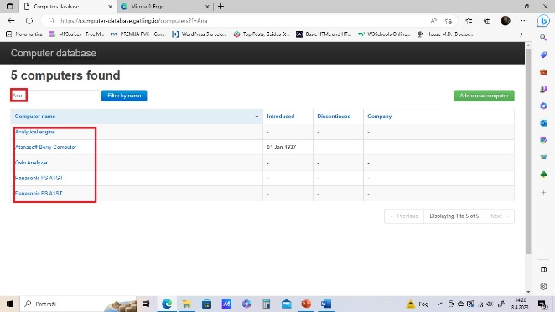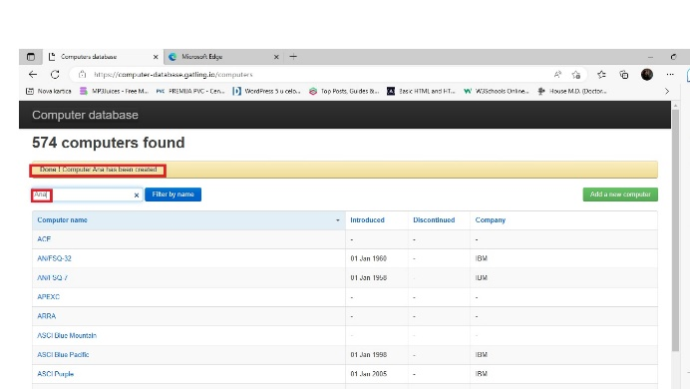

**Bug report 2**

**Bug report number:** BUG 002

**Summary:** Inability to delete a computer from the database

**Description:** Although the possibility for the user to delete an existing computer from the database is provided, it is not possible to do so.

**Steps to reproduce:**

1. Open browser

2. Open web page <https://computer-database.gatling.io/computers>

3. Click on a computer from the database of computers

4. In the upper right corner click on the button "Delete this computer"

5. In the search engine on the upper left side on the home page type in the name of the just deleted computer

6. Click on the button "Filter by name"

**Expected result:** After deleting, the name of the given deleted computer no longer exists in the database of computers.

**Actual result:** The computer is still in the database of computers after deletion.

**Priority:** high

**Severity:** high

**Repro rate:** 100%

**Screenshots:**

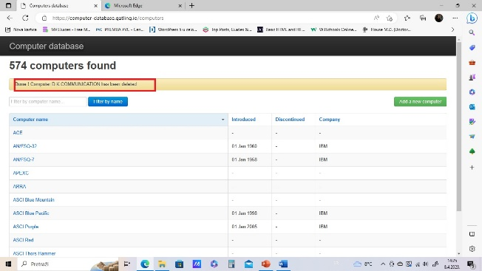 Slika na kojoj se nalazi tekst

Opis je automatski generisan