Kickstarter is one of a number of crowdfunding platforms for gathering money from the public, which circumvents traditional avenues of investment.

It is an enormous global community built around creativity and creative projects. Over 10 million people, from every continent on earth, have backed a Kickstarter project.

**Conclusions we can make about Kickstarter campaigns:**

**Conclusion 1:**

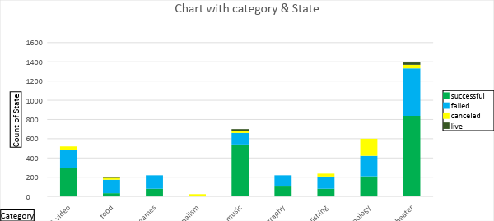

As you can see in the chart with category and state, state is the count of how many campaigns were "successful," "failed," "canceled," or is currently "live". We can draw the following conclusions:

* The most common campaign is theater and then music. People submit most of the projects in the theater category, so successful projects are also more in this area, but the failing or canceled rate is also greater.
* If we look at the ratio of successful against failed campaigns, then music projects are more successful than the theater projects.
* All projects in journalism were canceled.
* Projects in food, games, photography, publishing, technology categories have failed more than succeeded.

**Conclusion 2:**

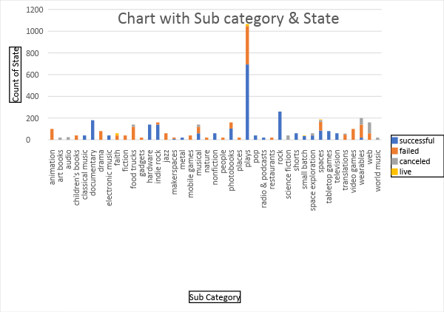

If we see the chart with subcategories and the state. We can draw the following conclusions:

* Plays have the most successful projects but also the most failed projects.
* Rock, classical music, documentary, hardware, metal, electronic music, nonfiction, pop, radio & podcasts, and television are all 100% successful. Rock is the most popular project that has a 100% success rate.
* Animation, video games and food truck have the greatest failure rate.
* Web projects have the greatest cancelation rates

**Conclusion 3:**

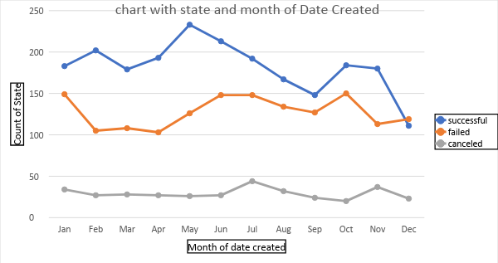

If we look at the chart with the date created and the state of the campaign, we can draw the following conclusions:

* Most of the successful campaigns are from the month of May
* Most of the failed campaigns are from the month of January, June, July, and October
* Most of the canceled campaigns are from the month of July
* December is not a good time for launching a product. There are more failed or canceled campaigns than successful campaigns.

**Limitations of this dataset:**

* Cannot find the success or failure timeline of the product. E.g. is the product more successful in the beginning or in the middle or in the end of the timeline.
* The rate of acceptance by the company, e.g. Do more people apply for the theater category or does the company accept more campaigns in this category?
* What portion of the pledged money goes to the campaign and how much go to Kickstarter.
* Kickstarter funds projects based on pledges, so we don’t know the actual cash collection.

**Other possible tables/graphs:**

* Create a pivot table and a graph for different countries to find the count of state in all countries.
* Create a scatter chart to show the participation of different countries.
* Find the ratio of success against failure by category
* Create a chart to show which year Kickstarter received the most campaigns, which will show the popularity of the company.