**Microsoft Azure**

**Regions and Zones**

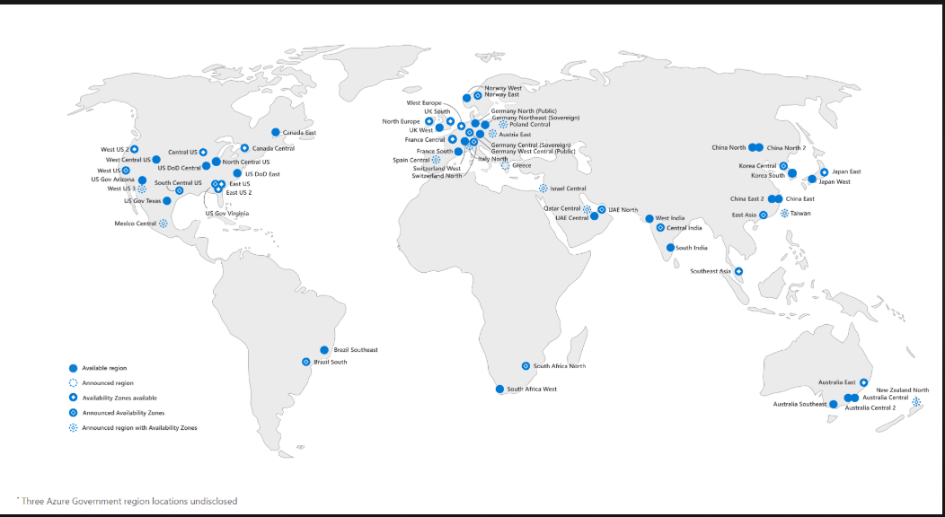

**Zones**

Available Regions

Announced Regions

Availability zones available

Announced availability zones

Announced Region with availability zones

**Creating account**

Azure.microsoft.com

Testing