All this events that occur in our country Ethiopia in 2023 still exist and may people and cattle’s was dead. In the next coming year also will the dangerous year more than the pervious, because of the conflict ethnic groups, the farmer they was not farming their land. So this project is to addresses the solution of all climate change effects, by busting sustainable development goals, with first stockholders

In general this is the sample picture

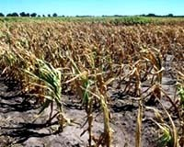

1. Climate Change Impacts on Crop Yields in Ethiopia

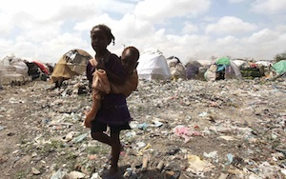

1. Climate Change Impact On Ethiopia | somalia

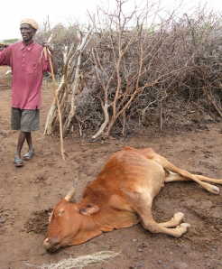

1. Impacts of Climate Change in Ethiopia|tigiray|

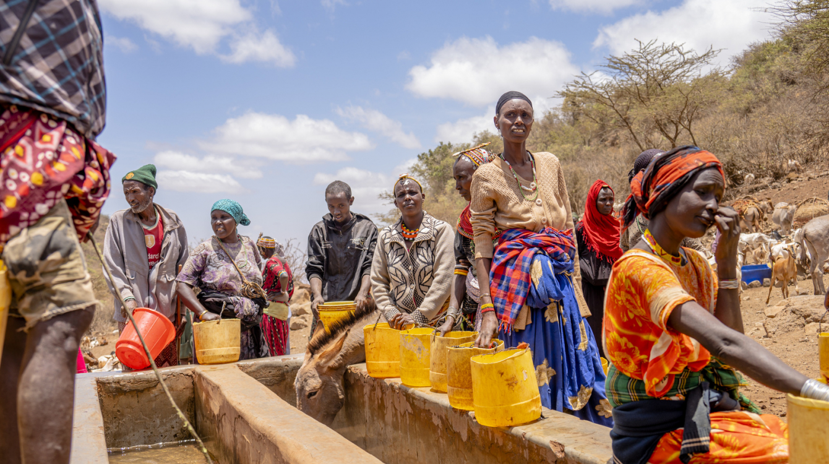

1. Horn of Africa: Climate-related health crisis worsens as disease outbreaks surge