Cairo University  
Faculty of Computers and Artificial Intelligent

**CS251 - Software Engineering I**

Parking Garage application

Software Design

**May,2022**

**Contents**

|  |  |  |
| --- | --- | --- |
| Sr.no | **Title** | **Page** |
| **1** | **Team** | **3** |
| **2** | **Document Purpose and Audience** | **3** |
| **3** | **System Models** | **4-11** |
| **3.1** | **I. Class diagrams** | **4** |
| **3.2** | **Important Algorithm** | **5-7** |
| **3.3** | **II. Sequence diagrams** | **8-11** |
| **3.4** | **Class - Sequence Usage Table** | **12** |
| **4** | **Owner report** | **13** |

# Document Purpose and Audience

**-What is this document?**

**-This document about The parking system which works with a combination of vehicle devices, software technology, and a mobile app for the best user experience.**

**-What will be included in this document?**

**1) class diagram.**

**2)** **sequence diagram**

**-who is excepted to read it?**

**1)who will design the system**

**2)who will right the code**

**System model**

1. **class diagrams**

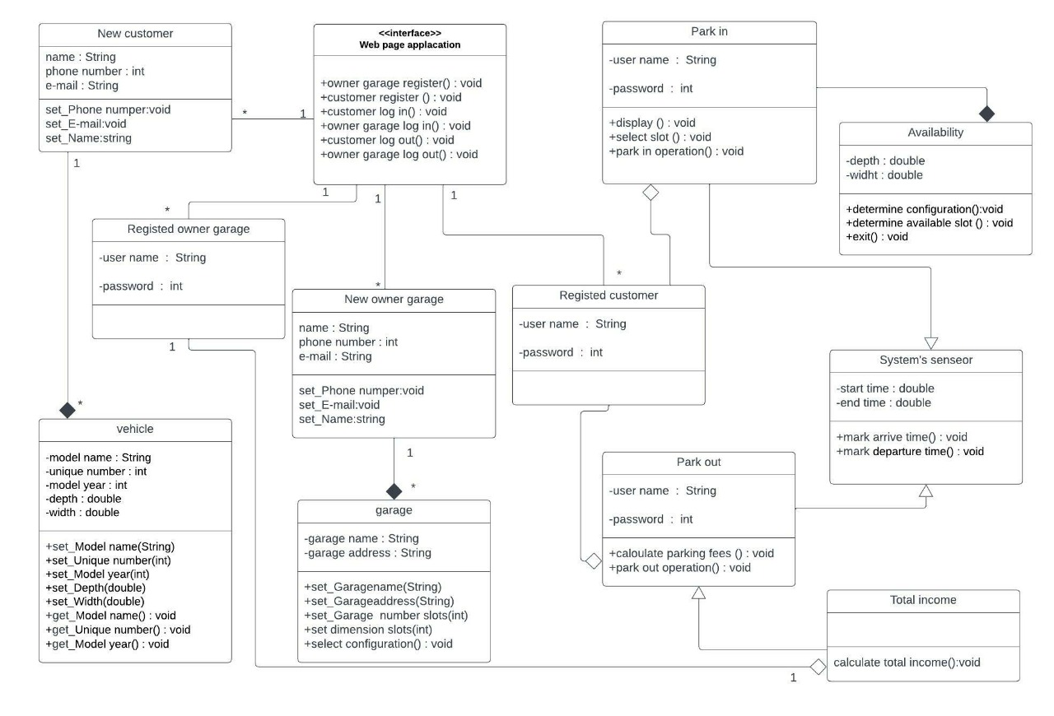

### Important Algorithm:

| **Class ID** | **Class Name** | **Description & Responsibility** |
| --- | --- | --- |
| 1 | New customer | The new customer registers and then enters his phone number, e-mail and name through the web page application |
| 2 | Registered customer | The registered customer enters his name and password via the web page in order to use the application |
| 3 | New owner garage | The New owner garage registers and then enters his phone number, e-mail and name through the web page application |
| 4 | Registered owner garage | The Registered owner garage enters his name and password via the web page in order to use the application |
| 5 | Park-in | This class makes a display for the available places, then another function makes a select slot based on the customer, and finally does a park-in operation. |
| 6 | Park-out | This class does the park-out operation and also calculates the parking fees. |
| 7 | vehicle | This class performs several functions based on the new customer, entering model numer, unique number, model year, depth and width. And also by outputting model number, unique number and model year. |
| 8 | garage | The new garage owner enters several functions such as garage name, garage address, garage number, diemension slots and configuration. |
| 9 | availability | This class determines several things such as determine configuration based on the owner of the new garage and determine availability slots in order for the customer to choose the appropriate place and then exit after completing his reservation |
| 10 | System's senseor | This class does the following things, mark the arrival time at park-in and also mark the departure time at park-out. |
| 11 | Total income | This class calculates total income at any time by the garage owner |
| 12 | Web page application | This interface class performs display and entry of information while using the application |

1. **sequence diagrams**
2. **sequence one**

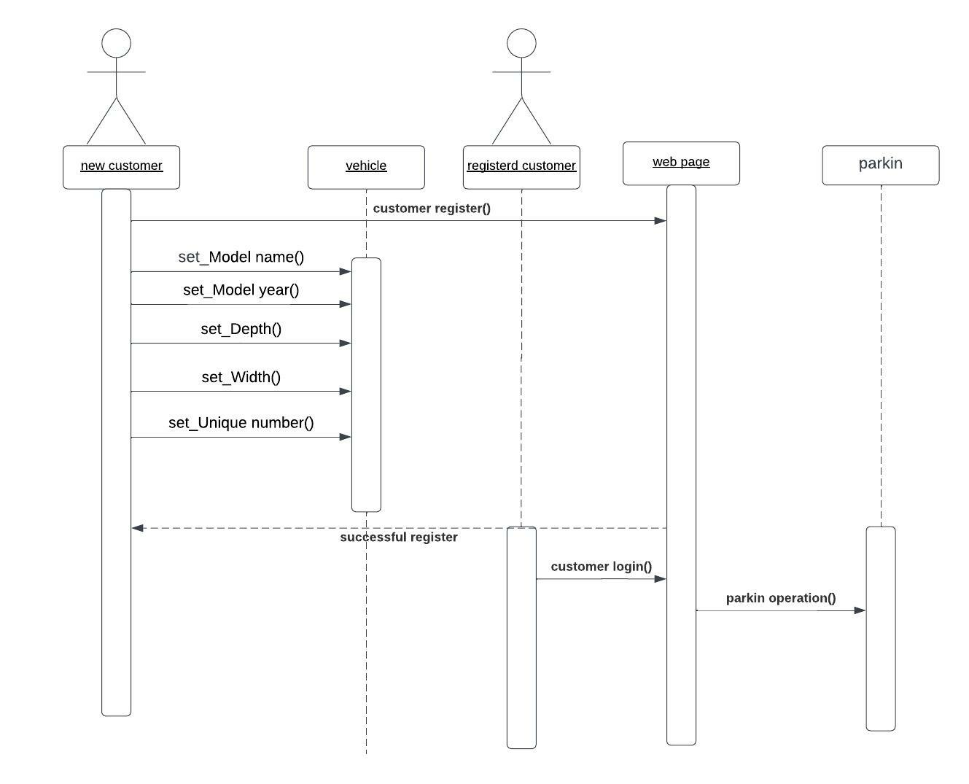

1. **sequence two**

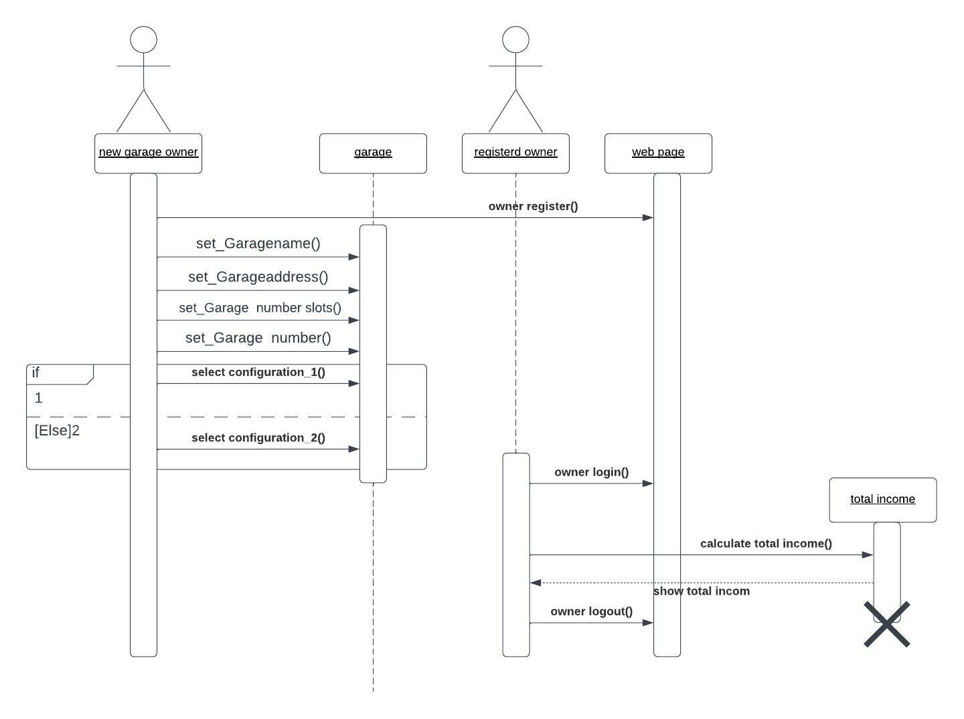

1. **sequence three**

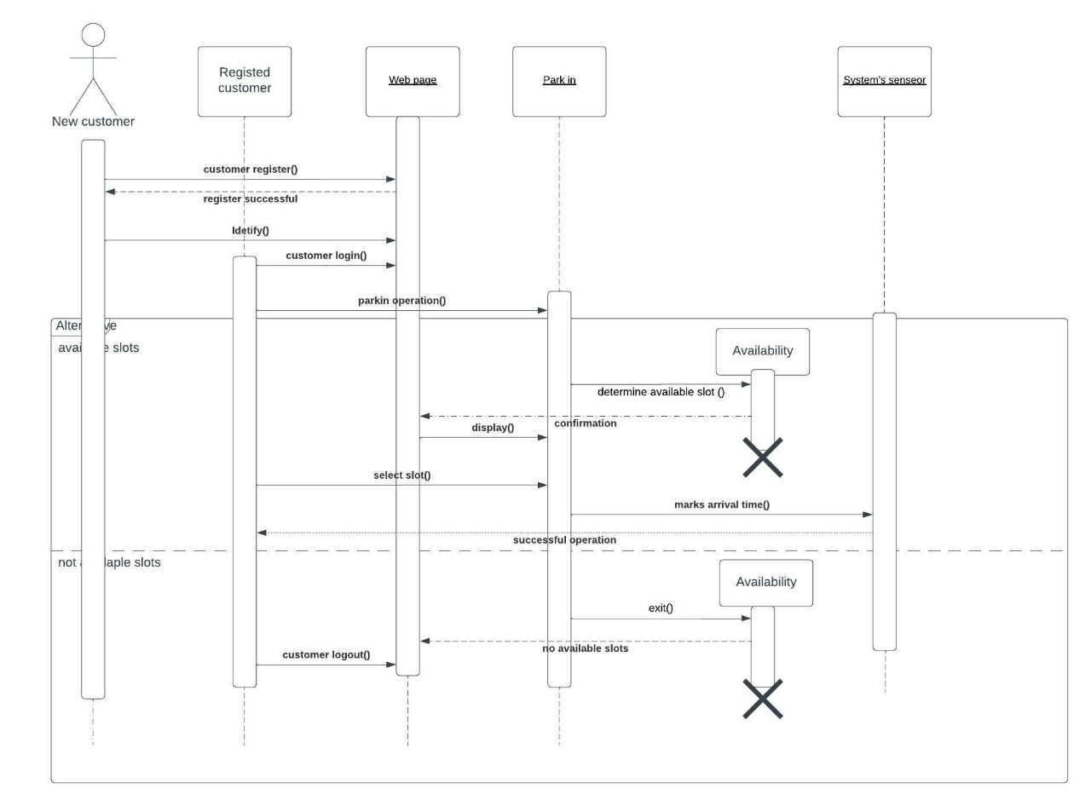

1. **sequence four**

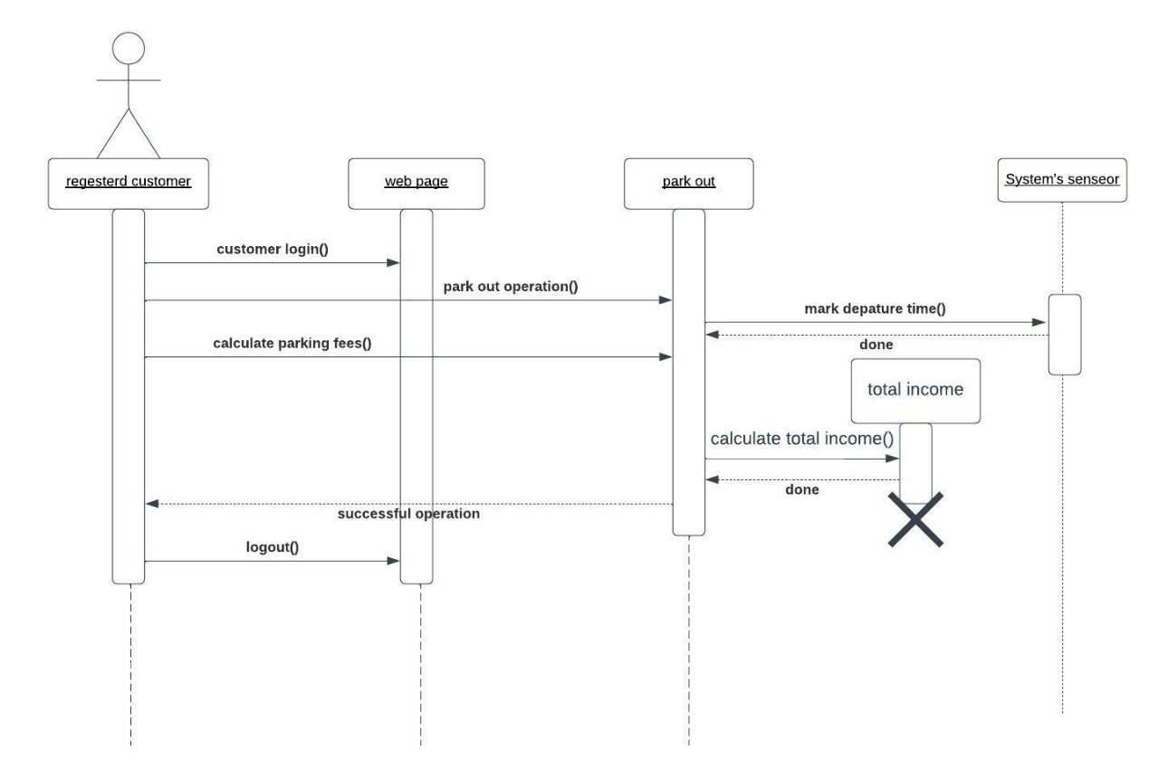

**Class - Sequence Usage Table**

| **Class Name** | **Sequence Diagrams** | **Overall used methods** |
| --- | --- | --- |
| Web page application | **1-2-3-4** | **owner garage register()**  **customer register ()**  **customer log in()**  **owner garage log in()**  **customer log out()**  **owner garage log out()** |
| New customer | **1-3** | **_** |
| New owner garage | **2** | **_** |
| Registered owner garage | **2** | **_** |
| Registered customer | **1-3-4** | **_** |
| vehicle | **1** | **set_Model name(String)**  **set_Unique number(int)**  **set_Model year(int)**  **set_Depth(double)**  **set_Width(double)** |
| garage | **2** | **display ()**  **select slot ()**  **park in operation()** |
| Park in | **1-3** | **Calculate parking fees ()**  **park out operation()** |
| Park out | **4** | **Calculate parking fees ()**  **park out operation()** |
| Availability | **3** | **determine available slot()**  **exit()** |
| System's senseor | **3-4** | **mark arrive time()**  **mark departure time()** |
| Total income | **2-4** | **Calculate total income()** |

# Ownership Report:

|  |  |
| --- | --- |
| **Item** | **Owners** |
| **Class diagram** | All team |
| **Sequence diagram** | All team |